- Data Description and Activity Information
Drone-based PM measurement data collected in January 2025 (January 16, 17, and 23) were used for model training and prediction, together with activity location information representing dust-generating operations.
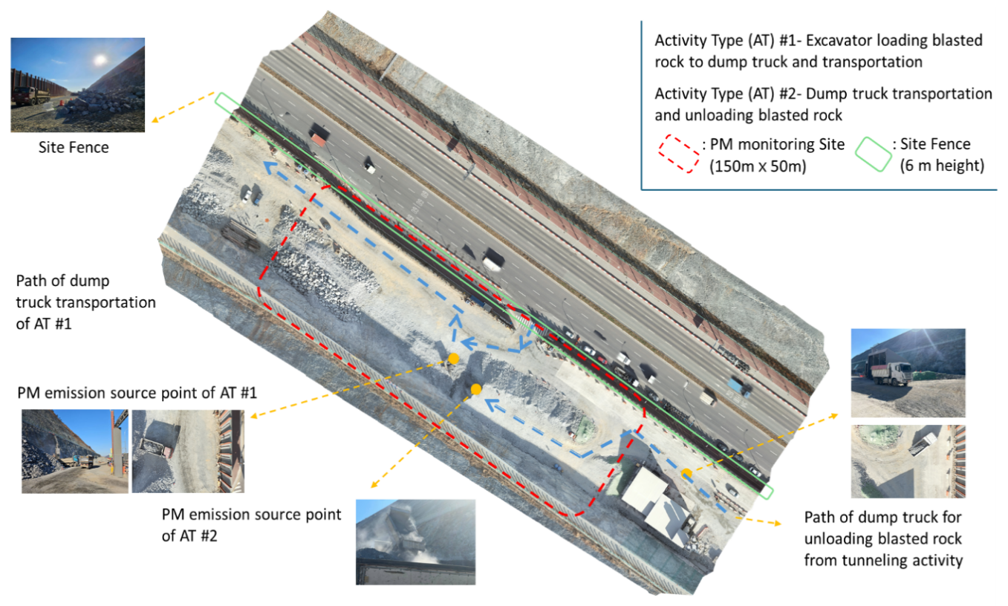
Activity ID | Latitude | Longitude
1 | 35.08805519 | 128.792906
2 | 35.08793621 | 128.7929106
Activities represent the locations of dust-generating equipment or operations.
The PM concentration at each prediction point is provided to the model through distance-based features computed from the nearest Activity or multiple Activities using weighted distance measures (Weighted_*).
- Preprocessing
  - Coordinate Difference Calculation
For each prediction point $i$ and each Activity $k$, the coordinate differences are computed based on their spatial locations. Prediction point coordinates are defined $\left(ϕ_{i},λ_{i},h_{i}\right)$, where $ϕ$ denotes latitude (degrees), $λ$ denotes longitude (degrees), and $h$ denotes altitude (meters).
Activity $k$ coordinates are defined as $\left(ϕ_{k,i},λ_{k,i},h_{k,i}\right).$ The latitude and longitude differences between the prediction point and each Activity are calculated as follows. Latitude and longitude differences are computed in degrees, while height (altitude) differences are computed in meters.
$$Δϕ_{k,i}=ϕ_{i}-ϕ_{k,i}$$
$$Δλ_{k,i}=λ_{i}-λ_{k,i}$$
  - Conversion of Latitude and Longitude Differences to Meters
The latitude and longitude differences computed in the previous step are initially expressed in degrees. To ensure consistency with height differences and enable accurate distance calculations, these angular differences are converted into metric distances.
The latitude difference is converted to meters using a constant scale factor:
$$Δy_{k,i}=Δϕ_{k,i}×110,574$$
The longitude difference is converted to meters using a latitude-dependent scale factor that accounts for the Earth’s curvature:
$$Δx_{k,i}=Δλ_{k,i}×111,320×cos\left(\overline{ϕ}\right)$$
where $\overline{ϕ}$ denotes the average latitude of the measurement area.
The converted values $Δx_{k,i}$ and $Δy_{k,i}$ represent the horizontal distance components in meters and are subsequently used for height-based and 3D distance calculations.
  - Height Difference Calculation
The vertical distance between each prediction point $i$ and Activity $k$ is computed based on their altitude information.
The height difference is defined as:
$$Δz_{k,i}=h_{i}-h_{k,i}$$
  - 3D Distance Calculation
To represent the spatial relationship between the prediction point and each Activity in three dimensions, the horizontal and vertical distance components are combined.
The three-dimensional distance between prediction point $i$ and Activity $k$ is calculated as:
$$D_{3D_{k,i}}=\sqrt{{\left(Δx_{k,i}\right)}^{2}+{\left(Δy_{k,i}\right)}^{2}+{\left(Δz_{k,i}\right)}^{2}}$$
  - Distance-Based Feature Aggregation (Inverse Distance Weighting, IDW)
Multiple Activities may influence the particulate matter concentration at a single prediction point.
To aggregate distance-related information from multiple Activities into a single representative feature, Inverse Distance Weighting (IDW) is applied.
For each prediction point $i$, the weight assigned to Activity $k$ is defined as:
$$w_{k,i}=\frac{1}{D_{k,i}^{p}}$$
Where $D_{k,i}$ represents the distance between prediction point$i$ and Activity $k$, and
$p$ is the distance power parameter. In this study, $p = 2$ is used.
Using these weights, a weighted distance-based feature is computed as:
$$Weighted_Feature_{i}=\frac{Σ_{k}\left(Feature_{k,i}×w_{k,i}\right)}{Σ_{k}w_{k,i}}$$
This aggregation is applied independently to generate the following input features:
- Weighted_3D_distance
- Weighted_Height_distance
- Weighted_Lat_diff_m
- Weighted_Lon_diff_m
  - Outlier Handling
Raw observational data may contain extreme outliers caused by sensor malfunctions, transient disturbances, or abnormal measurements.
Such outliers can degrade the predictive performance of machine learning models during training. Therefore, in this study, statistical outliers were removed using the following procedure.
Hampel Filter–Based Outlier Detection
To eliminate statistical outliers, the Hampel filter was applied.
- Reference variable: PM10
- Outliers were detected based on the median and the median absolute deviation (MAD) within a moving window.
- Threshold parameter $n_sigmas=8$
Time points identified as outliers by the Hampel filter were consistently removed across all particulate matter variables (PM1, PM2.5, and PM10).
  - Feature Scaling (Min–Max Scaler)
To ensure numerical stability and consistent feature ranges during machine learning model training, all input features are normalized using Min–Max scaling.
Distance-based features (e.g., weighted distance variables), meteorological variables, and altitude-related variables may have different physical units and value ranges. Without proper normalization, features with larger numerical ranges may dominate the learning process. Therefore, Min–Max scaling is applied to rescale each feature to a common range.
For each input feature 𝑥 the normalized value $x’$ is computed as
$$x^{'}=\frac{​x-x_{min}}{x_{max}​-x_{min}}​​$$
Feature | Train Min | Train Max
Weighted_3D_distance | 20.5426 | 244.1573
Weighted_Height_distance | -10.2589 | 127.5417
Weighted_Lat_diff_m | -118.4493 | 174.6684
Weighted_Lon_diff_m | -190.6601 | 203.9862
Wind_North | -5.45 | 8.53
Wind_East | -11.21 | 6.92
Temperature | 4.51 | 13.73
Humidity | 26.08 | 38.63
Pressure | 1010.87 | 1027.28

- Model Input Features
The input features for each PM model were selected based on the distance representation that achieved the highest predictive performance.
As a result, the distance-based input feature differs by PM type: Weighted_3D_distance is used for the PM1 model, while Weighted_Height_distance is used for the PM2.5 and PM10 models.
All remaining input variables and preprocessing steps are identical across models.
PM Type | Model file | Distance feature | Input features (order)
PM1 | XGBoost_PM1.pkl | Weighted_3D_distance | Weighted_3D_distance, Weighted_Lat_diff_m, Weighted_Lon_diff_m, Wind_North, Wind_East, Temperature, Humidity, Pressure
PM2.5 | XGBoost_PM2.5.pkl | Weighted_Height_distance | Weighted_Height_distance, Weighted_Lat_diff_m, Weighted_Lon_diff_m, Wind_North, Wind_East, Temperature, Humidity, Pressure
PM10 | XGBoost_PM10.pkl | Weighted_Height_distance | Weighted_Height_distance, Weighted_Lat_diff_m, Weighted_Lon_diff_m, Wind_North, Wind_East, Temperature, Humidity, Pressure
- Output
The output of the model is the predicted particulate matter (PM) concentration.
The output is expressed in µg/m³.
Depending on the PM type (PM1, PM2.5, or PM10), the prediction is generated using the corresponding trained model.

- Test Input Dataset Description
File: test_data_original.csv
This dataset provides an example of the input data used during model testing.
Each row represents a single prediction point, and all input features have been fully preprocessed and inverse-transformed from the scaler to restore their original physical units.
The last three columns contain the ground-truth values of PM1, PM2.5, and PM10, which are included only for evaluation and comparison purposes. These values are not used as model inputs and therefore may differ from the model’s predicted values.

