Library
Database Model

Domain Description
The library provides books for customers to read. It gives books for a temporary period and accepts them back after the due date.
Users can choose books from different categories such as fiction, scientific literature, history, children’s books, and others.
A book can be borrowed only if there is at least one available copy.
The library has the following employees:
- Administrator
- Librarian
- Operator
Members who come to the library are served by the administrator or librarian. Phone or online requests are handled by the operator.
Each loan operation is processed by one employee.
The library has a fine system:
- A fine is applied if a book is returned late.
- A fine is also applied if a book is lost or damaged.
Each registered member has a personal account in the system.

2. System Functionality

For Members:
- Search and view books
- See book details (category, author, published year, etc.)
- View loan history
- View fines and fine history

For Library Employees:
- Issue (give) books to members
- Accept returned books
- Change loan status (Active, Returned, Late)
- Assign fines
- View available books
- Prepare reports about overdue books

For Administrator:
- View most read books
- View employee performance reports
- View fines reports
- See the most active members
- Manage member database
- View reports about borrowed books

. Database Entities

Books
- Book_ID (Primary Key)
- Book_Title
- Published_Year
- Author_ID (Foreign Key)
- Category_ID (Foreign Key)
- TotalCopies
- AvailableCopies
- Created_at
- Updated_at

Members
- Member_ID (Primary Key)
- First_Name
- Last_Name
- Phone
- Email
- Created_at
- Updated_at

Authors
- Author_ID (Primary Key)
- First_Name
- Last_Name
- Country
- BirthDate
- Created_at
- Updated_at

Category
- Category_ID (Primary Key)
- Name

Loans
- Loan_ID (Primary Key)
- Book_ID (Foreign Key)
- Member_ID (Foreign Key)
- Employee_ID (Foreign Key)
- LoanDate
- DueDate
- ReturnDate
- Status (Active, Returned, Late)
- Created_at
- Updated_at

Employees
- Employee_ID (Primary Key)
- First_Name
- Last_Name
- Phone
- Role (Administrator, Operator, Librarian)
- Created_at
- Updated_at

Fines
- Fine_ID (Primary Key)
- Loan_ID (Foreign Key)
- Amount
- Paid (Boolean)
- Created_at
- Updated_at

4. Additional Information About the Model
- The fields Books.Book_Title, Members.Phone, and Members.Email are atomic attributes. This means they cannot be divided into smaller parts in this model.
- The Loans table stores general information about each loan. Each loan record is connected to one book, one member, and one employee.
- The Loans.Status field shows the current state of the loan and can have the following values:
  - Active
  - Returned
  - Late
- The AvailableCopies field is used to check book availability. A book can be borrowed only if AvailableCopies > 0.
- The Fines table stores information about penalties. The Paid field shows whether the fine has been paid or not.
- The model does not include a separate currency table. All fines are calculated in the national currency by default.

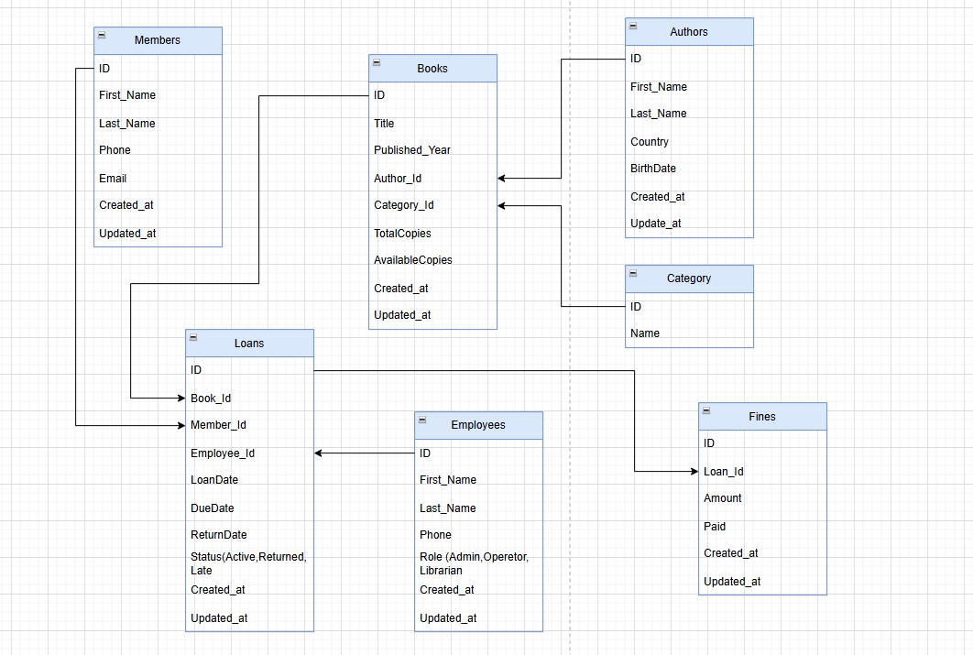

One loan can contain one or many books if we use a LoanItems table. Each loan item corresponds to only one book. At the same time, any book can be included in many loan items, or it may not be included at all.
Each loan is processed by one employee. Each employee can process any number of loans, or may not process any loan at all.
A book can be borrowed only if it is available (AvailableCopies > 0).
Fines are applied for late returns, lost books, or damaged books. Each fine is linked to one loan, but a loan may have zero or more fines.

