Midterm Project Preliminary Report
Predicting Sleep Debt from Bedtime Screen Use and Lifestyle Habits
Student Name: Meed

Introduction
For this project, I wanted to look at whether bedtime screen use and other lifestyle habits are related to sleep debt. I chose this topic because using a phone before bed is very common, and I was interested in seeing if it could help predict sleep problems. The dataset has 8,500 observations and 18 original variables, including demographic information, bedtime phone use, screen habits, caffeine use, physical activity, and sleep-related measurements.
Research question: Can lifestyle and bedtime screen-use habits predict whether a person has moderate-to-severe sleep debt?
The original response variable, sleep_debt_category, has four categories: Severe Sleep Debt, Moderate Debt, Mild Deficit, and Optimal Recovery. To make the classification problem simpler, I combined Severe Sleep Debt and Moderate Debt into a Moderate/Severe group. I also combined Mild Deficit and Optimal Recovery into a Mild/Optimal group. This gives me two classes that I can use as the response variable for the classification models later in the project.

Part A. Data Preprocessing

Variables and target preparation
I first looked through the variables to decide which ones would make sense as predictors. The dataset includes age, gender, occupation type, chronotype, bedtime phone minutes, primary bedtime app, screen brightness, blue light filter use, caffeine after 5 PM, physical activity, and several sleep measurements. I did not use user_id because it is only an identification number and does not tell us anything useful about sleep debt.
For the main analysis, I plan to use age, gender, occupation type, chronotype, bedtime phone minutes, primary bedtime app, screen brightness percentage, blue light filter status, caffeine after 5 PM, and physical activity. I decided not to use total_sleep_hours as a predictor. When I checked the data, the two sleep-debt groups were separated at about 6.75 hours of sleep. If I included total_sleep_hours, the model would almost be given the answer already. I removed it to avoid data leakage and make the classification problem more meaningful.

Missing values and duplicates
I checked the dataset for missing values and duplicated rows. I did not find any missing values or duplicate observations, so I did not need to remove any rows for these reasons.

Categorical encoding and scaling
Some of the predictors are categorical, such as gender, occupation type, chronotype, primary bedtime app, and blue light filter status. When I use a model that needs numerical inputs, I will convert these categories into dummy or one-hot variables. The numerical predictors are also measured on different scales. For a method such as K-Nearest Neighbors, I will standardize the numerical variables so that one variable does not have more influence only because its values are larger.

Outlier detection and handling
I also checked the main numerical variables for possible outliers using the 1.5 x IQR rule. Bedtime phone minutes had 237 possible outliers, caffeine after 5 PM had 483, and physical activity had 40. Age and screen brightness did not have any IQR outliers. I decided to keep the possible outliers for now because the values are still realistic. For example, someone could spend a long time on their phone before bed or drink a high amount of caffeine in the evening. I would rather keep this information unless it causes a clear problem later in the modeling step.

Part B. Data Exploration

Target distribution
After changing the original four sleep categories into two groups, there are 5,109 observations in the Moderate/Severe group and 3,391 in the Mild/Optimal group. This is about 60.1% Moderate/Severe and 39.9% Mild/Optimal. The groups are not perfectly balanced, but both still have a large number of observations.
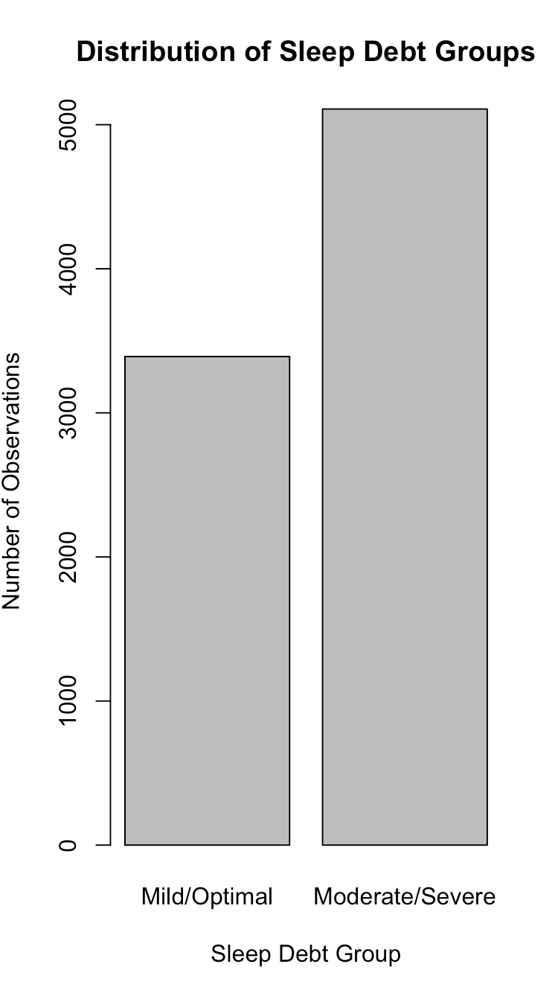
Figure 1. Distribution of the binary sleep debt outcome.

Summary statistics
The summary statistics give me a basic picture of the numerical predictors. The average age is about 34 years, and the average bedtime phone use is about 59 minutes. Bedtime phone use varies a lot in the dataset, with values ranging from 1 minute to 180 minutes. Caffeine use after 5 PM also has a wide range, from 0 to 250 mg.
Variable | Min | Q1 | Median | Mean | Q3 | Max
Age | 18 | 25 | 32 | 34.36 | 42 | 65
Bedtime phone minutes | 1 | 31 | 51 | 59.25 | 79 | 180
Screen brightness (%) | 10 | 42 | 55 | 55.15 | 69 | 100
Caffeine after 5 PM (mg) | 0 | 0 | 0 | 33.22 | 55 | 250
Physical activity (min) | 0 | 21 | 35 | 35.70 | 50 | 112

Correlation analysis
I calculated the correlations between the numerical predictors and the binary sleep-debt response. Bedtime phone minutes had the strongest correlation with sleep debt at about 0.412. Since I coded Moderate/Severe as 1 and Mild/Optimal as 0, the positive correlation means that people who spend more time on their phones before bed tend to be more likely to fall in the Moderate/Severe group. The correlations for age, screen brightness, caffeine after 5 PM, and physical activity were all very close to zero.
Predictor | Correlation with SleepDebtBinary
Age | -0.010
Bedtime phone minutes | 0.412
Screen brightness (%) | 0.010
Caffeine after 5 PM (mg) | 0.021
Physical activity (min) | 0.003
I also looked at the correlations among the numerical predictors themselves. They were all very small, so I do not see a strong correlation problem among these variables. It is also important to remember that the correlation with bedtime phone use only shows an association. It does not prove that phone use causes sleep debt.

Preliminary findings
From this first exploration, bedtime phone use stands out the most among the numerical predictors. It has a moderate positive relationship with the sleep-debt group, while the other numerical variables have much weaker individual relationships. That does not mean the other variables will be useless, because they could still help when several predictors are used together in a classification model. For the next part of the project, I will use these results as a starting point and compare classification methods using cross-validation.
Classification Methods and Cross-Validation
I used Logistic Regression and K-Nearest Neighbors (KNN) to predict Moderate/Severe sleep debt using the ten lifestyle predictors from Part A. For KNN, I used k = 15, converted categorical variables into numerical variables, and standardized the numerical predictors.
I used five-fold cross-validation to compare both models. Each model was trained on four folds and tested on the remaining fold. I evaluated their performance using accuracy, precision, recall, and AUC.
Table 2. Classification Model Performance
Metric | Logistic Regression | KNN
Accuracy | 86.64% | 82.76%
Precision | 89.27% | 85.82%
Recall | 88.39% | 85.44%
AUC | 0.9418 | 0.9048
Model Comparison
Logistic Regression performed better than KNN in all four metrics. It correctly classified 86.64% of observations and identified 88.39% of actual Moderate/Severe cases. The five-fold results were also consistent, with Logistic Regression accuracy ranging from 86.00% to 87.07%.
The ROC curves in Figure 2 show that Logistic Regression (blue) performed better than KNN (red), with a higher AUC. Both models performed better than random guessing.
The main difference is that Logistic Regression estimates probabilities using coefficients, making it easier to interpret, while KNN classifies observations based on their nearest neighbors.
Figure 2. ROC Curves for Logistic Regression and KNN.

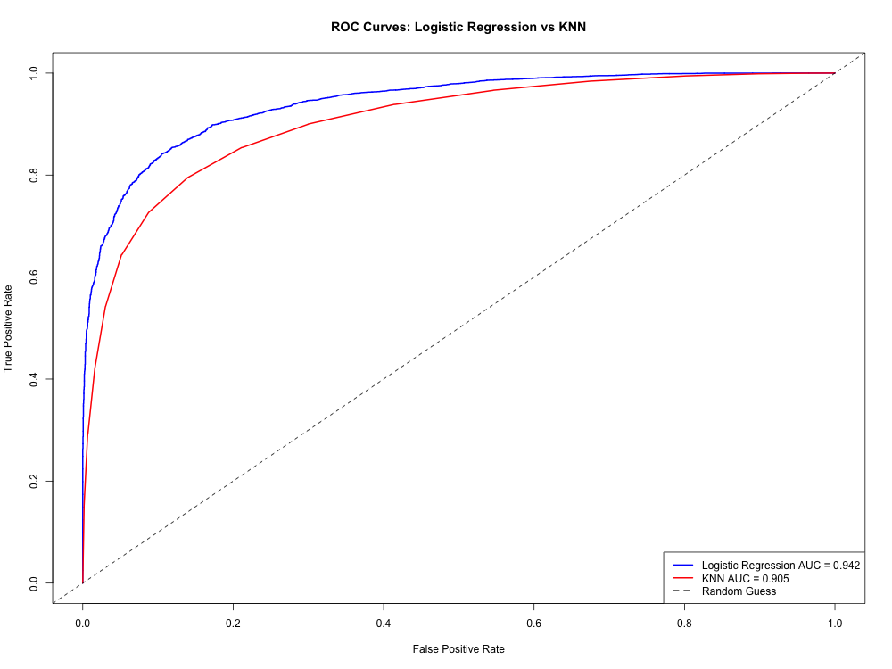

Best Model and Practical Takeaways
Based on my results, Logistic Regression was the best model because it had higher accuracy, precision, recall, and AUC than KNN. Its 86.64% accuracy was also much higher than the 60.11% accuracy from always predicting the majority class.
Bedtime phone minutes was an important predictor, with a coefficient of 0.0642 and an odds ratio of 1.0663. This means each additional minute of bedtime phone use was associated with approximately 6.63% higher odds of Moderate/Severe sleep debt, holding other predictors constant. Chronotype and occupation type also showed strong relationships with sleep debt.
Conclusion
I would choose Logistic Regression because it provides both better prediction performance and easier interpretation. KNN can recognize patterns among similar observations, but it is harder to explain individual predictor effects.
Overall, this project helped me understand how classification methods and cross-validation can be used to predict sleep debt. I found that bedtime phone use and other lifestyle factors were related to sleep debt, but these relationships do not prove causation.

