Name : Abdul Majid

ID : F2023266946

**Rooftop Gardening: Planting Coriander in a Container**

Materials Needed

Coriander Seeds: Fresh and good-quality seeds (split or whole).

Container: A small pot or container with drainage holes.

Watering Can: For gentle and even watering.

Sunlight Access: A rooftop spot that gets 4-6 hours of sunlight daily.

Step-by-Step Process

Step 1:

Prepare the Containe Ensure the container has adequate drainage holes to prevent waterlogging. Fill the container with potting mix, leaving about an inch of space from the top.

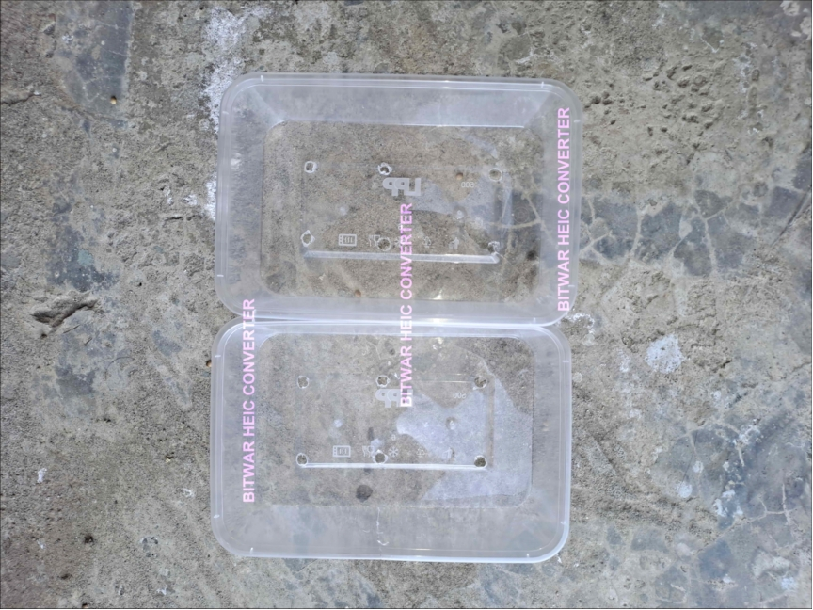

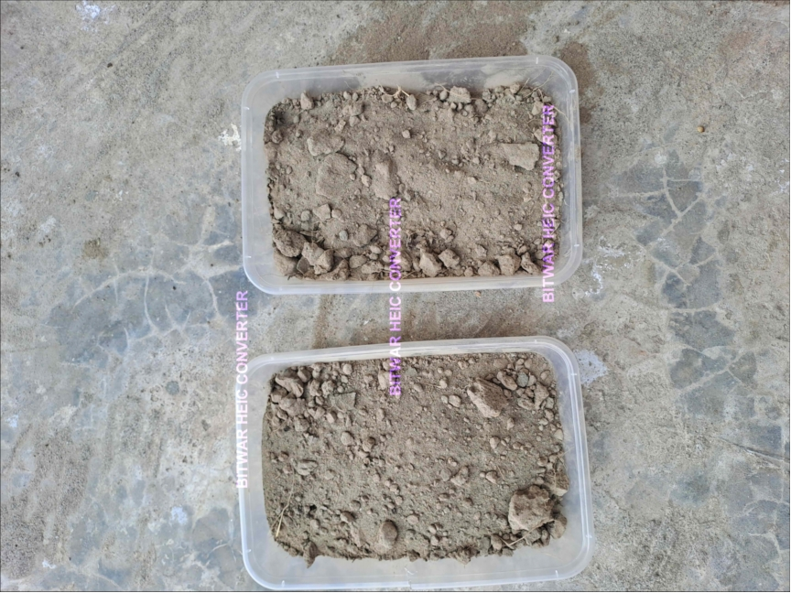

Step 2:

Prepare the Seeds Lightly crush the coriander seeds to split them (this helps them germinate faster).

Soak the seeds in water for 12-24 hours to soften the outer shell and boost germination.

Step 3:

Plant the Seeds Scatter the soaked seeds evenly over the soil surface.

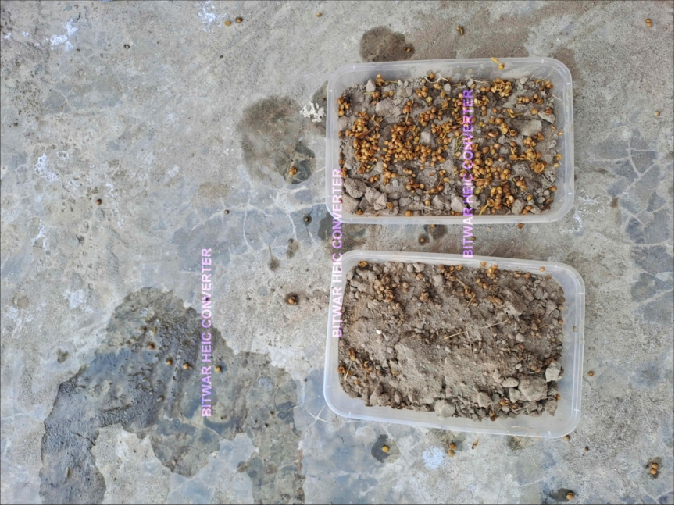

Cover them with a thin layer of soil, about 1/2 inch deep. Gently pat the soil to secure the seeds in place.

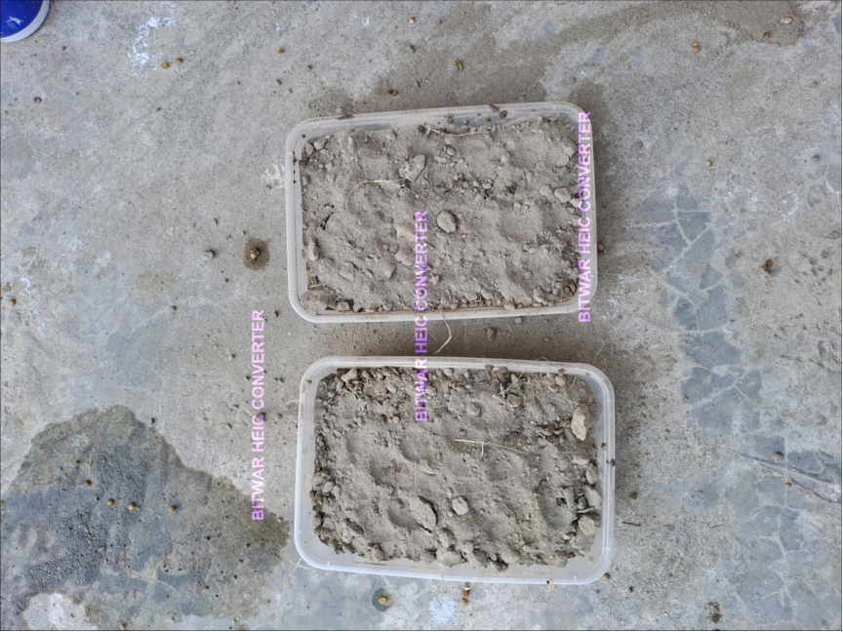

Step 4:

Water the Soil Use a watering can to moisten the soil evenly. Avoid overwatering, as coriander prefers moist but not soggy soil.

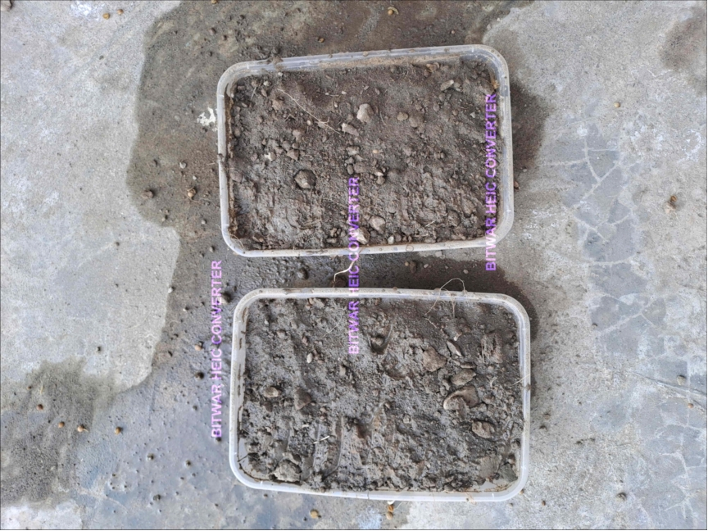

Step 5:

Place the Container Position the container in a spot on your rooftop that gets partial sunlight (4-6 hours daily).

Protect the plants from harsh afternoon sun if necessary, as coriander can wilt in extreme heat.

Step 6:

Monitor Growth Keep the soil moist by watering regularly but do not let it become waterlogged.

Germination should occur within 7-10 days.

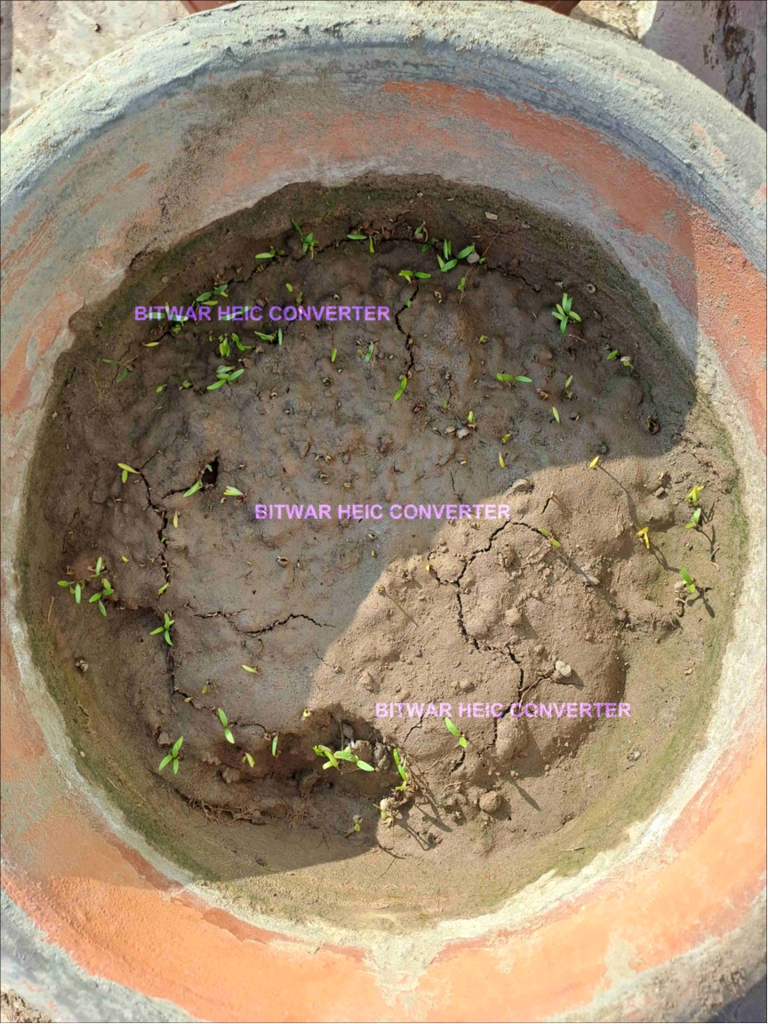

Here is link :

https://youtube.com/shorts/b4QmYyEjs9s?si=Q1Lgq5jGPq71WQuV