UNIVERSITY OF CENTRAL PUNJAB, LAHORE


SOFTWARE CONSTRUCTION AND DEVELOMENT LAB
PROJECT PROPOSAL DOCUMENTATION
SUBMITTED BY:
ABDUL MANAN – L1F23BSSE0042

FACULTY OF INFORMAATION TECHNOLOGY AND COMPUTER SCIENCE (FOIT)

TICKET RESERVATION SYSTEM

1. System Architecture & Component Mapping
The application follows an Object-Oriented, Single-Frame Desktop Architecture driven by Java Swing's Event Dispatch Thread (EDT). The UI components are decoupled structurally from operational data states by compartmentalizing structural creation, event handling, and data storage into distinct internal layers.
+-------------------------------------------------------------------+
| PRESENTATION LAYER |
| +-----------------------------------------------------------+ |
| | JFrame Main Window Container | |
| +-----------------------------------------------------------+ |
| +-----------------------------------------------------------+ |
| | JMenuBar System | |
| +-----------------------------------------------------------+ |
| +-----------------------------------------------------------+ |
| | CardLayout Workspace Panel Container | |
| | [Home View] [Booking View] [Cancel View] [View Map]| |
| +-----------------------------------------------------------+ |
+-------------------------------------------------------------------+
|
Event Interactions
v
+-------------------------------------------------------------------+
| APPLICATION CONTROL LAYER |
| * Action Listeners * Mouse Adaptation * SwingUtilities |
+-------------------------------------------------------------------+
|
Memory Management
v
+-------------------------------------------------------------------+
| DATA STORAGE LAYER |
| * HashMap (Seats Map) * TreeMap (Sorting) * Stacks (Logs) |
+-------------------------------------------------------------------+

2. In-Memory Data Structure Specifications
Since a database engine is omitted per system requirements, persistence is handled using collections optimized for specific performance bounds:

2.1 Seat Allocation Matrix (HashMap)
- Type: HashMap<String, Ticket>
- Complexity: $O(1)$ Average Case lookup, insertion, and deletion time.
- Purpose: Handles the seat matrix layout context. It maps unique alphanumerical seat keys (e.g., "E1", "B3", "V10") straight to memory locations containing instantiation properties of individual Ticket models.

2.2 Sorted Views Generation (TreeMap)
- Type: TreeMap<String, Ticket>
- Complexity: $O(\log n)$ extraction and search boundaries.
- Purpose: Instantiated dynamically during live view requests to automatically order alphanumeric row keys across Category domains before spitting out visual logs to the output monitor window.

2.3 Transaction History Rollbacks (Stack)
- Type: Stack<Ticket> (Instantiated independently as bookingStack and cancellationStack)
- Complexity: $O(1)$ sequential tracking performance rules.
- Purpose: Stores tracking histories using standard Last-In, First-Out (LIFO) tracking pipelines.
  - bookingStack.push(t) processes recent confirm operations.
  - cancellationStack.push(t) handles historical drops, allowing step-by-step state recovery without database storage engines.

3. Class Member & API Design Document

Class: TicketReservationSystem (Extends javax.swing.JFrame)

Inner Domain Class: Ticket
- String category: Categorical tier allocation ("Economy", "Business", "VIP").
- String customerName: String value capturing consumer data context.
- String seatNo: Unique primary key layout designation.
- boolean booked: Boolean verification flag tracking seat availability.

Global Core State Fields
- seats: Main structural mapping register matrix.
- bookingStack / cancellationStack: Dual tracking logs handling undo history profiles.
- cardPanel: Visual window panel wrapper.
- cardLayout: Card configuration mechanism managing screen switches.

Operational Methods & Lifecycle API
Method Name | Return Type | Description
initializeSeats() | void | Bootstraps memory arrays; loops configurations to spawn 30 standalone seat vectors (10 units per tier) into the seats directory map.
createMenus() | void | Compiles global frame window options, sets up look and feel parameters, and applies layout controllers to navigation items.
createBookingPanel() | JPanel | Generates the operational GridBagLayout configuration containing form components, verification parameters, and confirmation triggers.
createCancelPanel() | JPanel | Renders layout view allocations handling reservation release commands.
createViewSeatsPanel() | JPanel | Compiles systemic matrix status records. Calls sorting routines to arrange output tracking layout windows.
createStyledButton(String text) | JButton | Custom component factory. Explicitly overrides default OS window styling via .setContentAreaFilled(false) and .setOpaque(true) to build high-contrast solid deep blue buttons (#1D4ED8) with interactive hover behaviors (#30388A).
showAllSeats() | void | Fetches active data maps, injects them into a localized TreeMap, and appends formatted terminal matrices into output screens.
undoBooking() / undoCancellation() | void | Peeks into LIFO registers to pop operations, reverses reservation states, and refreshes data views dynamically.

4. UI Layout Hierarchy & Rendering Architecture
To keep interface frames responsive, components are layered through nested parent-child hierarchies that prevent screen elements from overlapping or clipping.
[JFrame Window Context Container] (Default BorderLayout, 850x620px Layout Dimensions)
│
├── [JMenuBar Menu Canvas Wrapper] -> Position: NORTH
│ └── File, Ticket, Undo, View, Help Options
│
└── [cardPanel Workspace Monitor] -> Position: CENTER (CardLayout Manager)
│
├── Card View 1: [Home Workspace Panel]
│ └── BorderLayout configurations displaying Quick Start info panels.
│
├── Card View 2: [Booking Workspace Panel]
│ └── GridBagLayout Panel Matrix (Edge-to-Edge Flush Canvas)
│ ├── Row 1: App Header Module Label
│ ├── Row 2: Customer Name Text Input Field
│ ├── Row 3: Seat Class Dropdown Selection (JComboBox)
│ ├── Row 4: Seat Alphanumeric Input Field
│ ├── Row 5: Solid Blue Execution Button (Confirm Booking)
│ └── Row 6: Dark Gray Terminal Log Output Wrapper Area
│
├── Card View 3: [Cancel Workspace Panel]
│ └── GridBagLayout Panel Matrix
│ ├── Row 1: App Header Module Label
│ ├── Row 2: Target Alphanumeric Seat Key Field
│ ├── Row 3: Solid Blue Execution Button (Cancel Reservation)
│ └── Row 4: Dark Gray Log Console Field
│
└── Card View 4: [View Matrix Panel]
└── BorderLayout Canvas hosting a high-contrast console matrix map.

5. System Data Flow Matrix

5.1 Ticket Booking Pipeline
- The user inputs transaction context credentials and executes the Confirm Booking trigger.
- The controller processes input string values, standardizes case formatting, and validates keys using seats.containsKey(seat).
- If valid, the target Ticket instance state parameters are updated (booked = true, assignment of customerName).
- The system updates the transaction logs by executing bookingStack.push(t).
- The view captures the action context state change and prints confirmation details directly inside the tracking panel's darkened log module area.

5.2 Transaction Undo Mechanism
- The user triggers the Undo Booking workflow option via the window navigation bar.
- The control block calls bookingStack.isEmpty() to check log states.
- If logs exist, the stack drops the top operation via .pop().
- The structural object model updates properties inline, resetting tracking attributes safely back to factory defaults.
- A JOptionPane success notification displays the updated state, and the core display layout updates automatically.

SOURCE CODE:
import javax.swing.*;
import javax.swing.border.EmptyBorder;
import javax.swing.border.LineBorder;
import java.awt.*;
import java.awt.event.MouseAdapter;
import java.awt.event.MouseEvent;
import java.util.*;
class TicketReservationSystem extends JFrame {
// Modern High-Contrast Minimalist Palette
private final Color PRIMARY_BLUE = new Color(29, 78, 216); // Pura solid deep blue button background ke liye
private final Color HOVER_BLUE = new Color(30, 58, 138); // Hover karne par thoda dark blue
private final Color APP_BACKGROUND = new Color(255, 255, 255); // Pure Clean White App Canvas
private final Color TEXT_DARK = new Color(17, 24, 39); // Near Black Main Text
private final Color TEXT_MUTED = new Color(107, 114, 128); // Cool Gray Subtext
private final Color INPUT_BG = new Color(249, 250, 251); // Soft Input Background
private final Color OUTPUT_BG = new Color(229, 231, 235); // Darker Contrast Gray for Output Logs
private final Color OUTPUT_TEXT = new Color(31, 41, 55); // Clear Charcoal text for logs
private final Font MAIN_FONT = new Font("Segoe UI", Font.PLAIN, 14);
private final Font TITLE_FONT = new Font("Segoe UI", Font.BOLD, 26);
class Ticket {
String category;
String customerName;
String seatNo;
boolean booked;
Ticket(String category, String seatNo) {
this.category = category;
this.seatNo = seatNo;
this.customerName = "";
this.booked = false;
}
}
private final HashMap<String, Ticket> seats = new HashMap<>();
private final Stack<Ticket> bookingStack = new Stack<>();
private final Stack<Ticket> cancellationStack = new Stack<>();
private JPanel cardPanel;
private CardLayout cardLayout;
private JTextArea seatsDisplayArea;
public TicketReservationSystem() {
initializeSeats();
setTitle("Ticket Reservation System");
setSize(850, 620);
setLocationRelativeTo(null);
setDefaultCloseOperation(EXIT_ON_CLOSE);
getContentPane().setBackground(APP_BACKGROUND);
// CardLayout setup full screen window flush fill karne ke liye
cardLayout = new CardLayout();
cardPanel = new JPanel(cardLayout);
cardPanel.setBackground(APP_BACKGROUND);
cardPanel.setBorder(new EmptyBorder(0, 0, 0, 0));
// Views generation
cardPanel.add(createHomePanel(), "Home");
cardPanel.add(createBookingPanel(), "Book");
cardPanel.add(createCancelPanel(), "Cancel");
cardPanel.add(createViewSeatsPanel(), "View");
add(cardPanel, BorderLayout.CENTER);
createMenus();
setVisible(true);
}
private void initializeSeats() {
for (int i = 1; i <= 10; i++) seats.put("E" + i, new Ticket("Economy", "E" + i));
for (int i = 1; i <= 10; i++) seats.put("B" + i, new Ticket("Business", "B" + i));
for (int i = 1; i <= 10; i++) seats.put("V" + i, new Ticket("VIP", "V" + i));
}
private void createMenus() {
JMenuBar bar = new JMenuBar();
bar.setBackground(Color.WHITE);
bar.setBorder(BorderFactory.createMatteBorder(0, 0, 1, 0, new Color(229, 231, 235)));
JMenu fileMenu = new JMenu("File");
JMenu ticketMenu = new JMenu("Ticket");
JMenu undoMenu = new JMenu("Undo");
JMenu viewMenu = new JMenu("View");
JMenu helpMenu = new JMenu("Help");
JMenuItem homeItem = new JMenuItem("Home");
JMenuItem exitItem = new JMenuItem("Exit");
JMenuItem bookItem = new JMenuItem("Book Ticket");
JMenuItem cancelItem = new JMenuItem("Cancel Ticket");
JMenuItem undoBookItem = new JMenuItem("Undo Booking");
JMenuItem undoCancelItem = new JMenuItem("Undo Cancellation");
JMenuItem viewItem = new JMenuItem("View All Seats");
JMenuItem aboutItem = new JMenuItem("About");
fileMenu.add(homeItem);
fileMenu.addSeparator();
fileMenu.add(exitItem);
ticketMenu.add(bookItem);
ticketMenu.add(cancelItem);
undoMenu.add(undoBookItem);
undoMenu.add(undoCancelItem);
viewMenu.add(viewItem);
helpMenu.add(aboutItem);
bar.add(fileMenu);
bar.add(ticketMenu);
bar.add(undoMenu);
bar.add(viewMenu);
bar.add(helpMenu);
setJMenuBar(bar);
// Window Card Layout Action Handlers
homeItem.addActionListener(e -> cardLayout.show(cardPanel, "Home"));
exitItem.addActionListener(e -> System.exit(0));
bookItem.addActionListener(e -> cardLayout.show(cardPanel, "Book"));
cancelItem.addActionListener(e -> cardLayout.show(cardPanel, "Cancel"));
viewItem.addActionListener(e -> {
showAllSeats();
cardLayout.show(cardPanel, "View");
});
undoBookItem.addActionListener(e -> undoBooking());
undoCancelItem.addActionListener(e -> undoCancellation());
aboutItem.addActionListener(e -> JOptionPane.showMessageDialog(this,
"Dynamic Ticket Reservation System\nJava Swing Clean UI Modernization",
"About", JOptionPane.INFORMATION_MESSAGE));
}
private JPanel createHomePanel() {
JPanel panel = new JPanel(new BorderLayout(30, 30));
panel.setBackground(APP_BACKGROUND);
panel.setBorder(new EmptyBorder(40, 40, 40, 40));
JLabel heading = new JLabel("Welcome back!", SwingConstants.LEFT);
heading.setFont(TITLE_FONT);
heading.setForeground(TEXT_DARK);
JTextArea area = new JTextArea();
area.setEditable(false);
area.setFont(MAIN_FONT);
area.setForeground(TEXT_MUTED);
area.setBackground(APP_BACKGROUND);
area.setLineWrap(true);
area.setText("Navigate through the application seamlessly using the Menu Bar above.\n\n" +
"• Quick Access Guide:\n" +
" - Ticket -> Book Ticket (Secure your seat)\n" +
" - Ticket -> Cancel Ticket (Release a reservation)\n" +
" - Undo -> Rollback your recent steps\n" +
" - View -> Check real-time seat availability map");
panel.add(heading, BorderLayout.NORTH);
panel.add(area, BorderLayout.CENTER);
return panel;
}
private JPanel createBookingPanel() {
JPanel container = new JPanel(new GridBagLayout());
container.setBackground(APP_BACKGROUND);
container.setBorder(new EmptyBorder(40, 50, 40, 50));
GridBagConstraints gbc = new GridBagConstraints();
gbc.insets = new Insets(12, 12, 12, 12);
gbc.fill = GridBagConstraints.HORIZONTAL;
JLabel title = new JLabel("Book a Ticket");
title.setFont(TITLE_FONT);
title.setForeground(TEXT_DARK);
gbc.gridx = 0; gbc.gridy = 0; gbc.gridwidth = 2;
gbc.anchor = GridBagConstraints.WEST;
container.add(title, gbc);
gbc.gridwidth = 1;
JTextField nameField = createStyledTextField();
JComboBox<String> categoryBox = new JComboBox<>(new String[]{"Economy", "Business", "VIP"});
categoryBox.setFont(MAIN_FONT);
categoryBox.setPreferredSize(new Dimension(320, 38));
categoryBox.setBackground(Color.WHITE);
JTextField seatField = createStyledTextField();
JTextArea resultArea = createStyledTextArea();
JButton bookButton = createStyledButton("Confirm Booking");
addFormRow(container, gbc, "Customer Name:", nameField, 1);
addFormRow(container, gbc, "Seat Category:", categoryBox, 2);
addFormRow(container, gbc, "Seat Number (e.g., E1, B3):", seatField, 3);
gbc.gridx = 1; gbc.gridy = 4;
gbc.fill = GridBagConstraints.NONE;
gbc.anchor = GridBagConstraints.WEST;
container.add(bookButton, gbc);
gbc.gridx = 0; gbc.gridy = 5; gbc.gridwidth = 2;
gbc.weighty = 1.0;
gbc.fill = GridBagConstraints.BOTH;
JScrollPane scrollPane = new JScrollPane(resultArea);
scrollPane.setBorder(null);
container.add(scrollPane, gbc);
bookButton.addActionListener(e -> {
String name = nameField.getText().trim();
String seat = seatField.getText().trim().toUpperCase();
if (name.isEmpty() || seat.isEmpty()) {
resultArea.setText("⚠️ Error: All fields must be filled out.");
return;
}
if (!seats.containsKey(seat)) {
resultArea.setText("⚠️ Error: Seat " + seat + " does not exist.");
return;
}
Ticket t = seats.get(seat);
if (t.booked) {
resultArea.setText("❌ Status: Seat " + seat + " is already booked.");
return;
}
t.customerName = name;
t.booked = true;
bookingStack.push(t);
resultArea.setText("🎉 Booking Confirmed!\n\n" +
"• Name: " + name + "\n" +
"• Seat No: " + seat + "\n" +
"• Tier: " + t.category);
nameField.setText("");
seatField.setText("");
});
return container;
}
private JPanel createCancelPanel() {
JPanel container = new JPanel(new GridBagLayout());
container.setBackground(APP_BACKGROUND);
container.setBorder(new EmptyBorder(40, 50, 40, 50));
GridBagConstraints gbc = new GridBagConstraints();
gbc.insets = new Insets(12, 12, 12, 12);
gbc.fill = GridBagConstraints.HORIZONTAL;
JLabel title = new JLabel("Cancel a Ticket");
title.setFont(TITLE_FONT);
title.setForeground(TEXT_DARK);
gbc.gridx = 0; gbc.gridy = 0; gbc.gridwidth = 2;
gbc.anchor = GridBagConstraints.WEST;
container.add(title, gbc);
gbc.gridwidth = 1;
JTextField seatField = createStyledTextField();
JButton cancelButton = createStyledButton("Cancel Reservation");
JTextArea output = createStyledTextArea();
addFormRow(container, gbc, "Enter Seat Number:", seatField, 1);
gbc.gridx = 1; gbc.gridy = 2;
gbc.fill = GridBagConstraints.NONE;
gbc.anchor = GridBagConstraints.WEST;
container.add(cancelButton, gbc);
gbc.gridx = 0; gbc.gridy = 3; gbc.gridwidth = 2;
gbc.weighty = 1.0;
gbc.fill = GridBagConstraints.BOTH;
JScrollPane scrollPane = new JScrollPane(output);
scrollPane.setBorder(null);
container.add(scrollPane, gbc);
cancelButton.addActionListener(e -> {
String seat = seatField.getText().trim().toUpperCase();
if (!seats.containsKey(seat)) {
output.setText("⚠️ Error: Seat layout context not recognized.");
return;
}
Ticket t = seats.get(seat);
if (!t.booked) {
output.setText("❌ Status: Seat is already open/vacant.");
return;
}
cancellationStack.push(t);
t.booked = false;
t.customerName = "";
output.setText("✔️ Success: Seat " + seat + " has been completely released.");
seatField.setText("");
});
return container;
}
private JPanel createViewSeatsPanel() {
JPanel panel = new JPanel(new BorderLayout(20, 20));
panel.setBackground(APP_BACKGROUND);
panel.setBorder(new EmptyBorder(40, 40, 40, 40));
JLabel title = new JLabel("Live Seat Matrix Status");
title.setFont(TITLE_FONT);
title.setForeground(TEXT_DARK);
panel.add(title, BorderLayout.NORTH);
seatsDisplayArea = createStyledTextArea();
JScrollPane scrollPane = new JScrollPane(seatsDisplayArea);
scrollPane.setBorder(null);
panel.add(scrollPane, BorderLayout.CENTER);
return panel;
}
private void showAllSeats() {
if (seatsDisplayArea == null) return;
seatsDisplayArea.setText("");
seatsDisplayArea.append(String.format(" %-15s | %-18s | %-20s\n", "SEAT NO", "CATEGORY", "STATUS"));
seatsDisplayArea.append(" -------------------------------------------------------------------\n");
TreeMap<String, Ticket> sortedSeats = new TreeMap<>(seats);
for (Ticket t : sortedSeats.values()) {
String status = t.booked ? "🔴 Reserved [" + t.customerName + "]" : "🟢 Available";
seatsDisplayArea.append(String.format(" %-15s | %-18s | %-20s\n", t.seatNo, t.category, status));
}
}
private void addFormRow(JPanel panel, GridBagConstraints gbc, String labelText, Component comp, int yRow) {
JLabel label = new JLabel(labelText);
label.setFont(MAIN_FONT);
label.setForeground(TEXT_DARK);
gbc.gridx = 0; gbc.gridy = yRow; gbc.weightx = 0.0;
gbc.anchor = GridBagConstraints.WEST;
panel.add(label, gbc);
gbc.gridx = 1; gbc.gridy = yRow; gbc.weightx = 1.0;
gbc.anchor = GridBagConstraints.WEST;
panel.add(comp, gbc);
}
private JTextField createStyledTextField() {
JTextField tf = new JTextField();
tf.setFont(MAIN_FONT);
tf.setPreferredSize(new Dimension(320, 38));
tf.setMinimumSize(new Dimension(320, 38));
tf.setBackground(INPUT_BG);
tf.setBorder(BorderFactory.createCompoundBorder(
new LineBorder(new Color(229, 231, 235), 1, true),
new EmptyBorder(4, 12, 4, 12)
));
return tf;
}
private JButton createStyledButton(String text) {
JButton btn = new JButton(text);
btn.setFont(new Font("Segoe UI", Font.BOLD, 14));
btn.setForeground(Color.WHITE);
btn.setBackground(PRIMARY_BLUE);
btn.setFocusPainted(false);
btn.setContentAreaFilled(false); // Windows basic native gradients ko disable karne ke liye
btn.setOpaque(true); // Taki solid background color settings load ho ske
btn.setPreferredSize(new Dimension(190, 42));
btn.setBorder(new LineBorder(PRIMARY_BLUE, 1, true));
btn.setCursor(new Cursor(Cursor.HAND_CURSOR));
// Pura solid hover dynamics listeners handles
btn.addMouseListener(new MouseAdapter() {
@Override
public void mouseEntered(MouseEvent e) {
btn.setBackground(HOVER_BLUE);
btn.setBorder(new LineBorder(HOVER_BLUE, 1, true));
}
@Override
public void mouseExited(MouseEvent e) {
btn.setBackground(PRIMARY_BLUE);
btn.setBorder(new LineBorder(PRIMARY_BLUE, 1, true));
}
});
return btn;
}
private JTextArea createStyledTextArea() {
JTextArea area = new JTextArea();
area.setEditable(false);
area.setFont(new Font("Consolas", Font.PLAIN, 14));
area.setBackground(OUTPUT_BG);
area.setForeground(OUTPUT_TEXT);
area.setBorder(BorderFactory.createCompoundBorder(
new LineBorder(new Color(209, 213, 219), 1, true),
new EmptyBorder(15, 15, 15, 15)
));
return area;
}
private void undoBooking() {
if (bookingStack.isEmpty()) {
JOptionPane.showMessageDialog(this, "No bookings found on the transaction logs.", "Undo Log Empty", JOptionPane.WARNING_MESSAGE);
return;
}
Ticket t = bookingStack.pop();
t.booked = false;
t.customerName = "";
showAllSeats();
JOptionPane.showMessageDialog(this, "Booking successfully reversed for Seat: " + t.seatNo);
}
private void undoCancellation() {
if (cancellationStack.isEmpty()) {
JOptionPane.showMessageDialog(this, "No cancellations found on the history logs.", "Undo Log Empty", JOptionPane.WARNING_MESSAGE);
return;
}
Ticket t = cancellationStack.pop();
t.booked = true;
showAllSeats();
JOptionPane.showMessageDialog(this, "Cancellation reversed! Seat restored to: " + t.seatNo);
}
public static void main(String[] args) {
try {
UIManager.setLookAndFeel(UIManager.getSystemLookAndFeelClassName());
} catch (Exception ignored) {}
SwingUtilities.invokeLater(TicketReservationSystem::new);
}
}

Screenshots:
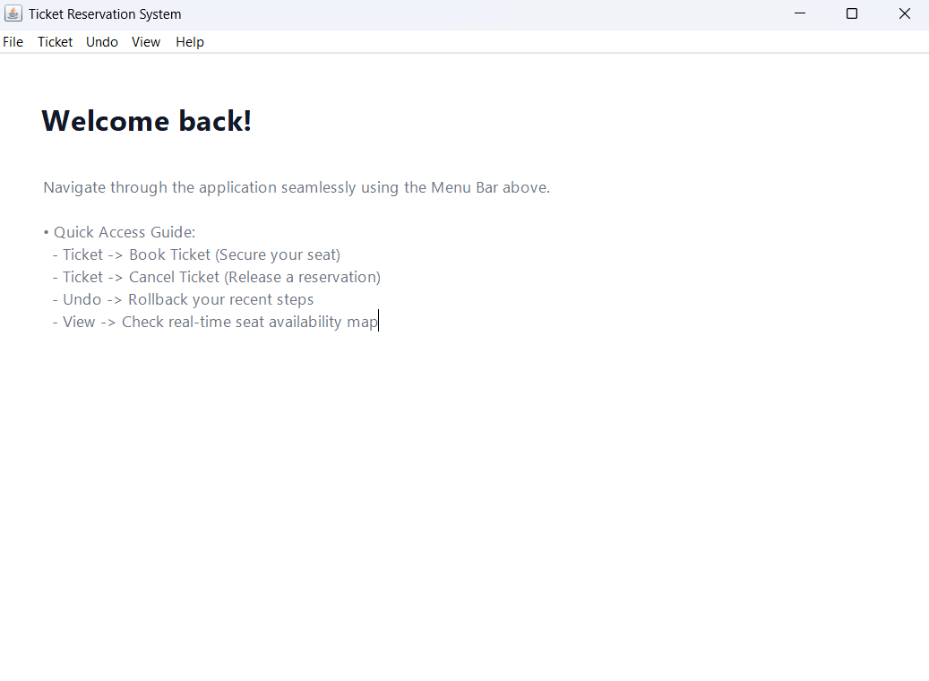

Ticket Book:
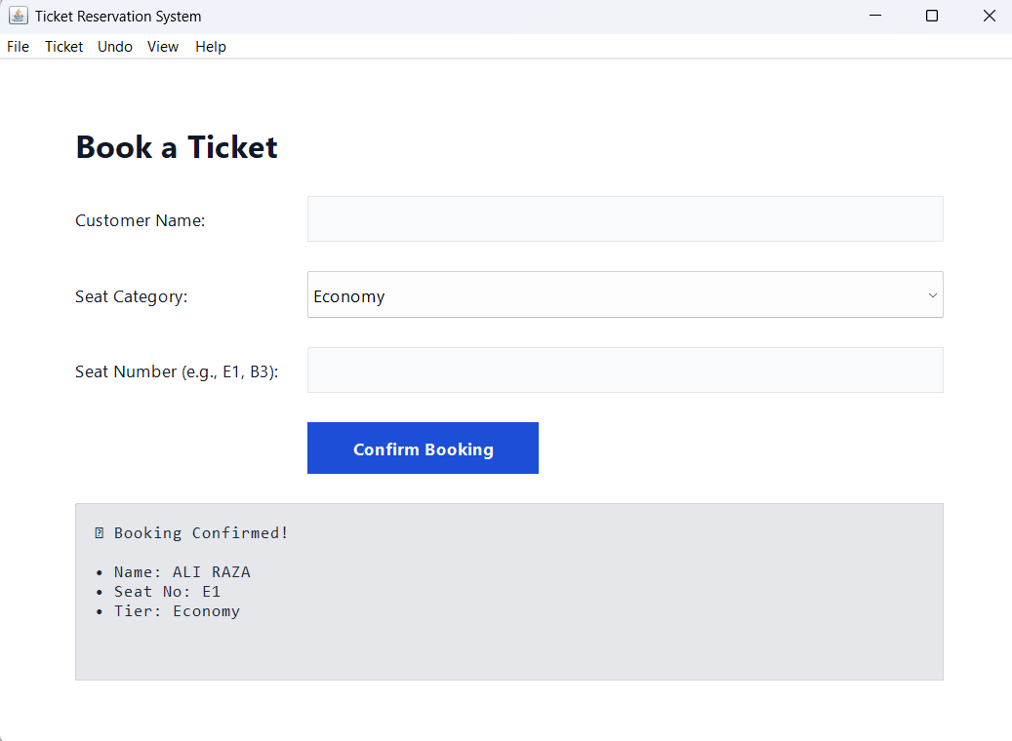
View Seats after booking:
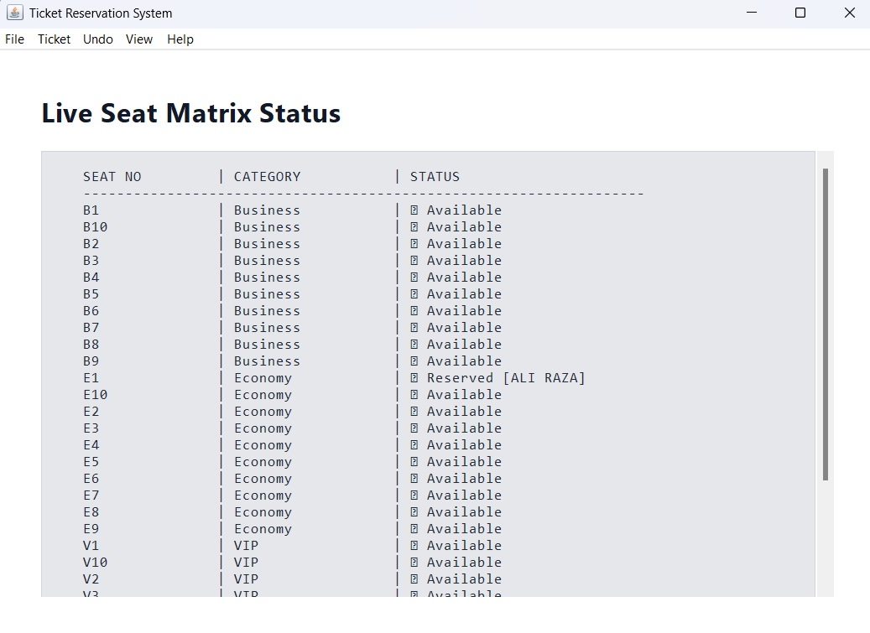

Cancel Booking:
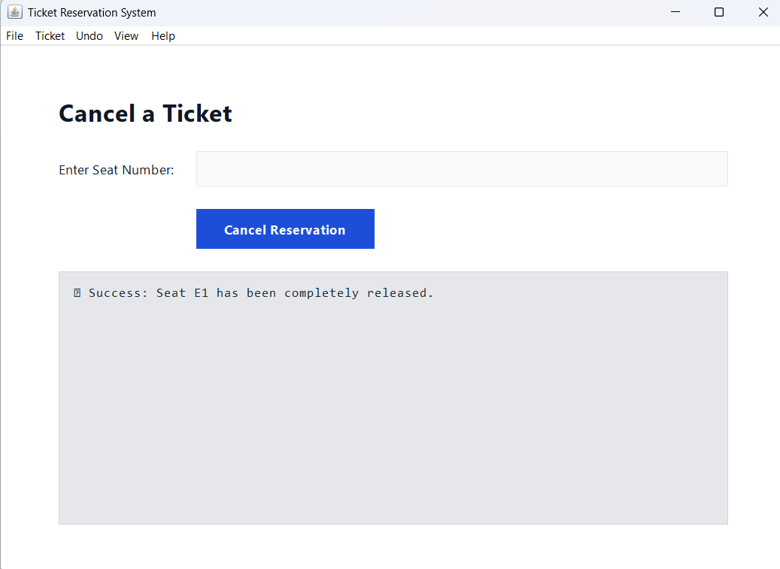
After cancelling booking:
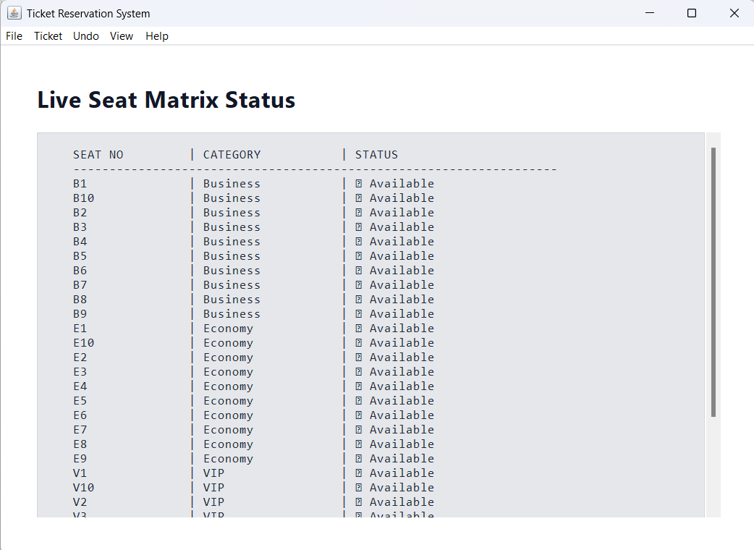

Undo Bookings:
