A Reproducible Scientific Manuscript
  - One source → HTML, PDF (LaTeX) and Word
Dr Abdul Mannan
2026-07-22
Abstract
This template shows a journal-style manuscript authored once in Quarto and rendered to HTML, PDF and DOCX. It demonstrates executable figures, numbered tables, cross-references and citations from a shared BibTeX file.

1 Introduction
Reproducible reporting keeps the analysis and the narrative in one place. Emicizumab prophylaxis, for example, was established by landmark trial evidence (Mahlangu et al. 2018). Methods conventions follow Example and Sample (2025).

2 Methods
We simulate a one-compartment pharmacokinetic model (Figure 1) and tabulate concentrations at fixed times (Table 1).
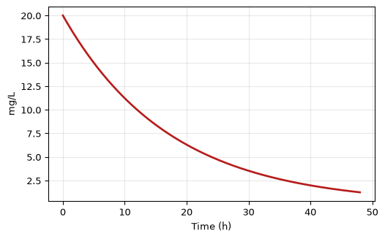
Figure 1: Simulated plasma concentration after a 1000 mg IV bolus.

3 Results
Table 1: Concentration at selected times.
 | Time (h) | Conc (mg/L)
0 | 0 | 20.00
1 | 6 | 14.14
2 | 12 | 10.00
3 | 24 | 5.00
4 | 48 | 1.25

As shown in Figure 1 and Table 1, concentration halves every 12 hours.

4 Discussion
The same .qmd produced this HTML page, a typeset PDF and an editable Word file with no manual re-formatting.

5 References
Example, Alex, and Sam Sample. 2025. “An Illustrative Method Reference (Placeholder).” Journal of Reproducible Publishing 1 (1): 1–10.
Mahlangu, Johnny, Johannes Oldenburg, Ido Paz-Priel, et al. 2018. “Emicizumab Prophylaxis in Patients Who Have Hemophilia a Without Inhibitors.” New England Journal of Medicine 379 (9): 811–22. https://doi.org/10.1056/NEJMoa1803550.

