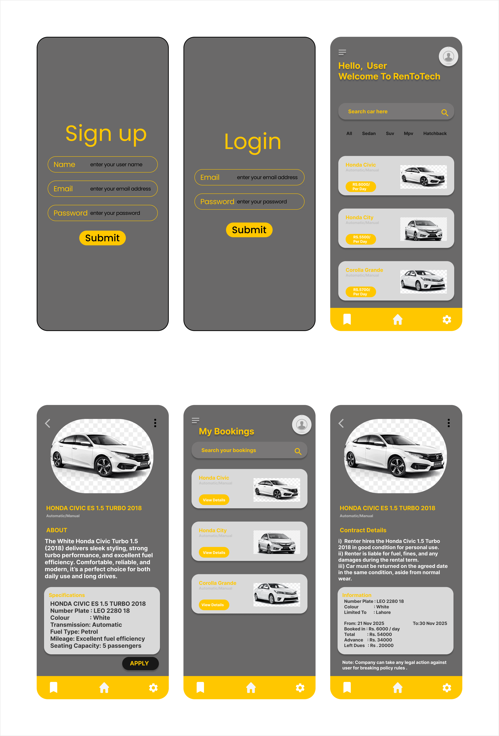
CarDetailsScreen MyBookingsScreen ContractDetailScreen
SignupScreen LoginScreen HomePageScreen

