Spelling and Typos only:

1.

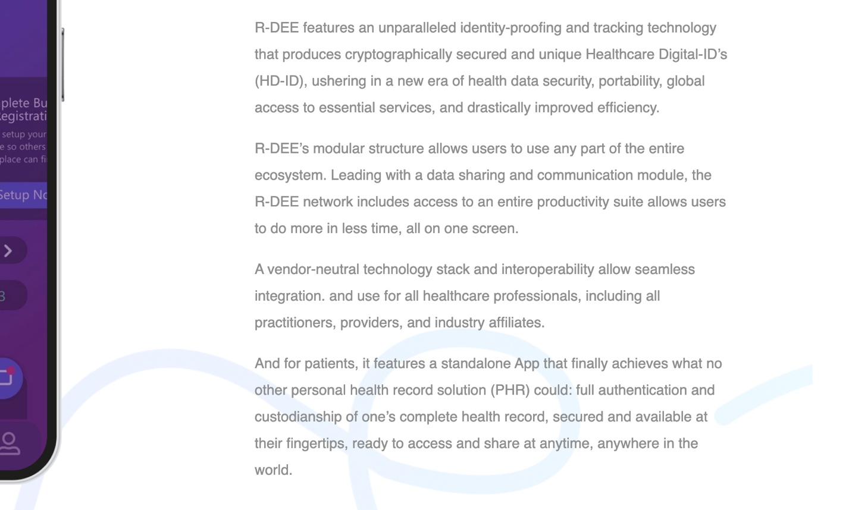

A vendor-neutral technology stack and interoperability allow seamless integration. and use for all healthcare professionals, including all practitioners, providers, and industry affiliates.

**Fixed-**

A vendor-neutral technology stack and interoperability allow seamless integration for all healthcare professionals, practitioners, providers, and industry affiliates.

2.

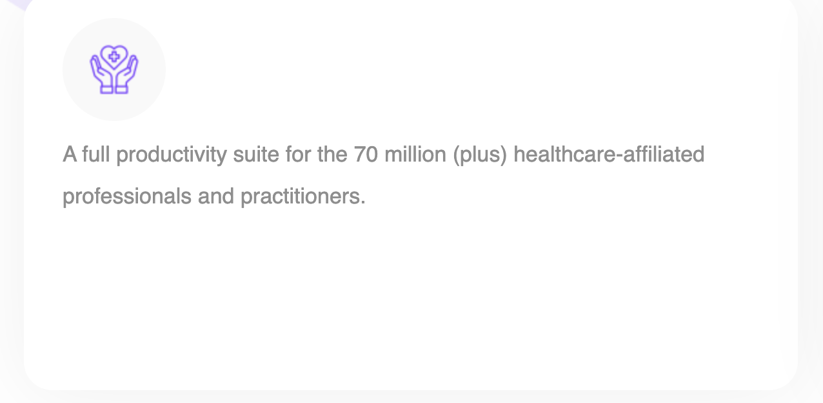

A full productivity suite for the 70 million (plus) healthcare-affiliated professionals and practitioners.

**Fixed-**

A full productivity suite for the 70 million plus healthcare-affiliated professionals, practitioners, and affiliates.

3.

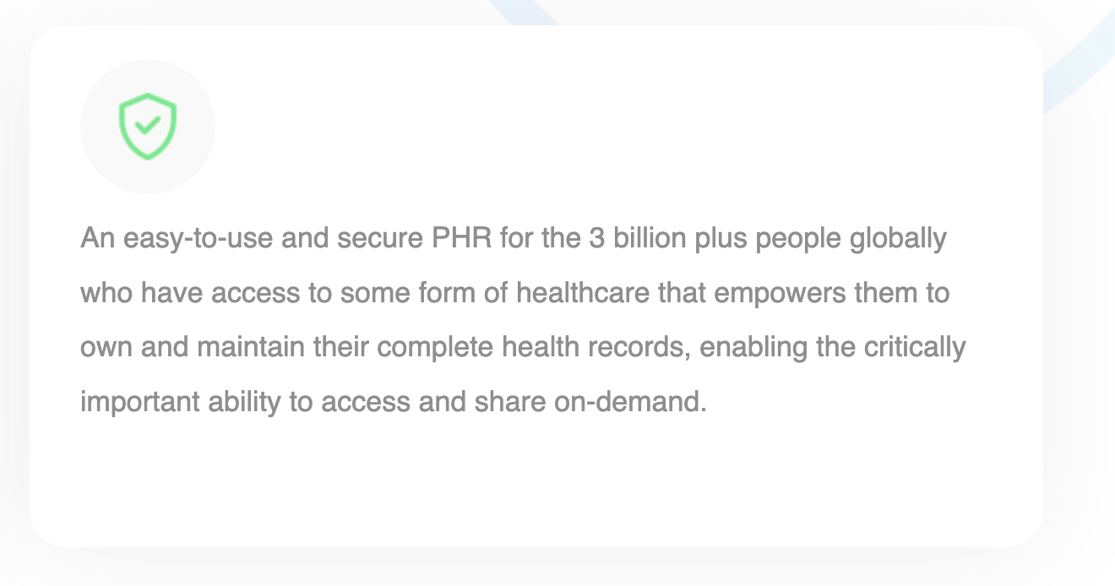

An easy-to-use and secure PHR for the 3 billion plus people globally who have access to some form of healthcare that empowers them to own and maintain their complete health records, enabling the critically important ability to access and share on-demand.

**Fixed-**

An easy-to-use and secure PHR for the 2 billion plus people globally who have access to some form of healthcare, one that empowers them to own and maintain their complete health records, enabling the critically important ability to access and share on-demand, anywhere they go, thus helping patients and providers.

4.

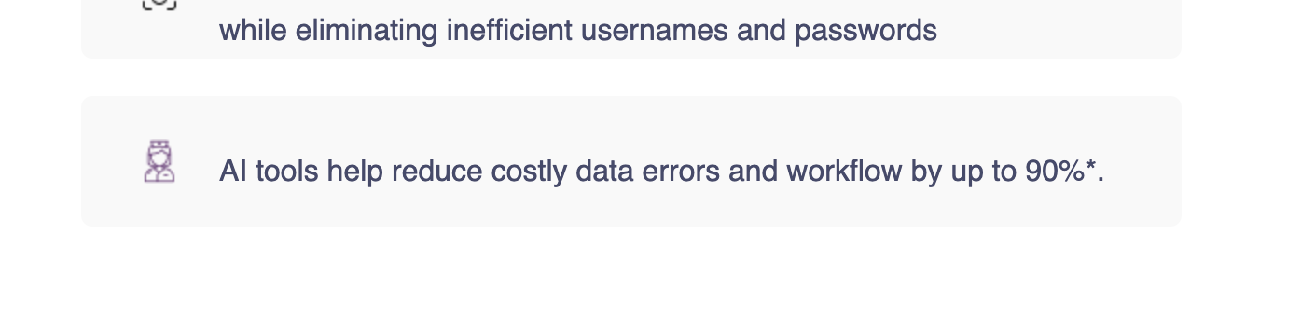

AI tools help reduce costly data errors and workflow by up to 90%*.

**Fixed- (removed period at the end).**

AI tools help reduce costly data errors and workflow by up to 90%*

5.

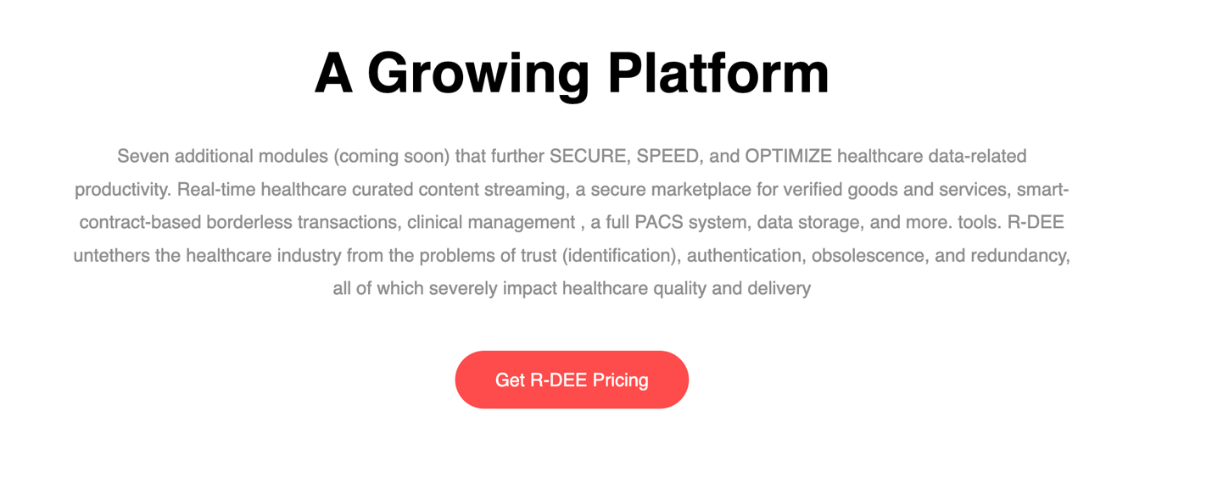

Seven additional modules (coming soon) that further SECURE, SPEED, and OPTIMIZE healthcare data-related productivity. Real-time healthcare curated content streaming, a secure marketplace for verified goods and services, smart-contract-based borderless transactions, clinical management , a full PACS system, data storage, and more. tools. R-DEE untethers the healthcare industry from the problems of trust (identification), authentication, obsolescence, and redundancy, all of which severely impact healthcare quality and delivery  
[Get R-DEE Pricing](http://common-size.surge.sh/#pricing)

**Fixed-**

Seven additional modules (coming soon) that further SECURE, SPEED, and OPTIMIZE healthcare data-related productivity. Meticulously chosen tools help eliminate most Health IT fragmentation pain points that exist today, helping to drastically reduce costs, increase workflow output, and save valuable time. Real-time healthcare curated content streaming, a secure marketplace for verified goods and services, smart-contract-based borderless transactions, clinical management, an entire PACS system, data storage, and more. tools. R-DEE untethers the healthcare industry from the problems of trust (identification), authentication, obsolescence, and redundancy, all of which severely impact healthcare quality and delivery.

6.

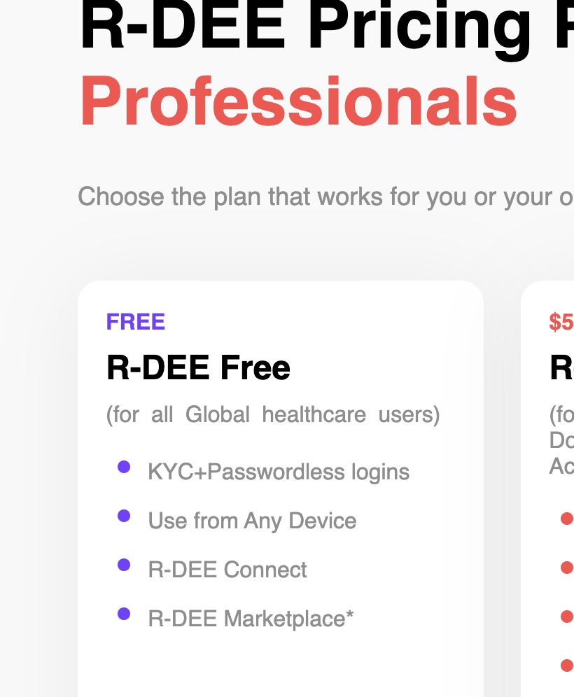

(for all Global healthcare users)

**Fixed-**

(All Global Healthcare Users)

7.

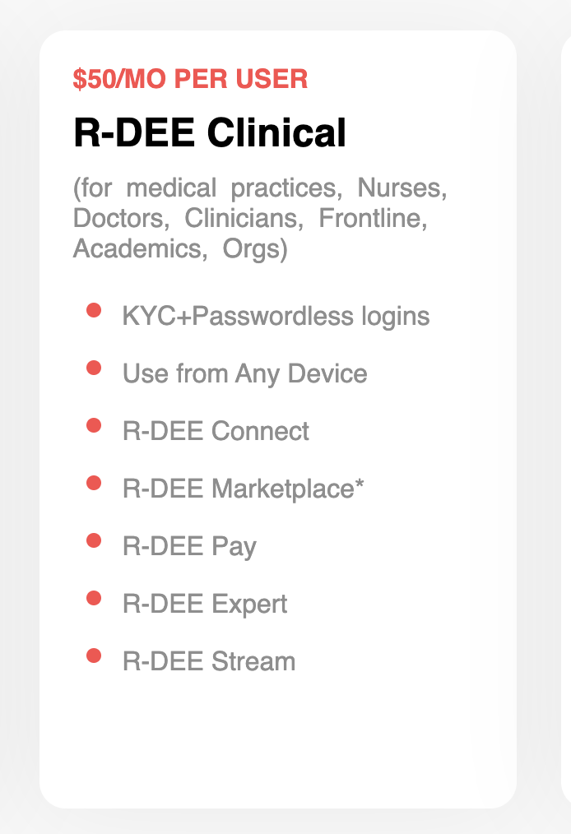

(for medical practices, Nurses, Doctors, Clinicians, Frontline, Academics, Orgs)

**Fixed-**

(Medical Practices, Nurses, Doctors, Clinicians, Frontline, Academics, Orgs, More)

8.

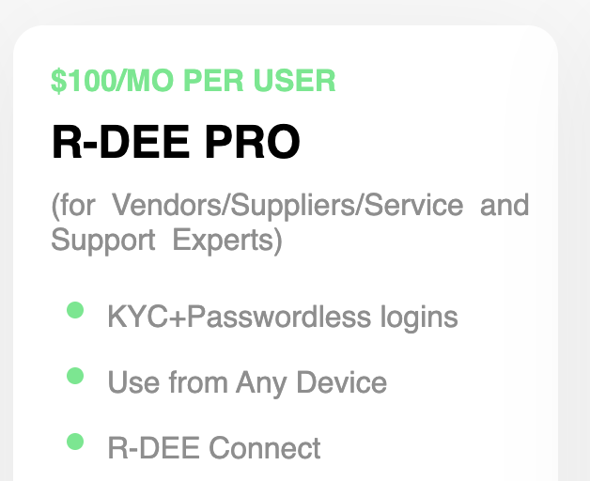

(for Vendors/Suppliers/Service and Support Experts)

**Fixed-**

(Vendors, Suppliers, Service and Support Experts)

9.

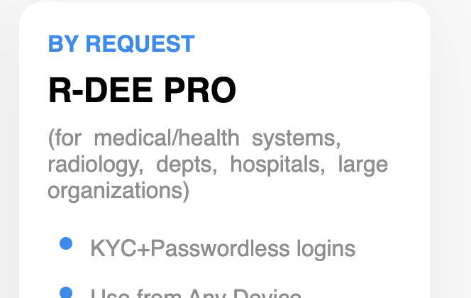

(for medical/health systems, radiology, depts, hospitals, large organizations)

**Fixed-**

(Medical/Health Systems, Radiology Depts, Hospitals, OEM’s, GOV)

10.

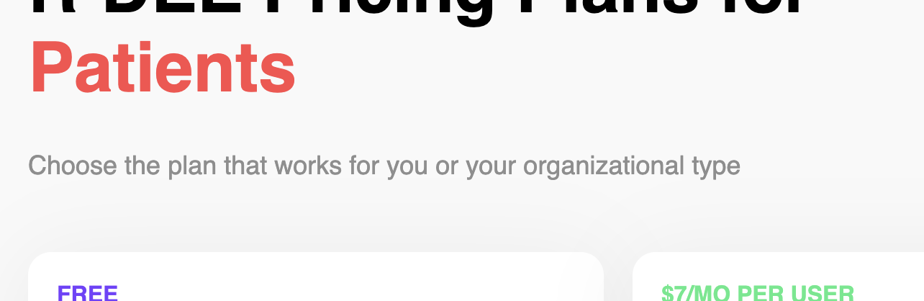

**Fixed-**

Choose the plan that works for you or your family

11.

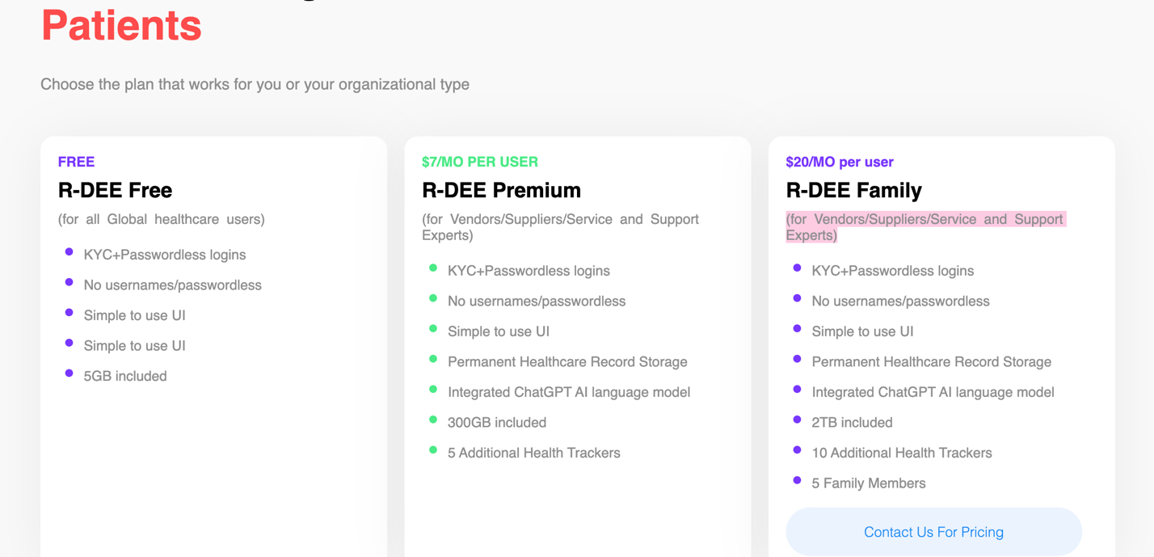

**Delete-**

(for all Global healthcare users)

**Delete-**

(for Vendors/Suppliers/Service and Support Experts)

**Delete-**

(for Vendors/Suppliers/Service and Support Experts)

12.

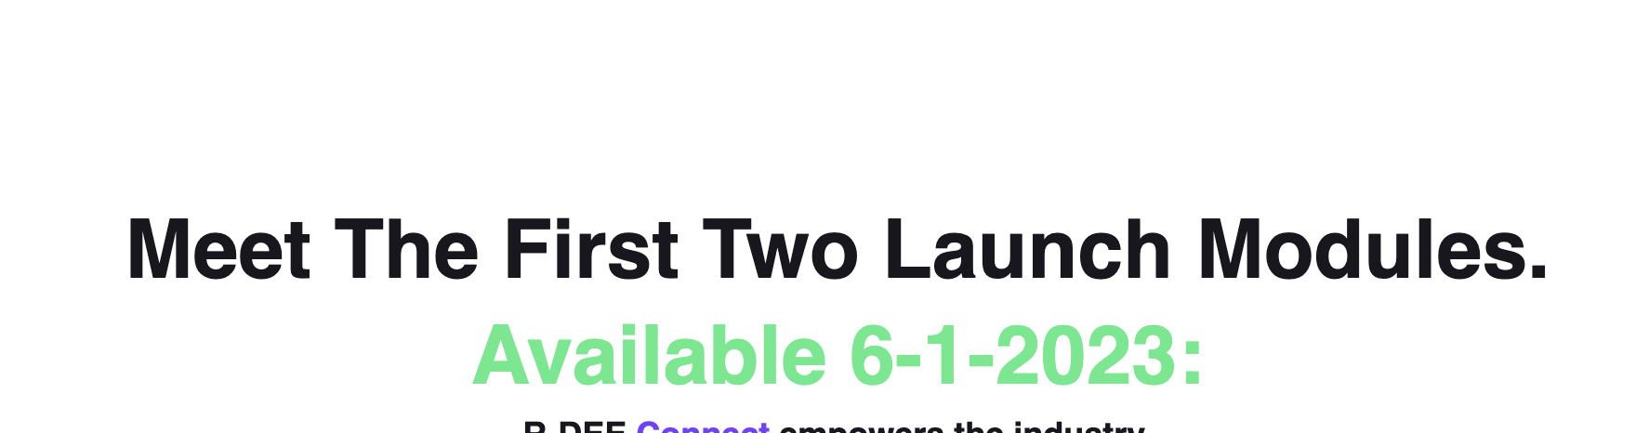

**Meet The First Two Launch Modules.**

**Fixed-**

# Introducing the Two Launch Modules.