SHOPSPHERE E-COMMERCE DATA ANALYSIS
Professional Data Understanding, Data Cleaning & Exploratory Data Analysis Report
Project: Assignment 1 — ShopSphere
Source Notebook: Assignment1_EDA.ipynb
Prepared from the completed Python/Pandas EDA workflow

1. Executive Summary
This project analyzes ShopSphere, an e-commerce dataset containing customer, order, and product information. The work follows an end-to-end analytical workflow: raw-data inspection, data-quality investigation, duplicate removal, text standardization, datatype correction, invalid-value treatment, missing-value handling, dataset integration, feature creation, and business-oriented exploratory data analysis.
The original data contained structural and quality issues across all three datasets. Customers contained duplicate records, inconsistent city and gender formats, invalid phone placeholders, malformed email addresses, mixed date formats, and invalid ages. Orders contained duplicates, missing dates and payment methods, invalid negative shipping costs, invalid discount values, and non-positive quantities. Products contained duplicate records, inconsistent category capitalization, missing prices/costs, and price values containing symbols or invalid values.
After cleaning, the working datasets contained 1,000 customers, 2,000 orders, and 500 products. The EDA then identified Karachi as the largest customer and revenue market, Electronics as the leading order, revenue, and profit category, Card as the most common payment method, and Delivered orders as the largest order-status group.

Key Results at a Glance
Metric | Result
Customers after cleaning | 1,000
Orders after cleaning | 2,000
Products after cleaning | 500
Largest customer city | Karachi — 298 customers
Largest revenue city | Karachi — PKR 31,371,320
Largest order category | Electronics — 621 orders
Largest revenue category | Electronics — PKR 34.91 million
Largest profit category | Electronics — PKR 14.49 million
Largest customer by revenue | C0014 — PKR 618,940.68
Top revenue product | Product 292 — PKR 952,848.40

2. Project Objectives
- Understand the structure and quality of the ShopSphere customer, order, and product datasets.
- Identify missing values, duplicates, inconsistent text, invalid values, datatype problems, and relationship issues.
- Clean the datasets using reproducible Pandas operations while preserving useful business records.
- Integrate order, product, and customer information for business-level analysis.
- Create analytical measures such as revenue and profit.
- Use visualizations and grouped summaries to identify customer, product, sales, revenue, and profitability patterns.
- Translate analytical results into practical business insights and recommendations.

3. Dataset Overview
Dataset | Original Rows | Columns | Final Rows | Final Columns
Customers | 1,020 | 9 | 1,000 | 9
Orders | 2,030 | 9 | 2,000 | 9
Products | 510 | 6 | 500 | 6

The original customers dataset contained 1,020 rows and 9 columns; orders contained 2,030 rows and 9 columns; products contained 510 rows and 6 columns. Exact duplicate removal reduced these to 1,000, 2,000, and 500 rows respectively.

4. Phase 1 — Data Understanding & Quality Assessment

4.1 Customers
- Original size: 1,020 rows × 9 columns.
- 20 exact duplicate rows were identified.
- Missing values included 81 emails, 23 phone numbers, and 33 signup dates.
- Age values were stored as strings and included invalid values such as -5, 150, and the text 'twenty five'.
- City values contained whitespace and capitalization inconsistencies such as 'Hyderabad ', ' Lahore', 'karachi', and 'KARACHI'.
- Gender contained seven representations, including Male, male, M, Female, female, F, and Unknown.
- Phone inspection identified invalid placeholder values such as '123' and 'abcd123'.
- Email validation identified malformed addresses such as 'user48mail.com'.

4.2 Orders
- Original size: 2,030 rows × 9 columns.
- 30 exact duplicate rows were identified.
- Missing values included 64 order dates, 399 payment methods, and 714 shipping-cost values.
- Quantity contained negative and zero values, with -2 and 0 occurring frequently.
- Discount contained invalid values of -5 and 120.
- Shipping cost contained the invalid value -50.
- Order status and payment method contained inconsistent capitalization/casing.
- 40 order customer IDs did not match the customer dataset, and 81 order product IDs did not match the product dataset during the initial relationship checks.

4.3 Products
- Original size: 510 rows × 6 columns.
- 10 exact duplicate rows were identified.
- 13 prices and 33 costs were missing.
- Price values included currency-formatted strings such as '$46535' and '20306 PKR', as well as an invalid negative price of -100.
- Category values included both 'electronics' and 'Electronics'.
- The product table represented 500 unique products and 20 suppliers after duplicate removal.

5. Phase 2 — Data Cleaning & Transformation

5.1 Duplicate Removal
Dataset | Before | Duplicates Removed | After
Customers | 1,020 | 20 | 1,000
Orders | 2,030 | 30 | 2,000
Products | 510 | 10 | 500

Exact duplicate rows were removed using Pandas drop_duplicates(inplace=True). Verification confirmed zero duplicate rows remained in each cleaned dataset.

5.2 Text Standardization
- Customer cities were stripped of leading/trailing spaces and converted to title case, reducing the city categories from 10 representations to 8 standardized cities.
- Gender values were standardized to Male, Female, and Unknown; M/F and case variants were normalized.
- Payment methods were standardized to Cash, Cod, Card, and Bank, while missing values were retained for later handling.
- Order-status values were standardized to Delivered, Cancelled, and Pending.
- Product categories were standardized so Electronics variants were represented consistently.

5.3 Datatype Correction
- Customer age was converted from string data to numeric values after handling invalid textual/out-of-range values.
- Customer signup_date was converted to datetime.
- Order order_date was converted to datetime.
- Product price was converted to numeric.
- Order quantity, discount, and shipping cost were transformed into suitable numeric forms for analysis.

5.4 Invalid Value Treatment
Field | Invalid Pattern | Treatment | Final Handling
Phone | 123 / abcd123 | Converted to missing | Retained as missing
Email | Malformed addresses | Converted to missing | Retained as missing
Shipping cost | Negative values / -50 | Converted to missing | Median imputation
Discount | <0 or >100 | Converted to missing | Median imputation
Quantity | <=0 | Converted to missing | Median imputation
Age | Out-of-range / text | Converted/cleaned | Valid numeric ages retained

For shipping cost, the negative values could not be reliably recovered from order status or payment method patterns. The cleaned non-negative values had a median of 465, which was used for missing/invalid shipping costs. For discount, invalid values were replaced and the median valid discount was 25. For quantity, invalid values were replaced and the median valid quantity was 3.

5.5 Final Data Quality Check
Dataset | Rows | Duplicate Rows | Remaining Missing Values
Customers | 1,000 | 0 | Email: 117; Phone: 72; Signup date: 33
Orders | 2,000 | 0 | Order date: 62; Payment method: 391
Products | 500 | 0 | None

The final check confirmed zero duplicate rows. Remaining missing values are explicitly visible in the cleaned datasets rather than being silently fabricated. In particular, customer contact fields and order payment/date fields still contain missing observations.

6. Phase 3 — Exploratory Data Analysis

6.1 Customer Analysis
The customer analysis focused on geographic distribution, gender composition, age distribution, and signup trends to understand the customer base and identify useful market segments.
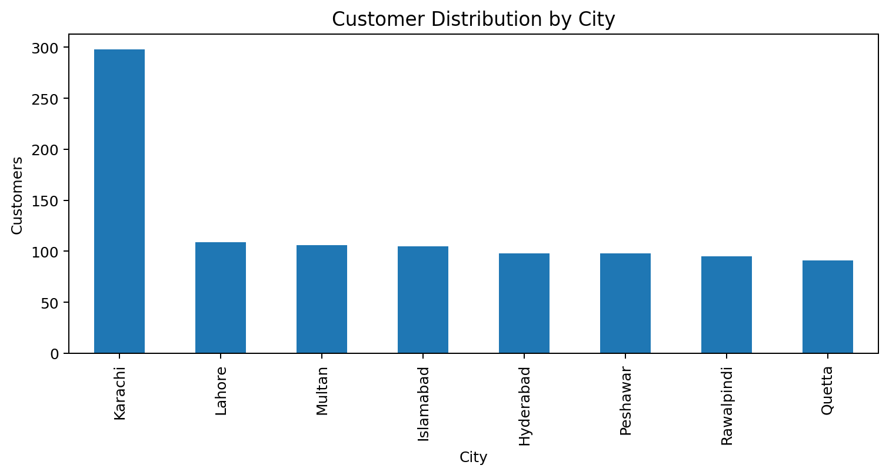
Figure 1. Customer distribution by city.
City | Customers
Karachi | 298
Lahore | 109
Multan | 106
Islamabad | 105
Hyderabad | 98
Peshawar | 98
Rawalpindi | 95
Quetta | 91

Karachi is the dominant customer market with 298 customers, while the other cities range from 91 to 109 customers. This indicates a strong Karachi concentration with relatively broad geographic coverage.
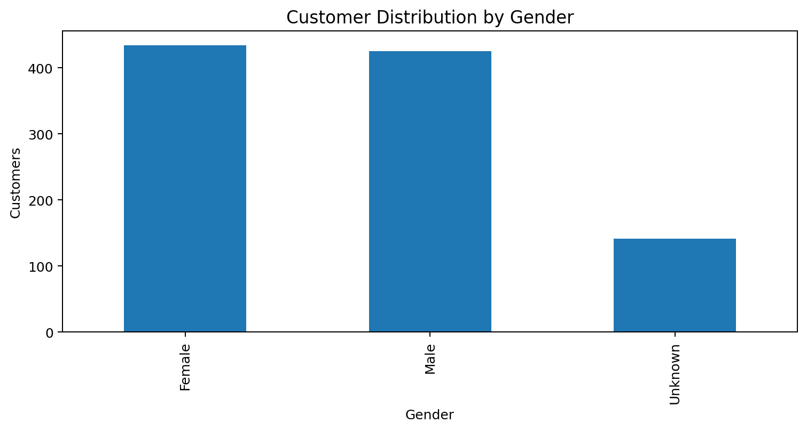
Figure 2. Customer distribution by gender.
Gender | Customers | Approx. Share
Female | 434 | 43.4%
Male | 425 | 42.5%
Unknown | 141 | 14.1%

The customer base is relatively balanced between Female and Male customers, while 14.1% are classified as Unknown. This unknown segment limits the precision of gender-specific marketing analysis.
Age analysis showed 1,000 valid customer ages after cleaning. The mean age was 41.87 years, the median was 42 years, the minimum was 18, and the maximum was 65. The middle 50% of customers fell between 30 and 53 years.
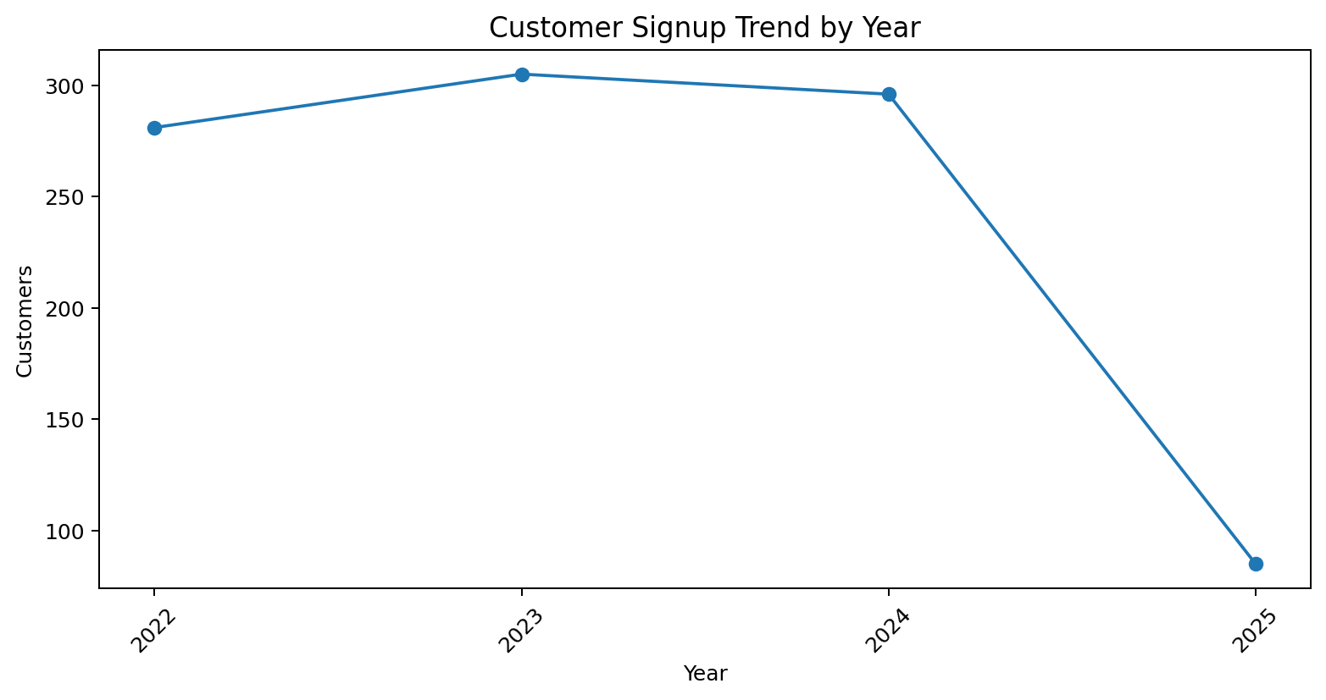
Figure 3. Customer signup trend by year.
Signup Year | Customers
2022 | 281
2023 | 305
2024 | 296
2025 | 85

Signup activity was highest in 2023 with 305 customers, followed by 2024 with 296 and 2022 with 281. The 2025 value is 85 because the available signup data ends in April 2025.

6.2 Order & Sales Analysis
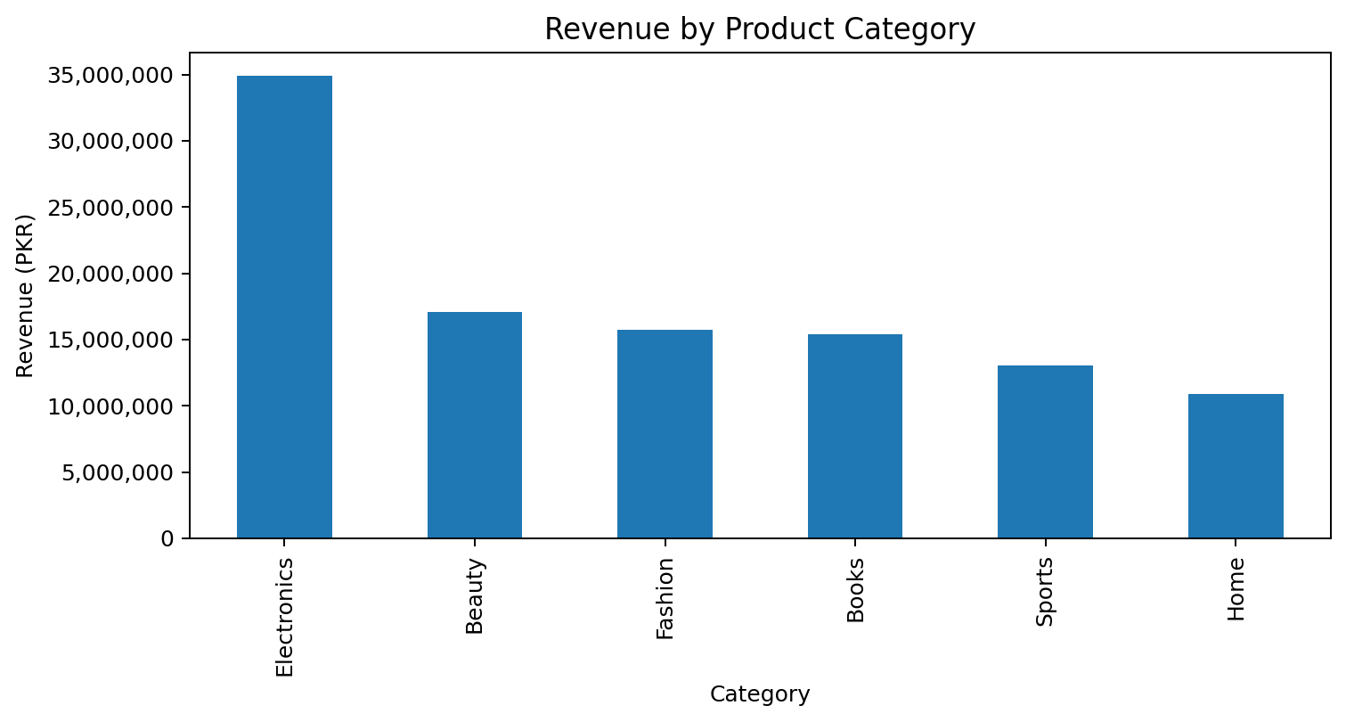
Figure 4. Revenue by product category.
Category | Orders | Revenue (PKR)
Electronics | 621 | 34,910,460.00
Beauty | 282 | 17,106,830.00
Fashion | 291 | 15,748,390.00
Books | 269 | 15,397,520.00
Sports | 230 | 13,051,440.00
Home | 227 | 10,898,870.00

Electronics is the strongest category across the core sales indicators. It generated approximately PKR 34.91 million in revenue and accounted for 621 orders, substantially ahead of the other categories.

6.3 Order Status
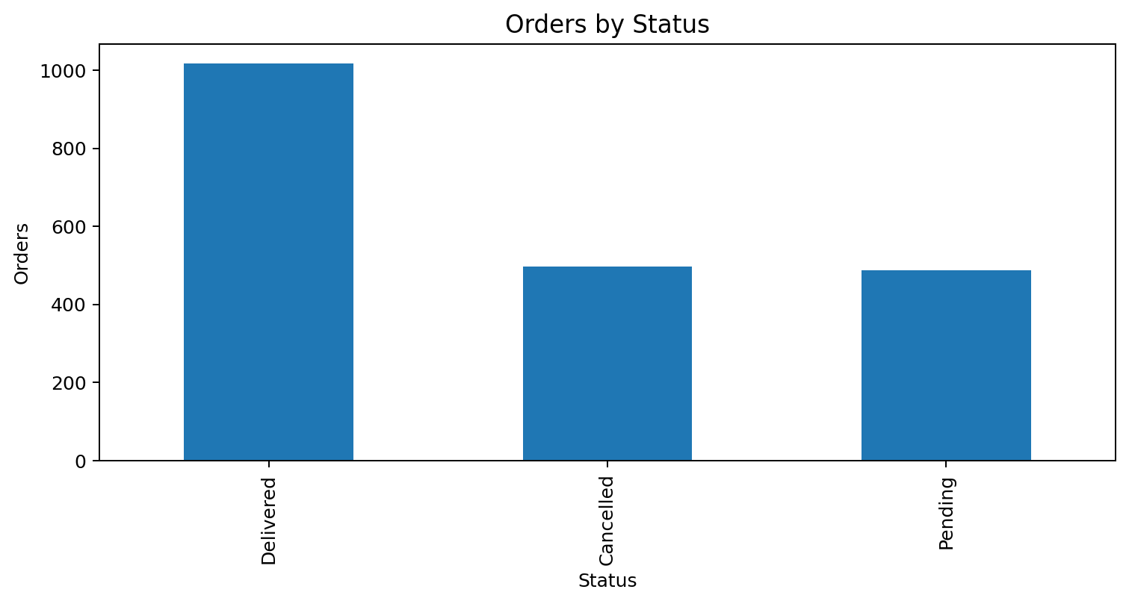
Figure 5. Order distribution by status.
Status | Orders | Share
Delivered | 1,017 | 50.85%
Cancelled | 496 | 24.80%
Pending | 487 | 24.35%

Delivered orders represent just over half of all orders. However, approximately half of the orders are either cancelled or pending, indicating a meaningful operational area for further investigation.

6.4 Payment Method
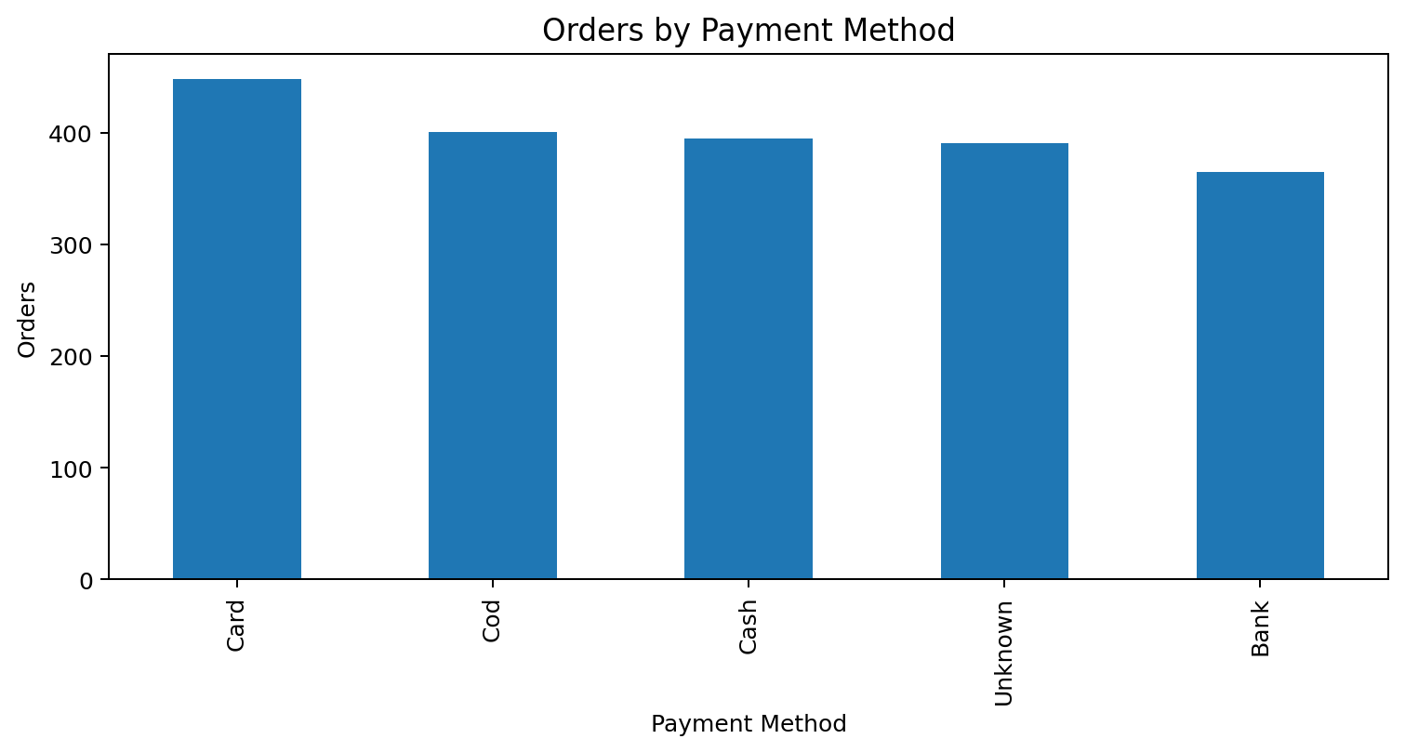
Figure 6. Order distribution by payment method.
Payment Method | Orders | Share
Card | 448 | 22.40%
Cod | 401 | 20.05%
Cash | 395 | 19.75%
Unknown | 391 | 19.55%
Bank | 365 | 18.25%

Card is the most common recorded payment method. A substantial 391 orders have an Unknown payment method, which is large enough to affect payment-behavior analysis.
Monthly order analysis covered January 2023 through December 2024. The highest observed monthly order count was 97 in January 2023. December 2024 recorded only 3 orders, which should be treated carefully because the dataset may represent an incomplete period.
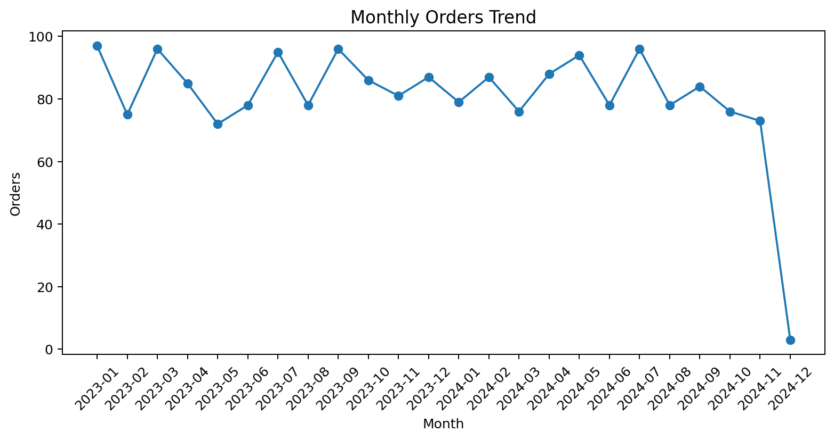
Figure 7. Monthly orders trend.
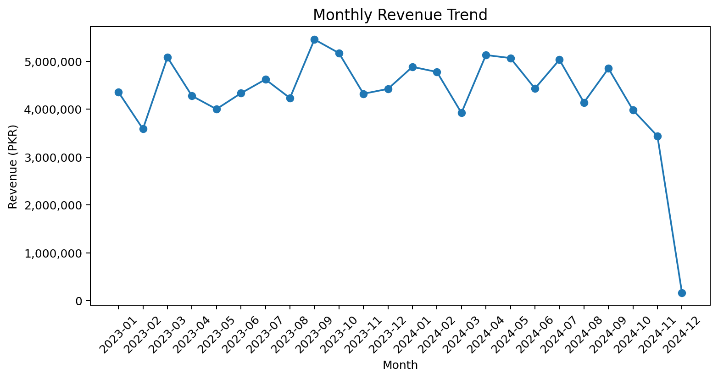
Figure 8. Monthly revenue trend.
Monthly revenue was strongest in September 2023 at approximately PKR 5.45 million. The December 2024 revenue value was only about PKR 169,029, matching the unusually low order count for that month and suggesting that December 2024 is likely an incomplete period in the available data.

6.5 Product Performance
Rank | Best-Selling Product | Quantity Sold
1 | Product 411 | 34
2 | Product 167 | 34
3 | Product 301 | 31
4 | Product 292 | 28
5 | Product 356 | 27
6 | Product 89 | 27
7 | Product 223 | 26
8 | Product 220 | 26
9 | Product 235 | 26
10 | Product 123 | 26

Product 411 and Product 167 tied for the highest total quantity sold at 34 units each.
Rank | Top Revenue Product | Revenue (PKR)
1 | Product 292 | 952,848.40
2 | Product 123 | 928,385.94
3 | Product 308 | 801,408.60
4 | Product 425 | 772,932.00
5 | Product 165 | 759,828.24
6 | Product 223 | 752,105.28
7 | Product 135 | 684,990.93
8 | Product 185 | 680,466.00
9 | Product 261 | 679,760.64
10 | Product 277 | 674,590.80

Product 292 generated the highest product-level revenue at PKR 952,848.40, followed by Product 123 at PKR 928,385.94. Quantity leadership and revenue leadership are not identical, demonstrating that high-volume products are not necessarily the highest-value products.

6.6 Customer Revenue
Rank | Customer ID | Revenue (PKR)
1 | C0014 | 618,940.68
2 | C0752 | 512,055.69
3 | C0386 | 491,746.08
4 | C0378 | 482,970.75
5 | C0949 | 464,823.83
6 | C0023 | 447,347.91
7 | C0647 | 443,605.50
8 | C0082 | 427,764.78
9 | C0933 | 416,664.00
10 | C0710 | 390,671.52

Customer C0014 is the highest-revenue customer in the analysis, generating PKR 618,940.68. This customer segment can be useful for retention, loyalty, and high-value customer strategies.

6.7 Revenue by City
City | Revenue (PKR)
Karachi | 31,371,320.00
Lahore | 12,233,880.00
Hyderabad | 11,175,740.00
Multan | 10,839,170.00
Islamabad | 10,581,110.00
Rawalpindi | 10,128,490.00
Peshawar | 10,093,280.00
Quetta | 8,807,280.00

Karachi leads revenue generation at approximately PKR 31.37 million. Lahore is second at about PKR 12.23 million. The large difference between Karachi and the remaining cities indicates that Karachi is both the largest customer market and the strongest revenue market.

6.8 Revenue by Payment Method
Payment Method | Revenue (PKR)
Card | 24,033,955.37
Cod | 21,759,650.66
Cash | 20,942,885.60
Unknown | 20,489,902.09
Bank | 19,887,104.78

Card generated the highest recorded payment-method revenue at approximately PKR 24.03 million. The Unknown group still represents more than PKR 20.49 million, highlighting the business impact of missing payment-method data.

6.9 Profitability Analysis
Profit was calculated using the available product price, product cost, quantity, and discount fields. The analytical relationship used was: Profit = (Price × Quantity × (1 − Discount/100)) − (Cost × Quantity).
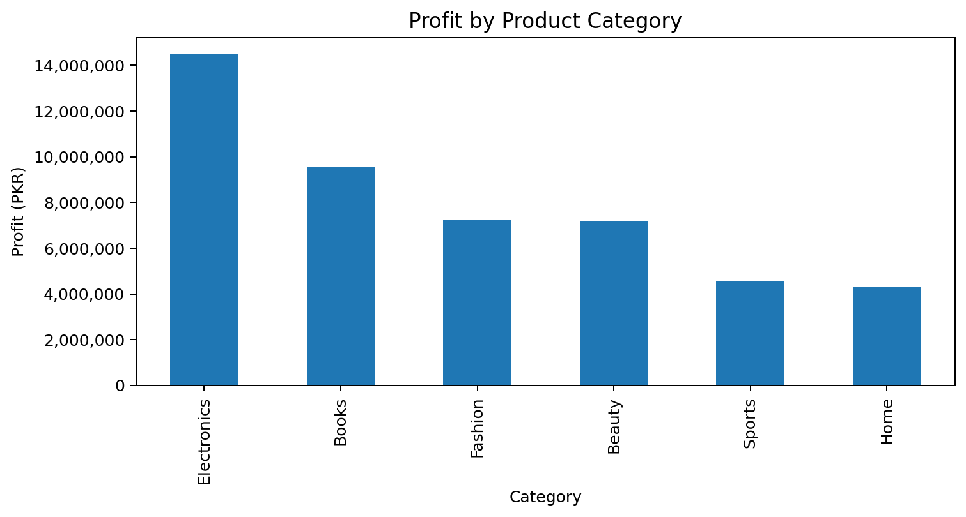
Figure 9. Profit by product category.
Category | Profit (PKR)
Electronics | 14,487,090.00
Books | 9,572,157.00
Fashion | 7,228,161.00
Beauty | 7,205,502.00
Sports | 4,541,827.00
Home | 4,297,090.00

Electronics produced the highest category profit at approximately PKR 14.49 million. Books ranked second at approximately PKR 9.57 million. Electronics therefore leads both revenue and profitability in this analysis.

7. Consolidated Business Insights
- Karachi is the primary market: it has the highest customer count (298) and the highest recorded revenue (about PKR 31.37 million).
- Electronics is the core business category: it leads orders (621), revenue (about PKR 34.91 million), and profit (about PKR 14.49 million).
- The customer base is fairly balanced by gender, but 14.1% of records have Unknown gender.
- The business has a substantial operational gap between delivered and non-delivered outcomes: 496 orders are cancelled and 487 are pending.
- Card is the most frequently recorded payment method and also generates the highest payment-method revenue.
- Missing payment-method data is material: 391 orders are Unknown, so payment-channel conclusions should be interpreted with caution.
- Product 292 is the strongest product by revenue, while Products 411 and 167 are the leaders by quantity sold.
- Customer C0014 is the highest-revenue customer and represents a potential high-value retention target.
- The December 2024 order and revenue collapse appears inconsistent with the preceding months and should be checked for period completeness before strategic decisions are made.

8. Business Recommendations

8.1 Marketing & Customer Strategy
- Prioritize customer retention and targeted campaigns in Karachi because it is the strongest customer and revenue market.
- Use high-value customers such as C0014 as the basis for loyalty, VIP, and repeat-purchase programs.
- Develop acquisition campaigns for smaller cities such as Quetta while maintaining service quality in established markets.
- Use the relatively balanced Male/Female customer base for broad campaigns rather than assuming a heavily gender-skewed audience.

8.2 Product Strategy
- Protect inventory and promotional availability for Electronics because it is the strongest category across orders, revenue, and profit.
- Monitor both volume leaders and revenue leaders: quantity and revenue rankings identify different product opportunities.
- Investigate the economics of Books, which ranks second in profit despite lower order volume than Electronics.

8.3 Operations & Data Quality
- Investigate the high cancellation and pending rates before increasing acquisition spending.
- Improve capture of payment methods because 391 orders are currently Unknown.
- Investigate the unusually low December 2024 order/revenue values to confirm whether the period is incomplete.
- Strengthen customer and product master-data validation so order IDs consistently map to known customers and products.
- Introduce validation rules for emails, phone numbers, dates, discounts, quantities, prices, and shipping costs at data-entry time.

9. Data Limitations & Analytical Considerations
- Some customer contact information and signup dates remain missing after cleaning because reliable source values were unavailable.
- Order dates and payment methods remain partially missing; this limits time-series and payment-channel completeness.
- The initial relationship check found 40 unmatched customer IDs and 81 unmatched product IDs in orders. These should be resolved in a production data pipeline.
- Revenue and profit calculations depend on successful product-price/cost matches. Records without required product attributes produce missing calculated values rather than invented figures.
- Median imputation was used for invalid/missing shipping cost, discount, and quantity. This preserves row counts but can reduce natural variability in those variables.
- The available 2025 customer signup data ends in April, so it should not be compared directly with complete prior years as if all years covered the same period.

10. Tools & Methodology
Area | Methods / Tools Used
Data loading | Pandas read_csv
Data inspection | shape, columns, info, describe, unique, value_counts
Missing-value analysis | isna(), isnull(), missing-value percentages
Duplicate handling | duplicated(), drop_duplicates()
Text cleaning | str.strip(), str.title(), replace()
Validation | Regex email validation, logical range checks
Datatype conversion | pd.to_numeric(), pd.to_datetime()
Grouping / aggregation | groupby(), value_counts(), crosstab()
Dataset integration | merge() / customer-product-order joins
Visualization | Matplotlib and Seaborn
Business metrics | Revenue and profit calculations

11. Conclusion
The ShopSphere project demonstrates a complete practical data-analysis workflow rather than a visualization-only exercise. The analysis began with raw, inconsistent data and systematically identified data-quality problems before producing business-oriented insights.
The final analysis shows a business strongly centered around Karachi and Electronics, with meaningful revenue contribution from several other categories and cities. At the same time, the high number of cancelled/pending orders, missing payment information, unmatched order relationships, and the unusual December 2024 decline are important areas for operational and data-quality follow-up.
Overall, the cleaned and analyzed dataset provides a much more reliable foundation for dashboards, customer segmentation, product analysis, forecasting, and future machine-learning work.

Appendix A — Final Clean Dataset Snapshot
Dataset | Final Shape | Important Remaining Missing Fields
Customers | (1000, 9) | email 117; phone 72; signup_date 33
Orders | (2000, 9) | order_date 62; payment_method 391
Products | (500, 6) | None

Appendix B — Core Cleaning Rules Applied
- Exact duplicate records were removed from all three datasets.
- Text categories were standardized for consistency.
- Malformed emails and placeholder phone values were treated as missing.
- Invalid shipping costs below zero were treated as missing and filled with the median valid shipping cost of 465.
- Invalid discounts below 0 or above 100 were treated as missing and filled with the median valid discount of 25.
- Non-positive quantities were treated as missing and filled with the median valid quantity of 3.
- Dates and numeric fields were converted to analysis-ready datatypes.
- Revenue and profit were calculated after integrating order and product information.

