**Assignment#1**

Imagine that you are a software developer for a company with more than 50,000 employees in all over Pakistan. You've been given primary responsibility for the development of a customized, in-house payroll application. You are fully responsible for project if it fails. If you fails to do so, there is no backup of application to be customized.

You have studied Software Process Models, their advantages and disadvantages, Figure below illustrates some of advantages and disadvantages of them.

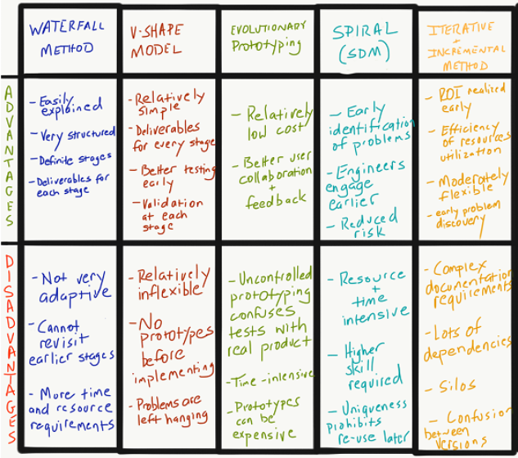

**After reading these advantages and disadvantages you are given key info about your company: -**

* As a large company, resources like time and money are in adequate supply, so your choices are not resource-limited
* It's clear that the company values quality over quantity, so you can use your adequate resources to achieve excellence
* Employees are widely spread geographically, so customer testing and feedback might have some logistical hurdles
* As a large company, there are other highly customized enterprise application projects in the hopper, so it would be nice to use an SDLC model that could be used for future projects
* In the future, the company may spin-off or acquire business units of significant size, so a model that is salable is desirable

**Understand you organization environment, requirements and available resources to you and choose one of the best fitted models for the given scenario and mention reason of your choice.**