**Hygieia: From Past to Future**

**Final Year Project Proposal**

**Session 2022-2026**

**A 3rd Year Student**

A project submitted in partial fulfillment of the

COMSATS University Degree

of

BSc. (Hons.) BS in Computer Science / Software Engineering (CUI)



Department of Computer Science

COMSATS University Islamabad, Lahore Campus

12 March 2025

**Project Registration**

|  |  |  |  |  |  |  |  |
| --- | --- | --- | --- | --- | --- | --- | --- |
| Project ID (for office use) | | |  | | | | |
| Type of project | | | [ ] Traditional [✓] Industrial [ ] Continuing | | | | |
| Nature of project | | | [✓] Development [ ] Research & Development | | | | |
| Sustainable Development Goals(SDGs) | | | [✓] Good Health and Well-Being [ ] Quality Education  [✓] Industry, Innovation, and Infrastructure [ ] Gender Equality  [✓] Decent Work and Economic Growth [ ] Climate Action | | | | |
| Area of specialization | | | [✓] Artificial Intelligence (AI) [ ] Data Science and Analytics  [ ] Internet of Things (IoT) [ ] Blockchain  [ ] Mobile App Development [✓] Web Development [ ] Cybersecurity  [ ] Game Development [ ] Natural Language Processing (NLP) | | | | |
| **Project Group Members** | | | | | | | |
| Sr.# | Reg. # | Student Name | | CGPA | Email ID | Phone # | Signature |
| (i) | FA22-BCS-040 | Abdul Moiz | | 3.42 | FA22-BCS-040@cuilahore.edu.pk | 0308 0485737 |  |
| (ii) | FA22-BCS-124 | Laiba Maqsood | | 3.30 | FA22-BCS-124@cuilahore.edu.pk | 0325 8705035 |  |
| **Declaration:** FYP group members have cleared all prerequisite courses For FYP-I as per their degree requirements.  For BS(Computer Science)  (CSC241 Object Oriented Programming, CSC291 Software Engineering Concepts, CSC371 Database Systems-I, HUM102 Report Writing Skills)  For BS(Software Engineering)  (CSC241 Object Oriented Programming, CSE291 Introduction to Software Engineering, CSC371 Database Systems-I , HUM102 Report Writing Skills) | | | | | | | |

# Plagiarism Free Certificate

This is to certify that, I am **Abdul Moiz** S/D/o **Iqbal Hamid**, group leader of FYP under registration no CUI /**FA22-BCS-040**/LHR the Computer Science Department, COMSATS University Islamabad, Lahore. I declare that my FYP proposal is checked by my supervisor and the similarity index is **14**% that is less than 20%, an acceptable limit by HEC. The report is attached herewith as Appendix A.

Name of Supervisor: **Mahwish Waqas** Co-Supervisor (if any): ____________________

Designation: **Lecturer** Designation: _____________________

Signature: ***Mahwish Waqas*** Signature: _____________________

Table of Contents

Project Abstract 5

1. Introduction 5

1.1 Background Information: 5

1.2 Problem Statement: 5

1.3 Proposed Solution: 6

1.4 Project Stakeholders: 6

1.5 AI & ML Modules 6

1.6 Web Modules 6

2. Success Criteria 7

3. Related Work 7

3.1 DermoScan: 7

3.2 Teladoc: 7

3.3 Ada: 8

3.4 Sehat Kahani: 8

3.5 My Fitness Pal: 8

4. Project Rationale 9

Purpose and Motivation 9

Relevance and Importance 9

What We Hope to Learn 9

4.1 Aims: 10

4.2 Objectives: 10

4.3 Scope: 10

4.3.1 Key Deliverables 10

4.3.2 Out-Scope 10

4.3.3 Cost Considerations 10

5. Proposed Methodology and Architecture 11

5.1 Development Methodology 11

Key Steps: 11

5.2 System Architecture 11

5.2.1 Presentation Layer (Frontend) 11

5.2.2 Application Layer (Backend) 11

5.2.3 Data Layer (Database & AI Processing) 11

5.3 System Flowchart 11

5.3.1 User Authentication & Profile Management 12

5.3.2 AI Symptoms Diagnosis 12

5.3.3 Appointment Booking Process 13

5.3.4 Fitness Tracking 13

6. Individual Tasks 14

7. Gantt Chart 14

8. Tools & Technologies 15

8.1 Frontend 15

8.1.1 Next.js (Web) 15

8.2 Backend 15

8.2.1 Nest.js 15

8.3 Database 15

8.3.1 MongoDB 15

8.3.2 Postgres 15

8.4 AI & Machine Learning 15

8.4.1 Python Server (AI/ML Processing) 15

8.5 API For Chatbot 15

8.6 Sample Datasets 15

9. References 16

# 

# Project Abstract

Good quality healthcare is typically difficult to achieve with busy lifestyles, geographical location, and disorganized healthcare services. Most individuals shy away from routine checkups, treatment is postponed, and trustworthy healthcare is difficult to reach. Hygieia is a healthcare platform that utilizes technology to overcome these challenges by providing symptom evaluation, telemedicine consultations, monitoring of health, fitness tracking.

It is developed to offer proactive and reactive healthcare solutions that enable users to monitor their health, access doctors, and experience medical services without limits. The platform's AI-based diagnosis feature enables users to upload images of visual signs of dental and acne issues. To do this, the platform uses classical AI models, each chosen according to the diagnostic task. Virtual consultations, combined with other medical treatment, enable users to consult certified doctors. Appointment scheduler enables online and physical access to healthcare. Fitness tracking encourages healthier lifestyles.

Using AI, and telemedicine, Hygieia transforms the availability of healthcare as it makes healthcare smarter, faster, and patient focused. It is a converged digital health platform that provides affordable, simple, and preventive medical care to international patients.

# 1. Introduction

## Background Information:

Hygieia, a health care platform with AI, is to surpass the deficiencies of traditional healthcare systems through integration of high technology such as digital tools, machine learning, and artificial intelligence. Problems with traditional healthcare often include inefficient procedures, long wait times, risk of infection, limitation of resources, and limited accessibility. To address all these problems, Hygieia provides a wide range of services such as telemedicine, AI diagnosis, online consultations with doctors, medication, scheduling appointments, and fitness tracking. Telemedicine, through digital communication technology, delivers clinical care remotely, improving accessibility, lowering costs, and reducing the risk of infection.

Hygieia is working towards the provision of a diagnostic tool that enhances early diagnosis, increases diagnostic precision, and enables individual treatment planning. The easy-to-use interface of the appointment scheduler makes scheduling and managing medical appointments straightforward. In addition, Hygieia's fitness tracking supports preventive care. Hygieia is working towards delivering a comprehensive, accessible, and patient-focused healthcare experience by addressing the limitations of traditional healthcare.

## 1.2 Problem Statement:

Healthcare is an integral part of any society, yet we face many challenges in accessing quality medical services. Many patients do not get timely medical attention because they lack guidance on which doctor to consult based on their symptoms. Limited availability of doctors, transportation issues and waiting time in hospital are some other major factors that delay the treatment.

## 1.3 Proposed Solution:

Hygieia is designed to address the issues discussed earlier in problem statement. The hospital system is designed in such a way that brings medical care directly to people’s fingertips. Whether someone needs to consult a doctor, book an appointment everything is available in one platform.

AI-driven symptom checkers help the patients to predict their disease, recommend them doctors according to the specific diseases and facilitate them to choose the appointment type of their own choice. Fitness tracking allows users to monitor their health and overall well-being. Built with modern technology, this system makes quality healthcare easy, efficient and accessible to everyone.

## 1.4 Project Stakeholders:

* **Patients** – Users seeking medical consultations, prescriptions, symptom diagnosis, view lab tests reports.
* **Doctors -** Manage appointments.
* **Healthcare Administrators** – Manage hospital operations (approving doctor etc.)
* **Lab Technicians** – Upload reports

## 1.5 AI & ML Modules

* **Skin Condition Detection**
* Employs CNNs trained on large datasets to precisely detect and categorize skin abnormalities from user submitted photos for diseases like Herpes Monkey pox and acne.
* **Dental Image Analysis**
* Applies CNN architectures like ResNet and Inception to diagnose dental problems like mouth ulcers, Data caries and hypodontia.

## 1.6 Web Modules

* **Appointment Scheduler**
* Online Appointment booking and automated reminders.
* **Electronic Health Records (EHR)**
* Secure storage of patient history, reports, prescriptions, and lab test results.
* **Fitness Tracking**
* Monitors physical activity.
* Diet and nutrition plans personalized for each patient.

# 2. Success Criteria

Success of Hygieia will be determined by the following factors:

* **AI Symptom Diagnosis Performance**: The AI-powered diagnostic system should perform on par with or better than general practitioners in the specified situations, with accuracy measures verified by external datasets.
* **Electronic health record management:** Itshould implement secure methods to prevent unauthorized access. It should securely store sensitive data including patient’s medical history and reports.
* **User Friendliness:** The frontend of the web should be user friendly by making the design responsive and incorporating user feedback to continuously improve usability.

# 3. Related Work

The advancement of telemedicine and AI-powered healthcare applications has revolutionized how medical services are delivered, especially in remote and underserved regions. Over the years, the integration of artificial intelligence (AI) in healthcare has significantly improved early disease detection, personalized treatment plans, and patient monitoring [1]. Notably, the use of machine learning algorithms for personalized treatment plans has shown considerable promise in improving patient outcomes, emphasizing the potential for tailored medical interventions [2]. Several existing platforms provide telehealth services, AI-powered symptom diagnosis, fitness tracking, yet most lack a comprehensive virtual healthcare ecosystem that integrates these features. Below is an overview of notable applications in this domain.

## 3.1 DermoScan:

DermoScan is a professional app that assists users with skin issues using AI-based symptom diagnosis. Users simply upload a picture of their skin condition, and with instant evaluation, they come to know if they require expert medical care or not. Although DermoScan is an excellent app for early diagnosis of dermatological conditions, it does not offer diagnosis for other diseases. Appointments can be booked by users, but they do not provide virtual consultations. The Proposed App is beyond skin health and provides diagnosis for various conditions and virtual consultations. Studies on AI-based dermatological diagnosis have revealed encouraging outcomes in terms of extending access to specialist healthcare [3].

## 3.2 Teladoc:

Teladoc is one of the top healthcare platforms that provide virtual doctor consultations, personalized diet plans, management of medical records, reminders and notifications, and e-commerce for medication. But it does not have AI-based symptom check and fitness monitoring, which our Proposed App provides. The adoption of integrated telehealth platforms such as Teladoc reflects the increasing trend towards the delivery of virtual healthcare [4]. Most importantly, integration of electronic health records (EHRs) into telemedicine platforms, as in the case of platforms such as Teladoc, is critical for unencumbered healthcare provision [5].

## 3.3 Ada:

Ada is a personal health assistant that views symptoms and gives diagnosis for illness. Although it is excellent at symptom analysis, it does not offer online consultation and booking of appointments. Our **Proposed App** enables users to book appointments and lab tests. Users can consult a qualified doctor and get fitness and dietary advice. The application of AI to symptom assessment is a fast-evolving field, with research currently addressing the reliability and validity of such systems [6].

Additionally, AI chatbots being utilized in health care, as with the underlying technology in Ada, could vastly increase patient involvement and deliver prompt medical information [7].

## 3.4 Sehat Kahani:

Sehat Kahani is a well-known app in Pakistan, which specifically assists individuals in the under-served areas. It offers online consultations, e-prescriptions, and booking lab tests. It does not offer AI-assisted symptom identification and fitness monitoring. The **Proposed App** optimizes healthcare by incorporating a full-fledged health management system. Telehealth's performance in enhancing the accessibility of healthcare among the under-served populations is well established [8].

## 3.5 My Fitness Pal:

MyFitnessPal is an app for fitness enthusiasts that helps users track their calorie intake, workouts, and diet plans. While it is an excellent app for maintaining a healthy lifestyle, it does not include online consultations with a nutritionist. Unlike MyFitnessPal, the **Proposed Virtual Hospital App** combines fitness tracking with medical care, allowing users to consult nutritionists and have their own personalized diet plan. Studies have shown that remote patient monitoring through wearable devices, similar in concept to fitness trackers, can improve the management of chronic diseases [9]. The integration of fitness tracking with medical consultations highlights the growing importance of holistic health management [10].

The following table compares the features of our proposed application with those of existing applications.

TABLE I RELATED WORK

|  |  |  |  |  |  |  |
| --- | --- | --- | --- | --- | --- | --- |
| **Applications** | | | | | | |
| **Features** | **Dermo**  **Scan** | **Teladoc** | **Ada** | **Sehat**  **Kahani** | **My Fitness Pal** | **Proposed App: Hygieia** |
| AI Symptoms Diagnosis | Yes | No | Yes | No | No | Yes |
| Health Monitoring & Record | No | Yes | Yes | Yes | Yes | Yes |
| Doctor Consultation | Yes | Yes | No | Yes | No | Yes |
| Notifications & Reminders | No | Yes | No | Yes | Yes | Yes |
| Fitness Tracking | No | No | No | No | Yes | Yes |
| Lab Tests | No | No | No | Yes | No | Yes |

# 4. Project Rationale

### Purpose and Motivation

Healthcare is a human right, yet millions of people are barred due to:

* Geographic boundaries
* Financial needs
* Lack of Awareness

Telemedicine fueled by AI can potentially revolutionize access to healthcare with digital solutions. The **World Health Organization** states that almost **50%** of the world's population does not have access to basic healthcare services. Digital health solutions such as AI-based telemedicine can fill this gap. Moreover, people forget about their health because of hectic lifestyles, missing regular check-ups, drugs and exercise objectives. **Hygieia** bridges this gap with the offering of a digital health ecosystem that:

* Makes health care accessible, efficient, and patient-centered.
* Meets the demands of the underserved and rural populations.
* Offers a single platform consisting of symptom screening, telemedicine, fitness tracking.

### Relevance and Importance

Most of the current healthcare platforms provide fragmented solutions, that is some provide only doctor consultations, some provide fitness tracking. But there is no all-encompassing, one-stop-shop healthcare system that offers proactive and reactive healthcare services on one platform.

### What We Hope to Learn

Through this project, we intend to learn an in-depth sense:

* **Medical apps based on AI** – Enhancing diagnostic accuracy and enabling clinical observation.
* **Web app development** – Creating an easy-to-use, responsive, and intuitive health platform.

In meeting the complexities of bundling disparate health care services in a single system, we shall be able to gain valuable experience in developing scalable, effective, and patient-centric solutions in the field of health care technology.

## 4.1 Aims:

The core aims of Hygieia are:

* To **bridge the gap** between healthcare providers and patients
* To offer a smart **AI-driven health care platform**
* Providing instant **medical assistance**
* To implement proactive **health tracking**

## 4.2 Objectives:

The primary objectives of **Hygieia** are:

* To develop an **AI-powered diagnosis system** for visual diseases.
* To provide **user friendly interface** for online doctor consultations.
* To develop **doctor recommendation system** based on the symptoms of patients.
* To facilitate **appointment scheduling** functionality.
* To use **reminders and alerts** for medical check-ups.
* To track **fitness** and provide personalized **diet plans**.

## 4.3 Scope:

### 4.3.1 Key Deliverables

The project will deliver:

* A **web-based** health platform for medical aid.
* A **symptom diagnosis AI system** for the identification of visual diseases.
* An online **doctor’s consultation** telemedicine feature.
* Health **history** **monitoring** and management of patient health for tracking patient history.

### 4.3.2 Out-Scope

✘ **Hospital Administration in Person:** The system will not be controlling hospital staff, bed capacity, or physical hospital processes.

✘ **Emergency Medical Services:** It is not built as an actual emergency response system in real-time.

✘ **AI-Supported Surgeries:** AI functionality will be used for diagnosis but not for treatment or surgical decision/surgery.

### 4.3.3 Cost Considerations

The estimated budget will cover:

* **Development Costs:** Frontend, Backend, and AI/ML Model Development
* **API & Hosting Costs:** Authentication, and AI model hosting
* **Third-Party Integrations:** Payment gateway, notifications, and telemedicine APIs
* **Regulatory Compliance:** Security measures for healthcare data protection

# 5. Proposed Methodology and Architecture

This section outlines the methodology and architectural design for developing **Hygieia**, ensuring a structured and efficient approach to implementation.

## 5.1 Development Methodology

We will use the **Agile Methodology** with **Scrum** for iterative development, ensuring flexibility and continuous improvement.

### Key Steps:

* **Requirement Analysis** – Define core features like AI symptom diagnosis, virtual consultations, and health tracking.
* **System Design** – Develop architectural diagrams, API endpoints, and database schemas.
* **Development & Integration** – Implement frontend (Next.js), backend (Nest.js), and AI/ML models (Python).
* **Testing & Validation** – Conduct unit testing, integration testing, and AI model validation for accuracy.

## 5.2 System Architecture

The **three-tier architecture** is efficient, secure, and scalable in data management.

### 5.2.1 Presentation Layer (Frontend)

* **Next.js** (Web) handle user interactions, displaying AI diagnosis, doctor consultations, and medical records.

### 

### 5.2.2 Application Layer (Backend)

* **Nest.js** serves as the API gateway, managing authentication, user requests, and interactions between the frontend and database.

### 5.2.3 Data Layer (Database & AI Processing)

* **MongoDB and PostgreSQL** securely store user profiles, medical history, and consultation records.
* **Python Server (AI/ML)** processes symptom diagnosis.

## 5.3 System Flowchart

### 5.3.1 User Authentication & Profile Management

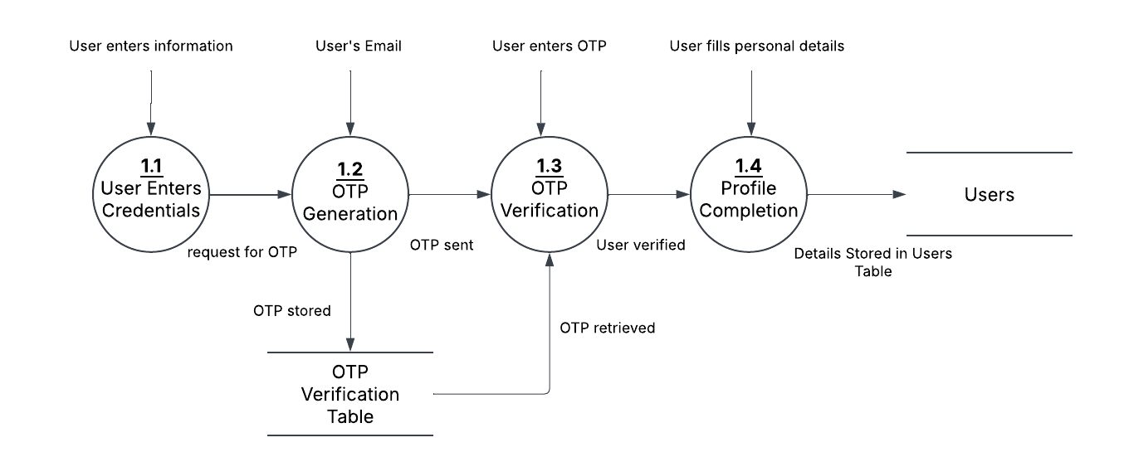

Figure 1 DFD of User Authentication

### 5.3.2 AI Symptoms Diagnosis

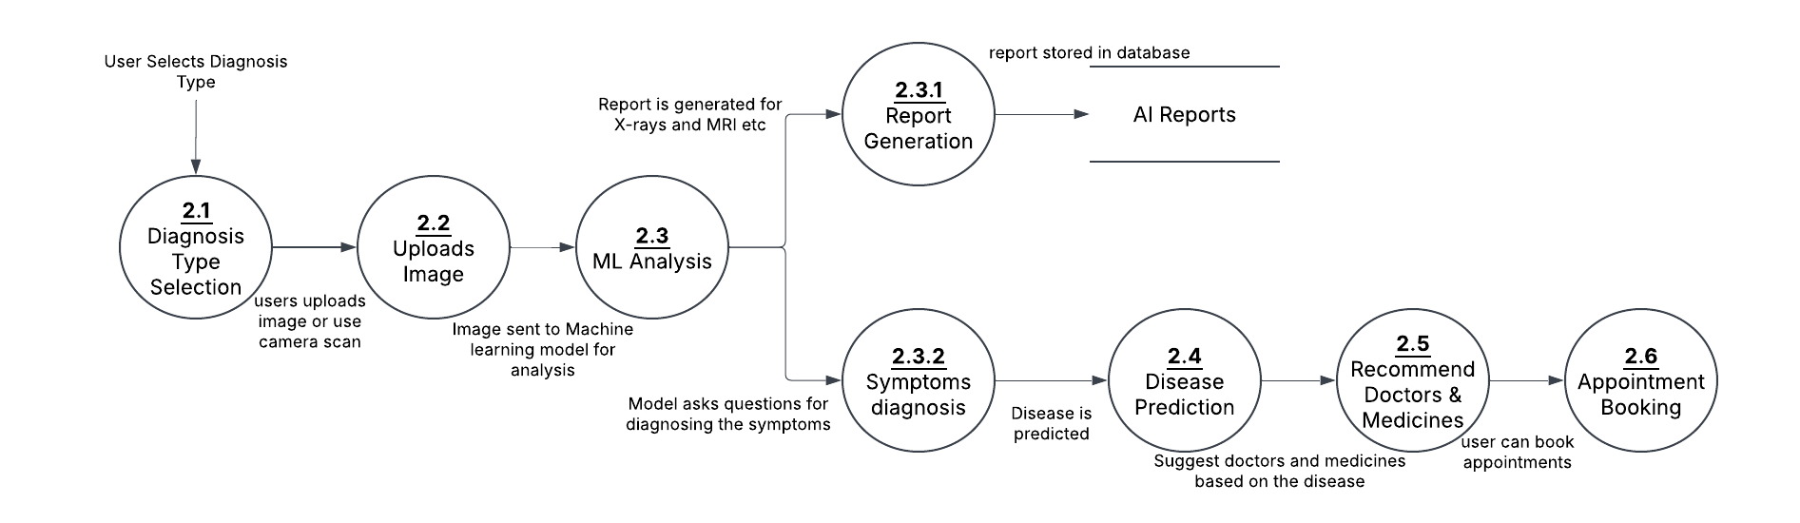

Figure 2 DFD of AI Symptom Diagnosis

### 5.3.3 Appointment Booking Process

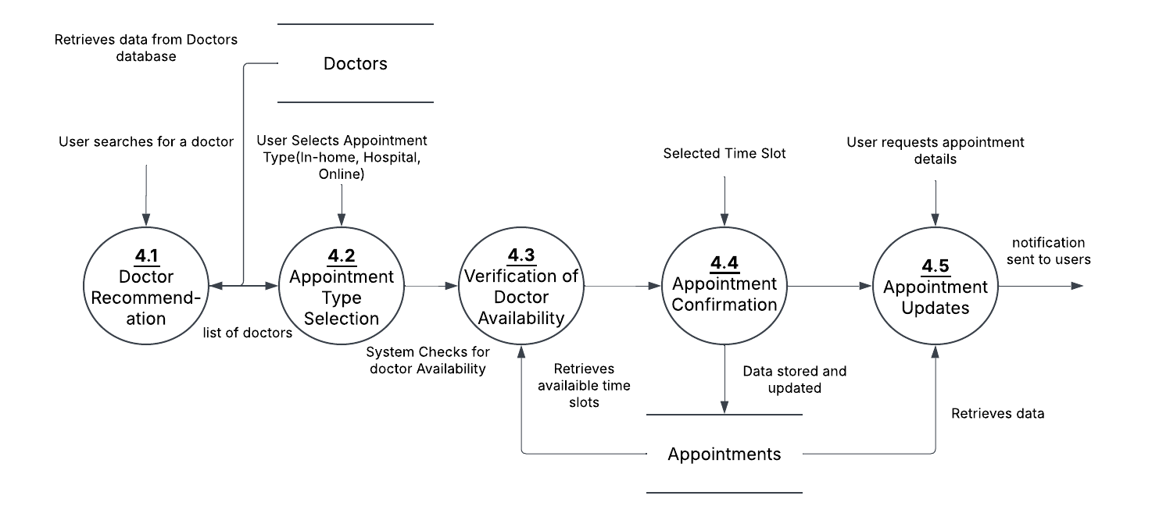

Figure 3 DFD of Appointment Booking Process

### 5.3.4 Fitness Tracking

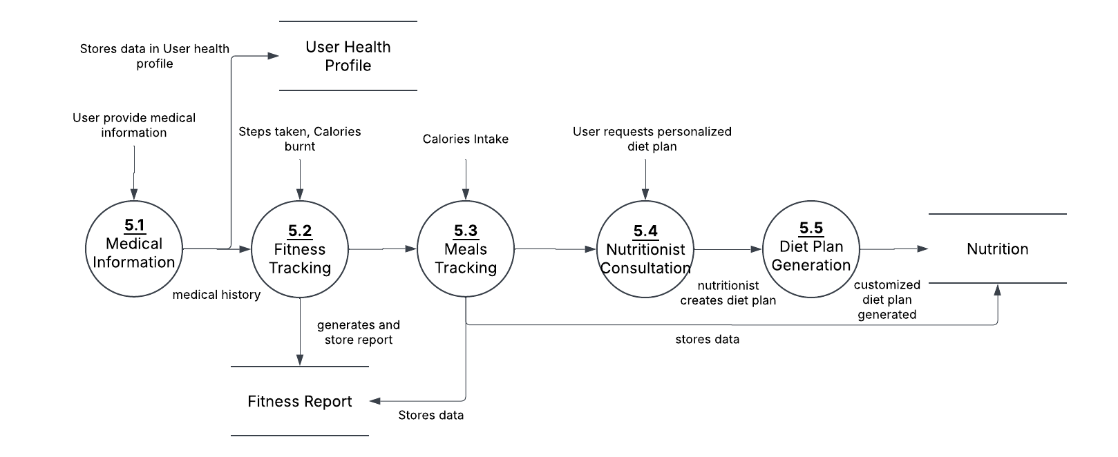

Figure 4 DFD of Fitness Tracking

# 6. Individual Tasks

|  |  |  |
| --- | --- | --- |
| **Team Member** | **Activity** | **Tentative Date** |
| Abdul Moiz,  Laiba Maqsood | Requirement Analysis | Sept 1,2025 - Sept 7,2025 |
| Abdul Moiz,  Laiba Maqsood | Design | Sept 8,2025 - Sept 20,2025 |
| Abdul Moiz (50%), Laiba Maqsood (50%) | Web Development | Sept 21,2025 - Oct 31,2026 |
| Abdul Moiz | Server Development | Nov 1,2026 - Dec 31,2026 |
| Abdul Moiz (50%),  Laiba Maqsood (50%) | Machine Learning Model | Jan 1,2026 - April 30,2026 |
| Abdul Moiz (60%), Laiba Maqsood (40%) | Testing | May 1,2026 – May 31,2026 |
| Abdul Moiz (40%), Laiba Maqsood (60%) | Documentation & Final Submission | May 1,2026 – June 1,2026 |

# 7. Gantt Chart

Figure 7 Gantt Chart (a)

Figure 8 Gantt Chart (b)

# 8. Tools & Technologies

The following tools and technologies will be used in our app.

## 8.1 Frontend

### 8.1.1 Next.js (Web)

* Chosen for its **server-side rendering (SSR)** and **SEO-friendly** nature.
* Ensures a **fast, responsive** web experience.

## 8.2 Backend

### 8.2.1 Nest.js

* A **scalable TypeScript-based** backend framework with **REST, Web Sockets.**
* Manages **user authentication, consultations, and secure health data processing**.

## 8.3 Database

### 8.3.1 MongoDB

* A **NoSQL database** optimized for **large-scale medical data storage**.
* Stores **patient profiles and AI-diagnosed reports** for fast retrieval.

### 8.3.2 Postgres

* A **SQL database** optimized for **large-scale medical data storage**.
* Stores **relational data.**

## 8.4 AI & Machine Learning

### 8.4.1 Python Server (AI/ML Processing)

* Powers **AI-driven symptom diagnosis** and **visual disease detection**.

## 8.5 API For Chatbot

* Groq or OpenAI

## 8.6 Sample Datasets

We will use dataset from Kaggle and other resources some example datasets are:

* Dental Diseases Dataset:

<https://www.kaggle.com/datasets/salmansajid05/oral-diseases>

* Acne dataset:

<https://www.kaggle.com/datasets/tapakah68/skin-problems-34-on-the-iga-scale>

* Skin Cancer Dataset:

<https://www.kaggle.com/datasets/devdope/skin-disease-lightweight-dataset>

# References

|  |  |
| --- | --- |
| [1] | F. Jiang, Y. Jiang, H. Zhi, Y. Dong, H. Li, S. Ma, Y. Wang, Q. Dong, H. Shen and Y. Wang, "Artificial intelligence in healthcare: past, present and future," *Stroke Vasc Neurol.,* vol. 2, no. 4, pp. 230-243, 2017. |
| [2] | C. M. Eckhardt, S. J. Madjarova, R. J. Williams, M. Ollivier, J. Karlsson, A. Pareek and B. U. Nwachukwu, "Unsupervised machine learning methods and emerging applications in healthcare," *Knee Surg Sports Traumatol Arthrosc,* vol. 31, no. 2, pp. 376-381, 2023. |
| [3] | N. Veeramani and P. Jayaraman, "A promising AI based super resolution image reconstruction technique for early diagnosis of skin cancer," *Sci Rep,* vol. 15, no. 1, p. 5084, 2025. |
| [4] | W. Barbosa, K. Zhou, E. Waddell, T. Myers and E. R. Dorsey, "Improving Access to Care: Telemedicine Across Medical Domains," *Annu Rev Public Health,* vol. 42, no. 1, pp. 463-481, 2021. |
| [5] | M. L. Graber, C. Byrne and D. Johnston, "The impact of electronic health records on diagnosis," *Diagnosis (Berl),* vol. 4, no. 4, pp. 211-223, 2017. |
| [6] | E. Riboli-Sasco, A. El-Osta, A. Alaa, I. Webber, M. Karki, M. L. El Asmar, K. Purohit, A. Painter and B. Hayhoe, "Triage and Diagnostic Accuracy of Online Symptom Checkers: Systematic Review," *J Med Internet Res,* vol. 25, no. 2, 2023. |
| [7] | S. Reddy, "Generative AI in healthcare: an implementation science informed translational path on application, integration and governance," *Implement Sci,* vol. 19, no. 1, p. 27, 2024. |
| [8] | R. Wootton and E. A. Krupinski, "Journal of Telemedicine and Telecare: expanding horizons," *J Telemed Telecare,* vol. 11, no. 1, pp. 1-2, 2005. |
| [9] | S. Majumder, M. Tapas and M. J. Deen, "Wearable Sensors for Remote Health Monitoring," *Sensors (Basel),* vol. 17, no. 1, p. 130, 2017. |
| [10] | J. R. Lieffers and R. M. Hanning, "Dietary assessment and self-monitoring with nutrition applications for mobile devices," *Can J Diet Pract Res,* vol. 73, no. 3, 2012. |

