OAuth Setup for Oracle Fusion Setup and Configuration Skills Registry (FSCR) Version 26D

OAuth Client Setup for FSCR Authentication

Integrated Application in OCI IAM Fusion Applications Identity Domain
Login to the OCI IAM identity domain of your Fusion Applications instance as an Identity Administrator.
Navigate to “Identity & Security / Domains”. Click on the identity domain of your Fusion Applications instance.
Select tab “Integrated applications”.
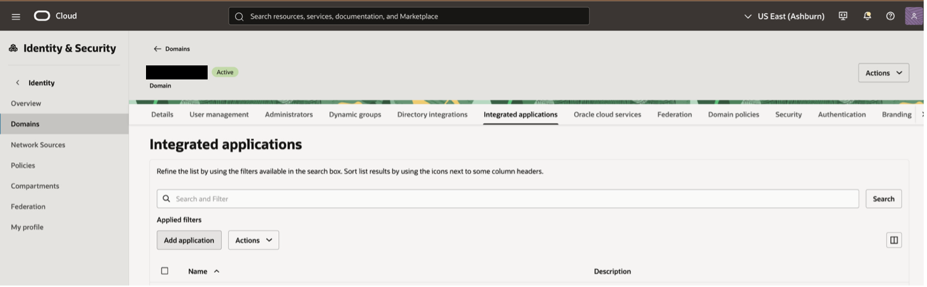
Click “Add application”.
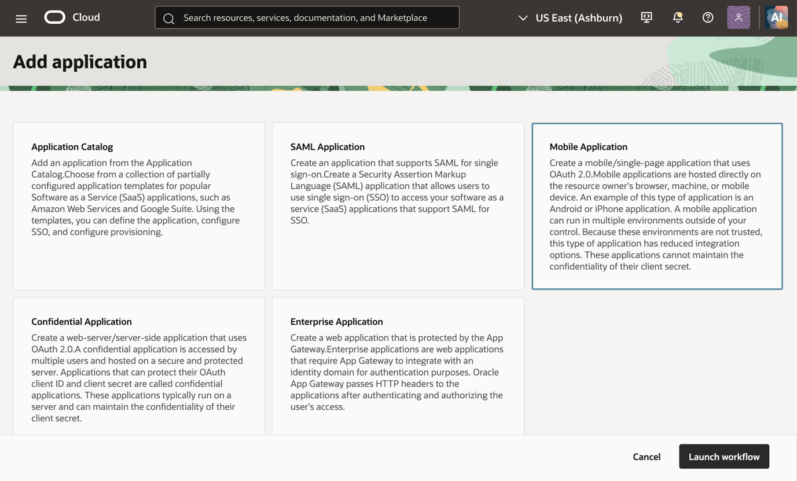
Select “Mobile Application” and click “Launch workflow”.
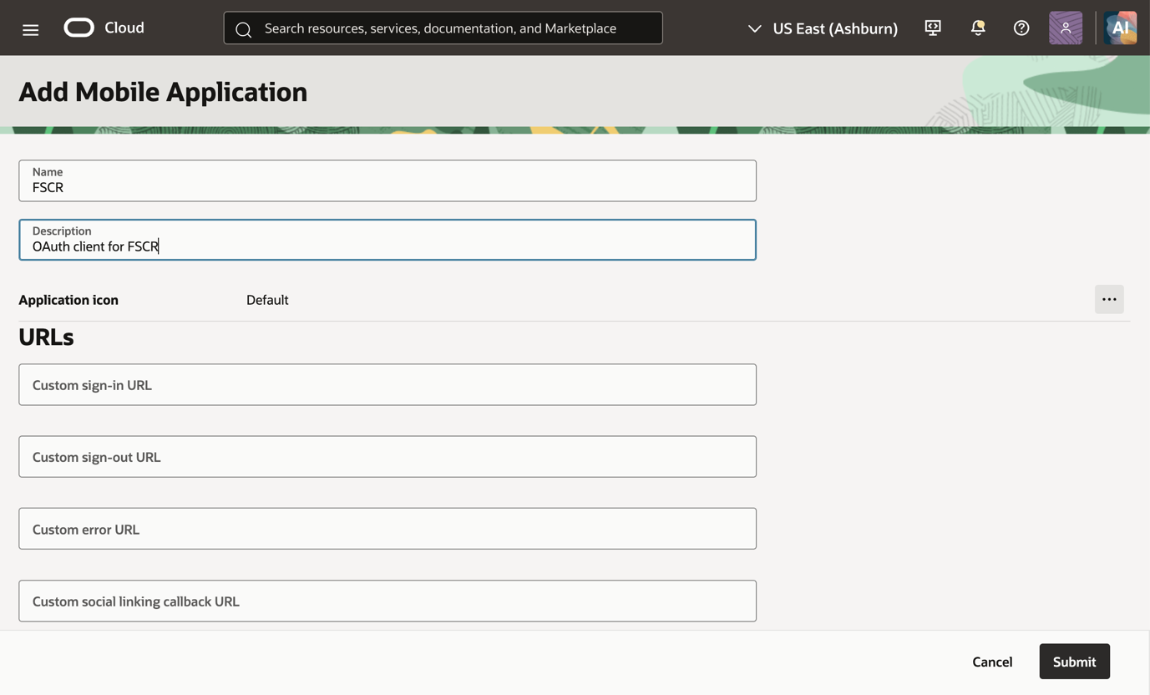
Give the application a name and a description.
(Optional): Check the flag “Enforce grants as authorization” if you want to restrict access only to specific users or groups. Those users or groups would need to be added in the “Users” or “Groups” tab of the created mobile application. If you enable this flag don’t forget to add your FSCR users to the mobile application after submitting, otherwise FSCR login won’t work.
No other entries are needed on this page.
Click “Submit”.
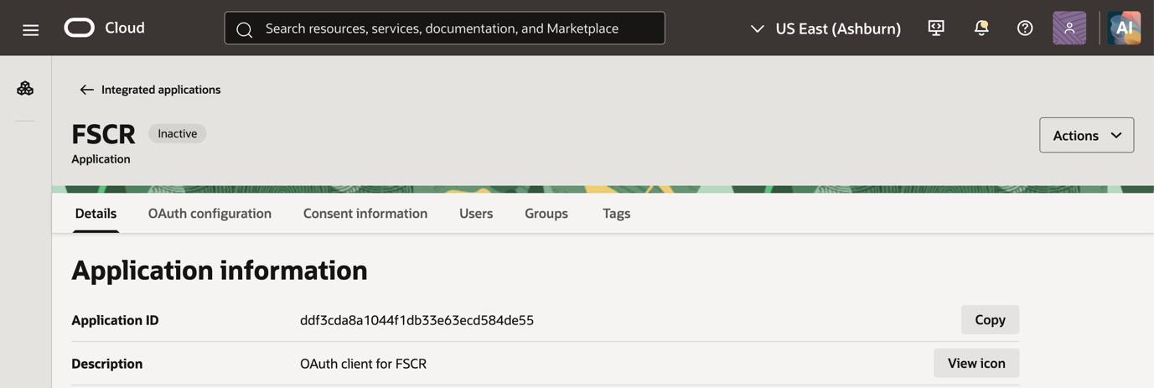
Select the “OAuth configuration” tab.
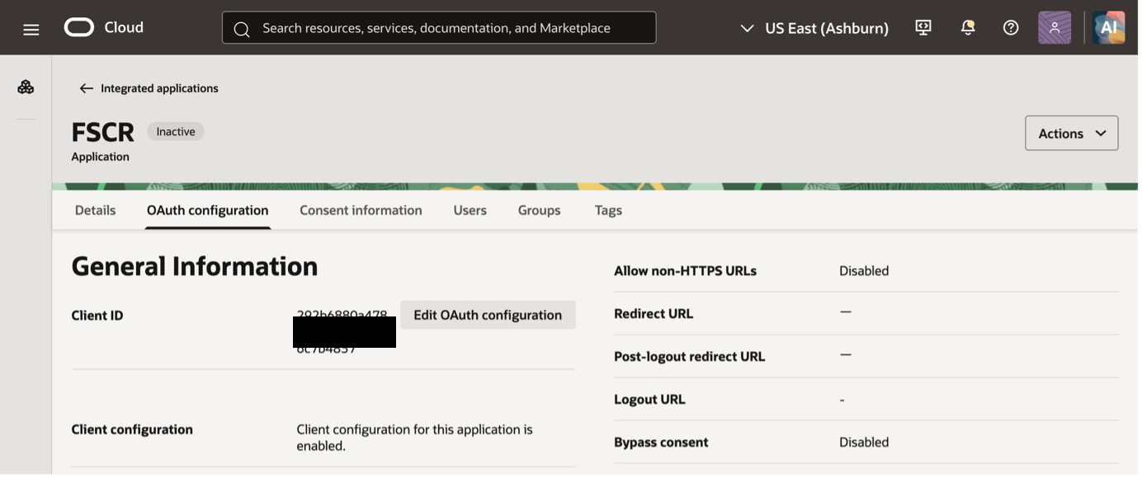
Click ”Edit OAuth configuration”.
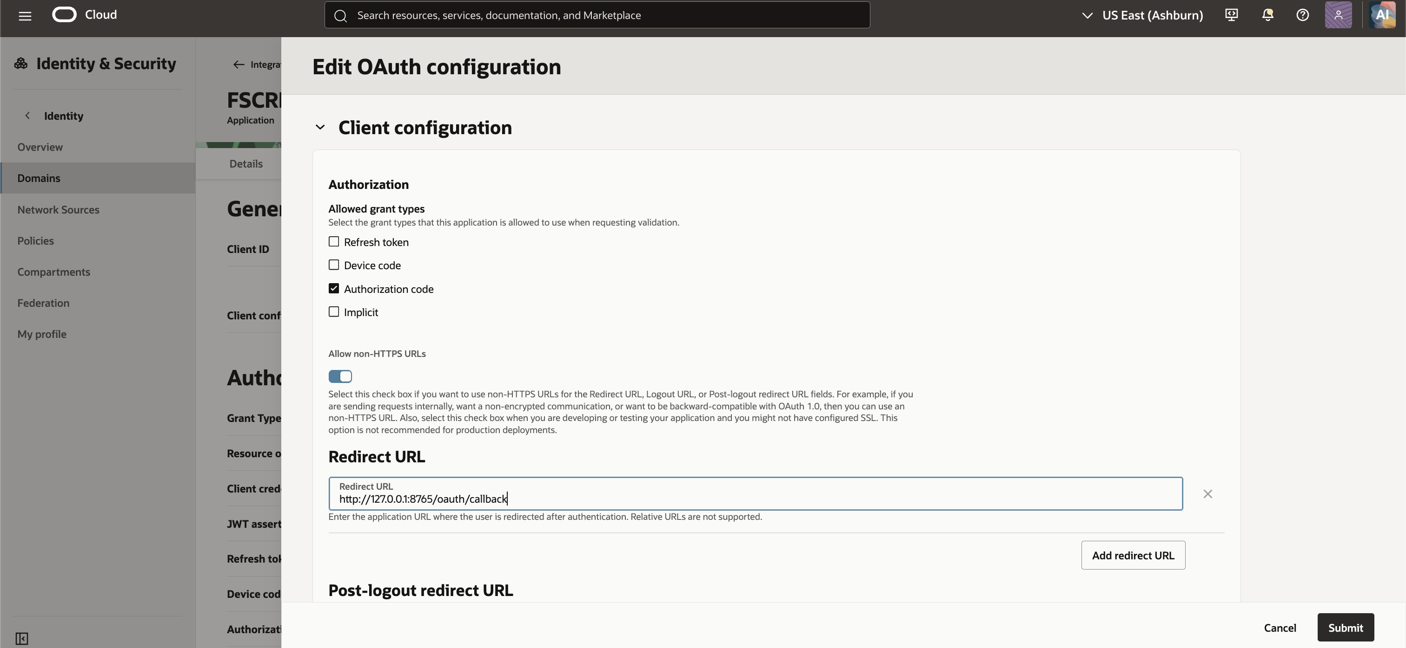
Enable grant type “Authorization code”.
Select “Allow non-HTTPS URLs” and add redirect url for Codex for codex callback listener “http://127.0.0.1:8765/oauth/callback”.
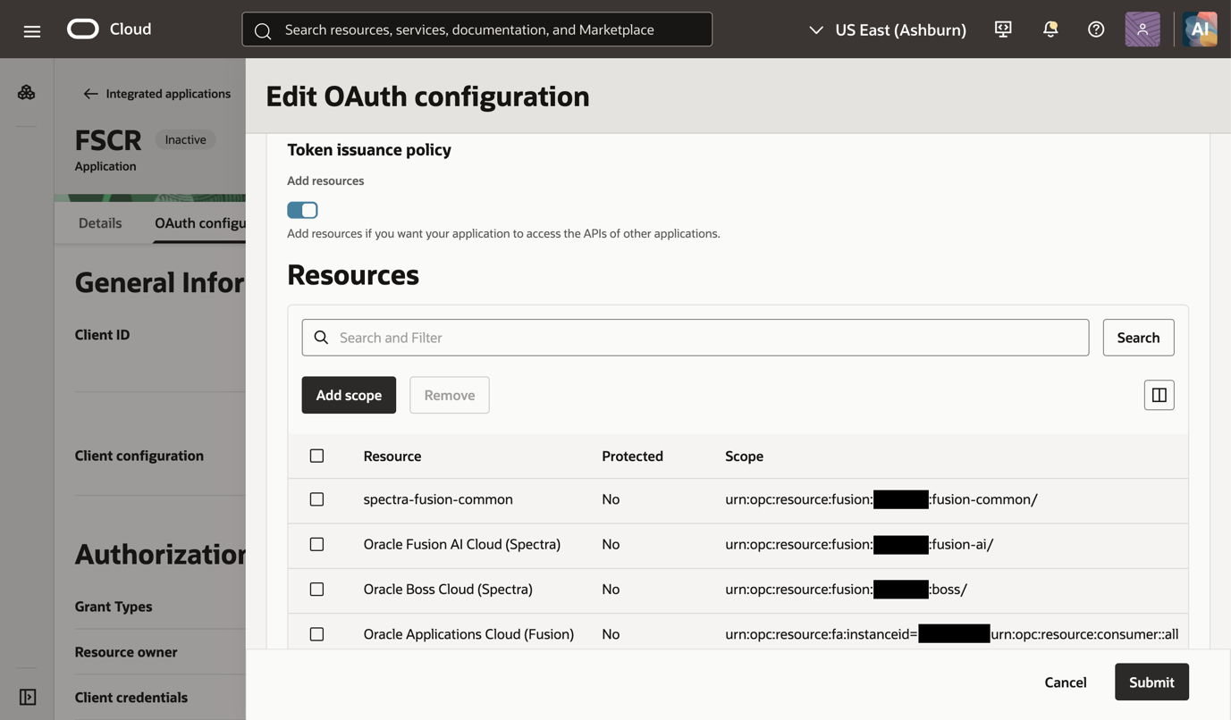
In section “Token issuance policy” enable “Add resources” and add the below resource scopes from your Fusion Applications environment resources:
- Oracle Applications Cloud (Fusion) (“scope”)
- Oracle Fusion AI Cloud (Spectra) (“ai_scope”)
- Oracle Boss Cloud (Spectra) (“boss_scope”)
- spectra-fusion-common (“fusion_common_scope”)
The other scopes mentioned in fusionEnv.properties file are optional and can be added as required for the Fusion Applications implementation.
- Risk Cloud (“rmc_scope”)
- spectra-knowledge-management (“km_scope”)
- CPQ (“cpq_scope”)
- Oracle Fusion Field Service (“fs_scope”)
- Oracle Unity (“cdp_scope”)
Note down the environment-specific scopes listed in the resource scope table.
Click “Submit”.
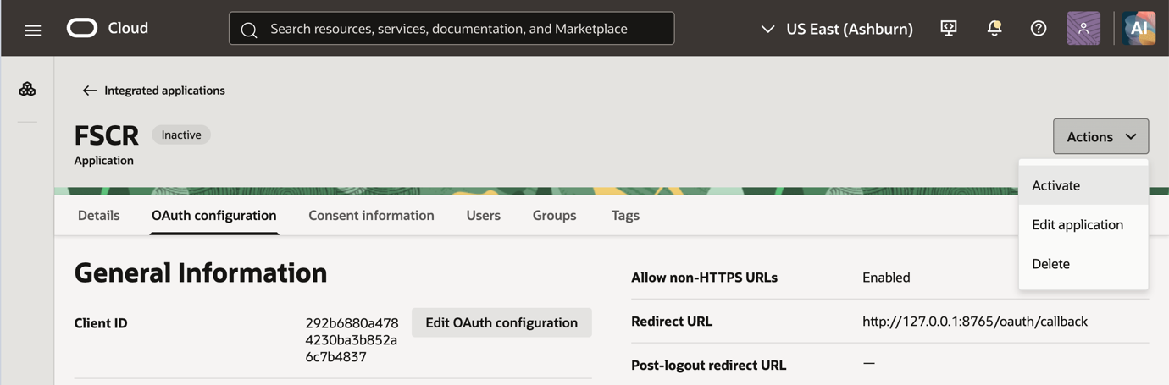
Activate the application by clicking “Activate” in the “Actions” menu.
Note down the Client ID.

FSCR fusionEnv.properties File
In the Codex FSCR folder populate the fusionEnv.properties file as shown below.
The fusionEnv.properties file is located in the sub-folder core/auth.
Replace the values for your Fusion Applications environment as appropriate.

environment=<your Fusion Applications environment name>
restBaseUrl=<Fusion Applications base URL like https://fa-xxxx -saasfaprod1.fa.ocs.oraclecloud.com>
clientId=<client id of OCI IAM mobile application for FSCR >
redirectUrl=http://127.0.0.1:8765/oauth/callback
# fscr scopes
scope=<Oracle Applications Cloud (Fusion) scope>
ai_scope=<Fusion AI scope>
boss_scope=<Boss scope>
fusion_common_scope=<Fusion common scope>
km_scope=<Knowledge management scope>
rmc_scope=<Risk Cloud scope>
cpq_scope=<CPQ scope>
fs_restBaseUrl=<Field Service base URL like https://xxxx.fs.ocs.oraclecloud.com>
fs_scope=<Field Service scope>
cdp_restBaseUrl=<Oracle Unity base URL like https://xxxx.cdp.ocs.oraclecloud.com>
cdp_scope=<Oracle Unity scope>
# Express mode Oracle CDN proxy support (including macOS discovery). Set false for direct access.
enableProxy=true

Test of OAuth Setup
Login within Codex using prompt “fusion login”.
You will be prompted for permissions and asked to login using your browser window. Complete the login process and Codex should be able to get the right access token.

