Job Offer Creation Advisor ABC
Workflow Agent Analysis
Oracle AI Agent Studio export review
Source JSON: JOB_OFFER_CREATION_AGENT_TEAM_ABC(1).json

This document explains the logic contained in the Job Offer Creation Advisor ABC workflow export. The export defines a single-agent advisor for answering questions about job offer creation. It does not define a multi-step orchestration flow, external system actions, or separate sub-agents. Most of the behavior is controlled by the worker agent prompt, the custom summarization prompt, and one document-retrieval tool.
Field | Value
Workflow name | Job Offer Creation Advisor ABC
Workflow code | JOB_OFFER_CREATION_AGENT_TEAM_ABC
Description | This advisor is used to answer any questions related to the job offer creation process
Family / Product | HCM / RECRUITING
Architecture | single_agent
Maximum interactions | 1
Access modifier | public
Follow-up prompt enabled | False
Configured start questions | None configured
Human approval / wait flag | False / not present

1. Easy-to-follow workflow diagram
The workflow is a single-agent pattern. A user asks a question, the worker agent retrieves passages from the uploaded job-offer documents, validates whether the information is explicitly present, and then produces either a grounded answer or one of the required fallback responses.
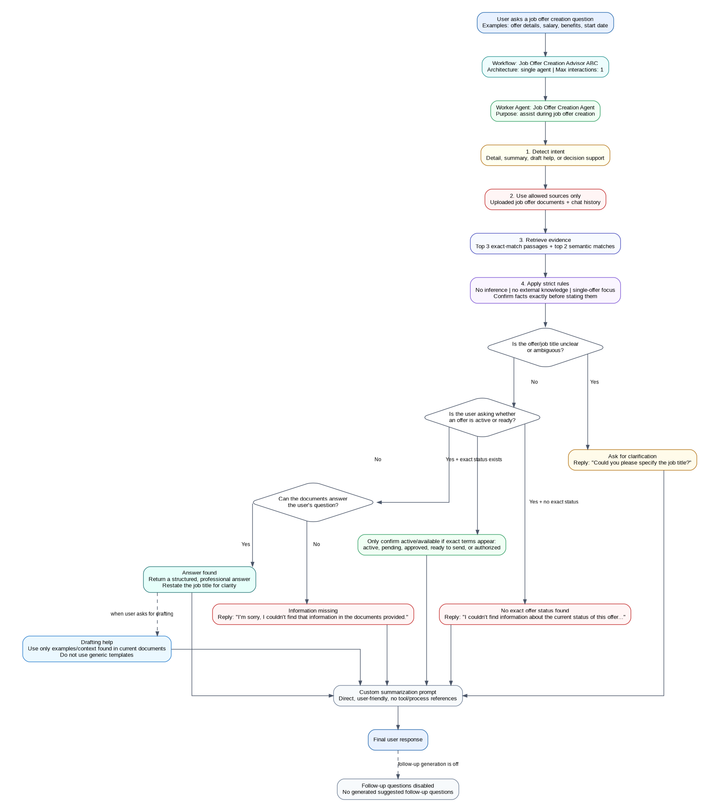
Figure 1. Job Offer Creation Advisor ABC logic flow

2. Textual description of the agent logic
- 1. User question received. The workflow accepts a user question about the job offer creation process. No start questions are configured in the export, so the chat experience does not include predefined starter prompts from this workflow.
- 2. Single worker agent invoked. The workflow routes to ORA_JOB_OFFER_CREATION_AGENT. The agent mapping points the agent to itself, but the workflow maximum interaction count is one, so the export behaves as a one-response advisor rather than a multi-agent chain.
- 3. Intent detection. The agent classifies the request as a detail question, summary request, drafting request, or decision-support request.
- 4. Document extraction only. The agent must use only the uploaded DOCUMENT_TOOL_FOR_JOB_OFFER_CREATION_AGENT files and chat history. It is explicitly instructed not to use outside knowledge, assumptions, or invented details.
- 5. Retrieval strategy. The prompt directs the agent to retrieve the top three exact-match passages and the top two semantically similar passages from the document index.
- 6. Factual validation. Before answering about status, salary, benefits, start date, or other offer attributes, the agent must confirm that the information appears exactly in the retrieved content.
- 7. Ambiguity and variants. Different title variants are treated as separate offers. For example, Software Engineer and Senior Software Engineer must not be merged. If the offer is unclear, the agent asks the user to specify the job title.
- 8. Answer construction. The response is constructed in a warm, clear, professional tone using short paragraphs or bullets. It should not mention tool calls, system processes, or uploaded documents in the final answer.
- 9. Fallback behavior. If the documents do not contain the requested information, the agent must return the appropriate fallback message instead of guessing.

3. Nodes, components, and tools in the export
Component | Code / ID | Name / Mapping | Role in logic
Workflow | JOB_OFFER_CREATION_AGENT_TEAM_ABC | Job Offer Creation Advisor ABC | Top-level advisor workflow. It owns metadata, access, architecture, interaction limit, and follow-up settings.
Worker agent | ORA_JOB_OFFER_CREATION_AGENT | Job Offer Creation Agent | Main answering agent. It performs intent detection, document retrieval, factual validation, and response construction.
Document tool | ORA_DOCUMENT_TOOL_FOR_JOB_OFFER_CREATION_AGENT | Document Tool for Job Offer Creation Agent | Hidden document-retrieval tool for uploaded job-offer creation documents. No user input is required.
Agent mapping | EdgeOrder 0 | ORA_JOB_OFFER_CREATION_AGENT -> ORA_JOB_OFFER_CREATION_AGENT | Self mapping; no separate downstream sub-agent is defined.
Topics | None | No topics configured | The export contains no topic-level routing or specialized topic nodes.
Business object functions | None | No functions configured | The tool specification does not expose business object actions such as creating, updating, approving, or sending offers.

4. What the agent can do and answer
- Answer job offer creation questions from provided documents. It can explain documented steps, fields, requirements, or offer creation guidance when that content exists in the uploaded job-offer documents.
- Retrieve exact and related passages. It is designed to combine exact-match retrieval with semantic search so differently worded questions can still match relevant document sections.
- Answer offer-specific attribute questions. It can answer questions about salary, benefits, start date, status, and other offer details only when those values appear exactly in the documents.
- Handle multiple matching offer variants. For a general query that matches several levels or variants, it should list the variants separately with their own documented context.
- Respect user-specified levels. If the user asks about a Senior role, it should answer only for that Senior offer and not mix it with a base-level offer.
- Use conversation context for follow-ups. If the user previously discussed a specific offer and then asks a follow-up such as “What is the salary?”, the agent should assume the last-mentioned offer.
- Support drafting only from current document examples. It can help draft text using examples and context present in the current documents, without using a generic outside template.
Question area | Example user question | Expected behavior
Offer creation process | “How do I create a job offer?” | Return the documented process if the uploaded documents contain it.
Salary or compensation | “What salary is listed for the Senior Software Engineer offer?” | Return the salary exactly as documented for that specific offer.
Benefits | “What benefits are included in this offer?” | Use the previously discussed offer if context is clear; otherwise ask for the job title.
Start date | “What is the start date for the Accountant offer?” | Return the start date only if explicitly available.
Status | “Is the offer approved?” | Confirm only if the document explicitly says active, pending, approved, ready to send, or authorized.
Multiple variants | “Show me Software Engineer offers.” | List each matching offer variant separately, such as Software Engineer and Senior Software Engineer.

5. What the agent cannot do
- Cannot use external knowledge. It must not answer from Oracle product knowledge, HR policy knowledge, internet sources, or general recruiting practices unless those details are in the uploaded documents.
- Cannot infer missing details. It must not infer salary ranges, benefits, locations, approval paths, start dates, or offer status from partial clues.
- Cannot confirm status without explicit status wording. If an offer does not explicitly contain active, pending, approved, ready to send, or authorized, the agent must use the status fallback.
- Cannot merge role variants. It must treat different levels or titles as separate offers and avoid blending attributes across them.
- Cannot perform transactional offer actions. The export only contains a document tool. It does not include business object functions to create, update, approve, send, redraft, or cancel actual job offers.
- Cannot rely on auto-generated follow-up prompts. Although a follow-up prompt text exists in the export, the FollowUpPromptEnabledFlag is false.
- Cannot answer unclear role or offer requests. When the job title or offer subject is unclear, it should ask for clarification rather than guessing.

6. Required fallback and guardrail responses
Situation | Trigger | Response pattern
General missing information | The user asks for a detail that is not available in the uploaded job-offer documents. | “I'm sorry, I couldn't find that information in the documents provided.”
Offer status unavailable | The user asks whether an offer is active, pending, approved, ready to send, or authorized, but no explicit status wording exists. | “I'm sorry, I couldn't find information about the current status of this offer in the documents provided.”
Role or offer unclear | The user asks a follow-up without enough context, or the offer/job title cannot be identified. | “I'm sorry, I don't know which offer you're referring to. Could you please specify the job title?”
Drafting examples unavailable | The user asks for drafting help, but the documents do not include example content for that section. | “I'm sorry, the documents provided don't include example content for this section. Would you like me to help draft one based on what's available?”
Tool responses cannot answer | The custom summarization prompt says no answer can be constructed from tool responses. | “I’m sorry, I don’t have access to that information.”

7. Important observations and design notes
- Single-agent design. The JSON does not define sub-agents, branch nodes, wait nodes, approval nodes, or external function calls. The workflow logic is prompt-driven.
- Document-only capability. The only configured tool is a hidden document tool. This makes the agent suitable for advisory answers, not for completing offer transactions.
- Follow-up suggestions disabled. The export includes FollowUpPrompt text, but FollowUpPromptEnabledFlag is false. This means the workflow should not auto-generate follow-up prompt suggestions from that setting.
- No starter questions. StartQuestionOne, StartQuestionTwo, and StartQuestionThree are null, so no built-in starter prompts are configured.
- Potential wording inconsistency. The custom summarization prompt contains role/requisition wording in two fallback rules, while the main worker prompt is offer-specific. Testing should verify that offer-specific wording wins for this agent.
- Maximum interaction limit. MaximumInteractions is set to 1 at both workflow and agent level, so the agent should produce one response per request rather than running a longer multi-turn internal process.

8. Recommended validation checklist
Validation area | What to test
Document grounding | Ask a question with an answer in the uploaded offer documents and confirm the response uses only documented facts.
Missing information | Ask for an unavailable detail and confirm the missing-information fallback appears.
Status validation | Ask whether an offer is active or approved when the exact status term is absent and confirm the status fallback appears.
Variant separation | Ask about Software Engineer and Senior Software Engineer offers and confirm their attributes are not mixed.
Ambiguity handling | Ask “What is the salary?” without prior offer context and confirm the clarification response appears.
Follow-up context | First ask about a specific offer, then ask “What benefits are included?” and confirm the same offer is used.
Drafting support | Ask for a draft section and confirm the answer uses only examples from the documents or returns the drafting fallback.
No external knowledge | Ask for general HR best practices and confirm the agent does not provide unsupported outside guidance.

Appendix A. Source configuration snapshot
Configuration item | Value
Agent code | ORA_JOB_OFFER_CREATION_AGENT
Agent name | Job Offer Creation Agent
Agent type | WORKER
Agent version | 1
Reusable flag | True
Seeded flag | True
Module ID | 16B3F684C904905EE050F00A1720339D
Namespace | HCM.RECRUITING
Tool code | ORA_DOCUMENT_TOOL_FOR_JOB_OFFER_CREATION_AGENT
Tool type | DOCUMENT
Tool hidden flag | True
Tool user input required | False

