**SMART FOOD ORDERING SYSTEM**

**FYP Proposal Number**

**CS-FYP-2017-___**

**Date of Submission**

**March 27, 2017**



**Submitted By**

**M.Najeebullah Khan (BSCS/F14/0133)**

**M.Talal Malick (BSCS/F14/0145)**

**Saim Ahmed (BSCS/F14/0146)**

**Supervisor:**

**Assistant Professor**

**Adnan Ahmed Siddiqui**

**DEPARTMENT OF COMPUTER SCIENCE**

**HAMDARD UNIVERSITY KARACHI,**

**MAIN CAMPUS**

# Table of Contents

Table of Contents 2

1. INTRODUCTION: 3

1.1 Problem Statement: 3

1.2 Aims and Objectives: 3

2. LITERATURE REVIEW: 4

3. PROJECT SCOPE: 7

3.1. Paper Based Traditional Restaurant System 7

3.2. Smart Food Ordering System: 8

4. METHODOLOGY FOR IMPLEMENTATION OF PROJECT 9

4.1. Project Approach: 9

4.2. Actors and Responsibilities: 9

5. PROJECT REQUIREMENT: 10

5.1 Software Tools: 10

5.2 Hardware Requirements: 10

6 FUNCTIONAL REQUIREMENT: 10

6.1 User Tablet/User Handheld Device: 10

6.2 Admin Interface: 10

6.3 Kitchen Display: 11

6.4 SMS Integration: 11

6.5 Menu Recommendation: 11

6.6 Customer Feedback: 11

6.7 Report Generation: 11

7 NON-FUNCTIONAL REQUIREMENTS: 11

8. PROJECT PLANNING: 12

Gantt Chart: 12

9. PROJECT BUDGET: 12

10. REFERENCES 13

­­

# List of Figures

Figure 1 System Design 8

Figure 2 Agile Approach 9

# INTRODUCTION:

## Problem Statement:

Nowadays each and every hotels and restaurants use the conventional pen and paper method for ordering and serving food items which takes time and energy cause the customer dissatisfaction and loses restaurant reputations. This is the common manual process ordering food in hotels and restaurants. It involves several steps that the customer searches the name of the item in the menu card then waiters noting down the order according to the customer, transfers the order to the kitchen unit, serving the order, and then prepare the bill from the cashier counter. This process is conventional and too sluggish. It requires more manpower which creates human errors, and also consumes a lot of time.

# 1.2 Aims and Objectives:

* Develop the smart system to automate food ordering process.
* To improve efficiency and accuracy in order processing.
* Develop a restaurant ordering system with mobile application based on  
  the client server application.
* Reduce Human error to get positive feedback from customers.
* To reduce wastage of money, time, and paper.
* This system determines best-selling food items, peak hours, and customers’ satisfaction.
* Use tablets and smart phone to communicate between customer and staff through mobile app.
* Real time feedback from the customers.

# LITERATURE REVIEW:

|  |  |  |  |  |  |
| --- | --- | --- | --- | --- | --- |
|  | **Author / Paper Name** | **Technique** | **Methodology** | **Disadvantages/Advantages** | **Future Scope** |
| [1] | Intelligent e-restaurant system with Wi-Fi service | Integration of touch technology in restaurants for ordering food using android. | A dynamic database system which fetches all data and information from a centralized database server. The tablet at the customer’s table contains the android application with all the menu details. The customer’s tablet, kitchen display and the cashier counter connects each other via Wi-Fi. | This system is less expensive and only requires one time investment.  The application is a user friendly.  Improves efficiency and accuracy for restaurants by saving time.  Reduce human error.  Centralize server that allow to share the customer data to the restaurants, this can help in providing better recommendations and user experience to the patrons. | Due to enhancement of technology, E-ordering system is developed for restaurant and provides easy interaction between customer and restaurant staff via wireless technology.  It Reduces human error and time. |
| [2] | Restaurant ordering billing and database monitoring system. | Establishment of Touchscreen Based electronic menu card. | E-Menu card proposed and connected to the Raspberry Pi which sends the order to the kitchen via Wi-Fi. The database keeps track each and every order given by the customer from the table. | Through this system the owner or admin can monitor the business through the webpage.  Dynamically update the orders.  Take care of billing that is remotely operated by the owner.  Avoid ambiguity. | This system can be implemented in large and small restaurant as well which get crowd at peak hours and need a real time efficiency, accuracy, and smooth operation. |
| [3] | Self-served food ordering system. | Using the wireless and multi touchable technology to replace the PDA based food ordering system. | This system wirelessly update order details in central database and correspondingly sent to kitchen and sent to cashier/admin respectively from touchpad tablet which is laying on the customer’s table. | This system increases the quality and speed of the service in a restaurant and give a cost efficient opportunity to a customer | System would attract customer and increase the efficiency to maintain the customers’ order and billing process. |
| [4] | Digital Table Booking and Food Ordering System Using Android Application. | Wireless Technology to automate food orders.  Android application. | Customer chooses the available food from digital menu application .application uses priority algorithm to determine which user serve first then use GPS to see customer’s location and can calculate user’s arriving time and booked order. | Remote order placing is preferable for every user.  It uses android app can easily run on android phone user.  Keep maintain all records related to orders of customers.  Rather updating paper based menu update centralized database. | Reduce wastage of Time and Money.  Reduce human error. |
| [5] | Implementation of Smart Restaurant with e-menu Card | Smart phone and tablet based ordering system. | Using microcontroller for computation , Wi-Fi for radio frequency to transmit data through customer to restaurant staff  Buzzer to beep audio signaling or alert device. | Much hardware usage that can be low in accuracy.  All hardware depends on another if any breakage or damage in one hardware system will stop.  Low power consumption.  High sensitive. | Wireless technology is implemented in this project that can tend to the user need.  Menu card replacement and grow digital world. |
| [6] | Android Application for Menu Recommendation System | Android based operating system and wireless communication through Wi-Fi | There will be 3 modules customer, chef, and Admin. Customer can add items (with ingredients) or delete from menu card according to his requirements and menu will be updated by admin.  Admin has all authorities. | It will minimize the number of employee at backend. Reduce cost of labor. Possible human errors like calculation or taking wrong orders will be eliminated. System will work 24 hours apart human can’t do work 24 hours. | Self-adding items in menu will cause of bad impression of restaurant because every customer will add or delete items and variation in menu card frequently can down the progress of hospitality industry. |

# PROJECT SCOPE:

## Paper Based Traditional Restaurant System

* Worldwide a conventional pen paper based system is one of the most commonly used for food ordering. In this process all the records store on the paper which creates various problems such as:
  + The most common blunder is waiter to make mistake while taking orders from the customer. Mostly specific details and orders of the customer are relied on waiter to remember it.
  + Wasting the waiter’s service time by calling them frequently from customers to know about their order status.
  + Managers have to search hundreds of receipt papers to find which are the bestselling food items, popular hot hours, and customer positive responses.
  + When food item/s not available or price need to be changed, updated menu card will be re-print again and again.
  + Large amount of human efforts required with less efficiency.

## Smart Food Ordering System:

* + - Smart food ordering system based on electronic devices with the screen presenting the food items menu accept user’s input through the mobile and web based application for order placing.
    - Only the available dishes will be shown in menu on screen.
    - A customer chooses the items from menu and place their orders through web based or mobile based application which will sent to the kitchen unit and admin too.
    - Kitchen staff checks the order from installed device in the kitchen then would prepare the dishes or items according to the customer order.
    - After completion of order waiter will be called who collect and deliver or serve the items to appropriate customer.
    - After serving the order the counter will generate a copy of bill for customer automatically. Customer can also view and calculate his respective food items according to the prices.
    - Customer will choose the payment method (Cash, Debit Card, PayPal etc.) according to his ease in application.
    - The management will have full authority to access all details of the customer which are fed into the customer.

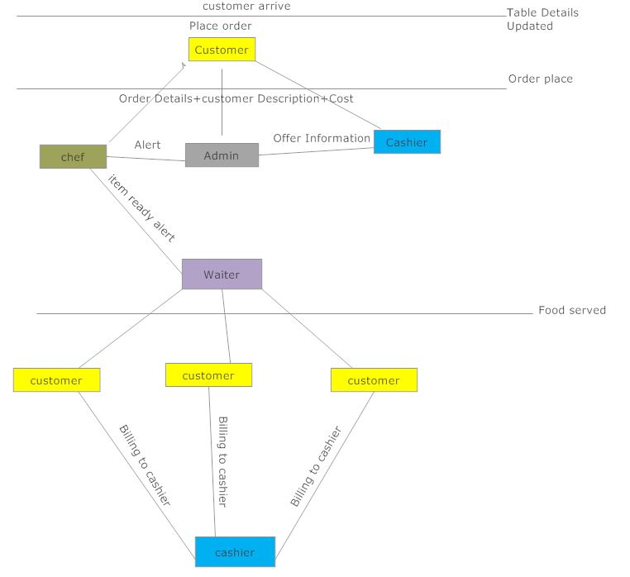

Figure 1 System Design

# METHODOLOGY FOR IMPLEMENTATION OF PROJECT

## Project Approach:

SDLC Agile project approach will be used for developing the project, it breaksthe task into small accretion with minimal planning, and directly not involved in long term planning.

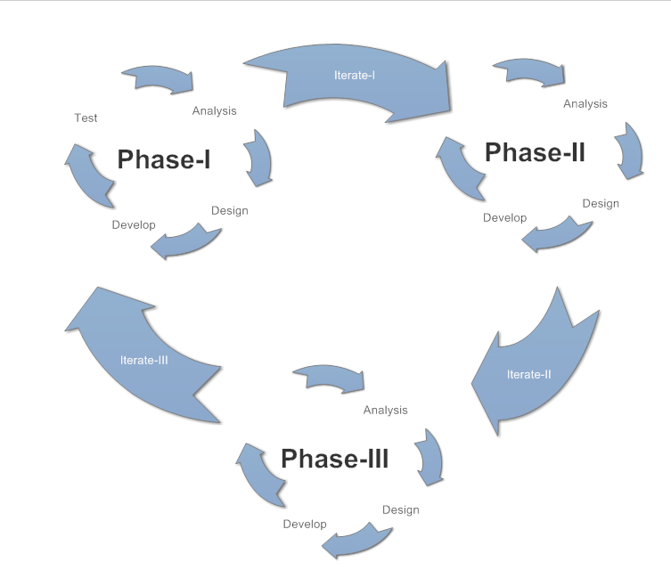

Figure 2 Agile Approach

## Actors and Responsibilities:

|  |  |  |  |  |
| --- | --- | --- | --- | --- |
| **Step No.** | **Description** | **Talal** | **Najeeb** | **Saim** |
| 1 | Initiation |  |  |  |
| 2 | Planning |  |  |  |
| 3 | Elicitation |  |  |  |
| 4 | Design |  |  |  |
| 5 | Development |  |  |  |
| 6 | Database |  |  |  |
| 7 | Testing |  |  |  |

# PROJECT REQUIREMENT:



## Software Tools:

HTML and CSS

JavaScript

React Native

Asp.Net

Oracle Database

Visual Studio

XAMPP/WAMP Software.

Adobe Photoshop.

## Hardware Requirements:

Tablets

Smart Phone

Desktop Quad Core Processor

Internet Device.

Wi-Fi Device.

Printer for Printing Reports.

# FUNCTIONAL REQUIREMENT:

This project consists of the following modules as follows:

## User Tablet/User Handheld Device:

* First customer has to be done registration after registration he will get a password and user name then he can order process.
* Bill is automatically goes to that particular user.
* These smart devices will consist of the whole menu of the restaurant.
* The items in the menu are non–editable.
* Customer can give order from anywhere in the city using login id.
* Communication between customer and restaurant through Wi-Fi connectivity.

## Admin Interface:

* This interface is especially for the use of the restaurant admin.
* The admin should be able to control the function of whole restaurant from a single desktop and mobile application.
* Admin can access any device and should be able to make changes to the menu.
* Admin can change price of particular item.
* Admin can disable particular item which is not available at that particular time.

## Kitchen Display:

* The device present at the kitchen near chef so that he should be able to see what a particular has ordered.
* All the ordered items are displayed on the screen also show the table number.
* They should be sufficiently large to be seen by chef at a reasonable distance.
* Chef should be able to notify to the customer and waiter when a particular item is ready.

## SMS Integration:

* At the time of registration customer has to be enter the contact number & other information, this contact number & other information will saved in database.
* If there is any offer in restaurant then server will automatically send SMS to the customer.
* Also send total bill amount to the customer through SMS.

## Menu Recommendation:

* Provide menu recommendation to the customer such as if customer order any item menu then our system will shows related menus to that order.

## Customer Feedback:

* Provide facility to the customer to give feedback about services of restaurant.

## Report Generation:

* The system generates daily, weekly, and monthly report to the admin.

# NON-FUNCTIONAL REQUIREMENTS:

* User Feasibility
* Interactive UI.
* Reduce human error.
* Quality.
* Automation.
* Reduce expenses.
* User’s Preferences.
* Reduce Staff
* Reduce Labor.
* Efficiency.
* Accuracy.
* Easy Updateable.
* Proper record Management.
* Robust.
* Save Time and money.

# PROJECT PLANNING:

## Gantt Chart:

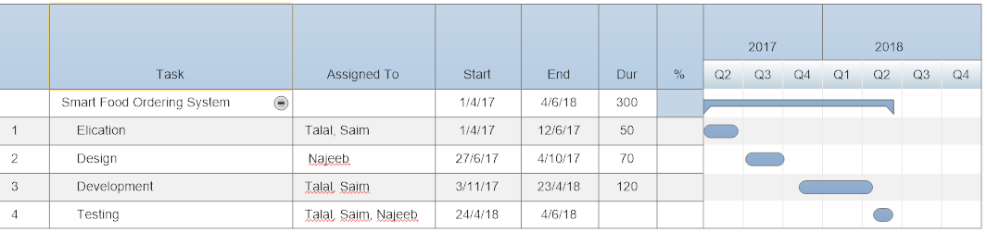

# PROJECT BUDGET:

|  |  |
| --- | --- |
| ITEM DESCRIPTION | AMOUNT(PAKISANI RUPEES) |
| Laptop/Desktop (for server) | Rs. 15,000 |
| 5 Tablets | Rs. 50,000 (Approx.) |
| 2 Smart Phone | Rs. 20,000 (Approx.) |
| Hosting | Rs. 20,000 |
| Printer | Rs. 5,000 |
| Other Charges | Rs. 5,000 |
| Total Cost | **Rs. 115,000** |

# REFERENCES

[1] S. Issue, “INTELLEGENT E-RESTAURANT SYSTEM WITH WI-FI,” vol. 4, no. March, pp. 192–200, 2015.

[2] A. N. Alwekar, “RESTAURANT ORDERING BILLING AND DATABASE MONITORING SYSTEM SYSTEM,” vol. 3, no. 3, pp. 1138–1142, 2016.

[3] K. Poonam, K. Priya, K. Snehal, and P. B. Ingale, “Self-Served Food Ordering System .,” no. 5, 2016.

[4] P. V. B. Dhore, S. Thakar, P. Kulkarni, and R. Thorat, “Digital Table Booking and Food Ordering System Using Android Application,” *Int. J. Emerg. Eng. Res. Technol.*, vol. 2, no. 7, pp. 76–81, 2014.

[5] M. D. Jakhete and P. C. Mankar, “Implementation of Smart Restaurant with e-menu Card,” *Int. J. Comput. Appl.*, vol. 119, no. 21, pp. 23–27, 2015.

[6] A. A. Tayade, S. P. Ramteke, and S. J. Matte, “Android Application for Menu Recommendation System,” vol. 6, no. 4, pp. 4791–4794, 2016.