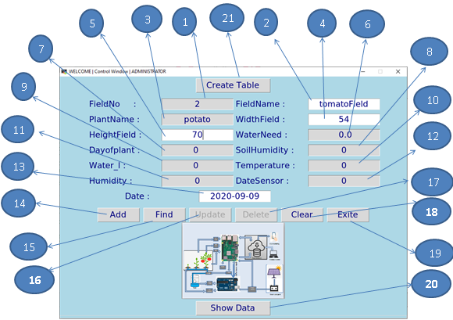

Desktop application:

This application written by python language to tolerate farmer to management the database of Field table.

The farmer can add, update, delete and show data of fields. This application runs without internet.

1. Field number generate automatically.
2. Use to insert or view field name.
3. Plant name by default potato change later by yolo algorithm.
4. Width of field by CM.
5. Height of field by CM.
6. Present the amount of water that field need.
7. Present the number of days from create the field
8. Present the value of soil humidity in field.
9. Present the value of temperatures of air in field.
10. Present value of humidity of air in the field.
11. Present the level water in tank.
12. Present the date of last reading data by sensors.
13. Present the date of creating the field.
14. Button that add field to database.
15. Button that show field data.
16. Button that update field after we do show for field.
17. Button that delete field.
18. Button reset application to add a new field.
19. Button that exit from application
20. Button that show all fields in database.
21. Button that create table in database if not exits.

