Sports Facility Booking Platform (SFBP)

Group #: 2
Members:
• Abdul Momin Abbasi ( 22i-1326 )
• Kaf Abbas ( 22i-0763 )

Date of Submission: March 20, 2025

Software Requirements Specification

1. Introduction

1.1 Purpose
This SRS document specifies the requirements for the Sports Facility Booking Platform (SFBP). The purpose of the system is to provide an online solution where users can search, view, and book various sports facilities—such as grounds, courts, and play areas—while offering facility owners a dedicated interface to update booking statuses (especially for reservations made outside the system). This document is intended for stakeholders including developers, testers, project managers, and facility owners.

1.2 Scope
The SFBP will be a web-based application accessible via modern browsers and mobile devices. It will support:
- User registration and profile management.
- Advanced search and filtering of facilities by location, sport type, availability, and pricing.
- Online booking with instant confirmation.
- A separate owner interface for updating off-system bookings and managing facility information.
- Notification systems for booking confirmations, reminders, and system alerts.

1.3 Definitions, Acronyms, and Abbreviations
- SFBP: Sports Facility Booking Platform.
- User: A sports enthusiast who uses the platform to search for and book facilities.
- Owner: A facility manager or owner responsible for updating facility availability and off-system bookings.
- RE: Requirements Engineering.
- UI: User Interface.
- SRS: Software Requirements Specification.
- IEEE: Institute of Electrical and Electronics Engineers.

1.4 References
- IEEE Std 830-1998, IEEE Recommended Practice for Software Requirements Specifications.
- IREB’s Guidelines for Writing Standard Requirements Specification (Chapter 5, pp. 49–57).
- Laplante, P. A. Requirements Engineering for Software and Systems (Appendix: Smart Home SRS, pp. 203–228).
- Pohl, K. & Rupp, C. Requirements Engineering Fundamentals: A Study Guide for the Certified Professional for Requirements Engineering Exam.

1.5 Overview
This document is organized as follows: Section 2 provides an overall description of the system, including its functions and constraints. Section 3 details the specific functional and non-functional requirements. Section 4 describes the external interface requirements and other system constraints. Finally, Section 5 includes appendices such as the glossary and any additional supporting material.

2. Overall Description

2.1 Product Perspective
The SFBP is envisioned as an independent, web-based solution that integrates with third-party payment gateways and mapping services. It fills the gap for users needing a consolidated platform to book sports facilities, while ensuring that facility owners can update their systems even when reservations occur off-platform. The system is modular, allowing future enhancements such as mobile app development and integration with external scheduling systems.

2.2 Product Functions
- User Functions:
  - User registration, login, and profile management.
  - Search and filter facilities by criteria such as location, sport type, availability, and price.
  - Real-time facility booking with confirmation.
  - Receive notifications regarding booking status, reminders, and cancellations.
- Owner Functions:
  - Login to a secured owner interface.
  - Update facility details and booking statuses manually.
  - Generate reports of bookings and revenue.
- Administrative Functions:
  - Manage user and owner accounts.
  - Monitor system usage and generate system performance reports.

2.3 User Characteristics
- End Users: Sports enthusiasts and local community members, likely with basic computer literacy.
- Facility Owners: Business owners or managers with moderate technical skills to update bookings and manage facility data.
- Administrators: Technical staff responsible for system maintenance, user support, and data management.

2.4 Operating Environment
- Hardware: The system will be hosted on a cloud-based server environment ensuring scalability. Users can access the system using desktops, laptops, tablets, and smartphones.
- Software: The application will run on modern web browsers (Chrome, Firefox, Edge, Safari) and may be developed using a standard web stack (e.g., HTML, CSS, JavaScript for front-end; Node.js, Python, or Java for back-end services).
- Network: Requires reliable Internet connectivity with HTTPS support for secure transactions.

2.5 Design and Implementation Constraints
- The platform must conform to industry-standard security protocols (e.g., SSL/TLS).
- Responsive design to ensure usability across various devices.
- Integration with third-party payment and mapping services.
- Adherence to privacy laws and data protection regulations.

2.6 Assumptions and Dependencies
- Users will have access to high-speed Internet.
- Facility owners are responsible for the accuracy of manual updates.
- The system will integrate with external APIs (e.g., payment gateways, Google Maps) which are assumed to be available and stable.
- Future sprints may add additional features (e.g., mobile apps, advanced analytics).

3. Specific Requirements

3.1 Functional Requirements

3.1.1 User Registration and Login
- FR-1: The system shall allow new users to register using an email address and password.
- FR-2: The system shall provide a secure login mechanism for both users and facility owners.
- FR-3: Users shall be able to recover their passwords via a secure reset process.

3.1.2 Facility Search and Booking
- FR-4: The system shall allow users to search for sports facilities based on location, sport type, and availability.
- FR-5: The system shall display detailed information for each facility, including images, available time slots, pricing, and facility description.
- FR-6: Users shall be able to book a facility by selecting a date and time slot, with the system confirming the booking instantly.
- FR-7: The system shall send a booking confirmation email and push notification upon successful reservation.

3.1.3 Owner Interface for Manual Updates
- FR-8: The system shall provide a separate login for facility owners to access a dedicated interface.
- FR-9: Owners shall be able to update facility availability and booking status, including marking reservations made off-system.
- FR-10: The interface shall allow owners to generate booking and revenue reports.

3.1.4 Notification and Communication
- FR-11: The system shall notify users of upcoming reservations and any changes or cancellations.
- FR-12: Facility owners shall receive notifications of new bookings and requests for manual updates.

3.2 Non-functional Requirements

3.2.1 Performance
- NFR-1: The system shall handle at least 100 simultaneous user sessions.
- NFR-2: The response time for any user request shall not exceed 3 seconds under normal conditions.

3.2.2 Reliability and Availability
- NFR-3: The system shall be available 99.5% of the time, excluding scheduled maintenance.
- NFR-4: Data backups shall be performed daily to ensure minimal data loss.

3.2.3 Security
- NFR-5: All user data and transactions shall be transmitted over secure (HTTPS) connections.
- NFR-6: The system shall implement role-based access control to restrict access to sensitive functionalities.
- NFR-7: Regular security audits shall be performed to identify and mitigate vulnerabilities.

3.2.4 Usability
- NFR-8: The user interface shall be intuitive and accessible, conforming to standard usability guidelines.
- NFR-9: The platform shall support multi-language options if required by the target user base.

3.2.5 Maintainability
- NFR-10: The system architecture shall be modular to facilitate ease of updates and scalability.
- NFR-11: Code and documentation shall adhere to industry best practices to support long-term maintenance.

3.3 External Interface Requirements

3.3.1 User Interface
- The system will provide a web-based UI with responsive design, ensuring usability on desktops, tablets, and smartphones.
- The interface shall provide clear navigation menus, search filters, and booking forms.

3.3.2 Hardware Interfaces
- The system will be hosted on cloud infrastructure, interfacing with load balancers and databases managed by the hosting provider.

3.3.3 Software Interfaces
- The system shall interface with third-party APIs for payment processing (e.g., PayPal, Stripe) and mapping services (e.g., Google Maps).
- The system will also integrate with an email service for notifications and password recovery.

3.4 Other Requirements
- Data Storage: All booking and user information shall be stored in a relational database with appropriate indexing for fast retrieval.
- Compliance: The system shall comply with applicable data protection laws (e.g., GDPR, HIPAA where applicable).
- Scalability: The design must support future enhancements such as mobile application development and integration with other service platforms.

Design Section - Sports Facility Booking Platform

1. Activity Diagrams
Below are the activity diagrams for three main processes in the system:

a. Facility Booking Process
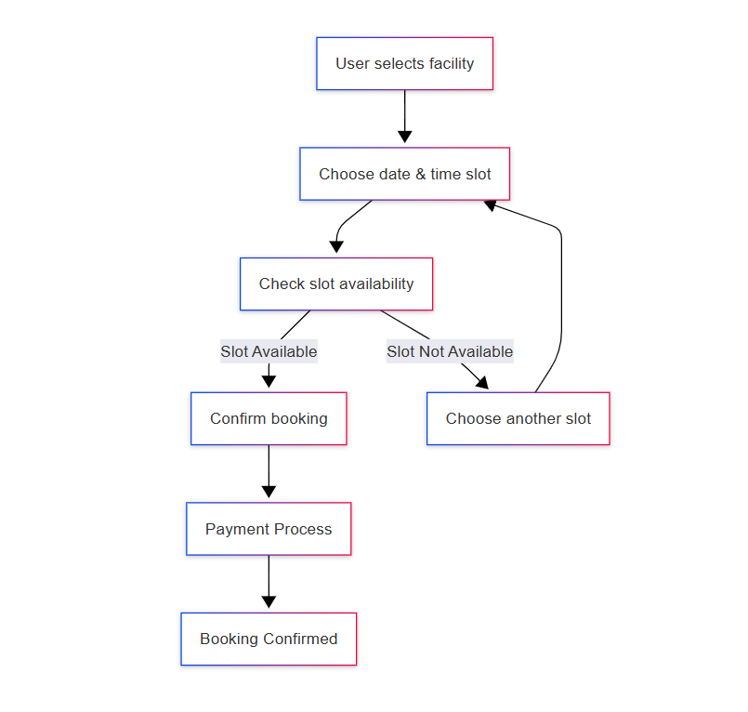

b. Facility Management by Owner
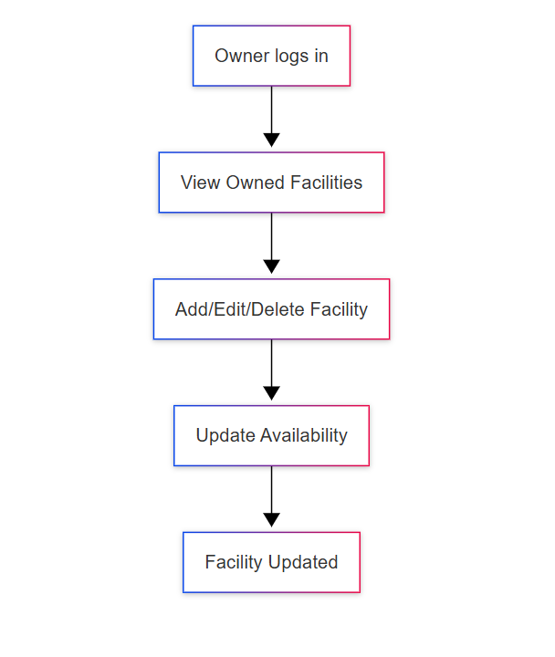

c. User Registration & Authentication
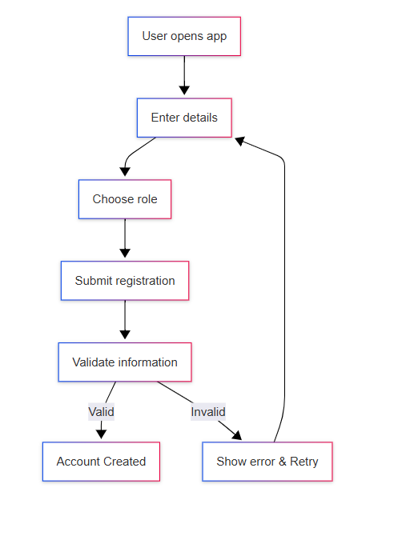

2. Use Case Diagram
User stories defined in previous submission

3. Sequence Diagrams
The following sequence diagrams represent the interactions between system components for three main activities:

a. Facility Booking Sequence
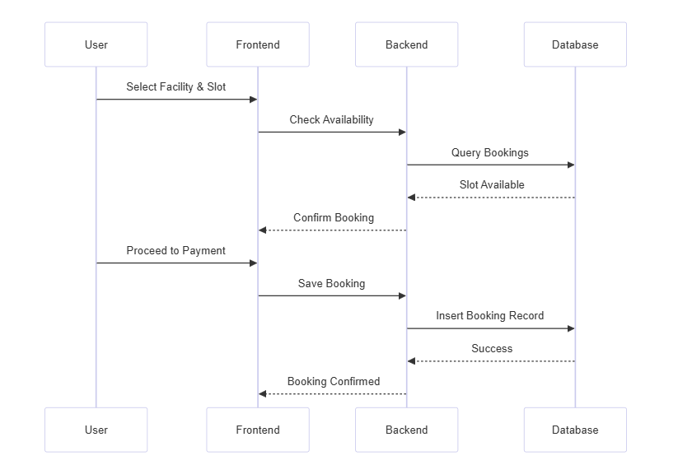

b. Facility Management by Owner
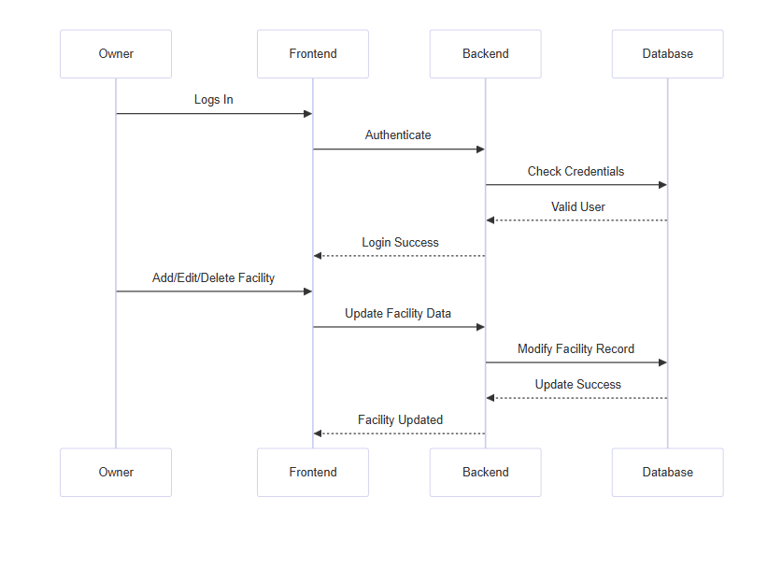

c. User Registration & Login
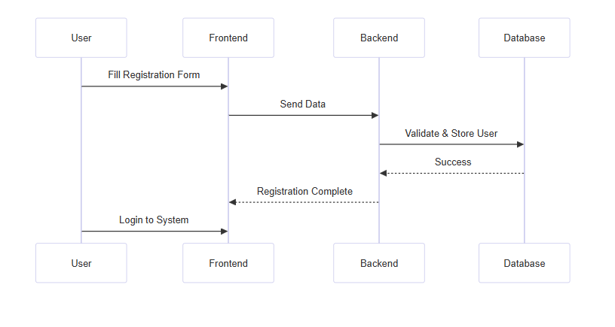

4. Class Diagram
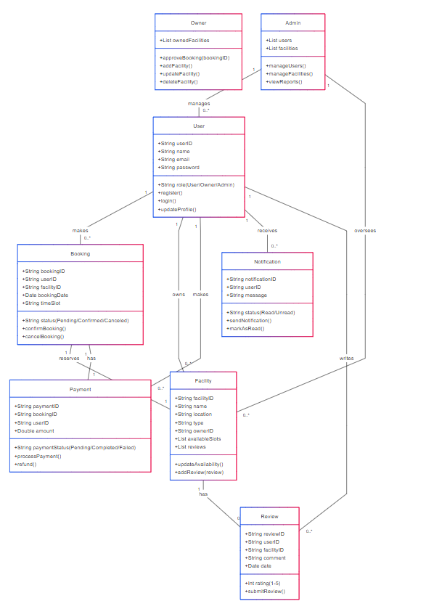

5. GitHub Repository & Trello Board Snapshots
- GitHub Repository Link: https://github.com/abdulmomin2003/Sports-Space.git
- GitHub Screenshot:
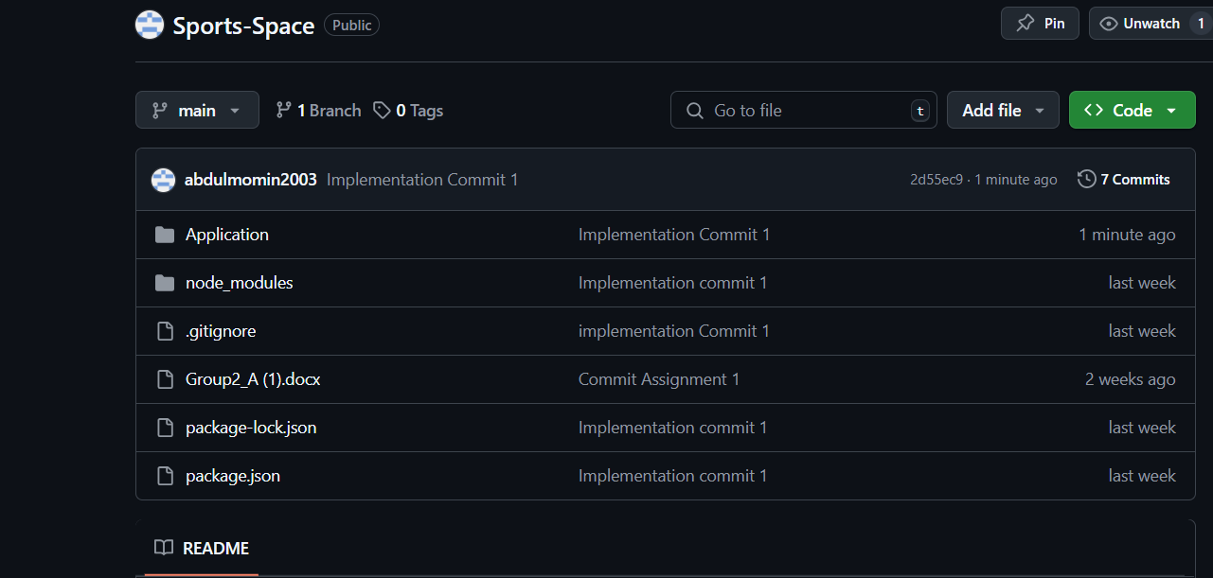
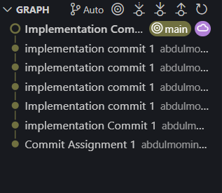
- Trello Board Snapshots:
Snapshot 1: Product Backlog
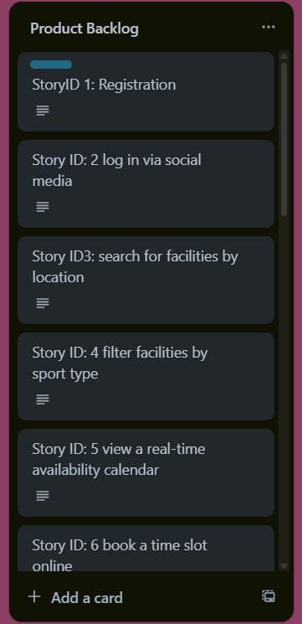

Snapshot 2: Sprint Backlog (with tasks for this iteration)
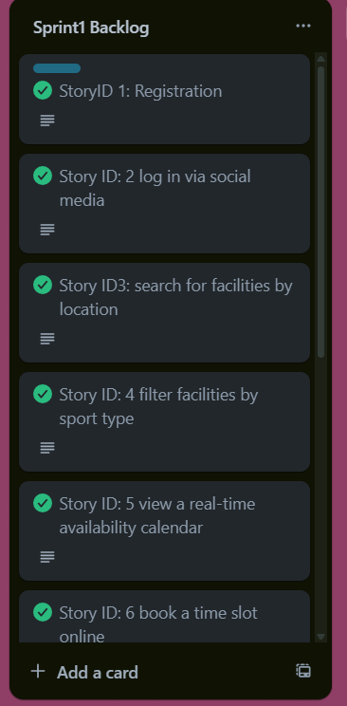

Snapshot 3: Next Sprint Backlog
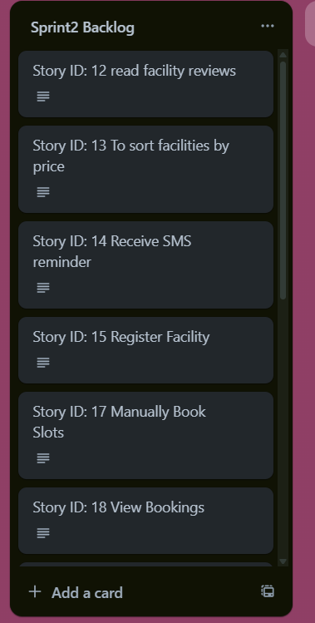

Design

Activity Diagrams
- Booking Facility

- Manage Facility

- Register User

