NUMERICAL METHODS – FLOWCHARTS

1. Secant Method
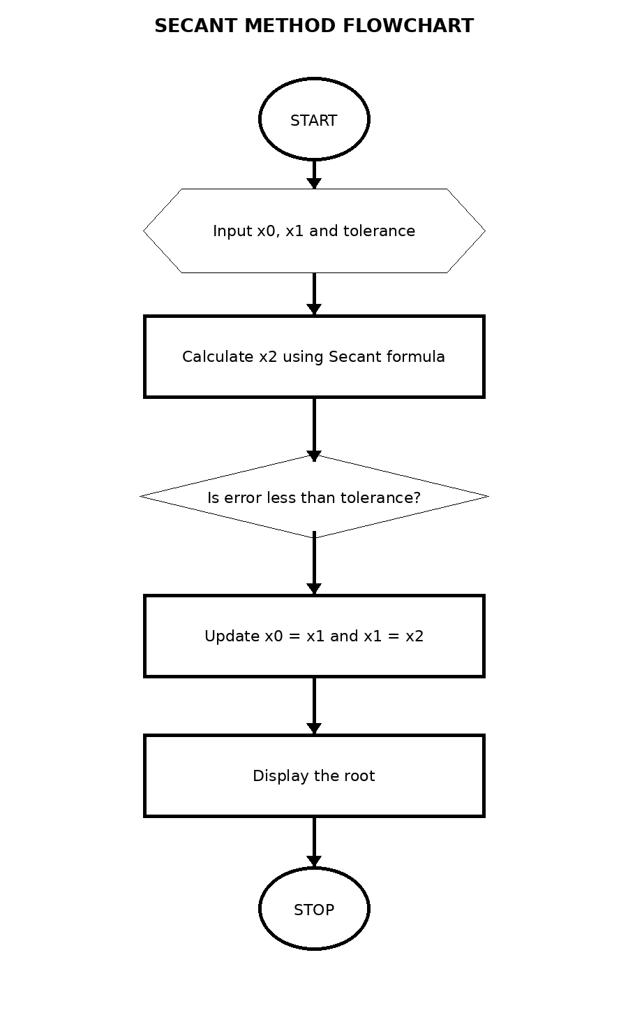

2. Newton–Raphson Method
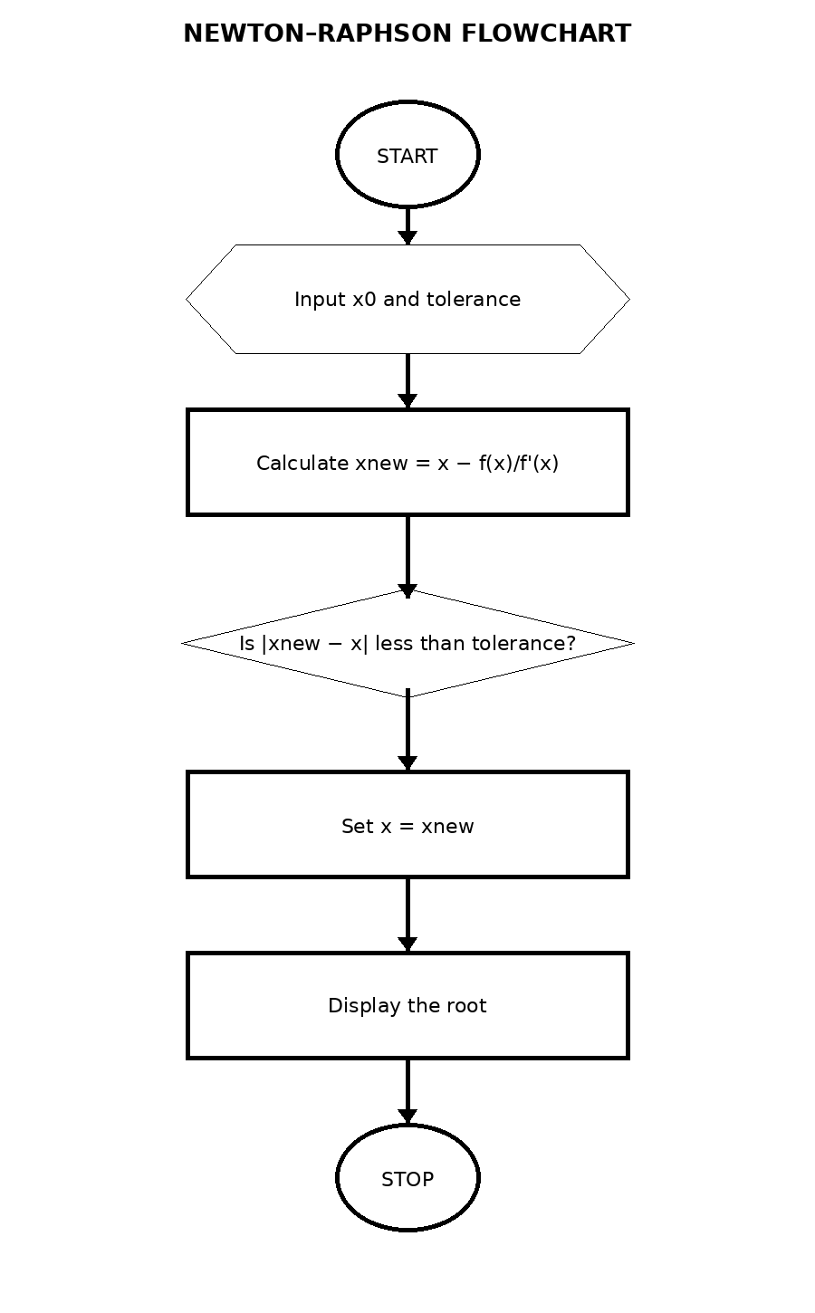

3. Runge–Kutta 4th Order
