Car Dealership Installment Management System

Abstract.
The Car Dealership Installment Management System is C++ based system designed to manage the sales of cars through installment plans. This system will manage different categories of cars, installment plans, customer information, payment records, contracts. The customer will be able to select a desired installment plan according to the car category and payment duration. This project will demonstrate the major concepts of Object Oriented Programming including encapsulation, inheritance, polymorphism, abstraction. File handling is also used to store data.

Objectives.
- To provide different installment plans in accordance with car categories to customers.
- A digital system to manage the car sales through installments.
- To manage different car categories.
- A system to calculate down payments, monthly installment, remaining balance.
- To maintain payment and customer record.

Team.

MUHAMMAD ABDULLAH NAEEM | FA25-BEE-026
ABDULLAH BIN ALTAF | FA25-BEE-023
ABDUL MUQEET | FA25-BEE-018

Motivation.
It is difficult for a car dealership to manage customer record and installment calculation, plans, vehicle availability record. So our system is a software based system that will aim to provide dealership a computerized solution to maintain their operations. In this way our project also indicates that how OOPS concepts can be applicable to practical real word problem.

High Level Design.
- High level design shows the clear composition of project.
- Our project will consist of the following main components.

Car management.
Stores and manages customer information like name, CNIC, cell number, etc.

Installment plan management.
It tells different installment plans to the customer according to their desired selected car in accordance with the car category, down payment , monthly instalment.

Contract management.
Connects a customer with selected plan and car and maintains the purchase agreement.

Payment management.
It manages the installment payments the available balance of the specific customer.

File management.
This part stores and retrieves cars, customer, payment records using the files.

User interface.
This is the main interface at which dealership staff can perform operations such as adding cars , registering customer, creating delas, managing payments , searching records, viewing information.
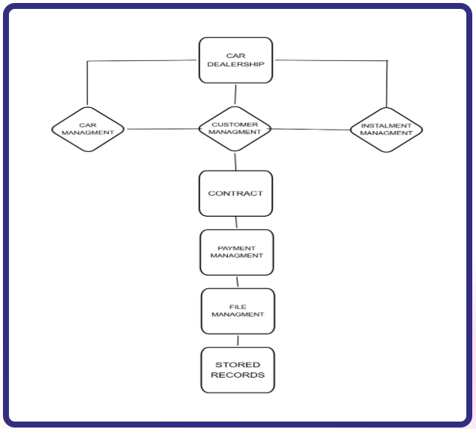

Block Diagram.

Tools.
- IDE: Code::Blocks
- UML: draw.io
- Version control: GitHub
- Data storage: C++ file handling

Gantt Chart.

Week 1 | UML / Class Design
Week 2 | Installment & Payment system / core work
Week 3 | File Handling & Managing All Data
Week 4 | Testing & checking for proper Functioning
Week 5 | Presentation & Final Integration

