**Admin Functions Testing**

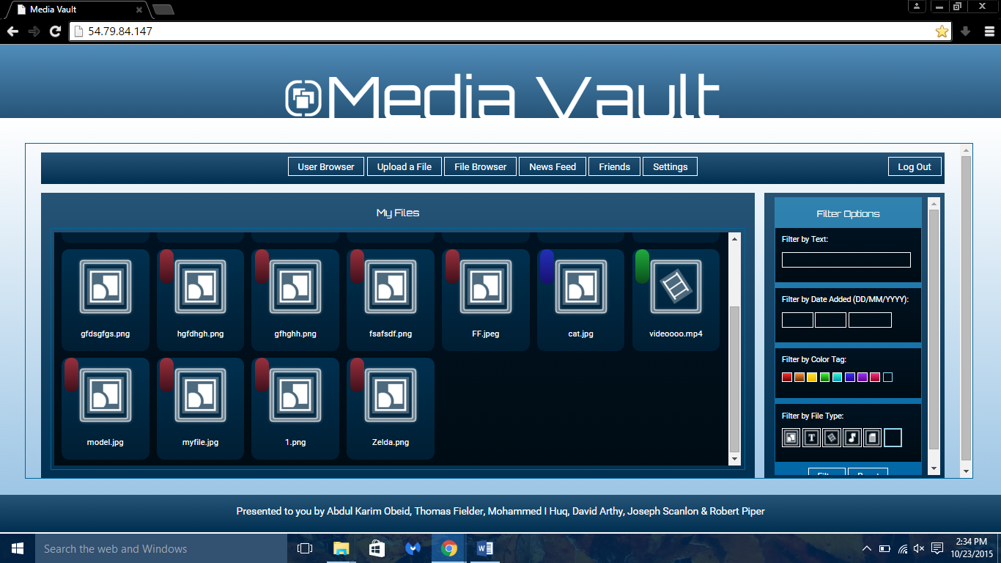

1. View All Users:

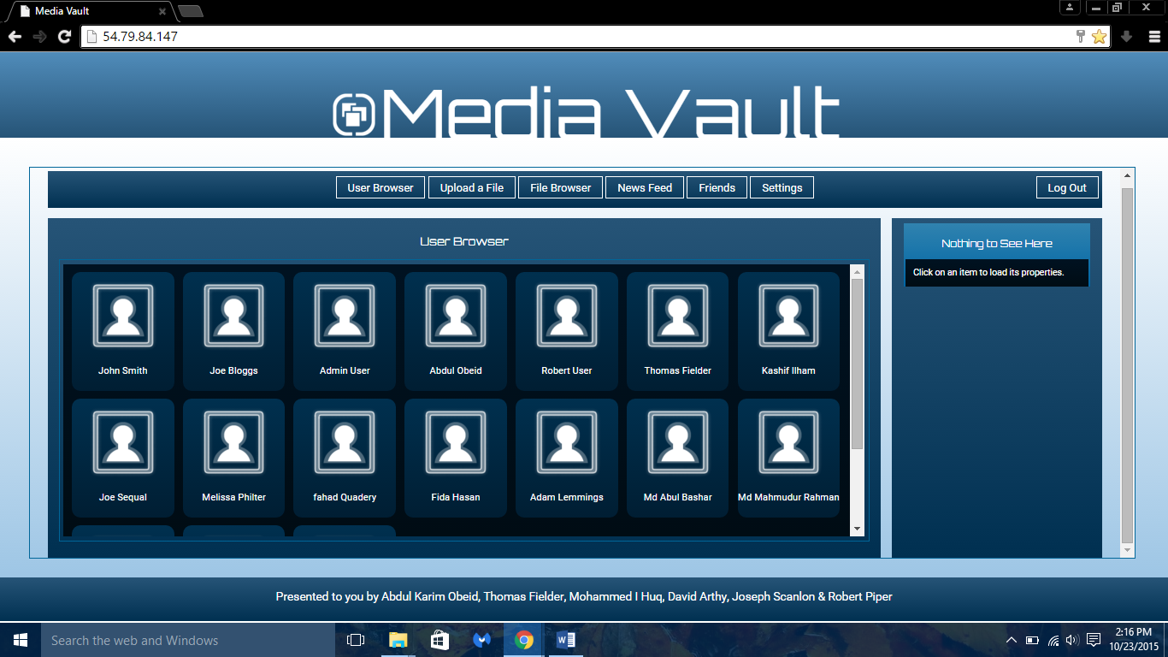

Viewing all users registered in the website.

1. User Editing:

* Selecting an user

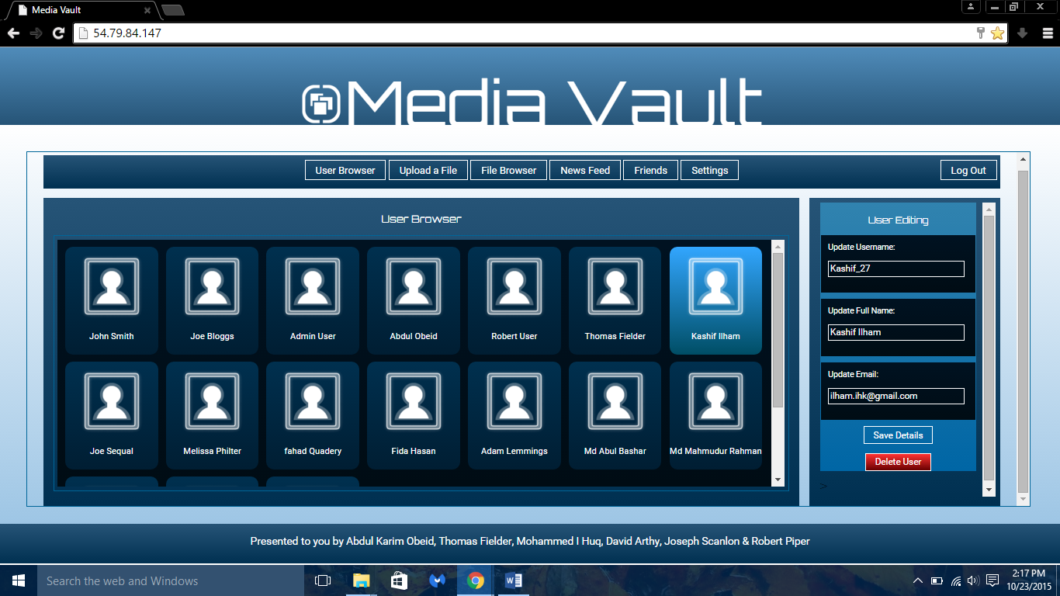

* Changing the details

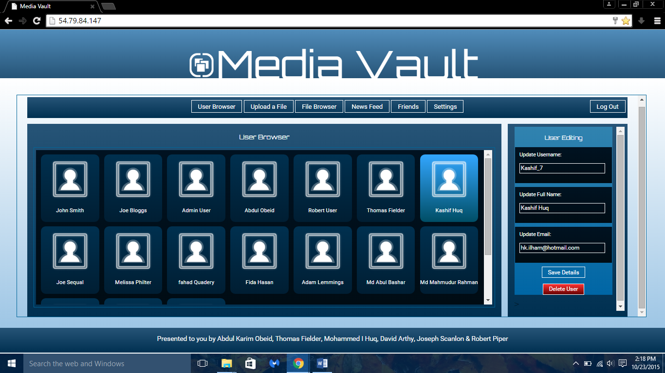

1. User’s file editing:

* Changing user file details, which due to wrong extension was not viewable.

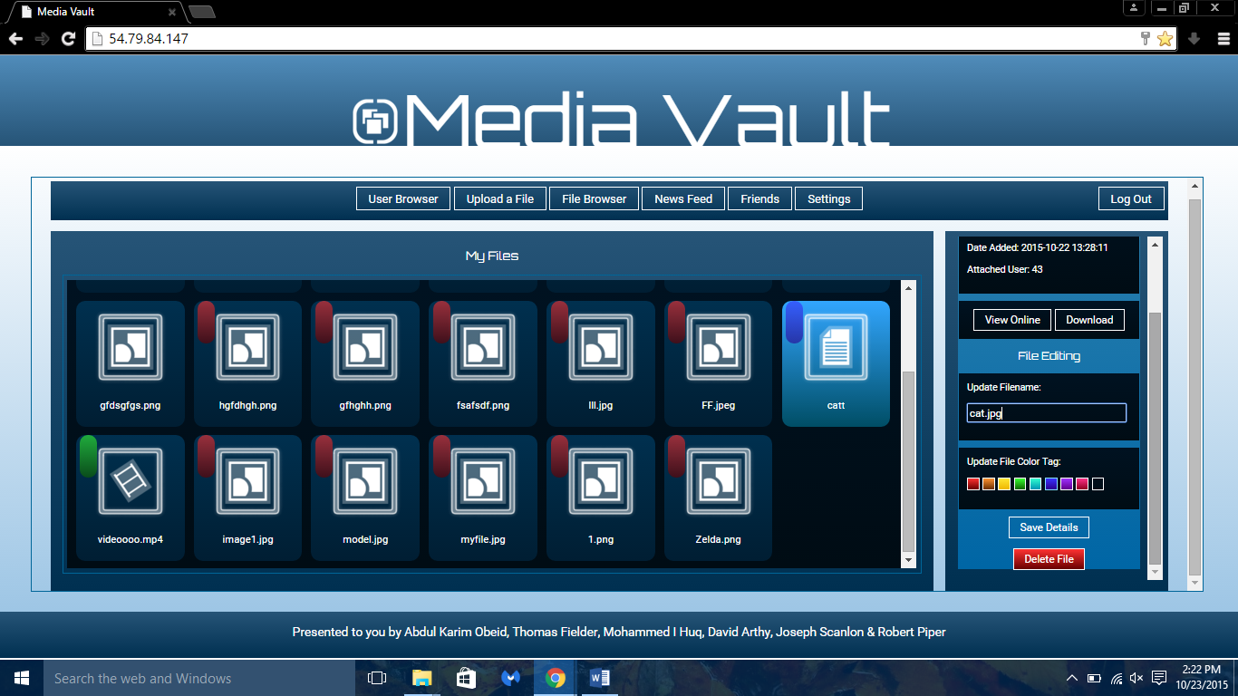

* User file viewing after editing

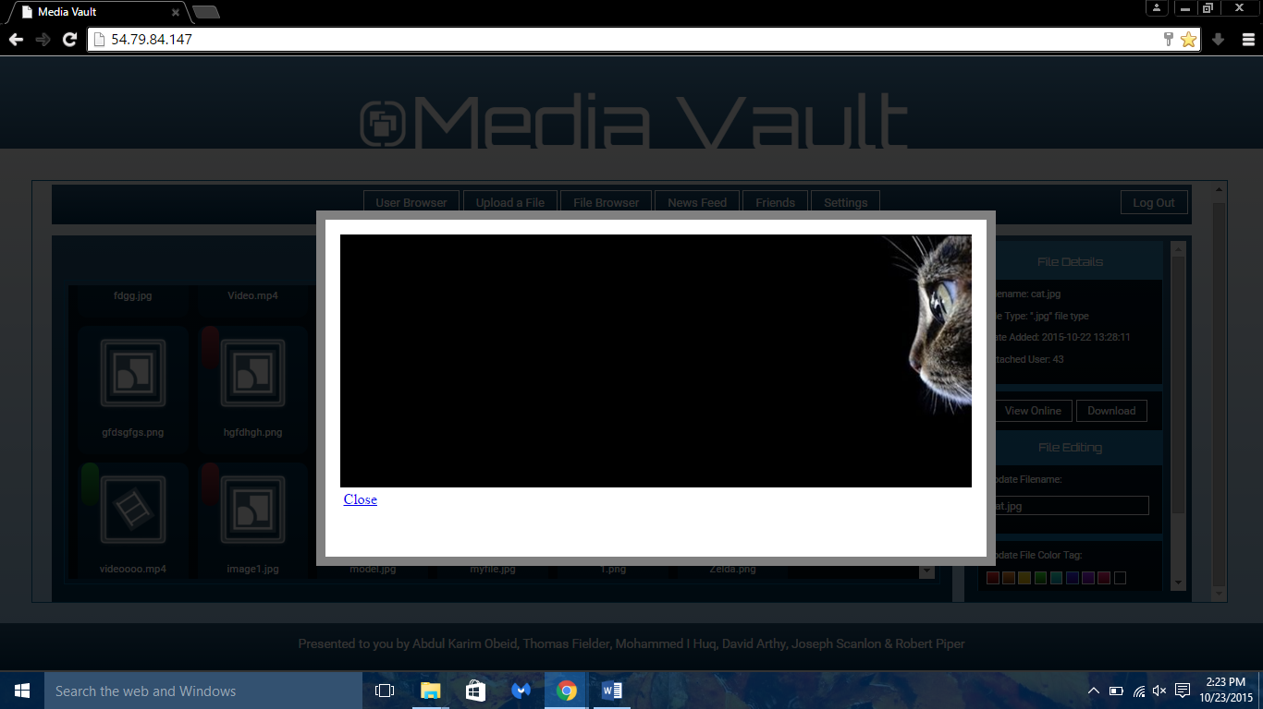

1. News Feed:

* Admin newsfeed

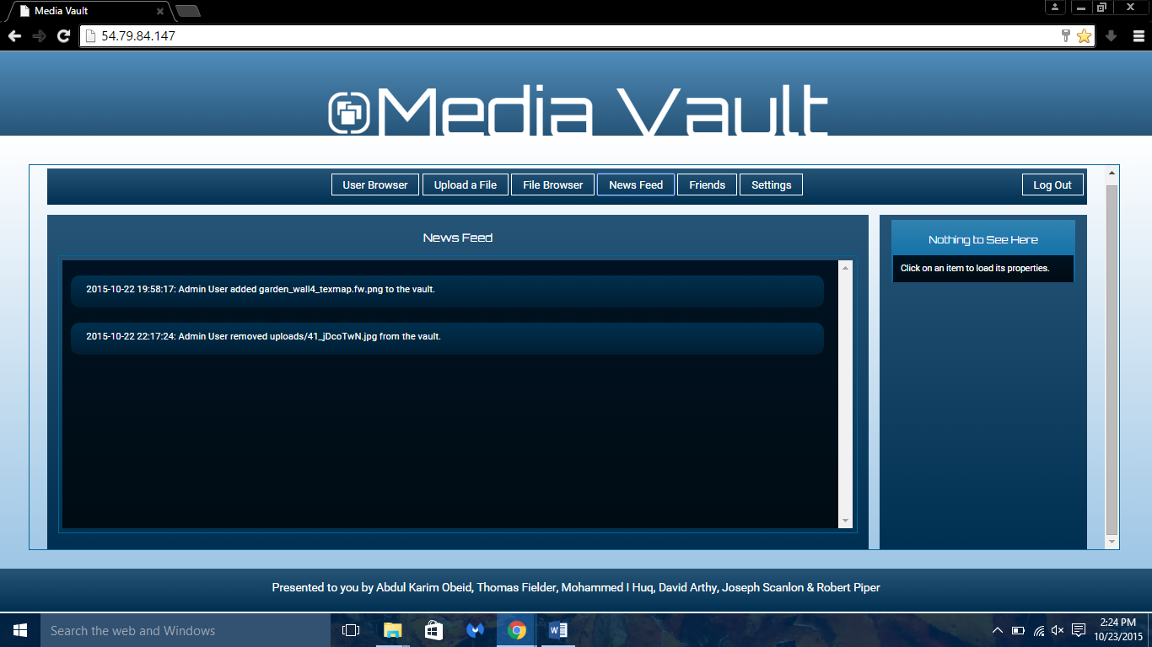

1. User Deletion Warning:

* Admin will have to confirm again before deleting an user.

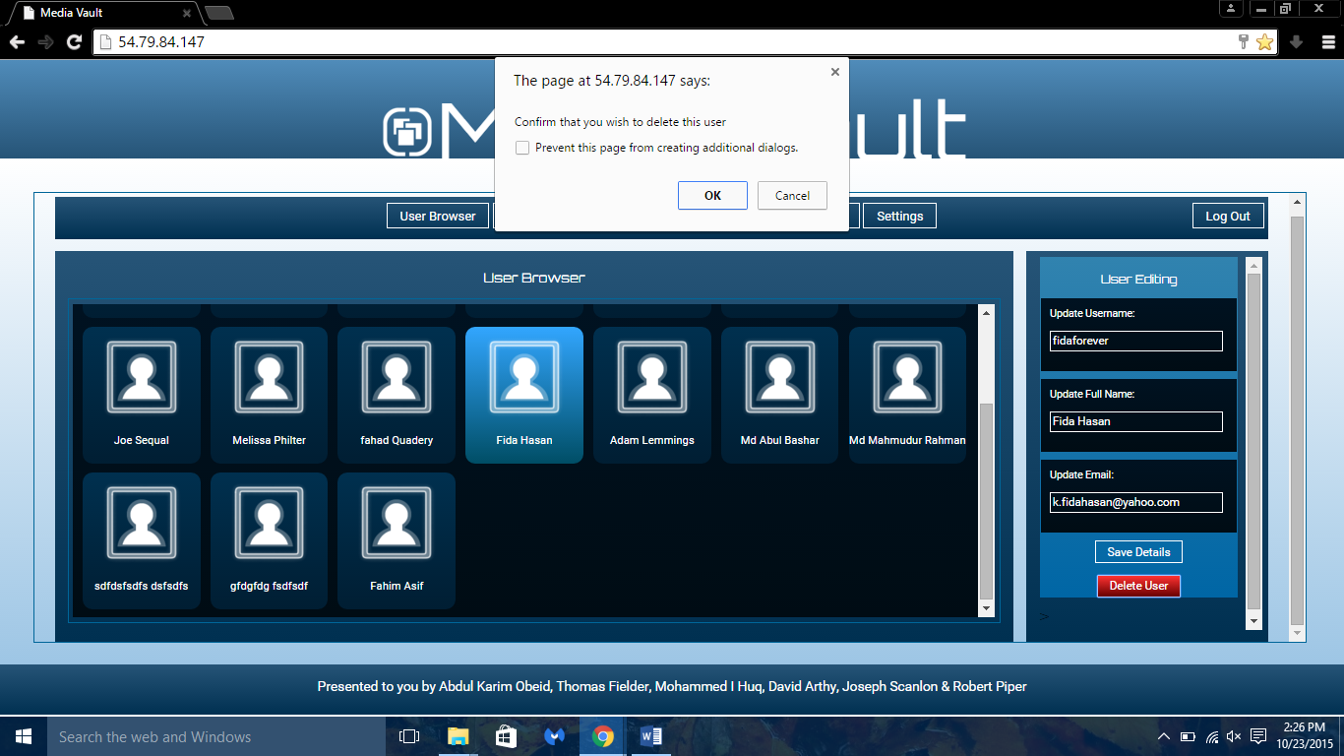

1. File Deletion

* Same as user deletion, will have to re-confirm for user’s file deletion.

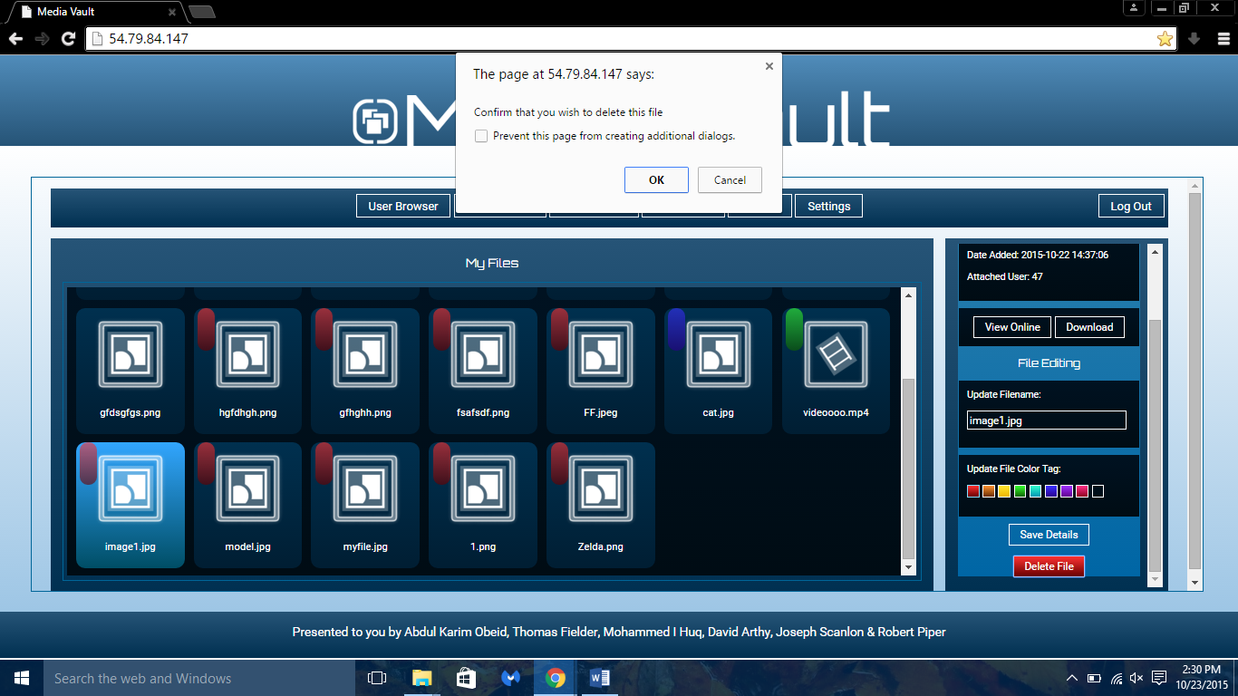

* File Successfully Deleted

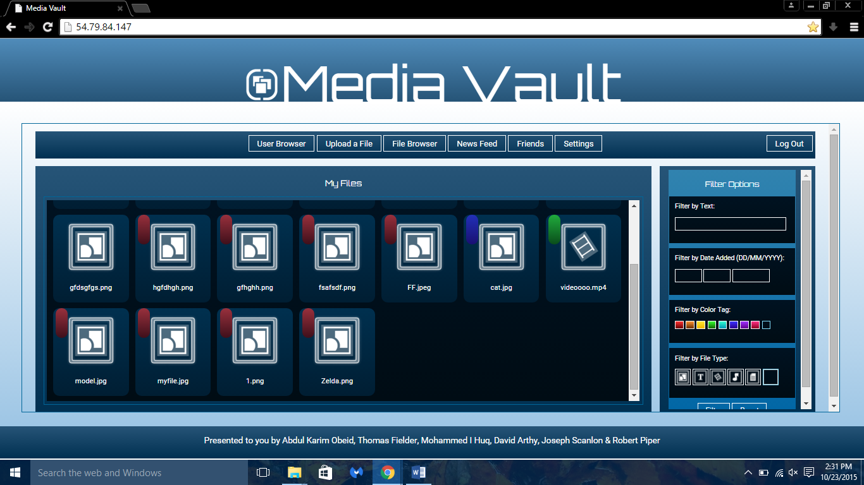

1. Friend Acquisition

* Adding a friend to an admin account.

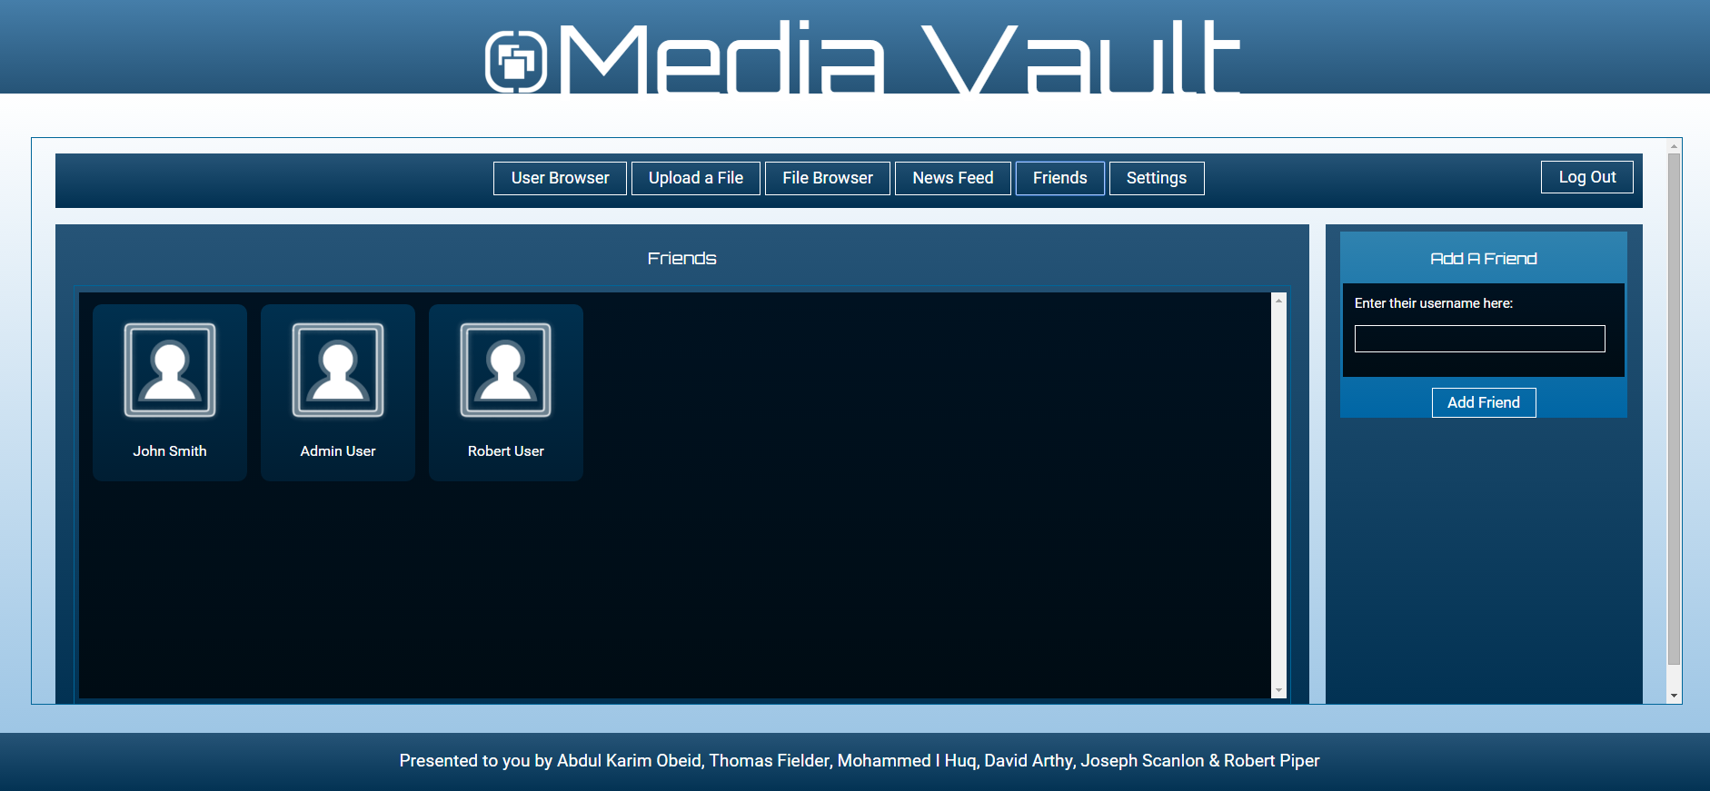

* Friend Successfully Added

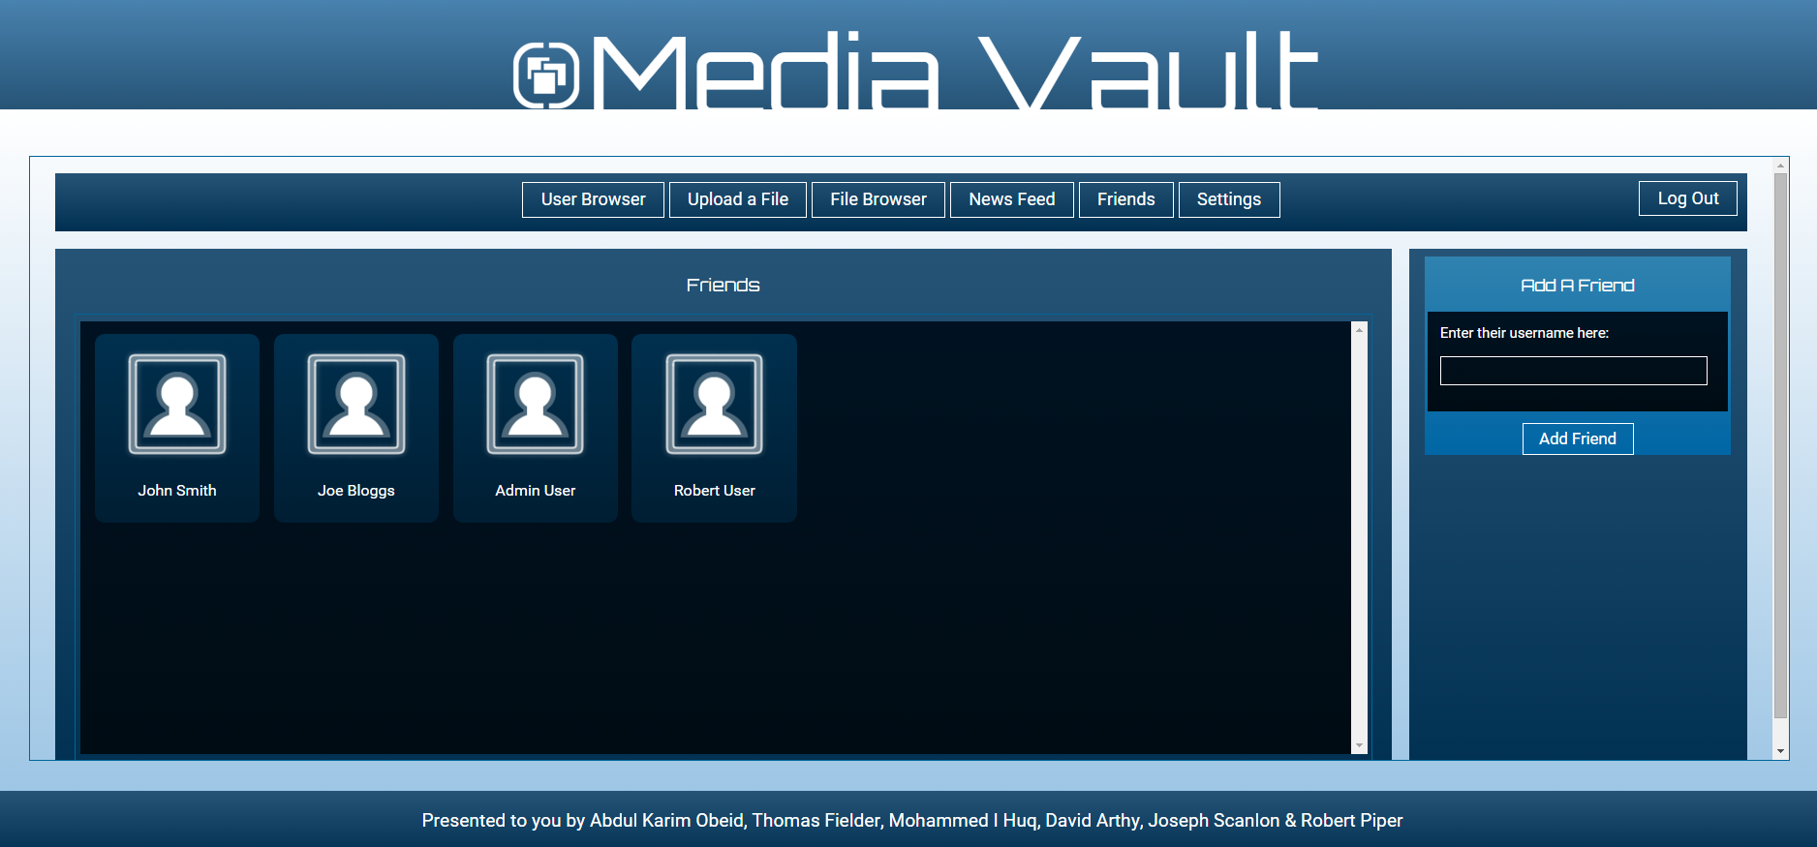

1. Friend Deletion

* Removal of existing friends

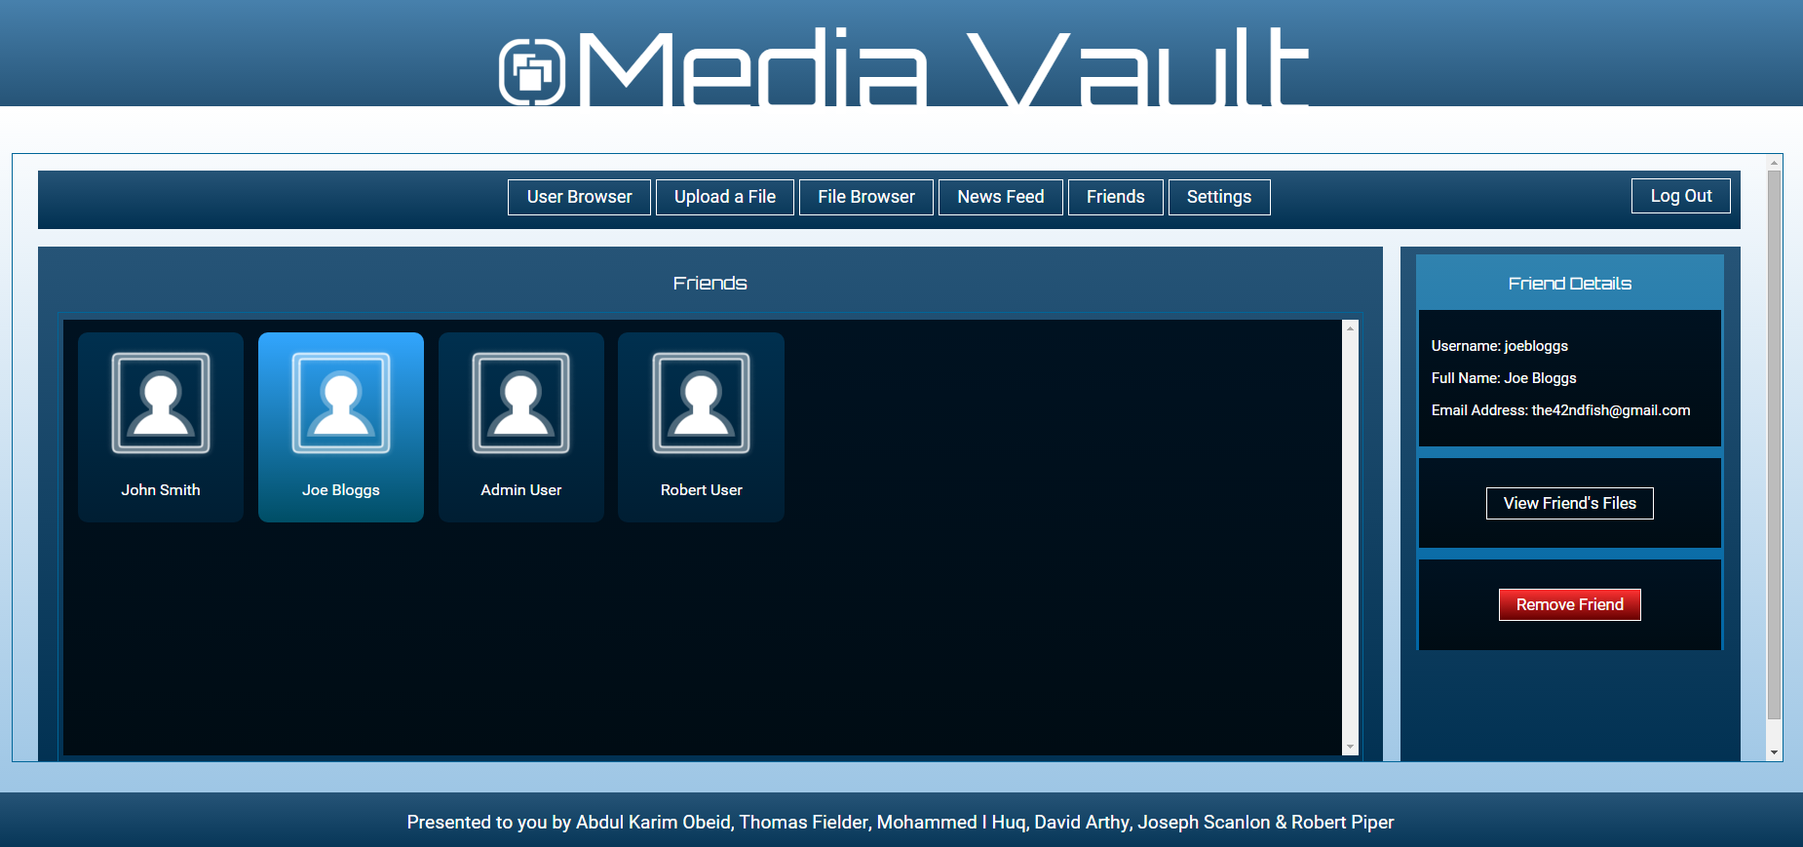

* Friend Deletion Successful

