5
Selected Features (Once): ['Digitalpulses', 'LERF', 'LELF', 'LERH', 'LELH']
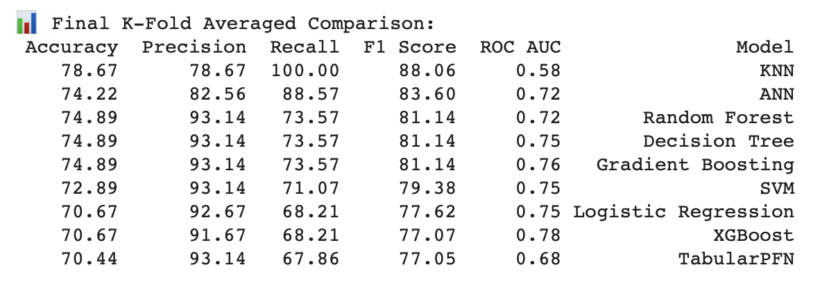

6
Selected Features (Once): ['Digitalpulses', 'WidthRF', 'LERF', 'LELF', 'LERH', 'LELH']
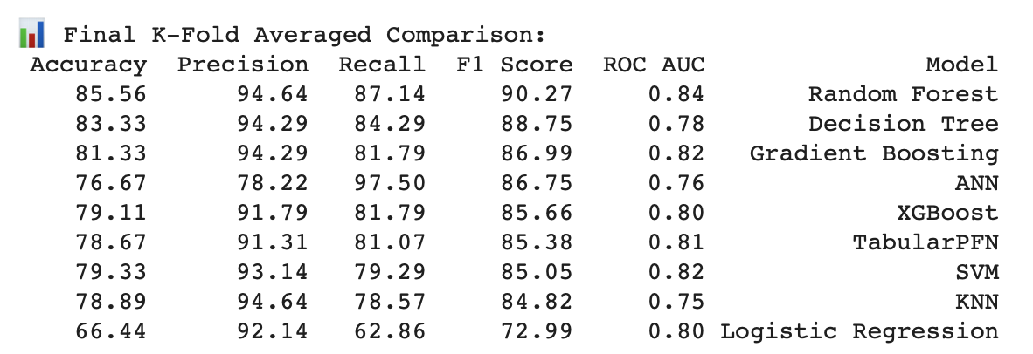
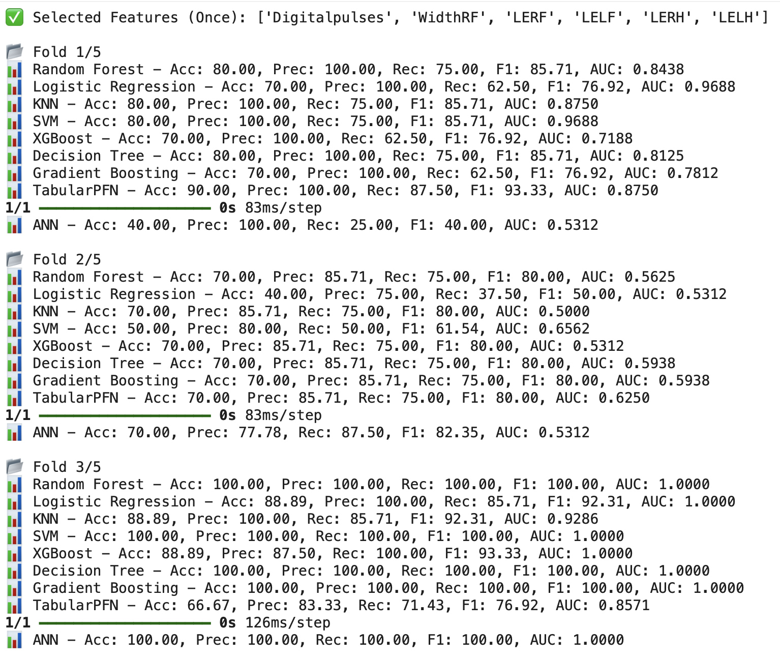
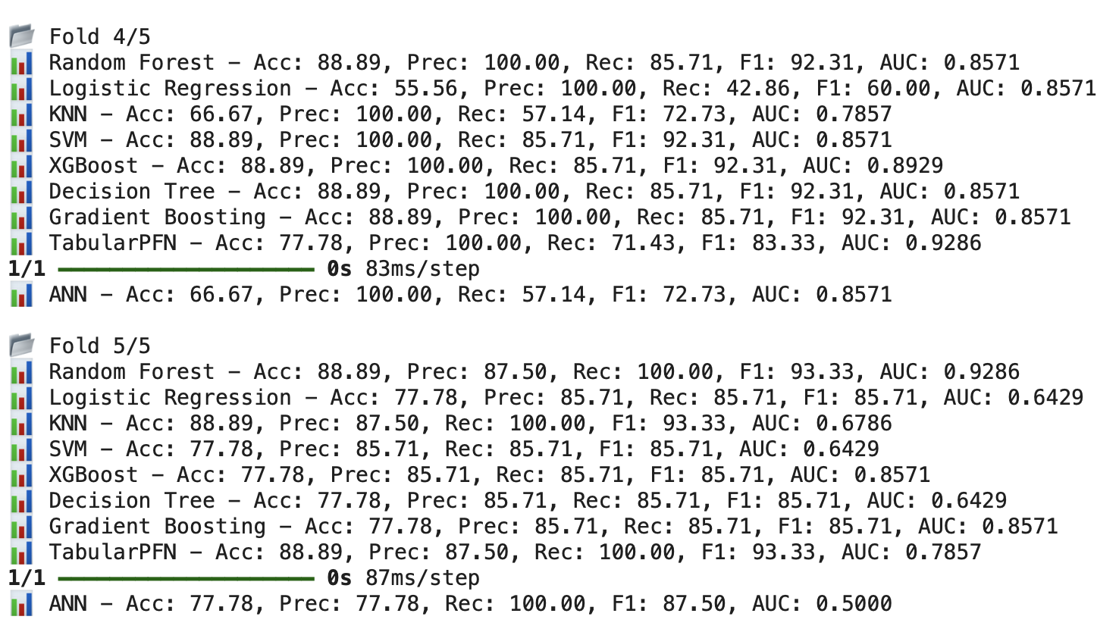

7
Selected Features (Once): ['Digitalpulses', 'WidthRF', 'WidthLF', 'LERF', 'LELF', 'LERH', 'LELH']
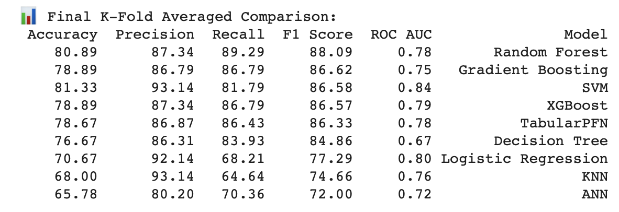

8
Selected Features (Once): ['Age(years)', 'Digitalpulses', 'WidthRF', 'WidthLF', 'LERF', 'LELF', 'LERH', 'LELH']
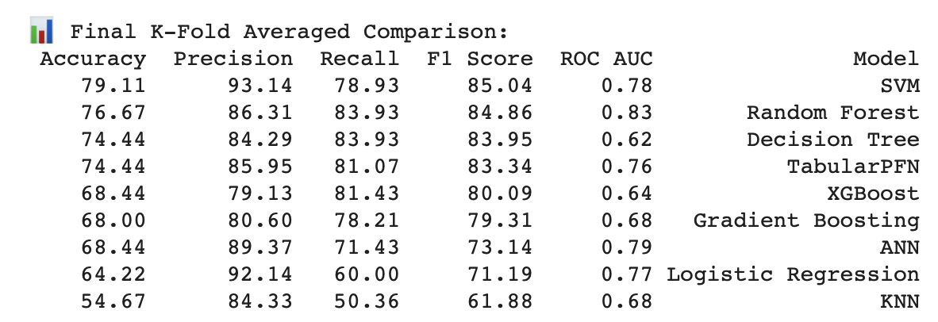
9
✅ Selected Features (Once): ['Age(years)', 'Digitalpulses', 'LengthLH', 'WidthRF', 'WidthLF', 'LERF', 'LELF', 'LERH', 'LELH']
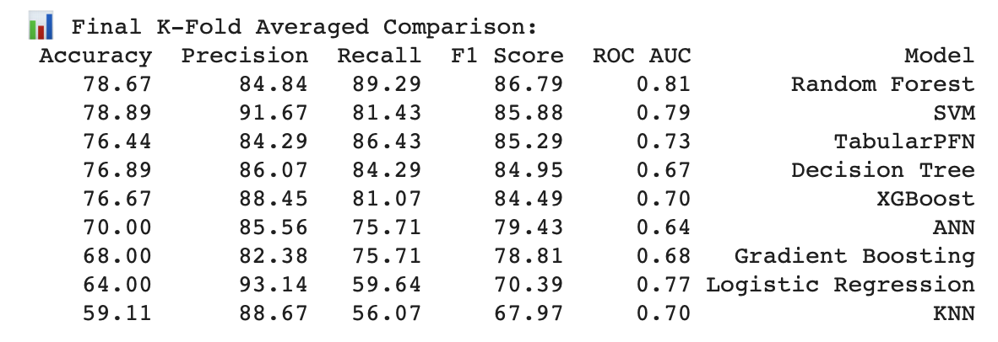
10
elected Features (Once): ['Age(years)', 'Digitalpulses', 'Bodyweight', 'LengthLH', 'WidthRF', 'WidthLF', 'LERF', 'LELF', 'LERH', 'LELH']
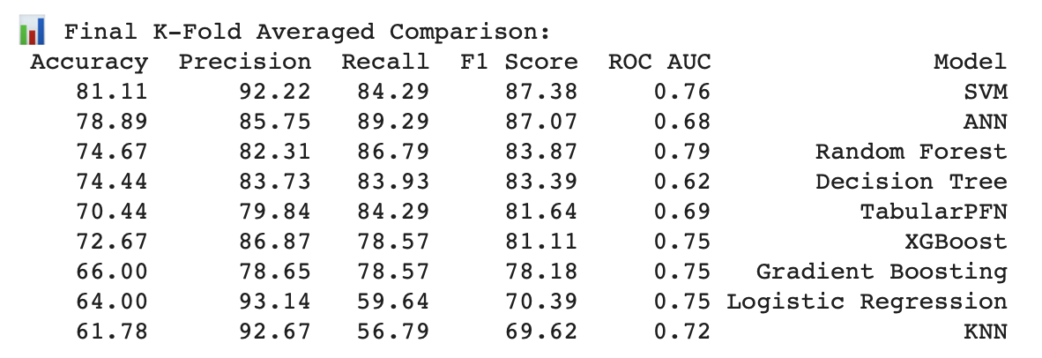

11
Selected Features (Once): ['Age(years)', 'Rectaltemperature', 'Digitalpulses', 'Bodyweight', 'LengthLH', 'WidthRF', 'WidthLF', 'LERF', 'LELF', 'LERH', 'LELH']
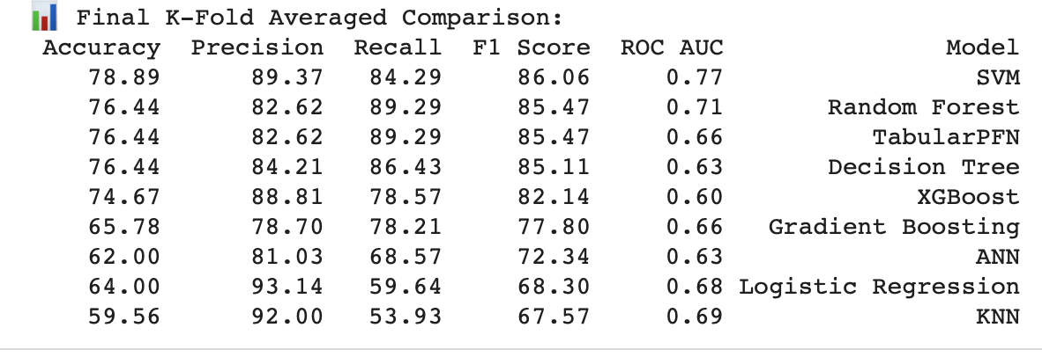
12
Selected Features (Once): ['Age(years)', 'Rectaltemperature', 'Gutsounds', 'Digitalpulses', 'Bodyweight', 'LengthLH', 'WidthRF', 'WidthLF', 'LERF', 'LELF', 'LERH', 'LELH']
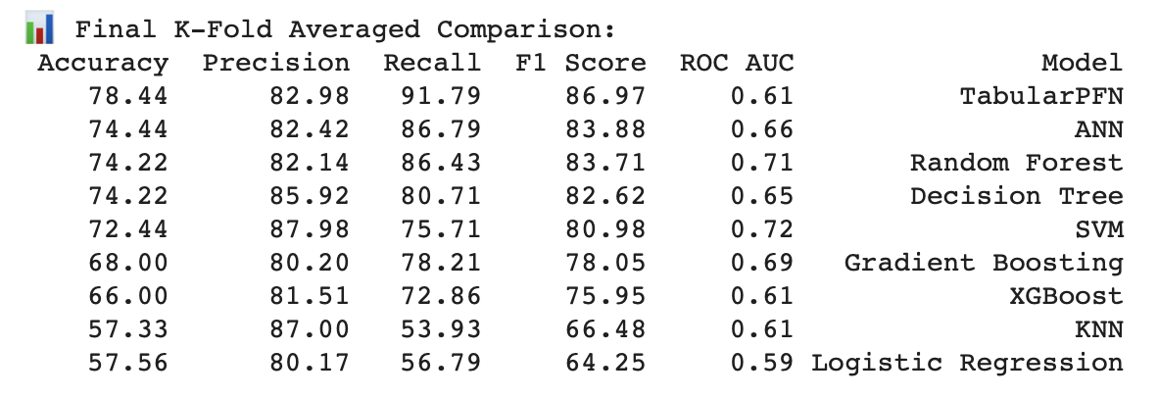
13
Selected Features (Once): ['Age(years)', 'Respiratoryrate', 'Rectaltemperature', 'Gutsounds', 'Digitalpulses', 'Bodyweight', 'LengthLH', 'WidthRF', 'WidthLF', 'LERF', 'LELF', 'LERH', 'LELH']
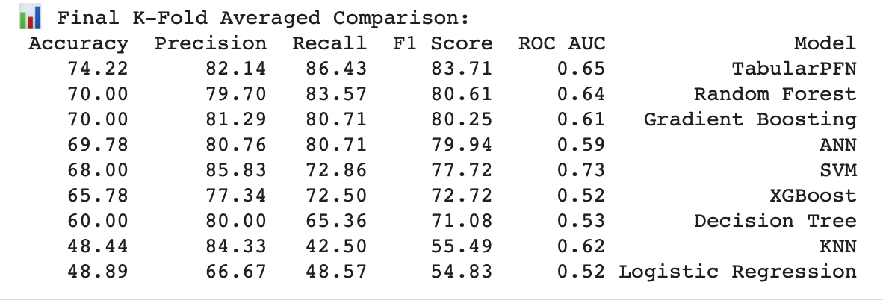
14
Selected Features (Once): ['Age(years)', 'Respiratoryrate', 'Rectaltemperature', 'Gutsounds', 'Digitalpulses', 'Bodyweight', 'BodyConditionScoring', 'LengthLH', 'WidthRF', 'WidthLF', 'LERF', 'LELF', 'LERH', 'LELH']
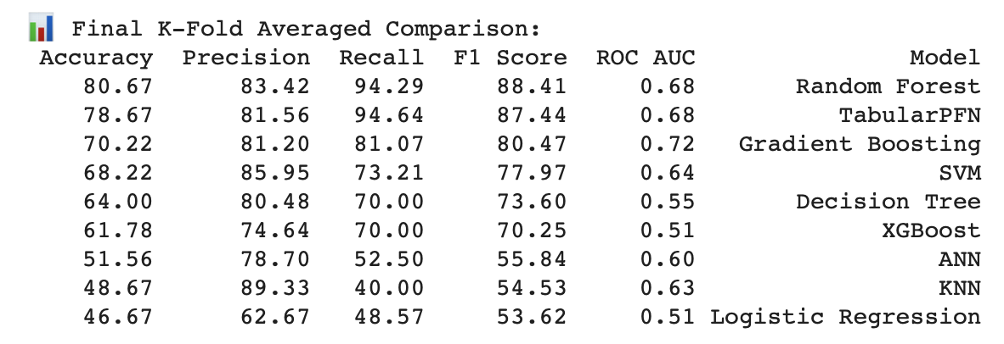
15
Selected Features (Once): ['Age(years)', 'HeartRate', 'Respiratoryrate', 'Rectaltemperature', 'Gutsounds', 'Digitalpulses', 'Bodyweight', 'BodyConditionScoring', 'LengthLH', 'WidthRF', 'WidthLF', 'LERF', 'LELF', 'LERH', 'LELH']
