Web_lab-4 (CSS Layout)

Name: Abdul Qudoos
CMS: 023-24-0233
Section: G

Task-1:
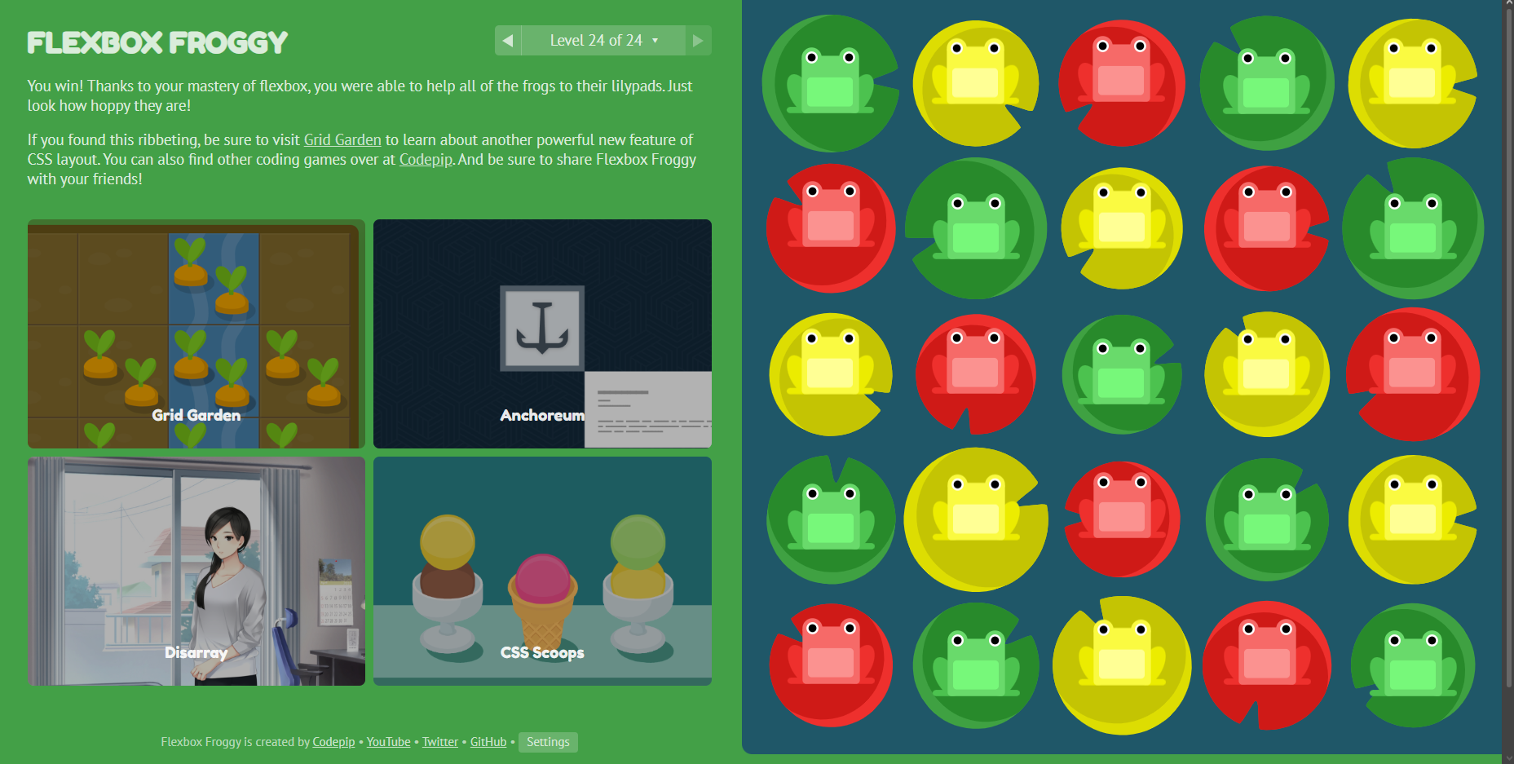

Task-2:
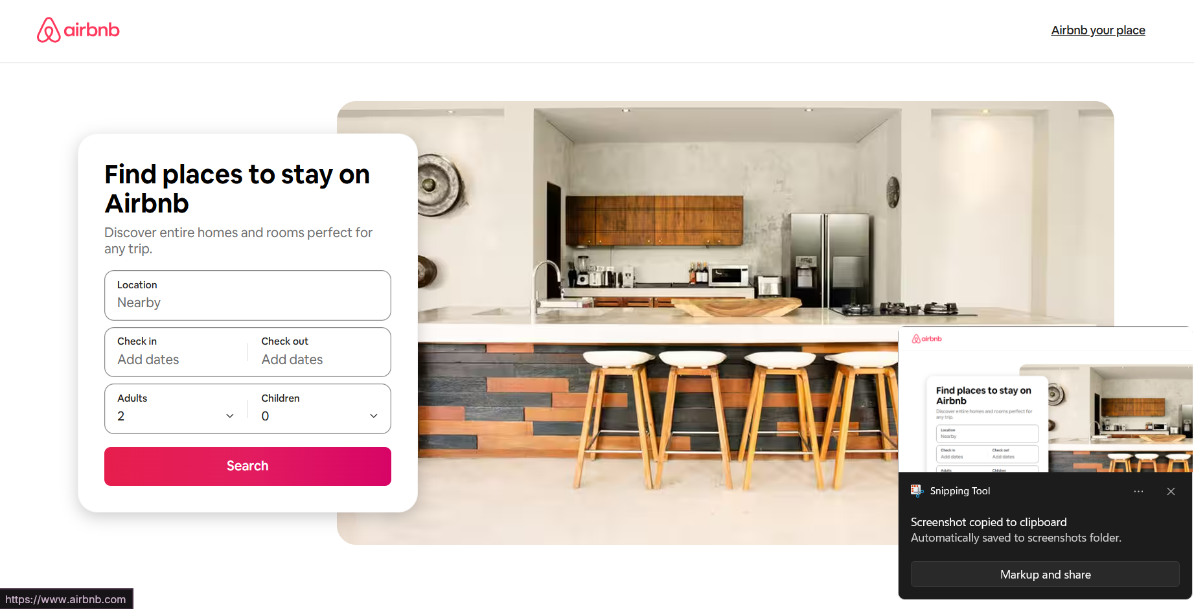

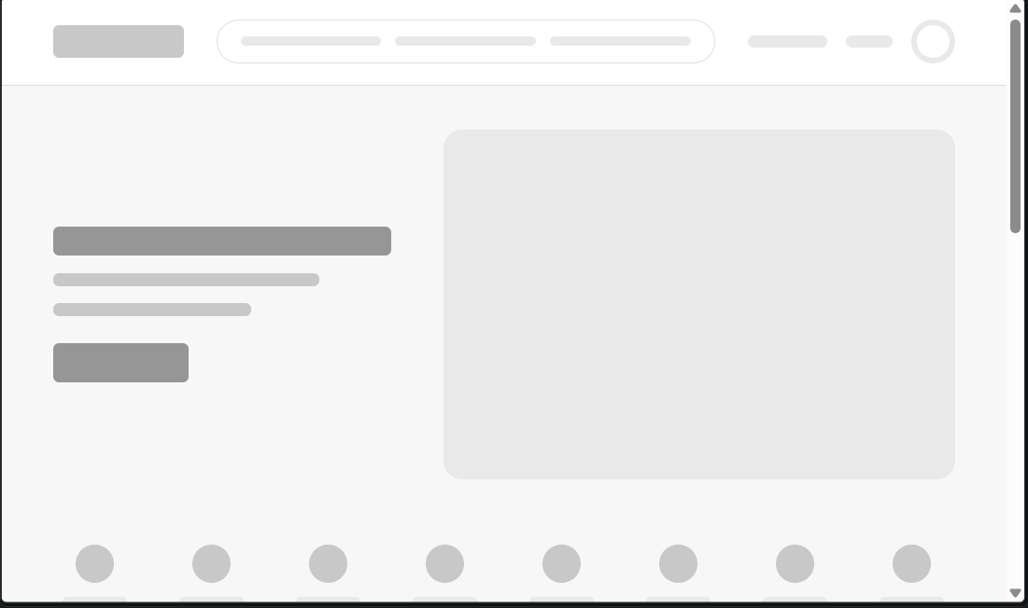

Task-3:
