Web-Lab-Activities:

Name: Abdul Qudoos
CMS: 023-24-0233
Section: G

1.
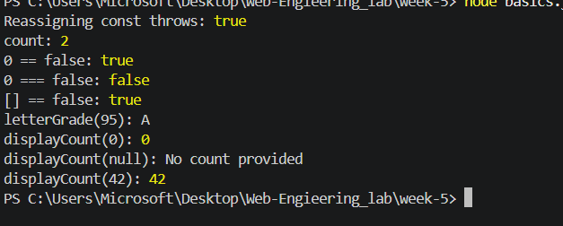

2.
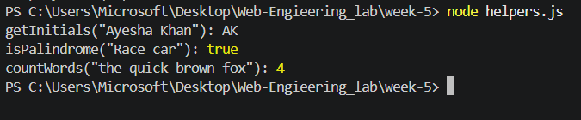

3.
