Web-lab-1
Name: Abdul Qudoos
CMS: 023-24-0233
Section: G

1.

2.
https://www.example.com:8080/products/search?category=shoes&color=black#reviews
Part | Value
Protocol | https
Host | www.example.com
Port | 8080
Path | /products/search
Query | category=shoes&color=black
Fragment | reviews

3.
Code 4xx: server side error:

Code 2xx: Successful
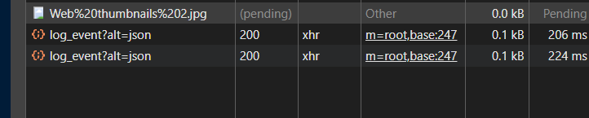

Code 3xx: Redirection

4.
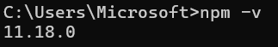
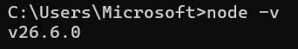

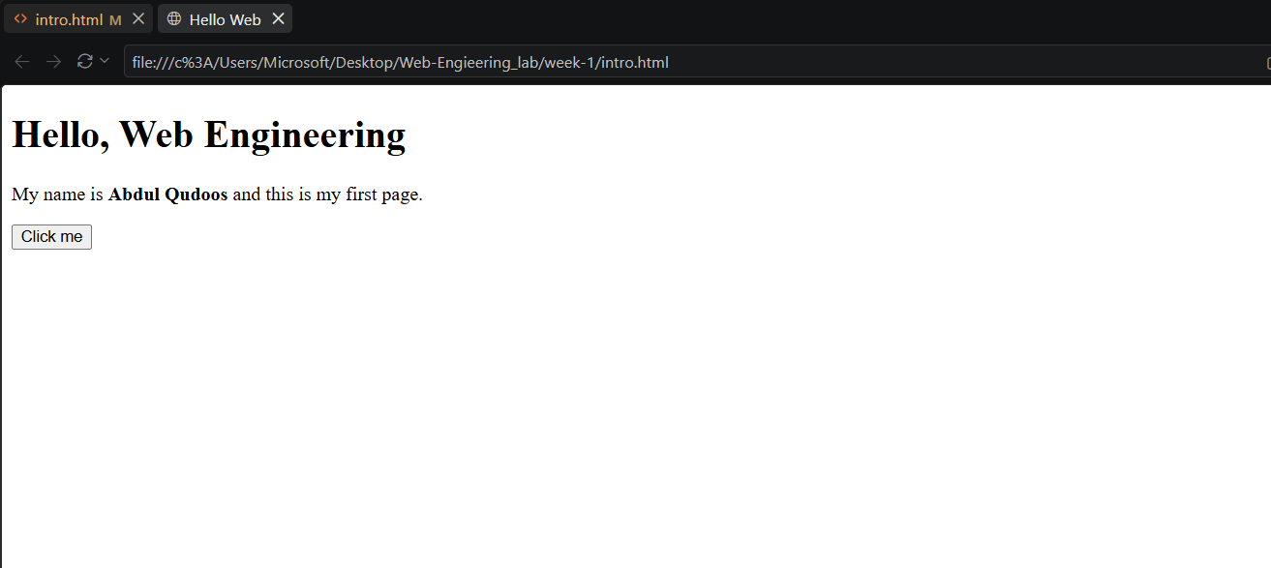
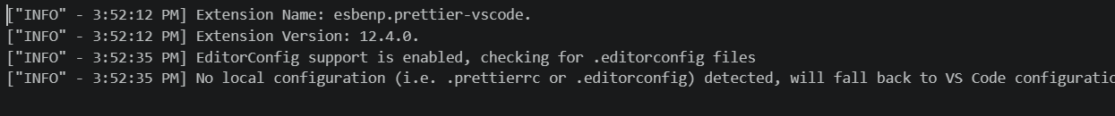

5.
