Web_lab-4

  - Name: Abdul Qudoos
  - CSM: 023-24-0233
  - Section: G

Class Activity A:
Before the flex box:
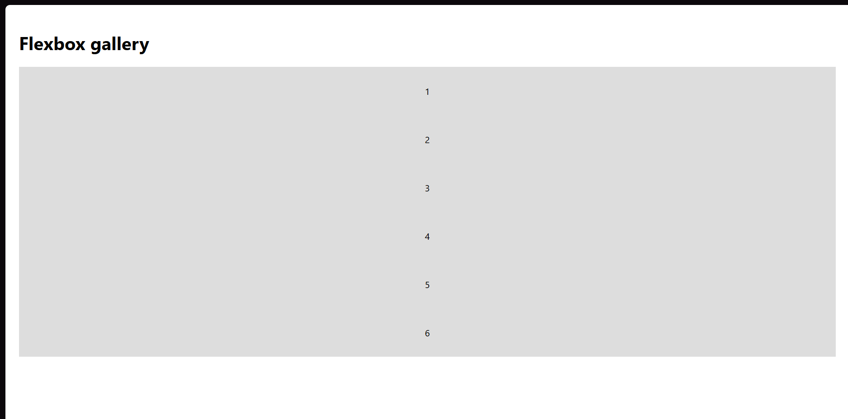

After:
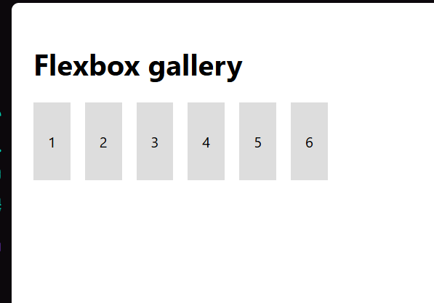

Class Activity B:
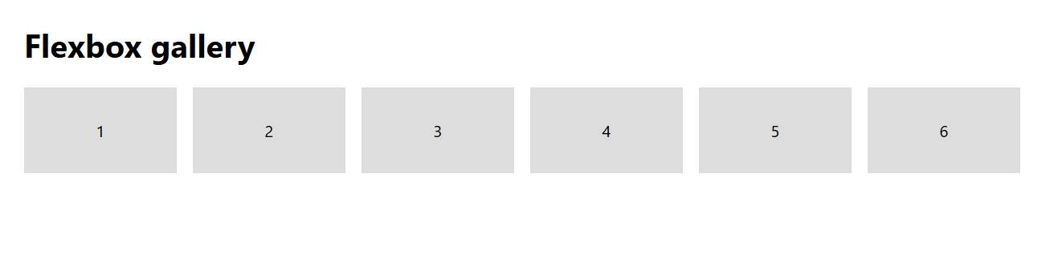
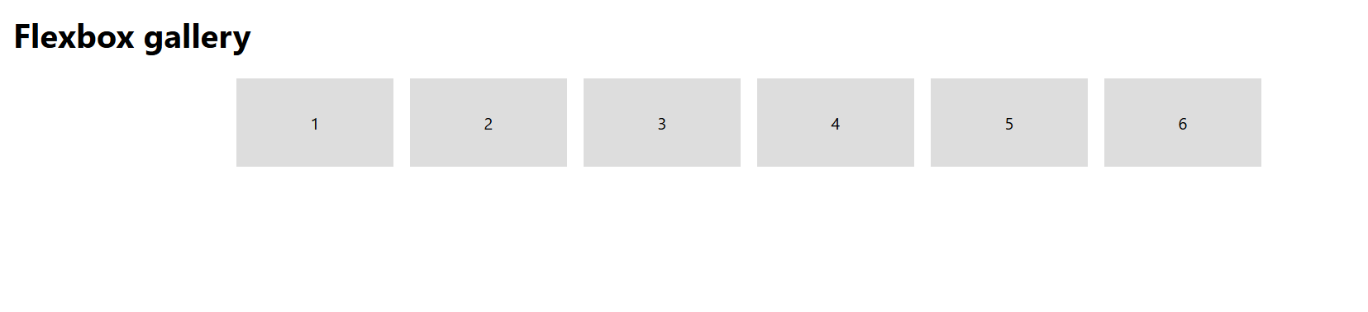


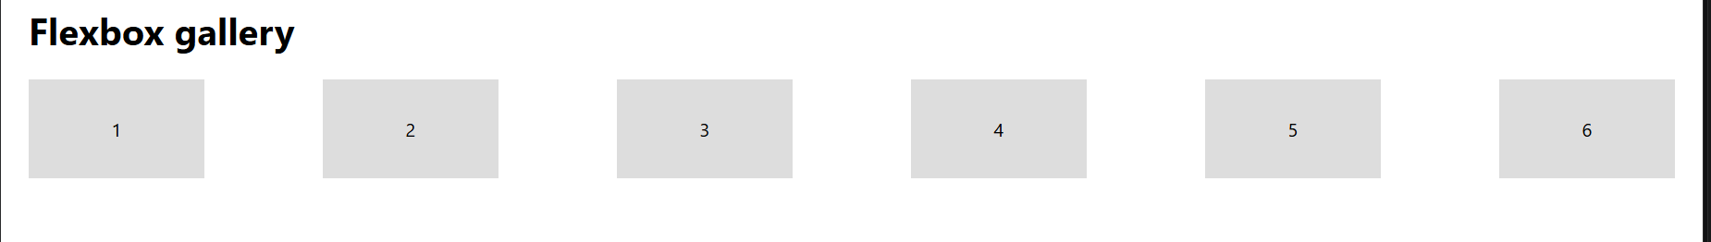
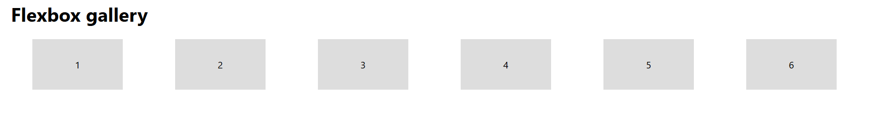
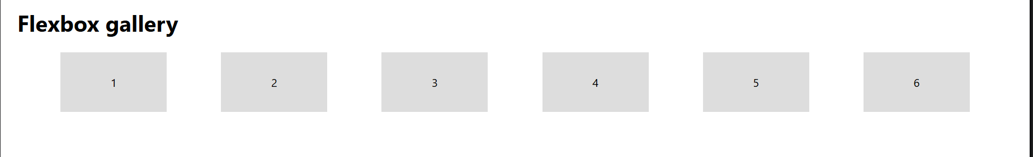

Class Activity C:
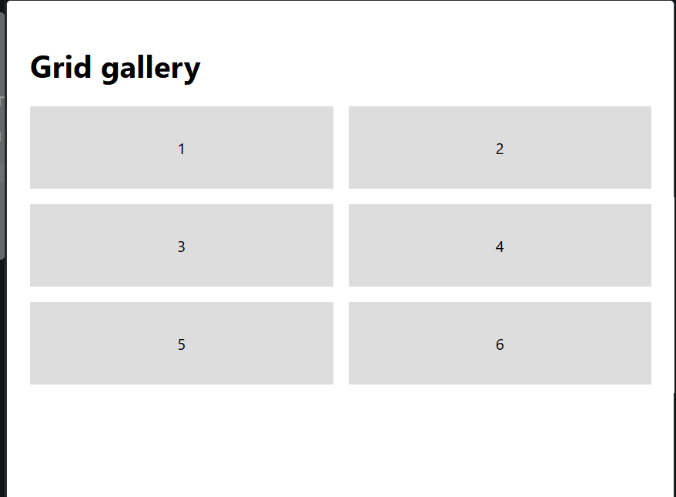
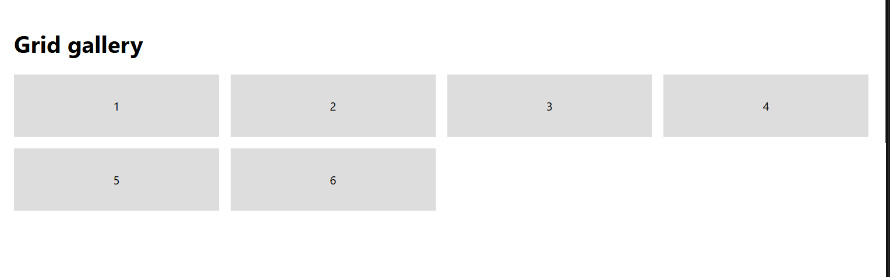

Class Activity D:
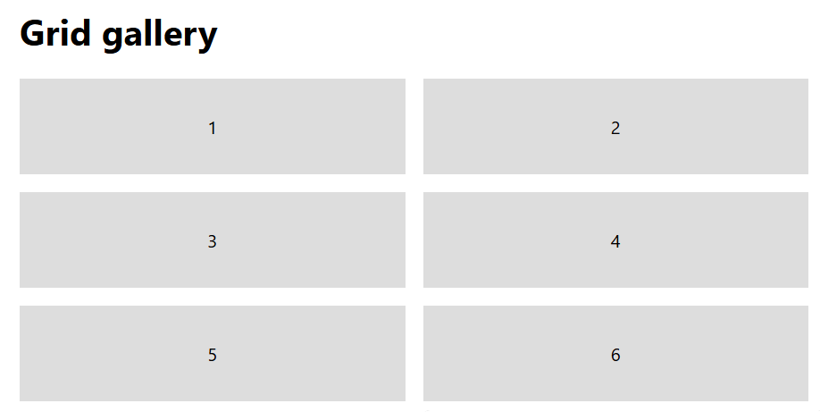
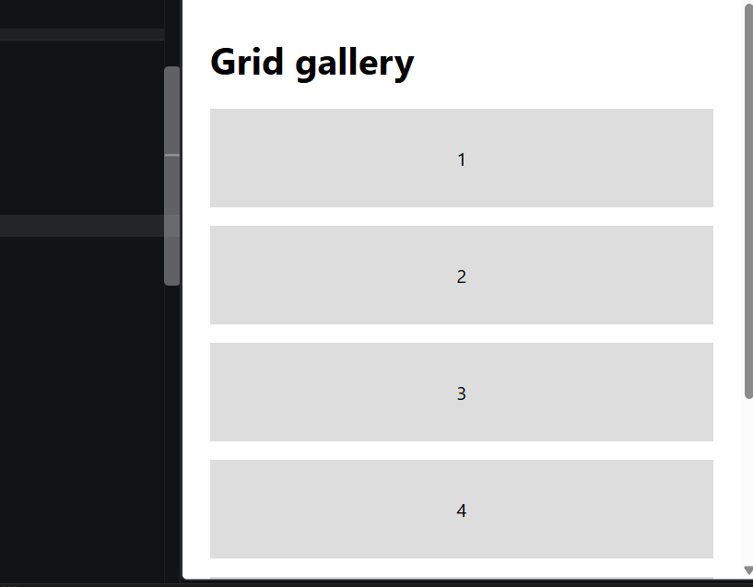
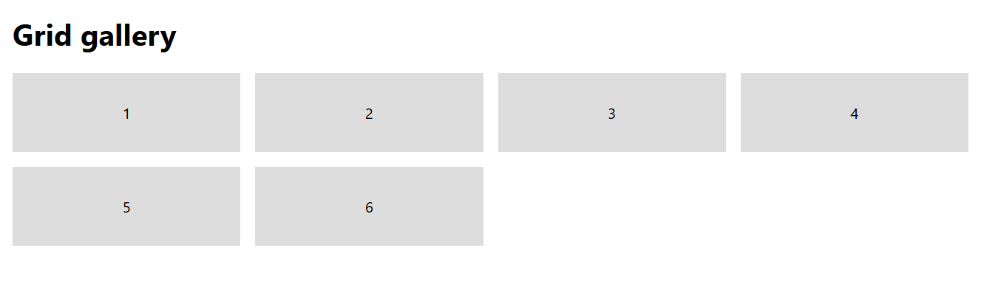

Class Activity E:
- Static is a normal layout with no responsiveness
- Relative is the one which leaves a ghost and red dot is used to close the gap in the absolute
- And sticky only moves around under its parent boundaries bur fixed is class independent

