PART A: Transformations
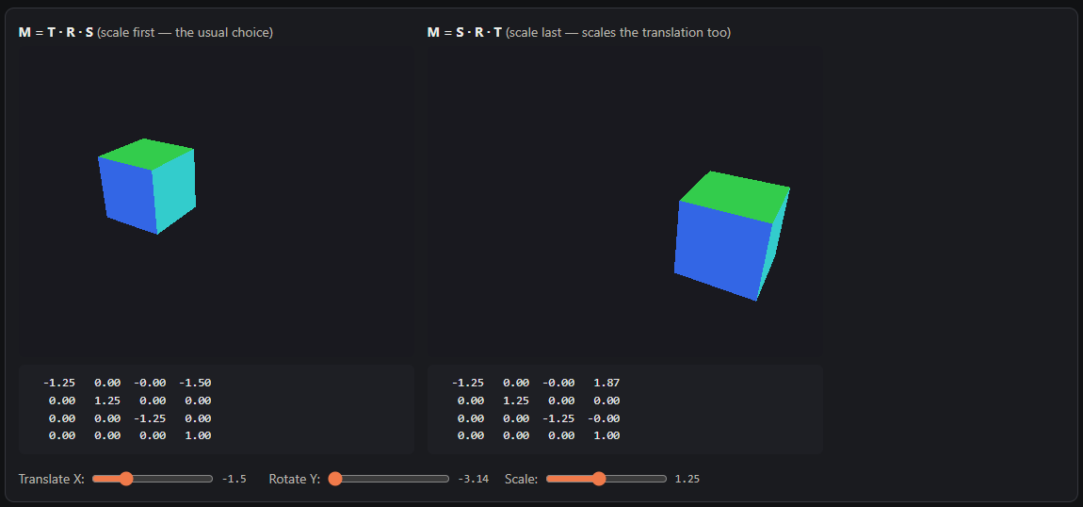
Matrix multiplication is non-commutative ($A⋅B≠B⋅A$), meaning the order in which transformation matrices are composed directly alters the object's final world position and orientation. In $M=T⋅R⋅S$, the scale matrix $S$ is applied first in local object space, followed by rotation $R$ around the local origin, and finally translation $T$ into world coordinates, keeping the object scaled at its local center. Conversely, in $M=S⋅R⋅T$, the object is translated away from the origin first; subsequent rotation swings the translated position vector in an arc around the global origin, and scaling expands or compresses that offset vector, resulting in a significantly different world matrix and displacement. For the remainder of this project, I adopt the standard $M=T⋅R⋅S$ convention so that objects scale and rotate predictably around their local pivots prior to placement in world space.

PART B: Scene Graph
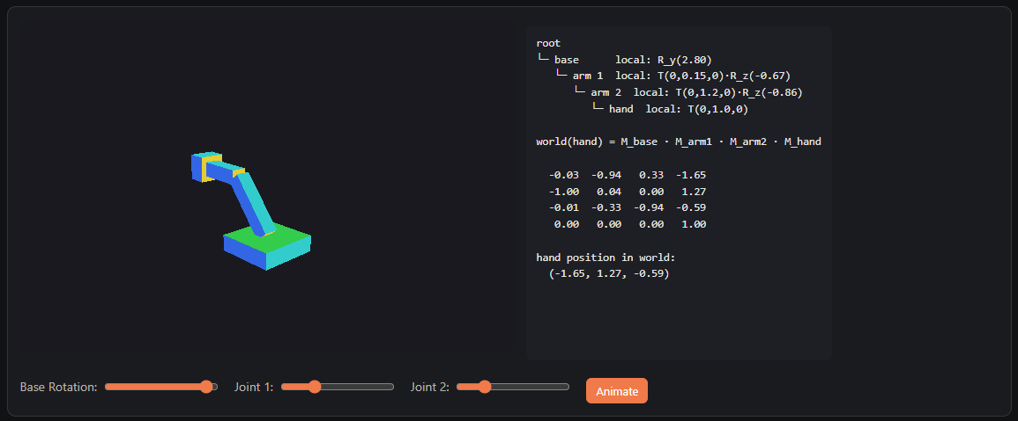
A scene graph calculates an object's global position by multiplying its local transformation matrix by the accumulated world matrix of its parent: $M_{\text{world}}=M_{\text{parent_world}}⋅M_{\text{local}}$. For a leaf node at depth 4, the world matrix is given by:
$$M_{\text{hand_world}}=M_{\text{base}}⋅M_{\text{arm1}}⋅M_{\text{arm2}}⋅M_{\text{hand}}$$
Testing the node chain with base rotation $a_{1}=3.14\text{ rad}≈π$, joint 1 angle $a_{2}=0.71\text{ rad}$, and joint 2 angle $a_{3}=-0.77\text{ rad}$:
- Joint Angles: Accumulated angle relative to the base $θ_{12}=0.71-0.77=-0.06\text{ rad}$.
- Local Displacement:
  - Arm 1 vector: $x_{1}=-1.2\sin\left(0.71\right)=-0.7822$, $y_{1}=1.2\cos\left(0.71\right)=0.9100$.
  - Hand vector: $x_{2}=-1.0\sin\left(-0.06\right)=0.0600$, $y_{2}=1.0\cos\left(-0.06\right)=0.9982$.
  - Local origin offset sum: $X_{\text{local}}=-0.7222$, $Y_{\text{local}}=0.9100+0.9982+0.30=2.2082$.
- World Transform: Pre-multiplying by $R_{y}\left(π\right)$ reflects the X position, yielding world position $\left(+0.72,2.21,0.00\right)$, which matches the $4×4$ column-major matrix generated by our traversal code:
$$\left[\begin{matrix}-1.00 & -0.06 & 0.00 & 0.72 \\ -0.06 & 1.00 & 0.00 & 2.21 \\ -0.00 & -0.00 & -1.00 & 0.00 \\ 0.00 & 0.00 & 0.00 & 1.00\end{matrix}\right]$$

PART C: Camera and Projection
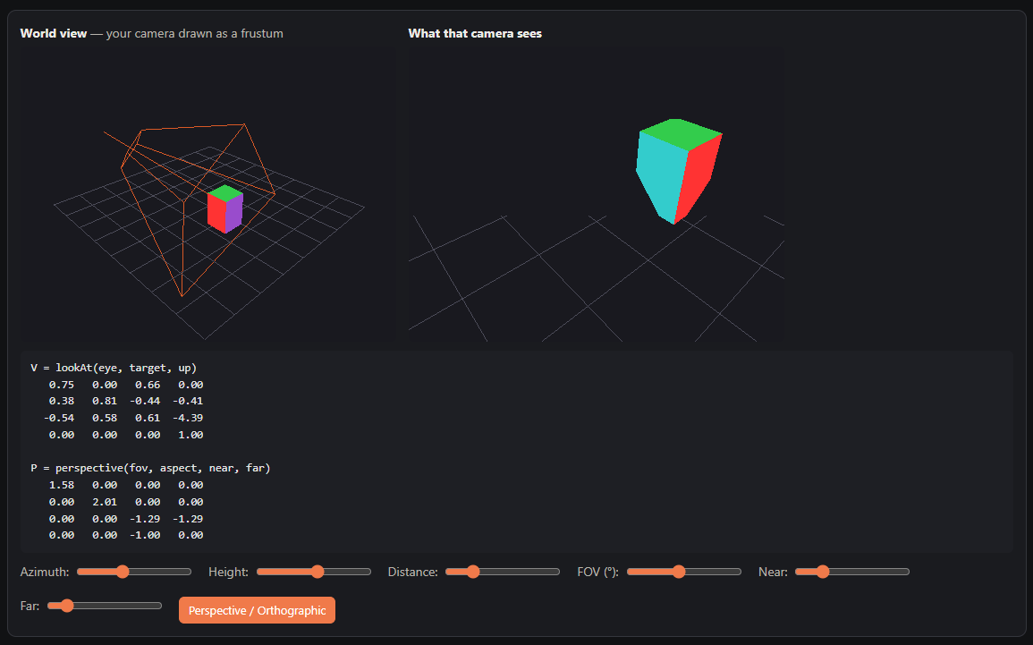
1. View Matrix (lookAt) & Degenerate Handling
Given camera position $e=\left(e_{x},e_{y},e_{z}\right)$, target position $t=\left(t_{x},t_{y},t_{z}\right)$, and up vector $u_{\text{raw}}$:
- Forward vector: $f=\frac{t-e}{‖t-e‖}$.
- View axis: $w=-f$ (since camera looks down $-Z$ in view space).
- Degenerate Check: If $|w⋅u_{\text{raw}}|>0.999$, $u_{\text{raw}}$ is collinear with $w$, causing their cross product to collapse to $0$. We handle this by switching to a fallback vector $u_{\text{raw}}=\left(1,0,0\right)$.
- Right vector: $r=\frac{u_{\text{raw}}×w}{‖u_{\text{raw}}×w‖}$.
- True Up vector: $v=w×r$.
Constructing the rigid transformation inverse yields the column-major view matrix:
$$V=\left[\begin{matrix}r_{x} & v_{x} & w_{x} & 0 \\ r_{y} & v_{y} & w_{y} & 0 \\ r_{z} & v_{z} & w_{z} & 0 \\ -r⋅e & -v⋅e & -w⋅e & 1\end{matrix}\right]$$
2. WebGPU Perspective Projection ($z∈\left[0,1\right]$)
Unlike OpenGL which maps clip-space depth to $\left[-1,1\right]$, WebGPU maps depth $z_{\text{NDC}}∈\left[0,1\right]$.
With field-of-view factor $f=\frac{1}{\tan\left(\text{fovY}/2\right)}$ and aspect ratio $A$:
$$P=\left[\begin{matrix}\frac{f}{A} & 0 & 0 & 0 \\ 0 & f & 0 & 0 \\ 0 & 0 & \frac{\text{far}}{\text{near}-\text{far}} & -1 \\ 0 & 0 & \frac{\text{near}⋅\text{far}}{\text{near}-\text{far}} & 0\end{matrix}\right]$$
Proof of $\left[0,1\right]$ Bounds:
- For a point on the near plane ($z_{\text{view}}=-n$):
$$z_{\text{clip}}=\left(-n\right)⋅\frac{f}{n-f}+\frac{n⋅f}{n-f}=0⟹z_{\text{NDC}}=\frac{0}{w_{\text{clip}}}=0$$
- For a point on the far plane ($z_{\text{view}}=-f$):
$$z_{\text{clip}}=\left(-f\right)⋅\frac{f}{n-f}+\frac{n⋅f}{n-f}=f⟹z_{\text{NDC}}=\frac{f}{-\left(-f\right)}=1$$

In WebGPU, depth buffering uses floating-point precision mapped non-linearly across clip space $z∈\left[0,1\right]$. Setting the near plane distance too small (e.g., $n<0.01$) or the far plane too large (e.g., $f>10000$) allocates a disproportionate percentage of depth buffer precision to geometry immediately adjacent to the camera eye, leading to z-fighting and rendering artifacts for distant objects. For this project, I chose $n=1.0$ and $f=8.0$ (ratio $f/n=8$), which comfortably bounds the scene geometry while preserving high floating-point precision across the view volume.

PART D: Curves over Painting
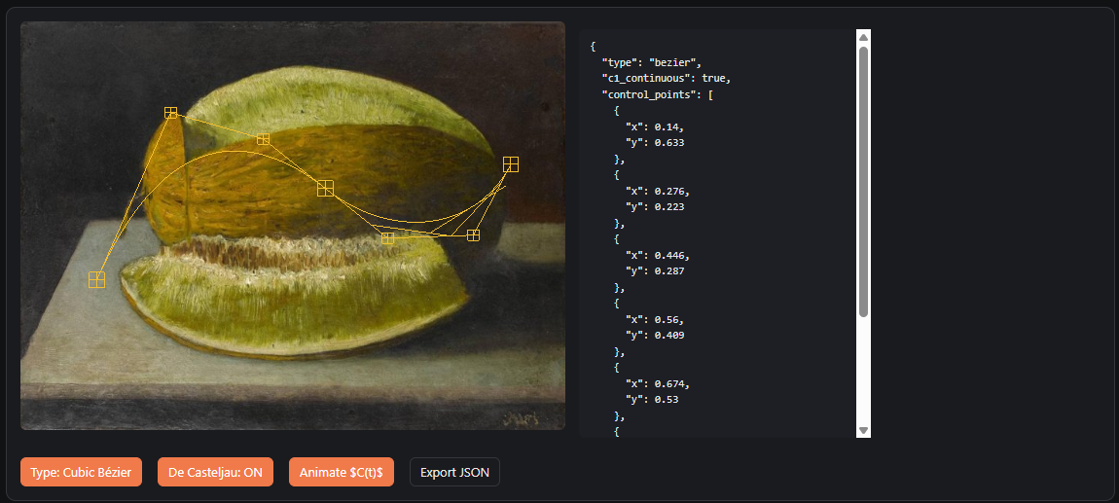1. Cubic Bézier Curve Evaluation & De Casteljau’s Algorithm
A cubic Bézier curve segment $B\left(t\right)$ defined by four control points $P_{0},P_{1},P_{2},P_{3}∈R^{2}$ for parameter $t∈\left[0,1\right]$ is evaluated using Bernstein polynomials:
$$B\left(t\right)={\left(1-t\right)}^{3}P_{0}+3{\left(1-t\right)}^{2}tP_{1}+3\left(1-t\right)t^{2}P_{2}+t^{3}P_{3}$$
De Casteljau’s algorithm evaluates $B\left(t\right)$ geometrically via successive linear interpolations:
- Level 1: $Q_{0}\left(t\right)=\left(1-t\right)P_{0}+tP_{1}, Q_{1}\left(t\right)=\left(1-t\right)P_{1}+tP_{2}, Q_{2}\left(t\right)=\left(1-t\right)P_{2}+tP_{3}$
- Level 2: $R_{0}\left(t\right)=\left(1-t\right)Q_{0}\left(t\right)+tQ_{1}\left(t\right), R_{1}\left(t\right)=\left(1-t\right)Q_{1}\left(t\right)+tQ_{2}\left(t\right)$
- Level 3 (Curve Point): $B\left(t\right)=\left(1-t\right)R_{0}\left(t\right)+tR_{1}\left(t\right)$
2. Tangent Vector $B'\left(t\right)$
Differentiating $B\left(t\right)$ with respect to $t$ yields the first derivative (tangent vector) used to align animated objects along the curve:
$$B'\left(t\right)=3{\left(1-t\right)}^{2}\left(P_{1}-P_{0}\right)+6\left(1-t\right)t\left(P_{2}-P_{1}\right)+3t^{2}\left(P_{3}-P_{2}\right)$$
3. $C^{1}$ Continuity Condition Across Joints
For two adjacent cubic Bézier segments $S_{1}$ (defined by $P_{0},P_{1},P_{2},P_{3}$) and $S_{2}$ (defined by $P_{3},P_{4},P_{5},P_{6}$), $C^{0}$ continuity requires sharing the joint point $P_{3}$.
$C^{1}$ parametric continuity requires the end tangent of $S_{1}$ at $t=1$ to equal the start tangent of $S_{2}$ at $t=0$:
$$S_{1}'\left(1\right)=3\left(P_{3}-P_{2}\right)=S_{2}'\left(0\right)=3\left(P_{4}-P_{3}\right)⟹P_{3}-P_{2}=P_{4}-P_{3}$$
Solving for $P_{4}$ yields the constraint enforced dynamically during interactive dragging:
$$P_{4}=2P_{3}-P_{2}$$
4. Catmull-Rom Spline Matrix Formulation
Catmull-Rom splines interpolate directly through control points $P_{1}$ and $P_{2}$, with tangent vectors determined by neighboring points $P_{0}$ and $P_{3}$:
$$C\left(t\right)=\frac{1}{2}\left[\begin{matrix}1 & t & t^{2} & t^{3}\end{matrix}\right]\left[\begin{matrix}0 & 2 & 0 & 0 \\ -1 & 0 & 1 & 0 \\ 2 & -5 & 4 & -1 \\ -1 & 3 & -3 & 1\end{matrix}\right]\left[\begin{matrix}P_{0} \\ P_{1} \\ P_{2} \\ P_{3}\end{matrix}\right]$$

Cubic Bézier curves provide intuitive shape control through convex hull handles ($P_{1},P_{2}$), making them well-suited for interactive design; however, they require explicit mathematical constraints ($P_{\text{after}}=2K-P_{\text{before}}$) to guarantee $C^{1}$ smooth continuity across multi-segment joints. In contrast, Catmull-Rom splines naturally achieve $C^{1}$ continuity and pass directly through all interior control points, eliminating the need to construct artificial handle handles. However, Catmull-Rom curves lack localized handle manipulation, meaning shifting a single point alters tangents across multiple neighboring segments.

