WSL / USA Soccer Leagues
Hierarchy & Data Population Flow Diagram
This flowchart visually explains how frontend hierarchy, APIs, and admin logic work together. Structure must exist before data population.
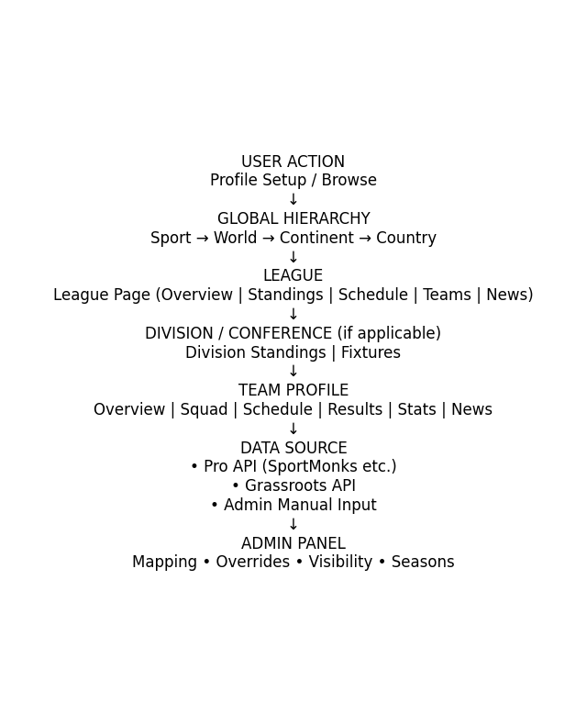
Key Principle:
APIs do not create structure. They populate predefined containers built into the frontend and managed via the admin panel.

