

Energy Policy 30 (2002) 189–205

Viewpoint

Global oil & gas depletion: an overview

R.W. Bentley*

The Oil Depletion Analysis Centre, Suite 12, 305 Gt. Portland Street, London W1W 5DA, UK

Abstract

The world’s production of conventional hydrocarbons will soon decline. Hydrocarbon shortages are inevitable unless radical changes occur in demand, or in the supply of non-conventional hydrocarbons. The details are as follows:

Global conventional oil supply is currently at political risk. This is because the sum of conventional oil production from all countries in the world, except the five main Middle-East suppliers, is near the maximum set by physical resource limits. Should Middle-East suppliers decide to substantially curtail supply, the shortfall cannot be replaced by conventional oil from other sources.

World conventional oil supply will soon be at physical risk. The Middle-East countries have only little spare operational capacity, and this will be increasingly called upon as oil production declines elsewhere. Large investments in Middle-East production, if they occur, could raise output, but only to a limited extent. (A partial exception is Iraq, but even here, there would be significant delays before prospects are confirmed, and infrastructure is in place.) If demand is maintained, and if large investments in Middle-East capacity are not made, the world will face the prospect of oil shortages in the near term.

Even with large investments, resource limits will force Middle-East production to decline fairly soon, and hence also global conventional oil production. The date of this resource-limited global peak depends on the size of Middle-East reserves, which are poorly known, and unreliably reported. Best estimates put the physical peak of global conventional oil production between 5 and 10 years from now.

The world contains large quantities of non-conventional oil, and various oil substitutes. But the rapidity of the decline in the production of conventional oil makes it probable that these non-conventional sources cannot come on-stream fast enough to fully compensate. The result will be a sustained global oil shortage.

For conventional gas, the world’s original endowment is probably about the same, in energy terms, as its endowment of conventional oil. Since less gas has been used so far compared to oil, the world will turn increasingly to gas as oil declines. But the global peak in conventional gas production is already in sight, in perhaps 20 years, and hence the global peak of all hydrocarbons (oil plus gas) is likely to be in about 10 or so years. r 2002 Published by Elsevier Science Ltd.

Introduction

The situation described in the Abstract is shown pictorially in Fig. 1. Though there are uncertainties in some of the numbers of this figure (see later in this paper), this is a reasonable estimate of the future hydrocarbon supply position.

The key elements in the figure are:

* near-term rapid decline in conventional oil produc-tion;



*Corresponding author. Department of Cybernetics, University of Reading, Whiteknights, Reading, Berkshire RG6 6AY, UK. Tel.: +44-0-118-931-8223; fax: +44-0-118-931-8220.

E-mail address: odac@btconnect.com (R.W. Bentley).

0301-4215/02/$ - see front matter r 2002 Published by Elsevier Science Ltd. PII: S0301-4215(01)00144-6

* a relatively modest contribution from non-conven-tional oils; and
* decline in conventional gas production from about 2020.

The overall outcome is a steep decline in global total hydrocarbon production from around 2010 or so.

The remaining sections of Part I of this paper outline the research that has led to these conclusions, and discusses the uncertainties that exist. In Part II, other approaches to modelling the future of global oil and gas production are analysed, in order to explain why the calculations presented here are not more widely known. Finally, in Part III, some general conclusions are drawn.

190 R.W. Bentley / Energy Policy 30 (2002) 189–205

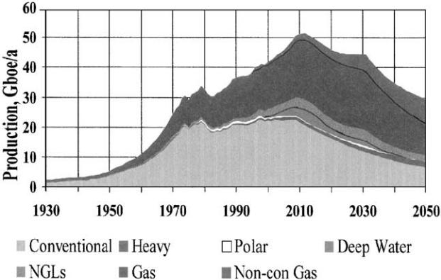

Fig. 1. Possible future production of ‘All Hydrocarbons’. Note that gas is represented here at a conversion factor of 10 Tcf gas=1 Gb oil equivalent. This is an industry norm, but the calorific value is nearer 6 Tcf gas=1 Gb oil equivalent. On the latter basis, the area of the graph representing gas becomes proportionally larger, but the overall shape of the graph changes little; and the peak date, of about 2010 for ‘All Hydrocarbons’ production, is essentially unchanged. Source: Colin Campbell; presentation at the Petrotech 2001 Conference, New Delhi, India, January 2001.

Part I: The research covered by this paper

1. Conventional oil

1.1. The modelling of Campbell and Laherrere"

The forecast of production of conventional oil shown in Fig. 1 is based on the analysis carried out by Campbell and Laherrere" in a 1995 study for Petrocon-sultants (Campbell and Laherrere," 1995).

The Campbell/Laherrere" calculations were as follows:

1. Estimation of ‘P50’ oil reserves, by country: (P50 reserves are those with a notional 50% probability, i.e., being equally likely to see downward revision as upward revision with time.) These estimates were generated by taking the reserves data from the Petroconsultants’ data base, but adjusting:
   * in the light of the authors’ extensive geological knowledge;
   * on the basis of a variety of reasonableness tests. A key one of these is to plot a field’s production vs. its cumulative production. For most fields, once in decline, this plot gives a good check of the field’s likely ultimately recoverable re-serves. (For fields in the former Soviet Union (FSU), for example, this approach shows that the reserves of many fields are significantly over-reported.)
2. Generation of estimates of oil yet-to-find: This analysis was on a basin-by-basin basis, where appropriate; and mostly used a range of statistical approaches, essentially based on the discovery data

to date, to estimate the quantities of conventional oil likely to be found within a reasonable explora-tion time-frame (for example, assuming twice as many wildcats as already drilled in a basin).

1. Addition of cumulative production, P50 reserves, and to yet-to-find, to give an estimate of each coun-try’s ‘ultimate’ (i.e., ultimately recoverable reserves).
2. Modelling each country’s future production by:
   * if already past peak, by declining production at the existing decline rate (i.e., by a fixed percen-tage of the remaining recoverable resource);
   * if prior to peak, by increasing production at an annual growth rate until cumulative production equals half that country’s ultimate, and there-after declining production at the then-existing decline rate;
   * in the case of the Middle-East ‘swing’ producers, calculating their production, subject to their own resource limits, using a small number of ‘geo-political’ scenarios.

While these results were presented in the consultants’ report for purchase, they were also made available by the authors, in an abridged (and later, updated) form, in a wide range of open publications; see, for example, (Laherrere," 1995, 1996, 1998, 1999a, b, 2001; Campbell, 1995, 1996, 1997a, b, 1999; Campbell and Laherrere,"

1998).

1.2. Checking by the University of Reading

In 1995, a group at the University of Reading came across one such publication, (Campbell, 1994/1995), and, recognising the importance of the topic, set about checking both the data and the calculations. The group (which includes the present author) contained petroleum geologists, engineers and physicists.

The research centred on checking:

* the adequacy of the Petroconsultants (later, IHS Energy) database for this type of analysis. The evaluation involved asking questions on what data were in the database; how these data are generated; what data might be missing, what happens when field data change; and so on.
* the suitability of modelling the yet-to-find on, largely, statistical indicators driven by past exploration performance.
* the validity of the Hubbert ‘decline from the mid point’ model. This was checked by looking at regions and countries (such as Alaska, and the US as a whole) that had already passed their conventional oil resource-limited peak; and also from theo-retical considerations of a basin’s likely production profile.

|  |  |
| --- | --- |
| R.W. Bentley / Energy Policy 30 (2002) 189–205 | 191 |

* analysis of some of the issues that bedevil hydro-carbon forecasting, including terminology (what is ‘conventional’ oil?); ‘reserves growth’ (is technology accessing substantially more oil in existing fields?), and the apparent fallibility of past forecasts.

The research included detailed discussions with oil analysts (including those holding strongly opposing views), Petroconsultants, oil companies, several energy ‘think tanks’, the UK government, the International Energy Agency (IEA), the European Union (EU), and the US Geological Survey (USGS).

1.3. Findings and uncertainties

The key findings were (Bentley et al., 2000):

* The Petroconsultants/IHS Energy database is ade-quate for the task, and in any event is the most comprehensive, and representative of the industry’s own knowledge. For the present analysis in our view, informed adjustment is required to some of the reserves data. This is not surprising, as the latter are drawn from a range of rather different sources.
* The ‘Hubbert’ model (i.e., the standard resource logistic curve) is a robust method for modelling future oil production, see Appendix A; in some cases, applying multiple curves where more than one discovery cycle has occurred. Note that the recent work by Laherrere" (2001) on time-shifting the discovery curve to match production is also robust, as it recognises that production largely has to mirror discovery.
* Calculations of production peak based on statistical methods to estimate oil yet-to-find seem correct. This is because the oil assumed in high estimates of ultimate is likely to be found at dates well past the point that it can affect the peak. (A good example is the US, where the largest single field, Prudhoe Bay, was found just before peak, but where this large, late find did not alter the date of peak.)
* Reserves growth, a key issue, is much misunderstood. It represents a change in a field’s reported reserves arising from one or more of three causes:
  1. an increase in the percentage recoverable;
  2. the late development of subsidiary reservoirs with new facilities;
  3. the correction of initial conservative reporting.

The rules of the Securities and Exchange Commission dominate the reporting of reserves. Only so-called proved reserves, namely those deemed to be drained by producing wells, are reported for financial purposes, and these values naturally grow over time as the fields are drilled up. Where the original reserves are stated as proved and probable, revisions should be statistically

neutral, but in fact show a general commercial tendency to be under-reported in large fields, and over-reported in small. Thus, while it is often claimed that new technology is responsible for observed reserves growth, it turns out that initial conservative reporting is primarily responsible.1

On the basis of the above findings, the University of Reading group concluded that the Campbell/Laherrere" calculations are probably the most accurate to-date on the future of conventional oil supplies; they are certainly some of the most detailed.

There are, naturally, uncertainties. For conventional oil, roughly in order of importance, we see these uncertainties as:

* The size of certain Middle-East (proved and prob-able) reserves. Public domain information is atro-ciously unreliable (see Part II, below), but there are large discrepancies even within the industry’s data. For example, various estimates for Saudi Arabian (proved and probable) reserves differ by a factor of about two (and, notably, are always lower than the published ‘proved-only’ reserves). Both Saudi Arabia and Iran may well have significantly smaller reserves than listed in the Petroconsultants/IHS Energy database.
* The size of Russian (proved and probable) reserves. Campbell and Laherrere" reduce the Russian reserves significantly from those reported in the Petroconsul-tants database. They do this from decline analysis of historical production data for a wide range of large Russian fields, using the technique of plotting annual versus cumulative production as a basis for extrapolation. While some in the oil press still hold out Russia as a great hope, there is recognition within the industry that it is now past its physical resource peak.
* The degree of investment in the Middle-East supply. As world oil supply declines elsewhere, the world must turn increasingly to the Middle East. Some analyses indicate that it will be hard for these countries to dedicate sufficient investment in the face of conflicting demands on the national budgets, implying that foreign investment will be called for. But this may not materialise for political reasons.
* The rate at which recent deep-water and Caspian oil finds can come on-stream. These finds have been made, but need off-take facilities and pipelines before

1 Note that in the Petroconsultants database there are, of late, some significant increases, in successive years, in the total of global discoveries reported against any given year. This trend needs additional investigation, but the present indications are that this relates to definitional issues of reserves in some specific regions, and should not be seen as due to technology gains across the board. We are supported in this view by the opinion of a senior analyst in one of the mega-majors.



192 R.W. Bentley / Energy Policy 30 (2002) 189–205

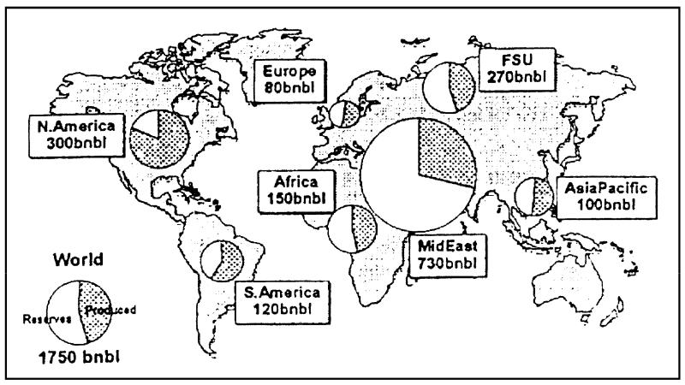

Fig. 2. Global conventional oil distribution: shows the world’s conventional oil that has been consumed (dark shading), and the currently discovered reserves (light colour). The figure uses industry (proved and probable) data for reserves (not public domain ‘proved’ reserves), and excludes oil ‘yet-to-find’. (Note that these reserves data do not include the adjustments made by Campbell and Laherrere," referred to in the text.) Source: Francis Harper (Manager, Reserves & Resources, BP); (1999).

they can come to market. There are more, or less, optimistic assumptions about the rate that such facilities will become available.

* Finally, uncertainty attaches to the rate that technol-ogy can lift recovery factors in existing fields, and allow smaller and more difficult fields to be econom-ic. While we have satisfied ourselves that the bulk of reserves growth is simply in the reporting, there is scope for additional research to determine more precisely the extent that application of existing and near-term technology might impact future produc-tion.

Overall, a realistic assessment makes it difficult to avoid the conclusion that the world will face conven-tional oil limits within the next few years.

It is important to recognise that more optimistic assessments would delay the global peak by no more than 10–15 years. Also, if Middle-East production were to be increased radically, unlikely as that seems, it would simply have the effect of making the global peak that much higher and sooner, and lead to a steeper subsequent decline.

1.4. Conventional oil depletion: summary

Fig. 2 presents pictorially the current world situation on conventional oil.

Since, as mentioned above, a region’s oil production peak occurs when about half the recoverable resource has been consumed, and since the medium-term yet-to-find is fairly small, Fig. 2 shows that:

* the world is about halfway through its effective recoverable resource base;
* this is essentially true for every region of the World except the Middle East, giving the latter potential control of the marginal barrel;
* North America has burnt about three-quarters of its recoverable conventional oil resource.

If one imagines the circles on this figure as clocks, with the hour hand dividing ‘produced’ from ‘reserves’, then oil decline sets in when the hour hand ticks round to about 6 o’clock. This is illustrated in the figure, where, for example, Asia-Pacific is at or close to decline; Europe is due to decline about now; and the US has been in decline since 1971.

2. Conventional gas

2.1. Estimates of total endowment

Whereas most exploration geologists with a global view agree that for oil, the current discovery trend, of decline since the mid-1960s, cannot change (see Section 5.1 on exploration geologists, in Part II), there is less of a consensus that this is true for gas. Some geologists feel that, since they have not been ‘looking for gas’, there will be a lot more to find once the effort is put in. The counter-argument is that, although there will almost certainly be large new gas finds (particularly in Northern Russia, for example), the long-term decline in discovery rate (since the late 1960s in the case of gas) makes it unlikely that the trend can be reversed. The underlying explanation is that for gas, as for oil, it is the big fields that tend to get found first, and it is these fields that largely determine the total quantity. In the light of the declining gas discovery rate, it is not surprising that

|  |  |
| --- | --- |
| R.W. Bentley / Energy Policy 30 (2002) 189–205 | 193 |

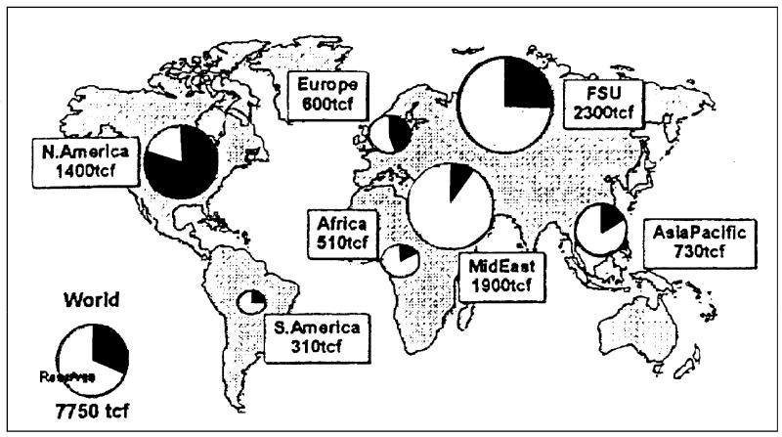

Fig. 3. Global conventional gas distribution: shows the world’s conventional gas that has been consumed (dark shading), and the currently

discovered reserves (lighter colour). As in Fig. 2, reserves reflect industry data. Gas ‘yet-to-find’ is excluded. Source: As for Fig. 2.

estimates for the world’s total original endowment of natural gas have changed little over the last 30 or so years (Harper, 1999).

Our best view at present, therefore, is that these estimates of the original endowment of conventional gas, at about 10,000 trillion cubic ft. (Tcf), are likely to be substantially correct. On this basis, though mankind is further from the peak point for global gas than for global oil, the end for conventional gas is already in sight: mankind has probably burned about half the gas needed to reach the world’s resource-limited conven-tional gas production peak.

2.2. Conventional gas depletion: summary

Fig. 3 presents the current world situation on conventional gas.

The point at which a region’s gas production peaks, as a percentage of its total recoverable resource, is not as well known as it is for oil. It is probable that this share is larger for gas than for oil; and going by the North American experience, which we believe to be more-or-less at peak on gas, the proportion may be around three-quarters.2 However, unlike oil, where output for a large region declines at perhaps 3% per year past peak, it is probable that gas production past peak falls off more steeply. On this basis, Fig. 3 shows that:

* Europe has a little way to go before its gas peak, and other regions further; and
* the world as a whole is about halfway to its gas peak.



* The IEA (1998), assumes that gas from a region peaks at 60% of ultimate. (One mega-major, however, points out that the experience of those, relatively small, countries that have already gone over their gas peak is that the peak may be closer to 50%.)

When the ‘clocks’ on this figure tick round to perhaps 8 or 9 o’clock, gas decline sets in; with the decline likely to be fairly steep.

For a prediction of future conventional gas produc-tion, refer back to Fig. 1. The latter uses information drawn from Petroconsultants’ 1996 study of global gas resources by Laherrere" et al. (1996).

3. Non-conventional oil and gas

3.1. The resource base

The decline in conventional oil supply will be offset to some extent, by:

1. improvements in oil recovery factors due to the use of tertiary recovery methods (‘enhanced recovery’ oil);
2. liquid supplies from:
   * natural gas liquids (NGLs),
   * non-conventional oils: heavy oils, tar sands and shale oils,
   * other non-conventional liquids: gas-to-gasoline, oil from coal, biofuels, etc;
3. substituting for oil, including use of gas (while supply is still increasing) for both heating and transport.

Fig. 4 is a preliminary attempt to depict the relevant volumes of both conventional and non-conventional hydrocarbons to a common scale. Data are drawn primarily from the paper by Harper (1999) and a 1998 study by Perrodon et al. (1998).

Among items to note from this figure are:

* the large amount of oil potentially available to enhanced recovery. (There is no parallel for

194 R.W. Bentley / Energy Policy 30 (2002) 189–205

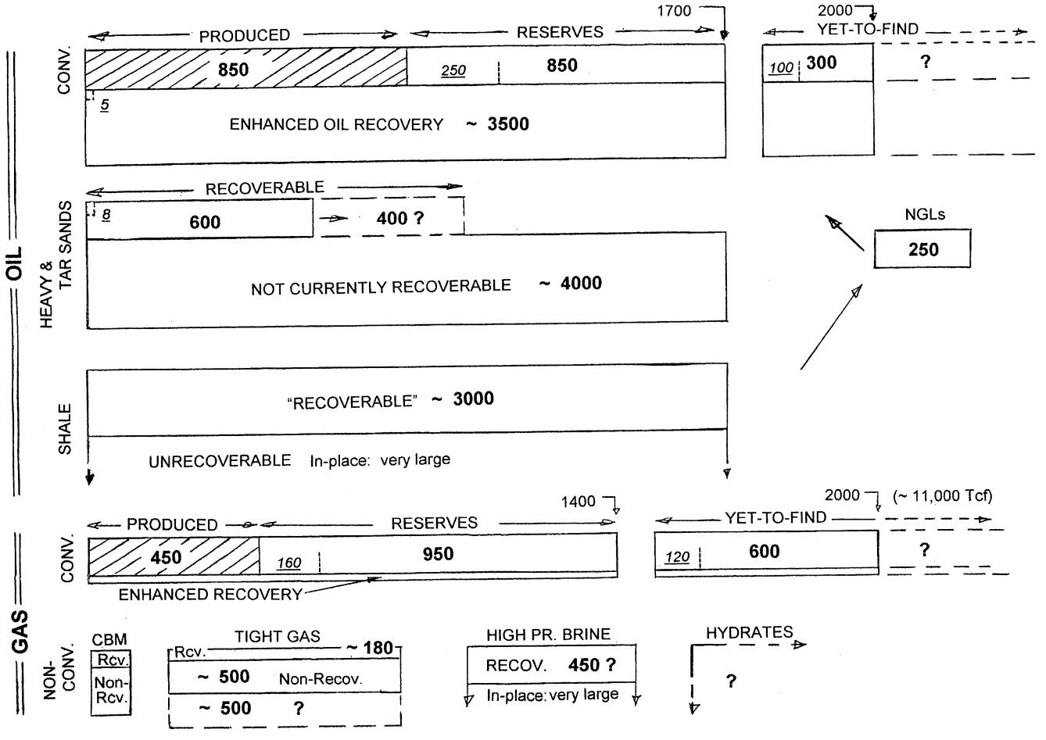

Fig. 4. Preliminary depiction of global oil and gas resources: the blocks in this figure are all to-scale. Data are given in billion of barrels of oil (or oil’s energy equivalent in the case of gas), Gboe. Reserves are industry data, i.e., proved and probable reserves. Abbreviations: CONV.Fconventional, NGLsFnatural gas liquids, CBM.FCoal bed methane. The figure shows the resources in-place, and the proportion thought to be recoverable under current and medium-term technology. For conventional oil and conventional gas, the hatched bars show the amount consumed to-date. (The author does not have the corresponding data for enhanced-recovery oil, and non-conventional oil and gas, but the amounts are relatively small.) Shows (by dotted lines, and smaller-font underlined figures in italics), for conventional oil and gas, and enhanced recovery and non-conventional oil, the quantities that will be consumed and found over the next 10 years, at the present consumption and discovery rates. For example, shows for conventional oil that in 10 years, the cumulative production will be 1100 Gb, i.e., past the halfway point of the recoverable resource, if the latter is

2000 Gb. (The author does not have the data for the 10-year consumptions of the non-conventional gases, but these are very small.) Note: Recoverable gas hydrate quantities may be large, but probably are not; see, e.g., papers by Laherrere". Sources: Based on data in Harper (1999); and Perrodon et al. (1998).

conventional gas, as its extraction rate from normal reservoirs is relatively high.)

* the often-quoted figures for the ‘recoverable’ portions of both Athabasca tar sands and Orinoco heavy oil, held to be ‘immense’ at about 300 billion barrels (Gb) in each case, yield a total of 22 years’ of world demand.
* the large amount of gas probably in-place in tight reservoirs, and in brine aquifers (but with long-standing questions over how much of these are practical to extract at any reasonable cost level).
* the question mark for methane hydrates: whether they exist in the quantities some calculate; whether

they can be extracted; and if so, without worsening global warming.

The main point of the figure is to indicate that the non-conventional resources are large, while the recover-able resources, when seen against near-term technolo-gies, are not so generous.

3.2. Rate of production

The main question, however, about non-conventional hydrocarbons, is the rate at which these resources can be made available, as conventional oil declines.

|  |  |
| --- | --- |
| R.W. Bentley / Energy Policy 30 (2002) 189–205 | 195 |

The Campbell/Laherrere" modelling indicates that once past the peak, the global production of conven-tional oil will decline at about 2 million barrels per day (Mb/d) each year. Also, if the world demand growth trend of the last few years is to be satisfied, an annual increase in the supply of petroleum liquids of roughly the same magnitude is required.

That is, the combined output from enhanced recovery and the non-conventionals must increase by something like 4 Mb/d each year if the recent demand trend is to be satisfied. This size of increase looks unlikely.

For enhanced recovery, various studies indicate that the amount of extra oil that can be made available, within the timescale that affects global peaking, will be rather small. One can look, for example, at UK production, where significant efforts have been made to improve recovery factors, but where the mid-range estimates for total quantity of recoverable oil have changed only a little since the mid-1970s, and hence the predicted mid-point peaking date has been relatively unaffected by 30 years’ of development. Also, the experience of the US and Germany has been that enhanced recovery becomes significant only well past the peak.

For the wide range of non-conventionals, the rate that these could be brought on-stream needs more analysis. But it would seem that the driving factors, that include technological readiness, energy content, investment limits, water requirement, and emissions of CO2 and other pollutants, all act to limit the rate that these will be available. For example, the IEA, in its 1998 World Energy Outlook (IEA, 1998) indicated that some 19 Mb/d of supply from ‘unidentified unconventional oil’ would be required by 2020 if demand were to be met, and went on to indicate that it felt such a production to be unlikely (Fleming, 2000). For non-conventionals, a key driver is energy content, and one must be cautious about assuming the effectiveness of a crash programme of increasing non-conventional output as conventional hydrocarbons get in short supply; too fast an expansion of non-conventionals leads to negative net energy production.

Overall, the production forecast for the various non-conventional hydrocarbons indicated in Fig. 1 seems to us realistic.

Part II. Other views of the future of oil and gas

Having painted a rather bleak picture of future hydrocarbon supply on the back of published detailed calculations of the recoverable resources, it is natural to ask why these results are not better known. The following sections set out a partial explanation; more detailed discussion of some of the topics is given in Bentley et al. (2000).

4. Misconceptions

First, we look at a number of misconceptions that still dominate much of the thinking about the security of hydrocarbon supply.

4.1. Confusion between reserves, and the total recoverable oil

Reserves are the amounts of oil expected to be produced from known fields, commonly stated under defined degrees of probability. By contrast, the total recoverable oil includes oil recoverable in fields that have not yet been discovered. Many people still confuse these two quantities, saying that ‘30 years ago we had 30 years of supply remaining; now we have 40 years remaining’.

Lomborg (2001) provides a nice analogy, by pointing out that if one is worrying about running out of food, it is foolish just to look at what is in your refrigerator (the reserves); one also has to see what is in the shops. Where Lomborg goes badly wrong, however, is by not realising that estimates for the world’s original endowment of conventional oil (in terms of his analogy, what has been eaten, plus the reserves in the ‘fridge’, plus the yet-to-find out in the shops) have remained essentially unchanged, at around 2,000 Gb, for 40 years, and it is the size of this fixed original endowment that makes the near-term production decline in conventional oil in-evitable.

Fig. 5 seeks to clarify, from a historical perspective, the difference between reserves and the recoverable resource.3

4.2. Confusion between proved reserves, and (proved+probable) reserves: the ‘reserves replacement’ problem

Proved reserves are defined to reflect a conservative value of what a field contains, with a view to reducing commercial fraud. As time moves on, and more of the oil within the field is accessed, such proved estimates naturally grow towards the (proved and probable)



* In terms of the credibility of these numbers, many economists (and some geologists with a background in coal) argue that higher prices, and increasing technology, can always access further reserves. The analogy with other mineral resources, such as coal, is misleading. A coal deposit covers a large area, but with only the most favourable sites in terms of seam concentration and access being mined. The amounts within range of the mine under current economic and technical conditions are termed reserves. If prices rise, or extraction costs fall, lower concentrations are viable, and the reserves will rise. But oil is different, being either in the field, or not there at all; and the oil–water contact sets a simple upper limit on the amount of oil present. It is true that higher prices might make some improved recovery technique economic, but higher prices do not change the amount of oil within the field’s physically defined volume (for additional discussion of these ideas, see Bentley et al., 2000).

196 R.W. Bentley / Energy Policy 30 (2002) 189–205

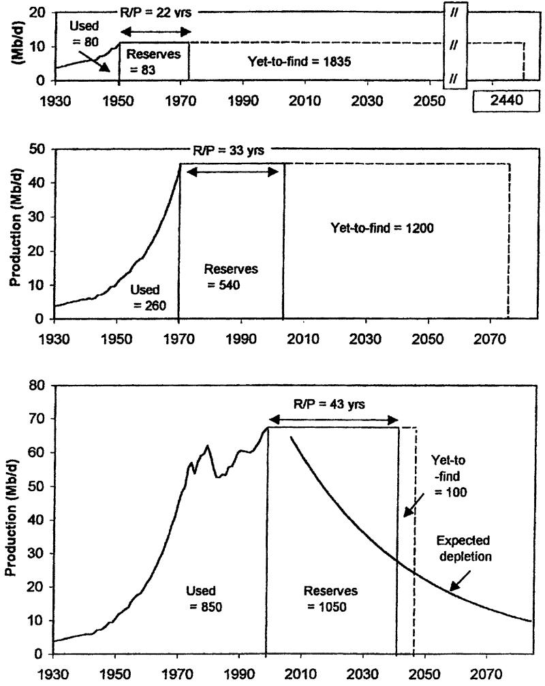

Fig. 5. A history of world oil: production, reserves, and yet-to-find in 1950, 1970 and 1998. Notes: excludes NGLs. Data in billion barrels (Gb).

Assumes a conventional ultimate of 2000 Gb, and calculates: Yet-to-find ¼ Ultimate Cumulative production þ ReservesÞ: Reserves here are public domain proved reserves. (This makes the end-’98 yet-to-find somewhat misleading. The industry end-’98 figure for (proved+probable) reserves, excluding NGLs, is around 850 Gb, giving a yet-to-find, based on a 2000 Gb ultimate, of about 300 Gb). Depletion curve: Exponential decline once 1000 Gb has been produced. Sources: Reserves data from BP Statistical Reviews, and as supplied by EDA Ltd. Production data pre-1965 from Campbell. NGL’s estimated.

estimate that is usually is close to the original geological estimate of what the field was likely to yield. For many countries, the Petroconsultants/ IHS Energy (proved and probable) reserves are typically of the order of 50% larger than the published proved reserves, though there are many exceptions to this rule (see Bentley et al., 2000, and the following section).

Most oil companies, in their annual reports, state that their reserves have been more than replaced over the year in question by discoveries, and by increases in the assessed recovery of existing fields. Such ‘reserves replacement’ is perhaps the single most important focus of financial analysts who help to set the companies’ share prices, and hence, in turn, is an issue of great sensitivity in company reporting.

But, as indicated above, proved reserves are expected to grow, and can do so without real oil being discovered, or recovery factors improving. This happens when reserves are simply re-categorised, coming out of probable reserves, and being placed in proved. Hence, booked replacement of proved reserves tells the analyst nothing about what is happening to the underlying, more realistic, (proved and probable) reserves. This is the heart of the ‘reserves replacement’ problem that, in our view, will become of great significance in the coming years.

It may be that the future impact on the oil industry of the apparent security provided by conservative ‘proved’ reserves reporting will have parallels with the impact on the nuclear industry of the apparent security provided by testing Chernobyl without its external grid.

|  |  |
| --- | --- |
| R.W. Bentley / Energy Policy 30 (2002) 189–205 | 197 |

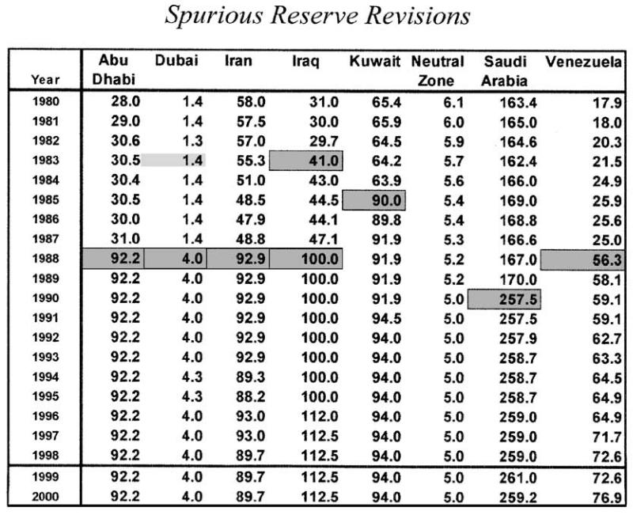

Fig. 6. Spurious revisions in proved reserves: Annual data of proved oil reserves for the countries indicated, in Gb. Note the step changes, and the

sequences of years with no changes. (Not the sort to data to use to find out if global reserves are rising or falling!). Source: Oil & Gas Journal (and

hence: BP Statistical Review), various issues.

4.3. Atrocious reporting of proved reserves

Overlaying the above considerations, in terms of assessing the global future of oil, is the atrocious reporting of proved reserves for many countries.

This is illustrated in Fig. 6. Key points here are:

1. The step changes in reported proved reserves of many countries in the late 1980s, due to the so-called ‘quota wars’. It was these fictitious changes in reserves

that misled Odell and others into thinking that the world was ‘running into oil’. (Odell, 1994, 1997, 1999)4 (The problems here were both that Odell and others do not seem to have done the simplest checks on the credibility of the data they used, but also, specifically in Odell’s case, that he did not subsequently offer a caveat concerning the data’s unreliability after his attention had been drawn to this fact.)



* See also, for example, the BP ‘house magazine’, BP Today, September/October 1997, where, under an article headed: ‘World oil supplies safe for decades, says economist’, Davies is reported as saying: ‘For the past 10 years the discovery rate has escalated to two new barrels for every one used.’

For our attempt to get BP to be more candid about the reliability of the reported proved reserves data, see footnote 35 in (Bentley et al., 2000). (Note that the reserves prior to these OPEC changes were probably too low, having been inherited from the companies before they were expropriated. But it is key to understand that no actual change occurred in the late 1980s, and that in terms of monitoring real discovery rate trends, these revisions must be backdated to the discovery dates of fields, most of which had been found up to 50 years before.).

1. For many countries, the reported reserves are simply not updated from one year to the next. This applies not only to the countries shown, but also to some other large-resource countries, such as Russia and China. Altogether, more than half of all countries with reserves reported by the Oil and Gas Journal (and hence also by BP’s Statistical Review of World Energy) are not generally reporting reserves changes. This simple fact invalidates all analyses that use apparent changes in the published proved reserves data to maintain that the conventional oil resource peak is still very distant.

Recent examples include papers by BP’s Peter Davies (Davies and Weston, 2000)5 and by BP’s Wolfgang Schollnberger (Schollnberger, 2001).6



* + This paper has a number of errors; some of them the same as in Schollnberger, below.

6 This paper has serious weaknesses. Its lines of argument on oil are:

* Economics dictates reserves. (But see the US’ experience during the ‘oil frenzy’ following the oil shocks, when some gas, but little extra oil was found.)
* Changes in proved reserves data in BP’s Statistical Review are meaningful. (‘yunderlying upward trend since 1965, and the trend shows no sign of slowing.’) (See Section 4.3.)
* Economics and technology have caused the USGS to raise its assessments. (‘The USGS applies consistent methodology y Compared with the first 1983 survey, the 1999 figure is a staggering 80+% higher.’) (This is not the case; earlier assessments excluded reserves growth outside the US. If this factor is removed, the USGS data have changed relatively little, see Section 5.3.)
* Global oil discoveries have not peaked. (An absolutely bizarre assertion; see Fig. 7, or Bentley et al., 2000. Schollnberger must

198 R.W. Bentley / Energy Policy 30 (2002) 189–205

Taken together, the spurious reported proved reserves data, and the way these are quoted by analysts who have access to better information, constitute a major impediment to the public understanding of the future of oil.

4.4. Danger of Using the ‘R/P’ ratio

Most analysis of the security of oil supply still relies on using the global oil ‘reserves-to-produc-tion’ ratio (R=P ratio). This ratio indicates that current oil reserves are enough to provide 40 years of supply at current rates, and since more oil will certainly be found, the R=P ratio would seem to place any risk of oil supply difficulties out to well beyond 40 years into the future.

This paper concentrates on the peak production date, after which the production of global conventional oil goes into steady decline. It is this declining production, in other words unsatisfied demand, that is the key factor about future oil supply. It is probable that as the production peak occurs, indeed, even as it is ap-proached, the world economy will suffer a very difficult adjustment. (At that point, paradoxically, it will then be necessary to remind the world that there are still 40 or so years’ of proved reserves in the ground, albeit largely in the Middle East, and the difficulty will be one of co-operatively managing decline, not an all-out problem of absolute lack of resources.)

Fig. 5 illustrates the danger of relying on the R=P ratio when about half the recoverable resource has been used, i.e., when the yet-to-find has become rather small.



(footnote continued)

know that this is not true. He uses data seriously misreported from CERA to support his case.)

* The EU Green Paper on security of energy supply has a ‘surprising omission’ in terms of Europe’s indigenous oil production; in that there are still large recoverable indigenous resources. (Possibly true, but the Green Paper got this bit right: despite these resources, EU indigenous oil production peaks right now.)

On gas, Schollnberger claims there is enough gas ‘to supply the world beyond 2050.’ (See Section 2.1).

Schollnberger’s underlying recoverable resource numbers come from his estimates presented in Energievorrate. und mineralische Rohstuffe: Wie lange noch? in Gedanken uber. die Kohlenwasserstof-

freserven der Erde. Wie lange konnen. sie vorhalte?; published in

.

Osterreichische Akademie der Wissenschaften, Erdwiss. Komm., Vol. 12, pp. 75–126, Vienna, 1998. Here he reports, for oil, as of January 1997 (in Gb): Cum. Prod. 790; Proven Reserves 1100; Field Growth 400; Undiscovered 1010; for a total of 3300 Gb. All these numbers, except the first, are open to question. Also, out to 2100, under his high case, he doubles this total ultimate. The year 2100 is a long way away; and who knows what recovery techniques might be available by then. What is certain is that such high recoverable resources are massively different from the 1700 Gb or so of oil found so far, and simply cannot be accessed in time to change the dates of peak.

4.5. Past forecasts

Finally, in terms of our summary of misconceptions related to predicting the future of hydrocarbons, we come to the apparent fallibility of the forecasts themselves. It is adamantly held in many quarters that all past hydrocarbon forecasts have been wrong; and the conclusion is drawn that uncertainties, primarily of technology and the effects of price, make the forecasting of hydrocarbon production impossible.

The facts indicate just the opposite. There were certainly fears in the 1970s of the ‘oil running out’, based in part on na.ıve use of the proved reserves figures, and, in some cases, on extrapolation of the high exponential growth rates of oil use in prior years. But by the 1970s, the original endowment figure of 2000 Gb for conventional oil was well established, and since only some 300 Gb had been used, competent authorities recognised that oil’s mid point (let alone ‘running out’) was still some way off. Forecasts in the 1970s and early 1980s by, for example, the UK Department of Energy, Esso, Shell, the World Bank, Hubbert and others, used the logistic curve (i.e., Hubbert’s ‘decline from the mid point’ argument) to calculate the date for the peak in the world conventional production. These authorities all used estimates for the world’s original conventional oil endowment in the region of 2000 Gb, and hence calculated that world conventional oil production would peak around the year 2000 (Bentley, 2000)7.

As explained above, if statistical methods are used to estimate the original endowment of conventional oil, this still stands today at about 2000 Gb, once NGLs are taken out; (see for example Harper, 1999). So the same calculation done today gives essentially the same prediction, but with the date of peak simply shifted by about 10 years to compensate for the reduction in global demand following the 1970’s oil shocks.

5. Experts’ views

We now turn from simple misconceptions of hydro-carbons’ past and future, to the views of those who should have a better grasp of the hydrocarbon realities. Unfortunately, here it is rather a sorry tale.

5.1. Exploration geologists

Exploration geologists should be the coal miners’ canaries, warning us of increasing discovery difficulties. But most geologists have concentrated on their own patch, and have not had the global overview to see that



* The same information is set out in more abbreviated form in footnote 50 of Bentley et al., 2000.

|  |  |
| --- | --- |
| R.W. Bentley / Energy Policy 30 (2002) 189–205 | 199 |

world find rates were declining.8 So, despite backdated oil find rates having declined since the mid-1960s, a number of exploration geologists tell us that it is only in the last few years that they have begun to see the difficulties ahead.

There have been exceptions, including Campbell himself, whose first global oil resource study was within Amoco in 1969, and whose second was when working for Fina, in a study commissioned in 1989 for the Norwegian Petroleum Directorate (Campbell, 1991). Other exploration geologists with this global view who put out explicit warnings have included Howell et al. (1993), Ivanhoe (1996), and Hatfield (1997). The most recent in this line is the excellent book: ‘Hubbert’s Peak’, by Deffeyes (2001).

5.2. Oil companies

Most people in the government that we talk to assume that the oil companies are doing large amounts of quantitative modelling, and since the companies are not reporting problems ahead, the Campbell/Laherrere" analysis must be wrong. It comes as a surprise, therefore, to find that the oil companies we have spoken to, by and large, are doing very little modelling.

One mega-major, for example, confirms its approach to oil’s future is ad hoc, and minimally staffed. A recent study of theirs, of which we have had sight, declares, in effect, ‘resource limits will not be a constraint on oil production for at least 20 years’. But on examination, we find that this study simply takes public domain proved reserves as its starting base. Given what has been set out above in Sections 4.2 and 4.3, this admission is too surprising to comment upon.

Turning now to Shell, we are grateful for the many useful and detailed exchanges of view they have granted us.

Shell is very bullish on the supply side; for example, recently telling the UK’s Department of Trade and Industry: ‘We believe that [oil] supply can easily match demand for at least the next twenty-thirty years.’ (Shell’s submission, 2000).

Moreover, Shell is adamant that they currently suffer no risk of the ‘reserve replacement’ problem outlined in Section 4.2. They say they measure all their reserves on an expectation basis, and while they do, over time, move their reserves down the risk category (i.e., in the general ‘probable’ to ‘proved’ direction), they find their reserves in the higher risk categories continue to grow. This may be the case, but it is worth pointing out that the backdated plot of Shell’s cumulative discovery over time simply mirrors that of other companies, and indeed the



* For example, a senior oil geologist, in a 1997 Workshop at the University of Reading, said he completely disbelieved the Campbell/ Laherrere" analysis of declining discoveries, and hence approaching peak, as he had just made a large new find off W. Africa.

world as a whole; showing a steep rise in the early years of Shell’s exploration history, and a long flat slope towards asymptote in more recent times. If we were Shell, we would want to be very sure that their changing reserves position was being correctly appraised.

For the global picture, as opposed to its own-company one, Shell say that they base much of their calculation on their own globally located fields, and rely only partly on industry data, such as that from Petroconsultants for reserves, PIRA for near-term field predictions, and the USGS for longer term estimates of the recoverable resource.

So the question is: how does Shell arrive at such a different global view of oil’s future from that of Campbell and Laherrere?" The explanations are probably that Shell:

* does not pull down the FSU and Middle-East reserves to the extent that Campbell/Laherrere" do, or even at all;
* has a significantly more optimistic view of the extra oil that technology can access than that held by Campbell/Laherrere". Shell asks the people in the field for estimates of ‘scope for further recovery’, where this covers a wide range of technology-related factors, not just enhanced-recovery oil. These opinions will be informed, but are opinions nevertheless. By contrast, the Campbell/Laherrere" approach, in essence, extra-polates the past rate of technology improvement into the future;
* despite their assurances, put more faith in the PIRA projections, and the recent USGS estimates, than the

data permit. Recent Shell scenarios, for example, are said to be based on the USGS data.9 (See below for the dangers of using the USGS numbers.)

* is sure that steam-assisted gravity-drainage tar sands production, and their own-technology gas-to-gaso-lines plants, will be able to bring in these non-conventionals at costs, and timescales, sufficient to mask the decline in conventional production.

It is perhaps worth noting that in discussions, Shell said they viewed quantitative forecasting of oil produc-tion as not possible, due to the underlying uncertainties; only broad scenario modelling had validity. Moreover, in commenting on the work of Campbell, Shell appears not to have understood that the recent data on conventional oil published by Campbell exclude polar and deepwater oil, as he models these separately.

Overall, in our view, perhaps the biggest problem with the Shell view is that it does not focus adequately on the



* For Laherrere’s" comments on the USGS numbers, see Is the USGS 2000 assessment reliable? placed in the ‘Cyber-conference’ of the World Energy Council, 2000, (see ‘‘Strategic Options’’ of http://www.ener-gyresource2000.com; or http://www.oilcrisis.com/laherrere/usgs2000/. Laherrere’s" comments on the recent Shell scenarios are ‘in press’, and may be expected to be on the web by the time this is print.

200 R.W. Bentley / Energy Policy 30 (2002) 189–205

probability that the resources they estimate to exist cannot be accessed in time to change the various regional dates of peak. Mankind has found so far some 1700 Gb of oil in the world, and the new field discovery trend has been declining for 35 years and now averages about 10 Gb/yr. Thus, while assumptions on the world’s original endowment of oil being much above 2000 Gb might, in the long run, turn out to be correct, it is only the currently known oil, and that which will be discovered soon, that can have any impact on the date of the production peak. Indeed, this is essentially the identical analysis to that given a few years ago, after retirement, by the CEO of the Shell Oil Co. in the US (Bookout, 1989).10

Finally, in terms of the generality of oil company views, it is probably fair to say, given what is set out in Section 4.2, that most companies, national as well as commercial, have a strong motivation to put a more optimistic gloss on the resource numbers than the latter actually warrant.

5.3. The United States Geological Survey (USGS)

As will be discussed below, recently both the IEA and the US’ Energy Information Administration (EIA) have made what seem to us very poor forecasts of future conventional oil production rates, based on data from the June 2000 USGS assessment of world oil resources. It is therefore useful to first discuss these USGS data.

1. Reserves: The USGS uses Petroconsultants P50 reserves data, but, importantly, does not make the significant downward adjustments to these made by Campbell and Laherrere".



1. CEO of Shell Oil Co. from 1976 to 1988. Bookout has:

‘For the oil and gas resource base, we have used the estimates of the US Geological Survey report presented at the last World Petroleum Congress. This is the most recently published comprehensive study, and Shell’s own view of the total resource is not materially different. The expected recovery volumes estimated in the report are 2 trillion barrels of ultimately recoverable oil and a nearly equivalent volume of natural gas.’

‘The recovery of an additional few hundred billion barrels each of oil and gas would be within the range of estimated uncertainty. For the purpose of our projection we have added 450 billion barrels of oil and gas equivalent. They are certainly possible as a result of additional exploration, improved drilling and recovery techniques and increased energy prices. For example, increasing recovery efficiency for oil from the estimated 34% up to 40%, would add some 350 billion barrels.’

Significantly, however, Bookout added this 450 Gb past peak, which he therefore calculated as occurring around the year 2010, on an assumed demand growth rate of 1% p.a. This matches well with the Campbell/Laherrere" peak of around 2005 based on the actual demand rise of closer to 2%. Adding the 450 Gb to the tail end is quite reasonable, referring to EOR, deepwater etc. Bookout concludes his article by discussing the post-peak world and its challenges. (Note that Bookout is just one of several oil company CEOs who have been explicit about hydrocarbon depletion after having left office, q.v. ARCO, AGIP.)

1. Oil yet-to-find: As mentioned earlier, Campbell and Laherrere" estimate the total recoverable resource in a region by discovery trend. The USGS, by contrast, strives to evaluate each basin’s fundamental geological ‘oiliness’. The USGS puts probabilities on its estimates of the global yet-to-find, and hence on its estimates of ultimately recoverable reserves. In the previous USGS assessment (Masters’, 1993), the estimates for the 95%-likely, mean, and 5%-likely world ultimates were: 2100, 2300, and 2800 Gb. In the June 2000 assessment, the comparable numbers were virtually unchanged, at 2000, 2300 and 2800 Gb.

Geological ‘oiliness’ is a reasonable way to assess the total amount of oil that may be out there, but pays no attention at all to the rate at which this oil can be found, and hence produced.

This is illustrated in Fig. 7, by plotting the world history of oil discovery, and then the rate at which the USGS’s yet-to-find quantities need to be found if they are to be discovered within the 30-year time horizon of the USGS study. As is dramatically clear, only the ‘95%-likely’ yet-to-find figure, corresponding to an ultimate of 2000 Gb, has any chance of being found within a timescale that will impact the approaching world peak date as indicated in Fig. 2.

Note that this is not to argue, intrinsically, with the USGS yet-to-find estimates (although there are technical questions on some aspects of their methodology). The oil they envisage may exist, but cannot be found soon. This is illustrated in the case of the UK. Here there is a possibility of quite large amounts of oil remaining in subtle stratigraphic traps, and an unknown amount in the deep Atlantic margin. But the UK output is already past peak, despite the potentially large yet-to-find. (Indeed, it is easy to show that the date of the UK peak was substantially determined back in about 1976, once the initial burst of discovery had started to decline, and just as production was getting underway.)

1. Reserves growth: The USGS applies to the whole world reserves growth factors based on US experience: of 6-fold growth over 50 years for on-shore fields, and 3-fold for off-shore fields. Reserves growth is also given a probability, and globally adds 220, 690 and 1160 Gb, respectively, to the estimates of ultimate reserves presented above. This gives the USGS ‘headline’ ultimates (i.e., including reserves growth) of 2200, 3000 and 4000 Gb for the 95%-likely, mean, and 5%-likely cases.

These amounts of growth in the Petroconsultants/IHS Energy reserves data are probably unrealistic in any event, but are certainly not realistic when used to predict the production profiles of relatively near-term peaking events. Specifically, with the USGS using global 1996 reserves data of 890 Gb, the numbers above indicate that existing fields will grow in size by 25%, 80% or 130% over the 30-year USGS time horizon. Given that

|  |  |
| --- | --- |
| R.W. Bentley / Energy Policy 30 (2002) 189–205 | 201 |

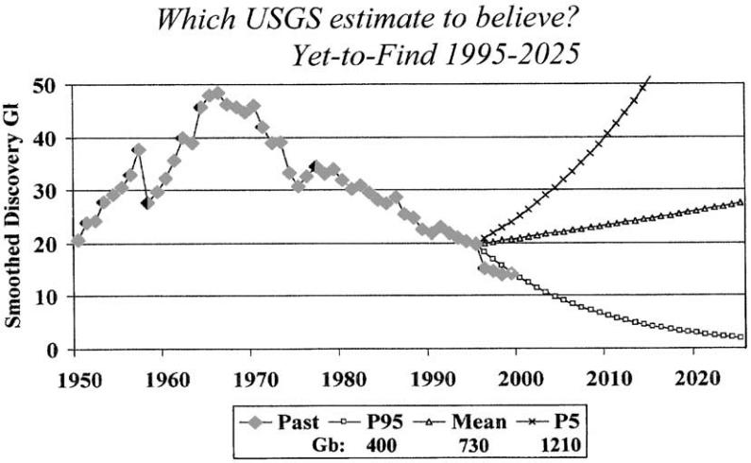

Fig. 7. World oil discovery vs. USGS estimates of yet-to-find: solid curveFsmoothed history of world oil discovery (industry data). Marked curvesFthe rates at which the USGS, June 2000 estimates of yet-to-find (400, 730 and 1210 Gb) must be discovered if these totals are to be found within 30 years. Note: Yet-to-find data run from 1996, discovery data continue to 1999; the overlap years can be compared. Source: Campbell.

peaking for most countries not yet past peak will occur within 5 or 10 years, the 25% growth in the industry reserves is just possible, but the 80% and 130% growth figures are simply untenable in terms of near- or medium-term field behaviour. This can be demonstrated by plotting production vs. cumulative production for typical fields and comparing the resulting asymptotes to the Petroconsultants’ estimates of the fields’ ultimately recoverable reserves. (Note that in the 1993 USGS assessment, Masters explicitly ruled out assuming significant reserves growth in fields outside the US.)

With this background, we can now examine the current forecasts from the IEA and the US’ EIA.

5.4. The International Energy Agency

The recent history of oil forecasting at the IEA is rather a curious one. As recently as 1996, the IEA still believed that world oil security was best measured by the world’s R=P ratio, of 40 years. It took pressure from one of the IEA’s staff, J.M. Bourdaire, to explain the need to use the Hubbert curve instead.

The IEA used the latter approach for the first time in its 1998 World Energy Outlook. However, since the IEA had not up to then assembled for itself, nor purchased, comprehensive world recoverable resource oil data, it had not built up any expertise in evaluating the applicability of the data it used. For the 1998 Outlook, the IEA took as its ‘base-case’ the 1993 USGS world ‘mode’ ultimate of 2300 Gb. Using this figure, the IEA calculated that non-OPEC oil production was more-or-less at peak, and that world production of conventional oil would decline from about 2015. These were seen as startling conclusions at that time, and it took some internal effort to get the results published, even if in rather anodyne form.

The IEA also used low- and high-case world conventional oil ultimates of 2000 and 3000 Gb.

The key question is: how realistic were the IEA’s recoverable resource numbers in terms of predicting peak? Since high estimates of ultimate cannot be used for this purpose, the forecast production curves based on 2000 Gb were realistic; those of the ‘base case’ of 2300 Gb somewhat optimistic; and those based on 3000 Gb simply unrealistic.

Subsequently, the USGS issued its June 2000 assess-ment, and this completely changed the IEA’s forecasts. In the subsequent IEA 2000 World Energy Outlook, out went the near-term peak in non-Middle East oil, and world peak in 2015, and instead the IEA forecasted global oil production able to meet rising demand out to the year 2020, reaching 115 Mb/d by that date (IEA, 2000). In our view this forecast is quite unrealistic, and the Campbell/Laherrere" forecast closer to the mark. The latter has global oil production in 2020, including 10 Mb/d of non-conventional supplies, at about 75 Mb/d; i.e., about 40 Mb/d below the IEA forecast.

As mentioned above, the reason is that the IEA uses the June 2000 USGS ‘headline’ data without taking into account the practical rates of oil discovery, and of recovery improvement. These factors place major constraints on the amount of oil that will be available in the near and medium term, and render the IEA 2000 forecast invalid.

5.5. The US DoE Energy Information Administration

The US’ EIA has recently forecast a world oil production figure for 2020 of 117 Mb/d, very close to the forecast above from the IEA (see the EIA website). Again, the explanation is that the EIA have little expertise in terms of calculating production rates, and

202 R.W. Bentley / Energy Policy 30 (2002) 189–205

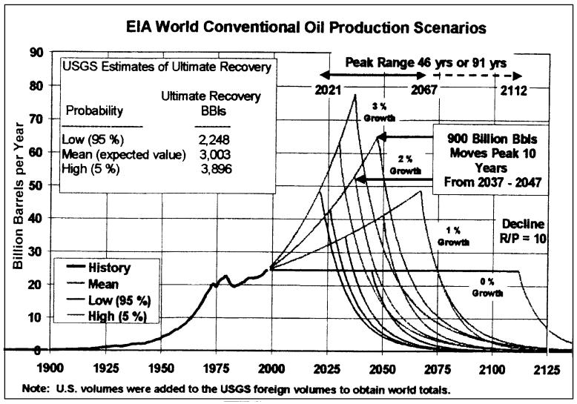

Fig. 8. US’ EIA scenarios of global oil production: shows forecast production curves based on the USGS ‘Mean’ global conventional oil ‘ultimate recovery’ (i.e. original endowment) of 3003 Gb, where this includes yet-to-find plus reserves growth, as a function of four possible demand growth rates; also shows the ‘95%’ and ‘5%’ probable cases. Errors are the use of a ‘mean’ ultimate recovery that is about 50% too high, in terms of driving peak; and a decline curve that is too steep, at 10% p.a., where a 3% decline is realistic. Source: EIA website.

have simply taken figures from the June 2000 ‘headline’ USGS assessment without analysis.

This is illustrated in Fig. 8. This EIA plot gives all combinations of the USGS numbers, and concludes that the world conventional oil peak may be as soon as the year 2021, or not until the year 2112, nearly 100 years later.

There are two serious problems here:

* To use the USGS mean value (including the spurious reserves growth numbers) of 3003 Gb to drive global peaking calculations is to use a figure about 50% too high.
* While individual oil fields may decline at 10% p.a., evidence from a wide range of regions and countries shows this to be unrealistically steep when the output of early and later fields are combined. (The EIA’s 10% decline figure is drawn from the US experience, where this is distorted by the US’ reserve reporting conventions.)

Overall, if a conventional oil endowment of about 2000 Gb is used, plus a realistic decline rate of 3% or so, the world predicted peak date becomes more-or-less that forecasted by Campbell and Laherrere".

5.6. Checking the ‘expert’s’ views

In summary, if you are a member of a government or agency with responsibility for energy supply, and are taking advice on future hydrocarbon production, you need to ask your informant the following:

* What resource data are being used: none, public domain, or industry?
* Are these data modified for specific countries where the data are less reliable?
* What assumptions are being made on reserves growth, and on future discovery rates; and are these assumptions realistic in terms of experience for the regions concerned?
* What assumptions are made for the regional or global decline rate, past peak?

The answers to these questions will surprise many who rely on ‘informed opinion’.11

Part III. Perspective, and Conclusions

6. Perspective

The US went over its resource-limited oil production peak in 1971, and output has declined since. The US peak had global consequences. At that date, world oil supply came almost entirely from the US, OPEC and Russia. With US supply in decline, and Russian oil largely confined to the communist world, the marginal barrel had to be supplied by OPEC. Thus the world’s oil supply was at the mercy of world events: the Yom Kippur war triggering the first oil shock, and market instability associated with the Iranian revolution the second. The combined effect of these shocks pushed the



1. For example, as evinced by a private discussion with a member of the EU’s DG-TREN.

|  |  |
| --- | --- |
| R.W. Bentley / Energy Policy 30 (2002) 189–205 | 203 |

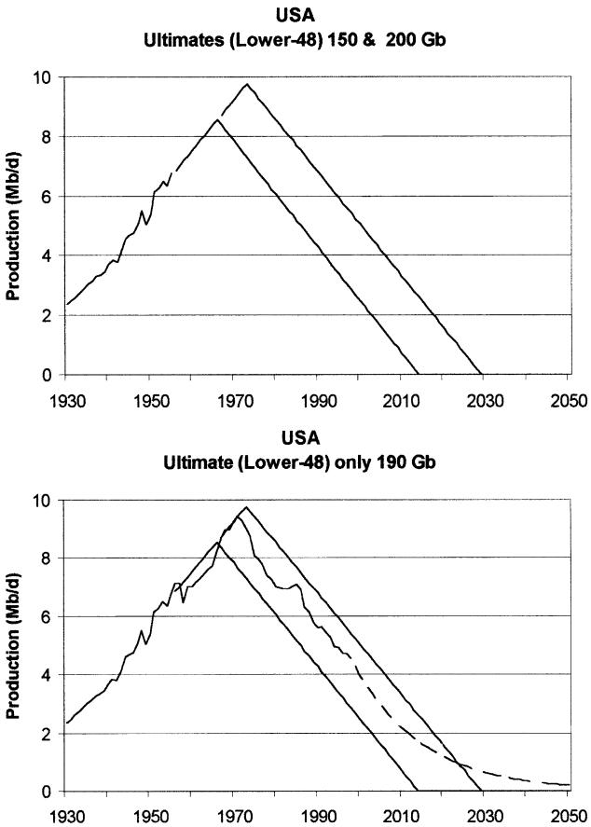

Fig. 9. Modelling Hubbert’s predictions of US Lower-48 output: Here triangles, rather than logistic curves, are used to indicate the size of the resource base. UpperFUS production to 1955, and two production predictions based on triangles of areas 150 and 200 Gb, respectively. LowerFthe two predictions, plus Lower-48 production to 1998, plus a simple exponential forecast decline. As can be seen, a simple ‘mid-point’ prediction can be reasonably accurate over a long period (nearly 50 years in this case), and correctly capture the peak.

world into a long and deep recession, and led to a wide range of other effects.

The present situation has important similarities. Now it is the oil supply from all countries of the world, except the five Middle-East members of OPEC, that is more-or-less at its resource-limited peak. It is this limit to non-OPEC supply that has allowed the current OPEC quotas to be effective. This time, however, the Middle-East producers are themselves severely constrained. Saudi Arabia, for example is already working hard to maintain output from its fields. These countries have significant domestic budgets, so have an incentive to sell their oil, but they have little spare operational capacity, and this will diminish as conventional oil elsewhere declines. Increased investment, if thought justified by the countries concerned, would certainly boost production for a while; but it is possibly largely only in Iraq that

there may be significant prospects (some already identified) to be brought on stream.

During the last oil shocks, the experience of the world’s ability to understand what was happening, and to take sensible decisions, was not an edifying sight. Hubbert’s forecast had been discounted, as had similar calculations by others (Yergin, 1991). Fundamentally, there was no adequate mechanism within society to consider the information that was available.

7. Conclusions

* The world is more-or-less at its non-OPEC conven-tional oil peak.
* The all-world conventional oil peak is 5–10 years away, after which production will decline at B3%/ year.
* Non-conventional oil production will increase, but

significant constraints, including cost, energy content, and CO2 emissions, will likely prevent these sources from fully offsetting conventional oil’s decline.

* The world is about halfway to its peak on conven-tional gas, after which production will fall rapidly.

Overall, on mankind’s ascent up the ‘oil produc-tion’ mountain:

* + demand was met;
  + producers generally had to pro-ration;
  + prices fell;
  + economies boomed. On our descent down:
  + ‘demand’ will not be met;
  + users may have to ration;
  + prices will rise;
  + there is likely to be inflation, recession, and international tension.

Appendix A. Predicting Conventional Oil Peak

How do we know that oil production declines when about half the recoverable resource has been used?

There is both empirical and theoretical evidence. The use of the ‘S’-shaped logistic curve to depict the cumulative use of a resource has been known for over a century. The rate of change of this curve, for oil, is called the ‘Hubbert’ curve. Empirically, in many regions and countries that have gone over peak, oil production has followed the Hubbert curve reasonably closely.

For the US, for example, Hubbert projected US production from 1956. He took the then-current upper and lower estimates from the US oil industry of the Lower-48 oil recoverable resource, of 150 and 200 Gb, and simply plotted production versions of the logistic curve for these quantities. 150 Gb led to a prediction

204 R.W. Bentley / Energy Policy 30 (2002) 189–205

that Lower-48 oil would peak in 10 years, and 200 Gb to a peak in 15 years. The actual peak was in 1971.

Hubbert’s forecast was widely rejected at the time, most commentators thinking that US oil supply problems would not occur ‘in their lifetime’. But in fact, the accuracy of the prediction was not surprising: peak discovery of Lower-48 oil was in the 1930s, so by the mid-50s quite a clear picture of the likely size of the resource base was available. Fig. 9 illustrates Hubbert’s forecast, but uses triangles to show the size of the resource base, rather than ‘Hubbert curves’, to illustrate the straightforward nature of the method.

Similar calculations can be done for any region where the discovery rate has been in decline long enough such that fairly good estimates of the recoverable resource base can be made. This applies, for example, to predictions of UK peak date based on government ‘Brown Book’ estimates of UK total oil made as early as 1976.

A simple theoretical basis for the observation of ‘decline from the mid-point’ is illustrated in Fig. 10. Here oil fields are assumed to produce, over their lifetime, to a roughly triangular shape; while gas fields are assumed to follow a more trapezoidal shape. For both oil and gas, the key assumption is that the larger fields get into production first. On these simple assumptions, we see that:

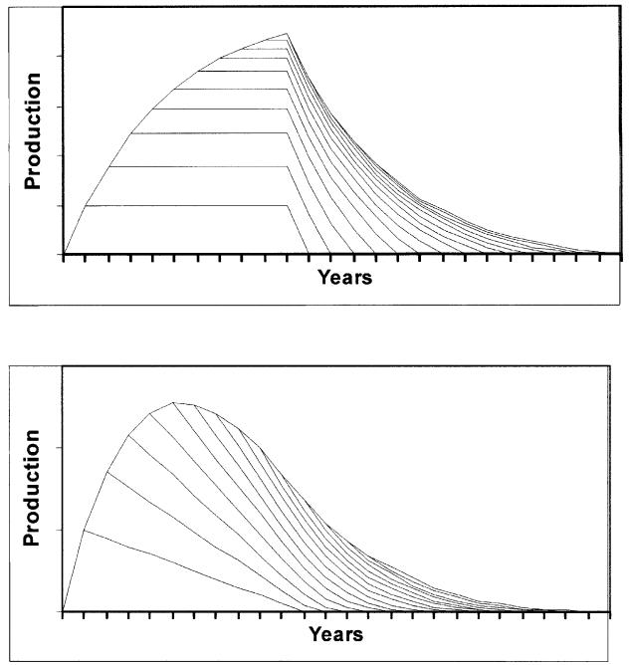

Fig. 10. Simple theoretical models of the combined output from a group of gas or oil fields: both graphs assumeFfields are found one year apart, larger fields are found earlier. Upper graphFfield production follows a trapezoidal profile, possibly typical of gas fields. Lower graphFfield production follows a profile typical of oil fields, i.e., a rapid build up, followed by a slow decline.

* oil provinces peak roughly at their mid-point, and decline away fairly gradually;
* gas provinces peak later, but then fall off more rapidly;
* discovery of later, smaller, fields helps ameliorate the decline, but does not impact the date of peak.

See Bentley et al. (2000), Deffeyes (2001) for a more detailed discussion of these issues.

Appendix B

Definitions and units

‘Hydrocarbons’ refers to oil or gas. Coal, though it contains some hydrogen, is not usually considered a hydrocarbon.

Conventional oil is defined here (and fairly generally) as oil produced by primary or secondary recovery methods (specifically: own pressure, physical lift, water flood, and water or natural gas pressure maintenance). However, this definition is not universal. On this definition, conventional oil currently accounts for about 95% of all oil production, with some 1–2% coming from enhanced recovery, and a further 2–3% from heavy oils, and tar sands. (In addition, an additional 10% of the ‘liquids’ supply is provided by natural gas liquids from gas fields.)

There is no agreed terminology for ‘reserves’, ‘resources’, etc., but here we use the fairly common definitions of:

* Resource: all of the mineral, whether discovered or not, whether recoverable or not;
* Recoverable resource: that part of the resource that is recoverable under certain assumptions (usually not stated) on price and technology level;
* Reserves: that part of the recoverable resource that has been located, but not yet used;
* Yet-to-Find: that part of the recoverable resource that has not yet been located;
* Ultimately recoverable reserves (the ‘ultimate’): the original endowment of reserves, hence this is the same as the recoverable resource.

Thus:

Ultimate

* Cumulative production þ Reserves þ Yet-to-find:

Reserves are generally classified as proved, probable, or possible; where these, usually, are seen as additive, so the largest amount of reserves judged reasonably likely are the (proved+probable+possible) reserves. Alterna-tively, one can quote reserves as 95% likely (P95); 50% likely (P50) or 5% likely (P5). Here we use P50 reserves and (proved and probable) reserves as

|  |  |
| --- | --- |
| R.W. Bentley / Energy Policy 30 (2002) 189–205 | 205 |

synonymous; this correspondence may not be strictly correct, but given the uncertainty in real-world reserves quantities (see text), appears justified. (See the text, also, for the extraordinary unreliability of published ‘proved’ reserves.)

Units: bFbarrel; MbFmillion barrels; Mb/dFmil-lion barrels per day; GbFgiga (billion) barrels; TcfFtrillion cubic feet.

References

Bentley, R.W., 2000. Were those past oil forecasts really so wrong? In: The industry newsletter: To-morrow’s Oil. OneOffshore Ltd., part of the PetroData Group, Aberdeen, November.

Bentley, R.W., Booth, R.H., Burton, J.D., Coleman, M.L., Sellwood, B.W., Whitfield, G.R., 2000. Perspectives on the future of oil. In: Energy Exploration and Exploitation, Vol. 18, Nos. 2 and 3. Multi-Science Publishing, Brentwood, pp. 147–206.

Bookout, J.F., 1989. Two centuries of fossil fuel energy. Episodes 12/4, 257–262.

Campbell, C.J., 1991. The Golden Century of Oil 1950–2050: The Depletion of a Resource. Kluwer Academic Publishers, Dordrecht, 1991.

Campbell, C.J., 1994/1995. Articles in SunWorld. The International Solar Energy Society, Quarterly issues: December, 1994; March and June 1995.

Campbell, C.J., 1995. Proving the unprovable. Petroleum Economist, May, 27–30.

Campbell, C.J., 1996. The status of world oil depletion at the end of 1995. Energy Exploration and Exploitation 14 (1), 63–81.

Campbell, C.J., 1997a. Better understanding urged for rapidly depleting reserves. Oil and Gas Journal, April, 51–54.

Campbell, C.J., 1997b. The Coming Oil Crisis. Multi-Science Publish-ing Company Ltd., Brentwood, (in association with Petroconsul-tants S.A.), ISBN 0 906522 11 0.

Campbell, C.J., 1999. Oil reserves and depletion. PESGB Newsletter, Petroleum Exploration Society of Great Britain, March 1999, pp. 87–90.

Campbell, C.J., Laherrere," J.H., 1995. The world’s supply of oil, 1930– 2050. Report from Petroconsultants S.A., Geneva.

Campbell, C.J., Laherrere," J.H., 1998. The end of cheap oil. Scientific American, March, 60–65.

Davies, P., Weston, P., 2000. Oil resources: a balanced assessment. Paper for Presentation at The Energy Forum: Running on Empty? Prospects for World Supplies. Rice University, Houston, May 19, 2000.

Deffeyes, K.S., 2001. Hubbert’s Peak. Princeton University Press, Princeton, NJ, ISBN 0-691-09086-6.

Fleming, D., 2000. After oil. Prospect, November, 12–13.

Harper, F., 1999. Ultimate hydrocarbon resources in the 21st century. Presentation at the American Association of Petroleum Geologists Conference on Oil and Gas in the 21st Century. September 12–15 1999, Birmingham, UK.

Hatfield, C.B., 1997. Oil back on the global agenda. Nature 387, 121. Howell, D.G., Bird, K.J., Gautier, D.L., 1993. Oil: When will we run

out? Earth, March, 26–33.

International Energy Agency, 1998. World energy outlook. November 1998; ISBN 92-64-16185-6.

International Energy Agency, 2000.World Energy Outlook.

Ivanhoe, L.F., 1996. Updated Hubbert curves analyze world oil supply. World Oil, November, 91–94.

Laherrere," J.H., 1995. World oil reservesFWhich number to believe? OPEC Bulletin, February, 9–13.

Laherrere," J.H., 1996. Distributions de type ‘‘Fractal Parabolique’’ dans la Nature. C. R. Academy of Science, Paris, Vol. 322 IIa, pp. 535–541.

Laherrere," J.H., 1998. The evolution of the world’s hydrocarbon reserves. Paper Delivered to the SPE, France, June.

Laherrere," J.H., 1999a. Erratic reserve reporting. Petroleum Review, The Institute of Petroleum, February, 24–26.

Laherrere," J.H., 1999b. Reserve growth: technological progress, or bad reporting and bad arithmetic? Geopolitics of Energy 22/4, 7–16.

Laherrere," J.H., 2001. Paper posted on the website of the International Institute for Applied Systems Analysis (IIASA).

Laherrere," J.H., Perrodon, A., Campbell, C.J., 1996. The world’s gas potential. Petroconsultants S.A., Geneva.

Lomborg, B., 2001. The Skeptical Environmentalist. Cambridge University Press, Cambridge.

Odell, P.R., 1994. World oil resources, reserves and production. The Energy Journal (IAEE) 15 (Special Issue), 89–113.

Odell’s, 1997. Presentation to the IEA Oil Reserves Conference, Paris, 11/November/97, p. 3.

Odell, P.R., 1999. Plentiful energy supplies for the 21st century.

Petroleum Review, Institute of Petroleum, March, 35–37.

Perrodon, A., Laherrere," J.H., Campbell, C.J., 1998. The world’s non-conventional oil and gas. The Petroleum Economist Ltd., London, March.

Schollnberger, W., 2001. Security of energy supply in Europe. Paper for Submission to the Committee on Industry, External Trade, Research and Energy of the European Parliament; Public Hearing on the Security of energy supply in Europe. Brussels, 21 June.

Shell’s submission, 2000. World oil supply. To the UK’s Department of Trade and Industry Energy Advisory Panel meeting, 5 September.

Yergin, D., 1991. The Prize. Simon & Schuster, New York.