|  |  |
| --- | --- |
| Research Article | 908 |
|  |  |



Nicolas Oppmann* Andreas Jess

Improving the Selectivity to Liquefied Petroleum Gas by Combining Fischer-Tropsch Synthesis with Zeolite Cracking

This is an open access article under the terms of the Creative Commons Attribution License, which permits use, distribution and reproduction in any medium, provided the original work is properly cited.



Supporting Information available online

The Fischer-Tropsch synthesis (FTS) is a heterogeneously catalyzed surface poly-merization reaction with a wide spectrum of hydrocarbons as products, following the Anderson-Schulz-Flory distribution. Subsequent cracking of the unwanted long-chain products can increase the desired product fraction of shorter hydrocar-bons (HCs). In this work, a Co/Mn-catalyzed FTS with additional cracking by a Pt/H-ZSM-5 zeolite was investigated to increase the selectivity of liquefied petro-leum gas (LPG). At lower zeolite temperatures, no cracking but isomerization and the conversion of alcohols took place. Raising the temperature of the cracking process resulted in cracking of long-chain HCs and increased the total LPG selec-tivity. Additional experiments by cracking of n-hexadecane as model substance were conducted.

Keywords: Fischer-Tropsch synthesis, n-Hexadecane, H-ZSM-5, Liquefied petroleum gas, Zeolite cracking

Received: September 16, 2022; revised: December 14, 2022; accepted: January 13, 2023

DOI: 10.1002/ceat.202200445

|  |  |  |  |  |  |
| --- | --- | --- | --- | --- | --- |
| 1 | Introduction |  | excess hydrogen can be utilized for the production of hydro- | |  |
|  |  |  | carbons (HCs) by FTS. Hence, about 3200 t of HCs per year | |  |
| Climate change due to the anthropogenic emission of green- | | | could be theoretically produced by FTS, if the H2 is partly, i.e., | |  |
| house gases by the combustion of fossil fuels is one of the main | | | about 1/3, converted by the reverse water-gas shift reaction | |  |
| global problems mankind is facing [1]. This makes it necessary | | | (CO2 + H2 > CO + H2O) to produce the CO needed for the | |  |
| to abandon fossil fuels as soon as possible and search for clean | | | FTS. Due to a high demand of liquefied petroleum gas (LPG) | |  |
| and renewable energy sources. To solve this problem, the pro- | | | in this rural area as fuel in households and small businesses, | |  |
| duction of fuels by means of Fischer-Tropsch synthesis (FTS) | | | the selectivity enhancement of LPG in this reaction is of great | |  |
| becomes an alternative [2–5]. The reaction allows producing | | | interest. |  |  |
| mainly linear hydrocarbons (HCs) by the conversion of syngas | | | Besides all advantages of FTS, there is one major drawback. | |  |
| (CO + H2) [6]. The FT reaction can be regarded as a surface | | | The kinetics of the FTS, which can be regarded as a heteroge- | |  |
| catalyzed polymerization, i.e., by a chain propagation mecha- | | | neously catalyzed surface polymerization reaction, results in a | |  |
| nism in which methylene units are consecutively incorporated: | | | statistical distribution of HCs, known as Anderson-Schulz- | |  |
| nCO þ 2nH2 fi ð CH2 Þn þ nH2O | |  | Flory distribution (ASF), characterized by the chain growth | |  |
| (1) | probability a1) [9, 10]. The selectivity towards LPG (C3 + C4 | |  |
|  |  |  | fraction) is therefore limited to a theoretical maximum of | |  |
|  | By the use of renewable produced hydrogen by water elec- | | » 32 wtC % (Fig. 1) at a » 0.55 considering the following | |  |
| trolysis and CO2 (e.g., separated from flue gases of power | | | assumptions: (i) only chain growth reactions take place and no | |  |
| plants, steel/cement production, chemical industry, from bio- | | | cracking occurs; (ii) both methane and C2 also follow the ASF | |  |
| gas, or in future even from air) as carbon source, this process | | | distribution. To overcome this limitation of FTS and to | |  |
| will emit much less CO2 than traditional fuels based on crude | | | increase the LPG selectivity, cracking of the longer chain com- | |  |
| oil [7]. | |  | pounds on acid zeolites is an option [11–15]. |  |  |
|  | One of the largest proton exchange membrane (PEM) elec- | | There are numerous investigations focusing on a hybrid con- | |  |
| trolyzers in Europe was just recently built in Wunsiedel (start- | | | cept of FT and zeolite catalyst in a single step for improving | |  |
| up in September 2022), a small city in Upper Franconia (north- | | | – |  |  |
| ern Bavaria), with a capacity of 1350 t of green hydrogen per | | |  |  |
| year [8]. Besides the direct use of H2 by a local gas company, | | | Nicolas Oppmann, Prof. Dr.-Ing. Andreas Jess |  |  |
|  |  |  | (Nicolas1.oppmann@uni-bayreuth.de) |  |  |
| – | |  | University of Bayreuth, Department of Chemical Engineering, Center | |  |
|  | of Energy Technology (ZET), Universitaetsstrasse 30, 95447 Bayreuth, | |  |
| 1) List of symbols at the end of the paper. | |  | Germany. |  |  |
| Chem. Eng. Technol. 2023, 46, No. 5, 908–917 | | ª 2023 The Authors. Chemical Engineering & Technology published by Wiley-VCH GmbH | | www.cet-journal.com |  |





|  |  |
| --- | --- |
| Research Article | 909 |
|  |  |

|  |
| --- |
| 15214125, 2023, 5, |

Figure 1. (a) Mass fraction on carbon basis of typical product fractions of Fischer-Tropsch synthesis with a varying chain growth probability a. (b) Mass fraction of LPG (C3 + C4) with varying a. Note that a values < 0.5 are not likely for FTS and are only shown for the sake of completeness/comparison.

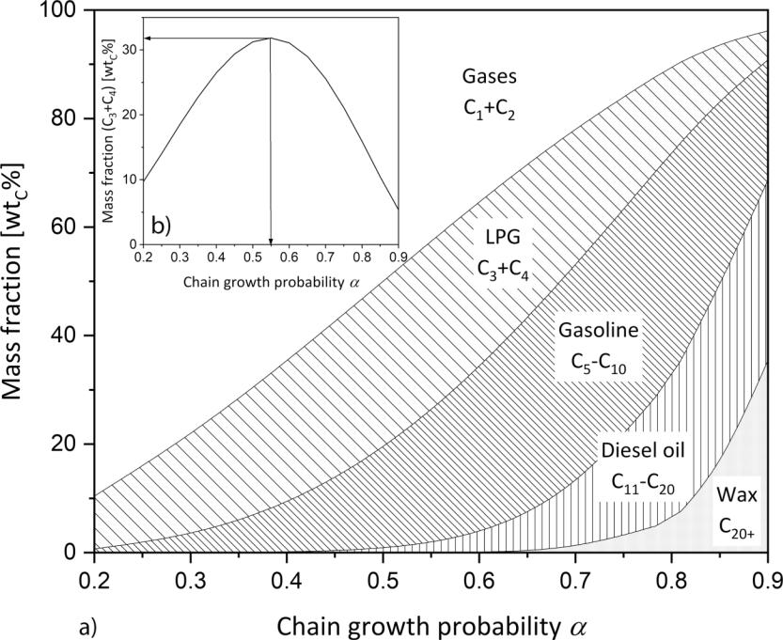

tivity (a = 0.55) but at higher a values, and thus with an initially higher yield of C5+-HCs (and lower yield of LPG, respec-tively) in the first process step of FTS. These C5+-HCs can then be subsequently cracked to LPG and therefore increase the overall LPG selectivity.

Lower a values (< 0.55) result in a high selectivity to methane and C2 gases (ethene, ethane) which of course cannot be further converted to LPG by cracking. Until now, it is an open question, which a value of FTS and which configuration and reaction con-ditions such as temperature of FTS and cracking are optimal to achieve the highest LPG yield in a process combining FTS and cracking.

The present works aims to increase the se-lectivity of LPG of the combined process by using a Co/Mn-FT catalyst and a platinum-doped acid zeolite (Pt/H-ZSM-5) as crack-ing catalyst in different reactor setups. The FTS was thereby investigated with and with-out combination with cracking. The crack-ing reactions only were also studied by using n-hexadecane (C16H34) as model substance for C5+-HCs typically formed by FTS.

|  |
| --- |
| Downloaded from https://onlinelibrary.wiley.com/doi/10.1002/ceat.202200445 by Universitaet Bayreuth, Wiley Online Library on [03/11/2023]. See the Terms and |

selectivity of gasoline range hydrocarbons. Namely, these con-cepts are physically mixing both catalysts, zeolite-supported FT catalysts and zeolite encapsulated FT catalysts [16]. Also dual-bed configurations are investigated in which both catalysts are separated in one reactor [17–19]. However, single-stage arrangements suffer from the disadvantage that at least one cat-alyst must operate under less than optimal conditions. There-fore, two-stage operation is performed for downstream pro-cessing of FT products [20].

Multiple combinations of FT and acidic catalysts for down-stream FT product conversion have been tested, many focusing on the increase of the gasoline fraction of hydrocarbons [21–25]. Little research is done to improve the selectivity of LPG from an FTS/zeolite process [11, 26], as LPG is often regarded as low-value product. Nevertheless, the sustainable production of LPG from non-petroleum sources is of great importance and the key objective of this paper. This work is of great interest, as we want to determine the optimal process pa-rameters for the production of LPG by the FTS/zeolite process.

Bifunctional hydrocracking on a catalyst having a (de)hydro-genation component, often a noble metal, and a Brønsted acid center is of advantage compared to catalytic cracking on mono-functional acid catalysts [27]. Marked differences are the lower reaction temperatures necessary for hydrocracking and the lower tendency for deactivation by coke precursors such as olefins and subsequent formation of carbonaceous deposits, respectively [28, 29].To achieve the highest overall selectivity for LPG by FTS combined with cracking, it is, from a theoreti-cal point of few, better to run FTS not at the highest LPG selec-

* Experimental

2.1 Catalysts

2.1.1 FTS Catalyst Preparation

Previous studies have shown that the promotor manganese increases the olefin (and alcohol) selectivity of Co-based FT catalysts significantly and also decreases the chain growth probability [30]. Hence, for the FTS experiments, a cobalt-manganese catalyst (20 wt % Co, 3 wt % Mn, amount of reduced metal on final catalyst) with a high yield of a olefins was used [30], as olefins show a higher reactivity for cracking reactions as the initial step of dehydrogenation is not required [31].

The catalyst was prepared by wet impregnation. The dry SiO2 support material (Aerolyst 3041, extruded cylinders, dP = 1.6 mm, 12 h, 110 LC) was impregnated with an aqueous solution containing a mixture of the required amounts of Co(NO3)2 6H2O and Mn(NO3)2 4H2O. Therefore, a solution of the calculated amounts of metal salts in water (6 mLH2Ogsupport material–1) was prepared and the support materi-al was added. After removing the solvent at 60 LC under reduced pressure in a rotary evaporator (1 h 300 mbar, 1 h 200 mbar, 1 h 100 mbar, 12 h 40 mbar), the solid was calcined by heating up in flowing air in a fixed-bed reactor (3 K min–1, 360 LC, 3 h hold, airflow of 1.5 L h–1gcat.–1). To avoid internal transport limitations (pore effectiveness factor < 1) during the reaction, the FT catalyst was crushed and sieved to particles with dP < 90 mm.

|  |
| --- |
| Conditions (https://onlinelibrary.wiley.com/terms-and-conditions) on Wiley Online Library for rules of use; OA articles are governed by the applicable Creative |

Chem. Eng. Technol. 2023, 46, No. 5, 908–917 ª 2023 The Authors. Chemical Engineering & Technology published by Wiley-VCH GmbH www.cet-journal.com

|  |
| --- |
| Commons License |



|  |  |  |  |  |  |  |  |  |  |
| --- | --- | --- | --- | --- | --- | --- | --- | --- | --- |
|  |  |  | Research Article |  |  |  |  | 910 |  |
|  | | |  |  |  |  | | |  |
| 2.1.2 Zeolite Preparation | | | |  |  | Gas flows were controlled by Bronkhorst mass flow control- | | |  |
|  |  |  |  | zeolite (NH4+-ZSM-5, | | lers. During the experiments the outflowing gas passed through | | |  |
| The ammonium form of ZSM-5 | | | | a trap heated to 180 LC and maintained at reaction pressure, to | | |  |
| SiO2/Al2O3 = 30) was purchased as powder from Thermo | | | | | | condense the heavy waxes of the reaction. After pressure relief | | |  |
| Scientific. To achieve the active protonic form (H-ZSM-5), the | | | | | | to ambient pressure, the gas stream was bubbled through an | | |  |
| sample was calcined in a fixed-bed reactor at 500 LC in N2 flow | | | | | | iced washing bottle filled with toluene to wash out the longer | | |  |
| for | 5 h | (3 K min–1, 2.0 L h–1gzeolite–1). The high | | | temperature | HCs. The products were collected for 4–6 h and the samples of | | |  |
| forms NH3, leaving behind the protonic form H+-ZSM-5, | | | | | | both separators were combined and quantified by adding | | |  |
| denoted as H-ZSM-5. An ion exchange method was used to | | | | | | cyclooctane as internal standard and measured by gas chroma- | | |  |
| impregnate the activated H-ZSM-5 with 0.5 wt % Pt (amount | | | | | | tography (GC). After the washing bottle, an internal standard | | |  |
| of reduced metal on final zeolite). Therefore, the appropriate | | | | | | of 1 vol % cyclopropane in N2 was introduced into the product | | |  |
| amount | | of [Pt(NH3)4](NO3)2 was | | dissolved | in water | gas. By the use of cyclopropane, it was possible to quantify the | | |  |
| (3.5 mLH2Ogzeolite–1) and the zeolite added. The ion exchange | | | | | | HCs still present, also by GC. The gases then passed a cold trap | | |  |
| was carried out for 24 h at 25 LC. After evaporating the solvent | | | | | | (–80 LC) and the gas composition (CO, CO2, CH4, H2) was | | |  |
| under reduced pressure in a rotary evaporator under the same | | | | | | detected with a gas analyzer. A soap bubble burette to measure | | |  |
| conditions as for the FT catalyst, the calcination was carried | | | | | | the volume flows was installed at the end. | |  |  |
| out in a fixed-bed reactor, by slowly heating up the sample | | | | | | Prior to the reactions, the catalysts were activated by heating | | |  |
| (0.2 K min–1, 350 LC, flowing air 2.0 L h–1gzeolite–1). | | | | |  | in 20 vol % H2 in N2 (3 K min–1 to 360 LC with 3 h hold) and | | |  |
|  |  |  |  |  |  | then kept for 2 h at 360 LC in pure hydrogen. After reduction, | | |  |
| 2.2 | Reactor System | | |  |  | the temperature was lowered to 150 LC and syngas (CO/H2 vol- | | |  |
|  |  | ume ratio of 1:2) was used to raise the reactor pressure to | | |  |
|  |  |  |  |  |  | 20 bar. Then the reactor temperature was | | increased to the |  |
| All experiments were carried out in fixed-bed reactors with an | | | | | | selected value. The reactor system was either operated as one | | |  |
| inner diameter of 14 mm. For isothermal conditions in axial | | | | | | reactor with two catalyst beds (at the same temperature), or as | | |  |
| direction the stainless-steel reactors were enclosed in an alumi- | | | | | | two subsequent reactors (tandem setup) with the option of | | |  |
| num block and the temperature was controlled by electrical | | | | | | running FTS and cracking at different temperatures. To study | | |  |
| heating jackets. The isothermal conditions of the reactor in | | | | | | FTS or cracking only, the reactor was loaded either only with | | |  |
| axial direction were analyzed and the results are displayed in | | | | | | the FT or the cracking catalyst, respectively. | |  |  |
| Fig. S3 in the Supporting Information. A detailed scheme of the | | | | | |  |  |  |  |
| experimental setups is illustrated in Fig. 2. | | | | |  |  |  |  |  |
|  |  |  |  |  |  |  | 2.2.1 Fischer-Tropsch Experiments | |  |
|  |  |  |  |  |  |  | In a typical experiment, the upper reactor was | |  |
|  |  |  |  |  |  |  | loaded with a mixture of FT catalyst and quartz | |  |
|  |  |  |  |  |  |  | sand (constant bed volume of | 18 cm3) to avoid |  |
|  |  |  |  |  |  |  | local temperature hot spots. For dual-bed experi- | |  |
|  |  |  |  |  |  |  | ments, the zeolite was firstly loaded in the reactor | |  |
|  |  |  |  |  |  |  | and physically separated from the FT catalyst by a | |  |
|  |  |  |  |  |  |  | layer of glass wool. This setup is presented in | |  |
|  |  |  |  |  |  |  | Fig. 2a. For tandem reactor experiments, the reac- | |  |
|  |  |  |  |  |  |  | tor containing the zeolite is connected directly to | |  |
|  |  |  |  |  |  |  | the FT reactor in down flow direction as shown in | |  |
|  |  |  |  |  |  |  | Fig. 2b mode (i). In all experiments, the reactor | |  |
|  |  |  |  |  |  |  | pressure and gas composition are constant and | |  |
|  |  |  |  |  |  |  | only the temperature was changed. | |  |
|  |  |  |  |  |  |  | To assure steady-state conditions of the FT reac- | |  |
|  |  |  |  |  |  |  | tion, the FTS was run for 48 h after reduction and | |  |
|  |  |  |  |  |  |  | also after every change of reaction conditions. In | |  |
|  |  |  |  |  |  |  | Fig. S4, both the reaction rate of CO and a as a | |  |
|  |  |  |  |  |  |  | function of time-on-stream are depicted, which | |  |
|  |  |  |  |  |  |  | supports the assumption of steady-state conditions | |  |
|  |  |  |  |  |  |  | after 48 h. |  |  |
| Figure 2. (a) Dual-bed reactor setup with catalyst beds physically separated by a | | | | | | | 2.2.2 Model Substance Experiments | |  |
|  |  |  |
| layer of glass wool. (b) Tandem reactor setup with two independent heatable | | | | | | | For cracking experiments with n-hexadecane as | |  |
| reactors. The tandem reactor setup can be used for (i) FTS/zeolite reactions and | | | | | | |  |
| model substance, the reactor setup displayed in | |  |
| (ii) n-hexadecane/zeolite experiments. In both cases the spacer is used to ensure | | | | | | |  |
| a defined position of the catalyst bed in the reactor. | | | | |  |  | Fig. 2b mode (ii) was used. n-Hexadecane is liquid | |  |
| Chem. Eng. Technol. 2023, 46, No. 5, 908–917 | | | | ª 2023 The Authors. Chemical Engineering & Technology published by Wiley-VCH GmbH | | | | www.cet-journal.com |  |

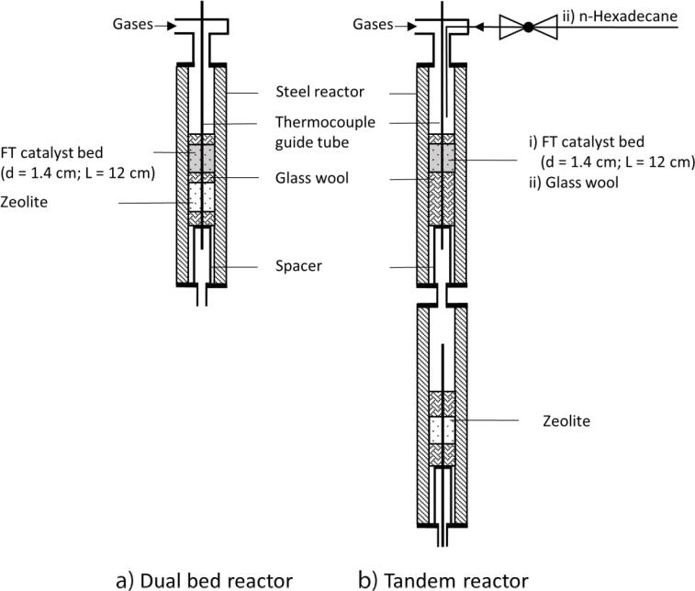

|  |
| --- |
| 15214125, 2023, 5, Downloaded from https://onlinelibrary.wiley.com/doi/10.1002/ceat.202200445 by Universitaet Bayreuth, Wiley Online Library on [03/11/2023]. See the Terms and Conditions (https://onlinelibrary.wiley.com/terms-and-conditions) on Wiley Online Library for rules of use; OA articles are governed by the applicable Creative Commons License |

with i is the carbon number of HC or carbon fraction (e.g., C3+4 = C3 + C4).

The conversion Xi was calculated using Eq. (5):

where i defines the carbon number of the HC and a the chain growth probability factor.

The logarithmic representation of Eq. (2) leads to Eq. (3), and the chain growth probability can be determined by the slope of the linear regression line of the measured mass frac-tion. For the calculation only the C3+-HCs are used, as meth-ane and C2 often do not follow the ASF distribution [32]. It must be made clear once again that the calculation of a can only be applied for mere FTS without zeolite cracking.

Research Article

at ambient temperatures and atmospheric pressure and has to be vaporized prior to reaction. For this, the upper reactor is only filled with glass wool and used as vaporizer at a tempera-ture of 350 LC. An HPLC pump was employed to feed the desired amount of n-hexadecane into the vaporizer.

2.3 Calculations

The carbon mass-based fraction of the chain product i is repre-sented by Eq. (2) defined as ASF distribution:



911

* Results and Discussion

3.1 Variation of FTS Reaction Temperature

|  |
| --- |
| 15214125, 2023, 5, Downloaded from |

wC;i ¼ i ai 1 ð1 aÞ2

|  |  |  |  |  |  |  |  |  |  |
| --- | --- | --- | --- | --- | --- | --- | --- | --- | --- |
| log | w C;i | ¼ i logða Þ þ log |  |  | 1 | a | 2 | ! |  |
|  |  | ð |  | Þ |  |  |
| i |  | a |  |  |  |

The carbon-related selectivity Si was calculated by Eq. (4):

mC;i

Si ¼

|  |  |  |  |  |  |
| --- | --- | --- | --- | --- | --- |
| ni;in | ni;out |  | mC;i;in mC;i;out | (5) |  |
| Xi ¼ |  | ¼ |  |  |
| ni;in | mC;i;in |  |



with i = CO, n-hexadecane.

The modified residence time t*zeolite is deter-mined by Eq. (6):

|  |  |  |  |  |
| --- | --- | --- | --- | --- |
| tzeolite* | ¼ | mzeolite | (6) |  |
| _ |  |
|  | Vtotalð p ; TÞ | |  |  |

The selectivities and the corresponding chain growth probabil-ity factors a for an increasing FTS temperature are illustrated in Fig. 3. Note that the results of FTS only without subsequent cracking are shown and a is therefore calculated for FTS only. Increasing the FTS temperature leads to a decrease of the LPG selectivity from 36.3 wtC % (210 LC) to 18.5 wtC % (270 LC) and an increase of the C5+ selectivity. As a result, the calculated a rises from 0.66 (210 LC) to 0.74 (270 LC) which do not agree

1. with the model obtained by Vervloet et al. [33] for the depen-dency of a with temperature. Their model describes the selec-tivity by the ratio of chain propagation and termination reac-tions which show a standard Arrhenius dependency with temperature, meaning a decrease in a with rising temperature. However, this model is very simple and does not take into account that other side reactions take place, such as the re-adsorption and chain propagation of olefins built in the FT reaction.

Primarily formed a-olefins can re-adsorb at the catalyst sur-face and initiate chain growth, forming HC chains that are indistinguishable from those formed from the direct reaction

of CO and H2 and eventually desorb as longer hydrocarbon

(3)

chains. Furthermore, it is postulated that an increased re-ad-sorption of olefins will decrease the total chain termination probability [34, 35]. The used Co/Mn catalyst shows a high selectivity for olefins (44 wtC % at 210 LC) and the rise of tem-perature obviously leads to enhanced re-adsorption and thus

1. chain propagation to longer HCs.

Taking only the FTS reaction into account, a lower tempera-ture and therefore a lower a value would be beneficial for a high LPG selectivity. However, if also a subsequent cracking reaction is taken into consideration, it would be advantageous

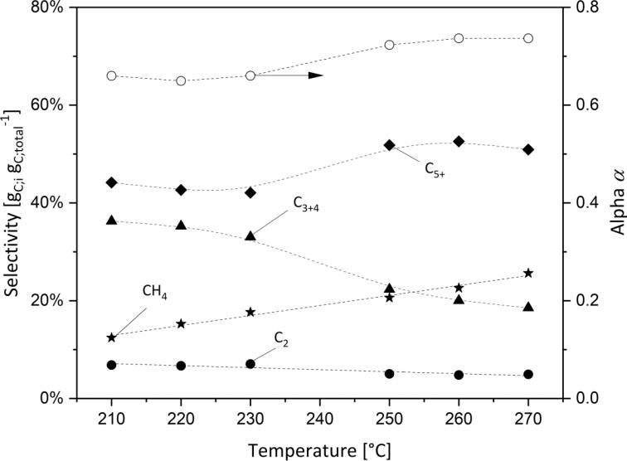

|  |
| --- |
| https://onlinelibrary.wiley.com/doi/10.1002/ceat.202200445 by Universitaet Bayreuth, Wiley Online Library on [03/11/2023]. See the Terms and Conditions (https://onlinelibrary.wiley.com/terms-and-conditions) on Wiley Online |

The carbon mass flow mC;i of each component i was calculated by Eq. (7):

|  |  |
| --- | --- |
| mC;i;liq: |  |
| mC;i ¼ mC;i;gas þ tcollection | (7) |

where tcollection is the time of product collection. The mass flow mC;i;gas of components in the gas phase was quantified by a defined mass flow of

cyclopropane introduced in the product gas flow.

The mass flow of the liquid products mC;i;liq: can be calculated by the mass of added cyclooctane and

the time of product collection.

Figure 3. Influence of temperature on HC selectivities of FTS only. Corresponding

a for each temperature is also shown (ptotal = 20 bar, pH2/pCO = 2, mcatalyst = 2.5 g (210–230 LC) or 0.19 g (240–270 LC), XCO = const. » 13 %).

|  |
| --- |
| Library for rules of use; OA articles are governed by the applicable Creative |

Chem. Eng. Technol. 2023, 46, No. 5, 908–917 ª 2023 The Authors. Chemical Engineering & Technology published by Wiley-VCH GmbH www.cet-journal.com

|  |
| --- |
| Commons License |

912

Table 1. HC selectivities of FTS compared with theoretical selectivities for the corresponding chain growth probability a according to ASF distribution. The a value was calculated using Eq. (3) and HC ‡ C3. Linear regression for the calcula-tion of a can be seen in Fig. S1 and Fig. S2.



Research Article

to drive the FTS to a higher a value to increase the yield of long-chain products available for cracking reactions. Therefore, a temperature of 260 LC (higher a value) was used for further FTS/zeolite experiments, i.e., for FTS combined with cracking.

|  |  |  |  |  |  |  |  |  |
| --- | --- | --- | --- | --- | --- | --- | --- | --- |
| Fig. 3 also depicts the selectivity of methane and | |  | a | Selectivity [wtC %] | |  |  |  |
|  |  |  |  |  |  |  |
| C2-HCs. Raising the temperature leads to a linear | |  |  | CH4 | C2 | C3+4 | C5+ |  |
| increase of the methane selectivity and decrease of |  |  |  |  |  |  |  |  |
|  | FTS (210 LC) | 0.66 | 12.4 | 6.8 | 36.3 | 44.2 |  |
| C2 selectivity. The formation of methane may be | |  |
|  |  |  |  |  |  |  |
| regarded as an independent reaction caused by an | | ASF distribution (a = 0.66) | 0.66 | 11.6 | 15.3 | 28.4 | 44.8 |  |
| increased termination probability of the chain reac- | | FTS (260 LC) | 0.74 | 22.6 | 4.8 | 20.0 | 52.6 |  |
| tion [36] or a reaction on special active sites [37]. | |  |
|  |  |  |  |  |  |  |
| The high reactivity of ethene (C2 ) is widely | | ASF distribution (a = 0.74) | 0.74 | 6.8 | 10.0 | 22.1 | 61.2 |  |
| acknowledged as the reason for the negative devia- | |  |  |  |  |  |  |  |
|  |  |  |  |  |  |  |
| tion of the C2 fraction from ASF distribution [35]. | |  |  |  |  |  |  |  |

|  |  |  |
| --- | --- | --- |
| It is re-adsorbed and incorporated in the formation of longer | Hence, even at a rather low temperature of 210 LC the alcohols |  |
| hydrocarbons. An increase in temperature therefore leads to an | are dehydrated to paraffins and olefins with equal carbon num- |  |
| increasing methane selectivity and decreasing C2 selectivity due | ber. |  |
| to enhanced re-adsorption. Both facts can lead to the already | There was also a significant number of branched HCs detect- |  |
| mentioned deviation of C1 and C2 from ASF distribution what | able after the zeolite bed (dual-bed mode), especially olefins. |  |
| can also be seen in Tab. 1. This deviation leads to higher selec- | This can be explained by reactions taking place at the zeolite |  |
| tivities for the C3+4-fraction (e.g., FTS (210 LC) 36.3 wtC %, ASF | surface. The 1-n-olefins adsorb at the acid sites of the zeolite |  |
| distribution 28.4 wtC %) than theoretically possible by ASF dis- | and are present as carbenium ions, which undergo hydride |  |
| tribution. | shift or type 2 isomerization [38]. These isomerized olefins can |  |
|  | desorb, isomerize again or be cleaved via type C cleavage. Since |  |
| 3.2 Product Composition at Varying Temperatures | isomerization and desorption are much faster than type C |  |
| cleavage, the latter plays a rather minor role at 210 LC. |  |
| for Dual Bed Setup | In Fig. 5, the HC distributions for (a) FTS and (b) FTS/zeo- |  |
|  | lite reaction is shown for a higher temperature of 260 LC both |  |
| To increase the selectivity for LPG, a Pt/H-ZSM-5 zeolite was | for FTS and cracking (compulsory for dual-bed mode). At this |  |
| inserted downstream of the FT catalyst, physically separated by | temperature, beside the isomerized olefins, also a significant |  |
| a layer of glass wool. The setup is denoted here as dual-bed set- | amount of branched paraffins occur in the product spectrum. |  |
| up. Within the experimental scatter of data, at a temperature of | These branched alkanes must have been formed by hydrogena- |  |
| 210 LC, there were no differences in chain length distribution | tion of previously formed branched alkenes on the Pt sites, due |  |
| visible for the dual-bed run (Fig. 4b) compared to FTS only | to the reaction pathway of bifunctional hydrocracking. Pt is |  |
| (Fig. 4a). However, no alcohols were present after the FTS | widely known to be a strong (de)hydrogenation catalyst, but its |  |
| products passed the zeolite in the dual-bed configuration. | activity seems here to be weakened, since a significantly higher |  |

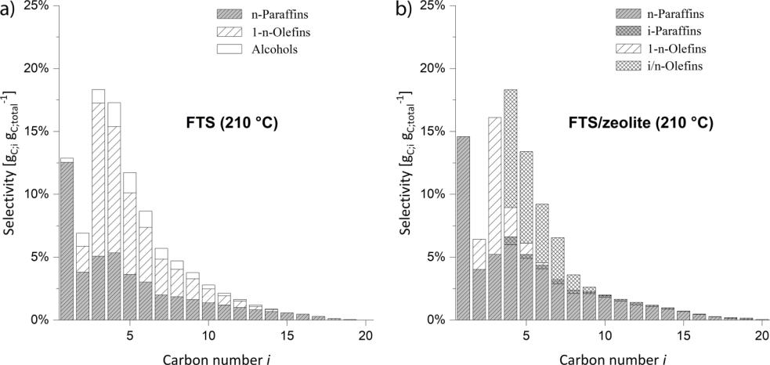

Figure 4. Comparison of HC distribution for (a) FTS at 210 LC and (b) FTS/zeolite in a dual-bed reactor at the same temperature. The denotation i-/n-olefins includes all branched and linear olefins except of the linear 1-olefins (ptotal = 20 bar, pH2/pCO = 2, mcatalyst = 2.5 g, mzeolite = 0.97 g, XCO = 12 %,

t*zeolite = 2.2 kgzeoliteh m–3).

Chem. Eng. Technol. 2023, 46, No. 5, 908–917 ª 2023 The Authors. Chemical Engineering & Technology published by Wiley-VCH GmbH www.cet-journal.com

|  |
| --- |
| 15214125, 2023, 5, Downloaded from https://onlinelibrary.wiley.com/doi/10.1002/ceat.202200445 by Universitaet Bayreuth, Wiley Online Library on [03/11/2023]. See the Terms and Conditions (https://onlinelibrary.wiley.com/terms-and-conditions) on Wiley Online Library for rules of use; OA articles are governed by the applicable Creative Commons License |



|  |  |
| --- | --- |
| Research Article | 913 |
|  |  |

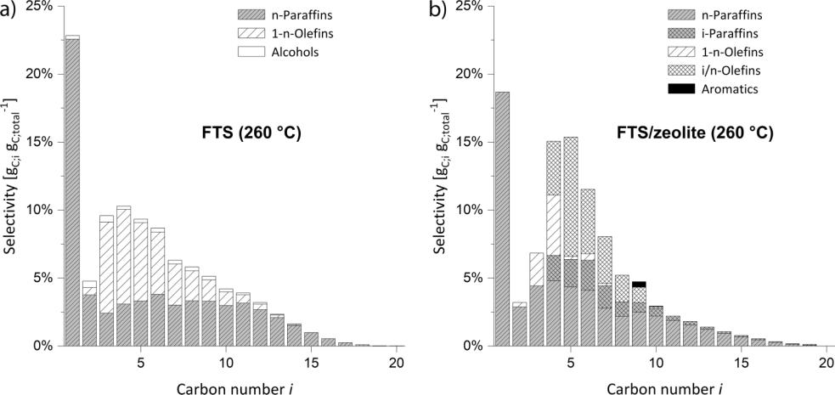

Figure 5. Comparison of HC distribution for (a) FTS at 260 LC and (b) FTS/zeolite in a dual-bed reactor at the same temperature (ptotal = 20 bar, pH2/pCO = 2, mcatalyst = 0.19 g, mzeolite = 0.97 g, XCO = 15 %,

t*zeolite = 1.3 kgzeoliteh m–3).

|  |
| --- |
| 15214125, 2023, 5, Downloaded from https://onlinelibrary.wiley.com/doi/10.1002/ceat.202200445 by Universitaet Bayreuth, Wiley |

proportion of alkenes is present in the product spectrum than according to the thermodynamic equilibrium.

Duyckaerts et al. observed that at syngas conditions in FTS/zeolite reactions, the CO inhibits the (de)hydrogenation functionality by CO poisoning of metal sites, leading to diver-gences in the reaction pathways compared to conditions with H2 only [31]. Furthermore, if the (de)hydrogenation activity is sufficiently high, long-chain products should no longer be pres-ent after passing the zeolite, since, from a thermodynamic point of view, the adsorption and conversion of olefins is more favorable with increasing chain length [39]. However, the selec-tivity of these long-chain hydrocarbons is almost unchanged compared to the FTS selectivity. From this it can be concluded that a weakening of the (de)hydrogenation component takes place.

Tab. 2 presents the HC selectivities for the temperature varia-tion in the range from 210 LC to 270 LC of FTS and FTS/zeolite in the dual-bed setup. Within the experimental scatter of data, the selectivities of the FTS reaction compared with the FTS/zeolite reaction remain unchanged. Since the reaction was performed in a dual-bed setup and both catalysts are in the same reactor, the temperature and residence time of the FT reaction and cracking could not be adjusted independently. To ensure a constant conversion of CO in the FTS, a high volume flow of CO is required due to an increased CO reaction rate at the high temperature of 270 LC. According to this, also the resi-dence time of primary FT products in the zeolite bed is reduced, which results in a decreased cracking rate. Because of the relatively low a values of the FTS, most primary FT prod-ucts are in the range of C1–C15. If it is also taken into account that the reaction rate during cracking is strongly dependent on the chain length and decreases sharply with decreasing length [39], it can be explained that the FT products are (almost) not cracked under the conditions in the dual-bed arrangement.

The acidity of the zeolite was proofed by NH3-TPD measure-ments showing two distinct NH3 desorption peaks indication acid centers at the catalyst surface (see Fig. S5). A general inac-tivity of the zeolite for cracking reactions can be excluded since

Table 2. HC selectivities of FTS and FTS/zeolite in a dual-bed setup.

|  |  |  |  |  |  |
| --- | --- | --- | --- | --- | --- |
|  | Temp. [LC] | Selectivity [wtC %] | |  |  |
|  |  | CH4 | C2 | C3+4 | C5+ |
|  | FTS only |  |  |  |  |
|  | 210 | 12.5 | 6.8 | 36.4 | 44.3 |
|  | 220 | 15.3 | 6.7 | 35.3 | 42.7 |
|  | 230 | 17.7 | 7.1 | 33.0 | 42.2 |
|  | 250 | 20.7 | 5.0 | 22.4 | 51.9 |
|  | 260 | 22.6 | 4.8 | 20.0 | 52.6 |
|  | 270 | 25.6 | 4.9 | 18.6 | 50.9 |
|  | FTS/zeolite |  |  |  |  |
|  | 210 | 14.6 | 6.4 | 34.4 | 44.6 |
|  | 220 | 15.9 | 6.6 | 34.3 | 43.2 |
|  | 230 | 18.0 | 6.2 | 31.0 | 44.8 |
|  | 250 | 16.6 | 3.2 | 22.1 | 58.1 |
|  | 260 | 18.7 | 3.2 | 21.9 | 56.2 |
|  | 270 | 22.5 | 4.0 | 22.9 | 50.6 |
|  |  |  |  |  |  |

the same catalyst shows cracking activity in the tandem reactor setup at elevated temperature (see Fig. 6).

The temperature in the dual-bed setup was limited to 270 LC to avoid a temperature runaway of the FT reaction and also excessive unwanted methane formation. Therefore, both reac-tions were separated in two different, independently heated reactors (tandem configuration, Fig. 2b). In this case, the reac-tion temperature of the zeolite bed could be increased further at constant lower FTS temperature.

|  |
| --- |
| Online Library on [03/11/2023]. See the Terms and Conditions (https://onlinelibrary.wiley.com/terms-and-conditions) on Wiley Online Library for rules of use; OA articles are governed by the applicable Creative |

Chem. Eng. Technol. 2023, 46, No. 5, 908–917 ª 2023 The Authors. Chemical Engineering & Technology published by Wiley-VCH GmbH www.cet-journal.com

|  |
| --- |
| Commons License |



|  |  |
| --- | --- |
| Research Article | 914 |
|  |  |

|  |
| --- |
| 15214125, 2023, 5, |

3.3 Product Composition at Constant FTS Temperature and Varying Cracking Temperature for Tandem Reactor Setup

For the tandem reactor setup both reactions (FTS and crack-ing) were carried out in two different reactors (see Fig. 2b). The FT reaction temperature was kept constant at 260 LC because of the high selectivity to long-chain HCs which can then be fur-ther cracked to achieve a higher overall LPG selectivity.

Fig. 6 depicts the selectivities for a varying cracking tempera-ture in a range of 260 LC to 450 LC. Up to a temperature of 360 LC, the (overall) selectivity of LPG increased from initially 26 wtC %, reflecting the value achieved by FTS only, to 42 wtC %. A further temperature rise did not significantly increase the LPG yield, but results in a strong increase in meth-ane selectivity. Also the selectivity for C2-HCs almost linearly increased with rising temperature. The additional formation of methane and C2 can be assigned to some superimposed Haag-Dessau [40] or thermal cracking at these high reaction temper-atures (> 360 LC). Methanation of the syngas can also be a rea-son for the additional methane formed. The preferable cracking temperature for this reaction setup regarding a high (overall) LPG yield is therefore 360 LC. Even though a higher tempera-ture decreases the C5+ selectivity, it also leads to an unwanted increase in C1 and C2 compounds due to thermal cracking, Haag-Dessau cracking or methanation.

Fig. 7 shows the distribution of HCs for the FTS base run at 260 LC (Fig. 7a) and the tandem reactor setup at a cracking temperature of 360 LC (Fig. 7b). Intensive cracking of the long-chain products of primary FTS can be observed because almost no HCs with a carbon number i higher than 10 were detected. Compared to the FTS experiment only, the selectivity towards olefins drastically drops after passing the zeolite. This indicates an increased hydrogenation reactivity of the Pt at 360 LC compared to 260 LC (see Fig. 5). In addition, since almost all C10+-HCs have now been cracked and paraffins must be acti-vated before they can react, this supports the assumption that the (de)hydrogenation activity strongly increases. The still large presence of C5 and C6 olefins and paraffins in the product

Figure 6. Selectivities for varying cracking temperatures at a con-stant FTS temperature (260 LC) for the tandem reactor setup. Filled data points show selectivities for only FTS reaction at 260 LC

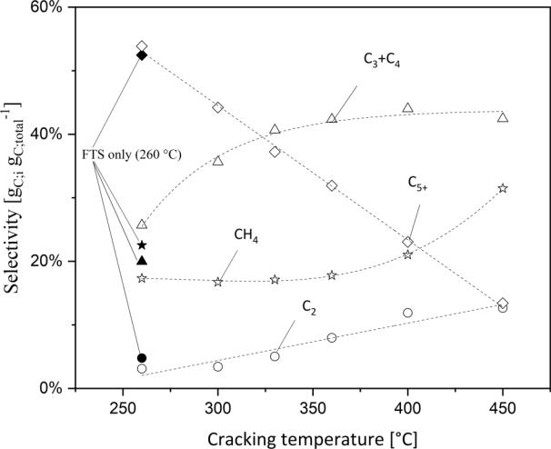

(ptotal = 20 bar, pH2/pCO = 2, mcatalyst = 0.19 g, mzeolite = 0.97 g, XCO = 15 %, t*zeolite (T) = 0.92 kgzeoliteh m–3 (450 LC) – 1.3 kgzeoliteh m–3

(260 LC)).

spectrum is attributed to bifunctional hydrocracking, in which HC with a chain length £ C6 are cracked very slowly. Also, a not negligible amount of aromatics were present in the product spectrum, originating from dehydrocyclization reactions.

3.4 Effect of Temperature on the Cracking of n-Hexadecane as Model Substance

To investigate the cracking reactions (only) in more detail and to find out the best conditions for a high cracking selectivity to LPG, n-hexadecane (n-C16) was used as model substance for long-chain FT products. Furthermore, the mechanisms of hydrocracking on the bifunctional Pt/H-ZSM-5 zeolite should

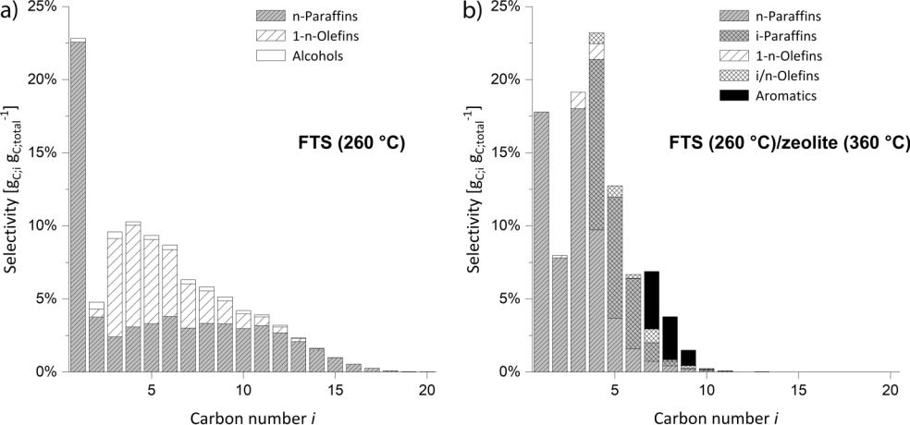

|  |
| --- |
| Downloaded from https://onlinelibrary.wiley.com/doi/10.1002/ceat.202200445 by Universitaet Bayreuth, Wiley Online Library on [03/11/2023]. See the Terms and Conditions (https://onlinelibrary.wiley.com/terms-and-conditions) on Wiley Online Library for rules of use; OA articles are governed by the |

Figure 7. HC distribution of (a) FTS only at 260 LC and (b) tandem reactor setup with cracking at 360 LC (ptotal = 20 bar, pH2/pCO = 2, mcatalyst = 0.19 g, mzeolite = 0.97 g, XCO = 15 %, t*zeolite = 1.3 kgzeoliteh m–3).

Chem. Eng. Technol. 2023, 46, No. 5, 908–917 ª 2023 The Authors. Chemical Engineering & Technology published by Wiley-VCH GmbH www.cet-journal.com

|  |
| --- |
| applicable Creative Commons License |



|  |  |
| --- | --- |
| Research Article | 915 |
|  |  |

|  |
| --- |
| 15214125, 2023, 5, |

be investigated to confirm the already obtained results of a decrease in the (de)hydrogenation activity.

Fig. 8 shows the HC distribution for the cracking at different temperatures. Even at the lowest temperature of 260 LC (con-version X = 51 %) the product pattern of cracking was asym-metric with a majority of the products in the C3–C5 region, in-dicating that secondary cracking already occurs. For ideal hydrocracking (pure primary cracking) a bell-shaped molar distribution curve would be characteristic [13]. These curves are obtained for catalysts with a strong (de)hydrogenation activity and large enough pores to ensure a rapid desorption of the primary cracked products.

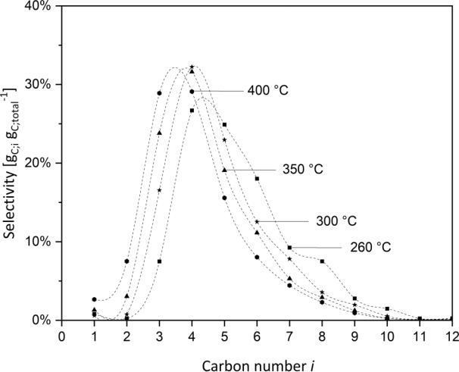

Figure 8. Distribution of HCs for different cracking temperatures

of n-hexadecane (ptotal = 20 bar, pH2/pCO = 2, pn–hexadecane = 0.14 bar, mzeolite = 0.97 g, Xn-hexadecane » const. = 51–65 %, t*zeolite = 0.26 kgzeoliteh m–3 (400 LC) – 2.84 kgzeoliteh m–3 (260 LC)).

selectivity to the C5+ products decreases with rising tempera-ture, indicating an increased secondary cracking of the HCs on the zeolite. However, since thermal or Haag-Dessau cracking is also favored with higher temperature and more C1 and C2 products are formed, a temperature of 350 LC is considered to be the optimum temperature for maximizing the LPG yield. These results are in good agreement with FTS/zeolite experi-ments presented in Fig. 6.

* Conclusions

It was found that a raise in temperature resulted in an increase of the chain growth probability a for FTS reaction on a Co/Mn catalyst. This also lowered the selectivity for the desired LPG. Since the maximal theoretical yield of LPG for FTS is limited due to the ASF distribution, a H-ZSM-5 zeolite was introduced for cracking longer HCs and by that, improving the overall LPG selectivity. In the dual-bed setup, i.e., at constant tempera-tures of FTS and cracking, the cracking reactions played only a minor role and did not further increase the LPG selectivity in a range of 210 LC to 260 LC. However, a certain conversion of FTS products, alcohol dehydration and isomerization of ole-fins, took place.

Integrating FTS and hydrocracking in a single reactor has the drawback that both catalysts must operate at the same tem-perature, i.e., at least in one case not at optimal reaction condi-tions. This problem can be circumvented by separating the combined reaction system in two separate reactors. A zeolite temperature of 360 LC was found to be optimal for achieving the highest overall selectivity for LPG of 42 wtC % with 260 LC for the upstream FTS. Besides bifunctional hydrocracking, also thermal and/or Haag-Dessau cracking contributed to cracking and C1 and C2-HCs were also produced to a small extent. In

|  |
| --- |
| Downloaded from https://onlinelibrary.wiley.com/doi/10.1002/ceat.202200445 by Universitaet Bayreuth, Wiley Online Library on [03/11/2023]. See the Terms and Conditions (https://onlinelibrary |

The deviation in shape of the product curve indi-cates a decrease of the (de)hydrogenation activity which could be already observed in FTS/zeolite experiments. This prolongs the residence time of carbocation intermediates on the acid sites of the catalyst, because of the lower number of olefins competing for active sites and secondary cracking reactions can then occur. Increasing the tempera-ture at a constant n-C16 conversion level shifted the maximum of the distribution curve to the left and also C1- and C2-HCs appear in significant amounts, indicating superimposed thermal or Haag-Dessau cracking at elevated temperatures. At increased temperatures also the slow type C b-scis-sions seems to take place and therefore decreases the C6 selectivity in favor of an increasing C3 selec-tivity.

Fig. 9 presents the selectivities for HCs at differ-ent cracking temperatures for the cracking of n-hexadecane at a constant conversion level. Up to a temperature of 350 LC, the selectivity for LPG increases and then remains fairly constant with further temperature increase. In the same way, the

Figure 9. Selectivities of HCs for different cracking temperatures of n-hexa-

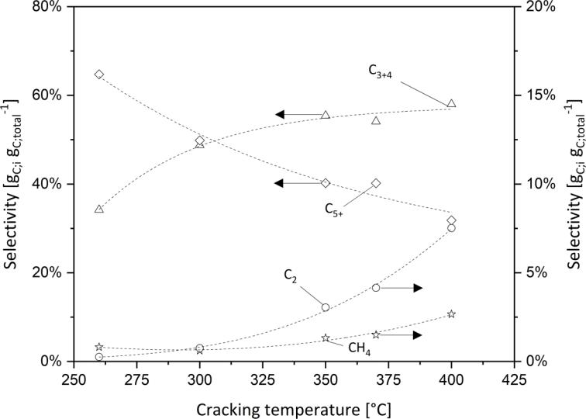

|  |  |  |  |
| --- | --- | --- | --- |
| decane (ptotal = 20 bar, pH2/pCO = 2, | | pn-hexadecane = 0.14 bar, | mzeolite = 0.97 g, |
| Xn-hexadecane | » const. = 51–65 %, | t*zeolite = 0.26 kgzeoliteh m–3 | (400 LC) – |
| 2.84 kgzeoliteh m–3 (260 LC)). | |  |  |

|  |
| --- |
| .wiley.com/terms-and-conditions) on Wiley Online Library for rules of use; OA articles are governed by the applicable Creative |

Chem. Eng. Technol. 2023, 46, No. 5, 908–917 ª 2023 The Authors. Chemical Engineering & Technology published by Wiley-VCH GmbH www.cet-journal.com

|  |
| --- |
| Commons License |



|  |  |
| --- | --- |
| Research Article | 916 |
|  |  |

|  |
| --- |
| 15214125, 2023, 5, |

addition, especially at higher temperatures, a not negligible amount of aromatics were formed.

To be able to investigate the cracking reactions independ-ently of the FTS product spectrum, experiments were carried out using n-hexadecane as a model cracking substance. This confirmed the results already obtained. Also a temperature of around 350 LC was found as optimum cracking temperature, because a further increase in temperature lowered the selectiv-ity of LPG due to the increased appearance of C1- and C2-HCs. Further studies are now conducted to evaluate the influence of CO and the gas compositions in general on the cracking reac-tions.

Supporting Information

Supporting Information for this article can be found under DOI: https://doi.org/10.1002/ceat.202200445. This section in-cludes additional references to primary literature relevant for this research [41–44].

Acknowledgment

The authors thank the Oberfrankenstiftung for financial sup-port. Open access funding enabled and organized by Projekt DEAL.

The authors have declared no conflict of interest.

Symbols used

|  |  |  |  |  |
| --- | --- | --- | --- | --- |
| d | [m] |  | diameter |  |
| dP | [m] |  | particle diameter |  |
| F | [–] |  | pore filling degree |  |
| L | [m] |  | length |  |
| m | [kg s–1] | | mass flow |  |
| m | [kg] |  | mass |  |
| n | [mol s–1] | | molar flow |  |
| p | [bar] | | pressure |  |
| S | [–] |  | selectivity |  |
| T | [LC] |  | temperature |  |
| _ | 3 | –1 | volume flow |  |
| V | [m s | ] |  |
| V | [m3] |  | volume |  |
| X | [–] |  | conversion |  |
| Greek letters | |  |  |  |
| a | [–] |  | chain growth probability factor |  |
| b | [–] |  | beta position |  |
| r | [kg m–3] | | density |  |
| t* | [kgzeoliteh m–3] | | modified residence time |  |
| w | [–] |  | mass fraction |  |

Sub- and superscripts

* carbon

i compound i

Abbreviations

ASF Anderson-Schulz-Flory

FTS Fischer-Tropsch synthesis

GC gas chromatography

HCs hydrocarbons

HPLC high-performance liquid chromatography H-ZSM-5 zeolite socony mobil-5 (hydrogen form)

LPG liquefied petroleum gas

PEM proton exchange membrane

References

* 1. Renewable Energy Sources and Climate Change Mitigation, Intergovernmental Panel on Climate Change, New York

2012.

* 1. M. E. Dry, Catal. Today 2002, 71 (3–4), 227–241. DOI: https://doi.org/10.1016/S0920-5861(01)00453-9
  2. P. Kaiser, R. B. Unde, C. Kern, A. Jess, Chem. Ing. Tech. 2013, 85 (4), 489–499. DOI: https://doi.org/10.1002/ cite.201200179
  3. Z. Gholami, Z. Tisˇler, V. Ruba´ˇs, Catal. Rev. 2021, 63 (3), 512–595. DOI: https://doi.org/10.1080/ 01614940.2020.1762367
  4. F. Fischer, H. Tropsch, Ber. Dtsch. Chem. Ges. 1926, 59 (4), 830–831. DOI: https://doi.org/10.1002/cber.19260590442
  5. A. Y. Krylova, Solid Fuel Chem. 2014, 48 (1), 22–35. DOI: https://doi.org/10.3103/S0361521914010030
  6. S. S. Ail, S. Dasappa, Renewable Sustainable Energy Rev.

2016, 58, 267–286. DOI: https://doi.org/10.1016/ j.rser.2015.12.143

* 1. D. Spohn, Energy & Management Powernews 2021, July 12.
  2. G. Henrici-Olive´, S. Olive´, Angew. Chem., Int. Ed. 1976, 15 (3), 136–141. DOI: https://doi.org/10.1002/ anie.197601361

1. N. O. Elbashir, C. B. Roberts, Ind. Eng. Chem. Res. 2005, 44 (3), 505–521. DOI: https://doi.org/10.1021/ie0497285
2. P. Lu, J. Sun, D. Shen, R. Yang, C. Xing, C. Lu, N. Tsubaki, S. Shan, Appl. Energy 2018, 209, 1–7. DOI: https://doi.org/ 10.1016/j.apenergy.2017.10.068
3. H. Kirsch, L. Bru¨bach, M. Loewert, M. Riedinger, A. Gra¨fen-hahn, T. Bo¨ltken, M. Klumpp, P. Pfeifer, R. Dittmeyer, Chem. Ing. Tech. 2020, 92 (1–2), 91–99. DOI: https://doi.org/ 10.1002/cite.201900120
4. A. V. Karre, A. Kababji, E. L. Kugler, D. B. Dadyburjor, Catal. Today 2012, 198 (1), 280–288. DOI: https://doi.org/ 10.1016/j.cattod.2012.04.068
5. Q. Zhang, K. Cheng, J. Kang, W. Deng, Y. Wang, ChemSusChem 2014, 7 (5), 1251–1264. DOI: https://doi.org/ 10.1002/cssc.201300797
6. S. Sartipi, M. Makkee, F. Kapteijn, J. Gascon, Catal. Sci. Technol. 2014, 4 (4), 893–907. DOI: https://doi.org/10.1039/ C3CY01021J
7. A. A. Adeleke, X. Liu, X. Lu, M. Moyo, D. Hildebrandt, Rev. Chem. Eng. 2020, 36 (4), 437–457. DOI: https://doi.org/ 10.1515/revce-2018-0012
8. R. L. Varma, N. N. Bakhshi, J. F. Mathews, S. H. Ng, Ind. Eng. Chem. Res. 1987, 26 (2), 183–188. DOI: https://doi.org/ 10.1021/ie00062a001

|  |
| --- |
| Downloaded from https://onlinelibrary.wiley.com/doi/10.1002/ceat.202200445 by Universitaet Bayreuth, Wiley Online Library on [03/11/2023]. See the Terms and Conditions (https://onlinelibrary.wiley.com/terms-and-conditions) on Wiley Online Library for rules of use; OA articles are governed by the applicable Creative |

Chem. Eng. Technol. 2023, 46, No. 5, 908–917 ª 2023 The Authors. Chemical Engineering & Technology published by Wiley-VCH GmbH www.cet-journal.com

|  |
| --- |
| Commons License |



|  |  |  |  |  |
| --- | --- | --- | --- | --- |
|  |  | Research Article |  | 917 |
|  |  |  |  |  |
| [18] | A. Freitez, K. Pabst, B. Kraushaar-Czarnetzki, G. Schaub, | | [31] | N. Duyckaerts, I.-T. Trotus˛, A.-C. Swertz, F. Schu¨th, G. Prie- |
|  | Ind. Eng. Chem. Res. 2011, 50 (24), 13732–13741. DOI: | |  | to, ACS Catal. 2016, 6 (7), 4229–4238. DOI: https://doi.org/ |
|  | https://doi.org/10.1021/ie201913s | |  | 10.1021/acscatal.6b00904 |
| [19] | K. Pabst, B. Kraushaar-Czarnetzki, G. Schaub, Ind. Eng. | | [32] | G. P. van der Laan, A. A. C. M. Beenackers, Catal. Rev. 1999, |
|  | Chem. Res. 2013, 52 (26), 8988–8995. DOI: https://doi.org/ | |  | 41 (3–4), 255–318. DOI: https://doi.org/10.1081/ |
|  | 10.1021/ie3030483 | |  | CR-100101170 |
| [20] | S. T. Sie, M. Senden, H. van Wechem, Catal. Today 1991, | | [33] | D. Vervloet, F. Kapteijn, J. Nijenhuis, J. R. van Ommen, |
|  | 8 (3), 371–394. DOI: https://doi.org/10.1016/ | |  | Catal. Sci. Technol. 2012, 2 (6), 1221. DOI: https://doi.org/ |
|  | 0920-5861(91)80058-H | |  | 10.1039/C2CY20060K |
| [21] | S. Wang, Q. Yin, J. Guo, B. Ru, L. Zhu, Fuel 2013, 108, 597– | | [34] | E. Iglesia, S. L. Soled, R. A. Fiato, G. H. Via, J. Catal. 1993, |
|  | 603. DOI: https://doi.org/10.1016/j.fuel.2013.02.021 | |  | 143 (2), 345–368. DOI: https://doi.org/10.1006/ |
| [22] | Y.-P. Li, T.-J. Wang, C.-Z. Wu, X.-X. Qin, N. Tsubaki, Catal. | |  | jcat.1993.1281 |
|  | Commun. 2009, 10 (14), 1868–1874. DOI: https://doi.org/ | | [35] | E. Iglesia, J. Catal. 1991, 129 (1), 238–256. DOI: https:// |
|  | 10.1016/j.catcom.2009.06.021 | |  | doi.org/10.1016/0021-9517(91)90027-2 |
| [23] | F. Botes, W. Bo¨hringer, Appl. Catal., A 2004, 267 (1–2), 217– | | [36] | B. W. Wojciechowski, Catal. Rev. 1988, 30 (4), 629–702. |
|  | 225. DOI: https://doi.org/10.1016/j.apcata.2004.03.006 | |  | DOI: https://doi.org/10.1080/01614948808071755 |
| [24] | S.-H. Kang, J.-H. Ryu, J.-H. Kim, I. H. Jang, A. R. Kim, G. Y. | | [37] | H. Schulz, K. Beck, E. Erich, in Studies in Surface Science |
|  | Han, J. W. Bae, K.-S. Ha, Energy Fuels 2012, 26 (10), 6061– | |  | and Catalysis (Eds: D. M. Bibby, C. D. Chang, R. F. Howe, |
|  | 6069. DOI: https://doi.org/10.1021/ef301251d | |  | S. Yurchak), Vol. 36, Elsevier, Oxford 1988. |
| [25] | K. M. Cho, S. Park, J. G. Seo, M. H. Youn, S.-H. Baeck, K.-W. | | [38] | P. Rausch, Hydrocracken von Fischer-Tropsch-Wachsen mit |
|  | Jun, J. S. Chung, I. K. Song, Appl. Catal., B 2008, 83 (3–4), | |  | Polyoxometallaten als Katalysator, Ph.D. Thesis, Universita¨t |
|  | 195–201. DOI: https://doi.org/10.1016/j.apcatb.2008.02.022 | |  | Bayreuth 2021. |
| [26] | A. Corsaro, T. Wiltowski, D. Juchelkova, S. Honus, Pet. Sci. | | [39] | K. Hedden, J. Weitkamp, Chem. Ing. Tech. 1975, 47 (12), |
|  | Technol. 2014, 32 (20), 2497–2505. DOI: https://doi.org/ | |  | 505–513. DOI: https://doi.org/10.1002/cite.330471202 |
|  | 10.1080/10916466.2013.845574 | | [40] | S. Kotrel, H. Kno¨zinger, B. C. Gates, Microporous Mesoporous |
| [27] | E. Blomsma, J. A. Martens, P. A. Jacobs, J. Catal. 1997, | |  | Mater. 2000, 35–36, 11–20. DOI: https://doi.org/10.1016/ |
|  | 165 (2), 241–248. DOI: https://doi.org/10.1006/ | |  | S1387-1811(99)00204-8 |
|  | jcat.1997.1473 | | [41] | J. G. Post, J. van Hooff, Zeolites 1984, 4 (1), 9–14. DOI: |
| [28] | J. Weitkamp, ChemCatChem 2012, 4 (3), 292–306. DOI: | |  | https://doi.org/10.1016/0144-2449(84)90065-4 |
|  | https://doi.org/10.1002/cctc.201100315 | | [42] | A. S. Al-Dughaither, H. de Lasa, Ind. Eng. Chem. Res. 2014, |
| [29] | A. Martinez, J. Rollan, M. Arribas, H. Cerqueira, A. Costa, | |  | 53 (40), 15303–15316. DOI: https://doi.org/10.1021/ |
|  | E. Saguiar, J. Catal. 2007, 249 (2), 162–173. DOI: https:// | |  | ie4039532 |
|  | doi.org/10.1016/j.jcat.2007.04.012 | | [43] | S. Ro¨ßler, C. Kern, A. Jess, Chem. Ing. Tech. 2018, 90 (5), |
| [30] | D. Schro¨der, J. Thiessen, A. Jess, J. Scholz, Catal. Sci. | |  | 634–642. DOI: https://doi.org/10.1002/cite.201700142 |
|  | Technol. 2020, 10 (2), 475–483. DOI: https://doi.org/ | | [44] | F. Po¨hlmann, C. Kern, S. Ro¨ßler, A. Jess, Catal. Sci. Technol. |
|  | 10.1039/C9CY02022E | |  | 2016, 6 (17), 6593–6604. DOI: https://doi.org/10.1039/ |
|  |  |  |  | C6CY00941G |

Chem. Eng. Technol. 2023, 46, No. 5, 908–917 ª 2023 The Authors. Chemical Engineering & Technology published by Wiley-VCH GmbH www.cet-journal.com

|  |
| --- |
| 15214125, 2023, 5, Downloaded from https://onlinelibrary.wiley.com/doi/10.1002/ceat.202200445 by Universitaet Bayreuth, Wiley Online Library on [03/11/2023]. See the Terms and Conditions (https://onlinelibrary.wiley.com/terms-and-conditions) on Wiley Online Library for rules of use; OA articles are governed by the applicable Creative Commons License |