Journal Pre-proof

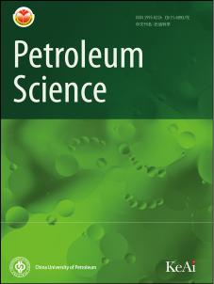

Risk assessment of Oil and Gas Investment environment in Countries along the Belt and Road Initiative

Bao-Jun Tang, Chang-Jing Ji, Yu-Xian Zheng, Kang-Ning Liu, Yi-Fei Ma, Jun-Yu Chen

PII: S1995-8226(23)00284-4

DOI: <https://doi.org/10.1016/j.petsci.2023.10.009>

Reference: PETSCI 650

To appear in: *Petroleum Science*

Received Date: 9 May 2023

Revised Date: 10 October 2023

Accepted Date: 10 October 2023

Please cite this article as: Tang, B.-J., Ji, C.-J., Zheng, Y.-X., Liu, K.-N., Ma, Y.-F., Chen, J.-Y., Risk assessment of Oil and Gas Investment environment in Countries along the Belt and Road Initiative, *Petroleum Science* (2023), doi: <https://doi.org/10.1016/j.petsci.2023.10.009>.

This is a PDF file of an article that has undergone enhancements after acceptance, such as the addition of a cover page and metadata, and formatting for readability, but it is not yet the definitive version of record. This version will undergo additional copyediting, typesetting and review before it is published in its final form, but we are providing this version to give early visibility of the article. Please note that, during the production process, errors may be discovered which could affect the content, and all legal disclaimers that apply to the journal pertain.

© 2023 The Authors. Publishing services by Elsevier B.V. on behalf of KeAi Communications Co. Ltd.



**Risk Assessment of Oil and Gas Investment environment in Countries along the Belt and Road Initiative**

Bao-Jun Tang a,b,c,d*, Chang-Jing Ji a,e , Yu-Xian Zheng a,b, Kang-Ning Liu a,b, Yi-Fei Ma a,b, Jun-Yu Chen a,b

1. *Center for Energy and Environmental Policy Research, Beijing Institute of Technology, Beijing 100081, China*
2. *School of Management and Economics, Beijing Institute of Technology, Beijing 100081, China*
3. *Collaborative Innovation Center of Electric Vehicles in Beijing, Beijing, China*
4. *Sustainable Development Research Institute for EconomyproofandSocietyBeijing, Beijing, China*
5. *Institute of Carbon Neutrality, ShanghaiTech University, Shanghai 201210, China*

* Corresponding author at: School of Management and Economics, Beijing Institute of Technology, Beijing 100081, China.

Tel.: +86 10 68918013.

*Email addresses:* [tbj@bit.edu.cn](mailto:tbj@bit.edu.cn) (Bao-Jun Tang)



**Abstract:** With the implementation of the Belt and Road Initiative, China is deepening its cooperation in oil and gas resources with countries along the Initiative. In order to better mitigate risks and enhance the safety of investments, it is of significant importance to research the oil and gas investment environment in these countries for China's overseas investment macro-layout. This paper proposes an indicator system including 27 indicators from 6 dimensions. On this basis, game theory models combined with global entropy method and analytic hierarchy process are applied to determine the combined weights, and the TOPSIS-GRA model is utilized to assess the risks of oil and gas investment in 76 countries along the Initiative rom 2014 to 2021. Finally, the GM (1,1) model is employed to predict risk values for 2022–2025. In conclusion, oil and gas resources and political facto s have the greatest impact on investment environment risk, and 12 countries with greater investment potential are selected through cluster analysis in conjunction with the predicted results. The research findings may provide scientific decision-making recommendations for the Chinese

government andJournaloilenterprisestostrengthen oil and gas investment cooperation with countries along the Belt d Ro d Initiative.

**Keywords:** Belt and R ad Initiative; Oil and Gas Investment; Risk Assessment

**1. Introduction**

The consumption of oil and natural gas in China continues to grow, while the nation's self-sufficiency in these resources is weak, resulting in a persistently high dependence on foreign sources. With the continuous development of China's economy, the demand for oil and gas is on an upward trend (as shown in Fig. 1), and in 2021, China's foreign dependence on oil and natural gas reached 72.2% and 46%, respectively. As a result, undertaking oil and gas investment cooperation and safeguarding energy supply security are crucial for China's economic development. The National Development and Reform Commission and the National Energy Administration jointly issued the "14th Five-Year Plan for Modern Energy System," which emphasizes the



need to consolidate and expand overseas energy resource security capabilities and enhance import diversification and security capabilities. Since 1993, Chinese oil companies have adhered to the "going global" strategy, achieving a series of results in oil and gas exploration and development, yet China's overseas oil and gas investments still face immense challenges.

Fig. 1. China's oil and gas supply and demand trends

At present, China's overseas exploration facesprooftherisksshrinking equity block areas and expiring contracts. For oil and gas fields with a primary cus on purchasing reserves, blocks with successful independent explo ati n have lower costs per barrel and higher benefits, making the success of independent ex loration crucial for overseas oil and gas projects (Dou et al., 2022). Taking China National Petroleum Corporation, which has the largest number of ove seas xploration blocks, as an example, the exploration block area during the peak years of 2007–2008 exceeded, while only

remaining by Journaltheendofthe13th Five-Year Plan, far below the level of major international companies. Moreover, fter reaching peak equity production of oil and

natural gas in 2029, the ove seas oil and gas production of the three major oil companies will decline sharply by 2035, and by 2040, equity production of oil and natural gas will be 35% and 54% of peak production, respectively (Dou et al., 2022). Therefore, China needs to acquire significant number of new projects in the future to maintain oil and gas production. Additionally, China's overseas exploration is adversely affected by the economic recession brought about by the COVID-19 pandemic, exacerbated trade protectionism, and other negative factors, significantly impacting oil and gas enterprises' overseas investments. Furthermore, there are notable differences in the oil and gas investment potential of resource-rich countries, with some facing obstacles from finance, policy, and geopolitics.

Since President Xi Jinping proposed the Belt and Road Initiative (BRI) in 2013, the countries along the initiative have gradually become the core oil and gas cooperation zones for Chinese oil enterprises overseas. Russia, Western Asia, and the Middle East,



situated in the world's "Oil Heartland," all lie within the scope of the Belt and Road Initiative, with the oil and gas production of countries along the Initiative accounting for over 60% of the world's total oil and gas production (Zhao et al., 2021). Therefore, assessing the risk of oil and gas investment environments in countries along the Belt and Road Initiative is of considerable importance for the macro-layout of overseas investments by Chinese oil enterprises in order to better mitigate risks and enhance investment safety. This paper is organized as follows: Section 2 provides a literature review, Section 3 details the methods and data, Section 4 presents the research process and results analysis, and Section 5 concludes with recommendati ns.

**2. Literature review**

Overseas oil and gas investment environment risk assessment research mainly focuses on risk identification and risk mod l construction. In terms of risk factor identification, there are many rating agencies worldwide that have conducted professional ratings and analyses of investment risks by constructing indicator systems. China's Academy of Social Sciences re eases the "China Overseas Investment Country Risk Rating Report" eve y year (Zhang et al., 2018), analyzing macro investment risks of various countries f om five aspects: economic foundation, political risk, China relations, social resilience, and debt repayment ability. The International Country Risk Guide (ICRG) released annually by the US International Reports Group evaluates 140 countries comprehensively through three types of risk indicators (e.g. political risk, financial risk, and economic risk) and their 22 variables (The PRS Group, 2023). However, these indicator systems are only applicable to national macro investment environments and do not consider the characteristics of the oil and gas industry. In constructing indicator systems for the oil and gas investment environment, the characteristics of oil and gas investment projects should be fully considered. Among the domestic and international indicator systems focusing on energy investment, the Fraser Institute proposes a mining investment environment evaluation system that mainly evaluates the potential policy index; the Behre Dolbear company proposes an oil investment environment evaluation system that mainly evaluates the political risks



affecting investment; China's Ministry of Land and Resources' "Global Mining Investment Environment Evaluation" considers investment environment from the aspects of accessibility of foreign investment in mining, investment security, and profitability (Chen et al., 2014); and Information Handling Services (IHS) builds an oil and gas exploration and exploitation attractiveness rankings from multiple perspectives such as politics, economy, oil and gas resources, and contracts. Generally speaking, the current construction of indicator systems mainly considers the impact of oil and gas resource risks (Zhou et al., 2020), economic risks (Hussain et al., 2020; Tang et al.,

2018), and political risks (Chen et al., 2021; Chenproofetal.,2016), and some research

includes environmental constraints for more comprehensive analysis (Li et al., 2020;

Hussain et al., 2020). However, although these indicat systems consider the specificity of oil and gas investment projects, they do not fully examine the bilateral relations between China and resource count i s, sulting in limited reference value for Chinese oil enterprises to carry out overseas oil and gas investment.

Existing literature classifies the methods used in risk assessment into three categories: qualitative, qua tit tive, nd integrated. In the early stages of overseas investment risk assessme t, scholars often used qualitative research methods. Later, scholars began to ad pt more scientific quantitative methods for research: Tafur et al. (2022) use AHP (Analytic Hierarchy Process) and TOPISIS (Technique for Order Preference by Similarity to an Ideal Solution) methods for comprehensive ranking of investment risks in the upstream oil sector of South American countries; Duan et al. (2018) evaluate overseas energy investment by a fuzzy integrated evaluation model based on the entropy weight. Zhao et al. (2021) rank the oil and gas resource cooperation of 28 countries along the BRI through an improved entropy-weighted TOPSIS method and uses cluster analysis to divide the cooperation risks into four levels; Duan (2021) applies the cloud parameter Bayesian network algorithm for dynamic assessment of oil and gas overseas investment risks in 10 countries. In recent years, to minimize the impact of "inconsistency of conclusions in multiple methods," evaluation methods tend to be combined. Yang (2020) combines the AHP fuzzy comprehensive evaluation method, principal component analysis method, entropy weight method and



improved fuzzy borda to evaluate the investment environment of overseas oil and gas exploration and development; Wang (2017) constructs an optimal weighted combined evaluation model of oil and gas investment environment based on seven single evaluation models.

Overall, existing research on the risk assessment of overseas investment environment still needs further improvement. First, in terms of the construction of overseas oil and gas investment systems, existing research lacks consideration of the overseas oil and gas investment environment from a Chinese perspective. Moreover, most research mainly revolves around the analysisproofgeplitical risks in resource countries, with less consideration for bilateral political relati ns, economic aspects of oil and gas contracts, etc. Second, in terms of evaluati n meth ds, most literature still adopts single evaluation methods for oil and gas investment environment risks, making it difficult to ensure the rationality of valuation conclusions. Third, oil and gas investment projects are long-term investments, and the research should fully consider

the time spanJournal.Currentresearchmainy focuses on the horizontal comparison or ranking of the oil and gas investme t e vironment in different countries, with relatively less

longitudinal comparison, maki g it difficult to reflect the changing trend of oil and gas investment risks int itively. Lastly, current research lacks predictions about the future development f the il and gas investment environment, with only a few scholars analyzing development trends from theoretical level.

Considering the limitations of existing literature, the key contributions of this paper are: (1) It improves the oil and gas investment environment risk assessment indicator system. By considering risk factors that measure bilateral relations, the article enhances the model's alignment with Chinese enterprises' overseas oil and gas investments, ultimately constructing an oil and gas investment environment risk assessment indicator system that includes five primary indicators and 27 secondary indicators. (2) It establishes a comprehensive evaluation model of the oil and gas investment environment for countries along the BRI. Based on global entropy value, analytic hierarchy process (AHP), TOPSIS model, and GRA model, the study constructs a combined evaluation model to address the inconsistency of evaluation



results caused by single evaluation methods. (3) It analyzes the dynamic evolution of oil and gas investment environment risks in countries along the BRI based on data from 2014 to 2021. (4) Using the grey prediction model, the article conducts short-term forecasts of the comprehensive risk values for each country from 2022 to 2025, providing a scientific basis for the future overseas oil and gas investment location selection of Chinese oil enterprises. (5) It carries out cluster analysis on preferred resource countries and proposes differentiated strategies for countries with different risk characteristics.

**3. Methods and Data**

In this section, an indicator system is constructed fi stly, and then we calculate the indicator weight by the game theory weighting model, which considers AHP and the global entropy method at the same time. Thirdly, it identifies the oil and gas investment environment risks by an integrated evaluation model which combines TOPSIS and GRA. Fourthly, based on evaluated risk values, it utilizes the grey prediction model forecasting country-specific risk v ues from 2022 to 2025.

**3.1 Construction of the i dicator system**

In this section, the indicator selection will be based on the literature analysis method, expert interview method, correlation analysis, and significant difference analysis to construct the risk assessment indicator system for the oil and gas investment environment in countries along the BRI. The construction process is shown in Fig. 2.

Fig. 2. Steps of indicator system construction

**3.1.1 Preliminary results of indicator selection based on literature analysis and**

**expert interview methods**

This study draws on research by authoritative institutions in recent years and literature related to domestic and international oil and gas investments to initially formulate alternative plans for the oil and gas investment environment risk assessment indicator system. This primarily refers to investment evaluation systems published by



authoritative institutions such as the Ministry of Land and Resources, Fraser Institute, mining consulting firm Behre Dolbear, U.S. International Reports Group, and the Chinese Academy of Social Sciences. By screening 37 literature pieces related to oil and gas investment environment risk assessment from domestic and foreign databases like CNKI and Web of Science, indicators used in the literature were classified and consolidated.1 Finally, indicators were combed through in terms of economic factors, political factors, China factors, resource endowment, and business environment, preliminarily sorting out a candidate indicator system including five primary indicators and 72 secondary indicators.

Considering that too many indicators would not only increase the difficulty of data search and tracking but also make it difficult to c mpare different countries (Streimikiene and Sivickas, 2008), experts in the oil and gas field were invited to select indicators based on their industry resea ch xp ri nce2 . Additionally, since existing literature pays less attention to the Chinese perspective when studying the risk assessment ofJournaloverseasoilandgas investment environments, some studies only measure Sino-foreign eco omic nd trade relations from aspects such as import and export trade volume, oil d gas exports, and direct investment, without fully considering bilateral p litical relations (Yan et al., 2017). This paper refers to the "bilateral political relati ns" indicator in the "China Overseas Investment Country Risk Rating Report" published annually by the Chinese Academy of Social Sciences (Zhang et al., 2018), and invites experts in the oil and gas field to score the political relations between each BRI oil and gas resource country and China, with the average score as the "bilateral political relations" indicator. The scoring range is [1,10], with higher scores indicating better political relations between the country and China, and vice versa. Ultimately, 29 secondary indicators were retained, taking into account expert feedback and data availability.

1. The keywords when we search literature are ((“oil investment” or “gas investment”) and “risk assessment”).
2. Our experts are senior researchers from CNOOC and Sinopec, which is the top 20 oil company in the world.



**3.1.2 Indicator selection results based on correlation analysis and significant**

**difference analysis**

In this section, the initially selected indicators are subjected to correlation analysis and significant difference analysis to avoid the repetition of information reflected by the indicators and ensure that the selected indicators have a significant impact on the evaluation results.

First, the correlation analysis results show that the correlation coefficients between

|  |  |  |  |
| --- | --- | --- | --- |
| the indices are mostly within the | range of [−0.5, 0.5], and the overall correlation | |  |
| between the indices is not very | proof | |  |
| strong (see Fig. A1). H wever, the correlation | |  |
| coefficients between "government revenue," "internal ate | | return for oil and gas |  |

contracts," and "net present value per barrel for investo s" a e all above 0.9, indicating a high degree of information duplication among the three, mainly because all three indicators are investment attractiveness ating indicators for oil and gas contract

profitability on the IHS website, with highly similar evaluation angles. In addition, the

exceed 0.9, but the correlation between the two indicators is still significant. This is

correlation coefficientJournalbetween"biteral trade volume" and " total GDP " does not

mainly because the st onger country's economic strength, the more active it will naturally be in the international trade market. Therefore, when constructing the indicator system, the ratio of "bilateral trade volume" to "total GDP", named as "bilateral economic and trade relations", is used as an indicator to measure the bilateral economic and trade relations between resource countries and China.

Secondly, the information reflected by the three indicators "government revenue," "internal rate of return for oil and gas contracts," and "net present value per barrel for investors" is repetitive. In order to retain the indicator with the most information content, these three indicators should be subjected to significant difference analysis, i.e., calculating the Gini coefficient between the indicators (Choudhury et al., 2020). The Gini coefficients of "government revenue," "internal rate of return for oil and gas contracts," and "net present value per barrel for investors" are 0.213, 0.184, and 0.194, respectively, indicating that the differences among resource countries in the



"government revenue" indicator are large. The information content of this indicator is better than that of "internal rate of return for oil and gas contracts" and "net present value per barrel for investors." Therefore, "government revenue" should be retained, and the other two indicators should be removed to simplify the oil and gas investment environment risk assessment indicator system.

**3.1.3 The indicator system for the evaluation of oil and gas investment risk**

Based on the literature analysis method and expert interview method for sorting out indicators and further screening using correlation analysis and significant difference analysis, a risk assessment indicator system for the oil and gas investment environment, including five primary indicators and 27 secondary indicat rs, is eventually constructed (Fig. 3).

Fig. 3. Oil and gas investment envi onm nt risk assessment indicator system 3.1.3.1 Political Environment

Due to theJournalgenerallylongproject cycle of oil and gas investments, a stable political situation plays crucial role in China's oil and gas investment projects, making the

political environment an importa t indicator for measuring the investment risk of oil and gas resource c ntries. This paper measures the political environment of resource countries through five sub-risk indicators: government stability, internal conflict, external conflict, corruption control, and the degree of democracy. Government stability is used to assess a country's government's execution ability of established plans and the stability of its regime; internal conflict is used to evaluate political conflicts in a country and the actual and potential impacts they cause; external conflict is used to assess the risks posed by other countries to a country's government, including non-violent external pressures (such as diplomatic pressure, cutting off aid, trade restrictions, territorial disputes, sanctions, etc.) and violent external pressures (such as full-scale wars triggered by border conflicts, etc.); corruption control is used to evaluate the corruption level of a country's political system; the degree of democracy reflects the government's response to public demands.



3.1.3.2 Economic Environment

Substantial capital flow is generated by oil and gas investments, and a robust economic environment provides support for these activities. Moreover, a well-developed economic system ensures the interests of investing countries and lowers investment risks. This study divides the economic environment risks into per capita GDP, GDP size, GDP growth rate, inflation risk, exchange rate risk, investment openness, and debt level. Per capita GDP, GDP size, and GDP growth rate are used to assess a country's economic development scale and potential. Inflation affects business

direct investment to its GDP. For host countries engagedproofininternational trade, a debt crisis would impact the investment secu ity of inv sting countries. Consequently, the

operating costs significantly, and exchange rates introduce uncertainty in project

financing costs. Therefore, evaluating resource-rich c untries' inflation risk and

exchange rate risk is essential. Investment openness is the atio a country's foreign

ratio of government debt to GDP is crucial in evaluating a country's financial burden capacity.

and China, consideringJournaltheperspective of overseas oil and gas investment risks from China. The China factor is measured through contracted foreign engineering projects,

3.1.3.3 China Factor

The success of Chi ese oil companies' overseas investments relies heavily on the

strength of dipl matic relations and the intensity of trade tensions. This study employs

the China fact to measure the bilateral relationship between resource-rich countries

bilateral economic and trade relations, "Belt and Road" index, and bilateral political relations. "Belt and Road" index represents the year when resource-rich countries joined the BRI. The time at which countries along the Belt and Road joined the initiative varies due to a variety of factors such as their individual economic development, political environment, and diplomatic relations with China. Countries usually joined initiative earlier if they have closer economic and diplomatic ties with China. Bilateral political relations are determined by expert assessments and scoring of political relationships between resource-rich countries and China in the oil and gas sector.

3.1.3.4 Resource Endowment



Oil and gas resources form the foundation for investing countries' oil and gas investments in resource-rich countries. This study uses oil and gas reserves, production, and undiscovered resources to measure resource endowment risks. By evaluating the oil and gas resources in resource-rich countries, the study assesses the potential and stability of oil and gas extraction.

3.1.3.5 Business Environment

|  |  |
| --- | --- |
| The business environment primarily measures the market competition level and | |
| policy restrictions for Chinese companies investing in overseas oil and gas projects. | |
| The lower the degree of monopoly in resource-rich countries, the more favorable the | |
| conditions for conducting oil and gas investments. This is measured by the number of | |
| companies investing in oil and gas projects in the c unt y. Waste emissions from | |
| resource development have long-term negative effects on the local environment. | |
| Therefore, environmental policy indicato s a introduced to assess the constraints | |
| faced by investments due to environmental | egulations (Dong et al., 2020). Access to |
| electricity reflects the local infrastructure | level. Business regulations, capital and |

personnel mobility restrictio s, d the legal and social order represent the threshold and protection for investme t e terprises in conducting business. Government income

reflects the revenue risks associated with oil and gas contracts in resource-rich countries.

**3.2 An Integrated evaluation model of oil and gas investment environment risk**

**3.2.1 Game theory combined weighting model to determine the indicator weight**

**3.2.1.1 Analytic hierarchy process**

The analytic hierarchy process (AHP) is a qualitative and quantitative decision-making method that decomposes elements related to decision-making into objectives, criteria, and alternatives. The method boasts systematic, flexible, and concise advantages and is widely applied in various research fields (He et al., 2021; Keshavarzi et al., 2020). The core principle of AHP is to judge the importance of each risk factor in an oil and gas investment risk level relative to the previous risk factor and to represent the human subjective judgment in numerical form using a reasonable scaling method. The most commonly used scaling method is the 1–9 scale method, which forms the



judgment matrix. Once the judgment matrix is formed, the maximum eigenvalue and its corresponding eigenvector can be calculated to obtain the relative importance weight value of a risk level for a particular risk element in the previous risk level.

**3.2.1.2 Global entropy method**

The entropy method is an objective weighting method based on the size of the information provided by the indicator observations to determine the weight of the indicators, typically using cross-sectional data for analysis. To dynamically analyze the oil and gas investment environment along the BRI countries, this study applies the global entropy method, introducing time series into the general cr ss-sectional data for dynamic risk assessment of the investment environment.

First, preprocess the raw data. For *n* resource count ies and *m* evaluation indicators, establish an initial global evaluation matrix *A* = (*xij* )*m n* . In the matrix, *xij* is the raw

data of indicator *j* for resource country *i*. To and dimensions on the evaluation, normalize

liminate the influence of indicator types *xij* for easier indicator comparison. This

study uses the extreme value method as the preprocessing method for its translation invariance, difference atio i variance, and interval stability properties.

For positive indicato s:

|  |  |  |  |  |  |  |  |  |  |  |  |  |
| --- | --- | --- | --- | --- | --- | --- | --- | --- | --- | --- | --- | --- |
|  |  |  |  | *xij* − min *xij* | | | |  |  |  | (1) |  |
|  |  |  |  |  | *j* |  | |  |  |  |  |
|  |  |  |  |  |  |  |  |  |  |
|  |  | max *xij* − min *xij* | | | | | |  |  |  |  |  |
|  |  |  |  | *j* | *j* | | |  |  |  |  |  |
| For negative indicators: |  |  |  |  |  |  |  |  |  |  |  |  |
|  |  |  |  | max *xij* − *xij* | | | |  |  |  | (2) |  |
|  |  |  |  | *j* |  |  |  |  |  |  |  |
|  |  |  |  |  |  |  |  |  |  |  |  |
|  |  |  | max *xij* | | − min *xij* | | |  |  |  |  |  |
|  |  |  |  | *j* | *j* | | |  |  |  |  |  |
| The normalized matrix *Bij* = (*yij* )*m n* | | | | | is obtained from Eqs. (1) and (2), where *yij* | | | | | | |  |
| is the normalized data of the *i*th country's *j*th indicator. | | | | | | | | |  |  |  |  |
| On this basis, the characteristic proportions | | | | | | | |  | of | | can be calculated. To |  |
|  |  |  |  |  |  |  |  |  |  |  |  |  |
| avoid zero values for, add 0.0001 uniformly to | | | | | | | |  | , as shown in Eq. (3): | | |  |
|  |  |  |  |  |  |  |  |  |  |  |  |  |
|  |  |  |  |  | *yt* + 0.0001 | | | |  |  |  |  |
| *pt* | = | |  |  | *ij* | | |  |  |  | (3) |  |
|  | *Tt*=1 *im*=1 ( *yijt* + 0.0001) | | | | | | |  |
| *ij* |  |  |  |  |  |



The information entropy of the indicator *j* can then be obtained:

|  |  |  |  |  |  |  |  |  |  |  |
| --- | --- | --- | --- | --- | --- | --- | --- | --- | --- | --- |
|  |  |  | 1 |  | *T m* |  |  |  |  |  |
| *e j* | = − |  |  | *p* | *t* | ln *p* | *t* |  |  |
| ln *mT* | | | *ij* | *ij* | (4) |  |
|  |  | *t* =1 *i*=1 |  |  |  |  |
|  |  |  |  |  |  |  |  |  |
| Using the information entropy | , the weight | | | | | | can be calculated: | |  |  |
|  | *j*= | |  | 1− *ej* | |  |  |  |  |  |
|  |  | | |  |  |  |  |  |
|  | *nj*=1 (1− *ej* ) | | |  |  |  | (5) |  |
|  |  |  |  |  |  |  |  |  |  |

**3.2.1.3 Game theory model**

To avoid the one-sidedness and arbitrariness of using a single method to determine

weights, this study constructs a game theory model with the Nash equilibrium as the

goal, treating the weight results obtained from AHP and the gl bal entropy method as the two parties in the game. By seeking the Nash equilib ium point of the two, the combined subjective and objective weights are calculated (Lai et al., 2015). Therefore, final weights reflect both the accuracy of obj ctive data and the reliability of expert experience judgment.

First, perform a consistency test. The essence of the game theory combined weighting is to integrate the results of the global entropy method and AHP in the assessment of oil and gas i vestment risk. Therefore, before using game theory for combined weighting, the weighting results of both methods must undergo a consistency test. The consistency degree of the results from different weighting methods can be

|  |  |  |  |  |  |  |  |
| --- | --- | --- | --- | --- | --- | --- | --- |
| represented by distance function: |  |  |  |  |  |  |  |
| Journal |  |  |  |  | 1 |  |  |
|  | 1 | *n* |  |  |  |  |  |
| 2 | 2 |  |  |
| *d* (*W*1*W*2 ) = | ( 1 *j* | − 2 *j* ) |  | (6) | |  |
| 2 |  |
|  | *j* =1 |  |  |  |  |  |

where 1 is the weight assigned by the entropy method; 2 is the weight assigned by AHP; 1  is the weight of the *i*th secondary investment risk indicator assigned by the entropy method; 2  is the weight of the *i*th secondary investment risk indicator assigned by AHP; the smaller the value of ( 1 2) , the higher the consistency between the two methods for overseas oil and gas indicator weighting results. It is considered to satisfy the consistency requirement when the value of ( 1 2) is less than 0.1 (Li et al., 2019).

To obtain the optimal weighting combination method, i.e., minimizing the



deviations between the game theory combined weighting result vector and the single method weighting result vector, the optimal weight coefficients are solved according to the following formula:

|  |  |  |  |  |  |
| --- | --- | --- | --- | --- | --- |
| *T* | − *k* | 2 | ( *k* =1, 2) | (7) |  |
| min*k k* |  |  |  |



1. =1

where ω is the combined weight vector of the entropy method and AHP; is the weighting result of a single method *k*; is the weight coefficient and is subject to the constraint that > 0 . After obtaining the optimal weight coefficient ( 1, 2 ), normalize the weight coefficients:

|  |  |  |  |  |  |
| --- | --- | --- | --- | --- | --- |
|  |  | *k* | | (8) |  |
| *k* | = | *k*2 | =1 *k* |  |
|  |  |

As a result, the comprehensive weight vector of oil and gas investment risk indicators is:

|  |  |  |  |  |
| --- | --- | --- | --- | --- |
| *=\**T*+\**T* | | | | (9) |
| 1 | 1 | 2 | 2 |  |

**3.2.2 TOPSISJournal-GRAmodeltonkthe investment environment risk**

The TOPSIS model measures the closeness of alternatives to positive and negative ideal solutions thro gh E clidean distance, while the GRA model employs grey relational coefficients to depict shape similarity between sequences. Both evaluation techniques have their merits and have been extensively applied in various domains. The comprehensive risk proximity of each resource country is weighted summation by results of TOPSOS and GRA, and the weights of different methods are based on decision-makers' preferences for location and shape. Their combination enables the assessment of alternative solutions in terms of both location and shape similarity, thus enhancing decision-making quality.

A shortcoming of the traditional TOPSIS model is its inability to accurately reflect the longitudinal changes in risk across different years due to the independence of ideal solutions (Ma and Jiang, 2022). To address this issue, this study integrates data from previous years in the selection of ideal solutions, ultimately facilitating the observation of longitudinal risk variations.

The weighted normalized matrix = ( ) × is obtained by multiplying each

column of the normalized matrix ***B*** representing the investment risk situation of

|  |  |  |  |  |  |  |  |  |
| --- | --- | --- | --- | --- | --- | --- | --- | --- |
| resource countries with the corresponding game-theoretic weight | | | | | | . Here, the product | |  |
| of the normalized data | *y* | *ij* | and the weight ∗ is denoted as | | | = | ∗. |  |
|  |  |  |  |  |  |  |  |
| Positive and negative ideal solutions + and − | | | | | are determined for each | | |  |
| secondary risk indicator, as shown in Eq. (10). | | | | |  |  |  |  |
|  | ***Z*** + = *z*1+ , *z* 2+ , | | | , *z n*+ , ***Z*** − = *z*1− , *z* 2− , | , *zn*− |  | （10） |  |
| where, *z* +*j* = max *z tj* , *z* −*j* | = max *ztj* ( *j* = 1, 2,..., *n*; *t* =1, 2,..., *T*) . | | | |  |  |  |  |
|  |  |  |  | (*zij* − *z*proof*j*) | | |  |  |
| After establishing the positive and negative ideal soluti | | | | | ns | r all indicators across | |  |



years, the Euclidean distances to the positive and negative ideal solutions can be computed for each resource country using Eqs. (11) and (12):

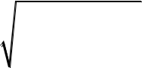

|  |  |  |  |  |  |  |  |
| --- | --- | --- | --- | --- | --- | --- | --- |
|  | *n* | + 2 |  |  |  |  |  |
| *d i*+ = | |  |  | （11） | |  |
|  | *j* =1 |  |  |  |  |  |  |
|  |  |  |  |  |  |  |  |
|  | *n* |  |  |  |  |  |  |
| *d i*− =(*zij* − *z*−*j* )2 | | | |  | （12） | |  |
|  | *j* =1 |  |  |  |  |  |  |
| The grey relational coefficient matrices | | ***A***+ = *aij*+ | | and | ***A***− = *aij*− | , |  |
|  |  |  | *m n* | | *m n* | |  |

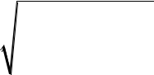

describing the relationships between each resource country and the positive and negative ideal s luti ns + and − , are calculated using Eqs. (13) and (14):

|  |  |  |  |  |  |  |  |  |  |  |  |  |  |  |  |  |  |  |  |  |  |  |  |
| --- | --- | --- | --- | --- | --- | --- | --- | --- | --- | --- | --- | --- | --- | --- | --- | --- | --- | --- | --- | --- | --- | --- | --- |
|  | min min | |  |  |  | *x*+ | − *x* |  |  | + max max | | | | |  |  | *x*+ | − *x* | |  | |  |  |
|  |  |  |  |  |  |  | |  |
| *a*+ = | *j* | *i* |  |  |  | *j* | *ij* |  |  |  | *j* | | *i* | |  |  | *j* | *ij* | |  | |  |  |
|  |  |  |  |  |  |  |  |  |  |  |  |  |  |  |  |  |
| *ij* |  | *x* + − *x* | | | | | + max max | | | | | | *x* + − *x* | | | | |  |  |  |  |  |  |
|  |  |  |  |  |  |  |  |
|  |  | *j* |  |  |  | *ij* |  |  |  | *j* | *i* | | *j* | |  |  | *ij* |  |  |  |  |  |  |
|  |  |  |  |  |  | *x* − |  |  |  |  |  |  | *x* − | |  |  |  |  |  |  |
|  | min min | | |  | | − *x* |  |  | + max max | | | |  | | − *x* |  |  |  |  |  |
|  |  | |  |  |  | |  |  |  |
| *a*− = | *j* | *i* |  |  |  | *j* | *ij* |  |  |  | *j* | | *i* |  |  |  | *j* | *ij* |  |  |  |  |  |
|  |  |  |  |  |  |  |  |  |  |  |  |  |  |  |  |  |  |
| *ij* |  | *x* − − *x* | | | | | + max max | | | | |  | *x* − − *x* | | | | |  |  |  |  |  |  |
|  |  |  |  |  |  |  |  |  |
|  |  | *j* |  |  |  | *ij* |  |  |  | *j* | *i* |  | *j* | |  |  | *ij* |  |  |  |  |  |  |
|  |  |  |  |  |  |  |  |  |  |  |  |  |  |  |  |  |  |  |  |  |  |

（13）

（14）

The distinguishing coefficient , with a range of [0,1], is set to 0.5 in this study. Grey relational degrees *ri* + and *ri* − , reflecting the proximity of each resource

country to the positive and negative ideal solutions, are determined as per Eqs.(15) and (16):



|  |  |  |  |  |  |
| --- | --- | --- | --- | --- | --- |
|  |  | 1 | *n* |  |  |
| *ri* + = | | *aij*+ | （15） |  |
| *n* |  |
|  |  | *j* =1 |  |  |
|  |  | 1 | *n* |  |  |
| *ri* − = |  | *aij*− | （16） |  |
|  | *n* |  |
|  |  | *j* =1 |  |  |

To account for the different result ranges of the TOPSIS and GRA methods, the euclidean distances and grey relational degrees are dimensionless-processed for each resource country using Eqs. (17), (18), (19), and (20):

|  |  |  |  |  |  |  |  |  |  |  |  |
| --- | --- | --- | --- | --- | --- | --- | --- | --- | --- | --- | --- |
| *R*+ = | | | | *r* + | | | | |  |  |  |
| *i* | |  |  |  |  | （17） |  |
| max *r* + | | | | |  |  |
| *i* | | | |  |  |  |
|  |  |  |  | *i* | | | | |  |  |  |
| *R*− = | | |  | *r* − | | | | |  |  |  |
|  | *i* |  | |  |  |  | （18） |  |
|  | max *r* − | | | | |  |  |
| *i* | | | |  |  |  |
|  |  |  |  | *i* | | | | |  |  |  |
| *D*+ = | |  | | *di*+ | | | |  |  | （19） |  |
|  | | max *d* + | | | | |  |  |
| *i* | | | |  |  |  |
|  |  |  |  | *i* | | | | |  |  |  |
| *D* − = |  | | | *di*− | | |  | |  | （20） |  |
|  | | | max *d* − | | | | |  |  |
| *i* | | | |  |  |  |
|  |  |  |  | *i* | | | | |  |  |  |
| where dimensionless-processed grey relational degrees are represented as | | | | | | | | | *R*+ | and *R*− , |  |
|  |  |  |  |  |  |  |  |  | *i* | *i* |  |

and dimensionless-processed Euclidean distances are represented as *Di*+ and *Di*− .

The comprehensive risk proximity of each resource country is constructed using

Eqs. (21) and (22):

|  |  |  |  |  |
| --- | --- | --- | --- | --- |
| *T* | += *D*−+ *R*+ | | | （21） |
| *i* | 1 *i* | 2 | *i* |  |
| *T* | −= *D*++ *R*− | | | （22） |
| *i* | 1 *i* | 2 | *i* |  |

where 1 and 1 indicate the decision-makers' preferences for location and shape,

|  |  |  |
| --- | --- | --- |
| and 1 + 2 = 1. Decision-makers can set 1 and | 1 | according to their preferences. |
| In this study, values are set as 0.5 for each. +and | − | represent the proximity of the |
|  |  |  |
| resource country to the positive and negative ideal solutions, respectively. | | |
| Finally, the relative proximity of each resource country is calculated using Eq. (23): | | |
| *S i* = *Ti* + / (*Ti* + + *Ti* − ) | | （23） |

where denotes the proximity of the sample to the positive ideal solution in terms of distance and shape. Smaller values of indicate closer proximity to the positive ideal



solution, implying lower oil and gas investment risk for the resource country.

**3.2.3 GM (1,1) Model to forecast the investment environment risk**

The GM (1,1) (grey prediction model) can filter or eliminate irregular fluctuations in empirical analysis sample sequences, reflecting trend characteristics and predicting future trends. As a dynamic system of quasi-differential equations, the grey prediction model essentially accumulates original data once, generating data sequences with specific patterns. A first-order differential equation model is then constructed, yielding a fitting curve for system predictions (Gu et al., 2016).

To establish the GM (1,1) model, a level ratio test must be per ormed on the time

|  |  |  |  |  |  |  |
| --- | --- | --- | --- | --- | --- | --- |
|  | − | 2 |  | 2 |  |  |
| series. If all level ratio values fall within (e | *n* + 2 , e *n*+2 ) , the data is suitable for model | | | |  |
|  |  |

construction. If the level ratio test is not passed, a "translation transformation" is applied to the sequence, ensuring the transform d s quence meets the level ratio test

|  |  |  |  |  |
| --- | --- | --- | --- | --- |
| requirements. The calculation formula for | | is giv n in Eq. (24). |  |  |
| *λ* = | *x* 0 ( *k* −1) | ; *k* = 2,3,..., *n* | （24） |  |
| *x* 0 ( *k*) |  |
|  |  |  |  |

In this study, all level atio values for different regional time series sequences are within the range (0.67, 1.492), indicating the original sequences are suitable for grey prediction model c nstr ction.

Before constructing the grey prediction model, the original time series data must be processed to weaken its randomness. The processed data is called a generated

|  |  |
| --- | --- |
| sequence. For an original sequence (0) and a newly generated sequence | (1) that |
| satisfy Eq. (25): |  |
| *k* |  |
| *x*(1) ( *k* ) =*x*(0) (*i*); *k* = 1, 2,3,..., *n* | （25） |
| *i*=1 |  |

where *X* (0) = ( *x* 0 (1), *x* 0 (2),..., *x* 0 ( *n*)), *X* (1) = ( *x*1 (1), *x*1 (2),..., *x*1 ( *n*)) is known as the first-order accumulated generation, denoted as 1-AGO (Accumulating Generation Operator). Accumulated generation involves successively accumulating data from the original time series to create a new generated sequence.

The GM (1,1) model primarily constructs a differential equation model for the new



generated data sequence, derives the time response function of the differential equation, performs inverse calculation using the accumulated subtraction method, and finally recovers the original data sequence to obtain the prediction model. The specific calculation steps are as follows:

First, define the grey derivative of (1) as:

|  |  |
| --- | --- |
| *d* ( *k* ) = *x* (0) ( *k* ) = *x* (1) ( *k* ) − *x* (1) ( *k* −1) | （26） |

Let (1)( ) be the adjacent value generation sequence of sequence (1), that is:

|  |  |
| --- | --- |
| *z* (1) ( *k* ) = *ax* (1) ( *k* ) + (1 − *a* ) *x* (1) ( *k* −1) | （27） |

The GM (1,1) grey differential equation model is defined as Eq. (28):

|  |  |
| --- | --- |
| *x* (0) ( *k* ) + *az* (1) ( *k* ) = *b* | （28） |
| In the above equation, (0) is the grey derivative, *a* represents the development | |
| coefficient of the sequence's development patt n and trend, | (1)( ) is the whitening |

background value, and *b* is the grey action quantity reflecting the sequence's changing

|  |  |  |  |  |  |  |  |  |  |  |  |  |  |  |
| --- | --- | --- | --- | --- | --- | --- | --- | --- | --- | --- | --- | --- | --- | --- |
| relationships. | *Journal* | | |  |  |  |  |  |  |  |  |  |  |  |
|  |  |  |  |  |  |  |  |  |  |  |  |  |  |
| Introduce vector matrix | |  | ot tion: | |  |  |  |  |  |  |  |  |  |  |
|  | = |  |  | *x* ( 0) 2 | | | | −*z*(1) (2) | | | | 1 |  |  |
|  | ,*Y* = *x* | | ( 0) | 3 | | , *B* = | −*z* | (1) | (3) | 1 |  |  |
|  |  |  |  |  |  |  |  |  |  |  |  |  |
|  |  |  |  |  | | |  |  |  | | | 1 | (29) |  |
|  | *b* | |  |  |
|  |  |  |  | *x* | ( 0) *n* | |  |  | −*z* (1) ( *n*) | | | 1 |  |  |
|  |  |  |  |  |  |  |  |  |  |  |  |  |  |  |
| Thus, the GM (1,1) model can be represented as Eq. (30): | | | | | | | | | | | |  |  |  |
|  |  |  |  |  | *Y* = *B***u** | | | |  |  |  |  | （30） |  |

Using the least squares method, the estimated value of *a* and *b* can be obtained:

|  |  |  |  |  |
| --- | --- | --- | --- | --- |
| *a* | | −1 |  |  |
| ˆ | = (*BTB*) |  |  |  |
| *u*ˆ = ˆ |  | *B T Y* |  |
| *b* |  |  |  |  |

Lastly, the whitening model is obtained:

d*x* (1) ( *t*) + *ax* (1) ( *t* ) = *b*



d*t*

The solution can be derived:

（31）

（32）



|  |  |  |  |  |  |  |  |  |  |  |  |  |
| --- | --- | --- | --- | --- | --- | --- | --- | --- | --- | --- | --- | --- |
|  | (1) |  | ( 0) |  |  | *b* | | − *a* ( *t* −1) |  | *b* |  |  |
| *x* |  | ( *t* ) = *x* |  | (1) | − |  | e |  | + |  | （33） |  |
|  |  |  |  | *a* |  |
|  |  |  |  |  |  | *a* | |  |  |  |  |

Finally, the observation prediction value is obtained as per Eq. (34):

|  |  |  |  |  |  |  |  |  |  |  |  |  |  |
| --- | --- | --- | --- | --- | --- | --- | --- | --- | --- | --- | --- | --- | --- |
|  | (1) |  | ( 0) |  |  | *b* | | −*ak* |  | *b* |  |  |  |
| *x*ˆ |  | (*k* + 1) = *x* |  | (1) | − |  | e |  | + |  | ; *k* = 0,1,......, *n* | （34） |  |
|  |  |  |  | *a* |  |
|  |  |  |  |  |  | *a* | |  |  |  |  |  |

**3.2.4 Data Sources**

The data sources for this study are diverse (see Table A1). Indicators measuring political factors mainly come from the ICRG reports released by the PRS Group. Economic indicators are sourced from the WorldproofBank,Heritage Foundation, and National Bureau of Statistics. Oil and gas resource indicat rs c me from EIA, IHS, and others. Business environment indicators are sourced om the Fraser Institute, BTI, and more. The "bilateral political relations" are obtained through expert panel scoring. Due to the large number of indicators, there Preasomemissing values for individual countries. In this study, the median imputation method is used for data processing.

By the end of 2021, China h s signed BRI cooperation documents with more than 140 countries around the world. B sed on data availability and oil and gas resource potential, this study selects 76 countries as the research subjects (see Table 1).

Table 1. Selected countries along the BRI

|  |  |  |
| --- | --- | --- |
| Areas | Countries |  |
|  |  |  |
| Middle East | Saudi Arabia, Iran, UAE, Qatar, Iraq, Turkey, Kuwait, Oman, |  |
| Lebanon, Bahrain, Yemen |  |
|  |  |
| Central Asia - Russia | Russia, Kazakhstan, Uzbekistan, Azerbaijan, Turkmenistan |  |
| Central and South America | Venezuela, Chile, Peru, Guyana, Trinidad and Tobago, Argentina, |  |
| Uruguay, Suriname, Ecuador, Bolivia |  |
|  |  |
|  | New Zealand, Malaysia, Indonesia, Sri Lanka, Philippines, Cambodia, |  |
| Asia-Pacific | Thailand, Pakistan, Mongolia, Brunei, Bangladesh, Papua New |  |
|  | Guinea, Myanmar |  |
|  | Morocco, South Africa, Nigeria, Gabon, Namibia, Algeria, |  |
|  | Madagascar, Kenya, Egypt, Ethiopia, Côte d'Ivoire, Congo |  |
| Africa | (Brazzaville), Mauritania, Ghana, Cameroon, Chad, Tunisia, Angola, |  |
|  | Liberia, Congo (Kinshasa), Tanzania, Niger, Uganda, Guinea-Bissau, |  |
|  | Libya, Mozambique, Sudan, Senegal |  |

Bulgaria, Romania, Italy, Poland, Czech Republic, Hungary, Croatia,

Europe

Albania, Ukraine

**4 Results and Discussion**

**4.1 Oil and gas resource and political factors are the key factors of investment environment risks**

The analytic hierarchy process requires experts to compare and score the risk indicators of the BRI countries' oil and gas investment environment. Considering the specificity of the petroleum industry, this study invites three oil and gas experts who have long been engaged in overseas oil and gas resource investment research to form an expert panel to score the risk indicators. After o ganizing and analyzing the expert evaluation opinions and discussing and adjusting with ex e ts repeatedly, the values of each judgment matrix are less than 0.1, i. ., passing the consistency test, and then obtaining the subjective weight of the isk ass ssment indicator system for the BRI countries' oil and gas investment environment.

Before usingJournalthegametheorymodel, we first conduct a consistency test on the

weights obtained by the lytic hierarchy process and the global entropy method, respectively. The distance of the weights of each indicator is 0.0857 (less than 1), which passes the consistency test, and we can proceed with the weight combination. The calculation results are shown in Fig. 4.

Fig. 4. Index weight value determined by game theory model（the Top figure shows the weights of first-level indicators and the bottom figure shows the weights of second-level indicators）

According to the combined weight results, oil and gas resources and political factors have the most significant impact on investment risk assessment among the primary indicators. Among the secondary indicators, besides oil and gas resources, government stability, “Belt and Road” Index, and internal conflicts have the highest proportions. The weight calculation results show that countries with a better oil and gas investment environment often have advantages such as richer resources, closer



economic and trade relations with China, a more stable government, and favorable contracts.

**4.2 Evolution of oil and gas investment environment risks**

This study evaluates the oil and gas investment environment of 76 BRI countries using data from 2014 to 2021. The smaller the score of the resource country, the lower the risk of its oil and gas investment environment. Fig. 5 depicts the dynamic evolution of oil and gas investment environment risks. From 2014 to 2016, there was a general leftward shift, mainly due to increased investments in the oil and gas industry by countries after the BRI was proposed in 2013 and facilitated by the global economic recovery. The overall oil and gas investment environment impr ved. However, from 2017 to 2021, a general rightward trend emerged, indicating that the overall risk of overseas oil and gas investment environment increased during this period, mainly due to intensified geopolitical conflicts andPretheoutbr ak of the pandemic, which raised overall oil and gas investment risks. Simila results were also found by Deloitte (2021)

and the PHBSJournalThinkTank(2022).

Fig. 5. Evolution of il a d gas investment environment risks in the BRI Countries

from 2014 to 2021

Based on the average composite risk values from 2014 to 2021, the BRI countries' investment environment risk levels are divided into low, medium, high, and extremely high-risk levels at ratios of 15%, 35%, 35%, and 15% 3 , respectively. The spatial differences in risk levels are shown in Fig. 6. Low-risk countries are mainly located in regions with abundant oil and gas resources. Among them, leading oil and gas resource countries such as Russia, Saudi Arabia, Iran, Qatar, and the United Arab Emirates generally have extensive experience in oil and gas exploration and development cooperation. Extremely high-risk countries are mostly located in Africa, where

1. The allocation of risk levels depends on the distribution characteristics of investment risk. It is a

fat-tailed distribution, which means that the probability density in the central part is higher than that at both ends, and the probability density at both ends decreases more slowly than that of a normal distribution charect. Besides, we also consider the investors’ tolerance, consulting experts from Cnooc and Sinopec.



exploration conditions are poor and domestic and international situations are turbulent, including Tanzania, Libya, Sudan, Guinea-Bissau, Bolivia, and Yemen.

Fig. 6. Spatial differences in oil and gas investment environment risk levels of the BRI Countries from 2014 to 2021

**4.3 Short-term oil and gas investment environment risk forecast**

Due to the long investment cycle of oil and gas, Chinese oil companies should fully consider the future investment situation of resource countries when making overseas investments. Currently, most studies on the risk assessment of overseas oil and gas investment environments are based on cross-secti nal data, and some studies only consider historical data when conducting dynamic analysis. However, in fields such as urban comprehensive carrying capacity and industrial development level, many studies have scientifically predicted the future bas d on historical comprehensive evaluation

results (PengJournalet.,2018;Jiangetal.,2021). Among them, the GM (1,1) model (grey prediction model) has the adv nt ge of low data requirements and is more suitable for

small sample prediction esearch (Mao and Chirwa, 2006). Therefore, this study conducts a grey prediction analysis of the oil and gas investment environment risks of BRI countries fr m 2022 to 2025 based on the risk assessment results of each country's oil and gas investment environment from 2014 to 2021. The results show that the ratio values of all risk value sequences are within the interval (0.982, 1.0098), indicating that the original risk value sequence is suitable for constructing a grey prediction model. At the same time, this study uses the relative error value to verify the accuracy and fitting effect of the grey prediction. The results show that the relative error test of all resource country risk value sequences is less than 20%, indicating that the prediction model has satisfactory accuracy. The forecast results of the comprehensive oil and gas investment environment risk for each country are shown in Table 2.

To depict the short-term dynamic evolution of oil and gas investment environment risks in resource-rich countries along the BRI from 2022 to 2025, kernel density estimation is also employed to analyze the data in Table 2. This study conducts kernel



density analysis on the overall oil and gas investment risk trends of 76 oil and gas resource countries from 2022 to 2025, as shown in Fig. 7. The results indicate that the overall oil and gas investment risks in the future will exhibit a trend of shifting peaks to the right and decreasing, signifying that the gap in the oil and gas investment environment among countries will widen from 2022 to 2025, with overall environmental risks increasing, mainly because of slow economic recovery and increased geopolitical uncertainty. The report from Deloitte (2021) also indicated that the increasing economic and political uncertainty enhance the risks of oil and gas investment during 14th Five Year.

Fig. 7. Evolution trend of oil and gas investment environment risk from 2022 to 2025



Table 2. Comprehensive risk prediction value of oil and gas investment in countries along the BRI from 2022 to 2025

|  |  |  |  |  |  |  |  |  |  |  |
| --- | --- | --- | --- | --- | --- | --- | --- | --- | --- | --- |
| Country |  | Prediction Value | |  | Country |  | Prediction Value | |  |  |
|  |  |  |  |  |  |  |  |  |
| 2022 | 2023 | 2024 | 2025 | 2022 | 2023 | 2024 | 2025 |  |
|  |  |  |
|  |  |  |  |  |  |  |  |  |  |  |
| Russia | 0.4512 | 0.4510 | 0.4508 | 0.4506 | Albania | 0.5577 | 0.5589 | 0.5601 | 0.5613 |  |
| Saudi Arabia | 0.5002 | 0.5006 | 0.5010 | 0.5014 | Trinidad and Tobago | 0.5557 | 0.5576 | 0.5595 | 0.5614 |  |
| Iran | 0.5072 | 0.5084 | 0.5096 | 0.5108 | Pakistan | 0.5587 | 0.5599 | 0.5611 | 0.5623 |  |
| Venezuela | 0.5253 | 0.5255 | 0.5257 | 0.5260 | Mong lia | 0.5581 | 0.5596 | 0.5611 | 0.5626 |  |
| UAE | 0.5265 | 0.5273 | 0.5281 | 0.5289 | B unei | 0.5598 | 0.5608 | 0.5619 | 0.5630 |  |
| Qatar | 0.5223 | 0.5245 | 0.5267 | 0.5290 | Tu kmenistan | 0.5603 | 0.5612 | 0.5621 | 0.5630 |  |
| Bulgaria | 0.5390 | 0.5399 | 0.5409 | 0.5418 | Argentina | 0.5596 | 0.5607 | 0.5619 | 0.5631 |  |
| Morocco | 0.5401 | 0.5411 | 0.5421 | 0.5431 | Ukraine | 0.5612 | 0.5621 | 0.5629 | 0.5638 |  |
| South Africa | 0.5414 | 0.5420 | 0.5426 | 0.5432 | Ethiopia | 0.5597 | 0.5612 | 0.5627 | 0.5641 |  |
| New Zealand | 0.5397 | 0.5409 | 0.5422 | 0.5435 | Uruguay | 0.5605 | 0.5617 | 0.5629 | 0.5642 |  |
| Kazakhstan | 0.5438 | 0.5441 | 0.5444 | 0.5447 | Cote d'Ivoire | 0.5616 | 0.5627 | 0.5639 | 0.5650 |  |
| Malaysia | 0.5466 | 0.5466 | 0.5467 | 0.5467 | Congo-Brazzaville | 0.5618 | 0.5629 | 0.5639 | 0.5650 |  |
| Rumania | 0.5438 | 0.5448 | 0.5459 | 0.5470 | Mauritania | 0.5641 | 0.5648 | 0.5655 | 0.5662 |  |
| Iraq | 0.5457 | 0.5461 | 0.5466 | 0.5470 | Oman | 0.5615 | 0.5635 | 0.5655 | 0.5675 |  |
| Italy | 0.5453 | 0.5460 | 0.5467 | 0.5474 | Ghana | 0.5647 | 0.5659 | 0.5670 | 0.5682 |  |
| Indonesia | 0.5465 | 0.5474 | 0.5483 | 0.5492 | Cameroon | 0.5661 | 0.5668 | 0.5675 | 0.5682 |  |
| Sri Lanka | 0.5450 | 0.5464 | 0.5478 | 0.5492 | Lebanon | 0.5660 | 0.5668 | 0.5676 | 0.5684 |  |
| Poland | 0.5468 | 0.5479 | 0.5490 | 0.5501 | Surinam | 0.5686 | 0.5690 | 0.5694 | 0.5698 |  |
| Turkey | 0.5477 | 0.5488 | 0.5500 | 0.5511 | Bangladesh | 0.5663 | 0.5676 | 0.5690 | 0.5703 |  |
| Uzbekistan | 0.5474 | 0.5487 | 0.5501 | 0.5515 | Chad | 0.5675 | 0.5685 | 0.5695 | 0.5704 |  |
| Azerbaijan | 0.5512 | 0.5513 | 0.5514 | 0.5516 | Ecuador | 0.5668 | 0.5681 | 0.5694 | 0.5707 |  |
| Czech Republic | 0.5505 | 0.5510 | 0.5514 | 0.5519 | Tunisia | 0.5668 | 0.5683 | 0.5699 | 0.5714 |  |



|  |  |  |  |  |  |  |  |  |  |
| --- | --- | --- | --- | --- | --- | --- | --- | --- | --- |
| Chile | 0.5496 | 0.5507 | 0.5519 | 0.5531 | Angola | 0.5689 | 0.5697 | 0.5706 | 0.5714 |
| Peru | 0.5516 | 0.5524 | 0.5532 | 0.5541 | Papua New Guinea | 0.5641 | 0.5666 | 0.5691 | 0.5716 |
| Nigeria | 0.5526 | 0.5531 | 0.5536 | 0.5541 | Liberia | 0.5666 | 0.5684 | 0.5703 | 0.5721 |
| Gabon | 0.5597 | 0.5581 | 0.5565 | 0.5549 | Congo-Kinshasa | 0.5715 | 0.5725 | 0.5735 | 0.5746 |
| Guyana | 0.5528 | 0.5537 | 0.5545 | 0.5553 | Tanzania | 0.5724 | 0.5732 | 0.5740 | 0.5748 |
| Philippines | 0.5540 | 0.5549 | 0.5557 | 0.5566 | Niger | 0.5716 | 0.5728 | 0.5740 | 0.5753 |
| Hungary | 0.5544 | 0.5556 | 0.5568 | 0.5580 | Myanmar | 0.5698 | 0.5716 | 0.5735 | 0.5753 |
| Namibia | 0.5543 | 0.5557 | 0.5572 | 0.5587 | Bahrain | 0.5721 | 0.5733 | 0.5745 | 0.5756 |
| Cambodia | 0.5550 | 0.5563 | 0.5577 | 0.5591 | Uganda | 0.5719 | 0.5737 | 0.5756 | 0.5774 |
| Croatia | 0.5562 | 0.5572 | 0.5581 | 0.5591 | Guinea-Bissau | 0.5760 | 0.5769 | 0.5778 | 0.5787 |
| Algeria | 0.5566 | 0.5574 | 0.5583 | 0.5591 | Libya | 0.5761 | 0.5777 | 0.5793 | 0.5810 |
| Madagascar | 0.5573 | 0.5580 | 0.5586 | 0.5592 | Mozambique | 0.5741 | 0.5766 | 0.5791 | 0.5816 |
| Kenya | 0.5564 | 0.5574 | 0.5585 | 0.5595 | Yemen | 0.5804 | 0.5816 | 0.5828 | 0.5841 |
| Kuwait | 0.5589 | 0.5593 | 0.5597 | 0.5600 | Sudan | 0.5787 | 0.5808 | 0.5829 | 0.5850 |
| Egypt | 0.5595 | 0.5598 | 0.5601 | 0.5604 | Senegal | 0.5732 | 0.5774 | 0.5816 | 0.5859 |
| Thailand | 0.5584 | 0.5591 | 0.5598 | 0.5606 | Bolivia | 0.5831 | 0.5853 | 0.5875 | 0.5897 |
|  |  |  |  |  |  |  |  |  |  |



Based on the forecasted comprehensive risk values for 2025, the investment environment risk levels of countries along the BRI are divided into low, medium, high, and extremely high-risk levels, with proportions of 15%, 35%, 35%, and 15%, respectively. Compared to the evaluation results from 2014 to 2021, 22 countries have experienced changes in risk levels (Fig. 8). This change also indirectly indicates that the formulation of overseas oil and gas investment decisions should consider the future risk evolution trends of resource countries.

By 2025, countries with increased risk levels are mostly characterized by political instability, intertwined tribal and religious forces, and a severe s cial security situation. Oil and gas investments have long cycles and significant investments; to avoid sunk costs, attention should be focused on countries with elevated risk levels to extremely high risks, including Myanmar, Uganda, Mozambique, and Senegal. Myanmar's domestic security situation remains tense, and f qu nt terrorist activities have led to a deteriorating oil and gas investment envi onment. In 2021 alone, Myanmar experienced

thousands of Journalexplosions,arson,and shootings. Violence from terrorist forces in

northern Mozambique's atur g s development zone has increased the short-term

investment environment isks for the country. In Senegal, due to the reform of the petroleum code, il c mpanies' earnings have decreased, resulting in a short-term decline in the investment environment.

By 2025, countries with decreased risk levels mostly have close cooperation with China, providing a safeguard for oil companies to carry out oil and gas investments. To seize opportunities in a timely manner, focus should be placed on countries with risk levels lowered to low risk, including Kazakhstan and Malaysia. Malaysia, as an essential node country along the Maritime Silk Road, has maintained a long-term energy cooperation relationship with China. Kazakhstan, located in Central Asia, has established a strategic partnership with China, engaging in deep cooperation in various aspects, such as politics, economy, energy, security, and culture.

Fig. 8. Short-term prediction of oil and gas investment environment risk level changes



for countries along BRI

**4.4 Optimal resource country cluster Analysis**

To further assist oil companies in developing differentiated overseas investment strategies, this study identifies variations in risk characteristics among countries using the systematic clustering method and classifies low-risk countries. Systematic clustering method is a widely used method in cluster analysis, it first regards each sample as a single category, selects the pair with the smallest distance under the condition of specifying the distance between categories, merges them into a new category, calculates the distance between the new category and ther categories, and then merges the two categories that are closest in distance. This way, one category will be reduced each time until all samples are merged into one category.

In this study, first, based on the comprehensive risk rediction results, we shortlist 12 low-risk resource countries with better sho t-t rm investment environments. Next, using the squared Euclidean distance between the average risk values of each country's primary indicators, we group low-risk countries with similar risk features. Combining the clustering analysis results, low-risk countries can be divided into five categories (see Table 3):

Table 3. Low Risk Country Classification

|  |  |  |  |  |
| --- | --- | --- | --- | --- |
|  | Cluster | Characteristics | Country |  |
|  |  |  |  |  |
|  | Cluster 1 | Rich resources, broad cooperation with China | Russia |  |
|  | Cluster 2 | Unstable political situation, good cooperation | Saudi Arabia, Iran, |  |
|  | with China | Venezuela |  |
|  |  |  |
|  | Cluster 3 | Stable political situation, excellent business | Qatar, UAE |  |
|  | environment |  |
|  |  |  |  |
|  | Cluster 4 | Good business environment, great potential for | New Zealand |  |
|  | cooperation with China |  |
|  |  |  |  |
|  | Cluster 5 | Balanced performances in risk factors, backward | Bulgaria, Morocco, South |  |
|  | exploration and production technologies | Africa, Kazakhstan, Malaysia |  |
|  |  |  |
|  |  |  |  |  |

1. Russia stands alone as the first category of low-risk countries, boasting abundant oil and gas resources and extensive potential for Sino-Russian cooperation. Russia's oil and gas resources are plentiful, with 26 oil and gas basins mainly developed



on its territory, concentrating 15.6% of the world's oil and gas resources in the Siberian region. Furthermore, Russia is keen to strengthen its collaboration with China. In 2022, the Russia-Ukraine conflict had far-reaching effects on Russia's political and economic environment. However, the sanctions accelerated Russia's eastward shift, and the divestments of western oil companies provided space for China's entry into the Russian market. Chinese President Xi Jinping's state visit to Russia from March 20 to 22, 2023, injected new momentum into the development of a comprehensive strategic partnership between China and Russia in the new era.

(2) Saudi Arabia, Iran, and Venezuela are the second categ ry low-risk countries, characterized by a strong willingness to cooperate with China, but with unstable domestic and foreign political situations.

Long-term geopolitical risks exist in Saudi Arabia. Firstly, since 2017, the power struggle of Crown Prince Mohammed has int nsifi d, indirectly leading to numerous significant domestic and foreign events, such as intervention in the Yemen war in 2015,

a massive antiJournal-corruptioncampaign in 2017, and the arrest of former Crown Prince Nayef in 2020. It is ticip ted th t internal contradictions in Saudi Arabia may

intensify around the time of C own Prince Mohammed's accession, potentially causing instability. Sec ndly, since 2015, the Houthi rebels in Yemen have carried out "deterrence and balance actions" with Iran's support, leading to short-term increases in international crude oil prices and temporary interruptions in Saudi oil exports.

Iran and Venezuela have been repeatedly sanctioned by the United States. Since 1979, U.S. sanctions against Iran have hindered the construction of Iranian oil and gas projects by international oil companies and impacted the development of Iran's oil and gas industry. In 2018, the United States announced its withdrawal from the Iran nuclear deal and resumed sanctions against Iran, leading Total and the China National Petroleum Corporation to withdraw from Iran's South Pars Phase 11 project. Similar to Iran's situation, since the U.S. sanctions against Venezuela began in 2016, Venezuela's crude oil production has declined dramatically, from 2.58 million barrels per day in 2016 to 635,000 barrels per day in 2021.

Despite the political turbulence in Saudi Arabia, Iran, and Venezuela, they value



their cooperation with China. In 2021, China and Iran signed the "China-Iran Comprehensive Cooperation Agreement for 25 Years," representing a new phase in energy cooperation between the two countries. This agreement will help China increase its investment in Iranian natural gas export facilities. Similarly, Venezuela was among the first Latin American countries to establish a strategic partnership with China. On March 2, 2021, Venezuelan President Maduro considered reforming the oil law to allow foreign oil companies to increase ownership and management rights in oil and gas fields, attracting foreign capital and introducing a "new business model" for Venezuela's oil

industry. The Saudi Arabian government's "Vision proof2030"initiative aims to prioritize

ensuring China's energy security, further consolidating the c mprehensive strategic partnership between China and Saudi Arabia.

(3) Qatar and the United Arab Emirates are the third category low-risk countries, characterized by an advantageous business nvi onment.

Qatar has an excellent business envi onment, with no history of violence against ethnic Chinese, no recent terrorist attacks, and no violent incidents targeting the oil and gas industry. Oil and gas production is the backbone of Qatar's domestic economy. Despite a deficit in 2016 due to low international oil and gas prices (Dong, 2020), the country has weathered the downturn thanks to its strong fiscal reserves, growing foreign exchange reserves, and numerous public investment projects and expansionary fiscal policies.

The UAE has a high per capita income, harmonious ethnic and religious relations, and no religious or ethnic conflicts. The UAE government effectively balances its interests with those of foreign companies, ensuring basic returns for contractors through tax adjustments. Foreign companies enjoy considerable autonomy and control over operations, maximizing potential or excess returns (Xia et al., 2013). In July 2018, Chinese President Xi Jinping visited the UAE at the invitation of the UAE government, resulting in cooperation agreements in finance, investment, technology, renewable energy, and the oil and gas industry, taking the friendly relationship between China and the UAE to a new level (Han et al., 2020).

(4) New Zealand is the fourth category of low-risk countries, known for its



excellent business environment and great potential for cooperation with China.

New Zealand has excellent economic, political, and business environment. In November 2020, China signed the Regional Comprehensive Economic Partnership (RCEP) with the ten ASEAN countries, Japan, South Korea, Australia, and New Zealand, which will enhance the protection of China's overseas investment projects. However, between 2014 and 2019, the bilateral trade volume between China and New Zealand was relatively small due to the distance between the two countries (Feng and Wang, 2022). Compared to other low-risk countries, New Zealand's "China factor" index is average.

1. Bulgaria, Morocco, South Africa, Kazakhstan, and Malaysia belong to the fifth category of low-risk countries.

These five countries have balanced performances in various risk factors but relatively backward oil and gas exploration and production technologies. Bulgaria has

a stable political and economic environment, and favorable oil and gas contracts.

Although SouthJournalAfricaandMorocco have not entered the top tier of African oil and gas resources, their oil a d g s contracts, infrastructure construction, and overall

performance are better than those of other African resource countries. Kazakhstan, as a major energy player in Central Asia, has achieved more successful oil and gas investment co perati projects with China (Li, 2022). China has numerous patents and world-leading technologies in the fields of oil and gas exploration, production, and deep processing, which are highly complementary to Kazakhstan's relatively less advanced industrial development. Malaysia's exploration and development technology, financial strength, and infrastructure limitations have resulted in low overall exploration levels in some oil and gas basins, leaving significant potential for further exploration.

**5. Conclusions and policy recommendations**

**5.1 Conclusions**

To mitigate the adverse effects of investment risks on overseas oil and gas projects in China, this study establishs a risk assessment index system for the oil and gas investment environment of the Belt and Road Initiative (BRI) countries, and identifies



the oil and gas investment environment risks of 76 BRI countries from 2014 to 2021 by employing TOPSIS-GRA evaluation model. Lastly, utilizing the grey prediction model based on historical risk values, country-specific risk values from 2022 to 2025 are forecasted. The primary research conclusions are as follows:

1. Significant regional heterogeneity exists in the investment environment risks of resource-rich countries. Low-risk countries are predominantly located in regions abundant in oil and gas resources, such as Russia, Saudi Arabia, Iran, Qatar, and the United Arab Emirates. Extremely high-risk countries are mostly situated in Africa, where exploration conditions are unfavorable, and domestic and international situations are unstable, including Tanzania, Libya, Sudan, Guinea-Bissau, and Bolivia.
2. Since 2017, the overall risk of investing in BRI es urce-rich countries has

been on an upward trend. From 2014 to 2016, the overall oil and gas investment environment improved for the 76 oilPreandgas source countries due to the global economy and the initiation of the BRI. However, since 2017, the intensification of

geopolitical conflicts and the global economic recession caused by the pandemic have increased overall oil and gas i vestment risks.

1. Different cou t ies exhibit significant variations in risk characteristics. According to the systematic clustering results, Russia faces extremely high economic risks due to sancti ns fr m Western countries. Saudi Arabia, Iran, and Venezuela have strong willingness to cooperate with China but possess considerable domestic and international political instability. Qatar and the United Arab Emirates maintain stable political environments and favorable business conditions. New Zealand enjoys an excellent business environment but has average bilateral relations with China. Bulgaria, Morocco, South Africa, Kazakhstan, and Malaysia demonstrate balanced risk factors but lag in oil and gas exploration and extraction technologies.

**5.2 Policy recommendations**

To formulate scientifically sound strategies for selecting target countries for overseas oil and gas investment, the following policy recommendations are based on the aforementioned research results:



First, when determining the location for oil and gas investments, consider the evolving trends of investment environment risks. In future oil and gas investments, focus on countries that consistently maintain low risk, such as Russia, Saudi Arabia, Iran, Venezuela, Qatar, United Arab Emirates, New Zealand, Morocco, South Africa, Bulgaria, Kazakhstan, and Malaysia.

Second, due to differing risk characteristics among countries, China should adopt more targeted measures when investing in overseas oil and gas. For countries under western sanctions, such as Russia, seize opportunities to enter the upstream oil and gas

market; for countries with unstable domestic and internationalprooflitical situations, such as Saudi Arabia, Iran, and Venezuela, establish security inf rmation assessment mechanisms and improve political risk early warning systems; f r countries with weak cooperation foundations, such as New Zealand, strengthen oil and gas cooperation at the national level and foster favorable int national relations through oil and gas collaboration; for countries with limited explo ation, such as Morocco, South Africa, Kazakhstan, JournalMalaysia,andBulgaria, everage China's technical advantages and seize opportunities in internatio competition.

**Acknowledgement**

We gratefully acknowledge the financial support from the National Natural Science Foundation of China (71934004), Key Projects of the National Social Science Foundation (23AZD065), and the Project of the CNOOC Energy Economics Institute (EEI-2022-IESA-0009).

**Reference**

1. Chen, H., Li, X.Y., Lu, X.R., et al., 2021. A multi-objective optimization approach for the selection of overseas oil projects. Computers & Industrial Engineering, 151, 106977. <https://doi.org/10.1016/j.cie.2020.106977>
2. Chen, H., Liao, H., Tang, B.J., et al., 2016. Impacts of OPEC's political risk on the



international crude oil prices: An empirical analysis based on the SVAR models. Energy Economics, 57, 42–49. <https://doi.org/10.1016/j.eneco.2016.04.018>

1. Chen, L., Xu, S., Ma, Y., et al., 2014. 2013 Global Mining Investment Climate

Assessment. Natural Resources Information, 157 (01), 20–26. <http://www.cqvip.com/qk/97514b/201401/661728754.html>(in Chinese)

1. Choudhury, S., Saha, A. K., Majumder, M., 2020. Optimal location selection for installation of surface water treatment plant by Gini coefficient-based analytical hierarchy process. Environment, Development and Sustainability, 22, 4073–4099. <https://doi.org/10.1007/s10668-019-00373-w>
2. Deloitte, 2021. The 14th Five-Year Plan for the Oil and Gas Industry - Risk Control

of Overseas Investment and International Trade[R/OL]. Shanghai: Deloitte. Access

on 2023-6-16. https://www2-.deloitte.com/cn/zh/pages/energy-and-resources/articles/digital-control-helps-oil-gas companies-invest-overseas-manage-international-trade-risks.html

1. Dong, X., Dong, W., Lv, X., 2020. Impact of environmental policy on investment efficiency: Evidence from the oil and gas sector in Canada. Journal of Cleaner Production, 252, 119758. <https://doi.org/10.1016/j.jclepro.2019.119758>
2. Dou, L., Yuan, S., Li , X., 2022. Progress and development countermeasures of overseas il and gas exploration of Chinese oil corporations. China Petroleum Exploration. 27 (02), 1–10. DOI: 10.3969/j.issn.1672-7703.2022.02.001 (in Chinese).
3. Dou, L., Wen, Z., Wang, J., 2022. Analysis of the world oil and gas exploration situation in 2021. Petroleum Exploration and Development, 49 (5), 1195-1209. <https://doi.org/10.1016/S1876-3804(22)60343-4>
4. Duan, F., Ji, Q., Liu, B.Y., et al., 2018. Energy investment risk assessment for nations along China’s Belt & Road Initiative. Journal of cleaner production, 170, 535–547. https://doi.org/10.1016/j.jclepro.2017.09.152
5. Duan, X., Zhao, X., Liu, J., et al., 2021. Dynamic risk assessment of the overseas 0il and gas investment environment in the big data era. Frontiers in Energy Research, 9, 638437. https://doi.org/10.3389/fenrg.2021.638437



1. Gu, L., Zhang, Y.X., Wang, J.Z., et al., 2016. Where is the future of China’s biogas? Review, forecast, and policy implications. Petroleum Science, 13, 604-624. <https://doi.org/10.1007/s12182-016-0105-6>
2. He, H., Xing, R., Han, K., Yang, J., 2021. Environmental risk evaluation of overseas mining investment based on game theory and an extension matter element model. Scientific Reports, 11 (1), 16364. https://doi.org/10.1038/s41598-021-95910-x
3. Hussain, J., Zhou, K., Guo, S., et al., 2020. Investment risk and natural resource potential in “Belt & Road Initiative” countries: A multi-criteria decision-making

approach. Science of the Total Envir nment, 723, 137981. <https://doi.org/10.1016/j.scitotenv.2020.137981>

1. Jiang, L., Zuo, Q., Ma, J., et al., 2021. Evaluation and prediction of the level of high-quality development: A case study of the Yellow River Basin, China. Ecological Indicators, 129, 107994. <https://doi.org/10.1016/j.ecolind.2021.107994>
2. Keshavarzi,JournalA.,Tuffour,H.O.,Bagherzadeh, A., et al., 2020. Using fuzzy-AHP and parametric technique to ssess soil fertility status in Northeast of Iran. Journal of

Mountain Science, 17 (4), 931–948. <https://doi.org/10.1007/s11629-019-5666-6>

1. Lai, C., Chen, X., Chen, X., et ., 2015. A fuzzy comprehensive evaluation model for flood risk based on the combination weight of game theory. Natural Hazards, 77, 1243–1259. <https://doi.org/10.1007/s11069-015-1645-6>
2. Li, T., Xue, J., Xia, W., et al., 2019. Application of combination weighting method

and comprehensive index method based on cask theory in ecological waterway assessment of Yangtze River. Journal of Basic Science and Engineering, 27 (1), 36–49. DOI: 10.16058/j.issn.1005-0930.2019.01.004 (in Chinese)

[18] Li, Z.X., Liu, J.Y., Luo, D.K., et al., 2020. Study of evaluation method for the overseas oil and gas investment based on risk compensation. Petroleum Science, 17, 858–871. <https://doi.org/10.1007/s12182-020-00457-7>

[19] Ma, E,T., Jiang, C., 2022. Research on risk measurement of local government debt in China based on AHP-TOPSIS method. Nankai Economic Studies, 228 (06), 47– 68. DOI:10.14116/j.nkes.2022.06.003 (in Chinese).



1. Mao, M., Chirwa, E. C., 2006. Application of grey model GM (1, 1) to vehicle fatality risk estimation. Technological Forecasting and Social Change, 73 (5), 588– 605. <https://doi.org/10.1016/j.techfore.2004.08.004>
2. Peng, B., Wang, Y., Elahi, E., et al., 2018. Evaluation and prediction of the ecological footprint and ecological carrying capacity for yangtze river urban agglomeration based on the grey model. International Journal of Environmental Research and Public Health, 15 (11), 2543. <https://doi.org/10.3390/ijerph15112543>
3. Streimikiene, D., Šivickas, G., 2008. The EU sustainable energy policy indicators

framework. Environment International,proof34(8), 1227–1240. <https://doi.org/10.1016/j.envint.2008.04.008>

1. The PRS Group, 2023. International country isk guide. Access on 2023-4-1, <https://www.prsgroup.com/explore-our-products/icrg/>
2. Tafur, Y., Lilford, E., Aguilera, R.F., 2022. Ass ssing the risk foreign investment

within the petroleum sector of South Ame ica. SN Business & Economics, 2 (6),

56. [https://doi.org/10.1007/s43546 - 022-00221-6](https://doi.org/10.1007/s43546-022-00221-6)

1. Tang, B.J., Song, X.T., C o, H., 2018. A study on overseas oil and gas investment to avoid the risk of the changes in tax policies: A case in China. Journal of

|  |  |  |  |  |  |
| --- | --- | --- | --- | --- | --- |
| Petroleum | Science | and | Engineering, | 160, | 35–46. |
| [https://doi.](https://doi.org/10.1016/j.petrol.2017.10.031) | [rg/10.1016/j.petrol.2017.10.031](https://doi.org/10.1016/j.petrol.2017.10.031) | | |  |  |

1. The PHBS Think Tank, 2022. Trends in the international oil market and China’s oil import trade[R/OL]. Shenzhen: The PHBS Think Tank. Access on 2023-6-16 https://thinktank.phbs.pku.edu.cn/2022/zhuantibaogao_0413/66.html (in Chinese)
2. Wang, X.M., Ding, H., 2017. Evolution of oil and gas investment environments and influence factors in the main oil and gas production countries overseas. Economic Geography, 37 (04), 107–116. DOI:10.15957/j.cnki.jjdl.2017.04.014 (in Chinese).
3. Yan, W., Peng, Y., Wang, Z., 2017. Risk assessment for oil&gas resource countries based on PCA-SVM model. 2017 20th International Conference on Information Fusion (Fusion), Xi'an, China, 2017, 1–7. doi: 10.23919/ICIF.2017.8009841.
4. Yang, Y., 2020. Evaluation Method Exploration and Development Based on



Combinational Assessment of Investment Environment for Overseas Oil and Gas.

China University of Petroleum (Beijing), Beijing.

DOI:10.27643/d.cnki.gsybu.2020.000989 (in Chinese).

1. Zhang, M., Wang, B., et al., 2018. Report of Country-risk Rating of Overseas Investment from China (CROIC - IWEP). China Social Sciences Publishing House, Beijing. [http://eniwep.cssn.cn/publications/publications_books/201806/t20180605_43443](http://eniwep.cssn.cn/publications/publications_books/201806/t20180605_4344393.shtml) [93.shtml](http://eniwep.cssn.cn/publications/publications_books/201806/t20180605_4344393.shtml)
2. Zhao, L., Li, D., Guo, X., et al., 2021. Cooperationproofriskil and gas resources between China and the countries along the Belt and R ad. Energy, 227, 120445.

<https://doi.org/10.1016/j.energy.2021.120445>

1. Zhou, N., Wu, Q., Hu, X., et al., 2020. Evaluation Chinese natural gas investment along the Belt and Road Initiative using super slacks-based measurement of

|  |  |  |  |  |  |
| --- | --- | --- | --- | --- | --- |
| efficiency | method. | Resou ces | Policy, | 67, | 101668. |
| <https://doi.org/10.1016/j.resourpol.2020.101668> | | |  |  |  |

**Appendix**

Table A1. Oil and gas investment environment risk assessment indicator system

|  |  |  |  |  |
| --- | --- | --- | --- | --- |
| **Primary** | **Secondary** | **Source** | **Direction** |  |
| **indicators** | **indicators** |  |  |  |
|  |  |  |  |  |
|  | Political stability | International Country Risk Guide (ICRG) | Positive |  |
|  | Internal conflict | International Country Risk Guide (ICRG) | Positive |  |
| Political | External conflict | International Country Risk Guide (ICRG) | Positive |  |
| factor |  |
|  |  |  |  |
|  | Corruption | International Country Risk Guide (ICRG) | Positive |  |
|  | Democratic | Worldwide Governance Indicators (WGI) | Positive |  |
|  | accountability |  |
|  |  |  |  |
|  |  |  |  |  |
| Economic | GDP per capita | World Economic Outlook Databases (WEO) | Positive |  |
|  |  |  |  |
| factor | GDP | World Economic Outlook Databases (WEO) | Positive |  |
|  |  |
|  |  |  |  |  |



|  |  |  |  |  |
| --- | --- | --- | --- | --- |
|  | GDP growth rate | World Economic Outlook Databases (WEO) | Positive |  |
|  | Inflation risk | International Country Risk Guide (ICRG) | Positive |  |
|  | Exchange rate risk | International Country Risk Guide (ICRG) | Positive |  |
|  | Investment opening | World Development Indicators (WDI) | Positive |  |
|  | degree |  |
|  |  |  |  |
|  | Debt level | World Economic Outlook Databases (WEO) | Negative |  |
|  |  |  |  |  |
|  | Foreign contracted | China Statistical Yearbook | Positive |  |
|  | project amount |  |
|  |  |  |  |
|  | Bilateral economic and | China Statistical Yearbook | Positive |  |
|  | trade relations |  |
| China factor |  |  |  |
|  |  |  |  |
|  | “Belt and road” index | Belt and Road P rtal | Negative |  |
|  | Bilateral political | Score by expe ts | Positive |  |
|  | relations |  |
|  |  |  |  |
|  |  |  |  |  |
|  | Oil and gas reserves | EIA | Positive |  |
| Oil and gas | Oil and gas production | EIA | Positive |  |
| resource |  |
| Oil and gas resources to |  |  |  |
|  | China National Offshore Oil Corporation | Positive |  |
|  | be discovered |  |
|  |  |  |  |
|  |  |  |  |  |
|  | Monopoly | IHS | Positive |  |
|  | Business egulation | Fraser Institute | Positive |  |
|  | Power on days | World Development Indicators (WDI) | Negative |  |
| Business | Envir nment policy | Transformation Index of the Bertelsmann Stiftung | Negative |  |
|  |  |  |  |
| environment | Law and order | International Country Risk Guide (ICRG) | Positive |  |
|  | Capital and People | Fraser Institute | Positive |  |
|  | Movement restrictions |  |
|  |  |  |  |
|  | Government take | IHS | Positive |  |
|  | Investment Profile | International Country Risk Guide (ICRG) | Positive |  |
|  |  |  |  |  |

Fig. A1. Thermal diagram of the relationship between indicators

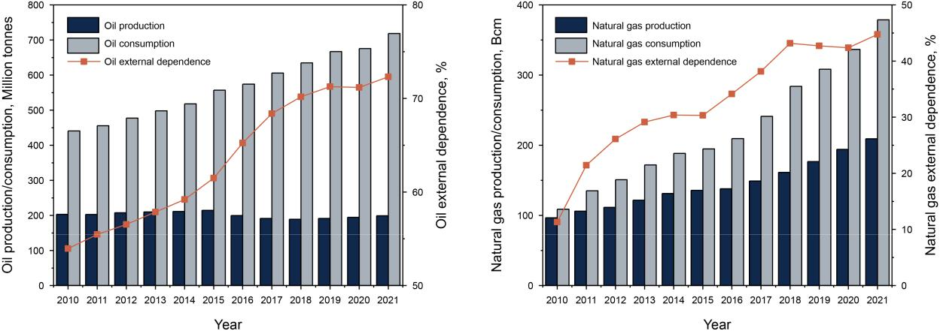

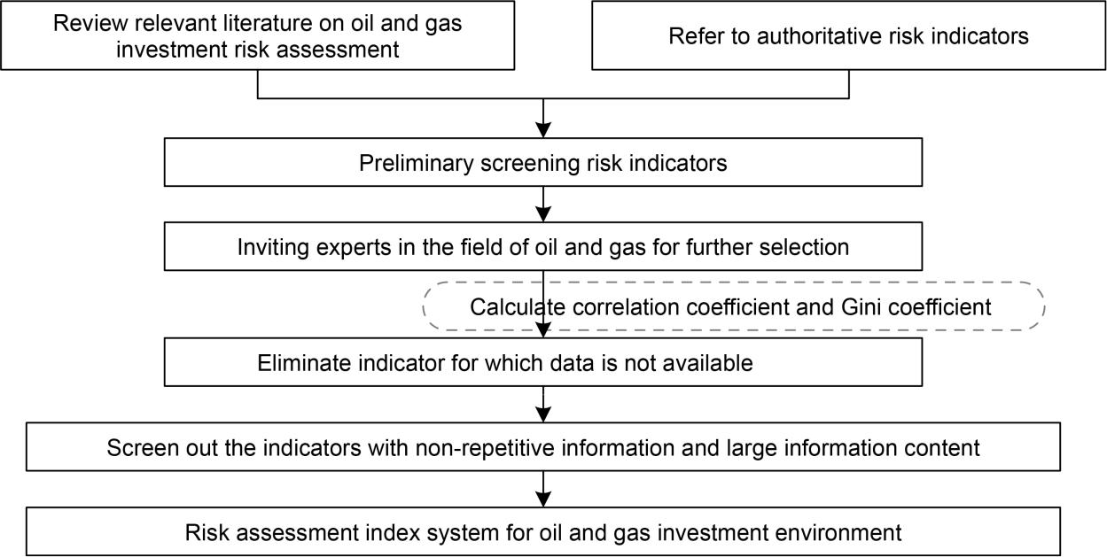

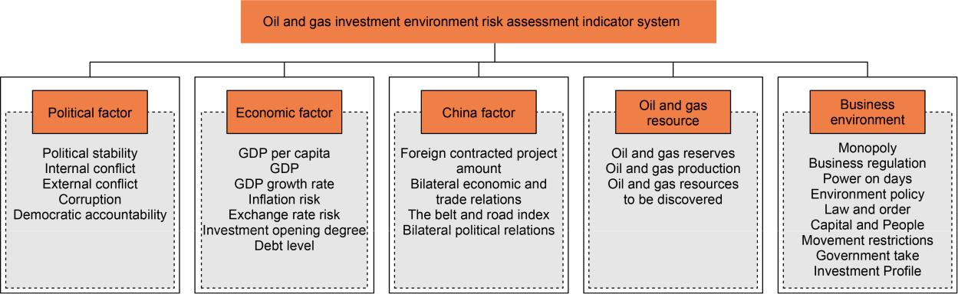

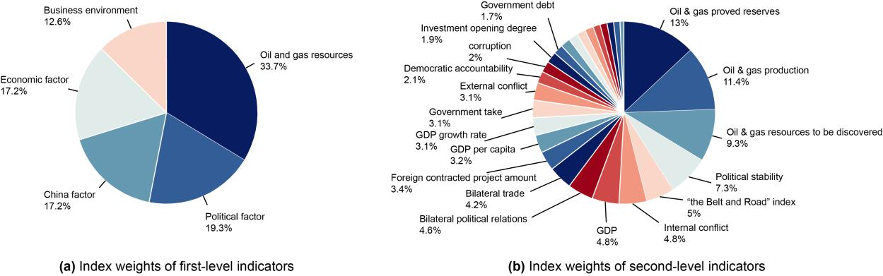

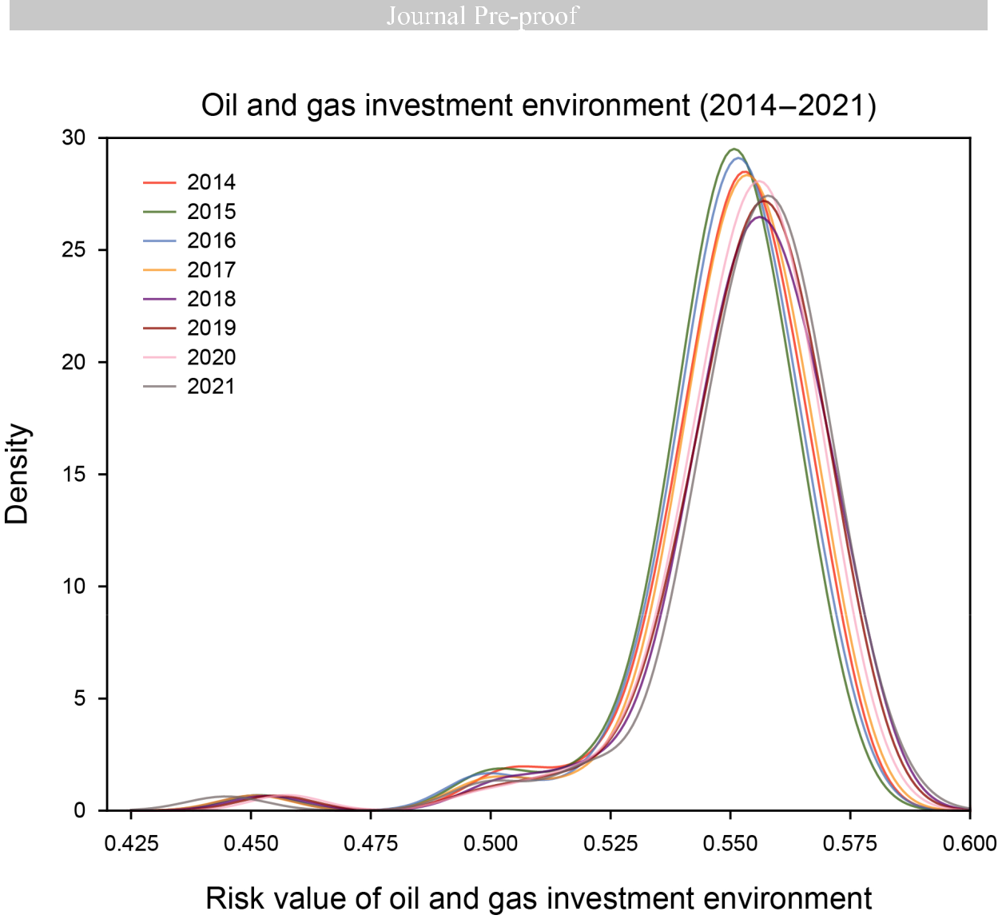

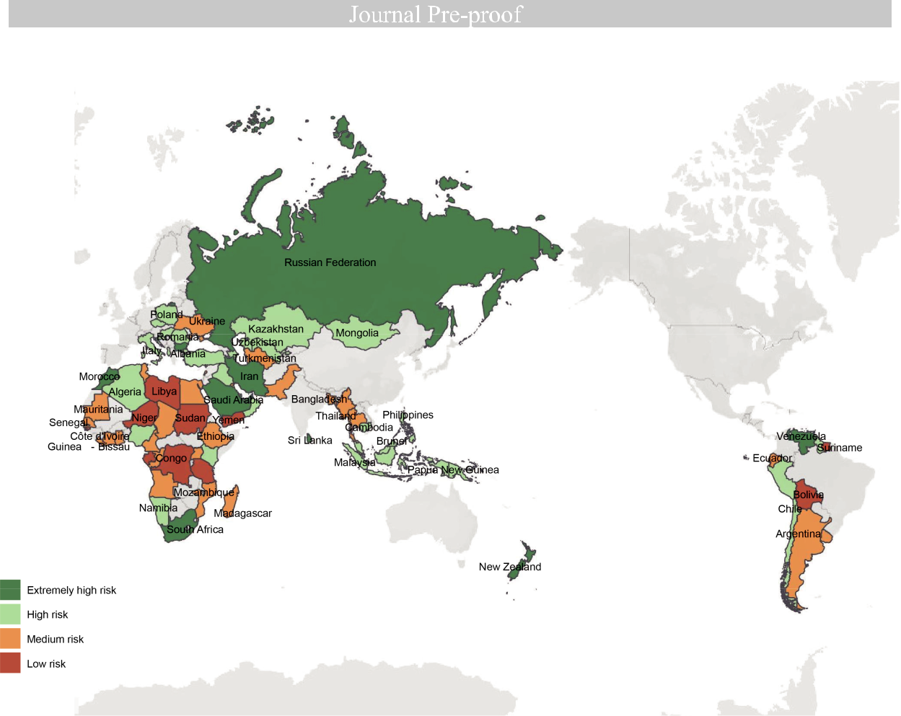

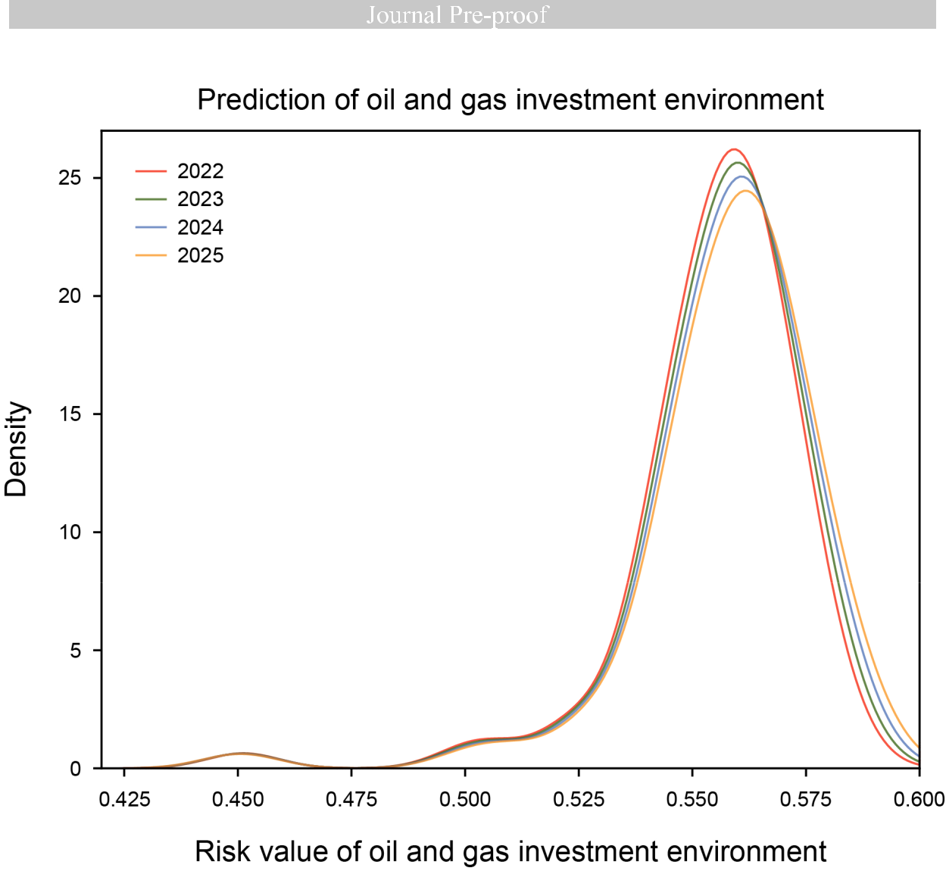

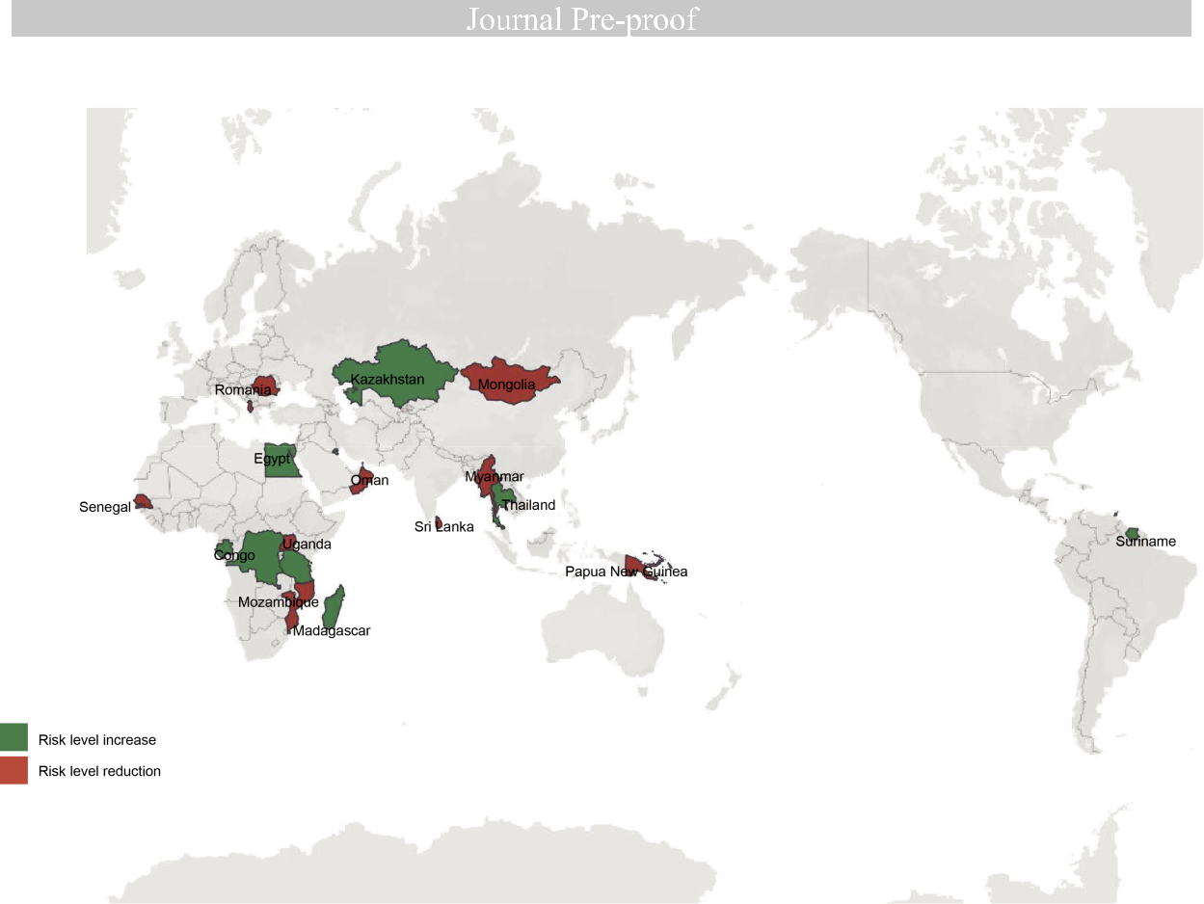

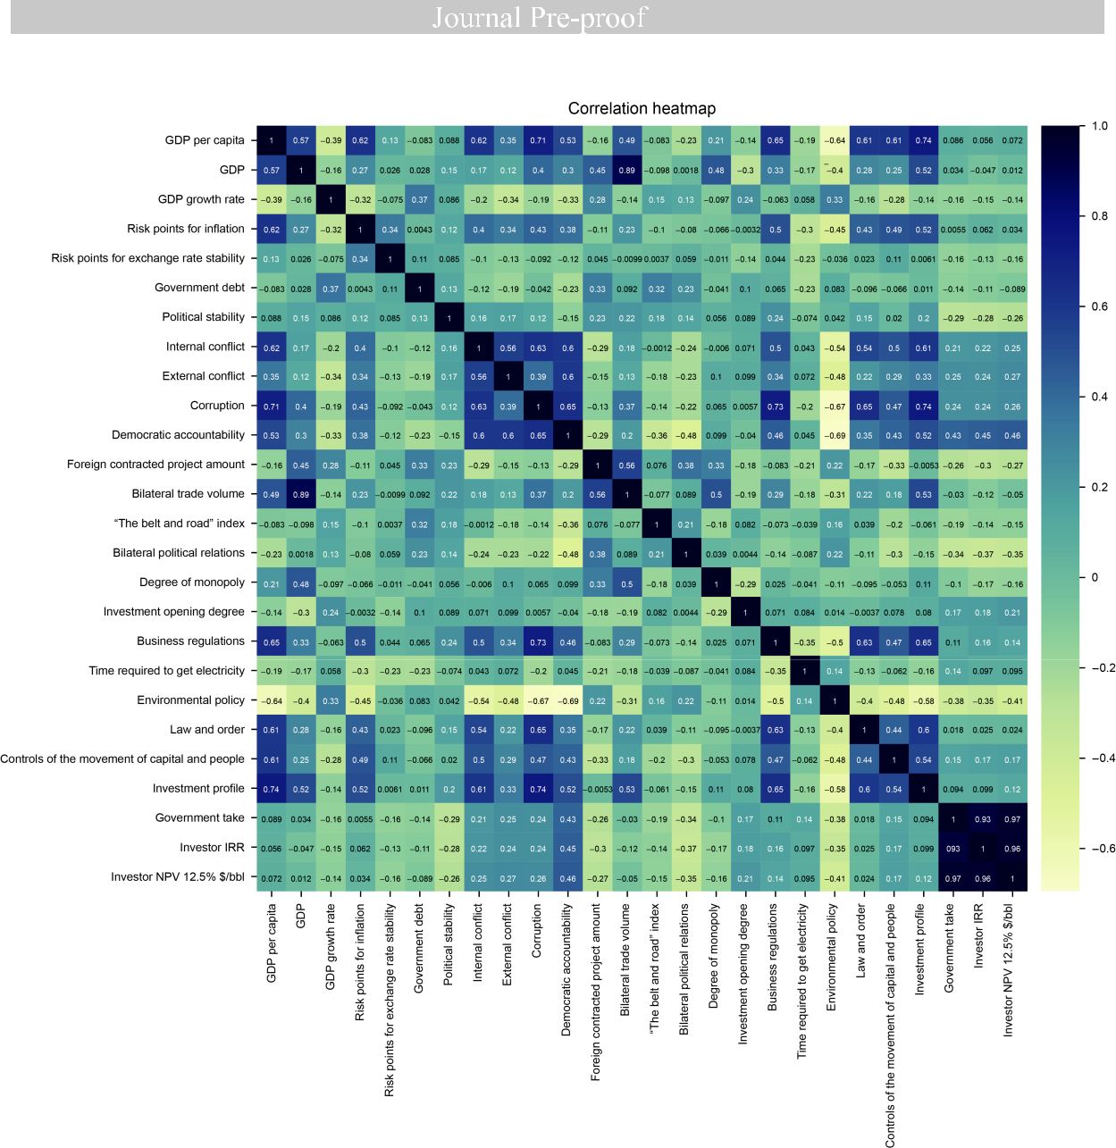



Conflict of Interest

The authors declare that they have no known competing financial interests or personal

relationships that could have appeared to influence the work reported in this paper.