 [***sustainability***](https://www.mdpi.com/journal/sustainability)



Review

**Sustainable Development for Oil and Gas Infrastructure from Risk, Reliability, and Resilience Perspectives**

**Yasir Mahmood 1, Tanzina Afrin 2,3, Ying Huang 1 and Nita Yodo 1,2,3,\***

* Department of Civil, Construction, and Environmental Engineering, North Dakota State University, Fargo, ND 58102, USA
* Department of Industrial and Manufacturing Engineering, North Dakota State University, Fargo, ND 58102, USA
  + Advanced System Engineering Laboratory, Fargo, ND 58102, USA **\*** Correspondence: nita.yodo@ndsu.edu

**Citation:** Mahmood, Y.; Afrin, T.; Huang, Y.; Yodo, N. Sustainable Development for Oil and Gas Infrastructure from Risk, Reliability, and Resilience Perspectives. Sustainability **2023**, 15, 4953. <https://doi.org/10.3390/su15064953>



Academic Editor: Mahmoud Bayat

Received: 25 January 2023

Revised: 4 March 2023

Accepted: 8 March 2023

Published: 10 March 2023



**Copyright:** © 2023 by the authors. Licensee MDPI, Basel, Switzerland. This article is an open access article distributed under the terms and conditions of the Creative Commons Attribution (CC BY) license [(https://](https://creativecommons.org/licenses/by/4.0/) [creativecommons.org/licenses/by/](https://creativecommons.org/licenses/by/4.0/) 4.0/).

**Abstract:** The oil and gas (O&G) sector is a critical energy infrastructure to a Nation’s welfare. As developed as the O&G industry may seem, its aging infrastructure gradually shows numerous chal-lenges to keep up with the growing energy demand, increasing operation costs, and environmental concerns. A robust O&G infrastructure that is risk-free, reliable, and resilient towards expected or unexpected threats can offer an uninterrupted supply of O&G to downstream stakeholders, com-petitive prices to customers, and better environmental footprints. With the shift towards renewable energy, the notion of sustainable development should be firmly embedded in O&G infrastructure and operations to facilitate the smooth transition towards future renewable energy generation. This paper offers a comprehensive and innovative approach to achieving sustainable development for O&G infrastructure by examining it from a holistic risk, reliability, and resilience (3Rs) perspective. The role of each individual concept and their collective influence on sustainable development in the O&G industry will be thoroughly discussed. Moreover, this paper will highlight the significant impact of the holistic 3Rs approach on sustainable development and propose future research directions. Given the complexity of O&G infrastructure, it is crucial to incorporate sustainable development practices into every dimension of the O&G infrastructure, iteratively and continuously, to achieve the ultimate goal of long-term sustainability. This paper makes a significant contribution to the field by providing valuable insights and recommendations for achieving sustainable development in the O&G industry.

**Keywords:** energy; oil; gas; infrastructure; sustainability; risk; reliability; resilience; sustainable development

**1. Introduction**

Oil and gas (O&G) sectors play a significant role in fulfilling a country’s energy require-ments and contribute towards the Nation’s economy and development. O&G infrastructure includes gathering, processing, storing, and delivering O&G from various sources to the end users. Today, O&G infrastructure has become one of the most critical, expansive, and complex energy networks in the United States (U.S.) since the early development of the U.S. commercial oil pipeline began in the mid-1900s [1]. Crude oil and raw natural gas are the top two forms of energy produced and consumed in the U.S., followed by renewable energy as the third energy source. According to the statistics presented in Figure 1 from the United States Energy Information Administration (U.S. EIA) monthly energy review of January 2023, O&G combined makes up 70% of total energy production (31% natural gas and 39% petroleum) and 70% of total energy consumption (37% natural gas and 33% petroleum) [2]. While O&G infrastructure seems to be a highly integrated energy network, they are not fail-safe as many of these infrastructures show significant aging signs and are operated at maximum or near-maximum capacity [3].

Sustainability **2023**, 15, 4953. <https://doi.org/10.3390/su15064953> <https://www.mdpi.com/journal/sustainability>

|  |  |
| --- | --- |
| *Sustainability* **2023**, *15*, x FOR PEER REVIEW | 2 of 22 |
|  |  |

|  |  |
| --- | --- |
| Sustainability **2023**, 15, 4953 | energy network, they are not fail‐safe as many of these infrastructures show significant2of22 |
|  | aging signs and are operated at maximum or near‐maximum capacity [3]. |

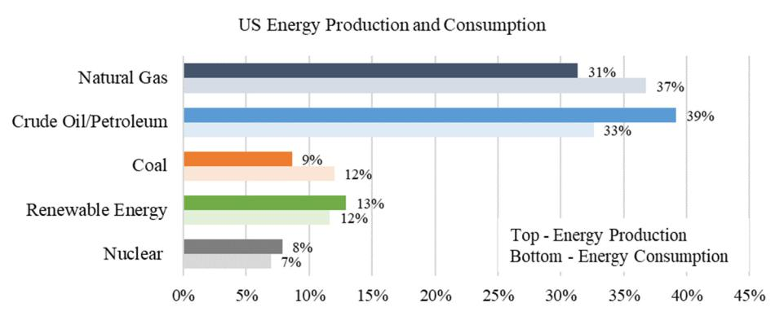

**Figure1.1**Primary**.**Primaryenergyenergyproductionproductionandandconsumptionconsumptionbreakdownbreakdown.Data. Source:DataSource:U.S.EnergyU.S.EnergyInfor‐ mationInformationAdministration,M**on**thly,MonthlyEnergyEnergyReviewReviewJanuaryJanuary2023[2]2023. [2].

Dorianetetalal..(2006)(2006)identifiedidentifiedfourfoursignificantsignificantchallengesthatthatthetheglobalglobalenergyenergysector,sector, includingthethe O&G industries, must address[[4]4..Thesechallengesincludeincluderesourceresourcescarcity,scar‐

energy security, environmental degradation, and meeting the growing energy demand. city, energy security, environmental degradation, and meeting the growing energy de‐ O&G is a fossil fuel and a non-renewable energy source with limited natural resources mand. O&G is a fossil fuel and a non‐renewable energy source with limited natural re‐

that cannot be replenished quickly. As the world’s population grows, so does the demand sources that cannot be replenished quickly. As the world’s population grows, so does the

for energy. According to a study by Shafiee and Topal (2009), global O&G reserves will demand for energy. According to a study by Shafiee and Topal (2009), global O&G re‐ be entirely depleted by 2050 [5]. Resource scarcity and increasing global demand present serves will be entirely depleted by 2050 [5]. Resource scarcity and increasing global de‐ significant challenges for the O&G infrastructure to provide an adequate, reliable, and mand present significant challenges for the O&G infrastructure to provide an adequate, affordable energy supply. Today, the majority of energy consumers depend on O&G prod-reliable, and affordable energy supply. Today, the majority of energy consumers depend ucts [4], such as crude oil (primarily used to produce gasoline and diesel for transportation on O&G products [4], such as crude oil (primarily used to produce gasoline and diesel for or manufacturing sectors) or natural gas (widely used for heating purposes) [6]. However, transportation or manufacturing sectors) or natural gas (widely used for heating pur‐ burning fossil fuels, including O&G, releases carbon dioxide (CO2) and other greenhouse poses) [6]. However, burning fossil fuels, including O&G, releases carbon dioxide (CO2) gas emissions into the environment, leading to environmental degradation and one of the and other greenhouse gas emissions into the environment, leading to environmental deg‐ leading causes of global warming that may trigger climate disasters [7,8]. Additionally, in radation and one of the leading causes of global warming that may trigger climate disas‐ the current era of political unrest and economic volatility, there is an escalating concern ters [7,8]. Additionally, in the current era of political unrest and economic volatility, there over O&G energy security. Their supply may become even more constrained and costly in is an escalating concern over O&G energy security. Their supply may become even more the future [4].

constrained and costly in the future [4].

The Intergovernmental Panel on Climate Change (IPCC) Sixth Assessment Reports The Intergovernmental Panel on Climate Change (IPCC) Sixth Assessment Reports (AR6) is a comprehensive scientific report that provides an up-to-date understanding of (AR6) is a comprehensive scientific report that provides an up‐to‐date understanding of the scientific, technical, and socioeconomic aspects of climate change [9]. It is the latest the scientific, technical, and socioeconomic aspects of climate change [9]. It is the latest in in a series of IPCC assessments that aim to inform policymakers, stakeholders, and the a series of IPCC assessments that aim to inform policymakers, stakeholders, and the gen‐ general public about the risks associated with climate change and the possible mitigation eral public about the risks associated with climate change and the possible mitigation and and adaptation options [10]. The main takeaway from the IPCC Sixth Assessment Report

adaptation options [10]. The main takeaway from the IPCC Sixth Assessment Report is

is that climate change is happening at an unprecedented rate and is primarily caused by

that climate change is happening at an unprecedented rate and is primarily caused by

human activity, particularly the burning of fossil fuels. The report presents strong evidence

human activity, particularly the burning of fossil fuels. The report presents strong evi‐ that the Earth’s climate is already changing, with impacts such as more frequent and

denceseverethatheatwaves,theEarth’sdroughts,climateandisalreadyfloodingchanging,.Italsowarnswith impactsofthepotentialsuchas formorecatastrophicfrequent

andimpactsseverein heatwaves,thecoming droughts,decades,includingandfloodingmore. Itfrequentalsowarnsand ofextremethepotentialheatwaves,for catamore‐

strophicintense hurricanes,impactsintherisingcomingsealevels,decades,andincludingwidespreadmorefoodfrequentandwaterand shortagesextremeheatwaves,.Thereport

moreemphasizesintense thehurricanes,needforrisingimmediatesealevels,and drasticandwidespreadactionto curbfood greenhouseandwatershortagesgasemissions.The

reportandoutlinesemphasizesrangethe ofneedpotentialforimmediatestrategiesandfordrasticmitigatingactionandtocurbadaptinggreenhousetothe impactsgasemisof‐

sionsclimateandchangeoutlines[11a]. range of potential strategies for mitigating and adapting to the im‐

pacts Inof climaterecentyears,changeefforts[11]. to expand renewable energy infrastructure, such as wind and

solarInpower,recent haveyears,beeneffortsmadeto expandasalternativerenewableenergyenergysourcesinfrastructure,toovercomesuchconcernsaswindoverandthe

solardepletionpower,of haveO&Gbeenand othermadenonasalternative-renewableenergysourcesto[12overcome].In2022,concernsrenewableoverenergythe

depletionfromvariousofO&Gsourcesandaccountedothernonfo‐**r**enewable12%oftheenergytotalenergysourcesconsumption[12].In2022,intherenewableU.S.,makingen‐

ergyitthefromthirdvariouslargestsourcesenergyaccountedsourceafterforO&G12% of(Figurethetotal1) [energy2].However,consumptioninthelargerinthe scopeU.S.,

of the O&G industries, problems associated with conjuncture may arise, where various social, economic, and political factors intersect, significantly impacting the direction and development of the O&G sector. For instance, the presence of paraffin deposits in oil can

|  |  |
| --- | --- |
| Sustainability **2023**, 15, 4953 | 3 of 22 |
|  |  |

destroy the entire infrastructure of an oil field [13]. Another example is the decarbonization challenges of O&G companies as they transition toward alternative energy sources in countries within the European Union [14]. Additionally, there are resource challenges with biodiesel fuel, another sustainable energy source. The production of biodiesel using raw food materials poses a significant risk of food and fuel competition, which is not sustainable [15]. Although it may seem far-fetched in the future for renewable energy to replace O&G as the primary energy source [4], O&G needs to remain sustainable until then to ensure a smooth transition. Thus, sustainable development must be securely incorporated into all O&G infrastructures, operations, practices, and strategies [9,10]. In this paper, sustainable development of a system refers to the capacity established in a system to maintain or improve the state and the availability of desired system conditions over an extended period [16].

As O&G infrastructures continue to evolve in complexity, there is no one-size-fits-all solution to achieving sustainable development as a long-term goal [17]. This paper proposes a holistic view of risk, reliability, and resilience (3Rs) as a possible pathway to sustainable development. Although the 3Rs concept has been explored extensively in their separate areas of study, their application to sustainable development in O&G applications has not been fully highlighted. The fundamental risk is related to the probability of unexpected events occurring, which can lead to undesirable consequences [18,19]. Reliability refers to the ability of a system to function without failures during its intended operational period [20,21], while resilience is associated with the ability to resist and recover from unexpected disruptive events [22,23]. By applying the 3Rs concept, risks can be identified, and mitigation plans can be formulated ahead of time to minimize delivery disruptions and recover from any disturbances swiftly in the event of inevitable disruptive events such as natural disasters [18,24]. This approach can also reduce operational downtime, resulting in a safer, more economical, and longer-lasting O&G infrastructure and operations [25,26].

In conjunction, risk, resilience, and reliability are key concepts in the O&G industry for managing and mitigating hazards and disruptions that may arise from various sources. Outside the O&G sector, the 3Rs approach toward sustainability has been applied in other sectors. Ardebili [15] provides a state-of-the-art review of the 3Rs application in dam safety engineering, focusing more on a risk-based probabilistic framework. Sweetapple et al. [27] propose the Safe & SuRe framework to show how threats to a water system can affect society, the economy, and the environment. Akiyama et al. [28] employed the 3Rs approach to study independent and interacting hazards and their effects on bridges and networks. The 3Rs concept has also been utilized in examining the impact of the COVID-19 crisis on the security of deliveries and the preparedness and responses of firms in the supply chain application [27]. In the O&G industry, the 3Rs concept can be applied towards sustainable development at all stages of the supply chain, from exploration and production to transportation and distribution.

Amid the current transitional period in the energy landscape, the O&G industry faces the pressing need to optimize its performance, reduce operational costs, and shift towards more environmentally sustainable practices to stay competitive [28]. This paper makes a novel contribution by proposing a holistic approach to achieving sustainable development in the O&G industry through the application of the 3Rs concepts at all levels of social, economic, and environmental aspects of O&G infrastructure. This innovative perspective underscores the need for a fundamental shift in the industry’s approach to sustainable development and has important implications for policymakers and practitioners. The overview of O&G infrastructure and its challenges to sustainable development will be introduced in Section 2. The individual roles of the 3Rs concept in the O&G application will be detailed in Section 3. In Section 4, a discussion on the holistic 3Rs’ influence on sustainable development and the direction of future research will be provided. Finally, the conclusion of this paper will be summarized in Section 5.

|  |  |
| --- | --- |
| *Sustainability* **2023**, *15*, x FOR PEER REVIEW | 4 of 22 |

will be detailed in Section 3. In Section 4, a discussion on the holistic 3Rs’ influence on sustainable development and the direction of future research will be provided. Finally,

Sustainability **2023**, 15, 4953 4 of 22

the conclusion of this paper will be summarized in Section 5.

**2. O&G Infrastructure and Challenges**

**2. O&G Infrastructure and Challenges**

Since the mid‐1900s, the infrastructure for transporting crude oil, natural gas, and

their productsSincethe onshoremid-1900s,andtheoffshoreinfrastructurehasgrownforconsiderablytransporting[1]crude.Thisoil,sectionnaturalprovidesgas,andan overviewthirproductsofO&Gonshoreinfrastructureandoffshoreandfocuseshasgrownonexploringconsiderablythechallenges[1].This sectionthatO&Gprovidesinfra‐ an overview of O&G infrastructure and focuses on exploring the challenges that O&G structure poses to sustainable development.

infrastructure poses to sustainable development.

*2.1. Overview of O&G Infrastructure*

2.1. Overview of O&G Infrastructure

O&G infrastructure is very expansive, and its operations are highly complex. Most O&G infrastructure is very expansive, and its operations are highly complex. Most O&G infrastructure can be generally separated into three main levels: upstream, mid‐ O&G infrastructure can be generally separated into three main levels: upstream, midstream, stream, and downstream [17,29]. A three‐level color‐coded petroleum pipeline system and downstream [17,29]. A three-level color-coded petroleum pipeline system modified modified from the Pipeline and Hazardous Materials Safety Administration (PHMSA) from the Pipeline and Hazardous Materials Safety Administration (PHMSA) [30] is shown [30] is shown in Figure 2. In this Figure 2, the upstream section is colored red, the mid‐ in Figure 2. In this Figure 2, the upstream section is colored red, the midstream components stream components are shaded in orange, and the green is for the downstream elements.

are shaded in orange, and the green is for the downstream elements.

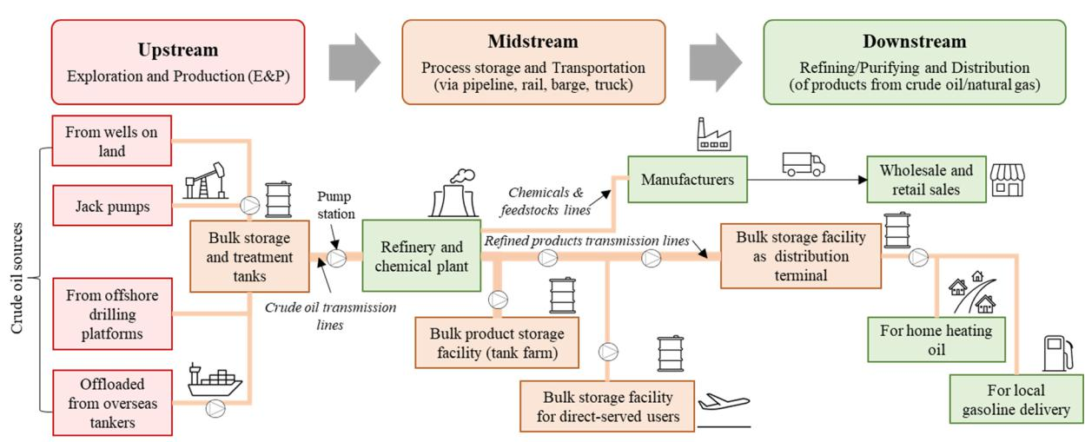

**Figure2.** Three major levels of a general petroleumpipelinesystem;modified fromthe Pipelineand

**2.** Three major levels of a general modified the and Hazardous Materials Safety Administration (PHMSA) [30].

Hazardous Materials Safety Administration (PHMSA) [30].

The O&G upstream level focuses on exploration and production(E&P)operations.. Exploration efforts includegeographicalsurveysininsearchofofpotentialoiloilandgasfields,fields, while production (such as drilling and operating oil wells) is carried out to extract crude oil or raw natural gas to the surface [31,32]3132. The midstream level includes long‐-distance transportation and storage facilities from upstream suppliers to downstream distributors or customers [29]29].. The O&G transportation can be carried out with various means, such as pipelines, rail freight, trucks, oil tankers, or inland barges [33]33].. Storage facilities vary based on the product stored.. Crudeoilandrefinedrefined oil are usually stored in above ground tanks or temporarilystoredin tankershipswhenlandstorageisisatatcapacity[34]34]..Under‐-ground storage, such as depletedreservoirs,isismoresuitablefornaturalgas[35]35]..Lastly, the downstream level involves the refineriesrefineries or processing facilities and short‐-distance distributiontotoendusers[36]36.]The.Thr**e**finersrefinersarearein chargeinchargeofturningofturningcrudecrudeoilandoil rawand natraw‐ uralnaturalgas gasintointorefinedrefinedoil,oil,purifiedpurifiednaturalgas,gas,andandmanyotherproductsforforeverydayuse.. The downstream operation often involves midstream elements in terms of transportation and storage components from refineriesrefineries to end‐-users.

Many of the components shownininFigure22,suchasasoiloilwells,storagesystems,pipeline‐

linesystems,systems,orrefiners,orrefiners,havetangiblehavetangibleattributesattributesandmay andberegardedmaybeasregardedphysical elementsasphysical.In addition to the physical system aspects, the O&G infrastructure and its operations involve

the cyber domain, have human interactions, and can be influenced by other external factors [37–39]. More details on O&G infrastructure and operations can be found in the following references [34,40–42].

ations involve the cyber domain, have human interactions, and can be influenced by other external factors [37–39]. More details on O&G infrastructure and operations can be found in the following references [34,40–42].

Sustainability **2023**, 15, 4953

*2.2. Sustainability and Sustainable Development*

5 of 22

In the late 1980s, the United Nations (U.N.) World Commission on Environment and Development was chaired by Gro Harlem Brundtland (former Norwegian Prime Minis‐ ter),2.2and.SustainabilitywasfocusingandSustainableontheimportanceDevelopmentof sustainable economic development without drainingIn thenaturallate1980s,resourcestheUnitedorharmingNatons the(U.Nenvironment.)WorldCommission[43].InontheirEnvironmentreport“Ourand Com‐ monDevelopmentFuture,”publishedwaschairedinby1987Gro [44Harlem–46],BrundtlandChapterone,(formSectionrNorwegianII.NewPrimeApproachesMinistr),to En‐ vironmentandwasfocusingandDevelopment,ontheiportancePointof 49sustainablementionseconomicthat‘sustainabledevelopmntdevelopment’withutdrainingseeks to “*meet*natural*the* resources*needsand*or*aspirations*hamingthe*of* environment*thepresentwithout*[43].In *compromising*theireport“Our*the*Common*abilityto*Future,”*meetthose of the*published*future*.”[47]in1987.This[44has–46],becomeChapteroneone,ofSectionthebestII.‐NewknownApproachesfoundationstoEnvironmentofsustainableanddevel‐

Development, Point 49 mentions that ‘sustainable development’ seeks to “meet the needs opment.

and aspirations of the present without compromising the ability to meet those of the future.” [47].

The concept of sustainability or sustainable development has become more prevalent This has become one of the best-known foundations of sustainable development.

in today’s practice [26], with the primary objective of ensuring the Earth is inhabitable for The concept of sustainability or sustainable development has become more prevalent futureintoday’sgenerationspractice.[26The],withtermthe‘sustainableprimaryobjectivedevelopment’ofensuringistheoftenEarthinterchangeablyisinhabitablefor used

withfuturethegenerationsbroaderconcept.Thetermof ‘sustainabilitytainabledevelopment’.’Ruggeriois (2021)ofteninterchanghaspresentedablyusedacomprehenwith‐ sivethereviewbroaderofconcepttheoreticalof‘sustaidefinitionsability.’andRuggeriothedifferences(2021)has presentedbetween theacomprehensivetwoconcepts [48]. Inreviotherw instances,ofheoreticalsustainabilitydefinitions andisoftenthedifferencesregarded asbetweenalongthe‐termtwogoal,conceptswhile[48sustainable].In

developmentotherinstances,referssustainabilitytothemanyis pathwaysoftenregardedtobecomingasalongsustainable-termgoal,while[47,48]sustainable.Sustainability development refers to the many pathways to becoming sustainable [47,48]. Sustainability

is commonly known to have three interconnected dimensions (pillars/elements/facets) en‐ is commonly known to have three interconnected dimensions (pillars/elements/facets)

compassing social, economic, and environmental factors (goals/objectives), graphically encompassing social, economic, and environmental factors (goals/objectives), graphically

shown in Figure 3a as the intersections of the three elements combined [49]. Thus, to real‐ shown in Figure 3a as the intersections of the three elements combined [49]. Thus, to realize

izethethesustainsustainabilitygoal, goal,sustainablesustainabledevelopmdevelopmentfcuseson focusesthedevelonpmentthe (improvedevelopment (im‐ provementprocess/practiprocess/practice)ofechpillarof(social,each pillareconomic,(social,and economic,nvironmental)and whileenvironmental)considering while consideringthelationstheiprelationshiporimpact ortheimpactotherfactors,ontheasothersownfactors,inFigureasshown3b. in Figure 3b.

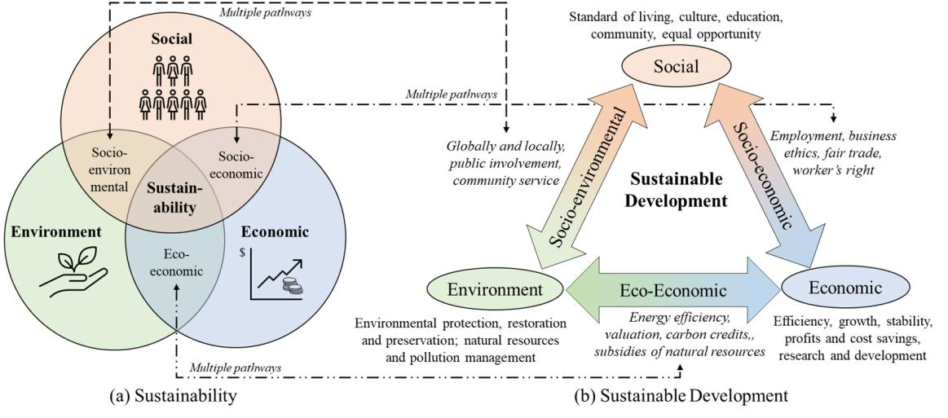

**Figure3. 3**The**.**Thegeneralgraphical representationofof(**a**)(**a**sustainability)withwiththreethreedimensionsdimensions(modified(modified fromfromPurvisetetalal..(2019) [49])49 and ((**bb**) )sustainabledevelopment(modified(modifiedfromfromRugerrioRugerrio(2021) (2021)[48] [48] andandMunasinghe(1993) [50])50..

Sustainable development seems contradictory to the property of non-renewable en-Sustainable development seems contradictory to the property of non‐renewable en‐

ergy, inherently due to its limited natural resources. There are still many debates about ergy, inherently due to its limited natural resources. There are still many debates about

defining, quantifying, realizing, and measuring sustainable development or sustainability defining, quantifying, realizing, and measuring sustainable development or sustainability

energy applications or the O&G industry. However, these topics will not be elaborated inonenergyfurtherapplications.Instead,thisorpapertheO&Gwill focusindustrymore.However,onansweringthesethetopicsquestionswill presentednotbeelaboratedin

onRuggeriofurther. (2021)Instead,[48]thisorNaredopaper will(2004)focus[51], moresuchason‘Whatansweringshouldbethesustainablequestionsand presentedforhow in Ruggeriolong?’and(2021)‘How[48]istheorgoalNaredoofsustainability(2004)[51],accomplishedsuchas‘*What*(inO&G*should*industry)?*besustainable*’.Inthe *and*O&G*for how long*industry,?’and the‘*How*answer*isthe*is*goal*straightforward,*ofsustainability*whereas*accomplished*theimplementation*(inO&Gindustry)?*isnot.The’. limitedInthe O&G

O&G natural resources must be sustained for as long as possible or at least until the next generation of renewable energy takes over. The goal of sustainability can be accomplished by incorporating various sustainable development practices into all aspects of O&G infras-

|  |  |
| --- | --- |
| *Sustainability* **2023**, *15*, x FOR PEER REVIEW | 6 of 22 |
|  |  |

industry, the answer is straightforward, whereas the implementation is not. The limited O&G natural resources must be sustained for as long as possible or at least until the next

Sustainability **2023**, 15, 4953 6 of 22

generation of renewable energy takes over. The goal of sustainability can be accomplished by incorporating various sustainable development practices into all aspects of O&G infra‐ structure and operations. However, this is not an easy task, as many challenges are present tructure and operations. However, this is not an easy task, as many challenges are present in the O&G industry.

in the O&G industry.

*2.3. Multidimensional Challenges*

2.3. Multidimensional Challenges

The O&G industry faces significant challenges when it comes to balancing conflicting The O&G industry faces significant challenges when it comes to balancing conflicting objectives in the pursuit of long‐term sustainability. Meeting the increasing demand for objectives in the pursuit of long-term sustainability. Meeting the increasing demand for oil and gas with limited natural resources is a primary challenge, alongside the need to oil and gas with limited natural resources is a primary challenge, alongside the need to increase production while reducing operating costs and adhering to environmental poli‐ while reducing operating costs and adhering to environmental policies cies to minimize contamination and pollution. Despite increasing attention focused on the

to minimize contamination and pollution. Despite increasing attention focused on the tran-transition of O&G industries to sustainable development, the complexity of O&G infra‐ of O&G industries o sustainable development, the complexity of O&G infrastructure structureandoperationsandoperationsmakeachievingmake achievingsustainablesustainabledevelopmentdevelopmentchallengingchallenging.Numerous. Numertheories,‐ ousconcepts,theories,andconcepts,methodsandare methodspropsedarewithproposedthistransition,withthisbuttransition,practicalbutimplementationpracticalim‐ plementationhasprovendifficulthasprovenanddifficultremainsandunremainssolved unresolvedduetosocialdueandtosocialmarketandmechanismsmarketmechof‐

anismssustainableofsustainabledevelopmentdevelopment[52]. [52].

Consideringonlythreeedimensions:sustainability,O&GO&Goperations,andandO&GO&Ginfrain‐-

structure,frastrcture,thisthismultimulti‐dimension-characteristicoftheof theO&GO&Gindustryindustrycancanbe representedntedbein

FigureinFigure4a.4Fora.Foreacheachdimension,theretheare aremultipletipelementselementsandandsub‐subdimensions-sions.As. theAs longthelong‐term-termgoal,goal,the sustainabilitythenabilitydimensionsionhas social,hassocial,economic,economic,and environmentaldenviromentalpil‐ larspillars(Figure(Figure3a)3a)[49]49.The].Thedayday‐to-‐today-dayoperationsofofthetheO&Gindustrydependonphysical

infrastructure, cyberinfrastructure(computing,internet-of‐of-things),‐andandhumans(operators,‐ tors,policymakers)policymakers)[37,38[37,38].TheO&G.TheinfrastructureO&Ginfrastructurehasthreehasmajorthreelevelsmajor(upstream,levels (upstream,midstream, midstream,anddownstream)anddownstream)[29].Inore[29]detailed.Inmoreviw,detailedeachO&Gview,infrastructureeachO&Ginfrastructurelevelmayinvolvelevel maynumerousinvolvexplorationnumerous andexplorationrefineryandsitesrefineryormillionssites orf millionsesof pipelineofmiles ofandpipelinecustomersand. customersTheO&G.sectorTheO&Gsuppliedsectoraboutsupplied27.6 abouttrillion27cubic.6trillionfeet (Tcf)cubicoffeetnatural(Tcf) gasofnaturalndbillionsgasandof billionstonsperofmiletonsofperliquidmilepetroleumofliquid petroleumtoapproximatelytoapproximately77.7million77consumers.7millionconsumersvia2.6millionvia

2miles.6millionofthemilesprimaryofthepipelprimarynedeliverypipelinesystemdeliveryin2021system[1].Thus,in2021sustainable[1].Thus,developmentsustainable developmentpracticesshouldpracticesbeincorporatedshouldbeincorporatedintoeveryimensionintoeveryiteratively,dimensionwhereveriteratively,appropriate,wherever appropriate,towardtheholistictowardsustainabilitytheholisticsustainabilitygol,asshowngoal,in Figureasshown4a. in Figure 4a.

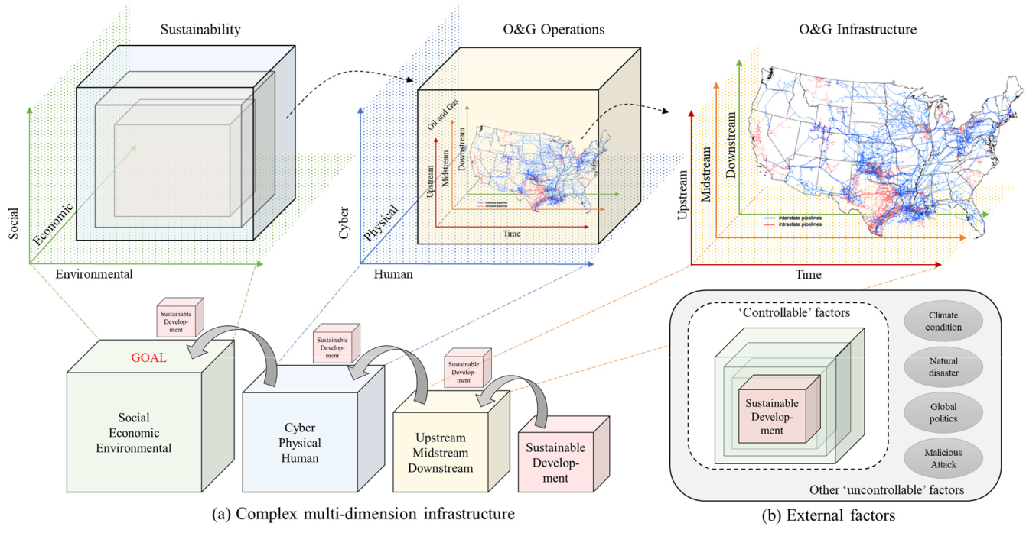

**Figure 4.** A representation of sustainable development with respect to (**a**) multidimensional O&G infrastructure and operations and (**b**) external factors. The map of U.S. interstate (blue) and intrastate (red) natural gas pipelines was obtained from the U.S. Energy Information Administration about U.S. Natural Gas Pipelines [1].

**Figure 4.** A representation of sustainable development with respect to (**a**) multidimensional O&G infrastructure and operations and (**b**) external factors. The map of U.S. interstate (blue) and intra‐ state (red) natural gas pipelines was obtained from the U.S. Energy Information Administration

Sustainability **2023**, 15, 4953 7 of 22 about U.S. Natural Gas Pipelines [1].

The three dimensions presented in Figure 4a are not the only dimensions influencing

the O&GThethreeindustrydimensionsinachievingpresentedsustainabilityFigure.4Otheraarenotexternaltheonlyfactors,dimensionssuchas inaturalfluencingdis‐ theasters,O&Gglobalindustrypoliticalinachievsituations,ngsustaiorrandomabilitymalicious.Otherexternalattacks, factors,mayalsosuchaffectasthenaturalO&G disasters,industry’sglobalroadmappolitoicalsustainabilityituations,or(Figurerandom4b) malicious[34,53,54] .attacks,Althoughmaythesealsoexternalaffectthefac‐ O&Gtors mayindustry’snotalwaysroadmapbecontrollable,tosustainabilitythe O&G(Figurestakeholders4b)[34,53,54should].Athoughfocus theseonsustainableexternal factorsdevelopmentmayotforalwaysthecontrollablebentrollable,factorsthe[12],O&Gsuchstakeholdersasinfrastructureshould focusprotections,sustainabletechnol‐

developmentogyadvancement,fortheenvironmentalcontrollablefactorsrehabilitations,[12],suchasorinfrastructurepolicyimprovementprotections,. technology advancement, environmental rehabilitations, or policy improvemeint.

To address the challenges of the current transitional period the energy landscape,

To address the challenges of the current transitional period in the energy landscape, this paper presents a comprehensive and innovative approach to achieving sustainable

this paper presents a comprehensive and innovative approach to achieving sustainable development in the O&G industry. This holistic approach involves applying the 3Rs’ con‐

development in the O&G industry. This holistic approach involves applying the 3Rs’ cepts across all social, economic, and environmental aspects of O&G infrastructure to op‐ concepts across all social, economic, and environmental aspects of O&G infrastructure to timize performance, reduce operational costs, and adopt environmentally sustainable optimize performance, reduce operational costs, and adopt environmentally sustainable practices for improved competitiveness. This novel perspective underscores the need for practices for improved competitiveness. This novel perspective underscores the need a transformative change in the industry’s approach to sustainable development and has for a transformative change in the industry’s approach to sustainable development and important implications for policymakers and practitioners. This paper will explore the has important implications for policymakers and practitioners. This paper will explore individual roles of risk, reliability, and resilience, and their collective influence on sustain‐ the individual roles of risk, reliability, and resilience, and their collective influence on able development in the subsequent section.

sustainable development in the subsequent section.

* 1. **Overview of Risk, Reliability, and Resilience**

1. **Overview of Risk, Reliability, and Resilience**

In the context of O&G operation and infrastructure, risk, reliability, and resilience In the context of O&G operation and infrastructure, risk, reliability, and resilience (3Rs)

(3Rs) are essential concepts. While pipelines are a secure and efficient means of transport‐ are essential concepts. While pipelines are a secure and efficient means of transporting ing O&G, they are vulnerable to various natural and human‐ induced hazards [55]. Pre‐ O&G, they are vulnerable to various natural and human-induced hazards [55]. Preventative ventative measures can be taken to reduce the severity and likelihood of such hazards measures can be taken to reduce the severity and likelihood of such azards through risk, reliability,throughrisk,and reliability,silienceapproachesandresilience.Thisapproachessectionwill.Thisintroducesectionthewillkeyintroduceconcepts theofrisk,key reliability,concepts ofandrisk,resiliencereliability,andandtheirresiliencesignificanceandintheirO&Gsignificanceapplicationin. O&G application.

3*3*.1*.1*. *.*RiskAnalysis,Assessment,esment,andManagementFramework

ThepipelinetransportationsystemisisesessentialtototheO&Gindustry,allowingforthe safeandefficientefficientmovementofofcrudeoil,naturalgas,andrefinedrefinedpetroleumproducts overlongdistances..However,asaswithanyinfrastructure,thepipelinesthatmakeupthis systemaresubjecttotowearandtearovertime,leadingtotovariousrisksandhazards..One ofofthemajorconcernsininrecentyearshasbebeentheagingofofthesepipelines,whichhas highlightedcorrosionosionasasaasignificantsignificantthreat. .Corrosionosioncanleadtotoleaksandburstsininthe pipeline,whichcancancausecauseharmharmto othertootherstakeholdersand andthe environmetheenvironment.Miigat.Mitigatingthis riskthisrequiriskrequirescafulcarefulconsiderationconsiderationndanandintegratedanintegratediskframeworkriskframeworkconsideringconsideringtherisksthe threateningrisksthreateningthepipelinethepipelinenetworknetwork.Anintegrated.Anintegratedriskframeworkriskframeworktypicallytypicallyinvolvesinvolvesrisk

analysis,riskanalysis,assessment,assessment,andmanagement,andmanagement,asshownasshowninFigureinFigure5a. 5a.

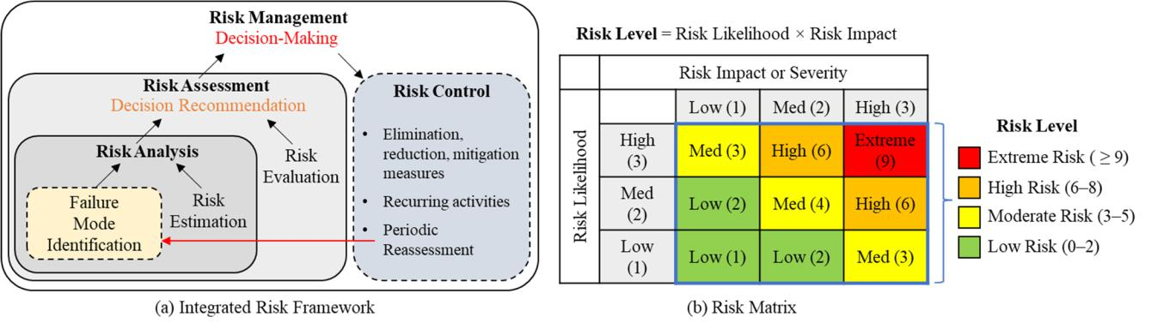

**Figure 5.** General representation of (**a**) risk management framework (redrawn from the Federal Emergency Management Agency (FEMA) [18]) and (**b**) risk matrix to measure the risk level of a particular threat.

|  |  |
| --- | --- |
| Sustainability **2023**, 15, 4953 | 8 of 22 |
|  |  |

The framework generally starts with identifying the hazard (failure or threat), estimat-ing and evaluating the impact, and mitigating the adverse effects by taking appropriate corrective measures [18,19]. Depending on the type and severity of threats or hazards, the decision-makers can take various risk control approaches to eliminate, reduce, mitigate, transfer, or resolve the risks [53]. However, it should be noted that there is always the pos-sibility that a system may fail not due to risk propagation, but from poor decision-making outcomes.

A risk framework in the O&G pipeline network identifies probable system failure causes, such as corrosion, cracks or leaks, digging, excavation, or operational errors [22,56]. In cases where a threat is identified, detected, or has occurred, appropriate corrective measures should be taken to control the risk and to ensure the pipeline is in working condition without any critical impact on downstream stakeholders [55]. For pipeline networks, the primary objective of risk management is to decrease the failures or limit their severity in case of occurrence [19]. Risk assessment is a subset of risk management and is preceded by analyzing the risk to measure its severity. In probabilistic terms, the risk level of a particular hazard can be quantified by taking the product of the risk likelihood and the risk impact. This information on risk likelihood, impact, and level is often presented in a consolidated table or matrix format known as a risk matrix, as shown in Figure 5b. A risk matrix is often color-coded based on the risk level to qualitatively represent the criticality of a hazard or threat.

Methods for risk assessment in most O&G applications can be broadly categorized into three groups: qualitative methods (or index modeling), quantitative methods (or prob-abilistic methods), and hybrid methods. The risk matrix in Figure 5b is often considered a qualitative method, although it may present a quantitative risk level. This number of risk levels is also known as the risk index. Additionally, in many qualitative risk methods [56], the weights or scores for different variables are determined based on the experts’ judg-ment; however, their precision is sometimes questionable. While the quantitative analysis method is often favored for its practicality and ability to perform in-depth data analysis, its accuracy can be compromised when applied to smaller data sets. Due to the large amount of operational data that can be obtained from sensors, many data-driven analyses, for example, machine learning algorithms or artificial intelligence approaches [57–59], are adopted for condition monitoring and anomaly detection purposes [24]. In hybrid risk assessment, the benefits of both qualitative and quantitative analysis are combined in a single model allowing for precision analysis and expert opinion to be incorporated into decision-making. Many hybrid risk assessment methods involve (1) traditional methods such as Failure Modes and Effects Analysis (FMEA), Failure Modes and Criticality Analysis (FMECA) [60,61], Event Trees and Fault Trees Analysis (FTA) [62,63], and Hazard and Operability Analysis (HAZOP) [64,65], and (2) probabilistic methods such as Bayesian networks [66–68]. A Bayesian network is a probabilistic directed graph that may not always be exclusively used for risk assessment [69–71], unlike FMEA/FMECA or FTA which are more often associated with the risk framework. Note that these methods identified are not exhaustive. There are various other methods that many researchers have proposed as risk frameworks in the O&G industry [58,67].

There are many types of possible risks in O&G applications: operational risks, human factor risks, environmental risks, technology risks, schedule risks, and others. In addition to a risk framework or matrix, other aspects of O&G infrastructure and operations need to be analyzed to gain a more profound knowledge of how risk can occur, its impact, and how it can be controlled, mitigated, or resolved. For example, the O&G pipeline’s integrity and operational availability are constantly threatened by corrosion [66,72], which must be assessed periodically and controlled effectively. In order to accomplish this, the details of pipeline systems down to the material properties must be thoroughly understood in terms of the prevalent corrosion mechanisms for each pipeline [24,56]. Corrosion risk is dynamically altered as process parameters change conditions during pipeline operation [73]. Due to varying risks, various information needs to be analyzed, including inlet and outlet

|  |  |
| --- | --- |
| Sustainability **2023**, 15, 4953 | 9 of 22 |
|  |  |

pressure, velocity during flow, outlet and inlet temperature, and many other controllable and uncontrollable parameters [74]. The dynamic corrosion risk of pipelines is to be assessed periodically with the combination of field data collection and simulation software; for example, internal crack problems and estimation of stress intensity factor for corrosion can be simulated with the finite element method [75,76]. Considering the changing nature of risk in the operation of a pipeline, dynamic risk analysis methods are essential when time is taken into consideration.

To ensure that the O&G industry always delivers its intended value to the downstream stakeholders, it is best that stakeholders from all levels can understand how O&G infras-tructure and operation may fail to perform as required. However, this may not always be possible, given the complexity of the O&G infrastructure and operation. Thus, risk analysis, assessment, and management should be incorporated into sustainable develop-ment practices to identify, analyze, and prioritize risks and to ensure that the likelihood of unintended events occurring, and their impact is minimized, monitored, and controlled. This effort, in turn, will promote sustainability in the long run.

3.2. Reliability Analysis

O&G pipeline reliability may be defined as delivering oil or gas products safely using a detailed medium in the required quality and quantity and within a definite time. If the operational reliability of the pipeline network is not monitored, there will always be a potential threat to users and to the environment. Operational reliability can be evaluated by determining the mean time between failures (MTBF) and identifying its cause in a system operation [77]. Reliability is one of the crucial attributes of any complex system. The concept of reliability can be defined as the ability of units or systems to perform a specific function within a specific time and circumstance [78].

According to reliability theory [79], the reliability of a system or component over time, R(t), can be expressed as the probability of the system, P(t), performing its intended function until time T. The reliability index, R, holds a maximum value of 1, meaning the system is 100% reliable. The reliability of a system changes over time R(t) and can be quantified based on its probability of failure (when the system fails before time T), denoted as P(T t), as shown in Equation (1).

|  |  |
| --- | --- |
| R(t) = P(T > t) = 1 P(T t) | (1) |

Many past studies have been conducted to assess the reliability of O&G infrastructure systems. Ahmad et al. [80] described the reliability analysis of a pipeline system as a three-step process: (i) division of a pipeline into segments and construction of its corresponding reliability block diagram (RBD)s, (ii) reliability assessment of the individual segments, and

1. evaluation of the reliability of the overall pipeline system based on the RBD and the individual segment reliability. A single or one-direction supply pipeline can be modeled as a series RBD [81]. However, the pipeline systems can also be a combination of series and parallel RBDs with either reserved components or subsystems [82]. Figure 6a shows that part of the pipeline system can be deconstructed into either a series, a parallel, or a combination of series and parallel structures. It should be noted that the complexity of the analysis increases with the number of components considered as part of the system.

Each component typically has a failure rate function, *l*(t), in the shape of a bathtub curve or following a Weibull distribution, as shown in the lower right subfigure of Figure 6b. The failure rate of a component is typically observed to have three stages of service life: start-up or commissioning, normal operations, and end-of-life [83,84]. In the first phase, there is a decreased failure rate probability as the component introduced in the system is often regarded as new and possesses a high-reliability index. However, there is also a risk of early failure due to many uncertainties when the system is introduced with a new component. After a period of adjustment, in the second stage, during the normal operating condition or useful life period, the failure rate of a component is constant over time until the wear-out stage. Although the component of a system is expected to be functioning

system is often regarded as new and possesses a high‐reliability index. However, there is also a risk of early failure due to many uncertainties when the system is introduced with a new component. After a period of adjustment, in the second stage, during the normal

Sustainability **2023**, 15, 4953 operating condition or useful life period, the failure rate of a component is constant10 overf22 time until the wear‐out stage. Although the component of a system is expected to be func‐ tioning until the end of its intended life, random failures can occur in the second stage untilthat maytheendreduceofitstheintendedsystem’slifreliability,random.Duefailurestoconstantlycanoccurbeingtheusedcondoroperated,stagethata maycom‐ reduceponenthemaysstem’sexperiencereliabilitynormal.Dueweartocoandstantlytearconditions,beingused whichoroperateventuallyd,componentincreasesmaythe experifailurenceratenormal.Thisthirdwearstageand tearisalsocnditioknowns,aswtheichendeventually‐of‐lifeorincreaseswear‐outthephase,failureandratethe. Thisreliabilitythirdstageofcomponentisalsoknownissignificantlyastheed-ofreduced-lifeorwearuntil-outitfailsphase,. and the reliability of a component is significantly reduced until it fails.

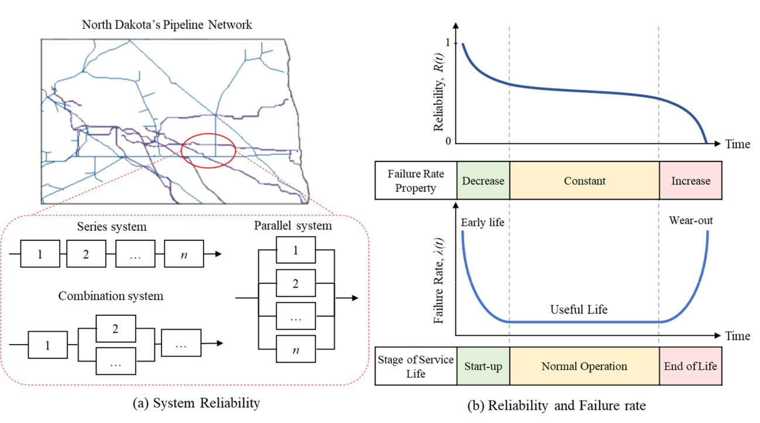

**Figure66..**Generalrepresentationofof(**a**(**a**))thevarioussystemreliabilitystructuresthatcanbebederived fromaacomplexsystem,and(**b**(**b**) )thetherelationshipbetweenreliabilityandandfailureraterateandandtime..

Basedonaacomponent’sfailureratefunction,*lλ*((t*t*),),reliability,R*R*(t(),*t*),canbebequantifiedquantified fromtheexponentialdistributionmodel,asasshownininEquation(2)(2)..

|  |  |  |  |  |  |  |  |
| --- | --- | --- | --- | --- | --- | --- | --- |
|  |  | R (t ) = e | | | Rot *l*(t) | (2a)(2a) |  |
| Assuming that *λ*(*t*) is | considered constant during the normal operation stage, the re‐ | | | | | |  |
|  | |  |  |  |  |  |
| Assuming that *l*(t) is considered constant during the normal operation stage, the | | | | | | |  |
| liability function can be simplified as follows. | | | | |  |  |  |
| reliability function can be simplified as follows. | | | | | | (2b) |  |
|  |  |  |  | = e *l*t | |  |
|  |  |  | R(t) | (2b) |  |
| Suppose a pipeline system is | | modeled as a serially connected system. If all system | | | | |  |
|  |  |  |  |  |  |

components are functioning at this time *t,* this system can be called reliable at *t*. If the Suppose a pipeline system is modeled as a serially connected system. If all system event *Ai*(*t*) represents the reliable functioning of the *i*th component of a serially connected components are functioning at this time t, this system can be called reliable at t. If the event system with *N* components at time *t*, then the overall reliability of the system can be ex‐ i( ) represents the reliable functioning of the th component of serially connected system

i

A

pressed in Equation (3a). This equation can be further modified using the assumption of with N components at time t, then the overall reliability of the system can be expressed

inmutualEquationindependence(3a).Thisequationofindividualcanbereliabilityfurther modifiedeventsof usingaseriesthesystemassumption.Thus, ofthemutualoverall

|  |  |  |  |  |  |  |  |
| --- | --- | --- | --- | --- | --- | --- | --- |
| system reliability with a series connection can be quantified with Equation (3b). | | | | | |  |  |
| independence of individual reliability events of a series system. Thus, the overall system | | | | | | |  |
| reliability with a series connection can be quantified with Equation (3b). | | | | | |  |  |
|  | series |  | ∩ | ∩ | ∩ | (3a) |  |
|  |  |  |  |  |  |  |

|  |  |  |  |  |  |  |  |  |  |  |
| --- | --- | --- | --- | --- | --- | --- | --- | --- | --- | --- |
| R | (t) = P (A1(t) | \ | A2(t) | \ | A3 | (t) | \ | AN (t)) | (3a) |  |
|  |  |  |  |
|  |  |  | N |  |  |  |  |  |  |  |
|  | Rseries(t) = ÕRi(t) | | | | | |  |  | (3b) |  |

i=1

Moreover, the overall series system reliability is generally less than or equal to the relia-

bility of the sub-component with the minimum reliability index. Thus, Rseries(t) min(Ri(t)).

Due to the redundancy property, the reliability of parallel and combination systems is

|  |  |  |  |  |  |  |  |  |  |  |  |  |  |
| --- | --- | --- | --- | --- | --- | --- | --- | --- | --- | --- | --- | --- | --- |
|  |  |  |  |  |  |  |  |  |  |  | (3b) | |  |
| Sustainability **2023**, 15, 4953 | |  |  |  |  |  | 11 of 22 | |  |
|  |  |  |  |  |  |  |  |  |  |
|  |  | Moreover, the overall series system reliability is generally less than or equal to the | | | | | | | | | | |  |
|  |  | reliability of the sub‐component with the minimum reliability index. Thus, | | | | | | | |  |  |  |  |
|  |  |  | . Due to the redundancy property, the reliability of parallel and combination | | | | | | | | | |  |
|  |  | usually higher than the sub-component with the minimum reliab lity index. | | | | | | | | The overall | | |  |
|  |  |  |  | |  |
|  |  | systems is usually higher than the sub‐component with the minimum reliability index. | | | | | | | | | | |  |
|  |  | system reliability with parallel connection can be qua tified with Equation (3c). For the | | | | | | | | | | |  |
|  |  | The overall system reliability with a parallel connection can be quantified with Equation | | | | | | | | | | |  |
|  |  | combination system s ructure, the reliability of the system can be quantified based on the | | | | | | | | | | |  |
|  |  | (3c). For the combination system structure, the reliability of the system can be quantified | | | | | | | | | | |  |
|  |  | combination of Equations (3b) and (3c). | | | | |  |  |  |  |  |  |  |
|  |  | based on the combination of Equations (3b) and (3c). | | | | | | | |  |  |  |  |
|  |  |  |  | Rparallel (t) = 1 | | | N | (1 | Ri(t)) |  | (3c) | |  |
|  |  |  |  |  |  | 1 | Õ1 |  |  |  |  |  |  |

i=1

Preserving the O&G infrastructures or ensuring smooth day‐to‐day operating condi‐ Preserving the O&G infrastructures or ensuring smooth day-to-day operating condi-tions is one means to realize sustainable development [85]. Reliability is often regarded as tions is one means to realize sustainable development [85]. Reliability is often regarded as a road toward sustainable development [86]. Therefore, it is vital to improve the reliability a road toward sustainable development [86]. Therefore, it is vital to improve the reliability of the aging O&G infrastructure. The reliability of a system can be enhanced with proper of the aging O&G infrastructure. The reliability of a system can be enhanced with proper corrective or preventive maintenance activities [25]. Reliability is closely related to the corrective or preventive maintenance activities [25]. Reliability is closely related to the concepts of maintainability and availability [87], however this is beyond the scope of this concepts of maintainability and availability [87], however this is beyond the scope of this

work, which focuses on the 3Rs.

work, which focuses on the 3Rs.

|  |  |  |
| --- | --- | --- |
| *3.3.* |  |  |
| 3.3. Resilience Assessment |  |  |
| O&G | is part of a Nation’s critical energy infrastructure sector, | |
| The O&G infrastructureis part of a Nation’s critical energy infrastructure sector, where | | |
| where its incapacitation would devastate national | | economy, public health, |
| its incapacitation would devastate national security, economy,security, public health, safety, and | | |
| safety, and other quality of life factors [88]. No matter how well or advanced the O&G | | |
| oth r quality of life factors [88]. No matter how well or advanced the O&G pipeline | | |
| pipeline system is designed, internal failures or | | induced by external factors are |
| system is designed, internal failures or failures indfailuresced by external factors are bound | | |

toboundoccurtowithoccurtimewith[39time].The[39] .O&GTheO&Ginfrastructureinfrastructureand andoperationsoperationsare arelsoalsosusceptiblesusceptibleto naturaltonaturaldisastersdisasters.Although.Althoughthe theoccurrenceofnaturalofnaturaldisastersdisastersmaymaybeprbepredictedwithwiththe

advadvancementtheinweatherinweather-pprediction‐technology,thethecharcharacteristicsofofitsitsuncertain aand widespreadespread iimpactsareoften iinevitable [[54]54.. In the case of an unavoidable adverse threat, tthe O&G iinfrastructurectre needs to be resilient[[39,89]3989]..

The Presidential PolicyDirective2121(PPDPD‐21):-21):CriticalInfrastructurectureSecuritySecurityandandRe‐ Resiliencedocument[90]90defines]definesresiliencelienceasas““*the*theability*to*toprepare forr *and adapt to* changing

cconditions *and* withstandst *and* recoverer rapidlyly from disruptionss.*.* Resilienceili iincludes t*the* aability to withstandandrecoverfrom*from*deliberateattattacks,accidents,*accidents,*ornatur*or*naturallyoccurring*occurring*threats*threats*orincidents*orinci*”*‐*. The*dents*performance.”Theperformanceofrsilientofaresilientsystemsystemisoftenis oftenprsentpresentedinaresilienceinaresiliencecurve,curve,P(*P*t), (as*t*),

T *T*

shownasshownin FigureinFigure7a. 7a.

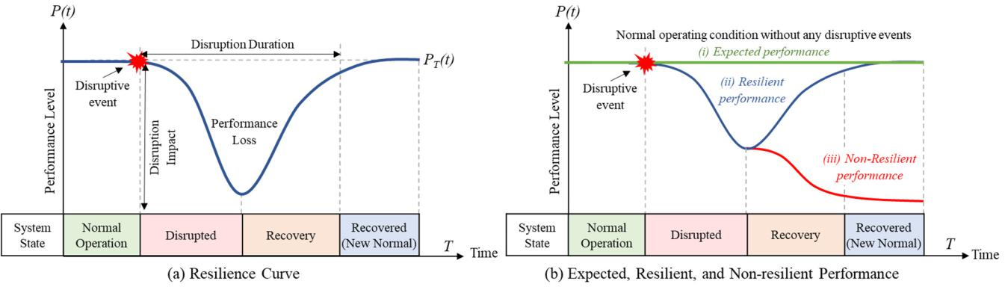

**Figure 77..**((**aa**)) General representation of aa four-‐state resilience curve, and ((**bb**)) the difference between resilient and non‐resilient performance compared to the expected performance. Figures are modi‐ resilient and non-resilient performance compared to the expected performance. Figures are modified fied from [39,91].

from [39,91].

There are many variations to a resilience curve depending on the actual system’s response to disruptive events [90,91]. Generally, in the first state of a resilience curve, the normal operation state, a system is expected to function as usual until the occurrence of a disruptive event. The second state, the disruptive state, is when the system starts to exhibit a performance loss from the negative impact of the disruptive event. The third state is the recovery state, where the system should be able to recover a portion or all of

|  |  |  |  |  |  |
| --- | --- | --- | --- | --- | --- |
|  |  | There are many variations to a resilience curve depending on the actual system’s re‐ | | |  |
|  | sponse to disruptive events [90,91]. Generally, in the first state of a resilience curve, the | | | |  |
| Sustainability **2023**, 15, 4953 | normal operation state, a system is expected to function as usual until the occurrence of a | | | |  |
|  |  |  | 12 of 22 |  |
|  | disruptive event. The second state, the disruptive state, is when the system starts to exhibit | | | |  |
|  | a performance loss from the negative impact of the disruptive event. The third state is the | | | |  |
|  | recovery state, where the system should be able to recover a portion or all of the perfor‐ | | | |  |
|  | the performance loss to a newly recovered state in state four. This state is often referred to | | | |  |
|  | mance loss to a newly recovered state in state four. This state is often referred to as the | | | |  |
|  | as the “new normal” state, as shown in Figure 7 [26]. The term “new normal” is used to | | | |  |
|  | “new normal” state, as shown in Figure 7 [26]. The term “new normal” is used to describe | | | |  |
|  | describe a state following a recovery event. It may or may not be the same as the system’s | | | |  |
|  | a state following a recovery event. It may or may not be the same as the system’s original | | | |  |
|  | original or normal operation state, depending on the system’s ability to recover from the | | | |  |
|  | or normal operation state, depending on the system’s ability to recover from the disrup‐ | | | |  |
|  | disruptive event and return to its previous state [91]. | | |  |  |
|  | tive event and return to its previous state [91]. | | |  |  |
|  |  | One characteristic that sets a resilient system apart from others is that it can be re- | | |  |
|  |  | One characteristic that sets a resilient system apart from others is that it can be recov‐ | | |  |
|  | covered, as opposed to a non-resilient system, as shown in Figure 7b. Additionally, a | | | |  |
|  | ered, as opposed to a non‐resilient system, as shown in Figure 7b. Additionally, a resilient | | | |  |
|  | resilient system should be able to resist the change posed by disruptive events, absorb | | | |  |
|  | system should be able to resist the change posed by disruptive events, absorb the adverse | | | |  |
|  | the adverse impact, and return to its original state [91,92]. Resilience in the context of the | | | |  |
|  | impact, and return to its original state [91,92]. Resilience in the context of the O&G sector | | | |  |
|  | O&G sector refers to the ability of the industry to adapt and recover from disruption events | | | |  |
|  | refers to the ability of the industry to adapt and recover from disruption events or other | | | |  |
|  | or other stressors. Disruptions and stressors in the O&G industry can include natural | | | |  |
|  | stressors. Disruptions and stressors in the O&G industry can include natural disasters, | | | |  |
|  | disasters, technological failures, supply chain disruptions, and fluctuations in demand | | | |  |
|  | technological failures, supply chain disruptions, and fluctuations in demand and pricing | | | |  |
|  | and pricing [89]. Resilience is important for the industry to maintain the continuity of | | | |  |
|  | [89]. Resilience is important for the industry to maintain the continuity of operations, min‐ | | | |  |
|  | operations, minimize financial losses, and reduce negative impacts on the environment | | | |  |
|  | imize financial losses, and reduce negative impacts on the environment and society. | | | |  |
|  | and society. | |  |  |  |
|  |  | Figure 8 shows three different system performances, *PA*(*t*), *PB*(*t*), and *PC*(*t*)*.* In all sub‐ | | |  |
|  |  | Figure 8 shows three different system performances, PA(t), PB(t), and PC(t). In all | | |  |
|  | figures in Figure 8, the | | of *PA*(*t*) > *PB*(*t*) > *PC*(*t*). Although it can be said that all | |  |
|  | subfigures in Figure 8, theresiliency of PA(t) > PB(t) > | | | PC(t). Although it can be said that all |  |
|  | three systems are | | they exhibit | in each stage of |  |
|  | three systems are resilient, they exhibit different resilient characteristics in each stage of | | | |  |
|  | the | *.* In | in the O&G | can |  |
|  | the resilience curve. Inpractice,resilience in the O&Gsector caninvolvevariousmeasures | | | |  |
|  | in | of | as |  |  |
|  | in each stage of the resilience curve, such as redundant infrastructure, backupsystems, | | | |  |

contingency plans, and response strategies..

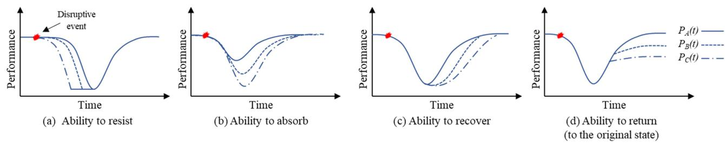

**Figure 88..**Variouscharacteristicsofofa resilientasystemsystemafterafterdisruptiveaevent:event:(**a**) Resist(**a**)Resistthedisrupthedis‐-tion,ruption,(**b**)A(**b**)sorbAsorbnegativenegativeimpactsimpactsfromfromthedisruption,thedisruption,(**c**)Respond(**c**)Respondorrecoverorrecovereffectivelyeffectivelyfrom thefrom disruption,thedisruption,and (and**d**)Return(**d**)Returntothetooriginaltheoriginalstatepriorstate topriorthe disruptiontothedisruption.Figures.Figuresaremodifiedaremodifiedfrom

[39,91].

from [39,91].

For example,O&Gcompaniesmayinvestininredundantpipelinesandandstoragefacili‐-

itiestotoensurebackupsystemsin incasecaseof aofdisruptionainthein thesupplysupplychainchain.This.Thisstrategystrategycan exhibitcanexhibitbetterbetterresistanceresistancetodisruptiontodisruptionandminimizeandminimizetheimpacttheimpactonoperationsoperations.Thechar.The‐ actecha**r**acteristicofresistingofresistingthechangethechangeisshownisshowninFigurein Figure8a,where8a, thewheresystemthe triedsystemto operatetriedto normallyoperatenormallyaslongasas pl**o**ngssibleas possibleafterthe aftedis**r**uptivethedisruptiveeventoccurredeventoccurredandbeforeandthebeforeperforthe‐ performancedeteriorationdeteriorationtookeffecttook. Ineffectthis. case,Inthis*PA*case,(*t*)canPAbe(t)viewedcanbe viewedasamoreasresilientamore resilientsystem comparedsystemcomparedto*P*(*t*) toandP *P*(t)(and*t*)sinceP(the)sinceperformancetheperformancedropoccursdropoccurslastamonglastamongthethreethe *.*threeThe.

*B* B *C* C

characteristicThecharacteristictoabsorbtoabsorbtheimpacttheimpactisshownis showninFigurein8b,Figuredenoted8b, denotedbythesmallestbythedecreasesmallest indecreasesystem inperformancesystemperformanceloss.Sinceloss*P*(.*t*)SincehastheP (smallest)hasthedrop,smallestitcandrop,bedeemeditcanbethatdeemed*P*(*t*)

*A* A *A*

isthatmoreP (resilient)ismorethan*resilientP*() andthan*P*P(*t*()t*.*) and P (t).

A *B* *C*B C

The O**&G** industries shouldhavesophisticatedcontingencyplansplansfor foremergenciesand andnaturalnaturaldisastersdisasterstorespondtorespondandrecoverandrecovereffectivelyeffectivelyfromthefromdisruptionthedisruptionassoon as possiblesoonas. possibleAmore.resilientAmoresystemresilientpossessessystemfasterpossessesrecoverabilityfasterrecoverability.Figure8shows.Figurethat8cPAshows(t)indicatesthat

the earliest and fastest recovery period. Thus, PA(t) is considered the most resilient among the three system performances.

Lastly, a resilient system should be able to return, as much as possible, to its original state. Resilience in the O&G sector can involve broader societal, economic, and environ-mental considerations by recognizing that the O&G industry’s impacts extend beyond its immediate operations. In Figure 8d, PB(t) and PC(t) are recovered to lower than their

|  |  |
| --- | --- |
| Sustainability **2023**, 15, 4953 | 13 of 22 |
|  |  |

original state. In this scenario, it can be said PB(t) and PC(t) are less resilient than PA(t), as PA(t) is recovered to, or similar to, its original state. This ability to return to its original condition can be improved by involving a range of measures. For example, engaging with local communities, implementing sustainable practices, or promoting a culture of continuous learning and improvement within the O&G sector can help ensure that lessons are learned from past experiences and applied to future activities to enhance the ability to return to its original state.

In many cases, recovery actions and time depend highly on the availability of external resources, typically in the format of monetary funds or human resources [26]. Thus, insuf-ficient resources may prolong or jeopardize the recovery state. Some systems inherently possess a more extended recovery period. For example, environmental rehabilitation will require a more extended period than replacing a failed component during an operation. It should be noted that there are also cases in a system that can be recovered to better than its original state [93].

Depending on the resilience assessment framework, the resilience index (RI) can be quantified based on its ability to recover [18]. Mathematically, RI can be measured as its recovery function, which is the area under the system performance of the second and third stages in the resilience curve presented in Figure 7a, as shown in the equation below.

|  |  |  |  |  |
| --- | --- | --- | --- | --- |
| RI(%) = Z | Tre2 P(t) | dt | (4) |  |
| Tre1 Tre2 |  |

where, tre1 is the occurrence time of the disruptive events, and tre2 is the completion time of the recovery action. P(t) is the system performance level at time t.

Another perspective of quantifying system resilience is to compare the expected performance with the resilient system performance. The resilience index (RI) can be measured as the performance loss ratio, as shown in Equation (5). With this approach, RI would have a maximum value of 1 if the resilience performance, P(t), is the same as the expected performance, EP(t). It is possible to have the RI value be more than 1 if the system is being recovered better than the expected performance.

R T P(t)dt

RI = o (5)

RoT EP(t)dt

In other cases, resilience also can be quantified from a system’s reliability perspec-tive [20,94], where it is expected to operate normally without failure (reliability, R) plus the ability to recover (recoverability, REC) when a failure occurs with probability , as shown in Equation (5). The recoverability can be quantified further based on correct diagnosis, prognosis, and success mitigation actions [20,94].

|  |  |
| --- | --- |
| RI(R, REC) = Reliability + *g* Recoverability | (6) |

There are still many debates on measuring and verifying resilience, what charac-teristics should be included in system resilience, or what protocol should be taken for complex system resilience. Equations (4)–(6) are examples of three different approaches. Other resilience quantification and recovery approaches can be referred to in these refer-ences [91,95–97]. Since O&G sustainable development encompasses many social, economic, and environmental pillars, resilience in each aspect may be distinctively defined. Environ-mental resilience would be characterized and analyzed differently than social or economic resilience [23,91,98,99]. This section mainly summarizes resilience from an infrastructure resilience point of view.

**4. O&G Sustainable Development and the 3Rs**

To achieve sustainable development in the O&G industry, it is crucial to consider the concepts of risk, reliability, resilience, and sustainability in tandem as they complement

**4. O&G Sustainable Development and the 3Rs**

To achieve sustainable development in the O&G industry, it is crucial to consider the

Sustainability **2023**, 15, 4953 14 of 22

concepts of risk, reliability, resilience, and sustainability in tandem as they complement each other. This paper introduces a new approach to achieving sustainable development in the O&G industry through the application of the 3Rs concept at all levels of social, eco‐

each other. This paper introduces a new approach to achieving sustainable development nomic, and environmental aspects of O&G infrastructure. This section highlights the 3Rs’ in the O&G industry through the application of the 3Rs concept at all levels of social, holistic role in serving as a pathway toward sustainable development in O&G infrastruc‐

economic, and environmental aspects of O&G infrastructure. This section highlights ture and operations.

the 3Rs’ holistic role in serving as a pathway toward sustainable development in O&G infrastructure and operations.

*4.1. Conceptual Relationship and the Holistic 3Rs*

4.1. ConceptualBasedontheRlatiprobabilitynshipandoftheoccurrenceHolistic3Rs(*p*) and the magnitude of impact, Figure 9a shows where the concepts of risk, reliability, and resilience stand; from Sweetapple et al.

Based on the probability of occurrence (p) and the magnitude of impact, Figure 9a shows [100]. Risk is generally known as the probability of occurrence of an unexpected event or where the concepts of risk, reliability, and resilience stand; from Sweetapple et al. [100]. Risk is outcome [101]. In risk, the possible outcome events can be anticipated quantitatively with generally known as the probability of occurrence of an unexpected event or outcome [101]. an assigned probability. However, the actual outcome is unknown until the event occurs. In risk, the possible outcome events can be anticipated quantitatively with an assigned Thus, a risk control plan can be formulated beforehand to account for all the possible out‐ probability. However, the actual outcome is unknown until the event occurs. Thus, a risk comes. Since there is a pre‐mitigation plan in place, typically the negative magnitude of control plan can be formulated beforehand to account for all the possible outcomes. Since

an outcome can be reduced to a low‐magnitude probability event if the outcome occurs. there is a pre-mitigation plan in place, typically the negative magnitude of an outcome

Reliability concerns the probability of a failure event expected to occur within the design can be reduced to a low-magnitude probability event if the outcome occurs. R liability life cycle. Thus, the occurrence probability is higher compared to the risk. To increase re‐ concerns the probability of a failure event expected to occur within the design life cycle. liability,Thus,themaintenanceoccurrence orprobabilityredundancyishigherisoftencomparedapproachedto [20,83]therisk.Resilience.Toincreaseismorereliability,com‐

monlymaintenanassociatedorredundancywithextreme,is oftenrare, andapproacheduncertain[20events,83]. Resiliencewhereitsoccurrenceismorecommonlyandim‐ pactassocannotiatedwithbequantifiedextrem,rare,withandanassigneduncertainprobabilityeventswhere[100]its. occurrenceForresilience,andfailureimpactiscannotoften expectedbequantifiedandcannotwithanbeassmitigated,gnedprobabilityalthough [the100occurrence].Forresilience,probabilityfailureofisthisoftenoutcomeexpectedis

oftenandcannotlow. be mitigated, although the occurrence probability of this outcome is often low.

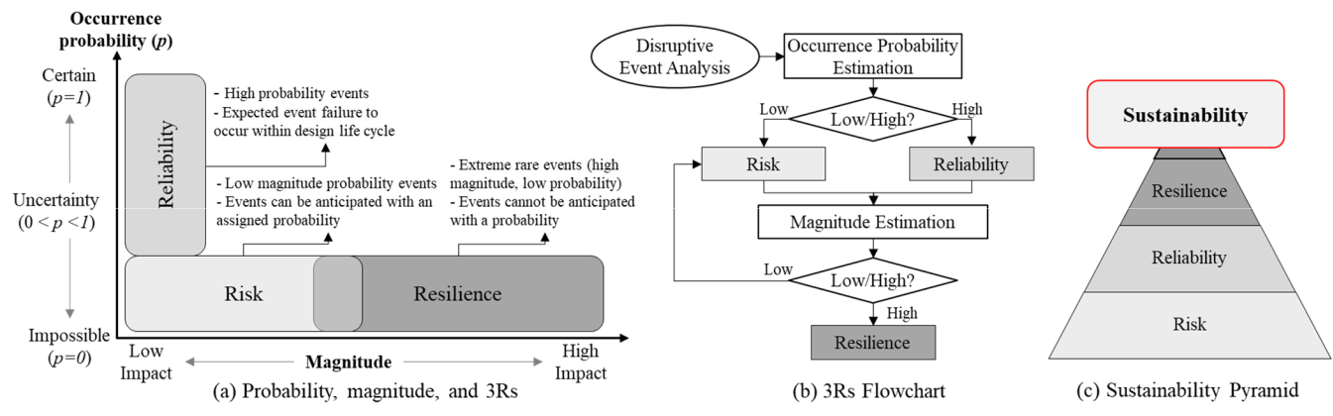

**Figure99..**((**aa**))Conceptual relationship **of** the 3Rs with respecttoprobability(modified(modifiedfromSweetapple‐ pleet alet. al[99.[99]),(**b**)(**b**the)the3Rs3Rsflowchartflowcharttotocomplementthetheconceptual relationship, and (**c**)) conceptual

pathwaysto sustainabilitywith a 3Rs foundation.

to with a 3Rs .

The flowchartflowchartofofthetherulesrulesof ofthumbthumbforforwhenwhenthe risk,therisk,reliability,reliability,and resilienceandresiliencecon‐ ceptconceptismoreismoreappropriateappropriatebasedbasedontheon disruptivethedisruptiveevents’events’probabilityprobabilityofoccurrenceofoccurrenceand magnitudeandmagnitudeisshownisshowninFigurein Figure9btocomplement9btocomplementthe3Rs conceptualthe3Rsconceptualrelationshiprelationshipandnav‐ igateand navigateissuesin issuesFigurein9aFigure.Theprobability9.Theprobabilityofdisruptiveofadisruptiveeventcaneventbeestimatedcanbeestimatedfromthe analysisfromthe.Ifanalysistheprobability.Iftheprobabilityislow,risk low,managementriskmanpl**a**gementcanbeplanformulatedcanbe ftormulatedmitigate orto reducemitigatetheo**r**iskreduce.However,theriskthe.However,reliability conceptthereliabilityshouldconceptbeemployedshouldif betheemployedprobabilityif isthehighprobability.Inaddition,ishighthe. magnitudeInaddition,ofthethemagnieventudeshouldofthebe eventestimatedshould.Forbelowestimated‐magnitude.For events,low-magnitudetheriskconceptevents,canthe beriskusedconcepttodevelopcanbeausedrisk managementtodevelop riskplan,managementwhilehigh‐magplan,‐ nitudewhile highevents-magnitudewillrequireeventsaresiliencewillrequireconceptaresiliencetosustainconceptthesystemtosustainandformulathesys**te**ma fastand

recoveryformulatestrategyfastrecoverytoreturnstrategyittonormaltoreturnoperatingittonormalconditionsoperating. conditions.

These risk, reliability, resilience, and sustainability concepts complement each other, and their conceptual relationship is summarized by Sweetapple et al. [100]. The relationship between reliability and resilience has been discussed previously in Section 3.3. For risk and reliability, it has been suggested that higher reliability may contribute to risk reduction as the failure is expected to occur less frequently. Risk and resilience have an overlapping uncertainty concept, but they complete each other, where the risk concept accounts for

These risk, reliability, resilience, and sustainability concepts complement each other, and their conceptual relationship is summarized by Sweetapple et al. [100]. The relation‐ ship between reliability and resilience has been discussed previously in Section 3.3. For risk and reliability, it has been suggested that higher reliability may contribute to risk re‐

Sustainability **2023**, 15, 4953 duction as the failure is expected to occur less frequently. Risk and resilience have15of an22 overlapping uncertainty concept, but they complete each other, where the risk concept accounts for events that can be controlled, and resilience accounts for events in which the negative impact cannot be contained.

events that can be controlled, and resilience accounts for events in which the negative

impactTocannotsummarize,becontained(i)the.risk concept is most applicable for low‐probability and low‐

magnitudeTosummarize,events,(ii)(i)thethereliabilityriskconceptconceptismostismostapplicablesuitableforfor lowhigh-probability‐andand low-‐ magnitude events,ts, (ii)andthe(iii)reliabilitytheresilienceconceptconceptismostismostsuitappropriatebleforhighfor-probabilityanyhigh‐ magand‐ lownitude-magnitudeevents.Thus,events,theandrisk,(iii)reliability,theresilienceandresilienceconcept conceptsismostappropricanaidastetheforfoundationanyhigh-magnitudeforsustainability,events. asThus,shownthe inrisk,thereliabiliconceptualy,andsustainabilityresilienceconceptspyramidcanin Figureadasthe9c. founInordera-titonrealizeforsusustainability,as shownallspectrumsinthecofnceptualeventprobabilitysustanabilityand pyramidmagnitudein shouldFigre 9bec. acIn‐ ordercountedtorealizeforin sustainableility,developmentallsectrumspracticesofevent. probability and magnitude should be

accounted for in sustainable development practices.

*4.2. Sustainable Development and the 3Rs*

4.2. Sustainable Development and the 3Rs

Although it has been emphasized that there is no one‐size fits all solution to the mul‐ tidimensionalAlthough challengesithasbendiscussedemphasizedinSectionthatthere2.3,theis no3Rsoneconcept-size fitscan allbe integratedsolutiontoiterathe‐ multidtivelyintomensionaleachof ctheallengesthreepillarsdiscussedofsustainability,Section2.3as, theshown3Rs inconceptFigurecan10abe.Thus,integratedpracti‐ itionerserativelycanintocontributeeachof tothesustainablethreepilarsdevelopmentofsustaiability,fundamentallyasshownfrominFigureanyaspect10.Thus,ofso‐ prcial,ctitieconomic,erscanorcoenvironmentaltrbutetosustainablesustainabilitydevelopmentpillars.Thisfundamentallyintegrated approachfromany aspectresultsofin social,thesustainableeconomic, developmentorenvironmental3Rs sustainabilitymatrixconsistingpllarsof. Thisafundamentalintegratedapproachmatrixandresultsacouin‐

theplingsustainablematrix,asdevelopmentshowninFigure3Rsmatrix10b. Theconsistingterm“fundamental”offundamentalrefersmatrixto andthe underlyingacoupling matrix,principlesasshownorbasicinconceptsFigure10thatb.Thegovernterm the“fundamental”behavioror propertiesreferstotheofunderlyingasystem,whileprinciples“cou‐ orpling”basicrefersconceptstothethatinteractiongovern thebetweenbehaviortwo or prmorepertiessystemsof aorsystem,subsystemswhile. “coupling” refers to the interaction between two or more systems or subsystems.

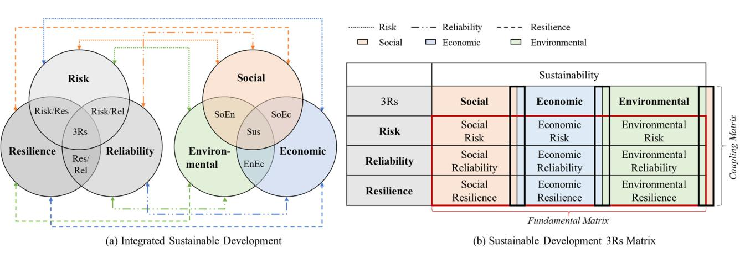

**Figure10..**A general representationof((**aa**)) the 3Rs integrated sustainable developmentapproachand (**b**(**b**) )thesustainabledevelopment3Rsmatrix..

Toreducethecomplexityofofthemulti-‐faceted sustainable development, the funda-‐ mental matrix for sustainable development suggested a targeted 3Rs effort to the social, economic, and environmental pillars of sustainability.. Thisfundamental matrix looks atat thedirectandimmediate impacts of aa particular activity or process on the environment,

economy,andsociety..Forexample,socialriskwillemphasizereducingrisksgenerated bybytheO&Gsectors,suchasashumanrightsviolationsororpoorlaborconditions,health,and safety.. Social reliability focuses onon the ability ofof O&G toto consistently provide aa reliable energysupplytotothethecommunitywhileminimizingthethenegativeimpactsonon society..Social aims to build a to and from the

resilience aims to build aresilientcommunity towithstand andrecover from thenegative

social impact caused by the O&G operations or failures. These fundamental effects can social impact caused by the O&G operations or failures. These fundamental effects can often be measured and quantified, and they may include factors such as emissions, water

usage, land use changes, operational costs, and other indices for measuring social welfare. Since the social, economic, and environmental influences often cannot be entirely distinguished from one another, the fundamental matrix for sustainable development in Figure 10b can be further expanded to include the coupling effect from the individ-ual sustainability pillar. This will result in a coupling matrix between the sustainability pillars and the 3Rs, which consist of: (1) social-economic risk, socio-environmental risk,

|  |  |
| --- | --- |
| Sustainability **2023**, 15, 4953 | 16 of 22 |
|  |  |

and eco-economic risk, within the risk framework, (2) social-economic reliability, socio-environmental reliability, and eco-economic reliability, within the reliability approach, and

1. social-economic resilience, socio-environmental resilience, and eco-economic resilience, within the resilience concept. The coupling matrix considers the indirect or long-term im-pacts of an activity or processes toward achieving sustainability. It should be noted as more coupling matrices are considered, the complexity of sustainable development increases.

In general, the coupling effect refers to the degree to which two or more things are connected or interrelated. In this context of sustainable development, the coupling effect refers to how changes in one part of the sustainability pillar can affect other parts of the pillar. The coupling effect can be positive, where a change in one part of the sustainability pillar leads to beneficial changes in the other pillars. The coupling matrix can also pose a negative effect, where a change in one part of the sustainability pillar leads to detrimental changes in other pillars. The coupling effect can be important to consider in the sustainable development of O&G applications, where it is often highly interconnected, and changes in one area can have significant consequences in other areas.

Although the coupling effects may not be immediately apparent, they can be signif-icant and wide-ranging. For example, the extraction and use of fossil fuels may have a fundamental effect in terms of carbon emissions and local environmental impacts, but it also has a coupling effect by contributing to climate change, which in turn can have far-reaching and often unpredictable impacts on ecosystems, economies, and societies around the world. The coupling effect is significant in sustainable development because it highlights the interconnectedness of environmental, social, and economic pillars and em-phasizes the need for a more holistic and integrated approach to sustainable development that considers both the direct and indirect impacts of human activities.

By considering the 3Rs fundamental and coupling matrices of sustainable develop-ment in the O&G application, stakeholders and policymakers can understand the impacts of O&G activities and work to achieve sustainability by minimizing negative impacts and maximizing positive ones. In the O&G sector, the role of risk toward sustainable devel-opment is to manage the potential risks that arise in O&G practices, achieve a balance between social, economic, and environmental considerations in the decision-making pro-cess, and understand the long-term impacts of those decisions on society, economy, and the environment as a whole. Reliable components, systems, and infrastructure are essential to O&G’s sustainable development in guaranteeing a continuous supply of O&G without disrupting society, economy, or environment, now and in the future. Reliability in the O&G industry’s sustainable development ensures that O&G will function well without requiring costly maintenance, excessive repairs, and unnecessary downtime due to replacements. For O&G’s sustainable development, resilience is necessary to ensure that society, the economy, and the environment can adapt to the world’s changing conditions, such as increasing O&G demand, climate change, or natural disasters.

In the U.S., the 3Rs (risk, resilience, and reliability) play a crucial role in current and future energy policy, especially in the oil and gas industry. The U.S. government has established regulations and guidelines to ensure that the industry operates safely and efficiently while addressing environmental and social concerns. The U.S. Department of Transportation’s Pipeline and Hazardous Materials Safety Administration (PHMSA) regulates pipelines transporting hazardous materials [30], while the U.S. Environmental Protection Agency (EPA) has established regulations to reduce air pollution, including emissions from oil and gas operations [8]. The U.S. government also encourages developing and using renewable energy sources to diversify the energy mix and reduce reliance on fossil fuels [102].

However, more needs to be done beyond these concepts to promote sustainable de-velopment in the energy industry. It may include investing in clean energy technologies, reducing greenhouse gas emissions, promoting energy efficiency and conservation, and working with local communities to ensure that energy development is aligned with their needs and priorities. Additionally, more holistic 3Rs approaches to energy policy and plan-

|  |  |
| --- | --- |
| Sustainability **2023**, 15, 4953 | 17 of 22 |
|  |  |

ning are necessary, which take into account a range of social, economic, and environmental factors and promote long-term sustainability. In short, the 3Rs are critical in shaping energy policy in the U.S., ensuring that the energy sector operates safely, sustainably, and in the best interest of the public; however, there is still work to be done to achieve long-term sustainability.

4.3. Future Research Directions

The problems within the O&G sector are not novel since O&G infrastructure has been developed for many decades. There have been many efforts from the O&G community to advance sustainable development in the O&G industry by investing in renewable energy development, transitioning to a low-carbon economy, implementing energy efficiency measures, improving the safety and well-being of the operators, and many more. However, sustainable development in the O&G industry will always have room for advancement as new risks continuously emerge and new technologies or policies are constantly being developed. Potential research directions for sustainable development in the O&G industry include all ranges from fundamental research to applications. Some examples are, but are not limited to, as follows:

* Fundamental research and development. Researching ways to use technology to improve and optimize O&G operations while minimizing human resources and negative environmental impact. Some examples include developing low-carbon technology to reduce the carbon footprint of O&G operations, innovating practical measures to integrate and store renewable energy, and utilizing advanced automation methods (such as artificial intelligence, machine learning, and the internet of things) to optimize day-to-day operations.
* Policy and administrative guidelines. Exploring policies that benefit society, the economy, and the environment, as a whole, without sacrificing one or another sus-tainability pillar. Some examples include social health and safety insurance policies, effective carbon pricing, recycling incentives, and other environmental protection and rehabilitation movements.
* Application, observation, and measures. Putting into effect sustainable development practices in the social, economic, and environmental aspects of the O&G sector and finding a way to holistically monitor and measure the effectiveness of sustainable development practices. The outcome can eventually be used to enhance the research and development efforts and update the policy or other administrative guidelines. This will further ensure sustainable development is continuously implemented in the O&G sector in this uncertain world’s condition.

Achieving sustainability in the O&G industry with the 3Rs approach requires a com-prehensive approach, as discussed in Section 4.2. It is essential to establish a proactive risk management plan that is comprehensive in addressing all possible risks and hazards. This includes both natural and human-induced risks, such as those caused by climate change, cyber threats, or supply chain disruptions. This plan should be updated regularly to address new risks that may emerge over time. Additionally, the O&G sector can focus on improving the resilience and reliability of its infrastructure and operations to withstand potential disruptions and recover quickly from any adverse events. By prioritizing risk management and infrastructure resilience, companies can better prepare themselves for potential disruptions and recover more quickly from adverse events.

The O&G industry must involve all stakeholders, including local communities, policy-makers, regulators, and investors, in sustainable development decision-making. Collabora-tion and transparency can help build trust and ensure that sustainable development goals align with all parties’ needs and expectations. Finally, regular monitoring and evaluation of sustainability practices and sustainable development plans are essential to identify areas for improvement and make necessary adjustments to achieve sustainability in the long term.

The continuation of this work will entail a deliberate focus on the creation and refine-ment of a comprehensive integration framework that is both structured and well-defined,

|  |  |
| --- | --- |
| Sustainability **2023**, 15, 4953 | 18 of 22 |
|  |  |

with a view to measuring sustainability more accurately and effectively using the 3Rs approach. The framework will also include a robust and reliable measurement assessment process to help capture and analyze critical data points, providing a more complete picture of sustainability efforts in the O&G industry.

**5. Conclusions**

Sustainable development in the O&G industry requires a balance between economic growth, energy security, and social and environmental concerns. This paper has proposed a novel approach to achieving sustainable development by introducing the holistic 3Rs concept and its influence on the industry. By integrating the 3Rs approach with the three pillars of sustainability, this paper has identified a fundamental and coupling matrix that can help reduce the complexity of sustainable development in practice. The contributions of this paper extend beyond the O&G industry and can be applied to other critical infrastructures to build a better future for future generations. This paper also suggests future research directions that require collaborative efforts from technology researchers, policymakers, and practitioners. The perspectives presented in this paper offer a fresh and valuable contribution to the field of sustainable development.

**Author Contributions:** Conceptualization, N.Y.; methodology, N.Y. and Y.H.; formal analysis, Y.M., T.A. and N.Y.; investigation, Y.M., T.A. and N.Y.; resources, N.Y. and Y.H.; data curation, Y.H.; writing—original draft preparation, Y.M., T.A. and N.Y.; writing—review and editing, N.Y. and Y.H.; visualization, Y.M., T.A. and N.Y.; supervision, N.Y. and Y.H.; project administration, Y.H.; funding acquisition, Y.H. All authors have read and agreed to the published version of the manuscript.

**Funding:** This research is made possible through funding from the National Science Foundation (NSF) EPSCoR R.I.I. Track-2 Program under the NSF award # 2119691. The findings and opinions presented in this manuscript are those of the authors only and do not necessarily reflect the perspective of the sponsors.

**Institutional Review Board Statement:** Not applicable.

**Informed Consent Statement:** Not applicable.

**Data Availability Statement:** No new data is generated.

**Conflicts of Interest:** The authors declare no conflict of interest.

**References**

1. Natural Gas Explained. About U.S. Natural Gas Pipelines 2022. Available online: [https://www.eia.gov/energyexplained/](https://www.eia.gov/energyexplained/natural-gas/natural-gas-pipelines.php) [natural-gas/natural-gas-pipelines.php](https://www.eia.gov/energyexplained/natural-gas/natural-gas-pipelines.php) (accessed on 15 January 2023).
2. U.S. Energy Information Administration. Month Energy Review January 2023. Available online: [https://www.eia.gov/](https://www.eia.gov/totalenergy/data/monthly/pdf/mer.pdf) [totalenergy/data/monthly/pdf/mer.pdf](https://www.eia.gov/totalenergy/data/monthly/pdf/mer.pdf) (accessed on 15 January 2023).
3. Divya Yasoda, R.; Huang, Y. Post-Fire Mechanical Properties of Thermally Sprayed Anti-Corrosive Coatings in Oil and Gas Pipelines. In Proceedings of the Pipelines 2022: Multidiscipline and Utility Engineering and Surveying, Indianapolis, IN, USA, 31 July–3 August 2022; pp. 203–210.
4. Dorian, J.P.; Franssen, H.T.; Simbeck, D.R. Global challenges in energy. Energy Policy **2006**, 34, 1984–1991. [[CrossRef](http://doi.org/10.1016/j.enpol.2005.03.010)]
5. Shafiee, S.; Topal, E. When will fossil fuel reserves be diminished? Energy Policy **2009**, 37, 181–189. [[CrossRef](http://doi.org/10.1016/j.enpol.2008.08.016)]
6. Sajid, M.J.; Yu, Z.; Rehman, S.A. The coal, petroleum, and gas embedded in the sectoral demand-and-supply Chain: Evidence from China. Sustainability **2022**, 14, 1888. [[CrossRef](http://doi.org/10.3390/su14031888)]
7. Sukumaran, K. Impact of Human Activities Inducing and Triggering of Natural Disasters. In A System Engineering Approach to Disaster Resilience; Springer: Berlin/Heidelberg, Germany, 2022; pp. 17–31.
8. Allen, D.T. Emissions from oil and gas operations in the United States and their air quality implications. J. Air Waste Manag. Assoc. **2016**, 66, 549–575. [[CrossRef](http://doi.org/10.1080/10962247.2016.1171263)]
9. Ming, A.; Rowell, I.; Lewin, S.; Rouse, R.; Aubry, T.; Boland, E. Key Messages from the IPCC AR6 Climate Science Report; IPCC: Geneva, Switzerland, 2021.
10. Pörtner, H.-O.; Roberts, D.C.; Poloczanska, E.; Mintenbeck, K.; Tignor, M.; Alegría, A.; Craig, M.; Langsdorf, S.; Löschke, S.; Möller, V. Summary for Policymakers; IPCC: Geneva, Switzerland, 2022.
11. Kikstra, J.S.; Nicholls, Z.R.; Smith, C.J.; Lewis, J.; Lamboll, R.D.; Byers, E.; Sandstad, M.; Meinshausen, M.; Gidden, M.J.; Rogelj, J. The IPCC Sixth Assessment Report WGIII climate assessment of mitigation pathways: From emissions to global temperatures. Geosci. Model Dev. **2022**, 15, 9075–9109. [[CrossRef](http://doi.org/10.5194/gmd-15-9075-2022)]

|  |  |
| --- | --- |
| Sustainability **2023**, 15, 4953 | 19 of 22 |
|  |  |

1. Yodo, N.; Wang, P.; Rafi, M. Enabling resilience of complex engineered systems using control theory. IEEE Trans. Reliab. **2017**, 67, 53–65. [[CrossRef](http://doi.org/10.1109/TR.2017.2746754)]
2. Ilyushin, Y.V.; Fetisov, V. Experience of virtual commissioning of a process control system for the production of high-paraffin oil. Sci. Rep. **2022**, 12, 18415. [[CrossRef](http://doi.org/10.1038/s41598-022-21778-0)]
3. Cherepovitsyn, A.; Rutenko, E. Strategic Planning of Oil and Gas Companies: The Decarbonization Transition. Energies **2022**, 15, 6163. [[CrossRef](http://doi.org/10.3390/en15176163)]
4. Kondrasheva, N.K.; Eremeeva, A.M. Production of biodiesel fuel from vegetable raw materials. J. Min. Inst. **2023**. [[CrossRef](http://doi.org/10.31897/PMI.2022.15)]
5. Harrington, L.M.B. Sustainability theory and conceptual considerations: A review of key ideas for sustainability, and the rural context. Pap. Appl. Geogr. **2016**, 2, 365–382. [[CrossRef](http://doi.org/10.1080/23754931.2016.1239222)]
6. Mojarad, A.A.S.; Atashbari, V.; Tantau, A. Challenges for sustainable development strategies in oil and gas industries. In Proceedings of the International Conference on Business Excellence, Bucharest, Romania, 22–23 March 2018; pp. 626–638.
7. Hariri-Ardebili, M.A. Risk, Reliability, Resilience (R3) and beyond in dam engineering: A state-of-the-art review. Int. J. Disaster Risk Reduct. **2018**, 31, 806–831. [[CrossRef](http://doi.org/10.1016/j.ijdrr.2018.07.024)]
8. Shahriar, A.; Sadiq, R.; Tesfamariam, S. Risk analysis for oil & gas pipelines: A sustainability assessment approach using fuzzy based bow-tie analysis. J. Loss Prev. Process Ind. **2012**, 25, 505–523. [[CrossRef](http://doi.org/10.1016/j.jlp.2011.12.007)]
9. Yodo, N.; Wang, P. Resilience modeling and quantification for engineered systems using Bayesian networks. J. Mech. Des. **2016**, 138, 031404. [[CrossRef](http://doi.org/10.1115/1.4032399)]
10. Davila-Frias, A.; Yodo, N.; Le, T.; Yadav, O.P. A deep neural network and Bayesian method based framework for all-terminal network reliability estimation considering degradation. Reliab. Eng. Syst. Saf. **2023**, 229, 108881. [[CrossRef](http://doi.org/10.1016/j.ress.2022.108881)]
11. Afrin, T.; Yodo, N. Resilience assessment of repair strategies against localized attacks for infrastructure protection. In Proceedings of the 2019 Annual Reliability and Maintainability Symposium (RAMS), Orlando, FL, USA, 28–31 January 2019; pp. 1–7.
12. Cimellaro, G.P.; Villa, O.; Bruneau, M. Resilience-based design of natural gas distribution networks. J. Infrastruct. Syst. **2015**, 21, 05014005. [[CrossRef](http://doi.org/10.1061/(ASCE)IS.1943-555X.0000204)]
13. Tan, X.; Fan, L.; Huang, Y.; Bao, Y. Detection, visualization, quantification, and warning of pipe corrosion using distributed fiber optic sensors. Autom. Constr. **2021**, 132, 103953. [[CrossRef](http://doi.org/10.1016/j.autcon.2021.103953)]
14. Yodo, N.; Afrin, T.; Yadav, O.P.; Wu, D.; Huang, Y. Condition-based monitoring as a robust strategy towards sustainable and resilient multi-energy infrastructure systems. Sustain. Resilient Infrastruct. **2022**, 8, 170–189. [[CrossRef](http://doi.org/10.1080/23789689.2022.2134648)]
15. Afrin, T.; Yodo, N. A Hybrid Recovery Strategy toward Sustainable Infrastructure Systems. J. Infrastruct. Syst. **2022**, 28, 04021054. [[CrossRef](http://doi.org/10.1061/(ASCE)IS.1943-555X.0000670)]
16. Bø, E.; Hovi, I.B.; Pinchasik, D.R. COVID-19 disruptions and Norwegian food and pharmaceutical supply chains: Insights into supply chain risk management, resilience, and reliability. Sustain. Futures **2023**, 5, 100102. [[CrossRef](http://doi.org/10.1016/j.sftr.2022.100102)]
17. Ahmad, T. Regulatory Challenges to Oil & Gas Industry and Environment Protection: A Critical Analysis of Asia. In Proceedings of the International Conference, New Horizons of Innovation and Technologies in Petroleum Engineering and Industries, Dubai, United Arab Emirates, 6–7 August 2018.
18. Al-Janabi, Y.T. An overview of corrosion in oil and gas industry: Upstream, midstream, and downstream sectors. In Corrosion

Inhibitors in the Oil and Gas Industry; Wiley: Hoboken, NJ, USA, 2020; pp. 1–39.

1. U.S. Department of Transportation. Pipeline and Hazardous Materials Safety Administration (PHMSA); U.S. Department of Trans-portation: Washington, DC, USA, 2016.
2. Hanga, K.M.; Kovalchuk, Y. Machine learning and multi-agent systems in oil and gas industry applications: A survey. Comput. Sci. Rev. **2019**, 34, 100191. [[CrossRef](http://doi.org/10.1016/j.cosrev.2019.08.002)]
3. Davies, R.J.; Almond, S.; Ward, R.S.; Jackson, R.B.; Adams, C.; Worrall, F.; Herringshaw, L.G.; Gluyas, J.G.; Whitehead, M.A. Oil and gas wells and their integrity: Implications for shale and unconventional resource exploitation. Mar. Pet. Geol. **2014**, 56, 239–254. [[CrossRef](http://doi.org/10.1016/j.marpetgeo.2014.03.001)]
4. Strogen, B.; Bell, K.; Breunig, H.; Zilberman, D. Environmental, public health, and safety assessment of fuel pipelines and other freight transportation modes. Appl. Energy **2016**, 171, 266–276. [[CrossRef](http://doi.org/10.1016/j.apenergy.2016.02.059)]
5. Coburn, T.C. Oil and Gas Infrastructure. In The Oxford Handbook of Energy Politics; Oxford Academic: Oxford, UK, 2020; p. 99.
6. Bai, M.; Song, K.; Sun, Y.; He, M.; Li, Y.; Sun, J. An overview of hydrogen underground storage technology and prospects in China. J. Pet. Sci. Eng. **2014**, 124, 132–136. [[CrossRef](http://doi.org/10.1016/j.petrol.2014.09.037)]
7. Kashef, R.; Xu, S. Optimal Inventory Policy in Oil Transportation: A Case Study. In Proceedings of the 2022 IEEE International IOT, Electronics and Mechatronics Conference (IEMTRONICS), Toronto, ON, Canada, 1–4 June 2022; pp. 1–6.
8. Fataliyev, T.K.; Mehdiyev, S.A. Analysis and new approaches to the solution of problems of operation of oil and gas complex as cyber-physical system. Int. J. Inf. Technol. Comput. Sci. **2018**, 10, 67–76. [[CrossRef](http://doi.org/10.5815/ijitcs.2018.11.07)]
9. Zingirian, N. Cyber-Physical Application for the Safety and Security Enforcement in Oil and Gas Transportation. In Proceedings of the IFIP International Internet of Things Conference, Virtual, 4–5 November 2021; Springer: Berlin/Heidelberg, Germany, 2021.
10. Yodo, N.; Arfin, T. A resilience assessment of an interdependent multi-energy system with microgrids. Sustain. Resilient Infrastruct. **2021**, 6, 42–55. [[CrossRef](http://doi.org/10.1080/23789689.2019.1710074)]
11. Gao, Z.; Kao, C.-K. Environmental Regulation of Oil and Gas; Kluwer Law International BV: Alphen aan Den Rijn, The Netherlands, 1998; Volume 11.
12. Giuliano, F.A. Introduction to Oil and Gas Technology; Springer: Berlin/Heidelberg, Germany, 1989.

|  |  |
| --- | --- |
| Sustainability **2023**, 15, 4953 | 20 of 22 |
|  |  |

1. Kennedy, J.L. Oil and Gas Pipeline Fundamentals; U.S. Department of Energy Office of Scientific and Technical Information: Oak Ridge, TN, USA, 1984.
2. Borowy, I. Defining Sustainable Development for Our Common Future: A History of the World Commission on Environment and

Development (Brundtland Commission); Routledge: Oxfordshire, UK, 2013.

1. Butlin, J. Our Common Future. By World Commission on Environment and Development: London, Oxford University Press, 1987, pp. 383,

£ 5.95; John Wiley & Sons, Ltd.: Hoboken, NJ, USA, 1989.

1. Costa, A.J.; Curi, D.; Bandeira, A.M.; Ferreira, A.; Tomé, B.; Joaquim, C.; Santos, C.; Góis, C.; Meira, D.; Azevedo, G.; et al. Literature review and theoretical framework of the evolution and interconnectedness of corporate sustainability constructs. Sustainability **2022**, 14, 4413. [[CrossRef](http://doi.org/10.3390/su14084413)]
2. Burton, I. Report on reports: Our common future: The world commission on environment and development. Environ. Sci. Policy Sustain. Dev. **1987**, 29, 25–29. [[CrossRef](http://doi.org/10.1080/00139157.1987.9928891)]
3. World Commission on Environment and Development. Our Common Future; United Nations: New York, NY, USA, 1987; Volume 10, pp. 1–300.
4. Ruggerio, C.A. Sustainability and sustainable development: A review of principles and definitions. Sci. Total Environ. **2021**, 786, 147481. [[CrossRef](http://doi.org/10.1016/j.scitotenv.2021.147481)]
5. Purvis, B.; Mao, Y.; Robinson, D. Three pillars of sustainability: In search of conceptual origins. Sustain. Sci. **2019**, 14, 681–695. [[CrossRef](http://doi.org/10.1007/s11625-018-0627-5)]
6. Munasinghe, M.; Shearer, W. An introduction to the definition and measurement of biogeophysical sustainability. In Defining and Measuring Sustainability, The Biogeophysical Foundations; The World Bank: Washington, DC, USA, 1995; pp. 17–30.
7. Naredo, J.M. Sobre el origen, el uso y el contenido del término sostenible. Cuad. Investig. Urban*í*stica **2004**, 7–18. Available online: <https://dialnet.unirioja.es/servlet/articulo?codigo=1333758>(accessed on 15 January 2023).
8. Litvinenko, V.; Tsvetkov, P.; Molodtsov, K. The social and market mechanism of sustainable development of public companies in the mineral resource sector. Eurasian Min. **2020**, 2020, 36–41. [[CrossRef](http://doi.org/10.17580/em.2020.01.07)]
9. Yodo, N.; Goethals, P.L. Cybersecurity Management via Control Strategies for Resilient Cyber-Physical Systems. In Proceedings of the IIE Annual Conference, Orlando, FL, USA, 18–21 May 2019; Institute of Industrial and Systems Engineers: Peachtree Corners, GA, USA, 2019; pp. 1584–1589.
10. Benevolenza, M.A.; DeRigne, L. The impact of climate change and natural disasters on vulnerable populations: A systematic review of literature. J. Hum. Behav. Soc. Environ. **2019**, 29, 266–281. [[CrossRef](http://doi.org/10.1080/10911359.2018.1527739)]
11. Singh, R. Pipeline Integrity: Management and Risk Evaluation; Gulf Professional Publishing: Houston, TX, USA, 2017.
12. Han, Z.Y.; Weng, W.G. Comparison study on qualitative and quantitative risk assessment methods for urban natural gas pipeline network. J. Hazard. Mater. **2011**, 189, 509–518. [[CrossRef](http://doi.org/10.1016/j.jhazmat.2011.02.067)]
13. Sircar, A.; Yadav, K.; Rayavarapu, K.; Bist, N.; Oza, H. Application of machine learning and artificial intelligence in oil and gas industry. Pet. Res. **2021**, 6, 379–391. [[CrossRef](http://doi.org/10.1016/j.ptlrs.2021.05.009)]
14. Aditiyawarman, T.; Kaban, A.P.S.; Soedarsono, J.W. A Recent Review of Risk-Based Inspection Development to Support Service Excellence in the Oil and Gas Industry: An Artificial Intelligence Perspective. ASCE-ASME J. Risk Uncertain. Eng. Syst. Part B Mech. Eng. **2023**, 9, 010801. [[CrossRef](http://doi.org/10.1115/1.4054558)]
15. Koroteev, D.; Tekic, Z. Artificial intelligence in oil and gas upstream: Trends, challenges, and scenarios for the future. Energy AI **2021**, 3, 100041. [[CrossRef](http://doi.org/10.1016/j.egyai.2020.100041)]
16. Kalathil, M.J.; Renjith, V.; Augustine, N.R. Failure mode effect and criticality analysis using dempster shafer theory and its comparison with fuzzy failure mode effect and criticality analysis: A case study applied to LNG storage facility. Process Saf. Environ. Prot. **2020**, 138, 337–348. [[CrossRef](http://doi.org/10.1016/j.psep.2020.03.042)]
17. Chakhrit, A.; Chennoufi, M. Failure mode, effects and criticality analysis improvement by using new criticality assessment and prioritization based approach. J. Eng. Des. Technol. 2021, ahead-of-print.
18. Badida, P.; Balasubramaniam, Y.; Jayaprakash, J. Risk evaluation of oil and natural gas pipelines due to natural hazards using fuzzy fault tree analysis. J. Nat. Gas Sci. Eng. **2019**, 66, 284–292. [[CrossRef](http://doi.org/10.1016/j.jngse.2019.04.010)]
19. Lavasani, S.M.; Ramzali, N.; Sabzalipour, F.; Akyuz, E. Utilisation of Fuzzy Fault Tree Analysis (FFTA) for quantified risk analysis of leakage in abandoned oil and natural-gas wells. Ocean. Eng. **2015**, 108, 729–737. [[CrossRef](http://doi.org/10.1016/j.oceaneng.2015.09.008)]
20. Mohammadfam, I.; Zarei, E. Safety risk modeling and major accidents analysis of hydrogen and natural gas releases: A comprehensive risk analysis framework. Int. J. Hydrog. Energy **2015**, 40, 13653–13663. [[CrossRef](http://doi.org/10.1016/j.ijhydene.2015.07.117)]
21. Marhavilas, P.K.; Filippidis, M.; Koulinas, G.K.; Koulouriotis, D.E. An expanded HAZOP-study with fuzzy-AHP (XPA-HAZOP technique): Application in a sour crude-oil processing plant. Saf. Sci. **2020**, 124, 104590. [[CrossRef](http://doi.org/10.1016/j.ssci.2019.104590)]
22. Shabarchin, O.; Tesfamariam, S. Internal corrosion hazard assessment of oil & gas pipelines using Bayesian belief network model. J. Loss Prev. Process Ind. **2016**, 40, 479–495. [[CrossRef](http://doi.org/10.1016/j.jlp.2016.02.001)]
23. Li, X.H.; Chen, G.M.; Zhu, H.W. Quantitative risk analysis on leakage failure of submarine oil and gas pipelines using Bayesian network. Process Saf. Environ. Prot. **2016**, 103, 163–173. [[CrossRef](http://doi.org/10.1016/j.psep.2016.06.006)]
24. Wang, W.; He, X.; Li, Y.; Shuai, J. Risk analysis on corrosion of submarine oil and gas pipelines based on hybrid Bayesian network. Ocean. Eng. **2022**, 260, 111957. [[CrossRef](http://doi.org/10.1016/j.oceaneng.2022.111957)]

|  |  |
| --- | --- |
| Sustainability **2023**, 15, 4953 | 21 of 22 |
|  |  |

1. Cai, B.-P.; Zhang, Y.-P.; Yuan, X.-B.; Gao, C.-T.; Liu, Y.-H.; Chen, G.-M.; Liu, Z.-K.; Ji, R.-J. A dynamic-Bayesian-networks-based resilience assessment approach of structure systems: Subsea oil and gas pipelines as A case study. China Ocean. Eng. **2020**, 34, 597–607. [[CrossRef](http://doi.org/10.1007/s13344-020-0054-0)]
2. Yazdi, M.; Khan, F.; Abbassi, R.; Quddus, N. Resilience assessment of a subsea pipeline using dynamic Bayesian network. J. Pipeline Sci. Eng. **2022**, 2, 100053. [[CrossRef](http://doi.org/10.1016/j.jpse.2022.100053)]
3. Yodo, N.; Wang, P.; Zhou, Z. Predictive resilience analysis of complex systems using dynamic Bayesian networks. IEEE Trans. Reliab. **2017**, 66, 761–770. [[CrossRef](http://doi.org/10.1109/TR.2017.2722471)]
4. Ba, Z.N.; Wang, Y.; Fu, J.; Liang, J.W. Corrosion Risk Assessment Model of Gas Pipeline Based on Improved AHP and Its Engineering Application. Arab. J. Sci. Eng. **2022**, 47, 10961–10979. [[CrossRef](http://doi.org/10.1007/s13369-021-05496-9)]
5. Huang, Y.; Tang, F.; Liang, X.; Chen, G.; Xiao, H.; Azarmi, F. Steel bar corrosion monitoring with long-period fiber grating sensors coated with nano iron/silica particles and polyurethane. Struct. Health Monit. **2015**, 14, 178–189. [[CrossRef](http://doi.org/10.1177/1475921714560070)]
6. Xu, L.; Zhang, D.; Huang, Y.; Shi, S.; Pan, H.; Bao, Y. Monitoring Epoxy Coated Steel under Combined Mechanical Loads and Corrosion Using Fiber Bragg Grating Sensors. Sensors **2022**, 22, 8034. [[CrossRef](http://doi.org/10.3390/s22208034)]
7. Yaylaci, M. Simulate of edge and an internal crack problem and estimation of stress intensity factor through finite element method. Adv. Nano Res. **2022**, 12, 405–414.
8. Shahzamanian, M.M.; Kainat, M.; Yoosef-Ghodsi, N.; Adeeb, S. Systematic literature review of the application of extended finite element method in failure prediction of pipelines. J. Pipeline Sci. Eng. **2022**, 2, 241–251. [[CrossRef](http://doi.org/10.1016/j.jpse.2021.02.003)]
9. Kwestarz, M. The Application of W. Kent Muhlbauer’s Model for The Risk Assessment of District Heating Networks. IOSR J. Mech. Civ. Eng. **2017**, 14, 65–73. [[CrossRef](http://doi.org/10.9790/1684-1403076573)]
10. Zio, E. Reliability engineering: Old problems and new challenges. Reliab. Eng. Syst. Saf. **2009**, 94, 125–141. [[CrossRef](http://doi.org/10.1016/j.ress.2008.06.002)]
11. Bilintion, R.; Allan, R. Reliability Evaluation of Engineering System; Springer: Berlin/Heidelberg, Germany, 1992; Volume 10.
12. Ahmad, W.; Hasan, O.; Tahar, S.; Hamdi, M.S. Towards the formal reliability analysis of oil and gas pipelines. In Proceedings of the International Conference on Intelligent Computer Mathematics, Coimbra, Portugal, 7–11 July 2014; pp. 30–44.
13. Zhang, Z.; Shao, B. Reliability evaluation of different pipe section in different period. In Proceedings of the 2008 IEEE International Conference on Service Operations and Logistics, and Informatics, Beijing, China, 12–15 October 2008; pp. 1779–1782.
14. Soszynska, J. Reliability and risk evaluation of a port oil pipeline transportation system in variable operation conditions. Int. J. Press. Vessel. Pip. **2010**, 87, 81–87. [[CrossRef](http://doi.org/10.1016/j.ijpvp.2010.01.002)]
15. O’Connor, P.; Kleyner, A. Practical Reliability Engineering; John Wiley & Sons: Hoboken, NJ, USA, 2012.
16. Breneman, J.E.; Sahay, C.; Lewis, E.E. Introduction to Reliability Engineering; John Wiley & Sons: Hoboken, NJ, USA, 2022.
17. Arscott, L. Sustainable development in the oil and gas industry. J. Energy Resour. Technol. **2004**, 126, 1–5. [[CrossRef](http://doi.org/10.1115/1.1653768)]
18. Ibrahim, Y.M.; Hami, N.; Abdulameer, S.S. A scale for measuring sustainable manufacturing practices and sustainability performance: Validity and reliability. Qual. Innov. Prosper. **2020**, 24, 59–74. [[CrossRef](http://doi.org/10.12776/qip.v24i2.1385)]
19. Yodo, N.; Wang, P. Resilience analysis for complex supply chain systems using bayesian networks. In Proceedings of the 54th AIAA Aerospace Sciences Meeting, San Diego, CA, USA, 4–8 January 2016; p. 0474.
20. Petit, F.; Bassett, G.; Black, R.; Buehring, W.; Collins, M.; Dickinson, D.; Fisher, R.; Haffenden, R.; Huttenga, A.; Klett, M. Resilience Measurement Index: An Indicator of Critical Infrastructure Resilience; Argonne National Lab: Argonne, IL, USA, 2013.
21. Watson, J.-P.; Guttromson, R.; Silva-Monroy, C.; Jeffers, R.; Jones, K.; Ellison, J.; Rath, C.; Gearhart, J.; Jones, D.; Corbet, T. Conceptual Framework for Developing Resilience Metrics for the Electricity Oil and Gas Sectors in the United States; Technical Report; Sandia National Laboratories: Albuquerque, NM, USA, 2014.
22. The White House. Presidential Policy Directive/PPD 21–Critical Infrastructure Security and Resilience; The White House: Washington, DC, USA, 2013.
23. Yodo, N.; Wang, P. Engineering resilience quantification and system design implications: A literature survey. J. Mech. Des. **2016**, 138, 111408. [[CrossRef](http://doi.org/10.1115/1.4034223)]
24. Ouyang, M.; Dueñas-Osorio, L.; Min, X. A three-stage resilience analysis framework for urban infrastructure systems. Struct. Saf. **2012**, 36, 23–31. [[CrossRef](http://doi.org/10.1016/j.strusafe.2011.12.004)]
25. Yodo, N.; Wang, P. A control-guided failure restoration framework for the design of resilient engineering systems. Reliab. Eng. Syst. Saf. **2018**, 178, 179–190. [[CrossRef](http://doi.org/10.1016/j.ress.2018.05.018)]
26. Youn, B.D.; Hu, C.; Wang, P. Resilience-driven system design of complex engineered systems. J. Mech. Des. **2011**, 133, 101011. [[CrossRef](http://doi.org/10.1115/1.4004981)]
27. Afrin, T.; Yodo, N. A concise survey of advancements in recovery strategies for resilient complex networks. J. Complex Netw. **2019**, 7, 393–420. [[CrossRef](http://doi.org/10.1093/comnet/cny025)]
28. Liu, W.; Song, Z. Review of studies on the resilience of urban critical infrastructure networks. Reliab. Eng. Syst. Saf. **2020**, 193, 106617. [[CrossRef](http://doi.org/10.1016/j.ress.2019.106617)]
29. Gasser, P.; Lustenberger, P.; Cinelli, M.; Kim, W.; Spada, M.; Burgherr, P.; Hirschberg, S.; Stojadinovic, B.; Sun, T.Y. A review on resilience assessment of energy systems. Sustain. Resilient Infrastruct. **2021**, 6, 273–299. [[CrossRef](http://doi.org/10.1080/23789689.2019.1610600)]
30. Bruneau, M.; Chang, S.E.; Eguchi, R.T.; Lee, G.C.; O’Rourke, T.D.; Reinhorn, A.M.; Shinozuka, M.; Tierney, K.; Wallace, W.A.; Winterfeldt, D.V. A framework to quantitatively assess and enhance the seismic resilience of communities. Earthq. Spectra **2003**, 19, 733–752. [[CrossRef](http://doi.org/10.1193/1.1623497)]

|  |  |
| --- | --- |
| Sustainability **2023**, 15, 4953 | 22 of 22 |
|  |  |

1. Ayyub, B.M. Infrastructure resilience and sustainability: Definitions and relationships. ASCE-ASME J. Risk Uncertain. Eng. Syst. Part A Civ. Eng. **2020**, 6, 02520001. [[CrossRef](http://doi.org/10.1061/AJRUA6.0001067)]
2. Sweetapple, C.; Astaraie-Imani, M.; Butler, D. Design and operation of urban wastewater systems considering reliability, risk and resilience. Water Res. **2018**, 147, 1–12. [[CrossRef](http://doi.org/10.1016/j.watres.2018.09.032)]
3. Aven, T.; Renn, O.; Rosa, E.A. On the ontological status of the concept of risk. Saf. Sci. **2011**, 49, 1074–1079. [[CrossRef](http://doi.org/10.1016/j.ssci.2011.04.015)]
4. Castaneda, M.; Aristizabal, A.J.; Cherni, J.; Dyner, I.; Zapata, S. Assessing renewable energy policy integration cost, emissions and affordability. In Proceedings of the AIP Conference Proceedings, Mataram, Indonesia, 2 November 2021; AIP Publishing LLC: Woodbury, LI, USA, 2021.

**Disclaimer/Publisher’s Note:** The statements, opinions and data contained in all publications are solely those of the individual author(s) and contributor(s) and not of MDPI and/or the editor(s). MDPI and/or the editor(s) disclaim responsibility for any injury to people or property resulting from any ideas, methods, instructions or products referred to in the content.