**TECHNICAL SUMMARY OF OIL & GAS PRODUCED WATER TREATMENT TECHNOLOGIES**

J. Daniel Arthur, P.E.

Bruce G. Langhus, Ph.D., C.P.G.

Chirag Patel

**ALL CONSULTING, LLC**

1718 South Cheyenne Ave., Tulsa, OK 74119

Ph: 918 382 7581

Fax: 918 382 7582

**Abstract**

*The objectives of oil and gas produced water treatment include meeting discharge regulations (local, state and federal), reusing treated produced water in oil and gas operations, developing agricultural water uses, rangeland restoration, cattle and animal drinking water, water for human consumption, and meeting water quality requirements for miscellaneous beneficial uses. Current produced water technologies and their successful applications have advantages and disadvantages and can be ranked on the basis of those factors. This paper attempts to describe, summarize and analyze various produced water treatment systems developed by oil and gas producers, research organizations, water treatment service companies, and universities. Treatment technologies, furthermore, have applicability to different kinds of produced water from strong brines to brackish waters.*

**Acknowledgements**

This paper was done as part of a research project funded by the National Energy Technology Laboratory (NETL) of the US Department of Energy (DOE). ALL Consulting and the Interstate Oil and Gas Compact Commission (IOGCC) as co- researchers are joined by the cooperating oil and gas agencies of several oil and gas producing states. The authors wish to thank the DOE and our co-researchers for their support.

________________________________________________________________________

March 2005

|  |  |
| --- | --- |
| ALL Consulting, LLC | 1 |

**Introduction**

Water produced during oil and gas extraction operations constitutes the industry’s most important waste stream on the basis of volume. The oil and gas industry produces approximately 14 billion bbls of water annually **[1, 2]**. The water varies greatly in quality and quantity and in some cases the water can be a useful by-product or even a salable commodity. Produced water is most often considered a waste, but the industry is beginning to consider this material as a potential profit stream. Whether waste or commodity, produced water has management costs that need to be kept in-line with each specific production project and region or it could adversely affect the life of the well, thereby leaving substantial recoverable reserves in the ground. Produced water handling practices must also be environmentally protective or the operator could face regulatory action. Produced water handling methodology depends on the composition of produced water, location, quantity and the availability of resources**.**

Some of the options available to the oil and gas operator for managing produced water might include the following:

1. *Avoid production of water onto the surface* – Using polymer gels that block water contributing fissures or fractures or Downhole Water Separators which separate water from oil or gas streams downhole and reinject it into suitable formations. This option eliminates waste water and is one of the more elegant solutions, but is not always possible.
2. *Inject produced water* – Inject the produced water into the same formation or another suitable formation; involves transportation of produced water from the producing to the injection site. Treatment of the injectate to reduce fouling and scaling agents and bacteria might be necessary. While waste water is generated in this option, the waste is emplaced back underground.
3. *Discharge produced water* – Treat the produced water to meet onshore or offshore discharge regulations. In some cases the treatment of produced water might not be necessary.
4. *Reuse in oil and gas operations* – Treat the produced water to meet the quality required to use it for drilling, stimulation, and workover operations.
5. *Consume in beneficial use* – In some cases, significant treatment of produced water is required to meet the quality required for beneficial uses such as irrigation, rangeland restoration, cattle and animal consumption, and drinking water for private use or in public water systems.

Treatment of produced water has been attempted and is proven to be an effective option for produced water handling. Studies conducted to identify, verify and compile existing and newly developed techniques demonstrate the economical benefits of produced water treatment. Treating oilfield water can help facilitate additional water management options for operators such as beneficial uses that in the short and long term can potentially provide certain community and economic advantages. Treated produced water has the potential to be a valuable product rather than a waste. The treatment of produced water is a necessity before the majority of the conventional produced waters can be applied to

|  |  |
| --- | --- |
| ALL Consulting, LLC | 2 |

other uses. The general objectives for operators when they plan produced water treatment are:

1. *De-oiling* – Removal of free and dispersed oil and grease present in produced water.
2. *Soluble organics removal* – Removal of dissolved organics.
3. *Disinfection* – Removal of bacteria, microorganisms, algae, etc.
4. *Suspended solids removal* – Removal of suspended particles, sand, turbidity, etc.
5. *Dissolved gas removal* – Removal of light hydrocarbon gases, carbon dioxide, hydrogen sulfide, etc.
6. *Desalination or demineralization* – Removal of dissolved salts, sulfates, nitrates, contaminants, scaling agents, etc.
7. *Softening* – Removal of excess water hardness.
8. *Sodium Adsorption Ratio (SAR) adjustment* – Addition of calcium or magnesium ions into the produced water to adjust sodicity levels prior to irrigation.
9. *Miscellaneous* – Naturally occurring radioactive materials (NORM) removal.

Selection of produced water treatment structure is often a challenging problem that is steered by the overall treatment objective. The general plan is to select the cheapest method – preferably mobile treatment units which assure the achievement of targeted output criteria. In this way technology can be positioned in the field for optimum convenience and the technology can be fine -tuned to meet specific end-uses for the water. The following sections discuss the major objectives of produced water treatment, the technology alternatives commercially available at the present time, and a summary of the advantages and disadvantages of the various technologies.

|  |  |
| --- | --- |
| ALL Consulting, LLC | 3 |

**Produced Water Treatment Objectives**

Produced water usually represents a waste product in the petroleum industry; it is more often than not only a cost that must be controlled to enhance project economics. Water management and cost control can be done by choosing appropriate water disposal options or by finding an appropriate beneficial use for the water. Waste options and beneficial uses are, however, highly dependent upon water quality and may require water treatment prior to disposal or use. Treatment of produced water may be required in order to meet pre-disposal regulatory limits or to meet beneficial use specifications. If the oil and gas operator aims to utilize a low-cost disposal option such as discharge to surface waters, the produced water must meet or exceed limits set by regulators for key parameters. The parameters might be specific constituents of concern such as ammonia or barium that can be toxic to sensitive animal and plant-life. Or the parameters may be more broadly-based such as Total Dissolved Solids (TDS) or Sodium Adsorption Ratio (SAR) that can affect several aspects of the environment. The regulatory community may make these limits seasonal so that spring run-off water is more carefully protected. In that case treatment options may also be seasonal.

If the oil and gas operator wishes to convey his produced water to a secondary user, the operator must be sure that the water falls within the specifications of the user. Specifications might be chemical (e.g., TDS), physical (temperature), or biological (coliforms per L). Specifications, regulatory limits and produced volume will define treatment objectives for the operator. Produced water treatment objectives may be mandated for several reasons and may be made necessary because of the presence of a number of constituents. The section below discusses some of these common treatment objectives.

***Oil and Grease Removal (De-oiling)***

Oil and grease in produced water includes free oil, dispersed oil (small oil droplets), and emulsified oil. Oil and grease discharge, along with produced water, involves compliance with stringent regulations. For example, monthly average oil content of 29 ppm (analyzed by EPA 1664 A) in dischargeable produced water is allowed for offshore operations in the Gulf of Mexico.

Oil and grease removal methods depend on the end usage of treated water and composition of oil in the produced water.

Table 1 **[2]** shows typical performance for oil removal treatment as expressed by oil particle size.

|  |  |
| --- | --- |
| ALL Consulting, LLC | 4 |

**Table 1** – Oil and grease removal technologies based on size of removable particles.

|  |  |  |  |
| --- | --- | --- | --- |
| **Oil Removal Technology** | **Minimum size of particles removed** | |  |
| **(microns)** | |  |
|  |  |
| API gravity separator | 150 | |  |
| Corrugated plate separator |  | 40 |  |
| Induced gas floatation (no flocculants) |  | 25 |  |
| Induced gas floatation (with flocculants) | 3 | – 5 |  |
| Hydroclone | 10 | – 15 |  |
| Mesh coalescer |  | 5 |  |
| Media filter |  | 5 |  |
| Centrifuge |  | 2 |  |
| Membrane filter | 0.01 | |  |
| (Source: Argonne National Laboratory) |  |  |  |

The performance of API gravity separators depends on retention time, tank design, oil properties, operating conditions and the effects of flocculants or coagulants if added. Gravity separation is ineffective with small oil droplets or emulsified oil. As the oil droplet size diminishes, the required retention time drastically increases in order to obtain efficient performance. Gravity separation of smaller droplets also requires higher capital, maintenance and cleaning costs.

Corrugated plates are packed to enhance the performance of gravity separation tanks (Figure 1). The oil droplets coalesce and form larger oil droplets as the corrugated plates provide a longer path for the oil droplets to travel to the top of the tank. It is a simple operation that allows the compact design of the API separation tank; however, the efficient oil removal limits the oil droplet size of 40 microns and larger. Removal of smaller oil droplets is difficult with corrugated plate separator.

Gas floatation units use air/gas to float out oil more rapidly from the produced water. The density of oil particles reduce as they attach to gas bubbles. Reduced density improves the speed of oil floatation to the surface. The oil lumps on the surface are skimmed off. There are two types of floatation systems; dissolved air floatation and induced gas floatation. Dissolved air floatation uses an air compressor to inject and dissolve air into the produced water steam.

Induced gas floatation (Figure 2) creates fine gas bubbles through mechanical, hydraulic or sparging systems. The induced gas bubbles adhere to the oil droplets as they move upward to the surface. It provides high oil removal efficiency at larger throughput or lesser retention time for a given rate. Efficient performance is limited to oil droplet size of greater than 25 microns. To achieve higher efficiency if smaller droplets are present, flocculants and coagulants are added to improve the performance. Produced water treatment systems based on micro-bubble floatation system have been developed which use 5-50 micrometer bubbles through the reactor **[3]**. Smaller bubbles more effectively separate oil from the produced water which results in low skim volume (Figure 3).

|  |  |
| --- | --- |
| ALL Consulting, LLC | 5 |

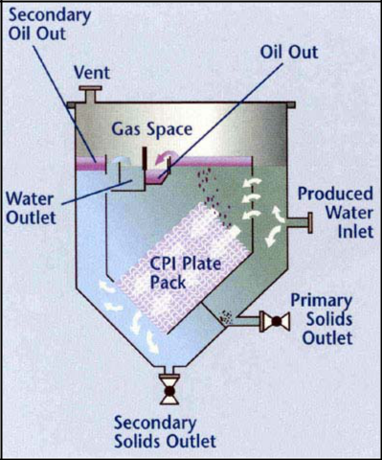

**Figure 1** – Corrugated Plate (CPI) packing separates oil and solids from produced water (Source: NATCO Group)

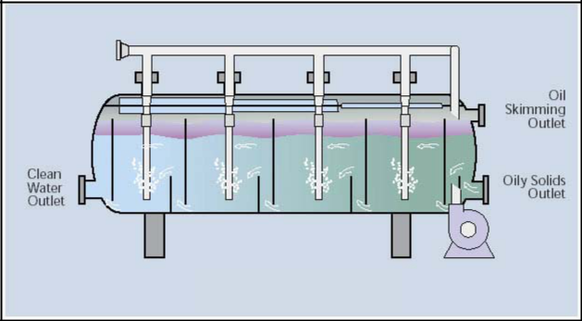

**Figure 2** – Induced gas floatation cell (Source: NATCO Group)

|  |  |
| --- | --- |
| ALL Consulting, LLC | 6 |

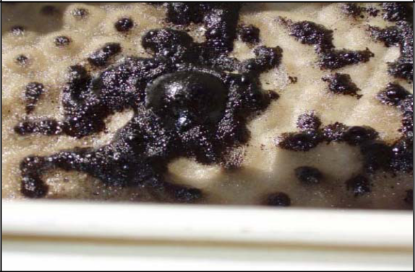

**Figure 3** – Oil droplets coalesce on the surface as oil micro bubbles adhere to them (Source: GLR Solutions Ltd., Canada)

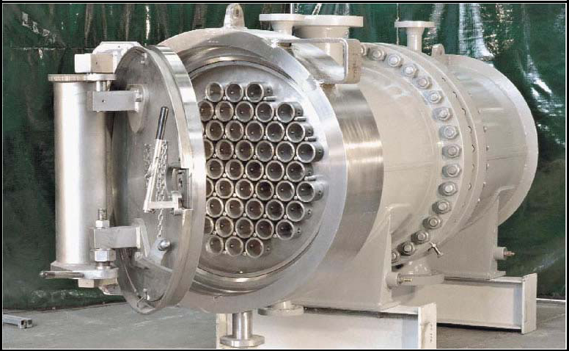

**Figure 4** – A vessel containing multiple hydrocyclones for de-oiling of produced water Maximum capacity – 120,000 barrels/day (Source: NATCO Group)

Hydrocyclones generate spinning motion of the fluid that creates centrifugal force to push heavier water outward and lighter oil into the middle core of the cones. The water continues down and exits out the tapered end. The improved gravity effect provides a higher rate of separation. The oil removal efficiency is higher with multi-cone (Figure 4)

|  |  |
| --- | --- |
| ALL Consulting, LLC | 7 |

modules that achieve small installation footprints. The devices are easily accessible and work even with high oil concentrations. The drawbacks of the operations are larger pressure drop across the device, inability to remove solids, higher maintenance costs and susceptibility to fouling and blockages from solids buildup.

Centrifuges operate on the same physical principle as hydrocyclones, but unlike hydrocyclones where tangential feed inlet generates centrifugal force, moving parts generate the spinning motion. They also remove suspended solid. It handles solid particles as small as 2 microns. The disadvantages of centrifuges include low throughput and high maintenance costs.

Macroporous polymer extraction (MPPE) treatment uses a packed column containing porous polymer beads with pore size of 0.1 to 10 microns. The polymer beads are filled with a specific extraction solvent. The solvent extracts dispersed oil and polycyclic aromatics from the contacting produced water stream **[4]**. In-situ generation of extraction liquid is accomplished by periodically stripping the extracted hydrocarbons with low pressure steam.

***Soluble Organics Removal***

Extraction of dissolved hydrocarbons with on-site liquid condensate (such as available from gas compression units) has been attempted by some oil and gas producers. Extraction enables enhanced removal of dispersed oil by coalescing small oil droplets during the process **[5].** This process utilizes the principle of higher solubility of heavier hydrocarbons in lighter hydrocarbons.

Adsorption is a widely accepted technology for the removal of soluble hydrocarbons from the produced water. Adsorption columns are packed with porous solid material known as adsorbent. The hydrocarbons present in the produced water adhere onto the surface of adsorbent and are eventually retained within the porous structure. The effluent from the adsorption column contains little or no hydrocarbons. Highly porous adsorbents with higher surface area offer better performance. Activated carbon, nutshell media, modified organoclay, etc. are some of the adsorbents used for produced water treatment. The major concern of adsorption operation is the requirement of retention time which limits the throughput capacity.

Oxidation of soluble organics and contaminants (bacteria, nitrate etc.) is an effective produced water treatment. Ozone and hydrogen peroxide are strong oxidizers. Oxidation process produce dissolved carbon dioxide which can be removed by air stripping. Ultraviolet (UV) light has also been used for oxidation, which de-ionizes water into hydrogen and hydroxyl ions. Hydroxyl ions are also strong oxidizers. UV light also kills bacteria and other microorganisms to disinfect the water. Advanced oxidation processes involving a combination of UV light and ozone or hydrogen peroxide have also been attempted. Oxidation is able to reduce chemical oxygen demand (COD), biological oxygen demand (BOD), organics, iron, nitrite, manganese, cyanides, pesticides, hydrogen sulfide and aromatic hydrocarbons. Biological decomposition (combined oxidation and reduction) of produced water in a constructed wetland is also useful for treating raw produced water and treating post-treatment water after it has been through other treatment

|  |  |
| --- | --- |
| ALL Consulting, LLC | 8 |

processes. Plants and microorganisms are utilized to naturally decompose the contaminants from the produced water.

***Desalination***

Removal of dissolved solid, salts or impurities is often the most important part of water treatment systems. TDS in produced water ranges from <2000 ppm to >150,000 ppm. Average TDS content in seawater is approximately 35,000 ppm. The choice of desalination method depends on TDS content and compatibility of the treatment system to work under the presence of extra contaminants present in the produced water. Oil and gas operators have attempted evaporation, distillation, membrane filtration, electric separation and chemical treatments to remove TDS from the produced water. Various desalination technologies are discussed in the next section with their applications for the treatment of produced water treatment.

***Disinfection***

Removal of bacteria, viruses, microorganisms, algae, etc. from the produced water is necessary to prevent scaling and water contamination. Microorganisms occur naturally in the produced water or may be added during de-oiling treatments. Advanced filtration techniques are one of the effective technologies used to remove microorganisms. UV light treatment, chorine or iodine reaction, ozone treatment and pH reduction are other treatments available to disinfect produced water. Some of the general and advanced disinfection treatments are discussed in the next section.

***Miscellaneous Treatment***

Produced water softening, SAR adjustments and removal of trace contaminants, pollutants, naturally occurring radioactive materials (NORM), etc. are the part of produced water treatment in some regions depending on the composition of produced water.

|  |  |
| --- | --- |
| ALL Consulting, LLC | 9 |

**Produced Water Treatment Technologies**

Treatment objectives can be addressed by treatment technology options. The options can differ in their inherent facility requirements, capital costs, operating expense, and waste streams; all three factors can be important to the oil and gas operator. Some technologies may have large space requirements that may not be possible in some oil and gas installations. Some technologies may be commercially available as small, skid-mounted units that can be easily relocated as production conditions change. Equipment costs are obviously important in some installations where a large amount of dedicated equipment must be purchased just for managing produced water. Higher power costs and chemical expenses could be unsupportable early in the life of an oil and gas development. Treatment wastes derived from produced water may no longer be classified as oil and gas wastes and may be more difficult and more expensive to manage. This section discusses various produced water technologies and their applications in fulfilling treatment objectives described above.

***Packed Bed Adsorption***

ET Ventures, L.L.C., South Carolina field tested its new ET #1 produced water treatment system at RMOTC (Rocky Mountain Oilfield Testing Center) in July 1996 to determine its effectiveness in adsorbing hydrocarbons from produced water **[6].** Water produced from the Tensleep formation was atmospherically cooled (to 90°F) and flowed through a three-stage packed bed adsorption treatment system. Higher temperature affects the removal efficiency of the adsorbent. The first two stages contained ET #1, a sodium bentonite modified organoclay adsorbent. The final stage contained granular activated carbon (GAC). The samples of inlet feed, effluent from ET #1 columns and effluent from the GAC column were analyzed by a standard EPA (EPA 1664-A) analytical testing method.

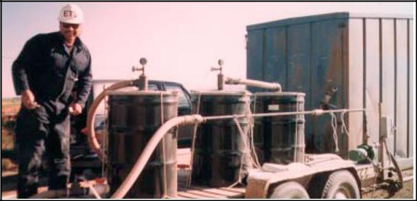

**Figure 5** – A mobile packed bed adsorption system for the treatment of produced water (Source: ET Ventures Inc)

|  |  |
| --- | --- |
| ALL Consulting, LLC | 10 |

Figure 5 shows a mobile treatment trailer used for the operation. The system was operated at 10 GPM flow rate and maximum 10 psi pressure drop.

Table 2 shows the result obtained for one of the trials during the treatment. ET #1 treatment was sufficient to remove TPH below detectable limits. Oil and grease values were below detectable levels after ET #1 adsorption treatment. BTEX were removed to below detectable levels after GAC adsorption treatment.

**Table 2** – Results from ET Venture’s mobile produced water treatment system

|  |  |  |  |
| --- | --- | --- | --- |
| **Contents** | **Before Treatment,** | **After Treatment,** |  |
| **ppm** | **ppm** |  |
|  |  |
| Total Petroleum Hydrocarbons (TPH) | 148 | 1.1 |  |
| Oil and Grease | 151 | 1.2 |  |
| Benzene | 3.14 | <0.5 |  |
| Toluene | 4.97 | <0.5 |  |
| Ethylbenzene | 4.95 | <0.5 |  |
| Xylene | 29.7 | <1 |  |

***Decomposition in Constructed Wetland***

The Department of Energy (DOE) Naval Petroleum Reserve No. 3 (NPR-3) bio-treatment facility with average throughput of 35,000 BPD of water is located in Natrona County in east central Wyoming **[7].** The wetland treatment facility started in January 1996 to provide a cheaper alternative to reinjection and to benefit local wildlife by way of water discharge. Wetlands are thin film bioreactors that utilize various species of plants and microbes along with sands that oxidize contaminants present in the water. A schematic of treatment process is shown in Figure 6.

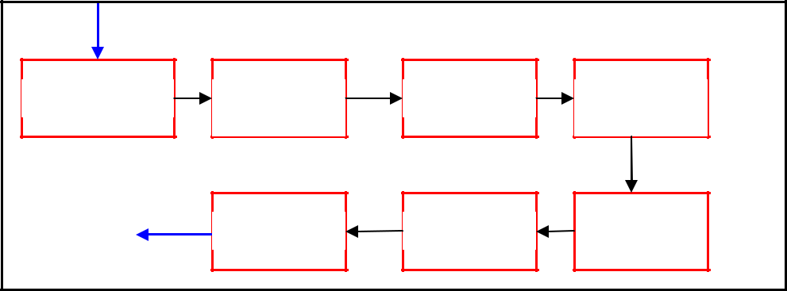

|  |  |  |  |
| --- | --- | --- | --- |
| Cooling Tower | Cooling | Netted Pond | Cooling |
|  | Trench |  | Trench |
|  | Creek | Oxidation | Wetland |

**Figure 6** – DOE Naval Petroleum Reserve’s bio-treatment process

The process undergoes the following steps:

1. Cooling tower followed by a shallow cooling trench to reduce the temperature of produced water from 180 – 200°F to below 100°F. Higher temperatures reduce the performance of plants in the subsequent wetland pond.

|  |  |
| --- | --- |
| ALL Consulting, LLC | 11 |

1. Netted pond or skimming pond further cooled the water and also removed suspended solid and oil under gravity effects. Dispersed oil on the top surface was skimmed off.
2. Specially developed flora and fauna including hydrocarbon decomposing bacteria, sulfate reducing bacteria, nitrifying and denitrifying bacteria, iron related bacteria, algae etc biodegraded various contaminants present in produced water.
3. Microorganisms in wetlands degraded most of the hydrocarbons and the remaining traces of hydrocarbons are removed in an oxidation process.

The produced water from the Tensleep formation was blended with the produced water from other formations before the treatment. The blending process reduced the level of some of the contaminants and also lowered the temperature. While TDS was not affected, certain persistent contaminants such as organics, alkalinity, and ammonia were greatly attenuated. Table 3 shows the result obtained using the bio-treatment facility.

**Table 3** – Summary of the performance of NPR-3 Bio-treatment facility which included wetland treatment

|  |  |  |  |
| --- | --- | --- | --- |
| **Constituents** | **Before treatment, ppm** | **After treatment, ppm** | **Overall removal, %** |
|  |  |  |  |
| NH3 | 2.03 | 0.54 | 73 |
| NO3 | <0.1 | <0.1 | - |
| Phosphorus | 1.83 | 0.46 | 75 |
| BOD | 28 | 2.3 | 92 |
| COD | 48 | 29 | 40 |
| TOC | 32.7 | 3.6 | 90 |
| TPH | 112 | 5.8 | 95 |
| Oil & Grease | 71.9 | 4.2 | 94 |
| Benzene | 0.143 | <0.001 | 100 |
| Toluene | 0.135 | <0.001 | 100 |
| Ethlybenzene | 0.035 | <0.001 | 100 |
| Xylene | 0.162 | <0.001 | 100 |
| Turbidity | 45.4 | 4.76 | 90 |
| TDS | 4380 | 4010 | 9 |
| Alkalinity | 713 | 190 | 73 |

***Ion Exchange***

The ion exchange process effectively removes arsenic, heavy metals, nitrates, radium, salts, uranium, and other elements from the produced water. Ion exchange is a reversible chemical reaction wherein positively or negatively charged ions present in the water are replaced by similarly charged ions present within the resin. The resins immersed in the water are either naturally occurring inorganic zeolites or synthetically produced organic resins. When the replacement ions on the resin are exhausted, the resin is recharged with more replacement ions.

|  |  |
| --- | --- |
| ALL Consulting, LLC | 12 |

***Ion Exchange Resins***

Ion exchange resins are classified as cation exchangers, which exchange positively charged ions and anion exchangers, which exchange negatively charged ions. The resins are further classified as:

*Strong Acid Cation (SAC) Resins*:

The hydrogen or sodium forms of the cation resins are highly dissociated and H+ or Na+ ions are readily exchangeable over the entire pH range. Equation 1 shows an example of salt removal with SAC.

|  |  |  |
| --- | --- | --- |
| 2(*R* − *SO*3 *H* ) + *NiCl*2 | → (*R* − *SO*4 )*Ni* + 2*HCl* | ..(1) |
| Equation 2 shows an example of Ca+ softening with SAC. | |  |
| 2(*R* − *SO H* ) + *Ca*+ → (*R* − *SO* )2 *Ca* + 2*H* + | | ..(2) |
| 3 | 3 |  |

These resins would be used in the hydrogen form for complete deionization (Na, Ca, Mg, Ba, etc. removal); they are used in the sodium form for water softening (Ca and Mg removal). After exhaustion, the resin is regenerated to the hydrogen form by contact with a strong acid solution, or to the sodium form with a sodium chloride solution.

*Weak Acid Cation (WAC) Resins:*

Weak acid resin has carboxylic acid (COOH) group as opposed to the sulfonic acid group (SO3H) used in strong acid resins. These resins behave similarly to weak organic acids that are weakly dissociated. WAC has high affinity for divalent salts. Equation 3 shows an example of Ca+ softening with WAC. Alkalinity present in bicarbonate form can also be removed by WAC.

|  |  |
| --- | --- |
| 2(*R* − *COOH* ) + *Ca* + → (*R* − *COO*)2 *Ca* + 2*H* + | ..(3) |

Free H+ ions can react with bicarbonate (present as hardness, Ca(HCO3 )2) to form carbonic acid. The carbonic acid decomposes in carbon dioxide as shown in equation 4. Removal of carbon dioxide or decarbonation **[8]** is necessary during the water treatment process.

*HCO*3− + *H* + → *H* 2*CO*3 → *CO*2 + *H* 2*O* ..(4)

Weak acid resins exhibit a much higher affinity for hydrogen ions compare to strong acid resins. This characteristic allows regeneration to the hydrogen form with significantly less acid than is required for strong acid resins. Almost complete regeneration can be accomplished with stoichiometric amounts of acid. The degree of dissociation of a WAC is strongly influenced by the solution pH. Consequently, resin capacity depends in part on solution pH.

|  |  |
| --- | --- |
| ALL Consulting, LLC | 13 |

*Strong Base Anion Resins*:

Strong base resins are highly ionized and can be used over the entire pH range. These resins are used in the hydroxide (OH-) form for water deionization. They will react with anions in solution and can convert an acid solution to nearly pure water. Equation 5 shows the reaction involved in an anion exchange step.

|  |  |
| --- | --- |
| (*R* − *NH* 3*OH* ) + *HCl* → (*R* − *NH* 3*Cl*) + *HOH* | ..(5) |

Regeneration with concentrated sodium hydroxide (NaOH) converts the exhausted resin to the hydroxide form.

*Weak Base Anion Resins:*

Weak base resins exhibit minimum exchange capacity above a pH of 7. The weak base anion resins sorbs anions associated with weak acid.

***Applications***

Ion exchange has several applications in water treatment processes such as hardness removal, desalination, alkalinity removal, radioactive waste removal, ammonia removal and heavy metal removal. Since divalent ions (Ca, Mg, etc.) are favored over monovalent (Na, etc.) ions by the resin for replacement, secondary treatment for SAR (sodicity) is required.

*Powder River Gas, LLC:*

Powder River Gas, LLC proposed a Project Plan of Development (POD) **[9]** to drill and test for coal bed natural gas (CBNG) in eight federal and eight fee wells at eight locations (two wells per location) in an area northeast of the Tongue River Reservoir, Big Horn County of southeastern Montana.

Part of their *NO FEDERAL ACTION* alternative was to treat water produced from the wells using a Higgins Loop (continuous counter-current ion exchange) treatment facility prior to discharging to the Tongue River. The proposed treatment facility will use 0.92 acres of private surface. The stationary Higgins Loop facility will be constructed along with 0.5 acre-feet capacity impoundment and chemical storage tanks. All chemical storage tanks will be surrounded by a shallow spill containment berm to prevent any accidental chemical spills.

Produced water from CBNG wells is to be treated stepwise within the treatment facility. Settling of suspended sediments and releasing of residual gas will be within the impoundment. Na+, barium and other heavy metals from produced water will be removed using SAC resins in the Higgins Loop. Removal of CO2 produced during the ion exchange process and adjustment of pH will be achieved by adding calcium hydroxide. CO2 can be removed by air-stripping or membrane degasification. The physical law governing this process is the equilibrium between the gas phase and the concentration of the solute gas in the liquid phase.

The schematic is shown in Figure 7. The Higgins Loop is a vertical cylindrical loop containing a packed bed of strong acid ion exchange resin that is separated into four

|  |  |
| --- | --- |
| ALL Consulting, LLC | 14 |

operating zones by butterfly (loop) valves. These operating zones (Adsorption, Regeneration, Backwashing and Pulsing) function like four separate vessels.

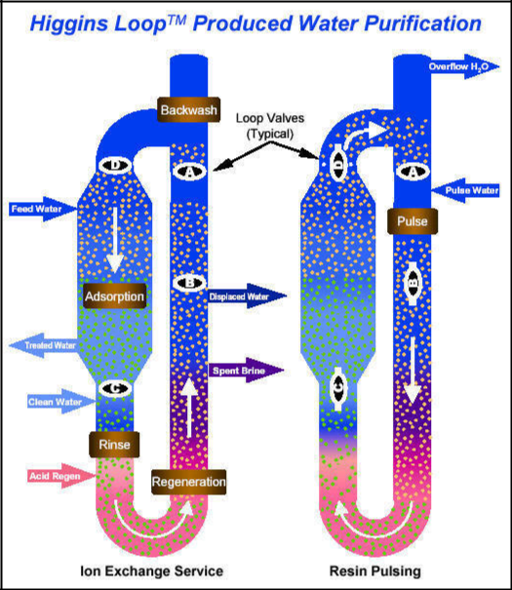

Figure 7 Higgins Loop schematic (Source: Seven Trent Services)

The Higgins Loop treats liquids in the adsorption zone with resin while the ions are being removed from loaded resin in the regeneration zone simultaneously. Intermittently, a small portion of resin is removed from the respective zone and replaced with regenerated or loaded resin at the opposite end of that zone. This is accomplished hydraulically by pulsing of the resin through the loop. The result is continuous and countercurrent contacting of liquid and resin. The cations (Ca+, Na+ etc.) are replaced by hydronium (H+) ions from resin beads. The hydronium ions are released in the treated water, which lowers the pH of the water. Cations are stripped from the resin in the regeneration zone concurrent with ion exchange in the adsorption zone. Dilute hydrochloric acid is injected into the loop and moves counter-current to the resin and the spent brine discharge, leaving the resin restored to the hydronium form.

Concentrated brine volumes average approximately 1.0% of the total Loop feed volume, depending on the cation loading that is removed from the treated water. Excess brine that is not recycled to other beneficial uses is proposed to be transported offsite by truck for disposal injection into a permitted Class I, deep disposal well located in Wyoming. The waste stream from the treatment process, at maximum flow, will generate approximately 60 barrels of brine or reject water per day. The treatment unit would discharge a total of 250 gpm of treated water.

|  |  |
| --- | --- |
| ALL Consulting, LLC | 15 |

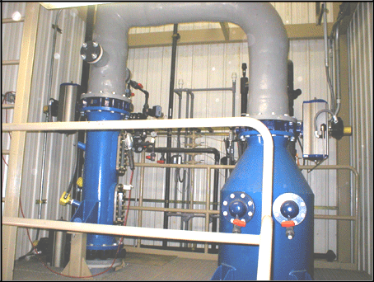

**Figure 8** – A Higgins Loop in operation (Source: Seven Trent Services)

*EMIT Water Discharge Technology, LLC:*

EMIT Water Discharge Technology, LLC **[10]** developed a new treatment process that uses DOWEX G-26 (strong acid cation exchange resin manufactured by DOW Chemical Company) . G -26 resin has sulfonic acid (SO3H+) group that exchanges Na +, Ba+, Ca2+, and Mg2+ etc ions with H+ ion. The ion exchange process is accomplished in a Higgins Loop. The Higgins Loop operation is followed by calcium addition to adjust pH, balance SAR and increase calcium concentration. Table 4 shows the results of a field trial for the treatment of produced water from Powder River Basin, Wyoming. The process focused on the removal of sodium ions and reduction of SAR using combination of Higgins loop and calcium addition.

**Table 4** – Performance of Higgins Loop treatment for a field trial at Powder River Basin site

|  |  |
| --- | --- |
| **Constituents** | **Influent Produced Water** |
|  |  |
| Na, ppm | 486 |
| Ca, ppm | 22.2 |
| Mg, ppm | 13.2 |
| K, ppm | 13.5 |
| Ba, ppm | 0.72 |
| Carbonate, ppm | <1 |
| Bicarbonate, ppm | 1430 |
| Chloride, ppm | 18 |
| Sulfate, ppm | 1 |
| SAR | 20.2 |
| pH | 8.1 |

**Treated Water**

12



113



<1



<1



ND



<1



311



42



1.1



0.3



6.5



**Removal %**

97.53

-409

>93

>93

100

-

78.52

-133.33

-10

98.51

19.75

|  |  |
| --- | --- |
| ALL Consulting, LLC | 16 |

The increment in calcium, chloride and sulfate levels were due to chemical addition during SAR adjustment. The field trial was conducted with throughput of 200 GPM. The treatment cost ranges from $0.05 to $0.20 per barrel of treated water depending on the influent composition, SAR, and availability of resources. The ion exchange treated water may then be discharged to the environment and the residue disposed off **[11].**

*Sandia Ion Exchange/Sorption Process:*

Sandia National Laboratory (SNL) reported use of Hydrotalcite (HTC) as anion exchanger and Permutite as cation exchanger **[12]**. These ion exchangers are comprised of durable inorganic oxides which provide stability over a large range of pH. Based on the results of various experiments, SNL reported average ion exchange capacity of HTC and Permutite as 2.5 mEq/gram (measured with Na2So4), and 1.7-2.7 mEq/gram (measured with NaOH) respectively.

Lime in HTC in

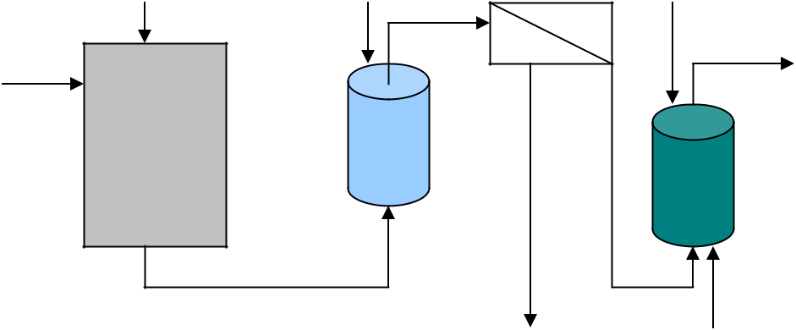

Water in

UF

Permutite in

Treated

water out

HTC Permutite

regeneration/disposal regeneration/disposal

**Figure 9** – Ion Exchange/Sorption desalination process (Source: SNL)

Anions in the inlet water are replaced by hydroxide ions (HTC anion exchange) and cations are replaced by hydrogen ions (Permutite cation exchange). Lime softening pre-treatment is optional stage.

Ion exchangers are regenerated after they are exhausted. In the regeneration process ion exchangers regain their ion exchange capacity. It may not be possible to regain 100% ion exchange capacity during regeneration process. SNL attempted to determine effects of regeneration on the ion exchange capacity of above mentioned ion exchangers and concluded that Permutite can regain ion exchange capacity without significant loss. Regeneration of HTC at low temperatures was not promising, and at high temperatures regeneration became costly.

|  |  |
| --- | --- |
| ALL Consulting, LLC | 17 |

***Electrodialysis (ED) and Electrodialysis Reversal (EDR)***

***Electrodialysis (ED)***

Most salts dissolved in water are ionic, being positively (cationic) or negatively (anionic) charged. These ions are attracted to electrodes with an opposite electric charge.

In ED, membranes that allow either cations or anions (but not both) to pass are placed between a pair of electrodes. These membranes are arranged alternately. A spacer sheet that permits feed water to flow along the face of the membrane is placed between each pair of membranes.

Figure 10 shows an ED assembly with feed spacer and ion exchange membrane placed between oppositely charged electrodes. Positively charged ions (Na+ etc) migrate to cathode and negatively charged ions (Cl- etc) migrate to anode.

|  |  |
| --- | --- |
| Cathode | Anode |
| ( - ) | ( + ) |
|  |  |

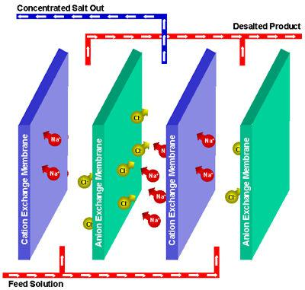

**Figure 10** – An ED unit in operation (Source: Electrosynthesis Company Inc)

During migration the charged ions are rejected by similarly charged ion exchange membranes. As a result, water within the alternate compartment gets concentrated leaving desalted water within the next compartment of the ED unit. The concentrate and desalted water are continuously removed from the unit. The basic electrodialysis unit consists of several hundred cell pairs bound together with electrodes on the outside and is referred to as a membrane stack.

|  |  |
| --- | --- |
| ALL Consulting, LLC | 18 |

Feed water passes simultaneously in parallel paths through all of the cells to provide a continuous flow of desalted water and brine to emerge from the stack. The feed water is circulated through the stack with a low-pressure pump with enough power to overcome the resistance of the water as it passes through the narrow passages. The raw feed water must be pre-treated to remove materials that could harm the membranes or clog the narrow channels in the cells from entering the membrane stack. A rectifier is generally used to transform alternating current (AC) to the direct current (DC) supplied to the electrodes on the outside of the membrane stacks.

Post-treatment consists of stabilizing the water and preparing it for distribution. This post-treatment might consist of removing gases such as hydrogen sulfide and adjusting the pH.

***Electrodialysis Reversal Process (EDR)***

An EDR unit operates on the same general principle as a standard electrodialysis plant except that both the product and the brine channels are identical in construction. At intervals of several times an hour, the polarity of the electrodes is reversed, and the flows are simultaneously switched so that the brine channel becomes the product water channel, and the product water channel becomes the brine channel.

The result is that the ions are attracted in the opposite direction across the membrane stack. Immediately following the reversal of polarity and flow, enough of the product water is dumped until the stack and lines are flushed out and the desired water quality is restored. This flush takes about 1 or 2 minutes, and then the unit can resume producing water. The reversal process is useful in breaking up and flushing out scales, slimes and other deposits in the cells before they can build up and create a problem. Flushing allows the unit to operate with fewer pretreatment chemicals minimizes membrane fouling. The charges of the electrodes are reversed by a motorized valve.

***Applications***

Electrodialysis is conducted at low pressure drops across the process (usually less than 25 psi). The pressure drop across the typical Reverse Osmosis (RO) membrane ranges from 400 – 1400 psi which indicates higher energy consumption.

*Wind River Basin, Lysite, WY:*

The produced water from a conventional well in Wind River Basin of Wyoming **[13]** contains H2S, oil, acid, BTEX, dissolved solids etc. About 93% of total TDS (8,300 to 10,000 ppm) is accounted for as sodium, chloride, calcium and bicarbonates. Oil and grease content was about 65 ppm and BOD value was more than 330 ppm (contributed by acetates and volatile acids). The treatment trailer consists of the following units:

1. De-oiling via induced gas floatation unit.
2. Dissolved organics removal via two fluidized bed reactors. First was the anaerobic and nitrate consuming reactor for reducing large amount of organics. The second was the aerobic reactor ensuring oxidation of dissolved organics.
3. Desalting/Demineralization using an ED unit.

|  |  |
| --- | --- |
| ALL Consulting, LLC | 19 |

ED provided economical demineralization in this case. The feed water had approximately 9,000 ppm TDS. As usual, the cost of the ED unit operation increases as the required TDS removal increases. Table 5 shows the overall removal of contaminants using different treatment technologies. The ED removed approximately 89% of TDS from the produced water.

**Table 5** – Produced water treatment performance at Wind River Basin, WY

|  |  |  |  |
| --- | --- | --- | --- |
| **Parameter** | **Influent, ppm** | **Effluent, ppm** | **Overall Removal, %** |
|  |  |  |  |
| Oil and Grease | 90 | 4 | 95.5 |
| BOD | 330 | 51 | 84.5 |
| BTEX | 11 | 0.1 | 99.1 |
| TDS (using ED) | 9,100 | 1,000 | 88.9 |

*High Efficiency Electrodialysis (HEEDTM), Frac Water Inc:*

Frac Water Inc developed mobile ED treatment units for treating CBM produced water and reusing it in fracturing treatment. Several case studies suggest that the mobile treatment units treat the produced water with TDS ranges from 11,400 to 27,000 ppm and sulphates from 4,000 to 14,000 ppm **[14].** ED provided the following benefits over RO:

1. ED can sustain high temperature; in fact higher temperature of produced water from the wellhead (140oF) improved the conductivity and reduced resistance during ED process which leads to lesser voltage usage. Also higher temperature reduced viscosity.
2. ED accepts feed water with Silt Density Index (SDI) value of 12 compare to SDI value of 3 for RO. Less SDI value indicates the necessity of pretreatment steps. The membranes are susceptible to fouling if feed water has high SDI.
3. Certain level of fouling also occurs in ED operations. ED membranes can be cleaned or regenerated using weak acid treatment.
4. Plate and frame configuration of ED system enables easier maintenance and cleaning.

Figure 11 shows mobile ED treatment units from Frac Water Inc. ED treatment primarily recovers 80-90% of brackish water. The patents-pending electrodialysis HEEDTM stack configuration with dual or multiple side-by-side ion exchange membrane cells and improved gasket design results in greater separation efficiencies and affords greater flexibility in unit design. The improved design requiring up to 40% less membrane area resulted in over 70% increase in energy efficiency.

|  |  |
| --- | --- |
| ALL Consulting, LLC | 20 |

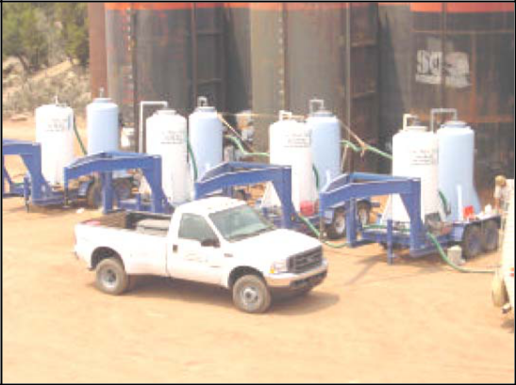

**Figure 11** – Mobile ED treatment trailer developed by Frac Water Inc

***Capacitive Deionization Technology (CDT)***

Capacitive deionization technology (CDT) is a new technology being developed for the purification of ocean and brackish ground water. A constant voltage is applied and soluble salts are collected on the surface of porous carbon electrodes, thus purifying the water for human consumption or industrial processes. In CDT, a brackish water stream flows between pairs of high surface area carbon electrodes that are held at a potential difference of 1.2 V. The ions and other charged particles (such as microorganisms) are attracted to and held on the electrode of opposite charge. The negative electrode attracts positively charged ions (cations) such as calcium (Ca), magnesium (Mg) and sodium (Na), while the positively charged electrode attracts negative ions (anions) such as chloride (Cl) and nitrate (NO3). Eventually the electrodes become saturated with ions and must be regenerated. The applied potential is removed, and the electrodes are flushed to release attached ions from the system, producing the more concentrated brine stream.

The current carbon aero gel electrodes provide approximately 500 m2/g surface area. They provide high electrical conductivity and high ion permeability. Carbon aero gel electrodes are expensive and their ion storage capacity is relatively low. The main problem is that the cost of the electrodes is too high due the high cost of the resorcinol (Resorcinol Fluoride, RF) from which the electrodes are made. TDA Research Inc has developed electrodes that provide higher surface area. CDT System Inc is developing impregnate of carbon nanotubes on the RF resins.

|  |  |
| --- | --- |
| ALL Consulting, LLC | 21 |

Figure 12 shows conceptual diagram of CDT. Unlike ion exchange, exchange of ions does not occur; ions are adsorbed within the pores of charged electrodes under the effect of capacitance.

Negative electrode attracts positively charged ions (anions).

Sodium (Na+)

Calcium (Ca+)

Magnesium (Mg+)

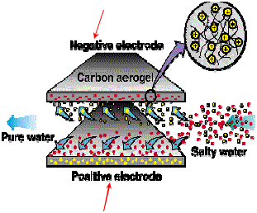

Positive electrode attracts negatively charged ions (anions).

Chloride (Cl-)

Nitrate (NO3-)

Silica (SiO2-)

**Figure 12** – A conceptual diagram of an AquaCell during CDT operation (Source: TDA Research Inc.)

***Applications***

*Desalination of produced water:*

Table 6 shows the result of the treatment of produced water from a CBNG well in Wyoming using CDT.

**Table 6** – Performance of CDT for the CBNG produced water treatment

|  |  |  |
| --- | --- | --- |
| **Constituent** | **Before treatment** | **After treatment** |
| Conductivity (micro s/m) | 2,100 | < 800 |
| Sodium ions (ppm) | 280 | 84 |
| Bicarbonate ions (ppm) | 520 | 144 |

CDT Mobile Systems can also be used to produce drinking water and water for agriculture purposes at a low cost. Table 7 shows the throughput capacity of a 28 ft. mobile CDT unit, which includes 30 AquaCells with the capability to be field expanded

|  |  |
| --- | --- |
| ALL Consulting, LLC | 22 |

to 88 AquaCells. The expected quality of treated water is fixed at 500 ppm TDS for drinking water and 1000 ppm TDS for agriculture water.

**Table 7** – Treatment capacity of CDT unit

|  |  |  |
| --- | --- | --- |
| **Feed Water TDS, ppm** | **Capacity, Potable Water** | **Capacity, Agriculture Water** |
|  |  |  |
| < 1,500 | 30,000 GPD | 30,000 GPD |
| 2,500 | 20,000 GPD | 27,000 GPD |
| 3,500 | 10,000 GPD | 17,000 GPD |
| 4,000 | 5,000 GPD | 12,000 GPD |

Source: CDT Inc, Dallas, TX

***Electrochemical Activation (ECA) Technology***

Electrochemical Activation (ECA) technology is an innovative water disinfection technology which involves the exposure of water, and the natural salts, to a substantial electrical potential difference. As an anode (+) and a cathode (-) are placed in pure water and direct current is applied, electrolysis of water occurs at the poles leading to the breakdown of water into its constituent elements. If sodium chloride (NaCI), or table salt is used as a solution, the dominant electrolysis end product is hypochlorite, a chlorine based reagent, which is commonly used to disinfect water and kill microorganisms. This disinfection technology is currently used in series with the capacitive deionization technology in an activated water type of application. With this technology the natural water chemistry is used to produce highly effective disinfection agents that would destroy viruses and bacteria.

Typically activated water would be dosed before and after the CDT AquaCells. Dosage before reduces the overall organic load into the AquaCells and also disinfects the feed stream, preventing biofouling. The dosage after the CDT AquaCells would then mainly serve as a final disinfection step specifically for potable water applications. Another benefit of the activated water technology is that the dosage before the AquaCells would also serve as a surfactant, thus reducing fouling, for example membrane fouling by CaCO3 (Calcium Carbonate) precipitation.

***Electro-deionization (EDI)***

Weakly-ionized species such as carbon dioxide, boron, and ammonia are difficult to remove via such membrane processes as reverse osmosis (RO) and electrodialysis reversal (EDR). EDI **[15]** is an electrically-driven membrane process. EDI combines ion-exchange resins, ion-exchange membranes, and a DC electrical field. In EDI, ionized species are removed much like conventional electrodialysis (ED), with the rate of ion removal greatly increased by the presence of the ion-exchange resins in the cell. In the cell, the DC electrical field splits water at the surface of the ion-exchange beads, producing hydrogen and hydroxyl ions which act as continuous regenerants of the ion-exchange resins. This allows a portion of the resins in the EDI to always be in the fully-regenerated state. Once ionized, these species are quickly removed under the influence of the DC electrical field. In effect, ionized species are removed in one area of an EDI stack, and weakly-ionized species are removed in a second area.

|  |  |
| --- | --- |
| ALL Consulting, LLC | 23 |

Figure 13 shows the removal of ions as water travels through the EDI cell. Strongly ionized species are removed first in the flow path and weakly ionized species are removed as the water moves down the flow path. Removal of ionized species such as sodium, chloride, sulfate, and calcium by EDI is usually well over 99% and has been well documented previously. Removal of weakly-ionized species is an area where a properly designed EDI can also achieve extremely high removal rates.

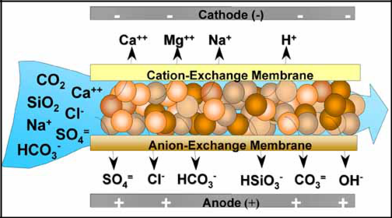

**Figure 13** – Schematic of an EDI cell (Source: Ionics Inc)

***Applications***

Ionics Inc has installed EDI units in various power plants and semiconductor plants in the US. Table 8 shows the average removal of weakly ionized ions using EDI in such plants. The results are based on the EDI operation only and no pretreatment or post treatment results are included. For example, EDI was able to remove approximately 97% of boron from the RO permeate. In this case RO was unable to effectively remove boron from the produced water.

**Table 8** – Average percentage removal of weakly ionized species using EDI

|  |  |  |
| --- | --- | --- |
| **Treatment** | **Performance, % removal (avg.)** | **Comments** |
| Silica | > 99.2 |  |
| CO2 | > 99.5 |  |
| Boron | > 97.0 | Post RO treatment only |
| Ammonia | > 97.4 |  |

The advantage of EDI is that it doesn’t require addition of chemicals to remove weakly ionized species from the produced water.

|  |  |
| --- | --- |
| ALL Consulting, LLC | 24 |

***Evaporation***

Direct treatment of the produced water in an evaporation system eliminates majority of chemical/physical treatment. The principle of this technique is to provide latent heat to the feed water to generate vapor which can be condensed into pure water form. The remaining stream contains high concentration of salts/solids.

Falling film vertical tube evaporators **[16]** have the highest heat transfer coefficient which is required to save energy. It also minimizes chances of fouling by keeping tubing surface wetted during operations. Produced water is de-oiled and pH is adjusted. Next, a pre-heater increase the temperature of produced water/brine. Hot brine goes to de-aerator, which removes non-condensable gases. Hot de-aerated brine enters the evaporator sump where it combines with the recirculating brine slurry. The slurry is pumped to the top of a bundle of heat transfer tubes and flows down into each tube through a liquid distributor. As the brine flows down the tubes, a small portion evaporates and the rest falls into the sump to be recirculated. The vapor travels down the tubes with the brine, and goes to a compressor through mist eliminators. Compressed vapor flows to the outside of the heat transfer tubes where its latent heat is transferred to the cooler brine slurry falling inside. As a result, vapor gets condensed into pure water form which is pumped back through the heat exchanger where it gives up sensible heat to the incoming wastewater. A small amount of concentrated slurry from the evaporator sump is continuously discarded through a blowdown valve to maintain density of the slurry in the evaporator. The concentrated blowdown can be disposed through a class I injection well or can be converted into solid waste in a crystallizer.

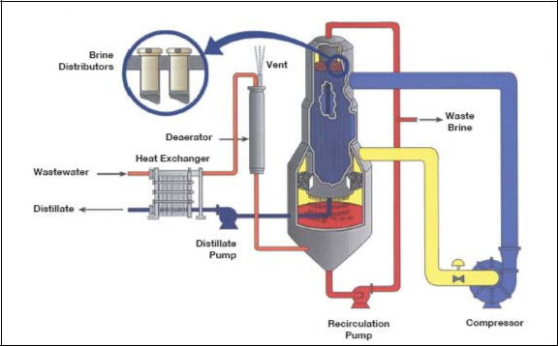

**Figure 14** – A vertical tube falling film vapor compression evaporator (Source: Ionics Inc.)

|  |  |
| --- | --- |
| ALL Consulting, LLC | 25 |

***Rapid Spray Evaporation (RSE)***

AquaSonics International has developed a Rapid Spray EvaporationTM (RSE) system of ejecting contaminated water at high velocities through a specialized injector-nozzle into waste heat. The unit uses a heating element for a heat source across which air is blown into the evaporation chamber. As the heated air moves along the evaporation chamber, nebulized wastewater is injected into the evaporation chamber. The moving vapor and brine droplets pass through a mechanical filter which traps the brine droplets. The pure vapor phase passes on to a condenser. The brine droplets are periodically flushed from the filter with the water being treated.

As the water vaporizes within milliseconds of ejection, the solids in the solution flash or separate out. The water vapor is condensed and collected while the precipitated solids form isolated crystalline particles, which are collected through a vacuum process and sold as a byproduct. RSE ejects the salt water through a nozzle into a stream of heated air, forming a mist of droplets which vaporize almost instantly. The minute flakes of solid salt left behind fall to the bottom of the evaporation chamber where they can be collected. The best success comes from developing nozzles that allow the process to work with hydraulic pressure.

***Applications***

Tests on the RSE system **[17]** carried out by Westwater Resources Inc, Albuquerque, NM, confirmed that it can process water containing up to 16% salt. The operating costs for RSE are about one-third of the cost of conventional desalination methods alone, producing 1,000 liters of fresh water for between 16 and 27 cents. AquaSonics claims to attain nearly 100% salt conversion of salt water into fresh water. Table 9 shows the results obtained during the testing phase.

**Table 9** – Rapid Spray Evaporation testing results (Source: WestWater Resource Inc, NM)

|  |  |  |  |  |
| --- | --- | --- | --- | --- |
| **Solute** | **Untreated** | **Treated** | **Concentrate** |  |
| **ppm** | **ppm** | **ppm** |  |
|  |  |
| Calcium | 79 | 1.6 | 20 |  |
| Magnesium | 490 | 1.7 | 600 |  |
| Sodium | 25,000 | 160 | 57,000 |  |
| Potassium | 610 | 1.9 | 1,100 |  |
| Chloride | 5,000 | 90 | 8,400 |  |
| Sulfate | 31,000 | 150 | 35,000 |  |
| Bicarbonate | 5,700 | 20 | 2,900 |  |
| Phosphate | 1,200 | 0 | - |  |
| Carbon Dioxide | 3,100 | 0 | - |  |
| TDS | 130,000 | 440 | 180,000 |  |

***Freeze Thaw Evaporation (FTE)***

Freeze-thaw/evaporation (FTE®) is a process whereby produced water is first stored in a holding pond until air temperatures drop below 0° C (32° F). The water is then removed from the pond using pumps and sprayed onto a separate freezing pad which consists of an

|  |  |
| --- | --- |
| ALL Consulting, LLC | 26 |

elevated pipe grid with strategically placed sprinklers. These sprinklers can be raised as the ice builds up on the pipe grid. The unfrozen brine water drains from the ice grid and is separated using conductivity-controlled valves.

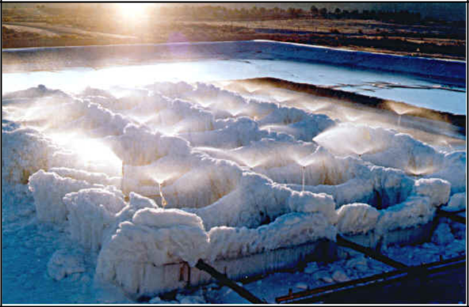

**Figure 15** – Spray Freezing FTE unit in operation (Source: Hart Energy Publications)

The concentrated brine water is then transported to separate storage ponds for either secondary treatment or for disposal. Figure 14 shows a picture of Spray Freezing unit with sprinklers. The alternate to Spray Freezing process involves allowing the holding reservoir to freeze, and draining the brine that forms below the ice. The ice in the pond melts in the spring leaving fresh water.

***Applications***

Crystal Solutions, LLC, a joint venture of Gas Technology and BC Technologies, utilized FTE **[18]** for produced water treatment at its first major commercial treatment facility near Wamsutter, Wyoming. The FTE uses naturally occurring ambient temperature swings to alternately freeze and thaw produced water, concentrating the dissolved solids and producing fresh water suitable for various beneficial uses.

During the 1999-2000 cycle, produced water with 14,000 ppm of TDS was converted to a concentrated brine of approximately 64,300 ppm TDS and the fresh water (melt from ice) having 924 ppm TDS. Roughly 55% of the feed was converted to melt water; about 30% is lost to evaporation and/or sublimation; and only about 15% of the original feed remains as concentrated brine. In this case, due to the concentrated brine having a potassium chloride concentration in excess of 2% it was a usable product for drilling applications.

|  |  |
| --- | --- |
| ALL Consulting, LLC | 27 |

***Pressure Driven Membrane Separation Technologies***

Microfiltration (MF), Ultrafiltration (UF), Nanofiltration (NF) and Reverse Osmosis (RO) utilize high pressure across the membranes to accomplish filtration of contaminants from the produced water. These technologies are the most common techniques of water purification. The membranes are also continuously being upgraded or modified for superior performance. Various applications of the pressure driven membrane technologies are listed in Table 10. Molecular Weight Cutoff (MWCO) is the ability of a membrane to reject the species of certain molecular weight measured as Daltons.

**Table 10** – Applications of advanced membrane filtration technologies

|  |  |  |  |
| --- | --- | --- | --- |
| **Membrane Filtration** | **Separation Specifications** | **Applications/Removal** |  |
|  |  |  |  |
| Microfiltration (MF) | >100,000 Daltons | bacteria, viruses, suspended |  |
| 10 - 0.1µm | solids etc |  |
|  |  |
| Ultrafiltration (UF) | 10,000 to 100,000 Daltons | proteins, starch, viruses, colloid |  |
| 0.05 - 5 e-3 µm | silica, organics, dyes, fats, paint |  |
|  |  | solids etc |  |
|  |  | starch, sugar, pesticides, |  |
| Nanofiltration (NF) | 1,000 to 100,000 Daltons | herbicides, divalent ions, |  |
| 5 e-3 - 5 e-4 µm | organics, BOD, COD, detergents |  |
|  |  | etc |  |
|  |  | metal ions, acids, sugars, aqueous |  |
| Reverse Osmosis (RO) | salts and lower MWCO | salts, dyes, natural resins, |  |
| 1 e-4 - 1 e-5 µm | monovalent salts, BOD, COD, |  |
|  |  | ions etc |  |
| Gas Liquid Membrane | CO2, H2S | decarbonation, hydrogen sulfide |  |
| removal |  |
|  |  |  |  |

MF, UF and NF are based on the principle of rejection of species higher than the pore size of the membrane under pressure. RO uses the operating pressure higher than the osmotic pressure of salt present in the water to drive pure water through the membrane, thereby rejecting the salts. It is reversal of the osmosis process where water flows from the higher concentration solution to the lower concentration solution to attain natural equilibrium. The notion of these filtration technologies is discussed in the literature **[19]**.

In gas-liquid separation, the pressure difference across a selective membrane is with pore size of about 0.03 micrometers (small enough to prevent water from leaking out but large enough to allow CO2 to pass through) is applied. Gas penetrates into the membrane at a rate that depends on diffusivity and solubility of molecules in order to attain the equilibrium between the gas phase and the solute gas in liquid. The pressure difference is created by either vacuum or gas sweep through the membrane.

Oil and gas operators exploit the clear advantages of using mobile produced water treatment units. Osmonics Inc, one of the leading manufacturers of membranes focusing

|  |  |
| --- | --- |
| ALL Consulting, LLC | 28 |

on produced water treatment applications, has been developing high performance compact membrane (such as spiral wound membrane) modules **[20]**. These membrane modules are easy to utilize in mobile systems. The spiral wound membrane offers the most efficient packing of membrane area to provide higher membrane contact area in limited space. The performance of these membranes is reduced by higher temperature; the upper limit for operating temperature is 113 to 122°F but some of the spiral wound elements it can be used up to 194°F. Higher temperature operations require more pressure differential across the membranes and so more energy is required to achieve desired separation. However, higher temperature reduces the viscosity of the solution which somewhat offsets the temperature effect **[21]**. The pH of the solution is also an important factor during the membrane filtration operations. High pH RO operation effectively removes boron if the membrane can sustain high pH.

Membrane fouling is a common problem in the various membrane filtration processes. Higher flow rate through the membrane module can produce enough shears near the membrane to avoid accumulation of oil and fouling agents. A hydrophilic membrane is less prone to oil fouling as it has a higher affinity for water and ability to reject oil and grease. New Logic Research developed vibrating membrane mechanism to avoid membrane fouling caused by free oils and scaling agents **[22]**. The sinusoidal vibration of the membrane avoids the migration of colloids onto the membrane surface. The colloids are washed away with reject in the cross-flow configuration. The anionic membrane repels anions (monovalent, divalent or multivalent) and also associated cations (sodium, magnesium, copper, zinc, iron etc.). Figure 15 shows a conceptual picture of Vibratory Shear Enhanced Processing (VSEP) membrane.

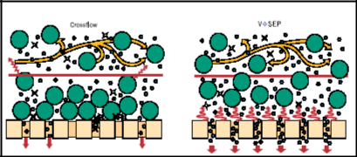

**Figure 16** – A VSEP membrane avoids fouling by continuous sinusoidal vibration (Source: New Logic Research Inc)

Petroleum recovery and research center (PRRC) of New Mexico Institute of Mining and Technology has developed inorganic membranes for the produced water treatment focusing on the treatment of high salinity produced water (> 50,000 ppm in San Juan and

* 100,000 ppm in Permian basin). The inorganic membranes made up from zeolite provided higher flux, pH compatibility, and thermal and chemical stability. Table 11 shows the higher removal efficiency, even lower differential pressure and higher flux operations. Each row is for different membranes.

|  |  |
| --- | --- |
| ALL Consulting, LLC | 29 |

**Table 11** – Performance of various zeolite membranes (Source: PRRC, NMIMT)

|  |  |  |  |  |  |  |
| --- | --- | --- | --- | --- | --- | --- |
| **Membrane** | **Ions in feed** | **TDS, ppm** | **Pressure, psi** | **Flux,** | **Rejection,** |  |
| **kg/m2.h** | **%** |  |
| 1 | Na+, K+, Ca2+, |  |  |  |  |  |
|  | Mg2+, NH4+, | 39,000 | 350 | 0.112 | 74.5 |  |
|  | Cl- |  |  |  |  |  |
| 2 | Na+, Cl- | 5,500 | 300 | 0.135 | 89.2 |  |
| 3 | Mg2+, Cl- | 9,400 | 300 | 0.081 | 68.6 |  |
| 4 | Ca2+, Cl- | 11,000 | 300 | 0.096 | 57.6 |  |
| 5 | Na+, SO4- | 14,200 | 300 | 0.097 | 57.4 |  |
| 6 | Na+, Cl- | 5,000 | 300 | 0.24 | 76.8 |  |

***Applications***

*GE Pilot Study, California:*

In 2001 Osmonics Inc performed a pilot study **[23]** to evaluate feasibility of membrane filtration technologies for the treatment of produced water in northern California near Bakersfield. The produced water came to the surface at 185°F with approximately 10,000 ppm of salt, a high level of suspended solids and free oil.

The three -step membrane separation combined with an ion exchange step proved to be sufficient to yield water suitable for irrigation (< 1,000 ppm TDS). The treated water contained 5 to 10 ppm boron which is higher than the 0.75 ppm limit for irrigation water. Purification of treated water using Ion Exchange produced boron levels below the 0.75 ppm limit. The schematic of produced water treatment is shown in Figure 16.

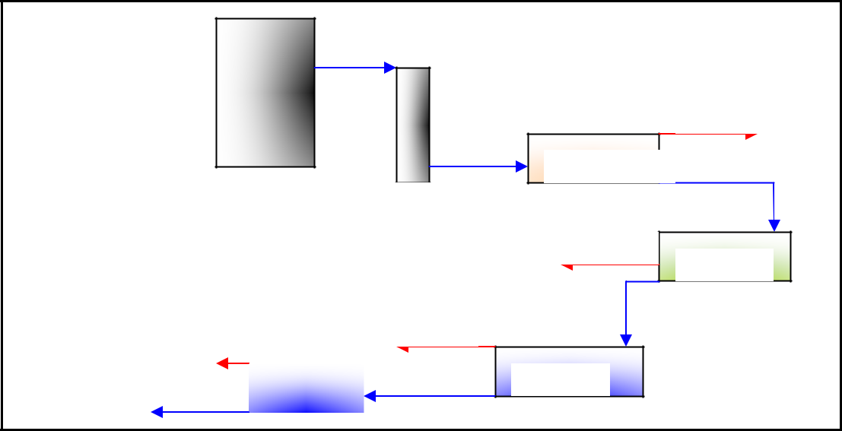

Feed Tank

12,000 GPD

From oil/water separator pH adjust 5.8 – 5.9

 185°F

Cartridge filter

Recycle

|  |  |  |  |  |
| --- | --- | --- | --- | --- |
|  | Recycle | | |  |
| **Permeate** |  |  |  |  |
|  |  |  |  |
|  |  | RO, 125°F |  |
| **Treated Water** |  |  |  |  |
|  |  |  |  |

UF, 185°F

Disposal / Reinjection

RO, 185°F

To oil/water separator

NF, 185°F

**Figure 17** – GE produced water treatment system, California

The pH of the produced water from the oil separators was adjusted to 5.8 with sulfuric acid. The suspended solids were allowed to settle in a tank with a conical bottom. CO2

|  |  |
| --- | --- |
| ALL Consulting, LLC | 30 |

and H2S were degassed from the top of the tank and feed from the middle of the tank is discharged to a cartridge filter to remove smaller particles and oil. The effluent from the cartridge filter is passed through high temperature UF, NF and RO units followed by cooling operation and a low temperature RO unit. The overall system recovery was more than 80% considering the recycling of the UF concentrate and the use of the RO concentrate for various purposes. Table 12 shows the results of the produced water treatment system composed of membrane filtration units.

**Table 12** – GE pilot water treatment plant results

|  |  |  |  |  |  |
| --- | --- | --- | --- | --- | --- |
| **Constituent** | **Feed, ppm** | **UF permeate,** | **NF permeate,** | **RO permeate,** |  |
| **ppm** | **ppm** | **ppm** |  |
|  |  |  |
| Sodium | 9,610 | 9,610 | 5,250 | 144 |  |
| Calcium | 715 | 715 | 163 | 5 |  |
| Magnesium | 412 | 412 | 115 | 2 |  |
| Potassium | 174 | 174 | 77 | 2 |  |
| Ammonium | 110 | 110 | 68 | 2 |  |
| Chloride | 8,010 | 8,010 | 4,710 | 114 |  |
| Sulfate | 1,090 | 1,090 | Non-detectable | Non-detectable |  |
| Oil | 10–50 | < 1 | Non-detectable | Non-detectable |  |
| Recovery, % | - | 90–95% | 90–95% | 80–90% |  |

*Placerita Canyon Oil Field, California:*

The pilot water treatment unit at Placerita Canyon oil field **[24]** consisted of warm softening, coconut shell filtration, cooling (fin-fan), trickling filter, ion exchange and reverse osmosis. The warm softening process removed approximately 95% hardness from the produced water. Silica levels in the softening effluent were 80 and 20 mg/l at a pH of 8.5 and 9.5, respectively. Silica level decreased to 3 mg/l when 400 mg/l of MgCl2 were added. More than 95% of TDS was removed by RO. Approximately 90% removal of boron was achieved at a pH of 10.5 or above. Ammonia removal was 80% at a pH of 8.7 or below. The capital cost of the treatment varied from $3.4-13.2 million. The annual estimated operation and maintenance cost varied from 6 to 27¢/barrel of water treated. Table 13 shows the summary of produced water treatment system. Figure 16 shows the schematic diagram of the produced water treatment system.

The first step was the Warm Softening process in which lime, MgCl2 and ionic polymer were added to the produced water in order to precipitate calcium and magnesium hardness. Equation 6 shows the removal of bicarbonate hardness by addition of lime.

|  |  |
| --- | --- |
| *Ca*(*HCO*3 )2 + *Ca*(*OH* )2 → 2*CaCO*3 + 2*H* 2*O* | ..(6) |

|  |  |
| --- | --- |
| ALL Consulting, LLC | 31 |

**Table 13**– A summary of utilized water treatment processes

|  |  |  |  |  |
| --- | --- | --- | --- | --- |
| **Process** | **Specifications** | **Treatment** | **Comments** |  |
| Warm | 100 gpm throughput with | Hardness, Boron, Silica, | sodium hydroxide/ polymer |  |
| 10 gpm/ft2 precipitate |  |
| softening | rising rate | Ammonia removal | MgCl2 addition |  |
|  |  |  |  |
| Cooling | Fin-fan heat exchanger | cooling effluent from | necessary to prevent |  |
| damage of the downstream |  |
|  |  | softening unit | units |  |
|  |  |  |  |
| Trickling | 400 ft3 of polypropylene | Biological oxidation of |  |  |
| packing 2.5 gpm/ft2 | effluent with < 2 ppm TOC |  |
| filter | Hydraulic loading | organic carbon |  |  |
|  |  |  |  |
| Ion | 5 ft3 of Ionac C-249 resin | Pretreatment to RO | cation exchange |  |
| with capacity of 25-30 | stage |  |
| Exchange | residual hardness | membranes |  |
| grains/ft3 |  |
|  |  | removal |  |  |
| RO | 4 X 40 spiral wound | TDS, Boron, Silica | high pH for Boron removal |  |
| membrane | removal |  |
|  |  |  |
| GAC | activated carbon packing | organics removal | post trickling filter |  |
| Adsorber | treatment |  |
|  |  |  |

|  |  |  |  |  |
| --- | --- | --- | --- | --- |
| Produced Water |  |  |  |  |
| Walnut | Warm Lime | Fin Fan | Trickling |  |
| Shell Filter | Softening |  |
| Cooling | Filter |  |
|  |  |  |
|  |  | Ion Exchange | Pressure |  |
| RO |  | Filters |  |

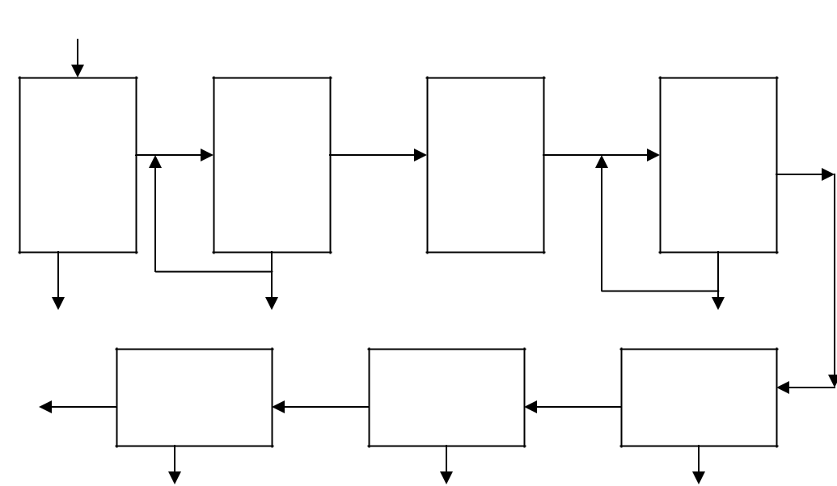

**Figure 18** – Schematic of produced water treatment process

Also boron, silica and ammonia were removed up to some extent in the Lime Softening process. The effluent from the softening process was discharged to a fin-fan type heat exchanger to cool the water from more than 150°F to just above ambient air temperature

|  |  |
| --- | --- |
| ALL Consulting, LLC | 32 |

as the units downstream of the softening unit were susceptible to damage at temperatures above 100°F.

The next step was the trickling filter for biological oxidation of organics **[25]**. Trickling filter is a plastic or rock packed system with large diameter to depth ratio. Influent water is trickled through from the top in the presence of air (oxygen). The microorganisms in the produced water attach on the surface of packed media to form a biological film. Subsequently the organic materials get degraded by the biological film. As the biological film thickens through microbial growth, oxygen penetration to the packed media is affected. Also portions of the film lose their ability as they are used to degrade organics. This causes the used layer to fall off from the packed media, known as sloughing process. Next the sloughed solids are removed in pressure filters. During most stages of testing, the trickling filter was bypassed to allow the microbes produced to acclimate to the water organics. When bypassing the trickling filter, the water was sent directly from the heat exchanger.

Next the processed water passed through the ion exchange softeners to remove any residual hardness. Finally, RO was used to remove TDS, boron and additional organics. The RO permeate was sent to a 2,000-gallon polyethylene tank for storage and the concentrated reject stream was sent to the system drain. pH adjustment is the most important step in the treatment system because boron, silica, ammonia and harness removal depends on pH of the solution. The relationships among the constituents are not monotonous which required careful pH adjustment during the process. For example, as the pH of the solution increases more silica gets ionized and that increases silica solubility, which may increase membrane leakage and deteriorates the silica removal. Opposite to that, as the silica solubility increases the chances of membrane fouling due to silica precipitation decreases, which improves RO membrane performance. As the pH of the solution increases ammonia solubility decreases, which diminishes ammonia removal by RO.

***High Efficiency Reverse Osmosis (HEROTM)***

Ionics Inc developed HEROTM **[26]** to provide higher water recovery, higher quality permeate, higher operating flux and lower overall cost than conventional RO treatment. The most important stage of HERO is pretreatment of the feed water before RO operation to raise the pH of feed water which enables higher efficiency. As discussed earlier, increase in pH improves boron removal and avoids membrane fouling.

As shown in Figure 18, HERO is a three step process.

1. *Hardness removal*: Calcium and Magnesium harness can precipitate on RO membranes at high pH, which causes membrane fouling. Alkali was added to balance alkalinity and hardness which improves weak acid cation exchange (WAC) softening process efficiency. WAC resins exchange hardness from the produced water as discussed earlier. The H+ addition increase pH that enabled conversion of bicarbonate alkalinity into carbon dioxide.

|  |  |
| --- | --- |
| ALL Consulting, LLC | 33 |

1. *Carbon dioxide removal*: As discussed in earlier sections, degasification using air stripping removes carbon dioxide from the water. The carbon dioxide removal further increases pH of the produced water.
2. *High pH RO*: High pH water increases solubility of silica and destroys biological organisms that cause membrane fouling. Dissolved solids were removed by the RO process.

|  |  |  |
| --- | --- | --- |
| Weak Acid |  | Carbon |
| Cation |  | Dioxide |
| Exchange |  | Removal |
|  |  |  |

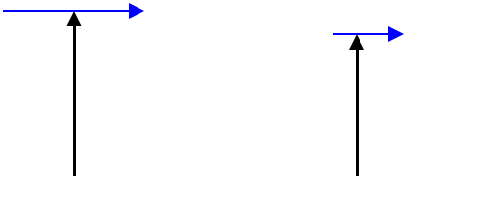

Alkali

|  |  |  |
| --- | --- | --- |
|  | Acid (if needed) |  |
| Alkali (if needed) |  |

Permeate

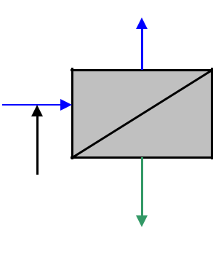

RO

Concentrate

**Figure 19** – A schematic of HERO system developed by Ionics Inc

The biggest advantage of the HERO system is the reduced capital cost (~15%) at higher flux rate (50 GPM). Because of reduced fouling and scaling of the RO membrane, the operating and energy costs for HERO are also less than conventional RO. The increase in water recovery is obvious with HERO systems due to the high performance of membrane. The shortcomings of HERO are the treatment chemical requirements and the higher costs at lower flux operations.

Ionics Inc tested a HERO system to upgrade the water purification plant of Sandia National Laboratories at Albuquerque, New Mexico. The system produced approximately 94% water recovery. The reported power usage was approximately 17 kWh per 1000 gallons of treated water. The reported operating cost was approximately $0.064 per gallon of treated water.

***Oxidation Reactor***

Newpark Environmental Services offers an innovative treatment system consisting of several components and is based on aggressive oxidation followed by precipitation of the contaminants present in the produced water **[28]**. Oxidation of contaminants is the most important part which is accomplished in HB Reactor, a proprietary design of Newpark Environmental Services. HB Reactor is the part of chemical/physical treatment stage of this multi-stage technology. Chemical/physical stage is often adequate to achieve many water treatment requirements on its own. Dissolved contaminants such as monovalent salts are extremely resistant to oxidation/precipitation and may not be removed during chemical/physical treatment stage. Such contaminants can be removed in the demineralization stage which consists of MF, UF and/or RO units. The chemical/physical treatment stage before the demineralization stage removes contaminants that can plug the membrane and improves efficiency of the demineralization stage.

|  |  |
| --- | --- |
| ALL Consulting, LLC | 34 |

The Newpark system contains three separate stages that can be used separately or in tandem: the chemical/physical stage, the demineralization stage, and the waste disposal stage.

**Chemical/Physical Stage**

The chemical/physical stage consists of the following elements:

* *Degasification* – recovery of methane gas from produced water inflow from CBM well and removal of CO2 from produced water.
* *Solids Removal* **–** water from degasification unit is flown through patented Clasiker equipment which removes suspended solids ranging from nails to micro fines.
* *pH adjustment* – pH of the water is adjusted to neutral as possible which would maximize the efficiency of oxidation reactor.
* *Liquid Ring Blower* – high volume low pressure air is pumped into the water stream just prior to the HB.
* *HB Reactor (sonic oxidation)* **–** the water/air mixture then flows through the reactor and is aggressively oxidized/energized. Water/air mixture then enters the reactor where millions of small micro-bubbles are generated from the entrained air, by mechanical means (5 to 10 psi pressure drop). The micro-bubbles carry positive charge and so repel other micro-bubbles but attract negatively charged ions (these negatively charged ions are associated with positively charged ions) in the form of a contaminant (Ca+CO3-, Na2+SO4-2 etc.).

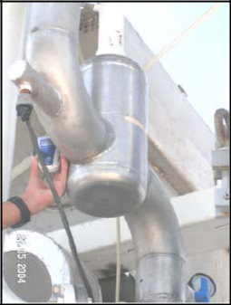

**Figure 20** – HB Reactor for aggressive oxidation of contaminants – proprietary design

(Source: Newpark Environmental Services)

|  |  |
| --- | --- |
| ALL Consulting, LLC | 35 |

The charged micro-bubbles attract more oppositely charged contaminants and become thicker which increases their surface tension continually. Due to ever increasing surface tension, the size of the micro-bubble decreases and the pressures and temperatures inside the bubble significantly increase, which creates points of highly localized temperature. Under the effects of increased pressure and temperature contaminants attached to micro-bubbles are violently reacted with O2 associated with atmospheric air inside the micro-bubble. The energy associated with this reaction results in ultrasonic wave and a very aggressive oxidation of contaminants. Those contaminants not oxidized are highly energized and in a very reactive state. The water (along with the oxidized and energized ions/contaminants) flows out of the reactor to the next stage.

* *Degasser* – at this stage all O2 has been consumed but a significant amount of N2 remains trapped in the water. Degasser removes the trapped N2.
* *Coagulation/Flocculation* – a coagulant (lime) and flocculent (anionic polymer) is mixed into the water to precipitate out the treated contaminants in the form of flocculants.
* *Frictioning* – frictioner settles and removes the larger flocculants.
* *High Rate Clarification* – a series of tubes settles out and removes the smaller flocculants.
* *Sand/Activated Carbon Filtration* – the water is then filtered through a sand and activated carbon to remove the smallest flocculants. The water becomes clear through this process

**Demineralization Stage**

Complete removal of dissolved contaminants can be achieved in demineralization stage by further treatment of effluent water from chemical/physical treatment system. The demineralization stage consists of following elements.

* *MF Unit* **–** sub-micron size particles or contaminants are removed in MF unit. This ensures undissolved sub-micron particles do not enter the RO system and plug the membranes.
* *RO Unit* – the water is then pumped at high pressure through a series of reverse osmosis membranes for the concentration and further removal of remaining dissolved contaminants.

**Waste Disposal**

Permeate from the RO unit can be utilized as a fresh water source with or without further treatment. Concentrate is generally hauled to the nearest disposal facility. Large volumes of concentrate, transportation costs, and limited capacity of disposal sites encourage further treatment of concentrate. Concentrate can be dried into a solid phase which would be easier to handle.

* *Crystalizer and Evaporator* – Crystallizer further concentrates the RO concentrate stream by extracting water. Total volume of the concentrate is reduced while the

|  |  |
| --- | --- |
| ALL Consulting, LLC | 36 |

associated TDS increases significantly. The water (extract phase) is re-circulated through the RO and concentrate (sludge-water) flows through evaporators. Water gets evaporated and the dissolved solids remain in sludge state. Handling and disposal of reduced volume of waste in sludge form is easier.

Figure 21 shows a schematic of produced water treatment system designed by Newpark Environmental Services. Newpark has tested this system for the treatment of produced water from various sources on the pilot scale.

Stage 1: Chemical-Physical

Stage 2:

Demineralization

Stage 3:

Waste disposal

|  |  |  |  |  |  |
| --- | --- | --- | --- | --- | --- |
| Produced Water |  | Air |  | Vent |  |
|  |  |  |  |
| Degaser | Clasiker |  | HB Reactor | Degaser |  |
| CH4 recovery | SS Removal |  | N2 removal |  |
| CO2 removal |  |  | Oxidation |  |  |
|  | Sludge | pH |  | Settler |  |

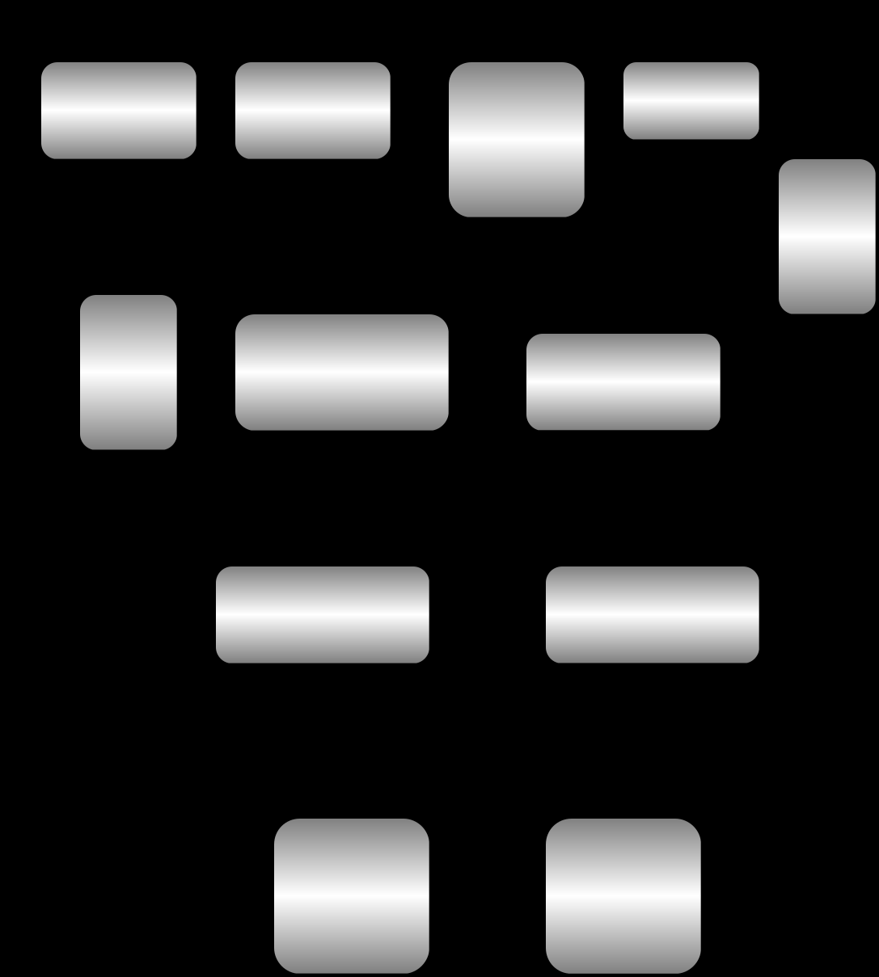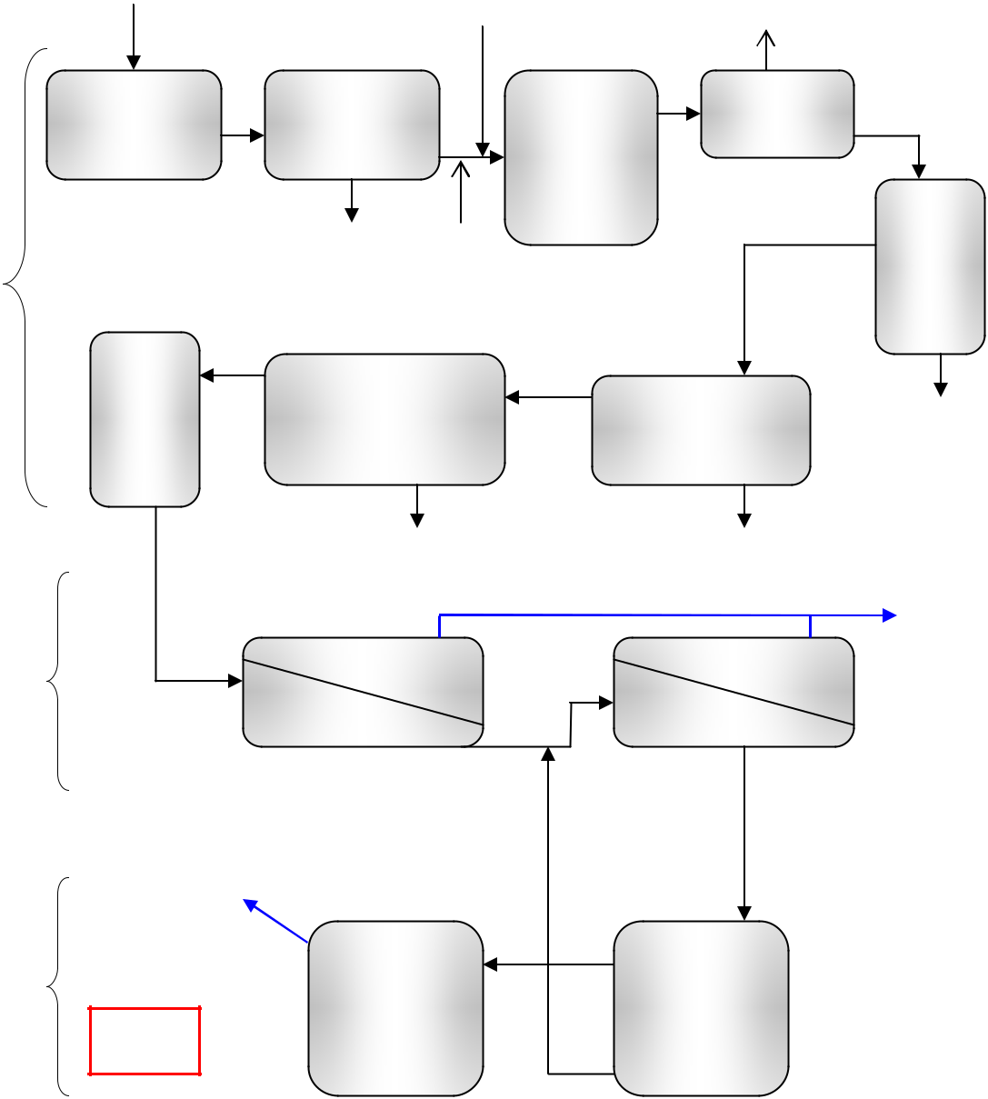

|  |  |  |  |  |
| --- | --- | --- | --- | --- |
| Activated | Clarifier |  |  |  |
| Carbon | Frictioning | Sludge |  |
|  | Contaminants removal |  |
| Polishing | Finer flocs removal | Large flocs removal |  |  |
| stage |  |  |  |  |

Sludge Sludge

Permeate Treated Water

MF RO

Concentrate

Water Recovery

Evaporator Crystallizer

Sludge

Disposal 

Concentrate

**Figure 21** – Produced water treatment system (Source: Newpark Environmental Services)

|  |  |
| --- | --- |
| ALL Consulting, LLC | 37 |

Table 14 shows the performance of Newpark’s system for the treatment of produced water from three facilities. The quality of effluent or treated water at the end of both the chemical/physical treatment stage and demineralization stage was supervised. The Pinedale and Gillette plants are company-owned facilities that process operators’ water on a contract basis.

**Table 14** – Results from field test with a produced water treatment system

|  |  |  |  |  |  |  |  |  |  |  |  |
| --- | --- | --- | --- | --- | --- | --- | --- | --- | --- | --- | --- |
|  | **Pinedale, WY** | |  | **Big Hills, TX** | | |  | **Gillette, WY** | |  |  |
|  | **(Pinedale Field** | |  | **(Conventional Oil and** | | | |  |  |
|  |  | **(CBNG Water)** | |  |  |
|  | **Produced Water)** | |  | **Gas Produced Water)** | | | |  |  |
|  |  |  |  |  |  |
| Parameter |  | Effluent | |  | Effluent | |  |  | Effluent | |  |
| Influent | Chemical/ | After | Influent | Chemical/ |  | After | Influent | Chemical/ | After |  |
| mg/L or ppm |  |  |
|  | Physical | RO |  | Physical |  | RO |  | Physical | RO |  |
|  |  |  |  |  |  |
|  |  |  |  |  |  |  |  |  |  |  |  |
| Carbonate | < 1 | - | - | < 1 | < 1 |  | < 1 | < 1 | - | < 1 |  |
| (CO3) |  |  |
|  |  |  |  |  |  |  |  |  |  |  |
| Bicarbonate | 842 | - | - | 312 | 156 |  | 7.3 | 2,782 | - | 12.2 |  |
| (HCO3) |  |  |
|  |  |  |  |  |  |  |  |  |  |  |
| Calcium | 68 | - | - | 2,388 | 303 |  | 0.96 | 43.67 | - | 1 |  |
|  |  |  |  |  |  |  |  |  |  |  |  |
| Chloride | 4,589 | - | 56.5 | 70,978 | 8,922 |  | 355 | 115 | - | 18 |  |
|  |  |  |  |  |  |  |  |  |  |  |  |
| Magnesium | 9 | - | - | 90 | 93 |  | 0.3 | 32.87 | - | < 0.1 |  |
|  |  |  |  |  |  |  |  |  |  |  |  |
| Sodium | 3,324 | - | 36.6 | 49,590 | 5,140 |  | 217 | 1,076 | - | 21.5 |  |
|  |  |  |  |  |  |  |  |  |  |  |  |
| Sulfates | 1 | - | - | 6 | 280 |  | < 1 | < 1 | - | <0.1 |  |
|  |  |  |  |  |  |  |  |  |  |  |  |
| Alkalinity as | 582 | - | - | 210 | 118 |  | 6 | 2,110 | - | 10 |  |
| CaCO3 |  |  |
|  |  |  |  |  |  |  |  |  |  |  |
| TDS | 11,957 | 3,004 | 93 | 174,452 | 19,053 |  | 93.1 | 3,203 | 1,358 | 46 |  |
|  |  |  |  |  |  |  |  |  |  |  |  |
| TPH | 5 | - | - | 8 | 2 |  | 1 | 1 | - | 1 |  |
|  |  |  |  |  |  |  |  |  |  |  |  |
|  | (Source: Newpark Environmental Services) | | | | | |  |  |  |  |  |

***NORM Treatment***

Naturally occurring radioactive materials (NORM) such as radium get mobilized from the oil or gas formations because of the solubility in the presence of chloride ions which are present in the water within formation **[29]**. The solubility of radionuclide is very low in sulfate species. The low solubility precipitates scale containing high concentrations of radium in the form of barium sulfate or barite [Equation 7] under the effects of varying temperature and pressure during the production operations.

*Ba* + + *Ra*+ + *SO*4 − → *Ba*[*Ra*]*SO*4 ..(7)

The handling and treatment of the precipitated sulfate deposits containing decaying radioactive materials is absolute necessity because of the dangers of radioactivity. BPF Inc., Texas **[30]**, developed mobile automated treatment includes separation of NORM

|  |  |
| --- | --- |
| ALL Consulting, LLC | 38 |

solids from other oil field waste (produced water) containing less than 30 pCi/g (Picocuries per gram, a measurement of radioactivity) radium and dissolving it into aqueous solutions. Extraction of radionuclide from the scales is done by dissolving the radioactive material in one or more aqueous solvents in the hydroclone which separates solids with no NORM from the solution. The NORM containing solution is transported to class II injection site and reinjected into the formation.

Radioactive materials also occur in natural gas in the form of radon. One of the methods to treat the gas is packed bed adsorption of radon with activated charcoal. Monitoring of radioactivity is an essential part of NORM treatment which is accomplished by in-situ radio-assay capability.

|  |  |
| --- | --- |
| ALL Consulting, LLC | 39 |

**Handling of Water Treatment Waste/Concentrate**

Produced water treatment technologies convert poor quality produced water into good quality water by removing contaminants and impurities. As discussed earlier, many of such treatment technologies decontaminate inlet produced water producing a waste stream with higher concentration of contaminants and a treated water stream. For example, membrane systems separate influent water into cleaner product water and a more concentrated stream that is called concentrate in RO, NF, and EDR systems and backwash in UF and MF systems. Considering large scale of produced water treatment, the amount of concentrated waste volume needs to be considered when planning water treatment facilities.

The selection of concentrate disposal practice depends on several factors such as regional disposal availability (geology, geographical. climate etc), local availability (existence of suitable disposal site, distance, compatibility etc), volume of concentrate stream, applicable environmental regulations (NPDES, underground injection control regulations, and underground water resource regulations etc. are imposed by local, state or federal agencies), environmental impacts, public reception, cost, etc. Along with cost contributing factors such as transportation, treatment, development of disposal site, etc; environmental regulations also have major impact on the feasibility of any particular concentrate disposal method.

***Disposal to surface water:***

Membrane wastes may be discharged to surface waters and ultimately reside within large receiving water bodies. Direct discharge to water bodies must have an NPDES permit (states authority) which requires meeting CWA regulations for effluent limitations. Large volumes of concentrate waste and level of contaminants in it are some of the limiting factors for this practice.

***Disposal to sewer:***

NPDES permit is not required for the disposal into publicly owned treatment works (POTWs). However, POTWs may enforce pre-treatment before disposal according to federal regulations to control the level of wastewater pollutants entering the sewage system.

***Disposal with injection well:***

Injection of concentrated waste through a Class I injection well beneath the lowermost underground source of drinking water requires meeting UIC regulations according to state and federal standards. Research is being attempted to evaluate disposal of concentrate into depleted oil or gas fields through Class I well **[31]**. Formation damage, scaling, etc., are some of the concerns for using depleted oil or gas fields.

***Evaporation ponds:***

Evaporation ponds utilize solar energy to evaporate water into atmosphere in vapor form leaving behind solids/salts in sludge form. This technology is limited to regions where

|  |  |
| --- | --- |
| ALL Consulting, LLC | 40 |

solar irradiation is high which results in higher evaporation rate. Permits may be required if potential of leakage into surface water or drinking water aquifer exists.

***Spray evaporation:***

An NPDES permit may be required for spray evaporation if the potential of waste runoff to a receiving water body exists.

***Zero liquid discharge:***

The objective of zero liquid discharge is to eliminate any liquid waste at the end of the water treatment. Evaporators or concentrators can be utilized to concentrate waste stream. Conversion of concentrated sludge into solids/salts form can be accomplished by using crystallizer. Disposal of solid waste from crystallizer must avoid contamination of surface or groundwater.

|  |  |
| --- | --- |
| ALL Consulting, LLC | 41 |

**Summary**

***Advantages, Disadvantages, and Applicability***

Treatment technologies are summarized in the following table that describes advantages and disadvantages and ranges of field applicability. Within each objective (for example “De-oiling”), technologies can be compared in terms of their advantages, disadvantages, resulting waste stream, and applications to oil and gas fields. Advantages and disadvantages are described in comparative terms rather than absolute figures that are subject to change; the aim is to compare technological options for a given objective. Durability and cost are important factors that will depend on site-specific conditions and the specific commercial version picked by the operator. Comparisons of inherent durability can be made within each objective but these are only generalizations. No attempt was made to ascribe economic factors to these technologies since costs will vary from location to location and may be dependent upon commercial configurations and innovations.

Waste products are specific to each technology; for example desalinization can result in a residue consisting of 20% of the input stream or a residue made up of 1% of the input. The 1% residue will be a more concentrated brine than the 20% residue, however, both may no longer be classified as oil and gas wastes. Produced water can usually be disposed of by way of an exemption from standard industrial waste regulations under the federal Resource Conservation and Recovery Act (RCRA). The oil and gas exemption means that produced water can be sent to deep disposal wells that inject the water back into deep, salt water bearing reservoirs with minimal regulatory requirements and cost. Industrial brines are subject to increased regulatory compliance costs.

Applications might include specific oil and gas operations as well as general producing situations. Applications include the treatment objective and the desired beneficial use or disposal route being employed. Geological and hydrologic settings for common oil and gas fields are also part of the description of certain applications.

|  |  |
| --- | --- |
| ALL Consulting, LLC | 42 |

**Treatment**

**Description**

**Advantages**



**Disadvantages**

**Waste**

**Stream**

**Oil and Gas Produced Water Applications**

***De-oiling***

|  |  |  |  |  |  |  |
| --- | --- | --- | --- | --- | --- | --- |
|  |  | No energy required, |  |  |  |  |
|  | separation of free oil | cheaper, effective for |  |  |  |  |
|  | bulk oil removal and | inefficient for fine oil |  |  |  |
|  | from water under gravity | suspended solid | suspended |  |  |
| Corrugated plate | effects enhanced by | removal, with no | particles, | particles slurry at |  |  |
| requirement of high |  |  |
| separator | flocculation on the | moving parts, this | the bottom of the |  |  |
| retention time, |  |  |
|  | surface of corrugated | technology is robust | separator |  |  |
|  | plates | and resistant to | maintenance |  |  |  |
|  |  |  |  |  |
|  |  | breakdowns in the |  |  | Oil recovery from |  |
|  |  | field. |  |  | emulsions or water |  |
|  | separation of free oil | efficient removal of |  |  | with high oil content |  |
|  |  |  | prior to discharge. |  |
|  | smaller oil particles |  |  |  |
|  | from water under | energy requirement |  | Produced water from |  |
| Centrifuge | and suspended |  |  |
| centrifugal force | for spinning, high |  | water-drive reservoirs |  |
| solids, lesser |  |  |
|  | generated by spinning the | maintenance cost | suspended | and water flood |  |
|  | centrifuge cylinder | retention time-high |  | particles slurry | production are most |  |
|  | throughput |  |  |
|  |  |  | as pre-treatment | likely feed-stocks. |  |
|  | free oil separation under |  | energy requirement |  |
|  | compact modules, | waste | Water may contain oil |  |
| Hydroclone | centrifugal force | higher efficiency and | to pressurize inlet, no |  | & grease in excess of |  |
| generated by pressurized | throughput for | solid separation, |  | 1000 mg/L. |  |
|  | tangential input of | smaller oil particles | fouling, higher |  |  |  |
|  | influent stream | maintenance cost |  |  |  |
|  |  |  |  |  |
|  | oil particles attach to | no moving parts, | generation of large |  |  |  |
|  | higher efficiency due | amount of air, | skim off volume, |  |  |
| Gas floatation | induced gas bubbles and | to coalescence, easy | retention time for |  |  |
| lumps of oil |  |  |
|  | float to the surface | operation, robust and | separation, skim |  |  |
|  |  |  |  |
|  |  | durable | volume |  |  |  |
|  |  |  |  |  |  |  |
|  | removal of free or | no energy required, | use of solvent, | solvent | Oil removal from water |  |
| Extraction | dissolved oil soluble in | easy operation, | extract handling, | with low oil and grease |  |
| regeneration |  |
| lighter hydrocarbon | removes dissolved | regeneration of | content (< 1000 mg/L) |  |
|  | waste |  |
|  | solvent | oil | solvent | or removal of trace |  |
|  |  |  |
|  |  |  |  |  | quantities of oil and |  |
|  | strong oxidizers oxidize | easy operation, | on-site supply of | solids | grease prior to |  |
| Ozone/hydrogen | soluble contaminant and | efficient for primary | oxidizer, separation | membrane processing. |  |
| precipitated in |  |
| peroxide/oxygen | remove them as | treatment of soluble | of precipitate, | Oil reservoirs and |  |
| slurry form |  |
|  | precipitate | constituents | byproduct CO2 etc. | thermogenic natural |  |
|  |  |  |
|  |  |  |  |  | gas reservoirs usually |  |
|  |  |  |  |  | contain trace amounts |  |
|  |  |  |  |  | of liquid hydrocarbons. |  |
|  |  |  |  |  | Biogenic natural gas |  |
|  | porous media adsorbs | compact packed bed | high retention time, | used adsorbent | such as CBNG may |  |
| Adsorption | less efficient at | media, | contain no liquids in |  |
| contaminants from the | modules, cheaper, | higher feed | regeneration | the reservoir but when |  |
|  | influent stream | efficient |  |
|  | concentration | waste | pumped to the surface, |  |
|  |  |  |  |
|  |  |  |  |  | the water takes up |  |
|  |  |  |  |  | lubricating fluids from |  |
|  |  |  |  |  | the pumps. |  |

|  |  |
| --- | --- |
| ALL Consulting, LLC | 43 |

**Treatment**

**Description**

**Advantages**



**Disadvantages**

**Waste**

**Stream**

**Oil and Gas Produced Water Applications**

***Disinfection***

|  |  |  |  |  |  |  |
| --- | --- | --- | --- | --- | --- | --- |
|  |  |  | on-site supply of |  | Microbes may exist in |  |
|  | passing UV light or | simple and clean |  | the subsurface |  |
|  | ozone, other |  |  |
| UV light/ozone | ozone produce hydroxyl | operation, highly |  | reservoir or can be |  |
| contaminants reduce |  |  |
|  | ions that kills microbial | efficient disinfection | small volumes of | introduced during |  |
|  | efficiency |  |
|  |  |  |  | suspended | production or during |  |
|  |  |  |  | water treatments. |  |
|  |  |  |  |  |
|  |  |  |  | particles at the |  |
|  |  |  |  | Disinfection may need |  |
|  |  |  |  | end of the |  |
|  | chlorine reacts with water |  |  | to be done to protect |  |
|  | cheaper and the | does not remove all | treatment |  |
|  | potability or to or to |  |
| Chlorination | to produce hypochlorous |  |  |
| simplest method | types of microbial |  | prevent fouling of the |  |
|  | acid which kills microbial |  |  |  | reservoir, tubulars, and |  |
|  |  |  |  |  |  |
|  |  |  |  |  | surface equipment. |  |
|  |  | ***Desalinization*** | |  |  |  |
|  |  |  |  |  |  |  |
|  | addition of lime to | cheaper, accessible, | chemical addition, | used chemical |  |  |
| Lime softening | remove carbonate, | post treatment | and precipitated |  |  |
| can be modified |  |  |
|  | bicarbonate etc. hardness | necessary | waste |  |  |
|  | dissolved salts or | low energy required, | pre and post |  |  |  |
|  | possible continuous | treatment require for |  |  |  |
| Ion exchange | minerals are ionized and | regeneration |  |  |
| removed by exchanging | regeneration of resin, | high efficiency, | chemicals |  |  |
|  | efficient, mobile | produce effluent |  |  |
|  | ions with ion exchangers |  |  |  |
|  | treatment possible | concentrate |  | These technologies |  |
|  | ionized salts attract and | clean technology, no | less efficient with |  |  |
|  |  | typically require less |  |
|  | approach to oppositely | chemical addition, | high concentration | regeneration | power and less pre- |  |
| Electrodialysis | charged electrodes | mobile treatment | influent, require | treatment than |  |
| waste |  |
| passing through ion | possible, less | membrane | membrane |  |
|  |  |  |
|  | exchange membranes | pretreatment | regeneration |  | technologies. Suitable |  |
|  | enhanced electrodialysis | removes of weakly | regeneration of ion | regeneration | produced waters will |  |
| Electro- | have TDS values |  |
| due to presence of ion | ionized species, high | exchange resins, | waste, filtrate |  |
| between 10,000 and |  |
| deionization | exchange resins between | removal rate, mobile | pre/post treatment | waste from post- |  |
| 1,000 mg/L. Some of |  |
|  | ion exchange membranes | treatment possible | necessary | treatment stage |  |
|  | the treatments remove |  |
|  | ionized salts are adsorbed |  |  |  |  |
| Capacitive | low energy required, | expensive electrodes, | regeneration | oil and grease |  |
| deionization | by the oppositely charged | higher throughput | fouling | waste | contaminants and some |  |
|  | electrodes |  |  |  | of them require oil and |  |
|  |  |  |  |  |  |
|  | ionized water reacts with | simultaneously salt |  |  | grease contaminants to |  |
| Electrochemical |  |  | be treated before these |  |
| ionized chloride ion to | and microbial | expensive electrodes | regeneration |  |
| operations. |  |
| Activation | produce chlorite that kills | removal, reduce |  | waste |  |  |
|  | microbial | fouling |  |  |  |  |
|  |  |  |  |  |  |  |
|  | injecting water at high |  | high energy required |  |  |  |
| Rapid spray | velocity in heated air | high quality treated | waste in sludge |  |  |
| evaporates the water | water, higher | for heating air, | form at the end |  |  |
| evaporation | required handling of |  |  |
| which can be condensed | conversion efficiency | of evaporation |  |  |
|  | to obtained treated water |  | solids |  |  |  |
|  |  |  |  |  |  |
|  |  |  |  |  |  |  |

|  |  |
| --- | --- |
| ALL Consulting, LLC | 44 |



|  |  |  |  |  |
| --- | --- | --- | --- | --- |
| **Treatment** | **Description** | **Advantages** | **Disadvantages** |  |
|  |  |  |  |  |
|  | utilize natural |  |  |  |
| Freeze thaw | temperature cycles to | no energy required, | lower conversion |  |
| freeze water into crystals |  |
| evaporation | from contaminated water | natural process, | efficiency, long |  |
| cheaper | operation cycle |  |
|  | and thaw crystals to |  |  |  |
|  | produce pure water |  |  |  |

**Waste**

**Stream**

**Oil and Gas Produced Water Applications**

***Membrane Treatment***

|  |  |  |  |  |
| --- | --- | --- | --- | --- |
|  | membrane removes | higher recovery of | high energy required, |  |
| Microfiltration | micro-particles from the | less efficiency for |  |
| fresh water, compact |  |
| water under the applied | divalent, monovalent |  |
|  | pressure | modules | salts, viruses etc. |  |
|  |  |  |
|  | membrane removes ultra- | higher recovery of | high energy, |  |
| Ultrafiltration | particles from the water | fresh water, compact | membrane fouling, |  |
| under the applied | modules, viruses and | low MW organics, |  |
|  |  |
|  | pressure | organics etc. removal | salts etc |  |
|  | membrane separation | low MW organics | high energy required, |  |
|  | removal, hardness | less efficient for |  |
| Nanofiltration | technology removes |  |
| removal, divalent | monovalent salts and |  |
| species ranging between |  |
|  | ultrafiltration and RO | salts removal, | lower MW organics, |  |
|  | compact module | membrane fouling |  |
|  |  |  |

|  |  |  |  |  |
| --- | --- | --- | --- | --- |
|  | pure water is squeezed | removes monovalent | high pressure |  |
| Reverse | from contaminated water | salts, dissolved | requirements, even |  |
| trace amounts of oil |  |
| Osmosis | under pressure | contaminants etc., |  |
| & grease can cause |  |
|  | differential | compact modules |  |
|  | membrane fouling |  |
|  |  |  |  |

concentrated waste from membrane backwash during membrane cleaning, concentrate stream from the filtration operation

Removal of trace oil and grease, microbial, soluble organics, divalent salts, acids, and trace solids. . Contaminants can be targeted by the selection of the membrane. The size distribution of the removable species for membrane filtration technologies is shown in table 9.

Removal of sodium chloride, other monovalent salts, and other organics. Some organic species may require pre-treatment. While energy costs increase with higher TDS, RO is able to efficiently remove salts in excess of 10,000 mg/L.

***Miscellaneous Treatment***

|  |  |  |  |  |  |  |
| --- | --- | --- | --- | --- | --- | --- |
|  | develops film of |  |  |  | Removal of suspended |  |
|  | microbial on the surface | cheaper, simple and | oxygen requirement, |  |  |
| Trickling Filter |  | and trace solids, |  |
| of packed material to | clean technology | large dimensions of |  | ammonia, boron, |  |
|  | degrade contaminants | the filter | sludge waste at |  |
|  |  | metals etc. Post- |  |
|  | within water |  |  |  |
|  |  |  | the end of the | treatment is normally |  |
|  |  |  | retention time |  |
| Constructed | natural oxidation and | cheaper, efficient | treatment | required to separate |  |
| requirement, |  |
| decomposition of | removal of dissolved |  | biomass, precipitated |  |
| wetland | maintenance, |  |  |
|  | solids, dissolved gases |  |
| treatment | contaminants by flora and | and suspended | temperature and pH |  |  |
| fauna | contaminants |  | etc. |  |
|  | effects |  |  |
|  |  |  |  |  |  |
|  |  |  |  |  | Balance high SAR and |  |
| SAR adjustment | addition of Ca or Mg ions | cheaper option | chemical addition |  | very low TDS (higher |  |
|  | percentage of sodium |  |
|  |  |  |  |  | salts) after membrane |  |
|  |  |  |  |  | processes. |  |

|  |  |
| --- | --- |
| ALL Consulting, LLC | 45 |

**Treatment**

**Description**

**Advantages**

**Disadvantages**



**Waste**

**Stream**

**Oil and Gas Produced Water Applications**

***NORM Treatment***

|  |  |  |  |  |
| --- | --- | --- | --- | --- |
| NORM | extraction of radioactive | efficient for reducing | extracted radioactive |  |
| material with aqueous | radioactive waste | materials need |  |
| treatment | further treatment or |  |
| solution | volume |  |
|  | disposal |  |
|  |  |  |  |
|  |  |  |  |  |

Produced waters containing high levels of Uranium or Thorium. Unless treatment is accomplished, radioactive scale can form in surface equipment extensive remediation.

***Natural Gas Recovery***

Air stripping

stripping of dissolved gas from water

concurrent or countercurrent operations, cheaper

post treatment, lower

efficiency

***Ranking***

The effectiveness and performance of the various treatment technologies can also be analyzed according to a new five-step ranking approach devised by the authors and described in this section. Rankings can best be used to select between technologies based on a carefully defined set of criteria. Rankings will need to be updated as commercialized technologies will change and as innovations are installed and made newly available. The ranking of each step depends on the rankings of other steps. Reasonable engineering judgment and experience assists in utilizing this ranking criterion. The following is an example of a ranking scheme for treatment technologies as they apply to the treatment and management of produced water. It should be noted that the rankings that follow are subjective, are the product of the authors, and are subject to change.

*Step 1 – Ability to remove technology specific contaminants:*

The simplest method to express the performance of a treatment technology is the removal of contaminants in percentage. Ranking can be assigned in five categories:

|  |  |
| --- | --- |
| Removal of contaminants, % | Rank |
| >95 | 5 |
| 90-95 | 4 |
| 75-90 | 3 |
| 50-75 | 2 |
| < 50 | 1 |

|  |  |
| --- | --- |
| ALL Consulting, LLC | 46 |

*Step 2 – Consumption of resources to achieve desire removal using given technologies:*

The consumption of resources in terms of effort, cost, energy, natural resources, etc. must be considered in ranking. As stated earlier regarding the interdependency of ranking criteria, in the case of RO operation, higher pressure across the membrane (energy) is required to achieve higher removal of salts at higher recovery rate. The ranking is thought to be assigned as:

|  |  |
| --- | --- |
| Level of resources consumption | Rank |
| low | 5 |
| moderately low | 4 |
| moderate | 3 |
| high | 2 |
| very high | 1 |

Continuing discussion of RO, 75-90% [rank 3] removal of dissolved salts requires moderate energy [rank 3]. For the same membrane and contaminants level >95% [rank 5] removal requires high energy [rank 2].

*Step 3 – Requirement of pre- or post-treatment technologies with given technologies:*

Most of the treatment technologies require pre- or post-treatments to improve efficiency, to achieve better quality, to handle byproducts, etc. The extent of such requirements significantly contributes to the overall performance but also adds to cost, facilities, and technological complexity. Ranking assigned in five categories is:

|  |  |
| --- | --- |
| Pre/Post treatment requirement | Rank |
| *Basic*: cooling, heating, settling, impoundment, | 5 |
| etc. |  |
| *Primary*: pH adjustment, softening, chemical | 4 |
| addition, de-oiling, suspended solid removal, sand |  |
| filtration, etc. + technologies in previous section |  |
| *Secondary*: soluble hydrocarbons removal, GAC, | 3 |
| dissolved gas removal, biological treatments, |  |
| disinfection, etc. + technologies in previous |  |
| sections |  |
| *Moderate*: regeneration, fouling prevention, | 2 |
| trickling filter, constructed wetland, ionization and |  |
| removal, UF or NF, low pressure RO, etc. |  |
| + technologies in previous sections |  |
| *Significant*: high pressure filtration, high pressure | 1 |
| RO, NORM treatment, etc. + technologies in |  |
| previous sections |  |

*Step 4 – Durability of the treatment technology:*

Some technologies rely on automated activation of pumps and valves to move fluid while other technologies feature simpler flow paths that are gravity-driven. Simpler

|  |  |
| --- | --- |
| ALL Consulting, LLC | 47 |

technologies are easier to maintain and cheaper to operate. This factor analyzes the degree of durability within a technology.

|  |  |  |  |
| --- | --- | --- | --- |
| Durability Factor | |  | Rank |
| Inlet water driven by gravity, no | | | 4 |
| moving parts, facility not prone to | | |  |
| fouling and scaling, maintenance by | | |  |
| schedule or automated warning | | |  |
| Simple automated pumping cycles and | | | 3 |
| few adjustments needed. | |  |  |
| Complex automated | cycles | needing | 2 |
| occasional adjustment and repair. | | |  |
| Operator onsite at all times makes | | | 1 |
| adjustments and | repairs | during |  |
| process. |  |  |  |

*Step 5 – Mobility of the treatment units:*

The compatibility of treatment technologies to be performed as mobile units benefits the produced water treatment and adds flexibility during oil and gas operations. If the treatment units are self-contained and mobile, the operator can change locations as water production changes within the field. Many of the individual technologies can be performed by mobile units. However, they may require pre- or post-treatments which can only be performed by fixed units. Such operations are categorized as partially mobile treatments in the following ranking;

|  |  |
| --- | --- |
| Mobility of treatment technologies | Rank |
| Fully mobile | 2 |
| Partially mobile | 1.5 |
| Fixed | 1 |

Good quality produced water from oil or gas formations may require minimum polishing treatments which can be accomplished by compact modules of GAC and RO operated on a mobile treatment truck. Such treatments are fully mobile [rank 2].

*Step 6 – Level of contaminants in influent produced water:*

The quality of influent produced water also contributes to the overall performance of treatment technologies. This can be ranked as:

|  |  |  |
| --- | --- | --- |
| Level of contaminants | Rank |  |
| *Low*: suspended solids, moderate |  |  |
| concentration of free or dispersed oil, low |  |  |
| hardness level, easily removable gases etc. | 5 |  |
| TDS: < 5,000 ppm |  |
|  |  |
| TOC, TPH: < 30 ppm |  |  |
|  |  |  |

|  |  |
| --- | --- |
| ALL Consulting, LLC | 48 |

|  |  |  |
| --- | --- | --- |
| *Medium*: ammonia, boron, hardness ions, |  |  |
| BTEX, dissolved gases, fine oil particles, |  |  |
| metal ions etc. | 4 |  |
| TDS: 5,000-10,000 ppm |  |
|  |  |
| TOC, TPH: >30-100 ppm |  |  |
| + contaminants in next section |  |  |
| *High*: hydrogen sulfide, heavy metals, |  |  |
| weak ions, NORM, monovalent salts, trace |  |  |
| soluble organics etc. | 3 |  |
| TDS > 10,000-35,000 ppm |  |
|  |  |
| TOC, TPH > 100 ppm |  |  |
| + contaminants in next sections |  |  |

*Final Step – Calculation of overall rank based on above ranking criteria:*

After estimating ranks of each five steps, the final formula as described below calculates overall rank. The possible highest rank is 7 and the least possible rank is 1. On the scale of 7, the treatment technologies with higher rank confirm better performance, economics and flexibility. The overall ranking formula is:

[(*step*.1+ *step*.2 + *step*.3 + *step*.4 + *step*.5)]

*step*.6

For example, considering treatment of a good quality produced water [step 6, rank 5] with low pressure RO [step 2, rank 4]. The secondary pretreatments [step 3, rank 3] would be sufficient in this case to achieve >95% removal [step 1, rank 5] of contaminants. This treatment can be operated with a fully mobile unit [step 5, rank 2]. The RO system may need attention of operator all the time [step 4, rank 1]. According to the formula the overall rank on a scale of 10 is: (5 + 4 + 3+1+ 2) / 5 = 3 (out of 7).

The formula is sensitive up to two decimal points. Even the difference of 0.05 can be significant. The following table compares performance of *HEROTM* (high efficiency RO) and *HEEDTM* (high efficiency ED) technologies discussed in earlier sections.

|  |  |  |
| --- | --- | --- |
| Criteria | HERO | HEED |
| Step 1: Removal efficiency | 5 | 4 |
| Step 2: Resources consumption | 3 | 4 |
| Step 3: Pre/post treatment requirement | 3 | 2 |
| Step 4: Durability of system | 1 | 1 |
| Step 5: Mobility of treatment | 2 | 2 |
| Step 6: Level of contaminants in feed | 3 | 3 |
| Overall Rank | 4.667 | 4.333 |

The results indicate better performance with *HEROTM* system and highlight that system’s higher efficiency in spite of requiring more resources. This ranking was made on the basis of individual, historical experience with these two systems and is in no way meant as an endorsement or widespread judgment of either system. It is meant as an illustration

|  |  |
| --- | --- |
| ALL Consulting, LLC | 49 |

of the ranking mechanism. This ranking scheme can be applied to a range of technological options for treating produced waters. The ranking can help the oil and gas operator choose between options, but of course an important part of the decision will depend on the requirements for the chosen end use for the water.

|  |  |
| --- | --- |
| ALL Consulting, LLC | 50 |

**References**

1. Reynolds Rodney R.: “Produced Water and Associated Issues,” a manual for independent operator, *Petroleum Technology Transfer Council* (2003).
2. Veil J.A., Puder M.G., Elcock D., and Redweik R. Jr. J.: “A White Paper Describing Produced Water from Production of Crude Oil, Natural Gas, and Coal Bed Methane,” *US DOE* (January 2004) W-31-109-Eng-38.
3. Broussard P. “Skip” Jr.: “Floatation Pump Proves Successful for The Treatment of Produced Water,” paper presented at the 10th IPEC (2003).
4. Lee R., Seright R., Hightower M., Sattler A., Cather M., McPherson B., Wrotenbery L., Martin D., and Whitworth M.: “Strategies for Produced Water Handling in New Mexico,” paper presented at the 2002 *Ground Water Protection Council*.
5. Knudsen B.L., Hjelsvold M., Frost T.K., Svarstad M.B.E., Grini P.G., Willumsen C.F., and Torvik H.: “Meeting the Zero-Discharge Challenge for Produced Water,” paper SPE 86671 presented at the 2004 SPE International Conference on Health, Safety, and Environment in Oil and Gas Exploration and Production, Calgary.
6. Doyle D.H., Daniel F., and Brown A.B.: “Field Test of Produced Water Treatment with Polymer Modified Bentonite,” paper SPE 38353 presented at the 1997 Rocky Mountain Regional Meeting, Casper, Wyoming.
7. Myers J.E., Jackson L.M., Bernier R.F., and Miles D.A.: “An Evaluation of the Department of Energy Naval Petroleum Reserve No. 3 Produced Water Bio-Treatment Facility,” paper SPE 66522 presented at the 2001 SPE/EPA/DOE Exploration and Production Environmental Conference, San Antonio, Texas.
8. Moftah K.: “High pH RO for Wastewater Treatment,” *Pollution Engineering* (October 2002).
9. Bost A.L., and Reid T.: “Powder River Gas L.L.C. Coal Creek CNBG POD – Hydrology Technical Report,” BLM Montana (November 2004).
10. “A Low Cost Option to Reduce Sodium Levels in Coal Bed Methane Coproduced Wastewater using DOWEX G-26 Resin,” DOWEX Ion Exchange Resins; The Dow Chemical Company.
11. “Handbook on Coal Bed Methane Produced Water: Management and Beneficial Use Alternatives,” ALL Consulting (July 2003).

|  |  |
| --- | --- |
| ALL Consulting, LLC | 51 |

1. Sattler A., Hightower M., Nenoff T., Pless J., Phillips M., Brister B., Arnold R., Cather M., and McPherson B.: “Managing Coal Bed Methane Produced Water for Beneficial Uses, Initially Using The San Juan and Raton Basins as a Model”, Interim Progress Report prepared for NETL, Sandia National Laboratory, 2004.
2. Hayes T.: “The Electodialysis Alternative for Produced Water Management,” Gas Technology Institute (2004).
3. Spitz L.R.: “Advanced Mobile Water Treatment Systems for Treating Coal Bed Methane Produced Water,” a paper presented at the 2003 Ground Water Protection Council meeting.
4. Hernon B., Zanapalidou H., Prato T., and Zhang L.: “Removal of Weakly-Ionized Species by EDI,” Ionics Inc.
5. Heins W., and Peterson D.: “Use of Evaporation for Heavy Oil Produced Water Treatment”, a paper presented at the 4th Canadian International Petroleum Conference held in Calgary, Canada, June 2003.
6. Turner W.: “Report on Treatment of Power Plant Waste Water Using The Aquasonics Rapid Spray Desalination Process,” WestWater Resource Inc, NM.
7. Lang K., “Managing Produced Water”, *Hart Energy Publications* Excerpts in Petroleum Technology Transfer Council Network News (4th Quarter 2000).
8. “Membrane Filtration,” Tech Brief, National Drinking Water Clearinghouse Fact Sheet (1999).
9. “Membrane Filtration of Oil and Gas Field Produced Water,” GE Infrastructure Water & Process Technologies.
10. Barrufet M.A., Iglesias-Silva G., Petriciolet A., Patel C.V., and Burnett D.: “A

Modular Design And Implementation of A Brine Conversion Process: Oil Removal and Desalting Units,” paper presented at the 11th IPEC, Albuquerque, NM (2004).

1. “Using VSEP to Treat Produced Water – An effective and economical solution,” cases study from New Logic Research.
2. “Produced Water Pilot Study,” GE Infrastructure Water & Process Technologies.
3. Funston R., Ganesh R., and Leong Lawrence Y.C.: “Evaluation of Technical and Economic Feasibility of Treating Oilfield Produced Water to Create a “New” Water Resource,” paper presented at the 2002 Ground Water Protection Council (GWPC) meeting.
4. “Wastewater Technology Fact Sheet – Trickling Filters,” *US EPA* (September 2000) 832-F-00-014.

|  |  |
| --- | --- |
| ALL Consulting, LLC | 52 |

1. Hayter S., Tanner S., Urbatsch E., and Zuboy J.: “Saving Energy, Water, and Money with Efficient Water Treatment Technologies,” *DOE/EE*-0294 (June 2004), A New Technology Demonstration Publication, Federal Energy Management Program.
2. Lincz R.: “Newpark’s HB Reactor Water Treatment Technology Used for Anadarko Coal Bed Methane Produced Water Treatment for Discharge County Line Production Field”, prepared by Newpark Environmental Services for DEQ-Water Quality Division, December 2004.
3. “Mobilization and Redeposition of NORM,” The Tenorm Page.
4. Smith K.P., Williams G.P., Blunt D.L., and Arnish J.J.: “Radiological Dose Assessment of NORM Disposal in Class II Injection Wells,” *US DOE* contract (1997) W-31-109-Eng-38.
5. Mickley M., “Membrane Concentrate Disposal: Practices and Regulation”, prepared by Mickley & Associates for U.S. Department of The Interior under agreement no. 98-FC-81-0054, Desalination and Water Purification research and Development Program Report No. 69, September 2001.
6. Nicot Jean-Philippe, and Dutton A.R.: “Please Pass the Salt: Using Oil Fields for the Disposal of Concentrate from Desalination Plants,” a report presented to the U.S. Bureau of Reclamation, September 2004.

|  |  |
| --- | --- |
| ALL Consulting, LLC | 53 |