[Petroleum Science 20 (2023) 1](https://doi.org/10.1016/j.petsci.2022.12.012)e[19](https://doi.org/10.1016/j.petsci.2022.12.012)



Contents lists available at [ScienceDirect](www.sciencedirect.com/science/journal/19958226)



Petroleum Science



j o u r n a l h o m e p a g e : [w w w . k e a i p u b l i s h i n g . c o m / e n / j o u r n a l s / p e t r o l e u m - s c i e n c e](www.keaipublishing.com/en/journals/petroleum-science)

Original Paper

Whole petroleum system and ordered distribution pattern of conventional and unconventional oil and gas reservoirs



Cheng-Zao Jia a, b, *, Xiong-Qi Pang b, c, Yan Song b, c

1. PetroChina Research Institute of Petroleum Exploration & Development, Beijing, 100083, China
2. State Key Laboratory of Petroleum Resources and Prospecting, China University of Petroleum, Beijing, 102249, China
3. China University of Petroleum, Beijing, 102249, China

a r t i c l e i n f o

Article history:

Received 20 June 2022

Received in revised form

15 September 2022

Accepted 29 December 2022

Available online 30 December 2022

Edited by Jie Hao and Teng Zhu

Keywords:

Conventional and unconventional oil and gas

Petroleum system Whole petroleum system Hydrocarbon reservoirs ordered distribution model Fossil energy

a b s t r a c t

The classical source-to-trap petroleum system concept only considers the migration and accumulation of conventional oil and gas in traps driven dominantly by buoyance in a basin, although revised and improved, even some new concepts as composite petroleum system, total petroleum system, total composite petroleum system, were proposed, but they do not account for the vast unconventional oil and gas reservoirs within the system, which is not formed and distributed in traps dominantly by buoyance-driven. Therefore, the petroleum system concept is no longer adequate in dealing with all the oil and gas accumulations in a basin where significant amount of the unconventional oil and gas resources are present in addition to the conventional oil and gas accumulations. This paper looked into and analyzed the distribution characteristics of conventional and unconventional oil/gas reservoirs and their differ-ences and correlations in petroliferous basins in China and North America, and then proposed whole petroleum system (WPS) concept, the WPS is defined as a natural system that encompasses all the conventional and unconventional oil and gas, reservoirs and resources originated from organic matter in source rocks, the geological elements and processes involving the formation, evolution, and distribution of these oil and gas, reservoirs and resources. It is found in the WPS that there are three kinds of hy-drocarbons dynamic fields, three kinds of original hydrocarbons, three kinds of reservoir rocks, and the coupling of these three essential elements lead to the basic ordered distribution model of shale oil/gas reservoirs contacting or interbeded with tight oil/gas reservoirs and separated conventional oil/gas reservoirs from source rocks upward, which is expressed as “S\T-C”. Abnormal conditions lead to other three special ordered distribution models: The first is that with shale oil/gas reservoirs separated from tight oil/gas reservoirs. The second is that with two direction ordered distributions from source upward and downward. The third is with lateral distribution from source outside.

© 2022 The Authors. Publishing services by Elsevier B.V. on behalf of KeAi Communications Co. Ltd. This is an open access article under the CC BY-NC-ND license ([http://creativecommons.org/licenses/by-nc-nd/](http://creativecommons.org/licenses/by-nc-nd/4.0/) [4.0/](http://creativecommons.org/licenses/by-nc-nd/4.0/)).

1. Introduction and issue

Since the end of the last century, unconventional oil and gas resources have been discovered and gradually developed into the dominant energy in current society. According to EIA data (Fig. 1), U.S. shale oil production accounted for 63.3% of total U.S. oil pro-duction in 2019; In 2020, the proved unconventional oil and gas reserves in China and the world were 350 million tons and 5.45 billion tons of oil equivalent respectively, accounting for more than

* + Corresponding author. PetroChina Research Institute of Petroleum Exploration
* Development, Beijing, 100083, China.

E-mail address: [Jiacz@petrochina.com.cn](mailto:Jiacz@petrochina.com.cn) (C.-Z. Jia).

50% of the newly added reserves. How are unconventional and conventional oil and gas different and related? What is their common distribution pattern in petroliferous basins? This is a sci-entific problem that petroleum geologists have been trying to explore since the discovery and utilization of unconventional oil and gas resources.

1.1. Breakthrough of unconventional oil/gas to conventional oil/gas

1.1.1. Buoyancy dominates conventional oil and gas accumulation in traps

Since the dynamic mechanism of buoyancy-driven oil/gas migration was published in Science (White, 1885) and the theory

<https://doi.org/10.1016/j.petsci.2022.12.012>

1995-8226/© 2022 The Authors. Publishing services by Elsevier B.V. on behalf of KeAi Communications Co. Ltd. This is an open access article under the CC BY-NC-ND license (<http://creativecommons.org/licenses/by-nc-nd/4.0/>).

C.-Z. Jia, X.-Q. Pang and Y. Song Petroleum Science 20 (2023) 1e19

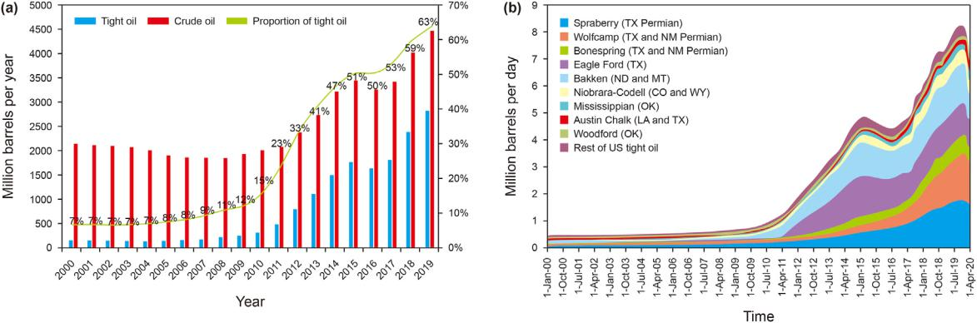

Fig. 1. Variation and composition of unconventional (shale) oil and gas production in the United States (EIA, 2020). (a) US conventional crude oil production and shale oil production statistics; (b) Production statistics of major shale oil accumulation combinations in the United States.

with oil/gas accumulation in traps was established (Levorsen, 1954), oil and gas geological exploration has achieved rapid development (Jia et al., 2012, 2017). After that, successive scholars proposed new concept about hydrocarbon reservoirs formation, such as the hydrocarbon being originated from kerogen (Schidlowski, 1981), the source rock controlling hydrocarbon accumulation (Tissot and Welte, 1978), and the petroleum system controlling hydrocarbon accumulation and distribution (Magoon and Dow, 1994). The petroleum system (PS) integrates the com-bined effects of various related geological factors on the formation and distribution of conventional oil and gas reservoirs, including the source-rock, reservoir-layer, cap-rock, trap, migration, protec-tion and so on, laying the theoretical foundation of modern oil and gas geology. Conventional oil and gas reservoirs are defined as oil and gas reservoirs in which oil/gas are migrated to and accumu-lated in traps dominantly by buoyancy-driven under actual geological conditions, and the distribution of oil, gas, and water in traps are controlled by buoyancy differentiation. This concept is consistent with that given by classical petroleum geology (Levorsen, 1954; Hunt, 1979). The trap is a widely accepted tech-nical term, defined as a place or geological unit where oil and gas are accumulated driven by buoyancy. The distribution boundary, area, height, hydrocarbon overflow point and storage volume of a trap can be quantitatively characterized, which is widely used in hydrocarbon resource evaluation and reserve calculation, dealing with hydrocarbon exploration and exploitation.

1.1.2. Non-buoyance dominates the formation of unconventional oil/gas reservoirs

With the increasing demand for oil and gas resources, the field for oil and gas exploration is being expanded, a lot of oil and gas resources have been found in the exclusion areas where classical oil and gas geology suggests that oil and gas reservoirs cannot be formed, and the reservoirs proved in these areas are commonly referred to as unconventional oil and gas reservoirs.

For the convenience of academic exchange, the unconventional oil and gas reservoirs in this paper are defined as oil/gas reservoirs in which oil/gas are migrated and accumulated dominantly by non-buoyancy-driven and not subject to significant hydrodynamic ef-fects, their distribution is not controlled by traps and commercial extraction often require specialized techniques. The concept of unconventional reservoirs usually is consistent with the concept of continuous hydrocarbon accumulation, which is widely used by international organizations and industry (Zou et al., 2013a). Un-conventional continuous oil and gas reservoirs were first discov-ered in the deep depression area of Albert Basin, Canada, and are

called deep basin oil and gas reservoirs (Masters, 1979). Subse-quently, it was discovered in different types of basins under different tectonic background conditions, so it was given different names by different scholars, including the basin central oil/gas reservoir (Rose et al., 1986), syncline oil/gas reservoir (Wu et al., 2015), source-contacted oil/gas reservoir (Zhang, 2006), currently summarized as tight continuous oil and gas reservoir (Schmoker and Oscarson, 1995; Hu et al., 2022a). The common characteris-tics of these oil/gas reservoirs are: non-buoyancy-driven, extensive dense, continuous distribution, low natural productivity, and the need for special measures to achieve commercial productivity (Zou et al., 2013a). There is no unified scientific definition for all un-conventional oil and gas reservoirs, which mainly in a broad sense include tight reservoir (Spencer, 1985), shale oil/gas reservoir (EIA, 2013), coal seam (oil) gas reservoir (Bustin and Clarkson, 1998), heavy oil and bitumen reservoir (Richard et al., 2007), natural gas hydrate reservoir (Pang et al., 2021a), water dissolved gas reservoir (Zhang et al., 2008) and so on.

Jia et al. (2021a) focused on the dynamic mechanism differences between conventional and unconventional reservoirs. Buoyancy is realized as the dominant driving force for the formation of con-ventional reservoirs and traps as the essential controlling factor, while non-buoyance is realized as the dominant driving force for the formation of unconventional reservoirs and intermolecular interactions as the essential controlling factor. For different un-conventional reservoirs, the driving forces and intermolecular dy-namic mechanisms are different: the formation and distribution of shale oil/gas reservoir is related to the molecular adsorption and source rocks; the tight oil/gas reservoir is related to the molecular interfacial tension and tight reservoir layers; the heavy oil and bitumen reservoir is related to molecular viscosity and extreme redox environments; and the natural gas hydrate reservoir is related to molecular cage interaction and abnormal high pressure and low temperature conditions. In general condition, the forma-tion and distribution of unconventional oil/gas reservoirs are controlled by special conditions such as tight media, extreme environment, and high pressure or low temperature. It is of great practical significance to elaborate the correlations and differences between the unconventional and conventional oil/gas reservoirs or resources from a macroscopic perspective.

1.1.3. The breakthrough of unconventional oil/gas to classical petroleum geology

The major breakthrough of unconventional oil and gas to clas-sical petroleum geology is mainly reflected in six aspects (Jia, 2017; Jia et al., 2021a): (A) oil and gas are continuously distributed in a

2

C.-Z. Jia, X.-Q. Pang and Y. Song

large area without obvious reservoir boundaries, breaking through the traditional concept of hydrocarbon accumulation in traps; (B) oil and gas exist in nano-scale pore-throat system, breaking through the traditional concept of within reservoirs with high porosity and high permeability; (C) oil and gas are enriched in reservoirs without cap-rocks but with “self-containment” for un-conventional reservoirs, breaking through the traditional concept of source-reservoir-cap combination forming conventional reser-voirs. (D) unconventional oil and gas migration and accumulation are dominated by non-buoyancy and distributed close to or within source rocks, breaking through the traditional concept of hydro-carbon migration and accumulation dominantly by buoyancy and separated from source rocks; (E) only the sweet spots of uncon-ventional reservoirs can be exploited commercially under the cur-rent conditions, breaking through the traditional concept of complete trap structure exploitation; (F) unconventional oil and gas are enriched in various forms such as free state, dissolved state, adsorbed and confined state, breaking through the concept of conventional oil and gas resources mainly existing in free state.

1.2. Petroleum system and challenges of its application

1.2.1. Petroleum system concept and its modification

Dow (1974) first put forward the concept of oil system (OS) at the AAPG meeting to describe the assemblage relationship between oil accumulation and source rock-reservoir combination, his paper was published in AAPG Bulletin in 1974 (Dow, 1974). The definition of petroleum system (PS) was first proposed in Perrondon and Masse's article published in 1984 (Perrodon and Masse, 1984; Perrodon, 1992), and the current accepted PS concept is given by Magoon and Dow in AAPG Memoir 60 (Magoon and Dow, 1994): a petroleum system (PS) is defined as a natural system that encom-passes a pod of active source rock and all related oil and gas and which included all the geologic elements and processes that are essential if a hydrocarbon accumulation is to exist (Fig. 2). The PS not only can be used to address the formation and distribution of oil and gas reservoirs by associating different geological factors, such as buoyancy-driven, trap accumulation and source controlling, but also proposed a research method of four figures and one table based on the research and evaluation of the correlation effect of various main controlling factors to explain and predict the distri-bution of oil and gas reservoirs. Among them, four maps refer to the burial history curve at critical moments, regional plane distribution map of petroleum system, profile characteristic distribution map of petroleum system, and geological events correlation map of pe-troleum system; one table refers to the statistical table of distri-bution of source rocks and related oil and gas reservoirs.

Petroleum system can explain the correlation between oil and gas reservoirs formation and distribution and geological elements, providing a way of approach method for predicting and evaluating potential oil and gas resources, which has been improved by many scholars in the practical application process.

In view of the problems that the multiple sets of effective source rocks are not considered in the PS, some scholars proposed the concept of composite petroleum system (He et al., 2000; Zhao and He, 2002). In order to calculate accumulated and dispersed hy-drocarbon amounts and evaluate effective oil/gas resource amounts, some scholars put forward a new concept of hydrocarbon accumulation system (HAS) based on study of petroleum system (Leu, 1999; Jin et al., 2003). In view of the problem that the un-discovered oil and gas reservoirs are not considered in the PS, some scholars proposed total petroleum system (Magoon and Dow, 1994) to deal with them. In order to solve the practical problems in evaluating oil and gas resources, the composite total petroleum system was proposed by scholars from the U.S. Geological Survey

Petroleum Science 20 (2023) 1e19

(USGS) (Wandrey et al., 2004), several individual total petroleum systems in the research area were combined into a single composite total petroleum system because few correlations of source to reservoir hydrocarbons were available at the time of the assess-ment, in addition, multiple stacked source rocks and reservoirs, and extensive fault systems, allow the mixing of hydrocarbons from multiple sources making further subdivision more difficult.

1.2.2. Challenges faced by unconventional oil and gas exploration Since Canada geologists discovered deep basin tight gas reser-

voirs in 1979 in the depression area of the Alberta Basin (Masters, 1979), a lot of shale oil and gas reserves were subsequently proved within more dense source rocks (Curtis, 2002; Jin et al., 2022). So far, many types of unconventional hydrocarbon re-sources have been discovered around the world. According to the evaluation results of different scholars, the potential of global un-conventional oil and gas resources is about 5e10 times that of conventional oil and gas resources, showing a broad development prospect (EIA, 2020; Jia et al., 2012; Zou et al., 2013b). Despite the rapid development of unconventional oil and gas, a series of un-solvable problems based on existing theories and technologies are encountered in exploration practice, which are mainly reflected in the following three aspects:

First, unconventional oil and gas are often found in areas that are considered impossible to form oil and gas reservoirs according to the classical oil and gas geology, but sometimes the conventional and unconventional reservoirs are often symbiotic or associated, and difficult to distinguish from each other. Second, unconven-tional reservoirs are widely and continuously distributed in layers with low porosity, low permeability, and low production, however, sometimes sweet spots with high porosity, high permeability, and high production can be encountered in unconventional reservoirs although their formation mechanism is unclear. Third, unconven-tional oil and gas resources are diverse and have great potential, but their formation conditions are complex, and it is very difficult to predict and evaluate them quantitatively. In addition to these, there are also other issues related to them which are very difficult to answer based the concept of the PS. For example, how are uncon-ventional and conventional oil and gas correlated and different? How are they typically distributed and related in petroliferous ba-sins? How can knowledges gained in conventional oil and gas exploration be used to guide future unconventional oil and gas exploration? To solve these problems is of great significance for understanding the genesis mechanism and distribution law of all kinds of oil and gas resources in petroliferous basins.

1.2.3. The classical PS is unsuitable for directing unconventional oil/ gas exploration

The classical source-to-trap petroleum system (Magoon and Schmoker, 2000) is proposed and developed in the study of oil and gas generation, migration, and accumulation for conventional oil/gas reservoirs in a basin, although improved and revised in the application process, it is still difficult to account for the vast un-conventional oil and gas within the system for the following reasons:

First, conventional oil and gas migration and accumulation are dominated by buoyancy and their distributions are controlled by traps, while unconventional oil and gas are just the opposite or totally different (Jia et al., 2021a). Second, the study of the source-to-trap petroleum system mainly involves the study of oil and gas migration and accumulation dominated by buoyancy-driven and follow the research method of four figures and one table, if the research content of the petroleum system is to be expanded to unconventional oil and gas reservoirs, the research methods are also needed to make a significant change, however, so far, no new

3

C.-Z. Jia, X.-Q. Pang and Y. Song Petroleum Science 20 (2023) 1e19

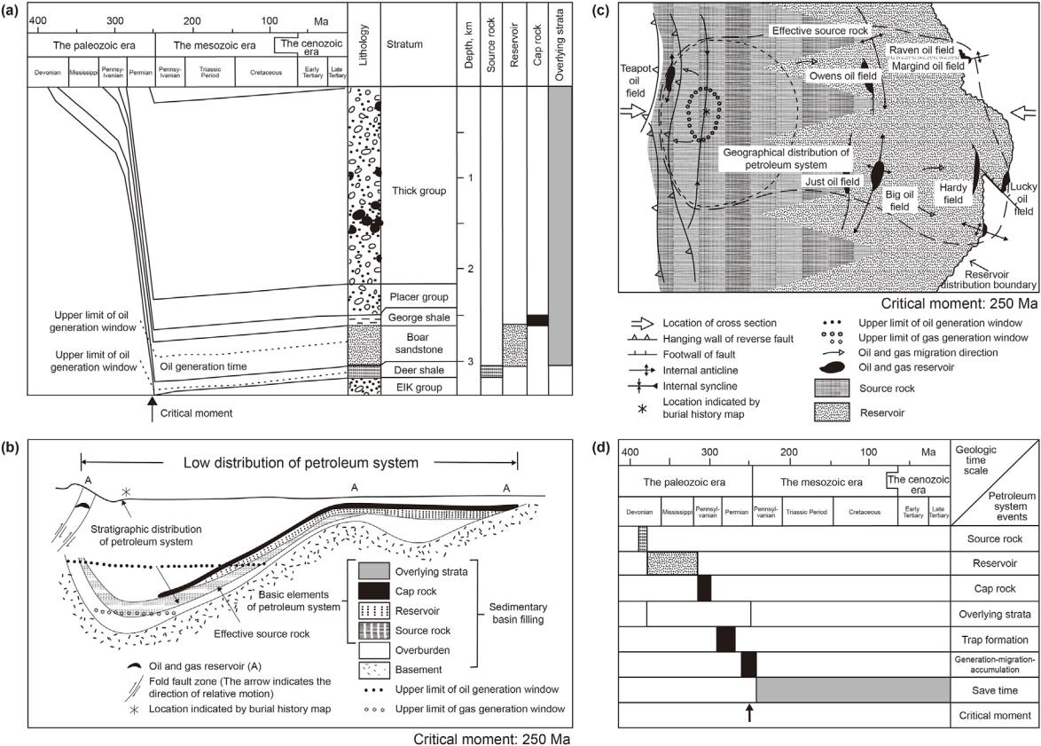

Fig. 2. Correlation model of a petroleum system elements and their controlling effect on oil and gas reservoirs formation and distribution (Magoon and Dow, 1994). (a) Vertical stratigraphic distribution and burial history map for a petroleum system; (b) Geological profiles of petroleum system at critical moment; (c) Plane distribution map of petroleum system at critical moment; (d) evolution events and relation at critical moment in petroleum system.

approach has been proposed for the study of unconventional oil and gas. Third, the core goal of studying the source-to-trap petro-leum system is to predict and evaluate the oil and gas potentials accumulated in traps and to guide the exploration of potential reservoirs, if the concept of traps is extended to the unconventional oil and gas, the concept of traps needs to be redefined, however, so far, no new definition for the trap has been proposed for the study of unconventional oil and gas reservoirs. Fourthly, the oil/gas migration under buoyancy-driven is free and voluntary, could staying away from the source rock, while the oil/gas migration under non-buoyancy-driven is bound by tight medium and special environment, it is neither free nor voluntary, usually connecting to the source kitchen, their formation mechanism is self-contained (Jia et al., 2021a). If the trap concept is redefined to be applied to unconventional hydrocarbon accumulation, implying that the classical petroleum geology has been overturned, and the basis of the source-to-trap petroleum system is totally changed.

Therefore, without changing the classical concepts of the trap, the conventional oil/gas reservoir, and others, the source to trap petroleum system concept is no longer adequate in accounting for all the oil and gas accumulations and distributions in a basin where significant amount of unconventional oil/gas resources are present in addition to the conventional oil/gas accumulations. Petroleum geology should be based on the model of whole petroleum system, not limited to the perspective of “from source to trap”, but from the perspective of “source-reservoir-dynamic coupling and sequential accumulation”, including accumulation of both conventional and unconventional oil and gas resources whether it is via a long-distance migration, short-distance migration, or no migration (Jia

et al., 2017; Jia, 2021b, c, d). The geological conditions of petrolif-erous basins are very complicated, the combination of different geological conditions lead to the formation of different oil/gas reservoirs, their distributions are especially complicated after the multistage structural changes and multi-stage reconstruction of oil and gas reservoirs. In order to cope with oil and gas exploration under more and more complicated conditions, the concept of whole petroleum system is proposed to explain the correlation, difference and distribution of conventional and unconventional oil and gas reservoirs, trying to make up for the deficiencies of pe-troleum system concept in practical application.

2. Whole petroleum system and its research scheme

2.1. Basic concept

The whole petroleum system (WPS) is defined as a natural system that encompasses all the oil and gas originated from organic matter in source rocks, the conventional and unconventional res-ervoirs and resources, the geological elements and processes involving in the formation, evolution, and distribution of these oil and gas, reservoirs, and resources. The core connotation of the WPS is that conventional and unconventional oil/gas reservoirs exist in a unified system in petroliferous basins (Jia, 2017), the system should be not limited to the perspective of “from source to trap”, but from the perspective of “hydrocarbon source-reservoir-dynamic coupling and sequential accumulation”, including accumulation of both conventional and unconventional oil and gas resources whether it is via a long-distance migration, a short-distance

4

C.-Z. Jia, X.-Q. Pang and Y. Song

migration or just remaining in source rocks (Hu et al., 2022a). In the following three national academic symposia, professor Jia reported their preliminary results on WPS research in the Annual Conference of China Petroleum Geology (Jia, 2021b), the 6th Unconventional Petroleum Geological Evaluation and New Energy Academic Con-ference and the 10th China Petroleum System (Jia, 2021c), and Reservoir Academic Conference (Jia, 2021d).

The theoretical basis for the WPS concept is the correlations between conventional and unconventional reservoirs, Pang et al. (2021d) has summarized seven aspects. First, conventional and unconventional reservoirs are both fossil resources. Second, con-ventional and unconventional reservoirs both distributed in strata with same ages. Third, conventional and unconventional reservoirs co-exist in the same petroliferous basins. Fourthly, conventional and unconventional reservoirs co-exist in the same petroleum systems. Fifthly, conventional and unconventional reservoirs co-exist in the same reservoir layers. Sixthly, all conventional and unconventional reservoirs co-exist in the whole petroleum system. Seventhly, conventional and unconventional reservoirs can be converted to each other as geological conditions change, and some time they cannot be distinguished from each other. In fact, there are five other genetic differences between conventional and uncon-ventional oil and gas. Our findings on the correlation and differ-ences between conventional and unconventional oil and gas reservoirs have been published in Gondwana Research. According to them, all the conventional and unconventional oil and gas res-ervoirs are divided into three major categories, six subcategories and 15 types. For details, refer to relevant literature (Pang et al., 2021d).

2.2. Technical approach route

By analyzing the distribution characteristics of conventional and unconventional reservoirs in WPS around the world, their differ-ences are confirmed and correlation model is established, and then applied to predict the remaining oil and gas distribution, which is carried out in six steps.

The first step is to collect data. Through the investigation, analysis and comprehensive study of the drilling results and geological characteristics of the proven conventional and uncon-ventional oil and gas reservoirs in representative basins of China, the relevant geological and geochemical data are collected to pro-vide reliable basic data for the analysis and study of the WPS.

The second step is to identify the hydrocarbon dynamic boundaries and divide the hydrocarbon dynamic fields. These dy-namic boundaries include the buoyance-driven hydrocarbon accumulation depth (BHAD, Pang et al., 2021b), hydrocarbon accumulation depth limit (HADL, Pang et al., 2021c) and the active source-rock depth limit (ASDL, Pang et al., 2020a), the critical conditions of these boundaries are confirmed, and then the dis-tribution characteristics and maximum buried depth for different oil and gas reservoirs are predicted. On this basis, the hydrocarbon dynamic fields (HDF) as Free-HDF, Confined-HDF and Bound-HDF (Pang et al., 2012) are divided, which determine characteristics of oil and gas accumulation.

The third step is to calculate the amounts of original hydrocar-bons in different dynamic fields and evaluate their hydrocarbon resource potentials. By studying the formation and evolution characteristics of source rocks, the critical conditions such as hy-drocarbon expulsion threshold (HET, Pang et al., 2005), hydrocar-bon expulsion peak (HEP) and ASDL are determined, and the hydrocarbon generation and expulsion history of source rocks are recovered, then the proportions of original hydrocarbon quantities in three different dynamic fields are calculated and their oil and gas resource potentials are respectively evaluated (Hu et al., 2022b).

Petroleum Science 20 (2023) 1e19

The fourth step is to identify types of reservoir rocks with different porosity and permeability and reveal their controlling on hydrocarbon accumulation. By studying the distribution charac-teristics of reservoir rocks under different buried depths, and the evolution characteristics of their porosity, permeability and pore throat radius with buried depths, the source conditions, the flow mechanism, and the types of oil/gas accumulations in these reser-voirs that may be formed in different HDFs are revealed. The con-trolling of different reservoir rocks on oil and gas migration, accumulation and distribution is confirmed by studying their relationship with hydrocarbon dynamic fields, original hydrocar-bon quantities, and oil and gas reservoir types.

The fifth step is to study the coupling of three essential factors to establish geological models for oil/gas accumulation and distribu-tion in different dynamic fields as well as in the whole petroleum system. The matching relationship among three essential factors as the HDFs, original hydrocarbon quantities and different reservoirs rocks is studied, and the spatial and temporal formation and dis-tribution patterns of conventional and unconventional oil and gas reservoirs for different dynamic fields as well as for the whole petroleum system are established.

The sixth step is to apply these models to describe the distri-bution characteristics of oil and gas in the whole petroleum system and predict different kinds of hydrocarbon resource potentials. By studying the variation characteristics of the total amount of oil and gas generated and retained in different dynamic fields, the amounts of oil and gas in migration, accumulated, lost, damaged in tectonic changes are studied. Based on these results, the remaining oil and gas resources and the potential favorable exploration areas and zones in WPS are predicted.

Finally, the reliability of the research results is tested. The theoretical prediction results are used to guide the drilling of oil and gas in WPS, and the practicability and reliability of the theo-retical model are tested after drilling.

2.3. Research area and data sources

In this paper, we mainly concentrate on the whole petroleum system in clastic sedimentary strata. The drilling results of 12237 exploration wells and 80762 oil/gas reservoir layers of conventional and unconventional oil and gas reservoirs in the Junggar, Tarim, Ordos, Sichuan, Bohai bay, and Songliao basins in China (Fig. 3) have been used to study the difference and correlation of conventional and unconventional oil and gas reservoirs (Pang et al., 2021d). The major reasons for our selecting these basins to focus our research are their geological representation: conventional and unconven-tional oil/gas reservoirs both are widely developed in them and have the highest oil/gas exploration degree in China; they have the largest proved reserves and the greatest resource potentials in China, account for 76.9% and account for 62.6% respectively; their geological conditions are representatives of petroleum basins in China and the world. The geographical distribution, exploration profiles and petroleum geological characteristics in the six repre-sentative basins have been introduced in the relevant literature (Ministry of Natural Resources of the People's Republic of China, 2017).

The WPS in representative basins of China are studied and dis-cussed in detail, their results are compared with those of other WPS in North America by investigating literatures, and then the com-mon characteristics for all WPS are summarized. We also investi-gate the correlations and differences between 52926 conventional and unconventional oil and gas accumulations in 1186 basins around the world (IHS Energy Group, 2016), statistically analyze the distribution characteristics of oil and gas reservoirs in the WPS, and then compare them with that in the WPS of major petroliferous

5

C.-Z. Jia, X.-Q. Pang and Y. Song Petroleum Science 20 (2023) 1e19

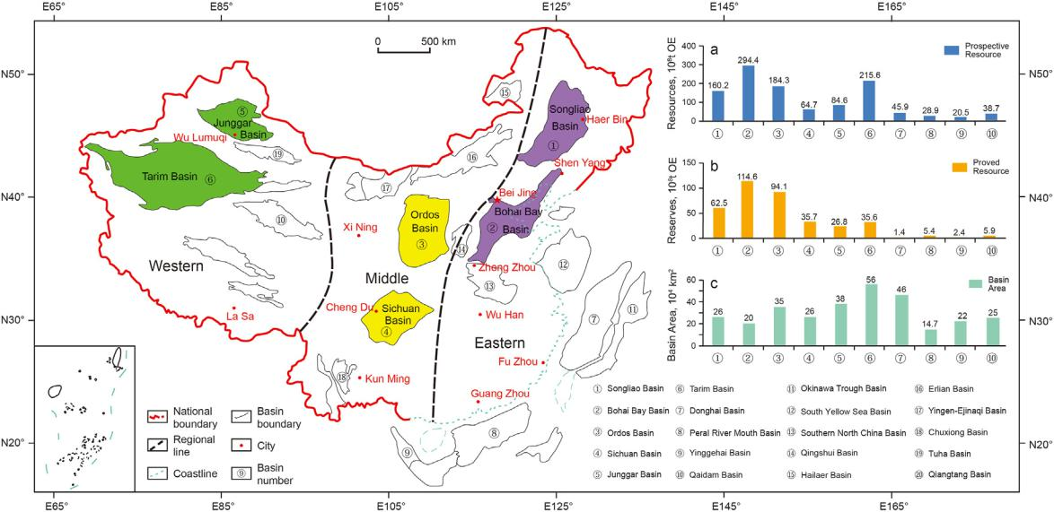

Fig. 3. Distribution of major petroliferous basins in China, including six representative basins selected in this study, the Tarim Basin and Junggar Basin in the west, the Sichuan Basin and Ordos Basin in the middle, and the Bohai Bay Basin and Songliao Basin in the east, modified from literature (Pang et al., 2020a).

basins in China and North America. The data used in this paper are all from CNPC Research Institute of Petroleum Exploration and Development and related CNPC oilfield companies, except for the explanatory notes.

3. Cases study of the whole petroleum system

3.1. The case study of Permian WPS in Junggar Basin

The Junggar Basin located in northwest China, covering an area of 3.8 105 km2, with predicted the deepest strata exceeding 9000 m (Fig. 4a). Four source rocks are known to be developed in the basin, namely in the Carboniferous, Permian, Triassic, and Jurassic. The target strata include Carboniferous, Permian, Triassic, and Jurassic. Conventional oil and gas, tight oil and gas, shale oil and gas, heavy oil and bitumen, coalbed oil and gas are all found widely in the basin. By 2020, the proven oil and gas reserve had reached 3.165 billion tons of oil equivalent, among them the unconventional oil and gas account for more than conventional oil and gas (Wang et al., 2021). The Permian is the main source rock, and it is also the most important target layer in the basin at present: heavy oil and bitumen have been found in the Permian, mainly in the northwest margin; conventional oil and gas reservoirs have been discovered mainly in the northwestern thrust fault zone; tight oil

and gas reservoirs are found in the upper part of Permian and the sandstone layers above them; shale oil and gas resources are found within the source rocks of Permian, all of these source rocks, res-ervoirs, geological conditions and evolution processes constitute a complete WPS. Conventional reservoirs are controlled by traps and distributed above BHAD; unconventional tight oil and gas are distributed continuously below the BHAD at the bottom of the low depression. The BHAD corresponds to the burial depth of 2800 m and sandstone porosity of 10% ± 2%. On the right side of the Fig. 4b, each sandstone porosity data point is the average value of the reservoirs over a thickness of 250 m, data points are from 5280 samples of 1789 Wells (Pang et al., 2021d). Shale oil and gas res-ervoirs are distributed within the source rock of Permian Feng-cheng Formation. In addition, some early conventional oil and gas in the northwestern margin of the basin were converted into heavy oil and bitumen due to trap damaged by strong tectonic movement.

3.1.1. Boundary range and maximum burial depth

The distribution of active source rocks determines the minimum boundary range and petroleum source center of the WPS, about 1.3 105 km2 (Fig. 5). The maximum thickness of the active source rocks is more than 300 m, distributed in the center of the basin, their parent materials are mainly type I to II, and the abundance of organic matter is TOC ¼ 2%e8% with an average of 6% (Zhi et al.,

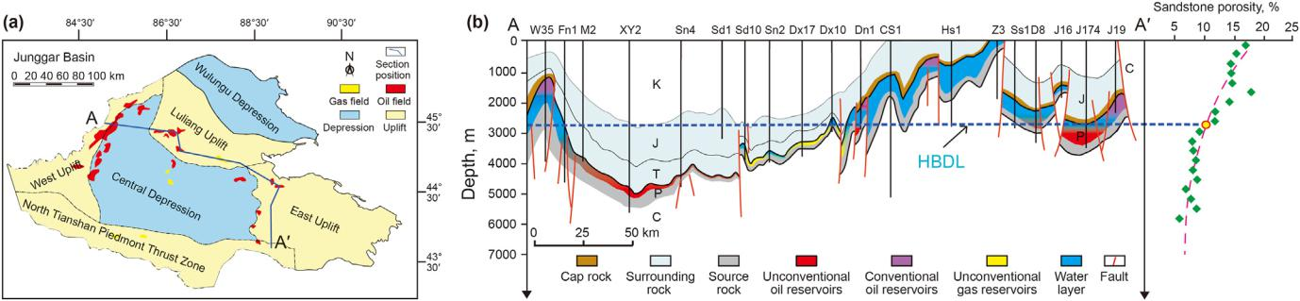

Fig. 4. Plane and section distribution of Permian WPS in Junggar Basin. (a) Distribution characteristics of oil and gas reservoirs and geological structure units in map view; (b) Distribution characteristics of oil and gas reservoirs, source rocks and reservoir layers in profile (modified from Pang et al., 2021d).

6

C.-Z. Jia, X.-Q. Pang and Y. Song Petroleum Science 20 (2023) 1e19

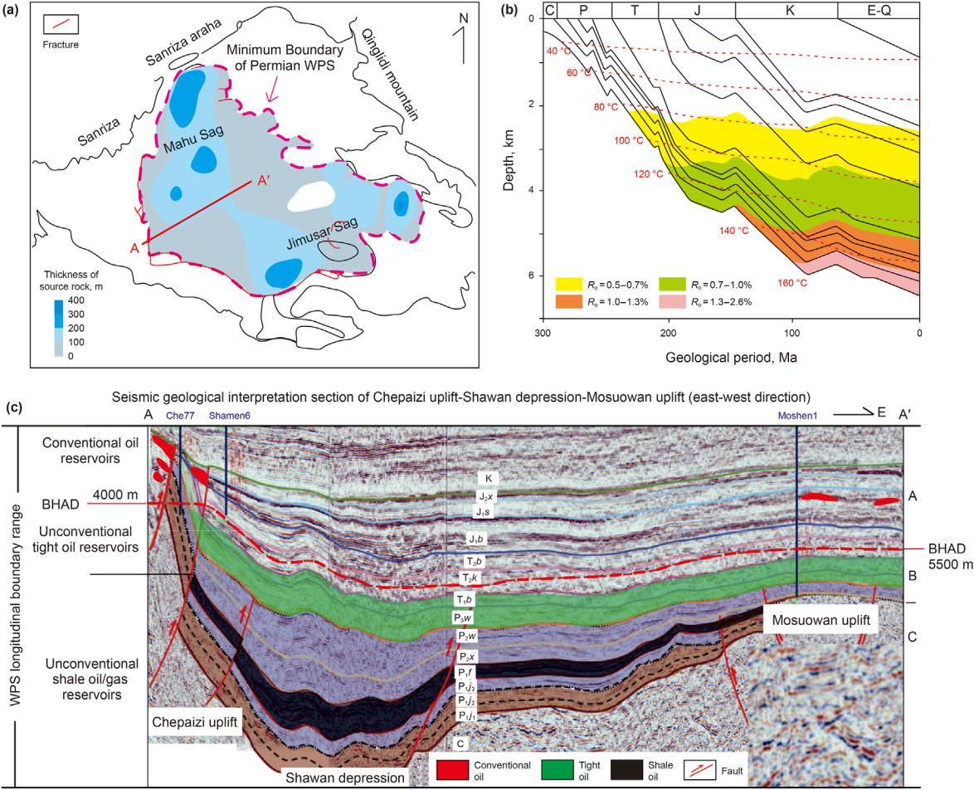

Fig. 5. The boundary range and maximum depth of the Permian WPS in Junggar Basin. (a) Plane distribution range of Permian source rocks with different thickness; (b) Burial depth and thermal evolution history of a pseudo-well in the center of the Mahu Sag in the Permian WPS; (c) Distribution characteristics of three types of oil and gas reservoirs in the profile of Permian WPS.

2019). Considering the outward migration of oil and gas from source rock center, the maximum distribution boundary range of the WPS at plane exceeds the actual distribution area of active source rocks (Fig. 5a). The peak of oil/gas generation and expulsion is in Jurassic to Cretaceous, representing the main period of oil and gas reservoirs formation. The ASDL determines the maximum burial depth of the WPS (Fig. 5b). The uneven thickness distribution of the source rocks has formed 3e4 hydrocarbon source centers (Fig. 5a), indicating that the maximum burial depth of the WPS varies with different depth of source rock centers. The theoretical maximum burial depth of the Permian WPS in the basin exceeds 8200 m (Pang et al., 2020a), and the maximum burial depth of the proved active source rock is up to 7800 m (Fig. 5c).

3.1.2. Distribution of conventional oil/gas reservoirs

The conventional oil and gas reservoirs formed in the Permian WPS are mainly distributed in the shallow reservoir layers with high porosity and permeability along the stepped fault belt in the northwestern margin of Junggar Basin (Fig. 6). Petroleum reservoirs have been also discovered in 17 formations from Carboniferous to Neogene, including N1s, K1q, J3q, J2t, J2x, J1s, J1b, T3b, T2k2, T2k1, T 1b, P3w, P2w, P2x, P1f, P1j and C, most of the oil and gas in them come from the Permian source rocks. There are many reservoir types, including sandy conglomerate, sandstone, volcanic rock, and mudstone with fractures. The types of conventional reservoirs are

fault block, lithology, stratigraphy, and compound. The middle and high permeability conglomerate reservoir in the northwest margin has a burial depth of 300e1700 m, mainly distributed in the Triassic Baikouquan Formation, Karamay Formation and Jurassic Badaowan Formation, their average porosity is about 17.5% and permeability is about 205.3 mD. Fig. 6a illustrates the distribution characteristics of conventional oil and gas reservoirs in Kebai area in the northwest margin, the oil and gas mainly come from the shale source rocks of the Permian Fengcheng Formation in the Mahu Sag of the basin, showing basic characteristics of oil accumulation in traps and controlled dominantly by buoyance-driven. Up to date, its proven geological reserve is about 510 million tons, annual output is 2.5 million tons of oil, and the recovery rate about 34%. Fig. 6b shows the distribution of porosity and permeability of reservoir layers in slope belt of northern margin: conventional oil and gas are accu-mulated in traps with high porosity and permeability reservoirs (Ф 12%, K 1 mD) and lower drilling rate; however, unconven-tional oil and gas are accumulated in widely and continuously distributed reservoir layers with low porosity and permeability (Ф < 12%, K < 1 mD) and higher drilling rate (Pang et al., 2021b).

3.1.3. Distribution of tight oil and gas reservoirs

The tight oil and gas reservoirs formed by the Permian WPS are widely distributed in Baikouquan Formation (T1b) and Upper Wuerhe Formation (P3w2) above the petroleum expulsion centers

7

C.-Z. Jia, X.-Q. Pang and Y. Song Petroleum Science 20 (2023) 1e19

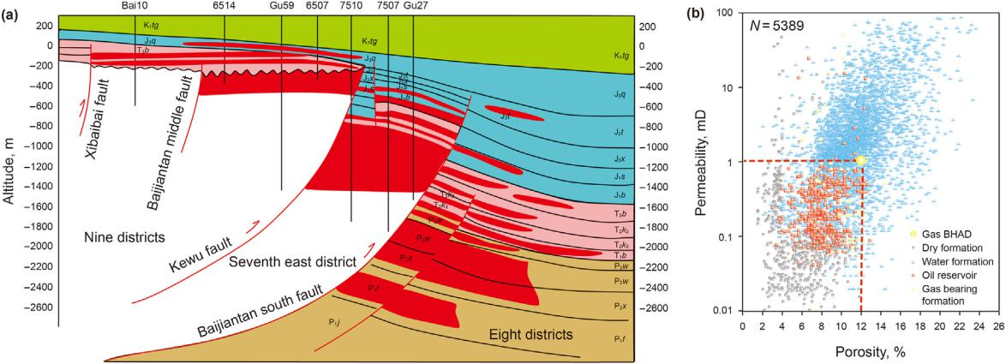

Fig. 6. Distribution characteristics and the porosity and permeability of conventional and unconventional oil/gas reservoirs of the Permian WPS in Junggar Basin. (a) The distri-bution of conventional and unconventional oil/gas reservoirs in the overthrust fault zone in the northwestern margin, the dark red indicating conventional oil and gas and pink indicating unconventional oil and gas; (b) Distribution of porosity and permeability of reservoir layers in slope belt of northern margin: conventional oil and gas are accumulated in traps with high porosity ( 12%) and high permeability ( 1 mD) reservoirs but lower drilling rate, however, unconventional oil and gas are accumulated in widely and continuously in reservoir layers with low porosity (< 12%) and low permeability (< 1 mD) but higher drilling rate.

of Permian source rocks in the basin (Fig. 6), the reservoir is a dense conglomerate with continuous distribution and no obvious edge and range on plane, its thickness is 40e80 m, and the burial depth is 3260e3320 m, the porosity of Ф ¼ (10%±2%)e2%, permeability of

1. ¼ 1e0.01 mD, pore throat radius of R ¼ 1e0.025 mm, single well productivity is very low, it needs fracturing to obtain economic benefits. The horizontal well of upper Wuerhe Formation in the slope area of Mahu Depression is developed with production of 20e30 t/d per well and gas-oil ratio of 100e200. EUR for Class 1 well is about 45000 tons, class 2 well is about 30000 tons, and is expected to exceed 5 million tons by 2025. Fig. 7a shows the sedimentary lithofacies model of Triassic Baikouquan tight oil reservoir in Permian WPS, their permeability varies greatly in plane (K ¼ 10e0.1 mD, R ¼ 1.8e0.1 mm) and is controlled by burial depth, sedimentary facies (lithology, argillaceous content, etc.) and frac-tures, and increases with pore throat radius increase. In the tight oil and gas reservoirs, the sand-gravel rock with high porosity and

permeability (K 1 mD, R 1 mm) is a high-yield sweet spot. Fig. 7b illustrates the variation of permeability and pore-throat radius of T1b conglomerate in the slope zone in the northwest margin with the change of mud content: from shallow to deep, the permeability and pore-throat radius decrease with the increase of the burial

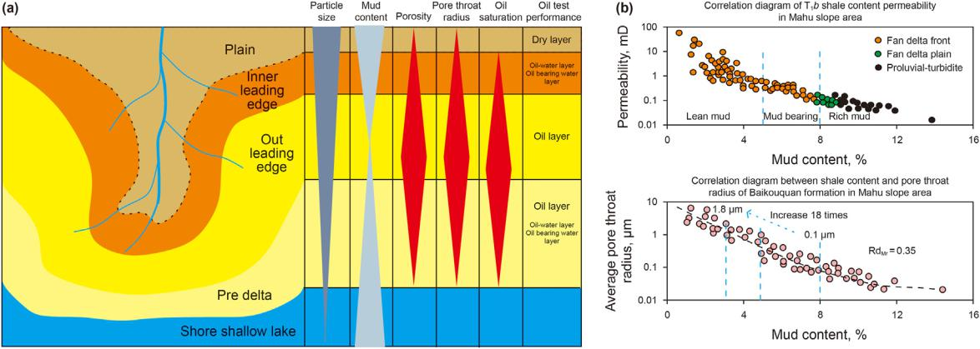

depth of the target layer. Conventional oil/gas reservoirs are mainly proved in the strata with Ф > 10 ± 2%, K > 1 mD, R > 1 mm in middle and shallow areas, and the tight oil/gas reservoirs are mainly proved in the strata with Ф 10% ± 2%, K 1 mD, R 1 mm in middle and deep areas.

3.1.4. The distribution of shale oil and gas

The shale oil and gas reservoirs are one part of the Permian WPS, are mainly formed and distributed within the source rocks of the Fengcheng Formation of Lower Permian, the Lucaogou and Ping-diquan Formations of the Middle Permian in Jimusar Sag (Fig. 8). They have a burial depth of 800e5200 m, a thickness of 25e300 m, and a distribution range of more than 2500 km2. The thickness of single reservoir layer is very thin, less than 0.1 m, and its maximum value is about 5 m, the lithology is diverse, mainly consisting of micro and nano pores, and the permeability of samples is mostly less than 0.1 mD. Fig. 8a shows the drilling results of shale oil in different strata, the thickness of shale oil in the Fengcheng For-mation is 477 m with overall oil shows, 365.38 m of continuous coring, and 23.76 m3 of tested oil per day in the lower member of the Fengcheng Formation (P1f1). Fig. 8b shows the sweet spot dis-tribution of shale oil in Lucaogou Formation, Jimusar sag: the upper

Fig. 7. Distribution characteristics of lithofacies, porosity, and permeability for the tight oil and gas reservoirs in Permian WPS in Junggar Basin. (a) Lithofacies distribution of tight sandy conglomerate oil and gas reservoir in Triassic Baikouquan Formation; (b) Distribution of permeability and throat radius for oil and gas reservoirs in different lithofacies from basin margin to center: they decrease with increasing mud content in reservoir layers.

8

C.-Z. Jia, X.-Q. Pang and Y. Song Petroleum Science 20 (2023) 1e19

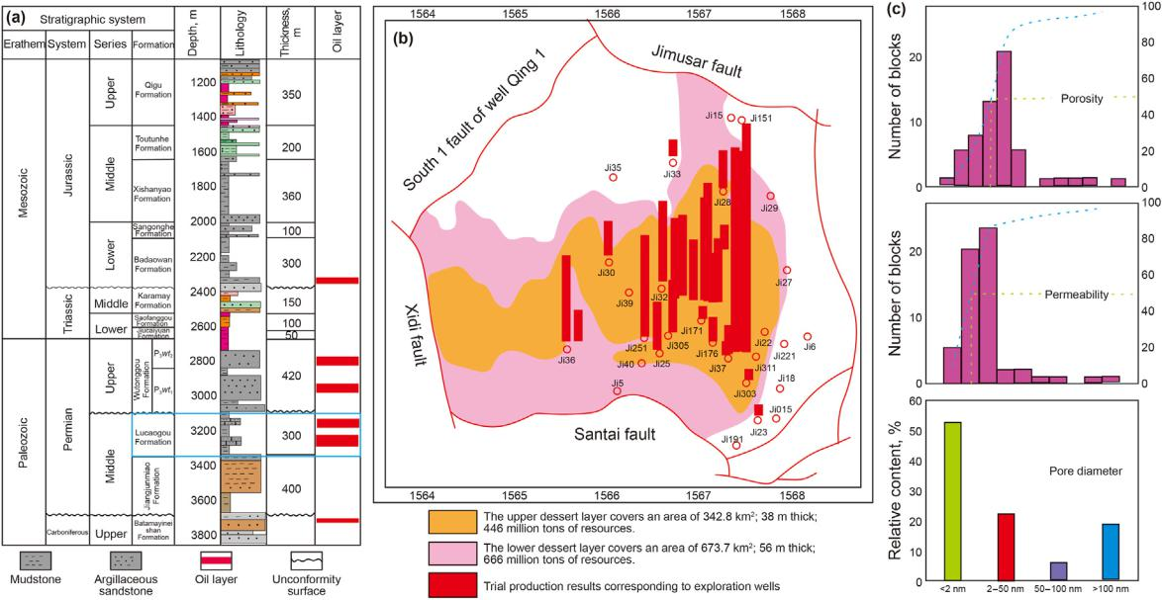

Fig. 8. Shale oil and gas drilling results and distribution characteristics of 2 “sweet spot” layers in the Permian WPS in Junggar Basin. (a) Comprehensive stratigraphic histogram of Jimusar Depression. (b) Sweet layer distribution of the shale oil in Lucaogou Formation, Jimusar Sag. (c) The measured results of porosity, permeability, and pore diameter of shale oil reservoir in Fengcheng Formation.

sweet spot layer covers an area of 342.8 km2, is 38 m thick and has 446 million tons of resources; the lower sweet spot layer is 673.7 km2, 56 m thick, with 666 million tons of resources. Currently, there are more than 100 wells drilled in the basin, with more than 2.5 billion tons of proven resources. Fig. 8c shows the measured results of pore permeability and pore diameter of shale oil reservoir: porosity of 1%e13% with average of 5%, permeability of 0.01e10 mD with mode value of 0.06 mD, pore diameter of 2 nme100 nm with average of < 50 nm.

3.2. Cases study of whole petroleum system in other basins

3.2.1. Whole petroleum system in other basins of China

In western China, the Triassic-Jurassic WPS is developed in Kuqa Depression of Tarim Basin and in Junggar Basin. In central China, the Triassic WPS is developed in Sichuan Basin and the Carboniferous-Permian WPS is developed in Ordos Basin. While, the Bohai Bay Basin and Songliao Basin in eastern China have developed Tertiary WPS and Cretaceous WPS, respectively. The shale, tight, and conventional oil and gas resources are formed in the WPS of these basins, and they all show distribution character-istics with “shale oil/gas - tight oil/gas - conventional oil/gas” up-ward from source rocks. For example, the target strata of Saertu, Putaohua, and Gaotaizi in Songliao Basin are located between two main source rocks of Qingshankou Formation and Nenjiang For-mation, and they form conventional oil and gas reservoirs in the structural high part of the target layers above the BHAD, and tight oil and gas reservoirs of the same layers in deep depressions below the BHAD, and shale oil and gas reservoirs formed within the source rocks of Qingshankou and Nenjiang Formations in the WPS. Bohai Bay Basin is the largest oil and gas production base in China at present, in which Zhanhua Sag is a relatively independent in Jiyang Depression, and various oil and gas resources mainly come from deep-buried source rocks of Es3 member and Es4 member (Shi et al., 2005), conventional oil and gas reservoirs are mainly distributed in the sandstone layers above the BHAD with a depth of about 3230 m, while unconventional tight oil and gas reservoirs are

mainly distributed in the same sandstone layers but with low porosity and permeability below the BHAD, and shale oil and gas reservoirs are developed within their source rocks (Liu et al., 2013; Wang et al., 2014; Wang et al., 2015; Ma et al., 2016).

3.2.2. Whole petroleum system in other basins of North America We have also investigated the distribution characteristics of

conventional and unconventional oil and gas reservoirs in major petroliferous basins in North America by learning from literatures, they are mainly related to the WPS formed by the main source rocks in these basins, including Devonian WPS of the Alberta Basin (Li et al., 1999; Chen et al., 2005), Woodford WPS in the Anadarko Basin (Philp et al., 2021; Michael and Drew, 2020), Marcellus WPS in the Appalachian Basin (Lash and Blood, 2014; Wang and Timothy, 2012), Bakken WPS in the Williston basin (Browne et al., 2020; Zain et al., 2021), Eagle Ford WPS in the Northwest Gulf of Mexico Basin (Carlos et al., 2020; Hou et al., 2021), Haynesville/Bossier WPS in the Southwest Basin (Mark, 2012; Alexej et al., 2015), Niobrara WPS in the Central and Western Basin (Gottardi et al., 2018; Gentzis, 2016), Wolfcamp WPS in Permian Basin (Ojha et al., 2017; Hackley et al., 2020). In the literatures on conventional and un-conventional oil and gas plays in North American basins, the shale and tight oil and gas are often lumped together and not separately distinguished in study, which is very different from the separation of shale and tight oil and gas reservoirs in petroliferous basins of China. The distribution characteristics of oil and gas reservoirs in WPS of different petroliferous Basins in North America are briefly introduced in this paper by examples: A WPS is developed in the Williston Basin of USA, the Bakken Formation is the major source rocks and forms shale oil and gas reservoirs within it, the tight oil and gas reservoirs formed and interbeded with source rocks or distributed very closely to the source rocks below the BHAD, and the conventional oil and gas reservoirs in the same reservoir layers and other younger reservoir layers are distributed above the BHAD, the BHAD in this basin corresponds to the depth of about 2800 m (Meissner, 1978). A WPS also exists in the Alberta Basin of Western Canada, the Devonian is the most important source rocks and forms

9

|  |
| --- |
| 10 |

Table 1

Distribution characteristics of conventional and unconventional oil/gas reservoirs in 8 representative basins in China and North America.



|  |  |  |  |  |  |  |  |  |  |  |  |  |  |  |  |  |  |  |  |  |  |  |  |  |
| --- | --- | --- | --- | --- | --- | --- | --- | --- | --- | --- | --- | --- | --- | --- | --- | --- | --- | --- | --- | --- | --- | --- | --- | --- |
| Spatial distribution sequence model of | | Basic geological characteristics of WPS in several representative basins in the world | | | | | | | | | | | | |  |  |  |  |  |  |  |  |  |  |
| oil and gas resources | |  |  |  |  |  |  |  |  |  |  |  |  |  |  |  |  |  |  |  |  |  |  |  |
| Tarim Basin | |  | Junggar Basin | | | Sichuan Basin | |  |  | Ordos Basin | | |  | Bohai Bay Basin | | Songliao Basin | | | Alberta Basin | | Williston Basin | |
|  |  |  |  |  |  |
|  |  |  | | |  | | |  | | | |  | | | |  | |  | | |  | | | |
| Upper | Reservoir age; Porosity | Cretaceous, etc; ф > | | | Jurassic, etc; ф > | | | Jurassic, etc; ф > 10%; | | | | Upper Permian; ф > | | | | Lower Tertiary | | Cretaceous, etc; ф > | | | Cretaceous, etc; ф Bakken formation and | | | |
| conventional | and permeability | 10%; K > 1 mD; | |  | 10%; K > 1 mD; | | | K > 1 mD; Sandstone | | | | 10%; K > 1 mD; | | | | system; ф > 10%; | | 10%; K > 1 mD; | | | > 10%; K > 1 mD; upper; ф > 10%; K > 1 | | | |
| oil and gas | characteristics; | Sandstone layer; | | | Gravel stratum; | | | layer; Structural trap; < | | | | Sandstone layer; | | | | K > 1 mD; Sandstone Sandstone layer; | | | | | Sandstone layer; | | mD; Dolomitized oolitic | |
|  | Reservoir lithology; | Structural trap; < | | | Structural trap; < | | | 4000 m |  |  |  | Structural trap; < | | | | layer; Structural | | Structural trap; < | | | Structural trap; < sandstone; Compound | | | |
|  | Reservoir control | 4500 m | |  | 2800 m | |  |  |  |  |  | 2500 m | | |  | trap; < 3500 m | | 1800 m | | | 3500 m | | trap; < 2500 m | |
|  | elements; Buried depth |  |  |  |  |  |  |  |  |  |  |  |  |  |  |  |  |  |  |  |  |  |  |  |
|  | of oil and gas reservoir |  |  |  |  |  |  |  |  |  |  |  |  |  |  |  |  |  |  |  |  |  |  |  |
| Contact relationship between oil and gas Mainly separation | | | | | Separation/contact | | | Mainly separation | | | | Mainly separation | | | | Separation/contact | | Separation/contact | | | Separation | | Separation | |
| reservoirs |  |  |  |  |  |  |  |  |  |  |  |  |  |  |  |  |  |  |  |  |  |  |  |  |
| Central tight oil Reservoir age; Porosity | | Jurassic, etc; ф < 10%; | | | Triassic/Permian; ф The second and fourth | | | | | | | Middle lower | | |  | Lower Tertiary | | Cretaceous; ф < | | | Jurassic-Triassic; | | Within Bakken | |
| and gas | and permeability |  | K < 1 mD; Widely | | < 10%; K < 1 mD; | | | members of Triassic | | | | Triassic; ф < 10%; | | | | System; ф < 10%; | | 10%; K < 1 mD; | | | ф<10%;K<1 | | formation; ф < 10%; | |
|  | characteristics; |  | continuous sandstone | | Widely continuous | | | System; ф < 10%; K < 1 | | | | K < 1 mD; Widely | | | | K < 1 mD; Widely | | Extensive | | | mD; Widely | | K < 1 mD; Widely | |
|  | Reservoir lithology; |  | reservoir; 4500 |  | sandstone oil | | | mD; Widely continuous | | | | continuous | | |  | continuous |  | continuous deep | | | continuous | | continuous sandstone | |
|  | Reservoir control |  | e7500 m |  | reservoir; 2800 | | | sandstone gas reservoir; | | | | sandstone gas | | |  | sandstone oil |  | basin reservoir; | | | sandstone gas | | and dolomite; 2500 | |
|  | elements; Stratum |  |  |  | e5000 m | | | 4000e5500 m | | |  | reservoir; 2500 | | |  | reservoir; 3500 | | 1800e3500 m | | | reservoir; 3500 | | e3500 m | |
|  | buried depth |  |  |  |  |  |  |  |  |  |  | e5350 m | | |  | e4500 m |  |  |  |  | e5000 m | |  |  |
| Contact relationship with source rock | | Proximity/interaction | | | Proximity/ | | | Proximity/interaction | | | | Proximity/ | | |  | Proximity/ |  | Proximity/ | | | Proximity/ | | Proximity/interaction | |
|  |  |  |  |  | interaction | | |  |  |  |  | interaction | | |  | interaction |  | interaction | | | interaction | |  |  |
| Lower shale oil | Reservoir age; Porosity | Lower Jurassic; ф < | | | Permian | |  | The first and third | | | | Lower Permian and | | | | Sha3 and Sha4 | | Cretaceous; ф < | | | Jurassic-Triassic; | | Within Bakken | |
| and gas | and permeability | 15%; K < 0.1 mD; In | | | Fengcheng | | | member of Triassic | | | | Carboniferous; ф < | | | | members of Eogene; | | 15%; K < 0.1 mD; In | | | ф<15%;K<0.1 | | formation; ф < 10%; | |
|  | characteristics; | shale; > 4500 m | |  | Formation; ф < | | | System; ф < 15%; K < 0.1 | | | | 15%; K < 0.1 mD; In | | | | ф < 15%; K < 0.1 mD; shale; > 1800 m | | | | | mD; In shale; > | | K < 0.1 mD; In shale; > | |
|  | Reservoir lithology; |  |  |  | 15%; K < 0.1 mD; In mD; In shale; > 4000 m coal layer; > 2500 m In shale; > 3500 m | | | | | | | | | | | | |  |  |  | 3500 m | | 2500 m | |
|  | Reservoir control |  |  |  | shale; > 2800 m | | |  |  |  |  |  |  |  |  |  |  |  |  |  |  |  |  |  |
|  | elements; Stratum |  |  |  |  |  |  |  |  |  |  |  |  |  |  |  |  |  |  |  |  |  |  |  |
|  | buried depth |  |  |  |  |  |  |  |  |  |  |  |  |  |  |  |  |  |  |  |  |  |  |  |
| WPS and scale |  | WPS of Jurassic | |  | WPS of Permian | | | WPS of Triassic Xujiahe | | | | WPS of Upper | | |  | WPS of the tertiary | | WPS of Cretaceous | | | WPS of Mesozoic | | WPS of baken | |
|  |  | Yangxia-ahe formation | | | Fengcheng | | | Formation in Western | | | | Paleozoic in Ordos; | | | | Bohai Bay depression in Gulong | | | | | in Alberta Basin; | | formation in Williston | |
|  |  | in Kuqa depression; | | | Formation in | | |  |  |  |  | area | ¼ | 30 104 | 2 | in the Bohai Basin; | | depression, Songliao | | | > |  | Basin; area > | |
|  |  | area > 2.8 104 | | 2 | Junggar; area > | | | Sichuan; | 10 | 4 | 2 |  |  | km , | area > 5 104 | 2 | Basin; area > | | | area 4 | 2 | 50 104 2 |  |
|  |  |  |  | km , |  | 4 | 2 | area ¼ 12 |  | km , | maximum buried | | | |  | km , | 6 10 | 4 | 2 | 6 10 | km , | km , maximum | |
|  |  | maximum buried depth 25 10 | | | |  | km , | maximum buried depth depth > 5350 m | | | | | | | | maximum buried | |  | km , | maximum buried buried depth > 3500 m | | | |
|  |  | > 7500 m | |  | maximum buried | | | > 5500 m |  |  |  |  |  |  |  | depth > 4500 m | | maximum buried | | | depth > 5000 m | |  |  |
|  |  |  |  |  | depth > 5000 m | | |  |  |  |  |  |  |  |  |  |  | depth > 3500 m | | |  |  |  |  |
| Literature source | | Jiang, 2015 | |  | Zhi et al. (2019) | | | Yang and Pang, 2012 | | | | Wang and Timothy, | | | | Pang et al., 2021b | | Wu et al., 2007 | | | Masters, 1979 | | Pollastro et al. (2012) | |
|  |  |  |  |  |  |  |  |  |  |  |  | 2012 | |  |  |  |  |  |  |  |  |  |  |  |
|  |  |  |  |  |  |  |  |  |  |  |  |  |  |  |  |  |  |  |  |  |  |  |  |  |



|  |
| --- |
| C.-Z. Jia, X.-Q. Pang and Y. Song |

|  |
| --- |
| Petroleum Science 20 (2023) 1e19 |

C.-Z. Jia, X.-Q. Pang and Y. Song Petroleum Science 20 (2023) 1e19

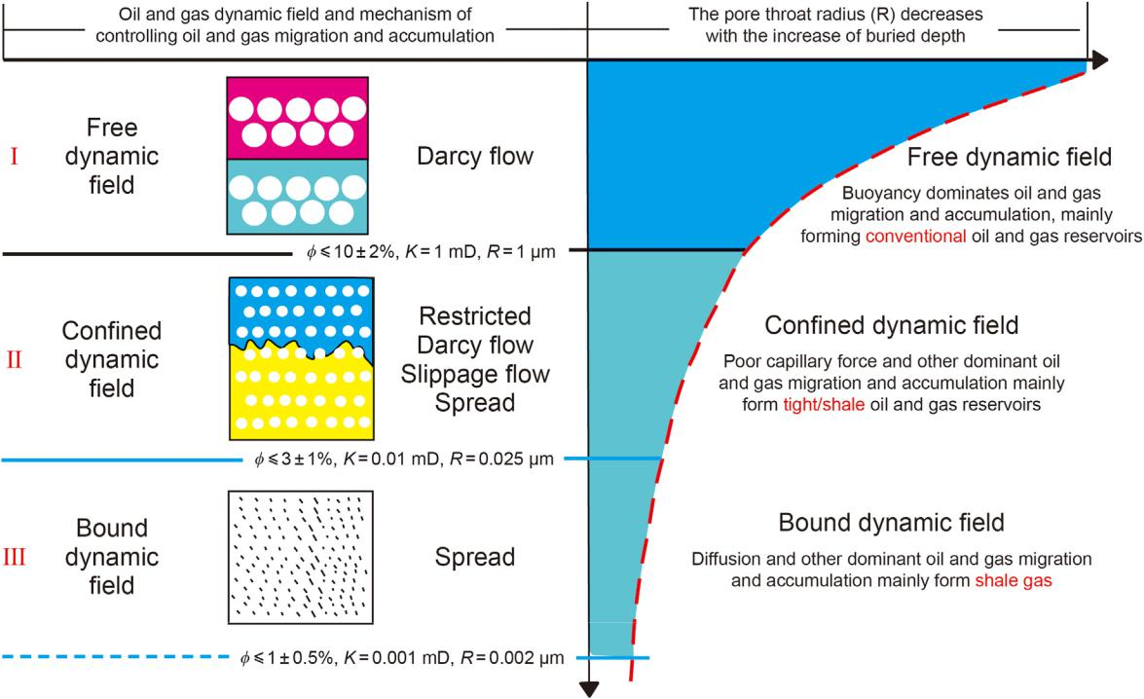

Fig. 9. The WPS comprises three different hydrocarbon dynamic fields. IeFree-HDF with buoyance dominating hydrocarbon migration and accumulation above the BHAD; IIeConfined-HDF with non-buoyance dominating hydrocarbon migration and accumulation out of the source rocks between the BHAD and HADL; IIIeBound-HDF with non-buoyance dominating hydrocarbon migration and accumulation within the source rocks or in strata between the HADL and ASDL.

shale oil and gas reservoirs within the source rocks, the tight deep basin gas reservoirs in the Carboniferous reservoirs formed and distributed immediately above the Devonian source rock, and conventional oil and gas reservoirs in the shallower part of the same strata but with high porosity and high permeability (Ma, 2008). Due to different geological setting and conditions for oil and gas generation, migration and accumulation, the relative abundances, phases (gas versus oil) and ratios of the shale, tight, and conventional oil/gas resources are quite different in China and North America, however, the relative distribution positions of the shale, tight, and conventional oil and gas resources upward from

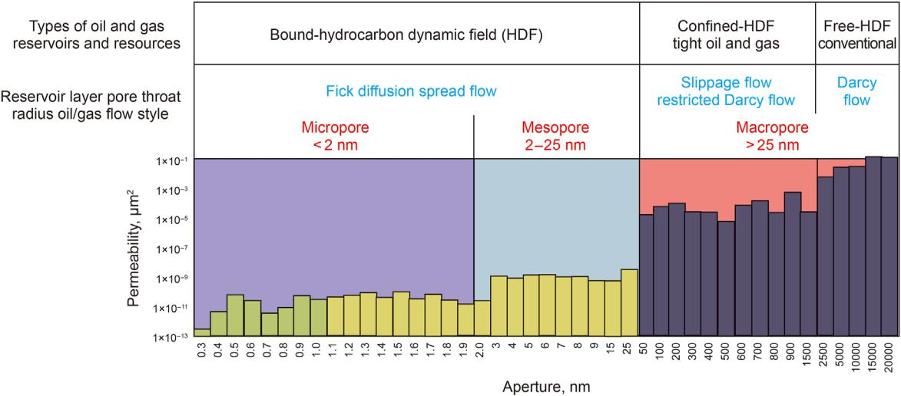

the source is consistent. Table 1 summarizes the distribution characteristics of conventional and unconventional oil and gas reservoirs in 8 representative basins in China and North America (Wu et al., 2007; Pollastro et al., 2012; Yang and Pang, 2012; Jiang, 2015; Wang et al., 2021; Zhi et al., 2019).

4. Composition feature of the whole petroleum system

It is found that the whole petroleum systems both in China and in North America consist of three parts: the three different hy-drocarbon dynamic fields, three different original hydrocarbon

Fig. 10. The pore throat radius of reservoir layers and hydrocarbon flow characteristics for conventional and unconventional reservoirs formation in different dynamic fields: A case study of the oil and gas reservoirs formation for Jiaoshiba shale source rocks in the Sichuan Basin (Modified from Wang et al., 2022).

11

C.-Z. Jia, X.-Q. Pang and Y. Song

quantities, and three different oil and gas reservoirs.

4.1. There are three kinds of hydrocarbon dynamic fields in WPS

The WPS comprises three different HDFs due to a progressive decreasing of the reservoir porosity and permeability of reservoir layers by overburden compaction with increasing depth, as shown in Fig. 9. The HDF is defined as the interrelated stratigraphic domain in which the dominant-driven force for oil and gas migration and accumulation is the same, the reservoir conditions are similar, and the type of oil and gas reservoirs formed in it is consistent (Pang et al., 2012, 2020b). Based on the hydrocarbon dynamic bound-aries, the HDFs are divided into three categories: Free-HDF, Confined-HDF, and Bound-HDF. The behavior characteristics of hydrocarbon migration and accumulation in different dynamic fields are different, determining the types of oil and gas reservoirs (Fig. 10).

The shallow area is favorable for developing Free-HDF, in which the oil and gas are driven dominantly by buoyancy in reservoir layers with larger porosity and permeability and following Darcy flow law, their maximum burial depth is theoretically controlled by BHAD. The deep area is favorable for developing Confined-HDF, in which the oil and gas are driven by non-buoyance in tight reservoir layers following the laws of slippage flow and restricted Darcy flow, their maximum burial depth is theoretically controlled by HADL. The areas within source rocks and below the HADL are favorable for developing Bound-HDF, in which the oil and gas are driven by non-buoyance and following the law of Fick diffusion spread flow, it is favorable to form shale oil and gas reservoirs. However, the area below the HADL is difficult for oil and gas to accumulate as a commercial reservoir duo to too tight media and disappearing of active source rocks. The maximum burial depth of Bound-HDF is theoretically controlled by ASDL, presenting the bottom of the WPS.

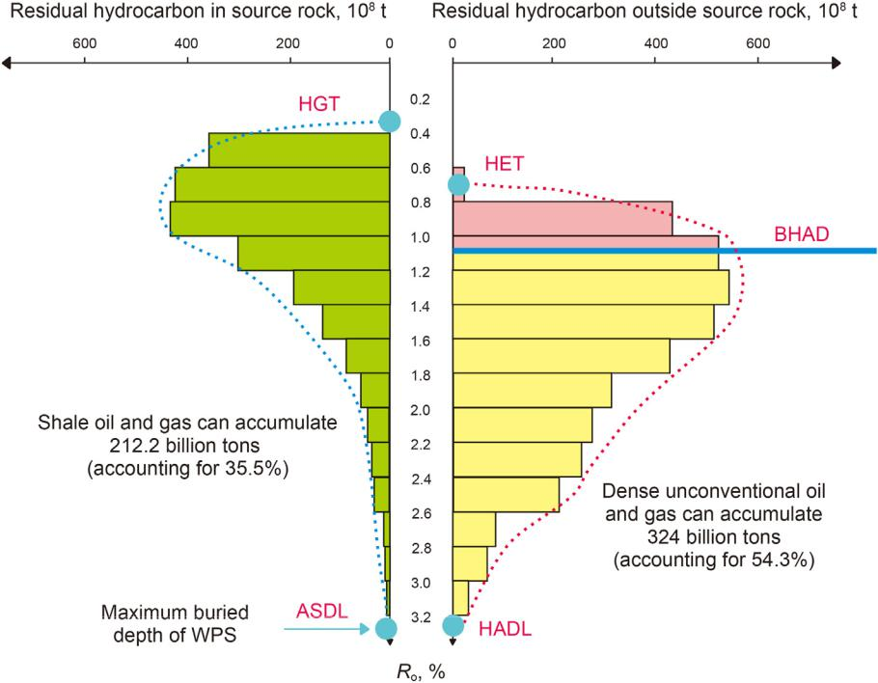

Petroleum Science 20 (2023) 1e19

4.2. There are three kinds of original hydrocarbon quantities

The source rocks in the WPS provide three types of original hydrocarbon quantities (Fig. 11). The first type is the original hy-drocarbon quantity (green), which is remained in the source rocks after their formation from organic materials. The remaining hy-drocarbons has been existing since the source rock enters the hy-drocarbon generation threshold (HGT, Tissot and Welte, 1978) until it reaches the ASDL, the duration is consistent with Ro ¼ 0.25%e 3.5%, and favorable to the formation of shale oil/gas resources. The second type is the original hydrocarbon quantity (red), which is expelled from source rocks in the early stage of the hydrocarbon formation and distributed in the area between the HET and BHAD, the duration corresponds to the evolution stage of about Ro ¼ 0.6%e 1.1%, which is favorable for the formation of conventional oil and gas resources. The third type is the original hydrocarbon quantity (yellow), which is expelled from source rocks in the late stage of hydrocarbon formation and distributed in the area between the BHAD and HADL, their duration corresponds to the evolution stage of about Ro ¼ 1.1%e3.0%, it is favorable to form unconventional tight oil and gas resources. Our research results show that among the 596.9 billion tons of oil equivalent generated from source rocks in Junggar Basin, the proportion of original hydrocarbon amount favorable to the formation of conventional oil/gas, tight oil/gas, shale oil/gas is 10.2%, 54.3% and 35.5%, respectively. In the basins of Songliao, Bohai Bay, Sichuan, Ordos, Tarim and Jungger basins, the proportion of original hydrocarbon amount favorable to the for-mation of conventional, tight and shale oil/gas resources is about 10%, 40% and 50%, respectively. Theoretically, the resource potential of unconventional (tight þ shale) oil/gas in the WPS is about 9 times that of conventional oil and gas, implying a greater explo-ration prospect for unconventional oil and gas resources.

Fig. 11. Longitudinal distribution characteristics of three original hydrocarbon quantities provided by the source rock evolution in Junggar Basin. Green represents original hy-drocarbons retained within source rocks; Red represents original hydrocarbons expelled from source rocks in the early stage from HET to BHAD; Yellow represents original hy-drocarbons expelled in the late stage from BHAD to HADL. HGTehydrocarbon generation threshold; HETehydrocarbon expulsion threshold; BHADebuoyancy-driven hydrocarbon accumulation depth; HADLehydrocarbon accumulation depth Limit; ASDLeactive source-rock depth limit.

12

C.-Z. Jia, X.-Q. Pang and Y. Song Petroleum Science 20 (2023) 1e19

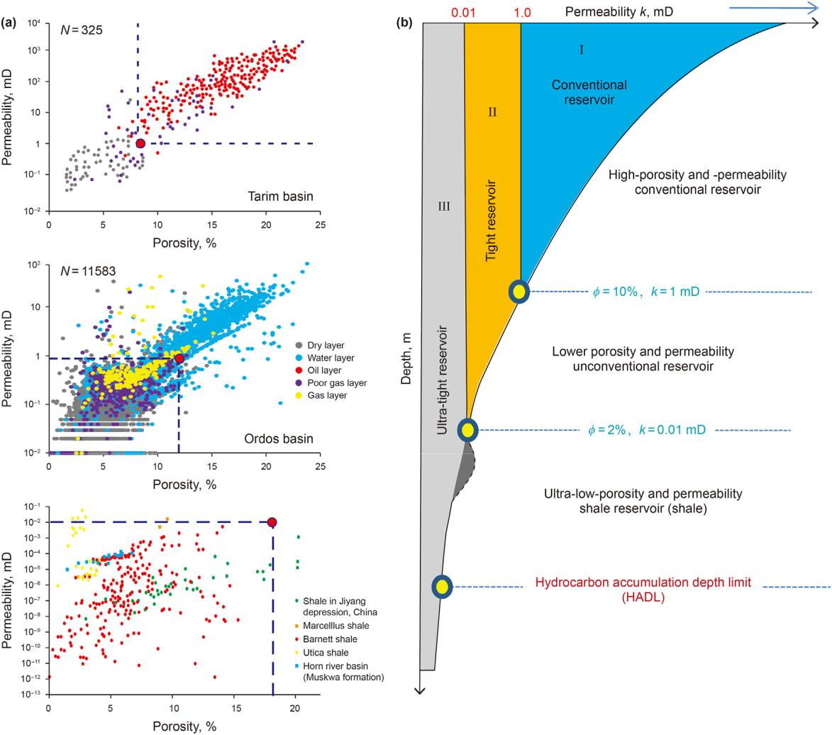

Fig. 12. There are three kinds of reservoir rocks in the whole petroleum system (modified from Pang et al., 2021d). (a) Porosity and permeability distribution characteristics of conventional reservoirs, tight reservoirs, and shale reservoirs: (a1) conventional reservoirs of Kuqa sandstone in Tarim Basin; (a2) tight reservoirs of Upper Paleozoic sandstone in Ordos Basin; (a3) shale reservoirs of mudstone in Bohai Bay Basin and North American basins. (b) Relationship between permeability and burial depth of conventional reservoirs (I), tight reservoirs (II) and ultra-tight shale reservoirs (III).

4.3. There are three kinds of reservoir rocks in the WPS

There are three kinds of different reservoir rocks in the WPS as those with high porosity and permeability, low porosity and permeability, and low porosity and ultra-low permeability respectively (Fig. 12). The first type (I) is the conventional reservoir rocks with higher porosity (ф 10% ± 2%), higher permeability (K 1 mD), and larger pore throat radius (R 1 mm), usually distributed in the formation with relatively shallow burial depth, and the three parameters decrease with the increase of burial depth. The second type (II) is the tight reservoir rocks with low porosity (10% ± 2% ф 2%), low permeability (1 mD K 0.01 mD), small pore throat radius (1 mm R 0.01 mm), usually distributed in the formation between the BHAD and HADL, and their three parameters decrease with the increase of burial depth. The third type (III) is reservoir rocks with lower porosity (ф < 12%), ultra-lower permeability (K < 0.1 mD), and smaller pore throat radius (R < 0.1 mm), usually distributed within the source rocks or in the area below the HADL, the porosity and permeability is not only related to the buried depth, but also to the amount, type, and thermal evolution of organic matter in the source rocks.

5. Ordered distribution patterns of different oil/gas reservoirs

5.1. Basic ordered distribution pattern of oil and gas reservoirs

The WPS has formed conventional, tight and shale oil/gas, res-ervoirs and resources in its evolution, and they are distributed orderly. The basic ordered distribution pattern of them is that the shale oil/gas reservoirs locate in the bottom of WPS, then the tight oil/gas reservoirs directly above the shale oil/gas reservoirs or interbeded with them, finally the conventional oil/gas reservoirs in shallow area, separated from the source rocks, in an occurrence of “shale oil/gas reservoirs\tight oil/gas reservoirs – conventional oil/ gas reservoirs” upward from the source rocks, shortly expressed in “S\T-C”. This basic ordered distribution patten is established by comparing the distribution characteristics of conventional and unconventional oil and gas reservoirs in representative basins of China and North America, as shown in Fig. 13. The secondary oil and gas reservoirs or heavy oil and asphalt reservoirs would be formed near the surface if their traps of original oil/gas reservoirs were damaged by tectonic movement and in environmental conditions for extreme oxidation. Natural gases released from deep original

13

C.-Z. Jia, X.-Q. Pang and Y. Song Petroleum Science 20 (2023) 1e19

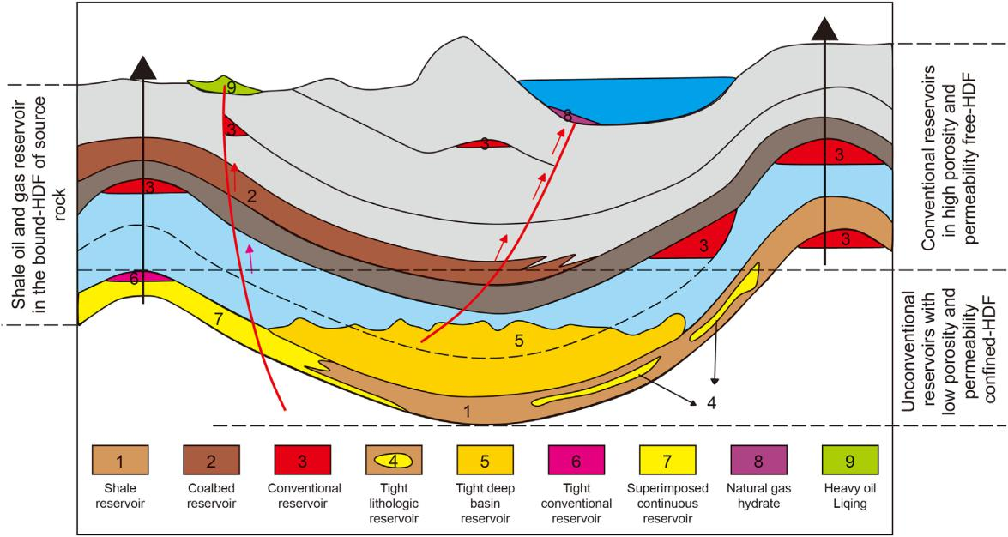

Fig. 13. Illustrates the basic ordered distribution pattern of conventional and unconventional oil and gas reservoirs in the WPS, expressed in form of “shale/tight e con-ventionaleabnormal” or “S/T-C-A”. Shale and S refer to shale oil/gas reservoirs; Tight and T refer to tight oil/gas reservoirs; Conventional and C refer to conventional oil/gas reservoirs; Abnormal and A refer to abnormal oil/gas reservoirs, such as heavy oil & asphalt, natural gas hydrate, etc.; “\” refer to close connection of shale oil/gas and tight oil/gas; “–” refer to separation of conventional oil/gas reservoirs from their source rocks.

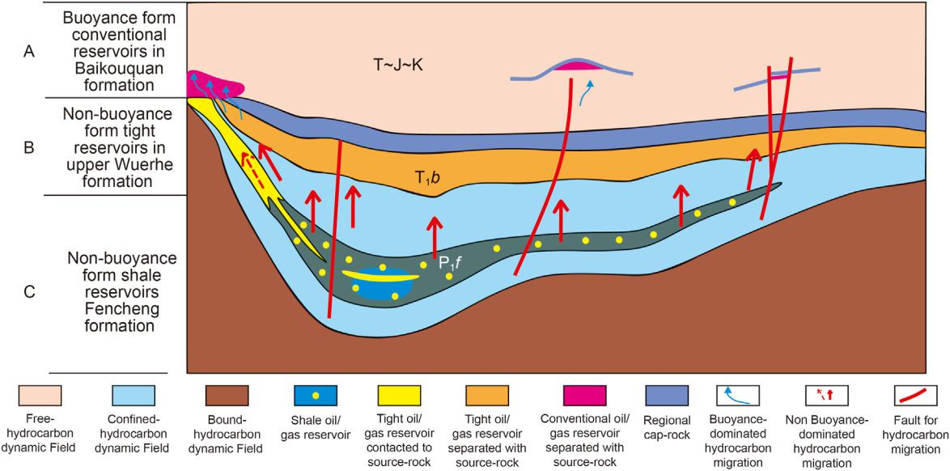

Fig. 14. Illustrates special ordered distribution of oil and gas reservoirs in the Permian WPS of Junggar Basin with tight oil/gas reservoirs separated from source rocks. A. Shallow Free-HDF dominantly forms conventional oil reservoirs (red); B. Middle Confined-HDF dominantly forms unconventional tight oil reservoirs (dark yellow) in the T1b Formation and the Upper Wuerhe Formation; C. Bottom Bound-HDF dominantly forms shale oil/gas reservoirs (dark green) within the source rocks of Fengcheng Formation.

hydrocarbon reservoirs might migrated upward to form natural gas hydrate in gas hydrate stable zone (GHSZ) with high pressure and low temperature (Sloan, 2003; Chong et al., 2016). In this abnormal case, the basic ordered pattern in a broad sense could be expressed as “shale/tighteconventional e abnormal” or “S/T-C-A”.

5.2. Special ordered distribution patterns of oil and gas reservoirs

5.2.1. Special pattern with shale oil/gas and tight oil/gas separated Three types of oil and gas reservoirs formed in the Permian WPS

in Junggar Basin constitute a special ordered distribution pattern, presenting as tight oil/gas separated from shale oil/gas, expressed in “S-T-C”, which is shown in Fig. 14. The Triassic Baikouquan For-mation is widely distributed in the upper Permian (green), which is not in close contact with the Permian source rock (dark) as in the basic pattern (Fig. 13). The oil and gas in the tight conglomerate of Baikouquan Formation comes from the Permian source rocks, how they overcome the strong capillary force in the tight reservoir rocks and form extensive continuous tight oil and gas resources is still being discussed. There are two possible dynamic mechanisms for

14

C.-Z. Jia, X.-Q. Pang and Y. Song Petroleum Science 20 (2023) 1e19

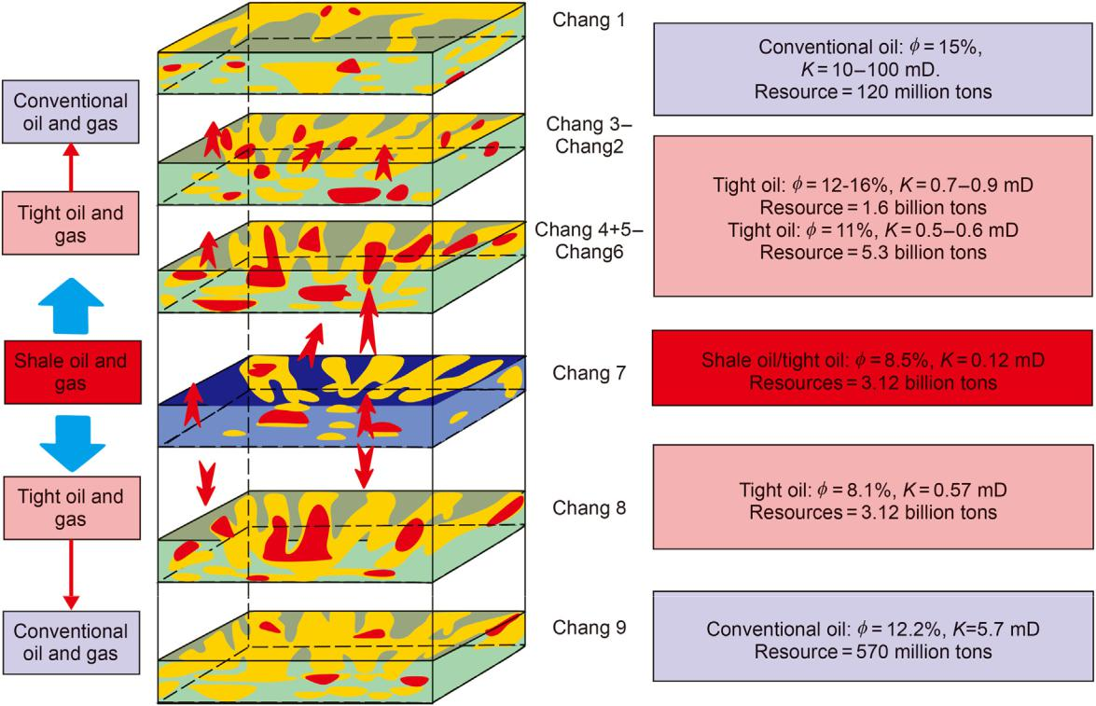

Fig. 15. Illustrates special ordered distribution pattern oil and gas reservoirs in the whole petroleum system of Chang 7 member of Triassic in Ordos basin, with two directions from source rocks up and down showing ordered distribution of “shale\tight–conventional” or “S\T–C”

this situation: One is that the high-pressured fluid with oil due to organic matter transformation, uncompaction of source rocks and increasing temperature with burial depth are discharged from source rock and then migrate upward along the fault zone and charged into the tight reservoir rocks to form the extensive continuous oil reservoirs, the main evidence is that the Permian (P2) source rocks with TOC ¼ 3% and Ro ¼ 0.8%e1.0% are in the peak of petroleum generation, and the products volume expansion force of organic matter transformation can be as high as 235.38e538.31 MPa. Another one is that the oil expelled early from the source rocks might had entered into the upper reservoir rocks with large porosity and permeability under buoyancy-driven to form conventional oil reservoirs, and then the conventional oil reservoirs are transformed into tight oil reservoirs due to the compaction of the later overlying strata, this is because the major source rocks have reached hydrocarbon generation peak in the period of 250 Ma (He et al., 2019) and the porosity and permeability of the reservoir rocks were larger enough to accumulate oil driven by buoyance at that time.

5.2.2. Special pattern with 2 direction ordered distributions

Three types of oil reservoirs formed in the Jurassic WPS of clastic sedimentary strata in Ordos Basin constitute a special pattern of ordered distribution: the proved oil reservoirs show two direc-tional ordered distributions in forms of “S\T-C” from source rocks upward and downward, as illustrated in Fig. 15. Chang 7 is a set of high-quality lacustrine source rocks with a thickness of 50e110 m and a distribution area of 8.5 104 km2, its organic matter abun-dance of TOC ¼ 2%e18%, Ro ¼ 0.9%e1.2%, and organic materials of type ¼ IeII, the shale oil resources (3.12 billion tons) are formed within the source rocks by their generated but remained oil. Oil generated in Chang 7 is expelled downward to form a wide continuous tight oil reservoirs in Chang 8 member, and the oil

continues to migrate downward to Chang 9 member to form con-ventional oil reservoirs with average porosity of Ф ¼ 12.2% and permeability of K ¼ 5.7 mD, the proved conventional reserves are 570 million tons and their distribution is discontinuous, controlled by the high point of traps. Continuous distribution of tight oil res-ervoirs with resources of 5.30 billion tons was formed in Chang 6-5-4-3-2 members upward, and the conventional oil reserves (120 million tons) controlled by traps were formed in Chang 1 member and Jurassic member upward.

5.2.3. Special pattern with lateral direction distribution

The three types of oil and gas reservoirs formed in the Creta-ceous WPS in Songliao Basin constitute a special ordered distri-bution pattern: the distribution of “shale oil reservoirs\tight oil reservoirs - conventional oil reservoirs” or “S\T-C” from the source to lateral spread, as showed in Fig. 16. The Cretaceous Qingshankou Formation is a set of high-quality continental source rocks with an average thickness of 15.78 m and a distribution area of more than 4 104 km2, it contains type I of organic parent material, TOC ¼ 0.9%e3.8%, Ro ¼ 0.5%e1.5%, and is currently in the stage of large amount of oil generation and gas condensate generation. The oil and gas generated and discharged from the source rock have migrated to the Daqing Placanticline under buoyancy-driven and formed the largest continental oil and gas reservoir in the world, which is the main body of Daqing Oilfield. During migration to the surrounding fine-grained siltstone or fine-grained sandstone, the discharged oil and gas have accumulated in situ and formed extensive continuous tight oil and gas reservoirs due to capillary pressure resistance. The oil and gas that cannot be discharged after generation are retained within source rocks by adsorption to form shale oil and gas reservoir. Fig. 16 shows the lake sedimentary characteristics in Gulong Depression of Songliao Basin from south to north of the deep-water fine-grained shale depositional system,

15

C.-Z. Jia, X.-Q. Pang and Y. Song Petroleum Science 20 (2023) 1e19

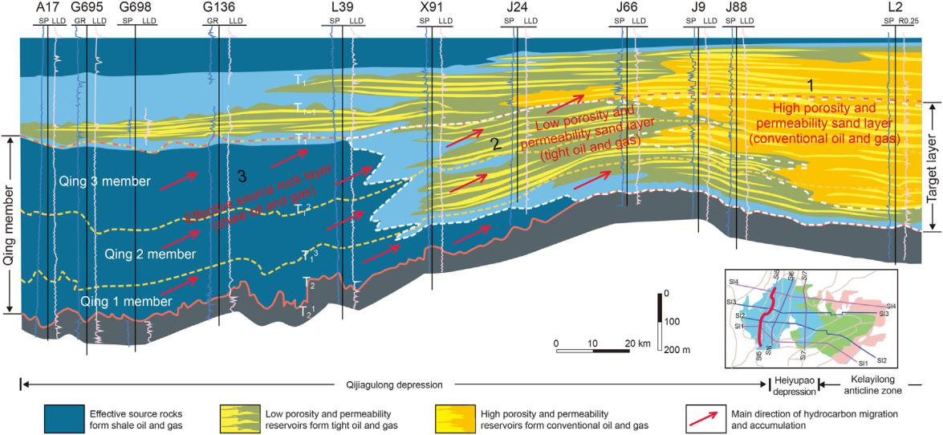

Fig. 16. Illustrates the special ordered distribution pattern with lateral direction and the basic characteristics of oil and gas reservoirs in Cretaceous whole petroleum system of Songliao Basin, China.

lake delta front fine silt sandstone sedimentary system, coastal rivers, coarse glutenite sedimentary system, presenting lateral or-dered distribution conditions for the formation of “S\T-C” oil res-ervoirs in the WPS.

5.3. Genetic mechanism of ordered distribution pattern in WPS

There are different types of oil and gas reservoirs and resources in nature duo to different petroleum geological conditions (Song et al., 2017), generally they are orderly distributed, but sometimes very complex, all of these are mainly depended on the combination of different actual geological conditions.

5.3.1. Ordered distribution is formed by the coupling of three factors in WPS

Ordered distribution of oil/gas reservoirs in the WPS is controlled by the coupling of three kinds of essential factors, such as the hydrocarbon dynamic fields, original hydrocarbon quantities, and three kinds of reservoir rocks. Different factors play different roles in the formation of different oil and gas reservoirs.

The hydrocarbon dynamic fields provide driving forces for oil and gas to migrate and accumulate, and determine the type of reservoirs. From shallow to deep, the oil and gas dynamic field changes from Free-HDF to Confined-HDF and then to Bound-HDF, and the dominant driving force and the form of oil and gas migration and accumulation in them also changes correspondingly. Finally, the oil/gas reservoirs type formed by them also changes from conventional to tight, and then to shale.

The original hydrocarbons from source rocks prepare materials for the formation of oil and gas reservoirs, determining the resource potentials as well as their relative ratios in the WPS. Original hy-drocarbons remained in source rocks is favorable to form shale oil/ gas reservoirs, which is tend to locate within source rocks of the WPS, the proportion of this kind original hydrocarbon content in total generated hydrocarbons for six representative basins of China is about 50% on average. Original hydrocarbons expelled in early stage above the BHAD is favorable to form conventional oil/gas reservoirs, which is tend to locate in the top or shallow area of the WPS, the proportion of this kind original hydrocarbon content in total generated hydrocarbons for six representative basins of China is about 10% on average. Original hydrocarbons expelled in late

stage between the BHAD and HADL is favorable to form extensive continuous tight oil/gas reservoirs, which is tend to locate in the bottom or deep area of the WPS, the proportion of this kind original hydrocarbon content in total generated hydrocarbons for six representative basins of China is about 40% on average.

The reservoir rocks provide pore space for the formation of oil and gas reservoirs, determining their basic geological characteris-tics. The oil/gas accumulation in reservoir rocks with high porosity and high permeability form conventional oil/gas reservoirs, they have a high ratio of movable hydrocarbons, with global oil and gas recovery averaging over 35%. The oil/gas accumulation in tight reservoir rocks with low porosity and low permeability form continuous oil/gas reservoirs, they contain a low percentage of movable hydrocarbons and require special measures to achieve commercial production, with current average recovery rates of less than 20%. The oil/gas accumulation in source rocks with low porosity and super low permeability usually form shale oil/gas reservoirs, they have a lower percentage of mobile hydrocarbons, with global shale oil and gas recovery averaging less than 10%.

5.3.2. Ordered distribution is determined by the evolution process of the WPS

Ordered distribution of oil and gas reservoirs is the evolution result of the WPS. Under normal geological conditions, the sedi-mentary strata have gone through three different stages in the process of deep burial, each stage presents different essential geological factors to forms different oil and gas reservoirs.

In the early evolution stage, the stratum buried depth is shallow. The hydrocarbons first generated tend to remain in the source rocks. As the generated oil and gas have not satisfied the needs of source rocks in remaining oil and gas, they cannot be expelled from source rocks in separate or free phase, can only form shale oil and gas reservoirs in the Bound-HDF within source rocks. However, it is difficulty to extract these shale oil and gas because their saturation is relatively low and the brittleness of the source rocks is too low to crushing.

In the middle evolutionary stage, the stratum is buried moder-ately and between HET and BHAD, the oil and gas expelled from source rocks in separate or free phase tend to migrate into traps in Free-HDF driven dominantly by buoyancy to form conventional oil and gas reservoirs, presenting their own unique geological

16

C.-Z. Jia, X.-Q. Pang and Y. Song

characteristics with four high points and distributed above the BHAD, separately away from their source rocks. At the same time, the oil and gas that are not expelled tend to form shale oil and gas reservoirs within the source rocks.

In the late evolution stage, the stratum buried deeply and distributed between BHAD and HADL, the oil and gas expelled from source rocks cannot migrate upward under buoyancy-driven. Instead, they can only accumulate in situ tight reservoirs to form unconventional continuous reservoirs driven by non-buoyancy, which are usually distributed in Confined-HDF and connecting to or interbeded with source rocks. At the same time, the oil and gas that are not expelled tend to form shale oil and gas reservoirs within the source rocks.

In the last evolution stage, the stratum is buried very deeply and distributed between HADL and ASDL. The oil and gas cannot be expelled from source rocks because of the disappearing of source rocks’ hydrocarbon generation and expulsion potential, which is also in B-HDF but is usually not conducive to the formation and distribution of reservoirs duo to the lack of oil and gas sources.

The ordered distribution of oil and gas reservoirs in the WPS is the concentrated reflection of different types of oil and gas reser-voirs under combination of different geological factors but formed in different periods. They are also the current results of the su-perposition and recombination of different types of oil and gas reservoirs which were formed in different periods in the same reservoir layers.

5.3.3. Ordered distribution pattern varies with geological conditions The three types of oil/gas reservoirs formed in the WPS are

orderly distributed in general condition, but will be reconstructed in special conditions as strong tectonic movements occur, which even lead to superposition and combination of these oil/gas res-ervoirs, category transformation and petroleum components alteration, showing very complex occurrence as in the following three situations. First, conventional oil and gas reservoirs formed earlier have been modified by the uplift and denudation of the overlying strata, the oil and gas in reservoirs have been partly lost or totally destroyed, some normal oil and gas reservoirs were transformed to heavy oil & bitumen as in the Permian WPS in the northwestern margin of Junggar Basin during tectonic activities, their total destroyed oil is estimated to be more than 1.5 billion tons oil equivalent (Wu et al., 2002). Second, due to the formation of overlying strata and the increase of burial depth, the conventional oil and gas reservoirs formed earlier in reservoirs with high porosity and permeability are transformed to tight oil and gas reservoirs, or cracked into gas reservoirs due to high temperature in deep depth as Puguang Gas Field and Yuanba Gas Field in the Permian WPS in Sichuan Basin (Ma et al., 2008; Wu et al., 2015). Thirdly, due to the formation of fault structures and strong un-derground fluid activities in the later stage, fractures and pores were formed in the reservoir layers, which made the originally accumulated oil and gas readjust and migrate upward under buoyancy-driven, leading to the formation of conventional oil and gas reservoirs in fractures of sandstone or in pores of carbonate rocks, such as those within Cambrian and Ordovician in Tazhong area of Tarim Basin (Shen et al., 2018).

1. Conclusion
   1. The source to trap petroleum system concept and research methods cannot be directedly applied to unconventional oil and gas accumulations because their formation and distri-bution are not controlled by buoyance and traps; the concept of whole petroleum system and its research approach have been proposed to study all kinds of oil and gas accumulations

Petroleum Science 20 (2023) 1e19

formed by the same source rocks and driven by different forces in a petroliferous basin.

1. The WPS majorly consist of three essential geological factors. The first is hydrocarbon dynamic fields, providing driving forces for oil and gas migration; the second is original hy-drocarbon quantity originating from source rocks, providing materials for oil and gas accumulations; and the third is oil and gas reservoir rocks, providing spaces for oil and gas to exist. The coupling of these three geological factors de-termines the types and potentials of different oil and gas reservoirs and resources.
2. Oil and gas reservoirs are orderly distributed in the WPS with a basic model of “shale\tight–conventional”, characterized with tight contacting to or interbeded with shale, and con-ventional separated from source rocks upward, which may appear in three special patterns: Special-1 with shale sepa-rated from tight; Special-2 with two directions from source upward and downward; and Special-3 with lateral ordered distribution from source outside.
3. The dynamic mechanism for ordered distribution of oil/gas reservoirs in the WPS are the coupling of dynamic fields, original hydrocarbons, and reservoir rocks. Shale oil/gas are formed in B-HDF by remained oil/gas within source rocks; Conventional oil/gas are formed in F-HDF by expelled oil/gas above BHAD; and Tight oil/gas formed in C-HDF by oil/gas below BHAD. Tectonic movements lead to reconstruction of oil/gas reservoirs, presenting a very complex occurrence.

Acknowledgements

This work was supported by the major science and technology projects of CNPC during the “14th five-year plan” (Grant number 2021DJ0101). We would like to thank the editors and reviewers for their highly review of this study and their suggestions for modifi-cation; We would also like to thank Dr. Kanyuan Shi and other graduate student of Basin and Reservoirs Research Center in China University of Petroleum, Beijing for their help in the process of manuscript compilation.

References

Alexej, M., Reinhard, F., Ralf, L., 2015. The role of pre-adsorbed water on methane sorption capacity of Bossier and Haynesville shales. Int. J. Coal Geol. 147e148, 1e8. <https://doi.org/10.1016/j.coal.2015.06.003>.

Browne, T.N., Hofmann, M.H., Malkowski, M.A., Wei, J., Sperlinget, E.A., 2020. Redox and paleoenvironmental conditions of the devonian-carboniferous Sappington formation, southwestern Montana, and comparison to the Bakken Formation, Williston Basin. Paleogeogr. Paleoclimatol. Paleoecol. 560 (1), 110025. [https://](https://doi.org/10.1016/j.palaeo.2020.110025) [doi.org/10.1016/j.palaeo.2020.110025](https://doi.org/10.1016/j.palaeo.2020.110025).

Bustin, R.M., Clarkson, C.R., 1998. Geological controls on coalbed methane reservoir capacity and gascontent. Int. J. Coal Geol. 38 (1e2), 3e26. [https://doi.org/](https://doi.org/10.1016/S0166-5162(98)00030-5) [10.1016/S0166-5162(98)00030-5](https://doi.org/10.1016/S0166-5162(98)00030-5).

Carlos, V., Dhrupad, R.B., Eiichi, S., John, D.M., Terry, A.R., Raymond, L., Nestor, M.R., 2020. Source rock evaluation in the central-western flank of the Tampico Misantla Basin, Mexico. J. South Am. Earth Sci. 100, 202552. [https://doi.org/](https://doi.org/10.1016/j.jsames.2020.102552) [10.1016/j.jsames.2020.102552](https://doi.org/10.1016/j.jsames.2020.102552).

Chen, Z.H., Osadetz, K.G., Li, M., 2005. Spatial characteristics of Middle Devonian oils and non-associated gases in the Rainbow area, northwest Alberta. Mar. Petrol. Geol. 22 (3), 391e401. <https://doi.org/10.1016/j.marpetgeo.2004.12.005>.

Chong, Z.R., Yang, S.H.B., Babu, P., Linga, P., Li, X.S., 2016. Review of natural gas hydrates as an energy resource: prospects and challenges. Appl. Energy 162, 1633e1652. <https://doi.org/10.1016/j.apenergy.2014.12.061>.

Curtis, J.B., 2002. Fractured shale-gas systems. AAPG Bull. 86 (11), 1921e1938.

<https://doi.org/10.1306/61EEDDBE-173E-11D7-8645000102C1865D>.

Dow, W.G., 1974. Application of oil-correlation and source-rock data to exploration in Williston Basin. AAPG Bull. 58 (7), 1253e1262. [https://doi.org/10.1306/](https://doi.org/10.1306/83D91655-16C7-11D7-8645000102C1865D) [83D91655-16C7-11D7-8645000102C1865D](https://doi.org/10.1306/83D91655-16C7-11D7-8645000102C1865D).

Energy Information Administration (EIA), 2013. Technically Re Coverable Shale Oil and Shale Gas Resources: an Assessment of 137 Shale Formations in 41 Coun-tries outside the United States. U.S, Washington, DC. [https://www.eia.gov/](https://www.eia.gov/analysis/studies/worldshalegas/pdf/overview.pdf) [analysis/studies/worldshalegas/pdf/overview.pdf](https://www.eia.gov/analysis/studies/worldshalegas/pdf/overview.pdf).

[Energy Information Administration (EIA), 2020. International Energy Outlook. U.S.,](http://refhub.elsevier.com/S1995-8226(22)00337-5/sref10)

17

C.-Z. Jia, X.-Q. Pang and Y. Song

[Washington DC](http://refhub.elsevier.com/S1995-8226(22)00337-5/sref10).

Gentzis, T., 2016. Review of the hydrocarbon potential of the Steele Shale and Niobrara Formation in Wyoming, USA: a major unconventional resource play? Int. J. Coal Geol. 166, 118e127. <https://doi.org/10.1016/j.coal.2016.07.002>.

Gottardi, R., Adams, L.M., Borrok, D., Teixeira, B., 2018. Hydrocarbon source rock characterization, burial history, and thermal maturity of the Steele, Niobrara and Mowry Formations at Teapot Dome, Wyoming. Mar. Petrol. Geol. 100, 326e340. <https://doi.org/10.1016/j.marpetgeo.2018.11.012>.

Hackley, C.H., Zhang, T.W., Jubb, A.M., Valentine, B., Dulong, F.T., Hatcherian, J.J., 2020. Organic petrography of Leonardian (Wolfcamp A) mudrocks and car-bonates, Midland Basin, Texas: the fate of oil-prone sedimentary organic matter in the oil window. Mar. Petrol. Geol. 112, 104086. [https://doi.org/10.1016/](https://doi.org/10.1016/j.marpetgeo.2019.104086) [j.marpetgeo.2019.104086](https://doi.org/10.1016/j.marpetgeo.2019.104086).

He, D.F., Zhao, W.Z., Lei, Z.Y., Qu, H., Chi, Y.L., 2000. Basic characteristics of composite petroleum system of superimposed basin in China. Earth Sci. Front. 7 (3), 23e37 (in Chinese).

He, W.J., Fei, L.Y., Ablimiti, Y.M., Yang, H.B., Lan, W.F., Ding, J., Bao, H.J., Guo, W.J., 2019. Analysis of deep oil and gas accumulation conditions and exploration potential in Junggar Basin. Earth Sci. Front. 26 (1), 189e201. [https://doi.org/](https://doi.org/10.13745/j.esf.sf.2019.1.12) [10.13745/j.esf.sf.2019.1.12](https://doi.org/10.13745/j.esf.sf.2019.1.12) (in Chinese).

Hou, L., Luo, X., Yu, Z., Zhao, Z., Lin, S., 2021. Key factors controlling the occurrence of shale oil and gas in the Eagle Ford Shale, the Gulf Coast Basin: models for sweet spot identification. J. Nat. Gas Sci. Eng. 94, 104063. [https://doi.org/10.1016/](https://doi.org/10.1016/j.jngse.2021.104063) [j.jngse.2021.104063](https://doi.org/10.1016/j.jngse.2021.104063).

Hu, T., Pang, X.Q., Jiang, F.J., Zhang, C.X., Wu, G.Y., Hu, M.L., Jiang, L., Wang, Q.F., Xu, T.W., Hu, T., Jiang, S., Wang, W.Y., Li, M.W., 2022a. Dynamic continuous hydrocarbon accumulation (DCHA): existing theories and a new unified accu-mulation model. Earth Sci. Rev. 232, 104109. [https://doi.org/10.1016/](https://doi.org/10.1016/j.earscirev.2022.104109) [j.earscirev.2022.104109](https://doi.org/10.1016/j.earscirev.2022.104109).

Hu, T., Wu, G.Y., Xu, Z., Pang, X.Q., Liu, Y., Yu, S., 2022b. Potential resources of conventional, tight, and shale oil and gas from Paleogene Wenchang Formation source rocks in the Huizhou Depression. Adv. Geo-Energy Res. 6 (5), 402e414. <https://doi.org/10.46690/ager.2022.05.05>.

[Hunt, J., 1979. Petroleum Geochemistry and Geology. Freeman, San Francisco](http://refhub.elsevier.com/S1995-8226(22)00337-5/sref19).

[IHS Energy Group, 2016. International Petroleum Exploration and Production](http://refhub.elsevier.com/S1995-8226(22)00337-5/sref20) [Database. Colorado, Englewood](http://refhub.elsevier.com/S1995-8226(22)00337-5/sref20).

Jia, C.Z., 2017. Breakthrough and significance of unconventional oil and gas to classical petroleum geology theory. Petrol. Explor. Dev. 44 (1), 1e10. [https://](https://doi.org/10.1016/S1876-3804(17)30002-2) [doi.org/10.1016/S1876-3804(17)30002-2](https://doi.org/10.1016/S1876-3804(17)30002-2).

Jia, C.Z., Pang, X.Q., Song, Y., 2021a. The mechanism of unconventional hydrocarbon formation: hydrocarbon self-sealing and intermolecular forces. Petrol. Explor. Dev. 48 (3), 437e452. <https://doi.org/10.1016/S1876-3804(21)60042-3>.

[Jia, C.Z., 2021b. New Progress in Unconventional Oil and Gas Geology. Report of the](http://refhub.elsevier.com/S1995-8226(22)00337-5/sref22) [Annual Conference of China Petroleum Geology, Haikou, China (in Chinese)](http://refhub.elsevier.com/S1995-8226(22)00337-5/sref22).

[Jia, C.Z., 2021c. Whole Petroleum System: from Source Rocks to Continuous Accu-mulation of Unconventional Oil and Gas and Conventional Oil and Gas Trap](http://refhub.elsevier.com/S1995-8226(22)00337-5/sref23) [Accumulation. The 6th Unconventional Oil and gas Geological Evaluation and](http://refhub.elsevier.com/S1995-8226(22)00337-5/sref23) [New Energy Conference, Wuhan, China (in Chinese)](http://refhub.elsevier.com/S1995-8226(22)00337-5/sref23).

[Jia, C.Z., 2021d. Whole Petroleum System: from Source Rocks to Unconventional](http://refhub.elsevier.com/S1995-8226(22)00337-5/sref24) [Hydrocarbon Continuous Accumulation and Conventional Hydrocarbon Trap](http://refhub.elsevier.com/S1995-8226(22)00337-5/sref24) [Accumulation. The 10th China Petroleum Systems and Reservoirs Academic](http://refhub.elsevier.com/S1995-8226(22)00337-5/sref24) [Conference, Wuhan, China (in Chinese)](http://refhub.elsevier.com/S1995-8226(22)00337-5/sref24).

Jia, C.Z., Zheng, M., Zhang, Y.F., 2012. Unconventional hydrocarbon resources in China and the prospect of exploration and development. Petrol. Explor. Dev. 39

(2), 129e136. <https://doi.org/10.1016/S1876-3804(12)60026-3>.

[Jiang, Z.X., 2015. Genesis Mechanism and Distribution Prediction of Tight Sandstone](http://refhub.elsevier.com/S1995-8226(22)00337-5/sref27) [Gas in Kuqa Depression. Science Press, Beijing (in Chinese)](http://refhub.elsevier.com/S1995-8226(22)00337-5/sref27).

[Jin, Z.J., Zhang, Y.W., Wang, J., et al., 2003. Hydrocarbon Accumulation Mechanism](http://refhub.elsevier.com/S1995-8226(22)00337-5/sref28) [and Distribution Pattern. Petroleum Industry Press, Beijing (in Chinese)](http://refhub.elsevier.com/S1995-8226(22)00337-5/sref28).

Jin, Z.J., Liang, X.P., Bai, Z.R., 2022. Exploration breakthrough and its significance of Gulong lacustrine shale oil in the Songliao Basin, Northeastern China. Energy Geoscience 3, 120e125. <https://doi.org/10.1016/j.engeos.2022.01.005>.

Lash, G.G., Blood, D.R., 2014. Organic matter accumulation, redox, and diagenetic history of the Marcellus Formation, southwestern Pennsylvania, Appalachian basin. Mar. Petrol. Geol. 57, 244e263. [https://doi.org/10.1016/](https://doi.org/10.1016/j.marpetgeo.2014.06.001) [j.marpetgeo.2014.06.001](https://doi.org/10.1016/j.marpetgeo.2014.06.001).

Leu, C.W., 1999. Migration and accumulation of hydrocarbons in the Swiss Molasse Basin: implications of a 2D basin modeling study. Mar. Petrol. Geol. 16, 511e531. <https://doi.org/10.1016/S0264-8172(99)00018-5>.

[Levorsen, A.I., 1954. Geology of Petroleum. W. H. Freeman and Company, San](http://refhub.elsevier.com/S1995-8226(22)00337-5/sref32) [Francisco](http://refhub.elsevier.com/S1995-8226(22)00337-5/sref32).

Li, M.W., Fowler, M.G., Obermajer, M., Stasiuk, L.D., Snowdon, L.R., 1999. Geochemical characterisation of Middle Devonian oils in NW Alberta, Canada: possible source and maturity effect on pyrrolic nitrogen compounds. Org. Geochem. 30 (9), 1039e1057. <https://doi.org/10.1016/S0146-6380(98)00094-1>.

[Liu, C., Wang, Y., Hang, H., Wang, X., 2013. Hydrocarbon accumulation mechanism](http://refhub.elsevier.com/S1995-8226(22)00337-5/sref34) [of tight sandstone reservoir in Jiyang Depression. Petrol. Geol. Exp. 35 (2),](http://refhub.elsevier.com/S1995-8226(22)00337-5/sref34) [115](http://refhub.elsevier.com/S1995-8226(22)00337-5/sref34)e[119 (in Chinese)](http://refhub.elsevier.com/S1995-8226(22)00337-5/sref34).

[Ma, Z.Z., 2008. Dynamic Mechanism and Development Model of Deep Tight](http://refhub.elsevier.com/S1995-8226(22)00337-5/sref35) [Sandstone Reservoirs. China University of Petroleum, Beijing (in Chinese)](http://refhub.elsevier.com/S1995-8226(22)00337-5/sref35).

Ma, Y.S., Zhang, S.C., Guo, T.L., Zhu, G.Y., Cai, X.Y., Li, M.W., 2008. Petroleum geology of the Puguang sour gas field in the Sichuan Basin, SW China. Mar. Petrol. Geol. 25 (4), 357e370. <https://doi.org/10.1016/j.marpetgeo.2008.01.010>.

Ma, Y.Q., Fan, M.J., Lu, Y.C., Liu, H.M., Hao, Y.Q., Xie, Z.H., Liu, Z.H., Peng, L., Du, X.B., Hu, H.Y., 2016. Climate-driven paleolimnological change controls lacustrine

Petroleum Science 20 (2023) 1e19

mudstone depositional process and organic matter accumulation: constraints from lithofacies and geochemical studies in the Zhanhua Depression, eastern China. Int. J. Coal Geol. 167, 103e118. <https://doi.org/10.1016/j.coal.2016.09.014>.

[Magoon, L.B., Dow, W.G., 1994. The Petroleum System-From Source to Trap.](http://refhub.elsevier.com/S1995-8226(22)00337-5/sref38)

[American Association of Petroleum Geologists](http://refhub.elsevier.com/S1995-8226(22)00337-5/sref38).

[Magoon, L.B., Schmoker, J.W., 2000. The Total Petroleum System: the Natural Fluid](http://refhub.elsevier.com/S1995-8226(22)00337-5/sref39) [Network that Constrains the Assessment Unit. US Geological Survey World](http://refhub.elsevier.com/S1995-8226(22)00337-5/sref39) [Petroleum Assessment](http://refhub.elsevier.com/S1995-8226(22)00337-5/sref39).

Mark, J.K., 2012. Haynesville shale play economic analysis. J. Pet. Sci. Eng. 82e83, 75e89. <https://doi.org/10.1016/j.petrol.2011.12.029>.

Masters, J.A., 1979. Deep Basin gas trap, western Canada. AAPG Bull. 63 (2), 152e181.

<https://doi.org/10.1306/c1ea55cb-16c9-11d7-8645000102c1865d>.

[Meissner, F.F., 1978. Petroleum geology of the Bakken Formation Williston Basin,](http://refhub.elsevier.com/S1995-8226(22)00337-5/sref42) [North Dakota and Montana. In: In: the Economic Geology of the Williston Ba-sin: Montana Geological Society, Williston Basin Symposium, pp. 207](http://refhub.elsevier.com/S1995-8226(22)00337-5/sref42)e[227](http://refhub.elsevier.com/S1995-8226(22)00337-5/sref42).

Michael, A.A., Drew, T., 2020. Geochemical evaluation of oil and gas samples from the upper devonian and Mississippian reservoirs Southern Anadarko Basin Oklahoma and its implication for the Woodford shale unconventional play. Mar. Petrol. Geol. 112, 104043. <https://doi.org/10.1016/j.marpetgeo.2019.104043>.

[Ministry of Natural Resources, PRC, 2017. National Oil/gas Exploration and Exploi-tation Report in 2016 (in Chinese)](http://refhub.elsevier.com/S1995-8226(22)00337-5/sref44).

Ojha, S.P., Misra, S., Tinni, A., Sondergeld, C., Chandra, R., 2017. Pore connectivity and pore size distribution estimates for Wolfcamp and Eagle Ford shale samples from oil, gas and condensate windows using adsorption-desorption measure-ments. J. Pet. Sci. Eng. 158, 454e468. [https://doi.org/10.1016/](https://doi.org/10.1016/j.petrol.2017.08.070) [j.petrol.2017.08.070](https://doi.org/10.1016/j.petrol.2017.08.070).

Pang, X.Q., Li, M.W., Li, S.M., Jin, Z.J., 2005. Geochemistry of petroleum systems in the Niuzhuang South slope of Bohai Bay Basin: Part 3. Estimating hydrocarbon expulsion from the Shahejie formation. Org. Geochem. 36 (4), 497e510. [https://](https://doi.org/10.1016/S0146-6380(03)00032-9) [doi.org/10.1016/S0146-6380(03)00032-9](https://doi.org/10.1016/S0146-6380(03)00032-9).

[Pang, X.Q., Liu, K.Y., Ma, Z.Z., Jiang, Z.X., Xiang, C.F., Huo, Z.P., Pang, H., Chen, J.Q.,](http://refhub.elsevier.com/S1995-8226(22)00337-5/sref47) [2012. Dynamic field division of hydrocarbon migration, accumulation and hy-drocarbon Enrichment rules in sedimentary basins. Acta Geol. Sin. Engl. Ed. 86](http://refhub.elsevier.com/S1995-8226(22)00337-5/sref47)

[(6), 1559](http://refhub.elsevier.com/S1995-8226(22)00337-5/sref47)e[1592](http://refhub.elsevier.com/S1995-8226(22)00337-5/sref47).

Pang, X.Q., Jia, C.Z., Zhang, K., Li, M.W., Wang, Y.W., Peng, J.W., Li, B.Y., Chen, J.Q., 2020a. The dead line for oil and gas and implication for fossil resource pre-diction. Earth Syst. Sci. Data 12 (1), 577e590. <https://doi.org/10.5194/essd-12-577-2020>.

Pang, X.Q., Jia, C.Z., Chen, J.Q., Li, M.W., Wang, W.Y., Hu, Q.H., Guo, Y.C., Chen, Z.X., Peng, J.W., Liu, K.Y., Wu, K.L., 2020b. A unified model for the formation and distribution of both conventional and unconventional hydrocarbon reservoirs. Geosci. Front. 12 (2), 695e711. <https://doi.org/10.1016/j.gsf.2020.06.009>.

Pang, X.Q., Chen, Z.H., Jia, C.Z., Wang, E.Z., Shi, H.S., Wu, Z.Y., Hu, T., Liu, K.Y., Zhao, Z.F., Pang, B., Wang, T., 2021a. Evaluation and Re-understanding of the global natural gas hydrate resources. Petrol. Sci. 18, 323e338. [https://doi.org/](https://doi.org/10.1007/s12182-021-00568-9) [10.1007/s12182-021-00568-9](https://doi.org/10.1007/s12182-021-00568-9).

Pang, X.Q., Jia, C.Z., Wang, W.Y., Chen, Z.X., Li, M.W., Jiang, F.J., Hu, T., Wang, K., Wang, Y.X., 2021b. Buoyance-driven hydrocarbon accumulation depth and its implication for unconventional resource prediction. Geosci. Front. 12 (4), 101133. <https://doi.org/10.1016/j.gsf.2020.11.019>.

Pang, X.Q., Hu, T., Larter, S., Jiang, Z.X., Li, M.W., Wu, L.Y., Liu, K.Y., Jiang, S., Wang, W.Y., Hu, Q.H., Zhang, K., Li, Z., Bai, H., 2021c. Hydrocarbon accumulation depth limit and implications for potential resources prediction. Gondwana Res. 12 (4), 101133. <https://doi.org/10.1016/j.gr.2021.10.018>.

Pang, X.Q., Shao, X.H., Li, M.W., Hu, T., Chen, Z.H., Zhang, K., Jiang, F.J., Chen, J.Q., Chen, D.X., Peng, J.W., Pang, B., Wang, W.Y., 2021d. Correlation and difference between conventional and unconventional reservoirs and their unified genetic classification. Gondwana Res. 97 (6), 73e100. [https://doi.org/10.1016/](https://doi.org/10.1016/j.gr.2021.04.011) [j.gr.2021.04.011](https://doi.org/10.1016/j.gr.2021.04.011).

Perrodon, A., 1992. Petroleum systems: models and applications. J. Petrol. Geol. 15

(2), 319e325. <https://doi.org/10.1111/j.1747-5457.1992.tb00875.x>.

Perrodon, A., Masse, P., 1984. Subsidence. Sedimentation and petroleum systems.

1. Petrol. Geol. 7 (1), 5e25. <https://doi.org/10.1111/j.1747-5457.1984.tb00158.x>. Philp, P., Symcox, C., Wood, M., Nguyen, T., Wang, H.D., Kim, D.W., 2021. Possible

explanations for the predominance of tricyclic terpanes over pentacyclic ter-panes in oils and rock extracts. Org. Geochem. 155, 104220. [https://doi.org/](https://doi.org/10.1016/j.orggeochem.2021.104220) [10.1016/j.orggeochem.2021.104220](https://doi.org/10.1016/j.orggeochem.2021.104220).

[Pollastro, R.M., Roberts, L.N., Cook, T.A., 2012. Geologic model for the assessment of](http://refhub.elsevier.com/S1995-8226(22)00337-5/sref57) [technically recoverable oil in the devonian](http://refhub.elsevier.com/S1995-8226(22)00337-5/sref57) e [Mississippian Bakken Formation,](http://refhub.elsevier.com/S1995-8226(22)00337-5/sref57) [Williston Basin. In: Breyer, J.A. (Ed.), Shale Reservoirs](http://refhub.elsevier.com/S1995-8226(22)00337-5/sref57)d[Giant Resources for the](http://refhub.elsevier.com/S1995-8226(22)00337-5/sref57) [21st Century: AAPG Memoir, vol. 97, pp. 205](http://refhub.elsevier.com/S1995-8226(22)00337-5/sref57)e[257](http://refhub.elsevier.com/S1995-8226(22)00337-5/sref57).

[Richard, F.M., Emil, D.A., Philip, A.F., 2007. Heavy oil and natural bitumen resources](http://refhub.elsevier.com/S1995-8226(22)00337-5/sref58) [in geological basins of the world. US Geological Survey 8](http://refhub.elsevier.com/S1995-8226(22)00337-5/sref58).

[Rose, P.R., Everett, J.R., Merin, I.S., 1986. Potential Basin-centered gas accumulation](http://refhub.elsevier.com/S1995-8226(22)00337-5/sref59) [in cretaceous trinidad sandstone, raton basin. ColoradoBiz 82, 190](http://refhub.elsevier.com/S1995-8226(22)00337-5/sref59)e[197](http://refhub.elsevier.com/S1995-8226(22)00337-5/sref59).

Schidlowski, M., 1981. Kerogen-Insoluble organic matter from sedimentary rocks. Chem. Geol. 34 (1e2), 179e180. <https://doi.org/10.1016/0009-2541(81)90080-2>.

[Schmoker, J.W., Oscarson, S.A., 1995. Descriptions of continuous-type (unconven-tional) plays of the U.S. Geological Survey 1995 National assessment of United](http://refhub.elsevier.com/S1995-8226(22)00337-5/sref61) [States oil and gas resources. U.S. Geological Survey.](http://refhub.elsevier.com/S1995-8226(22)00337-5/sref61)

Shen, W.B., Chen, J.F., Wang, Y.Y., Zhang, K., Chen, Z.Y., Luo, G.P., Fu, X., 2018. The origin, migration and accumulation of the Ordovician gas in the Tazhong III region, Tarim Basin, NW China. Mar. Petrol. Geol. 101, 55e57. [https://doi.org/](https://doi.org/10.1016/j.marpetgeo.2018.11.031) [10.1016/j.marpetgeo.2018.11.031](https://doi.org/10.1016/j.marpetgeo.2018.11.031).

Shi, D.S., Li, M.W., Pang, X.Q., Chen, D.X., Zhang, S.W., Wang, Y.S., Jin, Q., 2005. Fault-

18

C.-Z. Jia, X.-Q. Pang and Y. Song

fracture mesh petroleum plays in the Zhanhua Depression, Bohai Bay Basin: Part 2. Oil-source correlation and secondary migration mechanisms. Org. Geochem. 36 (2), 203e223. <https://doi.org/10.1016/j.orggeochem.2004.09.003>.

Sloan, E., 2003. Fundamental principles and applications of natural gas hydrates.

Nature 426, 353e359. <https://doi.org/10.1038/nature02135>.

Song, Y., Li, Z., Jiang, Z.X., Luo, Q., Liu, D.D., Gao, Z.Y., 2017. Progress and development trend of unconventional oil and gas geological research. Petrol. Explor. Dev. 44

(4), 638e648. <https://doi.org/10.1016/S1876-3804(17)30077-0>.

Spencer, C.W., 1985. Geologic aspects of tight gas reservoirs in the Rocky Mountain region. J. Petrol. Technol. 37 (7), 1308e1314. <https://doi.org/10.2118/11647-PA>.

[Tissot, B.P., Welte, D.H., 1978. Petroleum Formation and Occurrence. Springer-Ver-lag, New York](http://refhub.elsevier.com/S1995-8226(22)00337-5/sref67).

[Wandrey, C.J., Law, B.E., Shah, H.A., 2004. Patala-nammal composite total Petroleum](http://refhub.elsevier.com/S1995-8226(22)00337-5/sref68) [system, Kohat-Potwar geologic province, Pakistan. US Geol. Surv. Bull. 22 (8),](http://refhub.elsevier.com/S1995-8226(22)00337-5/sref68) [1](http://refhub.elsevier.com/S1995-8226(22)00337-5/sref68)e[20](http://refhub.elsevier.com/S1995-8226(22)00337-5/sref68).

Wang, H.S., Hu, T.Y., 2014a. Analysis of influence factors of shale oil formation in Zhanhua depression of Bohai Bay Basin. Nat. Gas Geosci. 25, 141e149. [https://](https://doi.org/10.11764/j.issn.1672-1926.2014.S1.0141) [doi.org/10.11764/j.issn.1672-1926.2014.S1.0141](https://doi.org/10.11764/j.issn.1672-1926.2014.S1.0141).

Wang, G.C., Timothy, R.C., 2012. Methodology of organic-rich shale lithofacies identification and prediction: a case study from Marcellus Shale in the Appa-lachian basin. Comput. Geosci. 49, 151e163. [https://doi.org/10.1016/](https://doi.org/10.1016/j.cageo.2012.07.011) [j.cageo.2012.07.011](https://doi.org/10.1016/j.cageo.2012.07.011).

Wang, M., Wilkins, R., Song, G., Zhang, L., Xu, Z., Li, Z., Chen, G., 2015b. Geochemical and geological characteristics of the Es3L lacustrine shale in the Bonan sag, Bohai Bay Basin, China. Int. J. Coal Geol. 138, 16e29. [https://doi.org/10.1016/](https://doi.org/10.1016/j.coal.2014.12.007) [j.coal.2014.12.007](https://doi.org/10.1016/j.coal.2014.12.007).

[Wang, X.J., Song, Y., Zheng, M.L., Ren, H.J., Wu, H.S., He, W.J., Wang, T., Wang, X.T.,](http://refhub.elsevier.com/S1995-8226(22)00337-5/sref73) [Zhao, C.Y., Guo, J.C., 2021. Composite petroleum system and composite accu-mulation in Junggar Basin. China Petroleum Exploration 26 (4), 29](http://refhub.elsevier.com/S1995-8226(22)00337-5/sref73)e[43 (in](http://refhub.elsevier.com/S1995-8226(22)00337-5/sref73) [Chinese)](http://refhub.elsevier.com/S1995-8226(22)00337-5/sref73).

Wang, G.Z., Jiang, Z.X., Tang, X.L., He, S.J., Wang, Y.C., Chang, J.Q., 2022. Critical pore size and transmission capacity of different transmission types of Longmaxi formation shale gas in jiaoshiba area, Sichuan Basin. Acta Geol. Sin. Engl. 1e11. [https://doi.org/10.19762/j.cnki.dizhixuebao.2022222 (in Chinese)](https://doi.org/10.19762/j.cnki.dizhixuebao.2022222%20(in%20Chinese)).

White, I.C., 1885. The geology of natural gas. Science 5 (125), 521e522. [https://](https://doi.org/10.1126/science.ns-5.125.521) [doi.org/10.1126/science.ns-5.125.521](https://doi.org/10.1126/science.ns-5.125.521).

Wu, Y.Y., Ping, J.B., Fu, J.L., Lu, B., 2002. Type and distribution of oil and gas reservoir failure in China. Geol. Rev. 48 (4), 377e383. [https://doi.org/10.3321/j.issn:0371-5736.2002.04.007 (in Chinese)](https://doi.org/10.3321/j.issn:0371-5736.2002.04.007%20(in%20Chinese)).

Petroleum Science 20 (2023) 1e19

Wu, H.Y., Liang, X.D., Xiang, C.F., Wang, Y.W., 2007. Characteristics of petroleum accumulation in syncline of the Songliao basin and discussion on its accumu-lation mechanism. Science in China (Series D: Earth Sci). 50 (2), 702e709. <https://doi.org/10.1007/s11430-007-0031->, 2007.

Wu, H., Wang, Y., Liang, X., Yun, J.B., 2015. Theory of petroleum accumulation in syncline and its significance to petroleum geology. Earth Sci. Front. 22 (1), 181e188. [https://doi.org/10.13745/j.esf.2015.01.015 (in Chinese)](https://doi.org/10.13745/j.esf.2015.01.015%20(in%20Chinese)).

Wu, X.Q., Liu, G.X., Liu, Q.Y., Liu, J.D., Yuan, X.Y., 2015. Geochemical characteristics and genetic types of natural gas in the Changxing-Feixianguan formations from the Yuanba gas field in the Sichuan Basin, China. Nat. Gas Geosci. 26 (11), 2155e2165. [https://doi.org/10.11764/j.issn.1672-1926.2015.11.2155 (in Chinese)](https://doi.org/10.11764/j.issn.1672-1926.2015.11.2155%20(in%20Chinese)).

[Yang, K.M., Pang, X.Q., 2012. Formation Mechanism and Prediction Method of Tight](http://refhub.elsevier.com/S1995-8226(22)00337-5/sref80) [Sandstone Gas Reservoir: A Case Study of Western Sichuan Depression. Science](http://refhub.elsevier.com/S1995-8226(22)00337-5/sref80) [Press, Beijing (in Chinese)](http://refhub.elsevier.com/S1995-8226(22)00337-5/sref80).

Zain, A., Susan, M.R., Harold, D.R., Stephen, N., 2021. Controls on organic matter accumulation in the Bakken Formation, Williston Basin, USA. Chem. Geol. 586, 120588. <https://doi.org/10.1016/j.chemgeo.2021.120588>.

[Zhang, J.C., 2006. From deep basin gas to root margin gas. Nat. Gas. Ind. 2,](http://refhub.elsevier.com/S1995-8226(22)00337-5/sref82) [46](http://refhub.elsevier.com/S1995-8226(22)00337-5/sref82)e[48](http://refhub.elsevier.com/S1995-8226(22)00337-5/sref82)þ[163](http://refhub.elsevier.com/S1995-8226(22)00337-5/sref82)e[164. (in Chinese)](http://refhub.elsevier.com/S1995-8226(22)00337-5/sref82).

[Zhang, F.M., Wei, G.Q., Li, J., Guo, J.H., Hu, G.Y., Shi, Q., 2008. Classification and](http://refhub.elsevier.com/S1995-8226(22)00337-5/sref83) [reservoir-controlling factors of water-dissolved gas in Eastern Chaidamu Basin.](http://refhub.elsevier.com/S1995-8226(22)00337-5/sref83) [Nat. Gas Geosci. 19 (6), 882](http://refhub.elsevier.com/S1995-8226(22)00337-5/sref83)e[887 (in Chinese)](http://refhub.elsevier.com/S1995-8226(22)00337-5/sref83).

[Zhao, W.Z., He, D.F., 2002. Characteristics and exploration strategy of composite](http://refhub.elsevier.com/S1995-8226(22)00337-5/sref84) [petroleum systems in China. Acta Pet. Sin. 22 (1), 6](http://refhub.elsevier.com/S1995-8226(22)00337-5/sref84)e[13 (in Chinese)](http://refhub.elsevier.com/S1995-8226(22)00337-5/sref84).

Zhi, D.M., Tang, Y., Yang, Z.F., Guo, X.G., Zhen, M.L., Wan, M., Huang, L.L., 2019. Geological characteristics and accumulation mechanism of continental shale oil in Jimsar sag, Junggar Basin, China. Oil Gas Geol. 40 (3), 524e534. [https://](https://doi.org/10.11743/ogg20190308%20(in%20Chinese)) [doi.org/10.11743/ogg20190308 (in Chinese)](https://doi.org/10.11743/ogg20190308%20(in%20Chinese)).

Zou, C.N., Yang, Z., Tao, S.Z., Yuan, X.J., Zhu, R.K., Hou, L.H., Wu, S.T., Sun, L., Zhang, G.S., Bai, B., Wang, L., Gao, X.H., Pang, Z.L., 2013a. Continuous hydro-carbon accumulation over a large area as a distinguishing characteristic of unconventional petroleum: the ordos basin, north-central China. Earth Sci. Rev. 126 (9), 358e369. <https://doi.org/10.1016/j.earscirev.2013.08.006>.

Zou, C.N., Zhang, G.S., Yang, Z., Tao, S.Z., Hou, L.H., Zhu, R.K., Yuan, X.J., Ran, Q.Q., Li, D.H., Wang, Z.P., 2013b. Concept, characteristics, potential and technology of unconventional oil and gas: also on unconventional oil and gas geology. Petrol. Explor. Dev. 40 (4), 385-399þ454. [https://doi.org/10.1016/S1876-3804(13)](https://doi.org/10.1016/S1876-3804(13)60053-1) [60053-1](https://doi.org/10.1016/S1876-3804(13)60053-1).

19