Systemic Practice and Action Research (2023) 36:111–140 https://doi.org/10.1007/s11213-022-09600-4

**ORIGINAL RESEARCH**



**Cultural Challenges of ERP Implementation**

**in Middle‑Eastern Oil & Gas Sector: An Action Research**

**Approach**

**Mohammed Ali1 · Farag Edghiem2 · Eman Saleh Alkhalifah3**



Accepted: 13 April 2022 / Published online: 31 May 2022

© The Author(s), under exclusive licence to Springer Science+Business Media, LLC, part of Springer Nature 2022

**Abstract**

The purpose of this paper was to examine the cultural barriers that existed at various stages of the Enterprise Resource Planning (ERP) implementation process, using the Middle-Eastern oil and gas sector as a case study. Due to a variety of cultural implications, ERP implementation rates in the oil and gas sector in Middle-Eastern developing countries are extremely low. Although the literature highlighted numerous ERP implementation theories that attempted to overcome the cultural complexities of ERP systems, there are few stud-ies that have framed these complexities using action research theory in order to provide potential solutions to these challenges, particularly in Middle-Eastern developing coun-tries where cultural settings are distinct from those in Western developed countries. Action research AR, in conjunction with documentation, observations, and interviews, aided in the exploration of the culturally complex barriers encountered during the pre-implementation (plan and propose), implementation (do), and post-implementation (assess and improve) stages of ERP projects conducted within a Middle-Eastern oil and gas organisation. This article confirms numerous cultural implications at each stage of the ERP implementation process, including team conflict, managerial authority, and a lack of an IT culture, all of which contributed to the project’s delay. Other impediments, such as a lack of commitment to training and technophobia, persisted throughout the post-implementation phase and the subsequent follow-up experience under the recent COVID-19 pandemic. This article con-tributes to theory and practise by highlighting the culturally complex barriers that under-pin many ERP implementations in the Middle Eastern oil and gas sector. This information can assist practitioners and researchers in developing future research and ideas to mitigate future ERP implementation challenges in this region.

**Keywords** Enterprise Resource Planning ERP · Implementation · Culture · Challenges · Action Research

**\***\ Farag Edghiem

\ f.edghiem@bolton.ac.uk

Extended author information available on the last page of the article

1 3

112 Systemic Practice and Action Research (2023) 36:111–140

**Introduction**

The implementation of Enterprise Resource Planning (ERP) systems have gained sig-nificant popularity over the past few decades owing to changes in the modern business environment, such as firms’ increasing demands for infrastructures that are capable of converging different information systems and business processes (Davenport 1998, 2000). Although the implementation of Enterprise Resources Planning (ERP) systems has many benefits ranging from improving a firm’s business performance, productivity and competi-tive position to promoting cost effectiveness and better management of operational data (Ali and Miller 2017), ERP systems have several notable challenges or implications rang-ing from cultural resistance and organisational conflict (Poti et al. 2011) to communication and trust (Loonam et al. 2018). In addition, 66% of ERP system implementations ran over time or over budget in 2021 (Statista 2022).

Although ERP system implementation is highly successful in Western regions owing to superior IT infrastructures and having more human and technical resources, developing countries in the Middle East are falling behind (Abdelghaffar 2012) owing to organisational and cultural differences (Poti et al. 2011; Saravanan and Joseph 2016). The implementation of ERP in the oil and gas sector in middle-eastern developing countries has gained some traction within the past decade, but with very low success. A number of authors confirm that ERP implementation has a high failure rate in not only the wider organisational con-texts, but also in the oil and gas context (Chakravorty et al. 2016; Jafari and Nair 2018; Leu and Lee 2017; Menon 2019; Mishra and Mishra 2009; Zerbino et al. 2017). This raises a serious question about the barriers contributing to the low success of ERP implementa-tion in organisations operating in the middle-east, which could, in part, be due to cultural implications and differences. Yet, multiple authors have discussed the social and cultural implications of ERP system implementation (Babaei et al. 2015; Menon 2019; Nair et al. 2019; Rajapakse 2012; Vos and Boonstra 2022; Zaglago et al. 2013; Zerbino et al. 2017).

This paper contributes to the understanding of ERP theory and practice by exploring the cultural barriers of ERP implementation in oil and gas organisations. The cultural chal-lenges are identified and assessed before, during and after the ERP implementation pro-cess. For that reason, this research is centred upon the following research questions:

***RQ1: How do the culture-specific barriers affect each stage of the ERP implementa-tion process?***

***RQ2: What lessons can be learned from the ERP implementation process in the oil & gas sector in the Middle Eastern context?***

**Literature Review**

**ERP Implementation in Organisations**

Culture represents an organisational issue in terms of ERP implementation. Organisational culture can be defined from different perspectives including, learning and development (knowledge), participative decision making, power sharing, support and collaboration, tol-erance for conflicts and risk (Ke and Wei 2008; Menon 2019; Vos and Boonstra 2022). This calls for effective knowledge management (KM) of ERP deployments, which Nonaka

1 3

|  |  |
| --- | --- |
| Systemic Practice and Action Research (2023) 36:111–140 | 113 |
|  |  |

and Teece (2001) refers to as the process of managing the life-cycle of knowledge that will support organisations in meeting their critical business visions and mission.

Nevertheless, researchers will agree that organisational culture concerns patterns of meaning that support various manifestations, which according to Schein (2010) can either be visible artefacts such as technology or invisible artefacts, such as organisational values, beliefs and assumptions that require effective KM to control because these cultural issues potentially impact the decisions made to effectively deploy a system (Vos and Boonstra 2022). This makes defining culture in ERP deployment terms problematic owing to the different perspectives of ERP deployment. This raises the further question about whether ERP implementation needs to be modified for different cultural contexts, which could bring about a number of ERP implementation challenges (Babaei et al. 2015; Hasheela-Mufeti 2017; Nair et al. 2019). With the consequent changes in organisational culture, there is a need to understand how different challenges have influenced ERP deployment in organisations.

**Cultural Challenges to ERP Implementation**

The implementation of ERP systems in organisations is crucial since they provide a systematic way of planning resources that align with the organisations’ needs (Vos and Boonstra 2022). This calls for process reengineering to align an organisation’s capabili-ties with their operational demands. Despite the systematic nature of ERP implementation, uncertain rapid change of ERP systems can lead to difficulties during the implementation process that aims to meet organisational and managerial demands. According to Shanks (2000) numerous ERP implementation projects have failed because of poor cost and time estimation owing to the organisation’s limited financial resources to implement ERP sys-tem (Zach et al. 2014). However, ERP systems have been around for close to three decades and their importance to organisations has resulted in a significant body of literature con-cerning ERP implementation where the perceptions of ERP implementation differ among organisations.

Previous studies have found that ERP implementation requires significant technological change (Lyytinen and Newman 2015; Nair et al. 2019; Sarfaraz et al. 2012). For instance, the multifaceted nature of ERP implementation has triggered significant changes in the dis-tribution of ERP and information strategy in organisations. However, the organisational culture and cultural characteristics will differ from one organisation to another and so will their IS strategic practices and levels of ERP learning and knowledge sharing during ERP implementation that could impact the organisational culture (Sasidharan 2019).

Schniederjans and Yadav (2013) state that organisational stakeholders based on their knowledge, perceive culture as a significant factor that can potentially foster and even enhance ERP implementation. For example, realising the organisation’s vision and imple-mentation strategy calls for knowledgeable personnel. Choi et al. (2013) argues that the complex implementation process calls for managers, in addition to other ERP project stakeholders to understand both business requirements and system implementation issues, though organisations often lack the ERP expertise to effectively manage ERP projects. This is impacted by the background and type of employees who are a part of that organisational culture, as well as organisational policies and regulations, national culture and the organi-sation’s mission/vision (Vos and Boonstra 2022; Yin Yeh and OuYang 2010).

A number of studies have emphasised that the outcome of ERP implementation is heavily linked to knowledge culture in organisational contexts (Ali and Miller 2017;

1 3

114 Systemic Practice and Action Research (2023) 36:111–140

Nandi and Kumar 2016; Osnes et al. 2018; Schniederjans and Yadav 2013; Vos and Boonstra 2022 ; Yin Yeh and OuYang 2010). Zhang (2018) found that top management can encourage and sometimes enforce learning and knowledge sharing by implementing knowledge management practices that encourage employees to adapt to the organisa-tion’s cultural norms and values. Although the cultural barriers impeding ERP imple-mentation have been overcome in some organisations through effective knowledge shar-ing, Nandi and Kumar (2016) argue that others will go beyond their intended mission and employ useful implementation strategies to further develop its knowledge culture of ERP implementation. For example, provide training, encourage a learning and knowl-edge culture, build trust in new technologies and establish awareness programmes, all of which requires a strong and robust organisational structure and competent management to succeed.

In the majority of cases, top management mainly manages the conflicts that arise from ERP implementation using the knowledge and expertise they have obtained over a number of years. Although organisations do not tolerate any conflict, they do very little to resolve it and top management intervention often encourages organisations to resolve this conflict. Tidd and Bessant (2014) highlights that conflict is resolved in a formal manner in which organisational stakeholders are not directly debating conflict, but rather their views are expressed and listened to by top management with an open mind. Consequently, this fac-tor was found to impede organisational learning of ERP and knowledge sharing, which in turn encourages a culture of highly resistant users of ERP (Alvesson and Willmott 2012), thereby calling for the need for better modes of communication to promote knowledge sharing.

The majority of organisations recognise the importance of communication in organi-sational cultures that implement ERP. In particular, Loonam et al. (2018) found that the effectiveness of communication as an essential cultural factor is linked to the outcomes of ERP implementation (success or failure). Facilitating strong communication requires organisations to develop a cultural climate that fosters resources of learning, enabling indi-vidual knowledge to be consistently developed and improved over time. This confirms that communication among potential systems implementers can be a determining factor that supports learning in an organisation’s culture, thus improving decision-making (Scott-Ladd and Chan 2004) and ultimately increasing the uptake of ERP (Tseng 2010).

Scott-Ladd and Chan (2004) argues that decision-making is a part of a communica-tion culture as it suggests that organisations have taken the opportunity to making those all-important decisions to improve the implementation experience by not only using the knowledge of human resources, but through the sharing of ideas that lead to important decisions regarding the ERP implementation process. This is linked to IS/IT strategic plan-ning and alignment since it defines and prioritises expected benefits and changes needed to deliver such benefits within the constraints of resources (Peppard and Ward 2004). This helps to determine the vision of how organisations’ need for ERP will address their overall business needs. Scott-Ladd and Chan (2004) also argues that the decision-making culture also helps to empower highly resistant employees to embrace ERP, in addition to enhanc-ing their communication, knowledge sharing, learning, organisational commitment and overall job satisfaction. In agreement with Scott-Ladd and Chan (2004), Wiewiora et al. (2013) confirmed that encouraging employees to become more involved in the decision making process by sharing ideas and engaging in group debates is the most ideal interven-tion for promoting continuous learning and knowledge sharing in a highly resistant organi-sational culture and environment, which in turn can gain the trust of employees to invest in ERP.

1 3

|  |  |
| --- | --- |
| Systemic Practice and Action Research (2023) 36:111–140 | 115 |
|  |  |

Trust is a significant factor that has been found to influence ERP implementation out-comes. Several authors have argued that trust should exist among all ERP stakeholders, the innovation or ERP system and the organisational culture (Nair et al. 2019; Rajapakse 2012; Schniederjans and Yadav 2013). Organisations recognise that trust is a very impor-tant factor in empowering ideas and individuals to make changes and encourage personal development (Tidd and Bessant 2014). The literature has also reported that trust should not be restricted to trust between top management and users, but rather be the norm for the entire organisation (Schniederjans and Yadav 2013). In contrast, ERP system outcomes can be determined by the degree of top management trust and system trust and a lack of trust in either could potentially impede ERP implementation and change attempts. This could potentially create a cultural resistance among organisational stakeholders.

Cultural resistance towards ERP implementation can be linked to trust, since the major-ity of organisations have change management policies to manage organisational change, which requires a high level of trust (Yin Yeh and OuYang 2010). Change management is essential in supporting the learning culture and thus helps to develop an understanding of ERP functions, which can lead to successful implementation. Organisations use change management to facilitate the implementation process, raise user awareness on ERP, and align the implementation with the change policies (Aladwani 2001). Although implement-ing an ERP system could impact organisational culture of the company based on stake-holders’ trust of ERP, organisational change could make or break the successful imple-mentation of ERP, depending on the degree of user resistance, which may arise from such change. Trust can also be related to a bureaucratic culture where ERP vendors provide and authorise redundant ERP services without the organisation’s permission, and thus increases bureaucracy when implemented and fails to provide any practical management information (Venkatraman and Fahd 2016).

Sticking to bureaucracy, the literature has established a link between the concept and corruption where ERP systems have been implemented to control corruption as a result of sociotechnical issues arising security breaches and the disclosure of private information (Bailey et al. 2017). Although Bhattacherjee and Shrivastava (2015) ERP systems have reported that the implementation of ERP can discourage corruption in organisations, cor-ruption is a looming issue as there will always be some degree of corruption, whether it be a security breach or other forms of corruption that may affect the organisational culture through bureaucracy e.g. siding with vendor decisions as opposed to decisions that priori-tise the organisation’s needs, thus creating vendor bias. Other cultural factors linked to trust include users’ fear of replacement by newly implemented systems, which can hinder not only a learning and knowledge sharing culture, but also create a resistance towards ERP implementation (Rajapakse, 2012).

Cultural change and resistance has also contributed the high failure rate of ERP imple-mentation, despite the popularity of ERP in contemporary organisations (Chakravorty et al. 2016; Leu and Lee 2017; Mishra and Mishra 2009; Vos and Boonstra 2022; Zerbino et al. 2017). Garg and Chauhan (2015) indicated that ERP projects have failed due to organisa-tions failing to meet their performance goals, while Ha and Ahn (2014) argue that ERP failure is down to poor performance during the post-implementation stage. This represents a huge concern for organisations wanting to implement ERP systems as it affects not only the technological culture of organisations, but also the organisational and individual cul-tures as well since stakeholders rely on ERP to meet not only the organisation’s targets, but also their own targets and interests. Other miscellaneous challenges identified in the literature include lack of ownership culture, subculture diversity, top management conflict, impatient culture and mismatch with local culture (Zaglago et al. 2013).

1 3

116 Systemic Practice and Action Research (2023) 36:111–140

**ERP during Covid‑19 Developments**

In summary, the literature has unravelled several key themes, including technical cul-ture, knowledge culture, communication culture and trust culture. Although the literature highlights the impact of the aforementioned themes, there is a lack of discourse about the impact of these cultural challenges on individuals or “people culture.” Therefore, there is a need for further empirical research into other user centric impediments to ERP imple-mentation in organisations. Table 1 summarises the key cultural factors affecting ERP implementation.

**Research Methodology**

This paper explores the cultural barriers facing all stages of ERP implementation process in an oil and gas organisations, including the pre-implementation, implementation and post-implementation stages. The rationale for examining each stage draws on the cultural implications which have been found to occur at each stage of the ERP implementation pro-cess that often result in ERP implementation failure. Figure 1 summarises each stage of the methodological process:

**Research Approach & Design**

**Qualitative Research Method**

A qualitative research approach was adopted to conduct the empirical investigation. This was the preferred choice over others because the goal of the research was provide an in-depth analysis of an ERP implementation process in action and obtain personal views and opinions of ERP managers to capture the ERP implementation process through a personal lens. To capture the ERP implementation process in action, the typology for the chosen research approach and design is the “KJ method.” KJ method is used to follow a logical process of determining themes, collecting data and drawing a roadmap to highlight the most significant findings. KJ method therefore acts a roadmap for the entire empirical research process (Cheng and Leu 2011).

|  |  |
| --- | --- |
| **Table 1** Cultural factors affecting | ERP implementation |
|  |  |
| Factors | Author(s) |
|  |  |
| Commitment to Training | Nandi and Kumar (2016) |
| Cost and time estimation | Zach et al. (2014) |
| Digital Divide | Ali and Miller (2017); Nandi and Kumar (2016); Osnes et al. (2018); |
|  | Schniederjans and Yadav (2013); Vos and Boonstra (2022); Yin Yeh |
|  | and OuYang (2010) |
| Management Commitment | Zhang (2018) |
| Open Communications | Scott-Ladd and Chan (2004); Loonam et al. (2018) |
| Process reengineering | Vos and Boonstra (2022) |
| Signifiant technological change | Lyytinen and Newman (2015); Nair et al. (2019); Sarfaraz et al. (2012) |
|  |  |

1 3

|  |  |  |  |  |  |  |  |  |  |  |
| --- | --- | --- | --- | --- | --- | --- | --- | --- | --- | --- |
| Systemic Practice and Action Research (2023) 36:111–140 | | | | | | | | | | 117 |
|  |  |  |  |  |  |  |  |  |  |  |
|  |  |  |  |  |  |  |  |  |  |  |
|  |  |  |  |  |  |  |  |  |  |  |
|  |  |  |  |  |  |  |  |  |  |  |
|  |  |  |  |  |  |  |  |  |  |  |
|  |  |  |  |  |  |  |  |  |  |  |
|  |  |  |  |  |  |  |  |  |  |  |
|  |  |  |  |  |  |  |  |  |  |  |
|  |  |  |  |  |  |  |  |  |  |  |
|  |  |  |  |  |  |  |  |  |  |  |
|  |  |  |  |  |  |  |  |  |  |  |
|  |  |  |  |  |  |  |  |  |  |  |
|  |  |  |  |  |  |  |  |  |  |  |
|  |  |  |  |  |  |  |  |  |  |  |
|  |  |  |  |  |  |  |  |  |  |  |
|  |  |  |  |  |  |  |  |  |  |  |
|  |  |  |  |  |  |  |  |  |  |  |
|  |  |  |  |  |  |  |  |  |  |  |
|  |  |  |  |  |  |  |  |  |  |  |
|  |  |  |  |  |  |  |  |  |  |  |
|  |  |  |  |  |  |  |  |  |  |  |
|  |  |  |  |  |  |  |  |  |  |  |
|  |  |  |  |  |  |  |  |  |  |  |
|  |  |  |  |  |  |  |  |  |  |  |
|  |  |  |  |  |  |  |  |  |  |  |

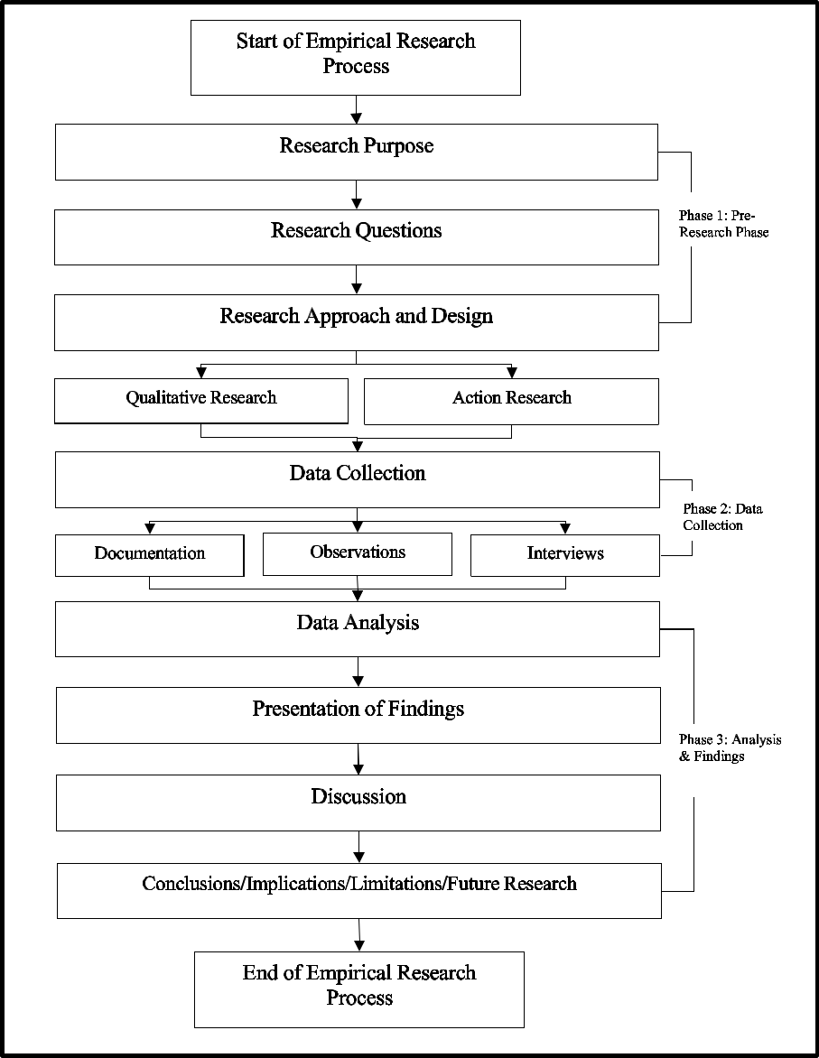

**Fig. 1** Empirical research process model

The triangulation of organisational documentation, observations and interviews allows to capture the ERP implementation process through experts’ perceptive lens. Steps include:

1. recognition of problem; 2) identify and recruit population/sample; 3) gather documenta-tion, conduct observations and interviews, analyse data, write up findings and take action/ decision-making. Therefore, this process coupled with the KJ method is an ideal fit because it aligns with the proposed AR methodology to analyse an ERP implementation in action (Kemmis et al. 2013).

1 3

118 Systemic Practice and Action Research (2023) 36:111–140

\ i.\ *Semi-structured interviews & Observations*

\Semi-structured interviews were conducted which enabled both flexibility and open-ness that provided a greater breadth of data (Myers and Newman 2007; Fontana and Frey 2000). 12 sessions of interviews were carried out while visiting the case study’s management premises during the initial phase of research. 10 further semi-structured interviews were eventually carried out in November 2021 to follow up on assessing the post implementation developments. Both stages of interviews, the initial stage and the follow up interviews, were audio recorded and the interviews’ recorded tracks were uploaded to computer-assisted qualitative data analysis software CAQDAS for audio-coding and analysis. The conduct of the follow up interviews was obstructed due to a series of political unrests and armed conflicts in the country since 2011. In view, the follow up interviews were carried out through online conference software due to the difficulties to revisit the case study’s management premises. The observation method was also applied to capture the follow-up of the ERP implementation within the studied organisation. The observation was guided by the theoretical framework (Iosifides 2011). During the course of observation, the researcher utilised field notes to record initial observations (Gebre-Mariam and Bygstad 2019). The outcome of this observation was used to provide contextual relevance allowing the researcher to describe the unit of analysis and compliment the previously conducted semi-structured interviews.

\ ii.\ *Documentary data*

\This research utilised the documentary review method to obtain retrospective to triangulate evidence to confirm/refute the initial stage of semi-structured interviews (Henfridsson and Bygstad 2013; Gebre-Mariam and Bygstad 2019) and assess post-implementation developments follow up interviews’ interpretations. The collected internal documents, through management facilitation, included ERP projects’ initia-tion documents business process and strategies, ERP project initiation documents, projects’ plans and meeting minutes and post-implementation challenges. Although the documentary review method was useful, it entailed some inherent limitations to be cautious of. For example, documents can involve varying levels of accuracy, reli-ability and comprehensiveness (Mogalakwe 2006). The meaning of information may also be unclear of which requires the researcher needs to verify further the meaning through other methods such as interviews (Mogalakwe 2006).

**Action Research (AR)**

The AR methodology proposed by Lewin (1946) encourages individuals to improve soci-ety and inspires to change industry’s working pattern and flow. Rapoport (1970) in Myers and Avison (1997) argues that the AR methodology is also an iterative process that consid-ers practical concerns of individuals in a given problematic situation. AR can therefore be used to manage the workflow and processes of various organisational activities. There is also no universal method to approach the AR process as different scholars have their own perceptions of AR. Evered and Susman (1978) outlined five steps of implementing AR activity: 1) diagnosing the problem through problem identification and definition; 2) plan for action by proposing methods and process to solve problem; 3) do i.e. action talking via practice action; 4) assess/evaluate: measuring overall performance; 5) lessons learned: propose new improvement methods and steps. Although similar AR processes have been proposed by other authors (Hjalmarsson et al. 2010; Kemmis et al. 2013), Evered’s and

1 3

|  |  |
| --- | --- |
| Systemic Practice and Action Research (2023) 36:111–140 | 119 |
|  |  |

Susman (1978) perception of AR best fits this paper as the findings suggest that the ERP implementation process followed a similar set of processes of plan, propose, do, asses and improve.

Although AR offers a great foundation for a qualitative and exploratory study of the IS implementation process, AR has been underutilised in the IS field (Checkland 1991; Lau 1999; Mumford 2001; Wood-Harper 1985). This prompted an AR approach to explore culturally complex challenges within oil and gas organisation operating in the middle-east (Braa and Vidgen 1999). AR was utilised in this research as it provided a roadmap and iterative process of evaluating the cultural challenges facing the pre-implementation (plan and propose), implementation (do) and post-implementation (assess and improve) stages of ERP projects conducted within an oil and gas organisation operating in the middle-east.

**Data Collection**

As part of the AR approach, a complete participatory on-site study within the ERP project’s implementation team was conducted. The implementation team comprised of a project manager, project leader, consultancy team (e.g. functional leaders) and IT team (e.g. tech-nical development managers), all of which are ERP specialists. This provided strong access and openness in terms of rapport and information. This access to knowledge and docu-mentation within the organisation helped to clarify that this research would be an active part of the organisational ERP implementation process (Avison et al. 1999). Although it is important to note that organisational users are active users of ERP who will have differing perceptions of the system, being actively on site allows action to be tracked on the basis of the data collected which adds to the validity of the research findings (Stringer 2013). So as part of the data collection process, field notes of daily observations were taken in addition to recording of events. This provided a deep understanding of the social/cultural and organ-isational context of the study, as well as to explore the “people culture” in ERP projects.

In addition to the observations of the ERP implementation process, data collection is done through multiple interviews based on the brainstorming sessions, discussions and meetings that took place during the implementation process. The unit of analysis for the interviews comprise of internal and external stakeholders. The internal stakeholders refer to the project manager and the project leader who work closely and manage with the exter-nal stakeholders. The external stakeholders refer to the ERP vendor who are involved with the deployment of the ERP system, provide SAP support and training, and provide practi-cal deployment and ERP consultancy services to Al-Shabam. Other external stakeholders include the researchers of this paper who were involved with the cultural research of Al-Shabam (the beneficiary) and the ERP vendor. In total, 12 ERP experts (1 project manager, 1 project leader and 10 ERP specialists) were interviewed who gave their feedback and experiences of the ERP implementation process, in addition to 3 cultural researchers who provided their sociotechnical expertise and personal experiences of the ERP project. An additional 20 stakeholders who were indirectly involved with the ERP project were omitted owing to their limited role during the process of the ERP project. A summary of the par-ticipants can be seen in Table 2.

Overall, 35 stakeholders were originally involved in the ERP project, but owing to the aforementioned omissions, 15 fully involved stakeholders were a part of the ERP project from start to finish. Furthermore, a similar process was carried out for the follow-up inter-views in which 8 ERP experts and 2 maintenance managers were interviewed, totalling 10 post-implementation interviews. The triangulation of documentation, supplemented

1 3

|  |  |  |  |
| --- | --- | --- | --- |
| 120 | Systemic Practice and Action Research (2023) 36:111–140 | | |
|  |  |  |  |
| **Table 2** Summary of participants |  |  |  |
| Participants | Interviews | Code |
|  |
|  |  |  |  |
|  | Implementation Phase |  |  |
|  | Project Manager | 1 | PM1 |
|  | Project Leader | 1 | PL1 |
|  | ERP Specialist | 1 | ERPS1 |
|  | ERP Specialist | 1 | ERPS2 |
|  | ERP Specialist | 1 | ERPS3 |
|  | ERP Specialist | 1 | ERPS4 |
|  | ERP Specialist | 1 | ERPS5 |
|  | ERP Specialist | 1 | ERPS6 |
|  | ERP Specialist | 1 | ERPS7 |
|  | ERP Specialist | 1 | ERPS8 |
|  | ERP Specialist | 1 | ERPS9 |
|  | ERP Specialist | 1 | ERPS10 |
|  | Post-Implementation Phase |  |  |
|  | ERP Specialist | 1 | PIERPS1 |
|  | ERP Specialist | 1 | PIERPS2 |
|  | ERP Specialist | 1 | PIERPS3 |
|  | ERP Specialist | 1 | PIERPS4 |
|  | ERP Specialist | 1 | PIERPS5 |
|  | ERP Specialist | 1 | PIERPS6 |
|  | ERP Specialist | 1 | PIERPS7 |
|  | ERP Specialist | 1 | PIERPS8 |
|  | ERP Maintenance Manager | 1 | MMERP1 |
|  | ERP Maintenance Manager | 1 | MMERP2 |
|  | Total: | 10 |  |
|  |  |  |  |

with data collection methods such as observations and interviews allowed the researcher to develop a holistic picture of the entire organisation using a joint construction of descrip-tive accounts of the situation (Creswell and Creswell 2018). A summary of semi-structured interviews conducted during both stages is detailed in Table 3.

**Data Analysis**

Data analysis procedure involved deducing the main themes from the triangulation of data taken from the collection process, which were when reapplied to sessions during the

|  |  |  |  |
| --- | --- | --- | --- |
| **Table 3** Participants’ interviews |  |  |  |
| Initial stage semi-structured interviews | |  |
| summary |  |
| Project Manager | | 1 h and 13 min interview |
|  |
|  | Project Leader | | 45 min interview |
|  | 10 ERP Specialists | | Total of 7 h of interviews |
|  | Follow up Observation | |  |
|  | 2 | ERP maintenance managers | 1 h discussion |
|  | 8 | ERP Specialists | Total of 4 h of discussion |
|  |  |  |  |

1 3

|  |  |
| --- | --- |
| Systemic Practice and Action Research (2023) 36:111–140 | 121 |
|  |  |

post-stages of the implementation process as part of the iteration process (Myers and Avi-son 1997). Although this provides active contextual implications which helped to facilitate the exploration of other issues or create a more in-depth analysis, the AR approach helped to further develop a collaborative verification of the context in question. In other words, the AR approach provides a more practical contribution to the body of knowledge regard-ing ERP implementation. For additional validation, data triangulation (Myers and Avison 2002), was utilised to internally check the validity of the data. A comparative method is also used to compare the observation findings and interview findings for additional valid-ity. With the data collection completed, common themes were identified and summarised to develop the findings and iterated the AR approach until the specific findings exhibited strong relations to the specific theme area.

**Findings**

**Background of Action Case**

The action case is based on a real-life ERP implementation project that was implemented in an oil and gas organisation situated in the middle-east. To protect the anonymity of the case organisation, the organisation is named under the pseudonym “Al-Shabam.”. Al-Sha-bam was established in the early 1970s to manage drilling operations for oil and gas mining and exploration in onshore areas. Main functions of the organisation include operational and technical responsibilities, namely onshore drilling operations, as well as consultancy and logistical roles, where logistical and functional support in terms of technical support, transportation and equipment is provided.

Functional and technical support roles were allocated to different sub-groups who made up the implementation team. Functional and technical roles were given to the ERP special-ists comprising of ERP consultants, a project manager and project leader, where knowledge integration activities concerning the ERP implementation is centered. The consultancy role involves knowing the best practices for assessing and deploying systems, mitigating risk, maximising return on investment and ensuring that the project remains on time and within budget. Specific duties include giving functional support to Al-Shabam during the develop-ment of the ERP project, as well as sharing industry knowledge, providing specialised skill sets ranging from functional expertise to risk migration, driving change management and providing training. ERP specialists were also tasked with installing the ERP software, sys-tem configuration, data migration and testing.

The scope of the current research is documenting the discord among the ERP special-ists, while considering the key cultural challenges of the ERP implementation process (Blackler 1993). The ERP specialists acted as facilitators throughout the research process and created insights through expert opinion and support (Baskerville and Wood-Harper 1996).

The timeline of the ERP implementation process was 3 years 7 months (2014–2017). During this time, the ERP specialists and researchers spent 6–8 months at each stage of the ERP implementation process where time was spent documenting and participating at the research site. The ERP researchers compiled documentation, including background infor-mation about Al-Shabam and their system requirements and needs. The implementation stages the ERP specialists were involved with were: 1) diagnosing the problem through problem identification and definition; 2) plan for action by proposing methods and process

1 3

122 Systemic Practice and Action Research (2023) 36:111–140

to solve problem; 3) do i.e. action talking via practice action; 4) assess/evaluate: measur-ing overall performance; 5) lessons learned: propose new improvement methods and steps. These steps reflect key components of the AR methodology, which is to define, propose, do, assess and improve.

During this entire process, the implementation of the ERP system was overseen and advice was given to Al-Shabam about the best methods to incorporate during this process. The advice given by the ERP specialists considered the cultural challenges facing ERP implementation as a means to alleviate or minimise any problems during the process (see Fig. 2 for summary of ERP process and Fig. 3 for the ERP Project Hierarchy from the Action Case).

**Case in Action**

This section aimed to address *RQ1: How do the culture-specific barriers affect each stage of the ERP implementation process?*

The case in action presents a real-world ERP implementation at an oil and gas organisa-tion (Al-Shabam) situated in Middle-East through. It provided insight into the process of implementing an ERP solution in an organisational context through an expert lens. The case in action provides an observational account of the experiences faced by the ERP spe-cialist who were working on the ERP project over a 3 year and 7 month period. The ERP system that the organisation had selected is SAP to manage functional and operational resources. The ERP system was implemented in five phases: plan, propose, do, assess and improve, which reflect the AR methodology (see Fig. 4).

**Plan (Pre‑Implementation)**

In the first step, key system and organisational requirements stage were defined based on the existing problem which was the absence of a resource management system. Here, clear system goals and organisational expectations were set together with the appointment of the ERP specialists who agreed on the timeframe and cost of the ERP project. This step took three months to complete. An observational account of the project’s stage is summarised as follows.

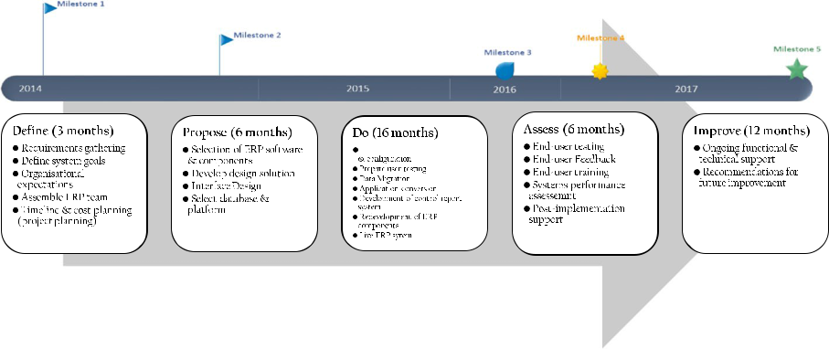

**Fig. 2** ERP implementation process based on action case

1 3

|  |  |  |  |  |  |  |  |  |  |  |  |  |  |  |  |  |  |  |  |  |  |  |  |  |
| --- | --- | --- | --- | --- | --- | --- | --- | --- | --- | --- | --- | --- | --- | --- | --- | --- | --- | --- | --- | --- | --- | --- | --- | --- |
| Systemic Practice and Action Research (2023) 36:111–140 | | | | | | | | | | | | | | 123 | | | | | | | | | | |
|  |  |  |  |  |  |  |  |  |  |  |  |  |  |  |  |  |  |  |  |  |  |  |  |  |
|  |  |  |  |  |  |  |  |  |  |  |  |  |  |  |  |  |  |  |  |  |  |  |  |  |
|  |  |  |  |  |  |  |  |  |  |  |  |  |  |  |  |  |  |  |  |  |  |  |  |  |
|  |  |  |  |  |  |  |  |  |  |  |  |  |  |  |  |  |  |  |  |  |  |  |  |  |
|  |  |  |  |  |  |  |  |  |  |  |  |  |  |  |  |  |  |  |  |  |  |  |  |  |
|  |  |  |  |  |  |  |  |  |  |  |  |  |  |  |  |  |  |  |  |  |  |  |  |  |
|  |  |  |  |  |  |  |  |  |  |  |  |  |  |  |  |  |  |  |  |  |  |  |  |  |
|  |  |  |  |  |  |  |  |  |  |  |  |  |  |  |  |  |  |  |  |  |  |  |  |  |
|  |  |  |  |  |  |  |  |  |  |  |  |  |  |  |  |  |  |  |  |  |  |  |  |  |
|  |  |  |  |  |  |  |  |  |  |  |  |  |  |  |  |  |  |  |  |  |  |  |  |  |
|  |  |  |  |  |  |  |  |  |  |  |  |  |  |  |  |  |  |  |  |  |  |  |  |  |
|  |  |  |  |  |  |  |  |  |  |  |  |  |  |  |  |  |  |  |  |  |  |  |  |  |
|  |  |  |  |  |  |  |  |  |  |  |  |  |  |  |  |  |  |  |  |  |  |  |  |  |
|  |  |  |  |  |  |  |  |  |  |  |  |  |  |  |  |  |  |  |  |  |  |  |  |  |
|  |  |  |  |  |  |  |  |  |  |  |  |  |  |  |  |  |  |  |  |  |  |  |  |  |

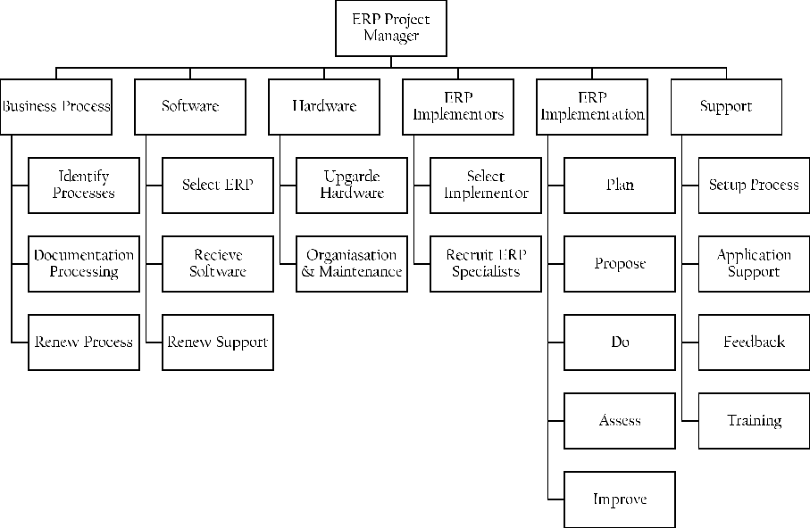

**Fig. 3** Al-Shabam ERP project hierarchy from the action case

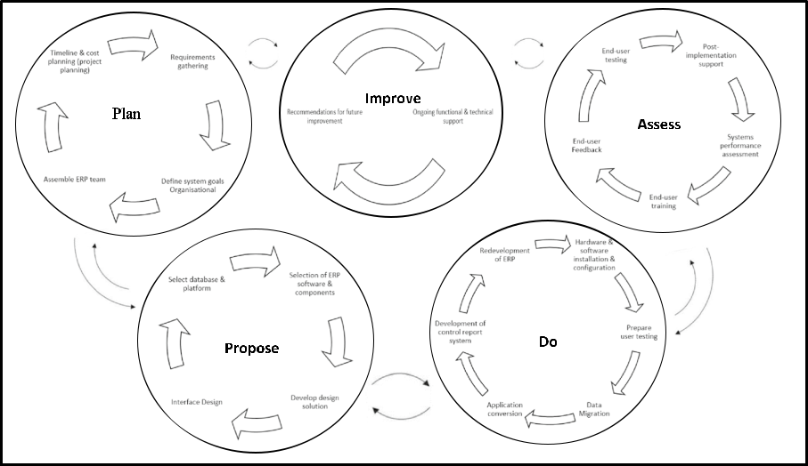

**Fig. 4** Iterative typology of cultural barriers facing ERP implementation

A key observation in this stage was building ERP implementation teams and establish-ing social networks within Al-Shabam. The ERP specialist team comprised of 10 mem-bers, who were expert consultants and researchers of ERP SAP implementation. Although team’s immediate task was to evaluate existing drilling systems and organisational prac-tices, Al-Shabam had very few information systems and many of the data they had was

1 3

124 Systemic Practice and Action Research (2023) 36:111–140

paper-based. This would prove to be a huge challenge for the ERP specialists later into the process in terms of data migration as it required not only the migration of data, but also digitise the paper data through transcription. Therefore, these additional requirements would result in huge delays in the project.

The ERP specialists were tasked with drafting project requirements, such as pre-systems analysis and brainstorming ideas to advise Al-Shabam about what ERP solutions (e.g. SAP or Oracle) to adopt for the implementation stage, whilst considering user and organisa-tional requirements. This was observed to be a critical task in ERP implementation process as this required the ERP specialists to draft a list of relevant ERP solutions that aligned with Al-Shabam’s organisational requirements. Ideas were shared amongst the ERP spe-cialists to propose the most suitable ERP implementation strategy. The cultural problems arising from these were related to the complexity of the Al-Shabam’s technology culture due to the implementation issues faced e.g. delayed data migration, complicated relation-ship between potential vendors and Al-Shabam and the culture of the ERP software itself, namely the integration of western developed software in middle-eastern culture, which cre-ates a misunderstanding of how the ERP software functions.

**Propose (Pre‑Implementation)**

In the second step, the plan for action involved selecting a suitable ERP software package by assessing the selection of a single ERP (e.g. SAP or Oracle) and the best of breed (e.g. choosing the most suitable module for each functional area). It was observed that after careful assessment of the pros and cons of each ERP solution, the ERP specialists opted for a SAP solution as the cost fell within the project budget (US$8 m) and would take the least time to implement (1–2 years), thus finishing before the projected deadline (3 years).

In terms of best of breed, SAP was found to have a variety of modules including Finan-cial Accounting (FI), Controlling (CO), Sales and Distribution (SD), Production Planning (PP), Materials Management (MM), Quality Management (QM) and Human Capital Man-agement (HCM). Since the main operations et al.-Shabam include, drilling, consultancy and logistical roles, where technical support, transportation and equipment is provided, CO, SD, MM, QM and HCM were the proposed modules. CO due to its ability to conduct control planning, monitoring and reporting processes for material handling. SD and MM because of inventory control and distribution of oil resources. QM to manage quality in production. And HCM to enhance working processes and data management.

Once the ERP solution was decided, the next part of this stage was to consider the design of the solutions by consulting about the user interface of the ERP and what plat-forms to consider installing the ERP on. The ERP specialists had completed the hardware specification and based on this specification and consultation from the team, a combina-tion of Dell and Compaq servers were obtained for data hosting. These servers opened a window of opportunity as to which platform to host the ERP data, which ended up being Microsoft SQL Server. This decision was down to existing relations between the ERP specialists and Microsoft who collaborated in previous ERP projects. This also increased installation times as existing computers were already hosting a windows 7 operating sys-tem, together with MS Office and MS Exchange server for word processing and email. As the plan for action phase was drawing to a close, the IT and consultancy teams moved to the development phase. This step took 6 months to complete.

Moreover, the cultural challenge arising from this were mostly down to sharing knowl-edge and decision making since the ERP specialists had many proposed methods to

1 3

|  |  |
| --- | --- |
| Systemic Practice and Action Research (2023) 36:111–140 | 125 |
|  |  |

implement the ERP, which led to conflicting ideas and huge debates. A SAP solution was finally agreed among the ERP specialists after a weeks’ worth of debates, which delayed the project. Despite coming to a final decision, conflicting mind-sets and attempts to assert authority over certain decisions being made among the ERP specialists had delayed this stage significantly. This was mostly down the project manager favouring one idea over another without any critical thought or rationale. This seemed to be a recurring issue dur-ing the entire process because as soon as an idea which the manager favoured was brought up, he seemed agree with that idea immediately without any thought. Both teams assumed that the project manager asserted his authority to speed up the process as the ERP project was already behind schedule. After much conflict and debate, everyone came to a mutual understanding and the project manager was advised by the consultants and researchers to think carefully about the decisions being made, even if it delays the project.

**Do (Implementation)**

In the third step, the action talking phase reflects the development and actual implementa-tion of the ERP solution. Here, the following activities were carried out: 1) setting up hard-ware; 2) installing and configuring the MS SQL server on the database server; 3) install-ing SAP on the platform, in addition to establishing a testing environment on a separate server; 4) prepare for user testing; 5) configure SAP applications; and 6) data migration and conversion of existing applications. Although the development phase ran smoothly, the actual implementation phase ran into a few problems. This was mostly down to the instal-lation of an oil and gas control reporting system that facilitates the process of maintaining recorded to measure the quantity of products. Production scheduling and logistical compo-nents, which are software driven, for this particular sector has to be equipped with a feature which enables users to record the distribution and movement of raw materials and products from one place to another. However, ERPs for oil and gas organisations are lacking such a feature, not to mention the culture surrounding the software itself, since the software was designed for western companies.

As a solution, Al-Shabam reached out to an ERP vendor who gave stakeholders the training required to use the ERP system that was capable of controlling oil and gas resources, as well as provide operations management and production scheduling features that aligned with Al-Shabam’s organisational culture. In spite of this solution, this delayed the implementation process by 1 year. Additional redevelopment of user interfaces, chang-ing requirements and initial user testing had further delayed the project by 6 months, thereby resulting in a cumulative 16 month delay. The implementation step was initially set to be completed within 1 year. These delays came about due to several cultural challenges, which all started at the early stages of the SAP system installation. The objective was to first install the ERP system into Al-Shabam’s production environment. Regular technical meetings were held among the ERP specialist team. The data taken from the existing leg-acy systems were verified to ensure nothing was left behind. The cultural challenges which arose were mostly related to the data migration deliverable, such as team conflict, cultural resistance, conflicting culture regarding ERP software, communication issues and authori-tarianism among the management team.

Team conflict arose due to a clash of ideas regarding the data migration method. Some members of the ERP specialist team thought that transcribing the data from paper-based to digital would be time consuming and rather start a fresh system, whereas the other mem-bers argued that it was necessary owing to the important production data in those files.

1 3

126 Systemic Practice and Action Research (2023) 36:111–140

Much debate about this issue severely delayed the project, though a middle-ground was finally agreed among the ERP specialists to transcribe the data and input it into the ERP system.

Cultural resistance, communication issues and authoritarianism were observed through the project manager’s decisions and action throughout the implementation process. Both teams during this process were constantly reminded by the project leader regarding a sys-tem that is functionally complex and culturally sensitive and one that would facilitate an autonomous environment of control and competition. It was discovered by the ERP spe-cialists that at the initial implementation stage, employees did not want to take new respon-sibilities due to laziness and do not feel the importance of the new system to facilitate their daily duties, as well as and adopt new processes that resulted from implementing the ERP system. Overall, the process was long and chaotic in the first 2 years, but with support from the ERP specialists and providing user feedback, helped to improve the overall success of this stage. Despite exceeding the deadline, Al-Shabam were satisfied with the implementa-tion phase once all of the key deliverables were met.

**Assess (Post‑Implementation)**

In the fourth step, the overall performance of previous three steps are assessed and evalu-ated. Therefore, this stage served as a reflection to the entire ERP implementation pro-cess from the initial stage to the post-stage. When the development and implementation of SAP was completed, user testing was carried out and staff training on using SAP was conducted. The user testing element was a good way to assess the performance of the pre-vious three phases as it helped to measure the extent of meeting both organisational and system requirements, as well as evaluating the quality of the developed ERP system and its features. Testing results showed mixed results and Al-Shabam had great expectations for SAP and was expecting beneficial outcomes.

Cultural challenges which arose from this process were mostly conflict-debate related as several ERP specialists were in disagreement with the final outcome of the implementa-tion. Some ERP specialists felt that the process was rushed and ongoing disputes in the team were the result of this, which effectively delayed the project. Other ERP specialists argued that the process went smoothly because of the advice they gave to Al-Shabam, though some ERP specialists felt that some of that advice was not taken on board because of the project manager’s authority over the project and his mentality of rushing the project in order to make up for previously missed deadlines.

The feedback obtained from the assessment could help to raise awareness to not only Al-Shabam, but also similar oil and gas organisations who are going through a similar process of transitioning from traditional legacy systems to ERP. The ERP specialists were tasked to give further advice as to how the organisation can maintain the ERP and maxim-ise the benefits from it after testing was complete. This step took around 6 months to com-plete. Although the post-implementation phase faced some cultural challenges, which led to the project finishing beyond the set deadline and over the initial budget, an actual system was fully implemented.

In January 2022, the researchers conducted a follow-up study of Al-Shabam to observe how the ERP system had supported the company after post-implementation and beyond. Since face-to-face observations were not possible owing to the pandemic and travel restric-tions, an online video conferencing tool was used to conduct the observations. The obser-vations served to assess whether ERP had effectively improved company operations, and

1 3

|  |  |
| --- | --- |
| Systemic Practice and Action Research (2023) 36:111–140 | 127 |
|  |  |

notes of the participant discussion were taken. The software in question was a secure remote tool known as team viewer, which enabled the researchers to observe the study setting without compromising any of the organisation’s private information. Prior to the observations, a pre-plan of how the observations would be approached, such as ensuring the company that their personal information was not shown on the screen or anything else that would compromise the privacy of the company.

Initially, there was a period of uncertainty as soon as the ERP went live and after the researchers had left, which led to some misunderstanding among users. Bugs were reported and some retraining was conducted, as well as system tweaking, and assistance from the maintainers of the system. However, not all of these areas were not addressed properly as it was reported by the maintenance team that despite their efforts to reduce the system bugs that hindered system performance, new staff were not properly trained and found it difficult to use the ERP; this created another culture of technophobia.

However, in the first few years, Al-Shabam begun to see the fruits of their investment. After a while, existing users felt more at ease with the interface and have more control over it. In the future, the company plans to develop new new reports, workflows, and some localisation. To cover the cost of service level agreement maintenance, the vendor’s licence fee will be paid. On-site maintenance for a complex system will now be handled by a third-party vendor. Furthermore, changes in technology occur concurrently with changes in busi-ness. New releases and versions of technology platforms such as operating systems and databases are available. The existing system soon become outdated within the first few years and needed to be updated on a regular basis in order to keep up with the latest ERP updates; however, the updates have been far and few due to budgetary constraints. With the rise of the COVID-19 pandemic, the requirements for the company’s business and techno-logical infrastructure have changed and will continue to change as technology advances. Updating and modifying the current system is expensive and fraught with complications. As a result, it is becoming increasingly difficult for the company to update and adapt the system. After considering other options, the company has decided that reimplementation is required since they have not adapted well to the changing landscape of technology, particu-larly since the pandemic.

**Improve (Lessons Learned)**

In fifth and final stage, advice to improve the ERP process based on the feedback given by the ERP specialists are provided. This helps to create an account of the lessons learned from the entire process by reflecting on the cultural barriers identified from the process and developing potential solutions to overcome them. The feedback was obtained via post-implementation interviews of the ERP specialists who worked closely with Al-Shabam at the critical stages of the ERP implementation process. This helped to develop post-imple-mentation strategies that acted upon the further lessons learned from the process.

Although the system was rolled out in the third year (2 years 7 months), meeting the initial deadline of 3 years, the SAP contract was extended for another year to provide ongoing development, as well as functional and technical support until system maturity was achieved. As part of proposing new improvement methods and steps, the extension of the SAP contract was based on the mixed feedback from the user testing feedback as some users reported difficulties of using the system in addition to other personal and technical. Therefore, the ERP team had to act upon these problems. The project took 3 years and 7 months to go fully live within Al-Shabam. Although this was counted as

1 3

128 Systemic Practice and Action Research (2023) 36:111–140

a success, the ERP process was considerably delayed within the third year owing to the mixed user feedback and having to extend the SAP contract, which delayed the system going live for another year, thus exceeding the initial deadline of 3 years.

The cultural barriers were categorised based on the stages in which they arose dur-ing the implementation process and their respected resolutions. Therefore, this section aimed to address *RQ2: What lessons can be learned from the ERP implementation pro-cess in the oil & gas sector in the Middle Eastern context?* The lessons learned reflectthe prior four stages of plan, propose, do and assess.

**Plan & Propose (Pre‑implementation)**

Several implications arose during the pre-implementation stage, such as conflicting ideas and mind -sets, authoritarianism, managerial conflict, change management and communication issues.

When coming to an agreement regarding the ERP project contract, several issues arose regarding to the Service Level Agreement (SLA), more predominantly from the language and culture in which the SLA was drafted (English written US SLA). One ERP specialist stated that:

*“A translator had to be hired to translate the SLA from English to Arabic in order for Al- Shabam to understand the SLA. A lesson learned from this process is to ensure that future SLAs are available in different languages to prevent delays of the project because of the need to hire a translator, which could have been avoided in the first place.”*

Installing a user integrity team for continuous transition into stabilisation and refinement of the system to minimise system future problems and team conflict as rec-ommended by another ERP specialist:

*“An integrity team should be brought in post-project to continue to support and learn the cross -functional processes associated with the system and end users. So the success of the system relies on continuous improvement strategies. This would resolve any authoritarian, communication, and change management issues going forward as managerial cooperation is a significant component of the pro-cess.”*

The ERP research team during the pre-implementation stage had identified potential risks, which are associated with the micro culture through conducting a risk assess-ment. An ERP specialist raised the issue concerning the risk of scepticism among Al-Shabam’s top management, such as religious holidays and policies of sick leave, in addition to conflicting ideas and discussions regarding the project. These risks were grossly overlooked whilst conducting the pre-implementation risk assessment, which would later lead to significant delays in the implementation and post- implementation stage, and ultimately led to the project exceeding the deadline by over two years. The ERP specialist therefore recommended:

*“…conduct a thorough risk assessment that takes into account human and tech-nological concerns as a precautionary measure to future potential risks of the ERP project, and ultimately minimise project delay.”*

1 3

|  |  |
| --- | --- |
| Systemic Practice and Action Research (2023) 36:111–140 | 129 |
|  |  |

**Do (Implementation)**

During the ERP implementation stage, problems surrounding the use of ERP software was a huge dilemma for the ERP specialists since the majority of ERP software is developed within a western culture, which in a middle-eastern culture would not translate well. An ERP specialist stated:

*“During the time of implementation, ERP software were English only, meaning that no Arabic versions were available. Even the English to Arabic translation was unclear owing to the culture in which the ERP software was developed, and thus the company found it difficult to understand. The lesson learned is that a user guide should have been developed in both English and Arabic in order to understand the functionality of the ERP software.”*

Expressing concerns about improving efficiency in terms of cost, an ERP specialist expressed their desire to:

“*Simplifying the system could reduce implementation expense and support common definitions for reporting purposes. Lesson learned here is that a more simplified sys-tem encourages ideas about the ERP system. This also provides a universal under-standing of the system so that all stakeholders are able to use the system.”*

Another ERP specialist stated that infrastructure was an important cultural barrier in which:

*“…limited technical resources resulted in a poor internet connection, this hindering the ERP infrastructure.*”

As a solution, an ERP solution was proposed with support of localised SAP modulation in which resources would be centralised locally as opposed to online, as well as the devel-opment of ERP software that suited the Al-Shabam’s organisational culture owing to the organisation’s incompatibility with western developed ERP software.

Although a more rigorous storage solution needed to be implemented to meet the local data demands of the organisation, this would create less of an inconvenience for the organi-sation because online centralised resources would become difficult to access or made una-vailable in the event of a slow internet connection or no connection at all. Therefore, data culture played a significant role to ERP success at the organisation.

**Assess (Post‑Implementation)**

An ERP specialist indicated that the system had some problems and developing strategies to sustain and maintain the system was vital to ongoing success:

*“We agreed that the continuous improvement and success of the system required the use of effective communication, commitment from our team and change management from the implementation strategies as conflict-debate was a recurring issue before and during the ERP process.”*

Additional continuous strategies pointed out by the ERP specialists included effective training of company stakeholders, performance metrics and upgrades to ensure that the ERP system is running efficiently beyond post-implementation:

1 3

130 Systemic Practice and Action Research (2023) 36:111–140

*“…given the limited knowledge of the ERP system among stakeholders, training is needed. A lesson learned is that future projects should seek training from the ERP vendor to ensure that the company stakeholders are able to use and benefits from the ERP system.”*

Throughout the years since the ERP’s implementation, some intriguing findings have emerged. Prior to the COVID-19 pandemic of 2020, company stakeholders were eventu-ally trained on how to use the ERP effectively, but to no avail, as stakeholders resisted the ERP:

*“…although I was given the training to use the new ERP system, I still prefer the old routine because this forced me to do something out of my comfort zone, thus chang-ing the way I deliver the work to my superiors, which I believe has decreased.”*

Absence of expertise, particularly during the pandemic, had an effect on the ERP’s functionality. While some stakeholders believed that the ERP would play a critical role in managing enterprise resources during the peak of the pandemic, others feared that the technology would cause harm to the company because it would be unsupervised by them but monitored off-site:

*“…I feared that since the ERP project team is usually supported by a project man-ager, who drives the process based on an implementation methodology of defining milestones together with the team and provides valuable input, the absence of this degree of expertise would impact the way the ERP would support the organisa-tion. It was a complete disaster because the pandemic had us all locked down and we were unable to supervise the system on-site.”*

The following descriptive statistics provide insight into the extent of the impact of post-implementation challenges associated with the ERP system on the organisation. Several of the critical implementation challenges identified by the majority of stakeholders as con-tributing to the ERP’s "failure" in the modern era ranged from technophobia to external influences such as pandemics. When the ERP was first implemented in 2017, some stake-holders were receptive to using it because they believed they had benefited from it for a few years prior to the pandemic, which altered their perception of the ERP. This change in perception culminated in a series of challenges, which are summarised below, stating with the most common to least common. A sample of 100 stakeholders were asked to fill out a post-implementation questionnaire, which helped to capture the below data (see Table 4):

**Table 4** Frequency of post-implementation challenges

|  |  |
| --- | --- |
| Challenges | Frequency |
|  |  |
| Technophobia | 32 |
| Lack of Commitment to Training | 20 |
| Digital Divide | 13 |
| Poorly Defined Goals for the ERP Software | 10 |
| Lack of Sufficient Management Commitment | 8 |
| Missing Expertise on Project Team | 4 |
| Lack of Open Communications | 4 |
| Production Processes Not Clearly Defined | 6 |
| Underestimating Data Migration | 3 |
| Total: | 100 |
|  |  |

1 3

|  |  |
| --- | --- |
| Systemic Practice and Action Research (2023) 36:111–140 | 131 |
|  |  |

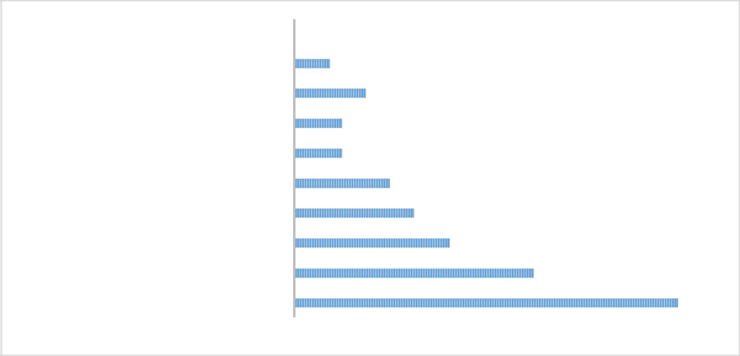

Underes„ma„ng Data Migra„on

Produc„on Processes Not Clearly Defined

Lack of Open Communica„ons

Missing Exper„se on Project Team

Lack of Suﬃcient Management Commitment

Poorly Defined Goals for the ERP So•ware

Digital Divide

Lack of Commitment to Training

Technophobia

0 5 10 15 20 25 30 35

**Fig. 5** Frequency of post-implementation challenges

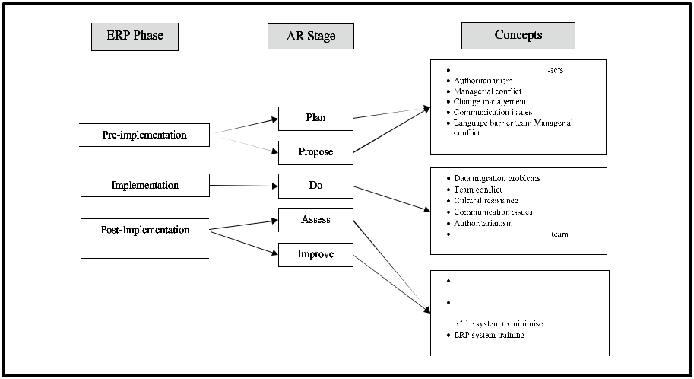

**Fig. 6** Cultural barriers in action case process

Table 4 and Fig. 5 above clearly indicate that technophobia and a lack of commit-ment to training are the most frequently cited challenges by stakeholders, correlating with the interview findings that a fear of technology and a lack of training would inhibit their willingness to embrace new technologies.

Figure 6 additionally showcases a typological framework of the cultural challenges arising before, during and after ERP implementation through an AR lens.

Following the results of 2017 and the post-implementation questionnaire, the researchers requested an update from Al-Shabam regarding the current state of the ERP system and whether the system was facilitating its operations. The observations used to conduct the follow-up revealed some intriguing findings, particularly in regards to the current state of the organisation during the current COVID-19 pandemic.

1 3

132 Systemic Practice and Action Research (2023) 36:111–140

Although Al-Shabam requested a reimplementation of their ERP given their struggles of adapting to the more recent technological trends, they had to make do with what they had. An ERP specialist during our observation stated that rapid changes in company policy and the implementation of pandemic restrictions would require the company to respond quickly to such changes in order to survive:

*“Controlling rapid change, whether internal or external, changes will occur quickly, and businesses we must adapt quickly. Our ERP enables this through the use of ana-lytics for rapid management decision-making.”*

One of the ERP maintenance managers stated that automating existing manual pro-cesses will allow them to focus on the impact of COVID-19:

*“…automating manual processes and approvals that are performed on a routine basis. This enables management to concentrate its efforts on mitigating the crisis’s impact.*”

Since remote work was possible through their existing ERP, the company enabled this feature to allow workers to access the ERP from home:

*“We were able to connect our existing ERP to other business systems and provide users with remote access to business data and the ability to work from home by ena-bling remote working in our existing ERP.”*

Although the researchers could not physically observe the users working from home, one of the ERP maintenance managers gave details of how the process works:

*“Users from home can access our portal, which is a sub-domain of our main web-site. The user logs into the ERP and are presented with a bunch of options and fea-tures. The system works similarly to a cloud architecture where masses amounts of data can be accessed from an external location via the user’s home computer. The downside to this is sometimes the users’ internet would be unavailable, preventing them from working. However, this was the best option at the time given the COVID-19 restrictions.”*

Similarly, an ERP expert mentioned that automation had reduced reliance on human labour, this requiring fewer employees to work from home:

*“With capabilities for integrating business processes, as well as managing our oil and gas resources, ERP provides the functionality necessary to minimise human intervention.*”

Another ERP expert claimed that despite the cloud ERP promoting automation and the need for fewer stuff, it still needed to be maintained by a human who required training:

*“We had recently trained our staff to use the ERP on-premises, but the pandemic changed the landscape of how we used the ERP since most of our staff had to work from home. This limited our options on how to train home users of the system. They had to work out how to use the system on their own, which I felt hindered the perfor-mance of the employees since they were not going off thorough training, but what was self-taught by the employees.”*

Additional lessons can be learned by assessing the existing process and the post-imple-mentation process based on the observations. To begin, there is an initial ethical con-cern regarding the observation conducted by the researchers via the remote digital media

1 3

|  |  |
| --- | --- |
| Systemic Practice and Action Research (2023) 36:111–140 | 133 |
|  |  |

platform. The researchers needed to ensure that the remote digital media platform did not reveal any information about Al-private Shabam’s company, but there was no such policy in place. This was something that the researchers considered throughout the observation process. As a result of this situation, and for future researchers to apply, a lesson that could be learned is that there must be a pre-existing policy in place for research conducted in this manner in order to avoid violating privacy and data protection regulations.

ERP systems must be upgraded in the event of a crisis. The Al-Shabam case dem-onstrates that a lack of training can impair not only employee performance, but also the ERP’s performance. As a result, there is a need to enhance the ERP system to ensure that it operates efficiently in the new normal or during times of crisis. This, however, may neces-sitate a software migration or an upgrade of the existing solution to provide more powerful capabilities. Although a cloud-based architecture was possible with Al-ERP, Shabam’s it did not provide the continuity they desired, necessitating additional training and mitigating potential technophobia.

**Conclusion**

**Summary of Findings & Recommendations**

In general, this study discovered that technophobia and a lack of commitment to train-ing were the most frequently cited barriers to adoption by stakeholders, meaning that a fear of technology and a lack of training would inhibit their willingness to embrace new technologies. This was reinforced during the post-implementation phase and subsequent observation. For example, some employees were still fearful of technological change, and those who overcame this were soon confronted with a greater challenge, as they now had to relearn how to use the ERP system with their home computers, as well as the cloud features of the adapted ERP, which they were unfamiliar with. With these new findings, Al-Shabam is currently at the re-implementations stage, since the ERP system has to align with current company policy in light of the pandemic and to allow staff to relearn the sys-tem in a home work environment. As a result, this overwhelmed the employees, who had just overcome one obstacle but were forced to relive it due to the pandemic.

Additional findings from the follow-up stage included the development of a limited policy to protect researchers and businesses that conduct remote communication activi-ties. Although the researcher’s suggestion to send a pre-plan prior to the observations was a good idea, it was based on a suggestion rather than a set protective policy that could prevent the disclosure of company information. Thus, any future researchers conducting remote observations must have a clear policy in place to protect themselves and the organi-sations with which they work and to ensure compliance with privacy and data protection laws. The following advice could be considered during future research processes:

•\

•\

It is important to think carefully about whether or not the subject matter is appropriate for an online interview. It is important for researchers to consider how an interview with a participant may affect his or her well-being before, during, and after the inter-view.

Any concerns about that need to be considered for remote-based action research activi-ties?

1 3

134 Systemic Practice and Action Research (2023) 36:111–140

•\ In advance of the interview, focus group or observation, participants should be given a policy, preferably from the publishing organisation or institution, complete an elec-tronic consent form and email it to the researcher. It is good practise to then verbally re-confirm informed consent for participation at the start of the interview. Participants should be given this policy in advance.

•\ When conducting online interviews or observations, researchers are advised to make use of TeamViewer, Zoom, Microsoft Teams, or Skype. Data security has been verified on these safe platforms.

•\ The Participant Information Sheet should clearly indicate if the interview will be recorded.

•\ Think about how standard procedures could be adapted if it is not culturally appropri-ate to collect identifiable consent. At the outset of the interview or observation, verbal consent might be appropriate.

•\ Ensure that a quiet and private location is chosen where the screen cannot be seen by others while conducting research. Use headphones instead of computer speakers if con-ducting research in an open area where other non-participatory parties over hear the conversation.

•\ Careful consideration must be given to the storage location of an interview recording. Records should be downloaded, moved to a more secure location, such as a OneDrive, and then deleted from the main system, as anyone who participated in the video con-ference can access it for a period of time; only researchers and authorised individuals (namely, the interviewer, and the interviewee) should be allowed access.

**Theoretical and Practical Implications**

The previous literature has highlighted the complexity of the ERP implementation process and concludes that additional research was required to explore the problems that influence the success/failure before, during and after this process. Although this study provides an understanding of the theoretical implications of ERP implementation, on a practical level, much is still needed to be explored to fully capture the implications of the ERP imple-mentation process. However, this paper offers research practitioners a first-hand experience of the ERP implementation process through an Action Research lens by documenting a real-world ERP project at the plan, propose, do, assess and improve stages and the cul-tural challenges faced at each of these stages, as well as to explore the “people culture” in ERP projects. The main focus of exploring the cultural challenges at each implementation stage may potentially contribute towards providing insight into what extent ERP challenges impact each of these stages and provide potential solutions to overcome these complexi-ties from an action research perspective. Although the literature highlights various ERP implementation theories that aim to overcome the cultural complexities of ERP systems, to the best of our knowledge no study has framed these complexities through action research theory to provide potential solutions to overcome them.

Moreover, this paper provides valuable insights into understanding the cultural impli-cations of ERP implementations in oil and gas organisations in Middle-East. Align-ment of typical ERP processes with an action case of oil and gas organisation has been proposed as a significant step in the ERP implementation process. After a 3 year and 7 month implementation process in the organisation, there were mixed results in this case. Noticeable improvements were observed after SAP solution was implemented, but the emphasis on this paper were on the cultural implications that delayed the ERP

1 3

|  |  |
| --- | --- |
| Systemic Practice and Action Research (2023) 36:111–140 | 135 |
|  |  |

project from meeting its initial deadline of 3 years. From this implementation expe-rience, although an ERP solution can help to revolutionise and transform the way resources are planned and managed, cultural implications can delay the opportunity for organisations to benefit from their ERP solution. Therefore, the initial planning of ERP projects has to involve proposing an implementation strategy in order to minimise the potential issues that could face the successive stages.

ERP teams have to also be weary of potential uncertainties at each stage that could delay an ERP project, irrespective of the effectiveness of the implementation strategy. In this regard, organisations have to be proactive by informing ERP teams about the potential risks and to mitigate them even before they have the opportunity to metasta-sise. Therefore, future researchers have to adopt a proactive and innovative approach to their research methods when evaluating the ERP implementation process, and thus could be an opportunity to adopt more hands-on techniques such as risk assessment and project management methodologies in studying this area. In short, this paper contrib-utes to theory and practice by highlighting the culturally complex barriers that underlies many ERP implementations in the oil and gas sector. Team conflict, managerial author-ity and poor IT culture were the main contributors to the delay of ERP implementation and post-implementation.

**Research Limitations**

One research limitation is that the study specifically focuses on ERP implementation in oil and gas organisations situated in the Middle-East, which in turn provides a narrow research scope and limits the findings. The focus on ERP implementation is another limitation since the study ruled out the implications of oil and gas organisations needing to adopt ERP systems to assess its feasibility. The final limitation refers to the conditions of the empiri-cal research process and the action research approach. This was a lengthy research process which spanned across several years owing to each stage of the ERP project taking an aver-age of 8 months to complete, in addition to the project delays. A considerable amount of time, effort and resources were invested to piece together this research. Therefore, future researchers pursuing this area of research must be prepared to invest time to conduct this type of research.

**Future Research Recommendations**

Although our research targets an academic audience, practitioners can benefit from our case observations and different statements of project stakeholders to better plan and man-age their future ERP initiatives. This would encourage the development of industry stand-ard ERP implementation strategies in order to minimise future complexities during each stage of an ERP project. Given the narrow scope of this research which was exploring the culture-specific challenges facing ERP implementation in oil and gas organisations, future studies could take this context to broaden the research scope to include similar types of organisations, such as energy companies who specialise in certain types of energy, such as wind or solar among others. A comparison between ERP implementation in non-renewable energy organisations and renewable energy organisations could be an interesting area of future research.

1 3

136 Systemic Practice and Action Research (2023) 36:111–140

**Appendices**

*Appendix 1: Post-Observation Sheet*



|  |  |  |
| --- | --- | --- |
|  | **Name:** | ERP Implementation Follow Up |
|  |
|  |  |  |
|  | **Date:** | 24/01/2022 |
|  |
|  |  |  |
|  | **Beginning Time:** | 2:00pm |
|  |
|  |  |  |
|  | **Ending Time:** | 3:00pm |
|  |
|  |  |  |
|  |  |  |
|  | **Number of** | 10 |
|  | **Employees:** |
|  |  |
|  |  |  |
|  | **Other General** | N/A |
|  | **Information:** |
|  |  |

**Layout (from perspective of**

**online TeamViewer):**

1 3

|  |  |  |  |  |  |  |  |  |  |
| --- | --- | --- | --- | --- | --- | --- | --- | --- | --- |
| Systemic Practice and Action Research (2023) 36:111–140 | | | | | | | 137 | | |
|  |  |  |  |  |  |  |  |  |  |
|  |  |  |  |  |  |  |  |  |  |
|  |  |  | **Time** |  |  | **Actions and Statements** |  |  |  |
|  |  |  | 2-3pm | Observation start – all issues | | below were mentioned by the employees e.g. specialists | and |  |  |
|  |  |  |  | maintainacne managers |  |  |  |  |
|  |  |  |  |  |  |  |  |  |

Disucssuin started with issues of uncertainty as soon as the ERP went live and after the researchers had left; misunderstanding among users



|  |  |  |  |  |
| --- | --- | --- | --- | --- |
|  | Bugs were reported and need for system tweaking, and assistance from the maintainers | | |  |
|  |  |  |  |  |
|  | Not all areas were not addressed properly…reported by the maintenance team that despite their | | |  |
|  | efforts to reduce the system bugs…new staff were not properly trained…found it difficult to use the | | |  |
|  | ERP | | |  |
|  | Existing users felt more at ease with the interface with more control | | |  |
|  | Company plans to develop new new reports, workflows, and some localisation. | | |  |
|  |  |  |  |  |
|  | To cover the cost of service level agreement maintenance, the vendor's licence fee will be paid. | | |  |
|  | On-site maintenance for a complex system will now be handled by a third-party vendor. | | |  |
|  |  |  |  |  |
|  | Changes in technology occur concurrently with changes in business…New releases and versions | | |  |
|  | of technology platforms | | |  |
|  | Existing system soon become outdated within the first few years and needed to be updated on a |  |  |  |
|  | regular basis…updates have been far and few due to budgetary constraints…COVID-19 chagned | | |  |
|  | the requirements for business and technological infrastructure |  | |  |
|  | Updating and modifying the current system is expensive and fraught with complications. | | |  |
|  |  |  |  |  |
|  | Reimplementation is required since they have not adapted well to the changing landscape of |  |
|  | technology, particularly since the pandemic | | |  |
|  | *“…automating manual processes and approvals that are performed on a routine basis. This* | | |  |
|  | *enables management to concentrate its efforts on mitigating the crisis's impact.”* | | |  |
|  | *“Controlling rapid change, whether internal or external, changes will occur quickly, and* | | |  |
|  | *businesses we must adapt quickly. Our ERP enables this through the use of analytics for rapid* | | |  |
|  | *management decision-making.”* | | |  |
| 2-3pm | *“We were able to connect our existing ERP to other business systems and provide users with* | | |  |
| *remote access to business data and the ability to work from home by enabling remote working in* | | |  |
|  | *our existing ERP.”* | | |  |
|  | *“Users from home can access our portal, which is a sub-domain of our main website. The user* | | |  |
|  | *logs into the ERP and are presented with a bunch of options and features. The system works* | | |  |
|  | *similarly to a cloud architecture where masses amounts of data can be accessed from an external* | | |  |
|  | *location via the user’s home computer. The downside to this is sometimes the users’ internet* | | |  |
|  | *would be unavailable, preventing them from working. However, this was the best option at the* | | |  |
|  | *time given the COVID-19 restrictions.”* | | |  |
|  | *“With capabilities for integrating business processes, as well as managing our oil and gas* | | |  |
|  | *resources, ERP provides the functionality necessary to minimise human intervention.”* | | |  |
|  | *“We had recently trained our staff to use the ERP on-premises, but the pandemic changed the* |  |  |  |
|  | *landscape of how we used the ERP since most of our staff had to work from home. This limited* | | |  |
|  | *our options on how to train home users of the system. They had to work out how to use the system* | | |  |
|  | *on their own, which I felt hindered the performance of the employees since they were not going* | | |  |
|  | *off thorough training, but what was self-taught by the employees.”* | | |  |
|  | Lessons learned - post-implementation process based on the observations…initial ethical concern |  |  |  |
|  | regarding the observation conducted by the researchers via the remote digital media | | |  |
| 2-3pm | platform…ensure that the remote digital media platform did not reveal any information about Al- | | |  |
| private Shabam's company…but there was no such policy in place…researchers considered | | |  |
|  |  |
|  | throughout the observation process…future researchers to apply…must be a pre-existing policy in | | |  |
|  | place for research conducted in this manner…avoid violating privacy and data protection regulations | | |  |
|  | ERP systems upgraded to meet the new normal's requirements or in the event of a crisis…a lack of | |  |  |
|  | training can impair not only employee performance…but also the ERP's performance. Need to | | |  |
|  | enhance the ERP system to ensure that it operates efficiently in the new normal or during times of | | |  |
|  | crisis. Necessitate a software migration or an upgrade of the existing solution to provide more | | |  |
|  | powerful capabilities…cloud-based architecture was possible with Al-Shabam's ERP it did not | | |  |
|  | provide the continuity they desired, necessitating additional training and mitigating potential | | |  |
|  | technophobia. | | |  |



**Data Availability Statement** The datasets generated during and/or analysed during the current study are not publicly available due to the confidentiality agreement with the investigated organisation and the research participants but are available from the corresponding author on reasonable request.

1 3

138 Systemic Practice and Action Research (2023) 36:111–140

**Declarations**

**Competing Interests Statement** The authors have no competing interests to declare that are relevant to the content of this article.

**Conflict of Interest Statement** The authors have no conflict of interest to declare that are relevant to the content of this article.

**References**

Abdelghaffar H (2012) Success factors for ERP implementation in large organizations: the case of Egypt. Electron J Inf Syst Dev Countries 52(1):1–13

Aladwani AM (2001) IT planning effectiveness in a developing country. J Glob Inf Technol Manag 4(3):51–65

Ali M, Miller L (2017) ERP system implementation in large enterprises–a systematic literature review. J Enterp Inf Manag 30(4):666–692

Alvesson M, Willmott H (2012) Making Sense of Management: A Critical Introduction. SAGE Publications Avison DE, Lau F, Myers MD, Nielsen PA (1999) Action research. Commun ACM 42(1):94–97

Babaei M, Gholami Z, Altafi S (2015) Challenges of enterprise resource planning implementation in Iran large organizations. Inf Syst 54:15–27

Bailey L, Seymour LF, Van Belle J-P (2017) Impact of ERP implementation on the quality of work life of users: a sub-Saharan African study. Afr J Inf Syst 9(3):3

Baskerville RL, Wood-Harper AT (1996) A critical perspective on action research as a method for informa-tion systems research. J Inf Technol 11(3):235–246

Bhattacherjee A, Shrivastava U (2015) ICT as a corruption deterrent: A theoretical perspective.

Blackler F (1993) Knowledge and the theory of organizations: Organizations as activity systems and the reframing of management. J Manage Stud 30(6):863–884

Braa K, Vidgen R (1999) Interpretation, intervention, and reduction in the organizational laboratory: a framework for in-context information system research. Account Manag Inf Technol 9(1):25–47

Chakravorty SS, Dulaney RE, Franza RM (2016) ERP implementation failures: a case study and analysis. Int J Bus Inf Syst 21(4):462–476

Checkland P (1991) From framework through experience to learning: the essential nature of action research. Information System Research

Cheng Y-M, Leu S-S (2011) Integrating data mining with KJ method to classify bridge construction defects. Expert Syst Appl 38(6):7143–7150

Choi YE, Park JP, Lee E-K (2013) A study on the factors affecting government-support ERP systems adop-tion for SMEs. J Inf Syst 22(4):1–22

Creswell JW, Creswell JD (2018) Research Design: Qualitative, Quantitative, and Mixed Methods Approaches. SAGE Publications

Davenport TH (1998) Putting the enterprise into the enterprise system. Harv Bus Rev 76(4):121–131 Davenport TH (2000) Mission critical: Realizing the promise of enterprise systems. Harvard Business Press Evered RD, Susman GI (1978) An assessment of the scientific merits of action research. Adm Sci Q

23(4):582–603

Fontana A, Frey JH (2000) The interview: From structured questions to negotiated text. In: Denzin NK, Lin-coln YS (eds) Handbook of qualitative research, 2nd edn. Sage, Thousand Oaks, CA

Garg P, Chauhan A (2015) Factors affecting the ERP implementation in Indian retail sector: A structural equation modelling approach. BIJ 22(7):1315–1340

Gebre-Mariam M, Bygstad B (2019) Digitalization mechanisms of health management information systems in developing countries. Info Organ 29(1):1–22

Ha YM, Ahn HJ (2014) Factors affecting the performance of Enterprise Resource Planning (ERP) systems in the post-implementation stage. Behav Inf Technol 33(10):1065–1081

Hasheela-Mufeti V (2017) Current prospects and challenges of enterprise resource planning (ERP) adoption in developing countries. Int Sci Technol J Namibia 95–106

Hjalmarsson A, Rudmark D, Lind M (2010) When designers are not in control–experiences from using action research to improve researcher-developer collaboration in design science research. International Conference on Design Science Research in Information Systems

1 3

|  |  |
| --- | --- |
| Systemic Practice and Action Research (2023) 36:111–140 | 139 |
|  |  |

Henfridsson O, Bygstad B (2013) The generative mechanisms of digital infrastructure evolution. MIS quarterly, 907–931

Jafari AA, Nair SSK (2018) ERP Implementation in the Oil and Gas Sector: A Case Study in Sultanate of Oman. 2018 7th International Conference on Reliability, Infocom Technologies and Optimiza-tion (Trends and Future Directions) (ICRITO)

Ke W, Wei KK (2008) Organizational culture and leadership in ERP implementation. Decis Support Syst 45(2):208–218

Kemmis S, McTaggart R, Nixon R (2013) The action research planner: Doing critical participatory action research. Springer, Singapore

Lau F (1999) Toward a framework for action research in information systems studies. Inf Technol People 12(2):148–176

Leu J-D, Lee LJ-H (2017) Enterprise resource planning (ERP) implementation using the value engineer-ing methodology and Six Sigma tools. Enterp Inf Syst 11(8):1243–1261

Lewin K (1946) Action research and minority problems. J Soc Issues 2(4):34–46

Loonam J, Kumar V, Mitra A, Abd Razak A (2018) Critical success factors for the implementation of enterprise systems: A literature review. Strateg Chang 27(3):185–194

losifides T (2011) A generic conceptual model for conducting realist qualitative research: examples from migration studies

Iosifides T (2016) Qualitative methods in migration studies: A critical realist perspective

Lyytinen K, Newman M (2015) A tale of two coalitions – marginalising the users while successfully implementing an enterprise resource planning system. Inf Syst J 25(2):71–101

Menon S (2019) Critical challenges in enterprise resource planning (ERP) implementation. Int J Bus Manag 14(7):54

Mishra A, Mishra D (2009) ERP system implementation: An oil and gas exploration sector perspective. Product-Focused Software Process Improvement, Heidelberg

Mogalakwe M (2006) The use of documentary research methods in social research. African Sociological Review/Revue Africaine De Sociologie 10(1):221–230

Mumford E (2001) Advice for an action researcher. Inf Technol People 14(1):12–27

Myers MD, Avison D (1997) Qualitative research in information systems. MIS Q 21(2):241–259 Myers MD, Avison D (2002) Qualitative research in information systems: A reader. SAGE Publications Myers MD, Newman M (2007) The qualitative interview in IS research: Examining the craft. Inf Organ

17(1):2–26

Nair J, Reddy DB, Samuel AA (2019) Socio-technical change perspective for ERP implementation in large scale organizations. In Advanced methodologies and technologies in business operations and management. IGI Global, pp 827–840

Nandi ML, Kumar A (2016) Centralization and the success of ERP implementation. J Enterp Inf Manag 29(5):728–750

Nonaka I, Teece DJ (2001) Managing industrial knowledge: Creation, transfer and utilization. SAGE Publications

Osnes KB, Olsen JR, Vassilakopoulou P, Hustad E (2018) ERP systems in multinational enterprises: A literature review of post-implementation challenges. Procedia Comput Sci 138:541–548

Peppard J, Ward J (2004) Beyond strategic information systems: towards an IS capability. J Strateg Inf Syst 13(2):167–194

Poti S, Bhattacharyya S, Kamalanabhan T (2011) Social and cultural challenges in ERP implementation:

a comparative study across countries and cultures. Int J Inf Syst Soc Chang 2(4):44–67

Rapoport RN (1970) Three dilemmas in action research: with special reference to the Tavistock experi-ence. Human relations 23(6):499–513

Rajapakse J (2012) Can ERP adoptions change organisational culture in developing countries in Asia? An empirical investigation. 2012 45th Hawaii International Conference on System Sciences

Saravanan D, Joseph D (2016) Implementation and cultural issues going together for successful adoption of ERP systems. Int J Bus Inf Syst 23(1):87–96

Sarfaraz A, Jenab K, D’Souza AC (2012) Evaluating ERP implementation choices on the basis of cus-tomisation using fuzzy AHP. Int J Prod Res 50(23):7057–7067

Sasidharan S (2019) Reconceptualizing knowledge networks for enterprise systems implementation: incorporating domain expertise of knowledge sources and knowledge flow intensity. Inf Manag 56(3):364–376

Schein EH (2010) Organizational culture and leadership (Vol. 2). John Wiley & Sons

Schniederjans D, Yadav S (2013) Successful ERP implementation: an integrative model. Bus Process Manag J 19(2):364–398

1 3

140 Systemic Practice and Action Research (2023) 36:111–140

Scott-Ladd B, Chan CC (2004) Emotional intelligence and participation in decision-making: strategies for promoting organizational learning and change. Strateg Chang 13(2):95–105

Shanks G (2000) A model of ERP project implementation. J Inf Technol 15(4):289–303

Statista (2022) Percentage of enterprise resource planning (ERP) implementation projects overrunning costs from 2010 to 2020. Retrieved 9th Feb from <https://www.statista.com/statistics/526423/worldwide-erp-implementation-projects-cost-overrun/>

Stringer ET (2013) Action research. Sage Publications

Tidd J, Bessant J (2014) Managing innovation: Integrating technological, market and organizational change. Wiley

Tseng SM (2010) The correlation between organizational culture and knowledge conversion on corporate performance. J Knowl Manag 14(2):269–284

Venkatraman S, Fahd K (2016) Challenges and success factors of ERP systems in Australian SMEs. Sys-tems 4(2):20

Vos JFJ, Boonstra A (2022) The influence of cultural values on Enterprise System adoption, towards a cul-ture – Enterprise System alignment theory. Int J Inf Manag 63:102453

Wiewiora A, Trigunarsyah B, Murphy G, Coffey V (2013) Organizational culture and willingness to share knowledge: A competing values perspective in Australian context. Int J Project Manage 31(8):1163–1174

Wood-Harper T (1985) Research methods in information systems: using action research. Res Methods Inf Syst 169:191

Yin Yeh J, OuYang YC (2010) How an organization changes in ERP implementation: a Taiwan semicon-ductor case study. Bus Process Manag J 16(2):209–225

Zach O, Munkvold BE, Olsen DH (2014) ERP system implementation in SMEs: exploring the influences of the SME context. Enterp Inf Syst 8(2):309–335

Zaglago L, Apulu I, Chapman C, Shah H (2013) The impact of culture in enterprise resource planning sys-tem implementation. Proceedings of the world congress on engineering

Zerbino P, Aloini D, Dulmin R, Mininno V (2017) Framing ERP success from an information systems fail-ure perspective: A measurement endeavor. J Electron Commerce Org 15(2):31–47

Zhang Z (2018) Organizational culture and knowledge sharing: design of incentives and business processes. Bus Process Manag J 24(2):384–399

**Publisher’s Note** Springer Nature remains neutral with regard to jurisdictional claims in published maps and institutional affiliations.

**Authors and Affiliations**

**Mohammed Ali1 · Farag Edghiem2 · Eman Saleh Alkhalifah3**



\ Mohammed Ali

\ m.ali@manchester.ac.uk \ Eman Saleh Alkhalifah \ esalkhalifah@pnu.edu.sa

1\ University of Manchester, Manchester, UK

2\ Institute of Management Greater Manchester, Manchester, UK

3\ Princess Nourah Bint Abdulrahman University, Riyadh, Saudi Arabia

1 3