SOC Detection Laboratory

Phase 1
Flat-Network Detection Environment

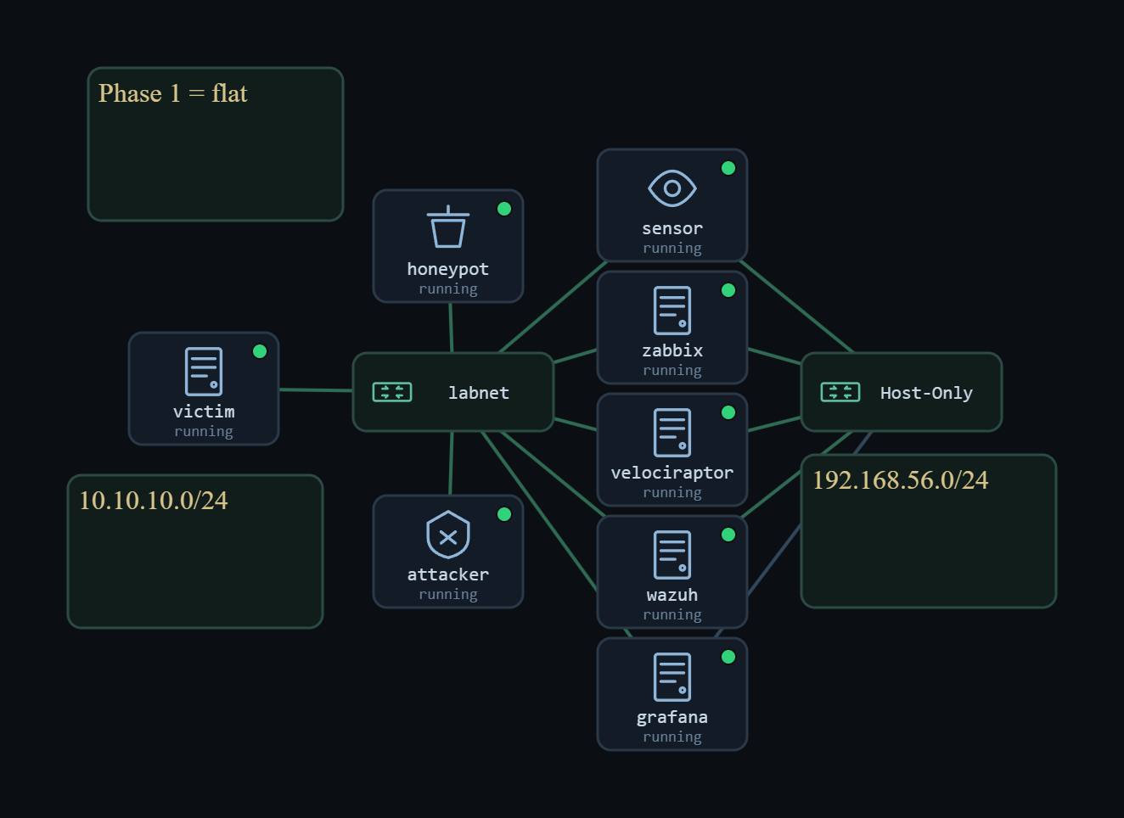
Figure 1. The Phase 1 flat network topology.

Project | Home-lab Security Operations Center
Phase | 1 of 4 — Flat Layer 2 network
Prepared by | Abdulrahman Salem Alshoubaili
Date | 9 / 14 / 2026
Network | labnet 10.10.10.0/24 (no gateway)
Baseline snapshots | phase1-final

Contents
Right
Contents 2
1. introduction 3
2. The Environment 3
3. The Five Detection Planes 4
4. Building 4
5. The Files That Make Phase 1 Work 6
5.1 Suricata custom rules — local.rules 6
5.2 Suricata alert output — eve.json 6
5.3 Zeek connection log conn.log and the JSON converter 7
5.4 Wazuh agent configuration — ossec.conf (file integrity) 7
5.5 Wazuh manager configuration the VirusTotal integration 8
5.6 Wazuh custom rules and decoders local_rules.xml 9
5.7 Cowrie honeypot — cowrie.json and the swapped ports 9
5.8 Availability agent zabbix_agentd.conf 9
6. The Attacks, and What Each One Left Behind 11
6.1 SSH brute-force into the honeypot 11
6.2 Malware delivery — FIM and VirusTotal 12
7. What the Monitoring Actually Recorded 13
8. FIM and VirusTotal 14
9. Kill-Chain Coverage 15
10. Readiness Check (Run Before Every Session) 15
11. What Bit Us 15
12. Conclusion 16
Appendix A — Snapshots and Insert Fields 17

-click the field below and choose Update Field in Word to fill in page numbers.

1. introduction
Phase 1 was deliberately the easy case. Before any routing, firewalls, or address translation entered the picture, we wanted to settle one narrow question on a flat network, where a single sensor can see everything, does the monitoring actually catch an attack, and can we prove it from the evidence rather than assume it?
Everything sat on one segment, labnet 10.10.10.0/24, with no gateway and no router. Every host shared a single broadcast domain. That is the worst case for containment and the best case for learning detection Layer 2 attacks work without any real effort, and one passive sensor sees all of the traffic. We stood up five kinds of monitoring on that segment, ran real attacks from an attacker VM against real victims, and then went looking for the matching evidence at each layer.
The point was never to defend a company. It was to build a monitoring stack we understood, and to keep two things clearly apart that are easy to confuse whether an attack worked, and whether we could see that it worked. On a flat network those two usually go together. That stops being true later, which is the whole reason for the phases that follow.
The concrete objectives for the phase were, Stand up five detection planes network, endpoint, availability, forensic, and deception on one flat segment. Run real attacks from the attacker VM rather than describe them, and capture the evidence each one produced. Add an automated malware verdict by pairing file integrity monitoring with a VirusTotal lookup. Put a repeatable readiness check, clean snapshots, and analyst dashboards in place so the results were reproducible.

2. The Environment
The whole lab runs on one Windows 11 desktop under VirtualBox, and the machines are joined by a VirtualBox internal network so the traffic never leaves the host. One setting is what makes flat-network monitoring possible at all the sensor's capture interface is put in promiscuous mode. Without it the sensor would only receive frames addressed to itself, and the passive tap would be blind to everything else on the segment.
VM | Role | labnet IP
wazuh | SIEM manager + OpenSearch indexer | 10.10.10.20
sensor | Suricata + Zeek network sensor (passive tap) | passive
zabbix | Availability monitoring | 10.10.10.x
velociraptor | Endpoint forensics / DFIR | 10.10.10.x
grafana | Dashboards / analyst interface | 10.10.10.x
Throwaway (victim) | Generic victim endpoint | 10.10.10.x
honeypot | Cowrie deception (fake SSH) | 10.10.10.70
attacker | Kali-style attack box | 10.10.10.40
Table 1. Phase 1 VM inventory — everything on the flat labnet segment.
Analyst note — On this segment a source address can be taken at face value, because nothing between two hosts rewrites it. That is a luxury Phase 1 has and the later phases do not, so it is worth naming here when we say an event came from 10.10.10.40, the flat network is the reason we can say it plainly.

3. The Five Detection Planes
Each plane answers a different question, and the reason for running all five is that no single tool is ever the only witness. When two planes see the same event, the evidence stops being a claim and becomes something we can corroborate. Every plane feeds Wazuh, which correlates the events and passes them to Grafana for the analyst to work from.
Plane | Question it answers | Tools
Network | What suspicious traffic crossed the wire? | Suricata, Zeek
Endpoint | What happened inside a host? | Wazuh agents
Availability | Is the infrastructure up and collecting? | Zabbix
Forensic | What can we recover from a host after an alert? | Velociraptor
Deception | Did anyone touch a system they should not? | Cowrie honeypot
Table 2. The five planes and what each one is for.

4. Building
The build order was routine static labnet IPs and a shared time source on every VM, the wazuh manager and indexer up first, each VM enrolled as an agent, Suricata and Zeek on the sensor, then zabbix, velociraptor, and Cowrie. The step we treat as non negotiable is the capture test. Before trusting a single alert, we prove the sensor is actually receiving traffic, because a sensor that silently sees nothing is far more dangerous than one that is obviously down — the dashboards stay quiet either way.
Verification · The sensor is receiving traffic before any detection work begins
Command: sensor: sudo tcpdump -i <tap> -n icmp | another host: ping 10.10.10.20
Expected: the ping packets appear in the sensor's tcpdump. If pings succeed but the sensor shows nothing, the labnet VMs need a cold power-cycle; a warm reset does not restore promiscuous flooding.

Analyst note — We hit exactly that failure pings working, sensor at zero packets and only a cold power-cycle brought the tap back. It is worth doing this check first every session, because every downstream result depends on it being true.
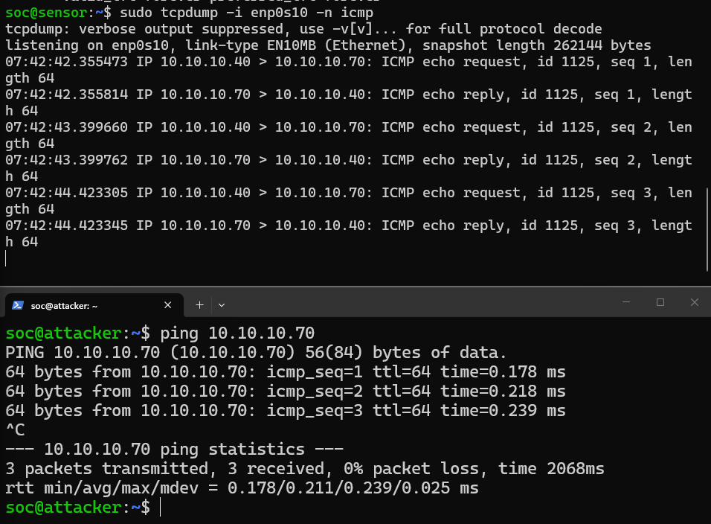
Figure 3. The capture test showing live packets on the sensor.

5. The Files That Make Phase 1 Work
Most of the actual work sits in a handful of configuration and log files. This section takes them one at a time what each is, why we needed it, and what an analyst reads in it — because understanding these files is how someone reading the report can see how the detection is wired together rather than just take our word for it.

5.1 Suricata custom rules — local.rules
Suricata ships with a large community rule set, but we added a few of our own so that we had detections we could trigger on demand and be certain about. They live in the reserved 9000000-and-up range so they never collide with the shipped signatures. Three matter here: a test ICMP rule (sid 9000001), a local-file-inclusion rule that matches a request for /etc/passwd (sid 9000010), and a rule that flags the sqlmap tool by its User Agent. The ICMP rule is really a self test if we send the marked ping and no alert appears, we know the sensor pipeline is broken before we start blaming an attack for not showing up.
Verification · The rules load and the sensor fires on the test signature
Command: sensor: sudo suricata -T -c /etc/suricata/suricata.yaml then send the test ICMP
Expected: the config test passes and the LAB TEST ICMP alert appears in eve.json with the right source and destination.

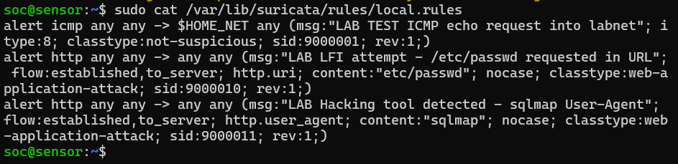
Figure 4. The custom Suricata signatures in local.rules.

5.2 Suricata alert output — eve.json
Suricata writes everything it detects to eve.json, one JSON event per line. This is the file the rest of the SOC reads for network alerts. Each alert record carries the fields that matter to an analyst the event type, source and destination IP and port, the protocol, and the signature that matched. Because it is already JSON, it moves into Wazuh and Grafana without any reformatting, which is why the network plane appears in the same dashboards as the endpoint events.
Analyst note — The network-alert counts quoted later in this report come from this file. The way to read it is to filter for event_type equal to alert, then group by signature and source a single scan, for instance, shows up as one source touching a long list of ports.
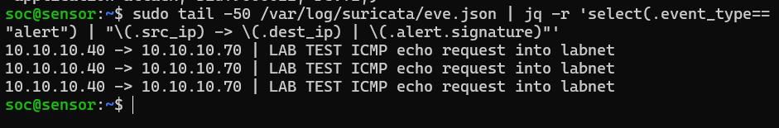
Figure 5. A Suricata alert record in eve.json.

5.3 Zeek connection log conn.log and the JSON converter
Where Suricata tells us which traffic matched a signature, Zeek records every connection that happened, suspicious or not. Its conn.log holds the source and destination, the ports, the protocol, how long each connection lasted, and how many bytes moved. That context is what turns a lone alert into a story for example, one host opening thousands of short connections in a few seconds reads very differently from the same host making one. Over a test session Zeek produced on the order of sixteen thousand connection records.
Getting that data into the SIEM took an extra step. Zeek writes conn.log as tab-separated text, and Wazuh handles JSON far more cleanly than Zeek's native format, so left alone the connection data would have stayed on the sensor as flat text fine for manual hunting, but not correlated with anything else. To close that gap we wrote a small Python script. It reads each new line of conn.log, maps the fields into a JSON object source and destination address, destination port, protocol, connection state, duration, and byte counts and writes them out as JSON lines. Wazuh then picks that file up through a localfile entry and indexes it, so Zeek's records sit alongside the Suricata and endpoint events instead of in a separate world.
Verification · Zeek is logging and the converter is producing JSON Wazuh can read
Command: sensor: wc -l /opt/zeek/logs/current/conn.log then run the converter and: tail -f <output>.json
Expected: conn.log grows during traffic, and the converter emits valid JSON lines with id.orig_h / id.resp_h / id.resp_p that the Wazuh localfile then reads.

Analyst note — This is the plainest example in the phase of plumbing mattering as much as detection. The data existed the whole time. It only became useful to the SOC once it was in a shape the SIEM could actually read.
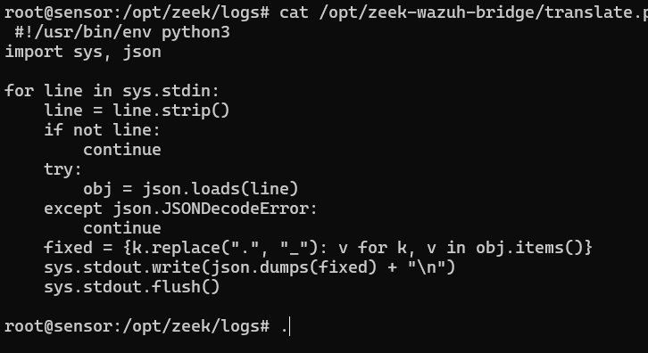
Figure 6. The conn.log-to-JSON converter and its output.

5.4 Wazuh agent configuration — ossec.conf (file integrity)
On each monitored host the Wazuh agent is configured through ossec.conf. The part that matters most in Phase 1 is the file-integrity section, where the agent is told to watch /tmp in real time and report any file added, changed, or removed. /tmp is a sensible target because it is where dropped files and staging tend to land. The same file also holds the localfile entries that decide which logs the agent ships, including the Suricata and Zeek JSON on the sensor.
Verification · The agent is active and file-integrity monitoring is armed on /tmp
Command: wazuh manager: /var/ossec/bin/agent_control -l and read the syscheck block in the agent ossec.conf
Expected: the agent shows as active and the /tmp directory is present in syscheck with realtime enabled.

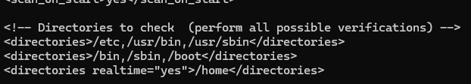
Figure 7. The file-integrity monitoring configuration on the agent.

5.5 Wazuh manager configuration the VirusTotal integration
The VirusTotal lookup is configured once, on the manager, and covers every agent. It is a single integration block that names VirusTotal, holds the API key, ties itself to the file integrity group, and asks for JSON alerts. When an agent reports a new file, the manager sends the file's hash to VirusTotal and raises an alert if the service calls it malicious. One detail cost us real time VirusTotal is a cloud service and the lab is otherwise isolated, so the manager needed an outbound NAT interface just for this lookup. Without that path the integration failed quietly with an empty response, and no verdict ever came back.
Verification · The VirusTotal integration is loaded and can actually reach the service
Command: wazuh manager: grep -A6 virustotal /var/ossec/etc/ossec.conf and check /var/ossec/logs/ossec.log after a file drop
Expected: the integration block is present, and after a test file the manager log shows a VirusTotal response rather than an egress or timeout error.

Analyst note — The lesson here was that the configuration was correct long before it worked. What it was missing was a way out to the internet. Cloud enrichment needs egress, and in an isolated lab that is a design decision rather than a checkbox.
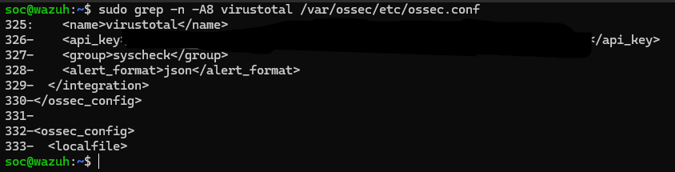
Figure 8. The VirusTotal integration block on the manager.

5.6 Wazuh custom rules and decoders local_rules.xml
Wazuh decides what is worth alerting on through its rules. A few are central to Phase 1: the SSH brute-force rules 5710 and 5712, which fire on repeated authentication failures; rule 554, which flags a newly added file from the integrity monitor; rule 87105, which fires when VirusTotal returns a malicious verdict; and rule 100034, which records a Cowrie honeypot session. Knowing these IDs is what lets an analyst move quickly, since searching for a rule ID is faster than reading raw logs line by line.
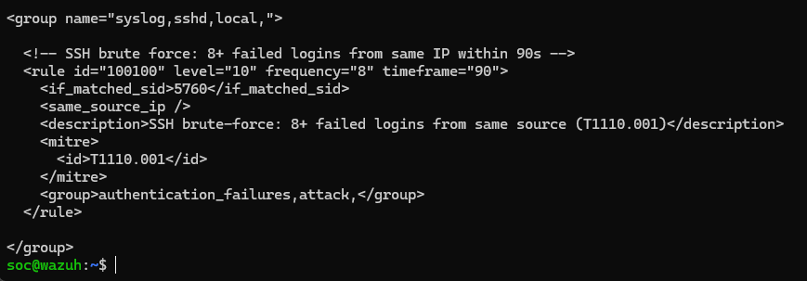
Figure 9. The custom Wazuh rules used in Phase 1.

5.7 Cowrie honeypot — cowrie.json and the swapped ports
Cowrie is a fake SSH service that records everything done against it. We swapped the ports on purpose: Cowrie listens on port 22, where an attacker naturally looks, and the real administrative SSH was moved to 2022. Anyone hitting 22 is therefore in the trap, and every command they type is written to cowrie.json with their source address attached. That is what makes deception valuable here the attacker's own actions become clean, high confidence evidence, tied to the address they came from, without us having to infer anything.
Verification · Cowrie is capturing sessions against the fake SSH service
Command: honeypot: sudo tail -f /var/log/cowrie/cowrie.json during a login attempt to port 22
Expected: each connection and command is logged as JSON, including the source 10.10.10.40 and the commands entered.

Figure 10. A captured attacker session in cowrie.json.

5.8 Availability agent zabbix_agentd.conf
The availability plane runs on Zabbix. Its agent config on each host names the Zabbix server and the host's own name, and from there Zabbix collects health metrics such as CPU, memory, and uptime. In Phase 1 this plane mostly confirms that the infrastructure itself is up and collecting; it earns its place later, when an attack starts to affect a host's performance.
Analyst note — One honest caveat sits here. After a snapshot restore the lab clock runs a couple of days behind real time, so some Zabbix tiles show No data because the time windows do not line up. The data is being collected this is a time sync problem on the lab side, not a monitoring failure but it is worth stating rather than dressing up.
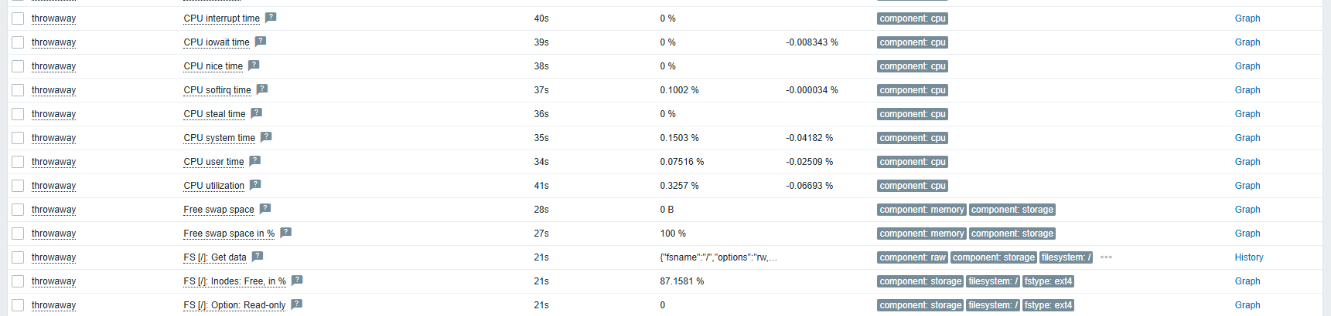
Figure 11. Zabbix showing host health for the lab.

6. The Attacks, and What Each One Left Behind
Every test below was run live from the attacker at 10.10.10.40 against a real victim. The set is weighted toward Layer 2 and flat network attacks plus one file-delivery test, because those are the attacks a flat segment is actually exposed to. For each one the useful question is not only whether it worked, but what evidence it produced and which plane held that evidence.
# | Attack | MITRE | What it does | Caught by
1 | Traffic sniffing | T1040 | Passive capture of segment traffic | Observed on the sensor
2 | MAC flooding | T1498.001 | Floods the switch CAM table | Sensor (with a caveat)
3 | SSH brute-force | T1110 | Repeated logins into the Cowrie honeypot | Wazuh + Cowrie
4 | Malware delivery (EICAR) | T1204 | Drops a known test malware file in /tmp | Wazuh FIM + VirusTotal
Table 3. The Phase 1 attacks and the plane that held the evidence for each.

6.1 SSH brute-force into the honeypot
This is the test where two independent sources agree, which is why it is the most convincing capture in the phase. The attacker scanned the segment, found SSH open on port 22, and started guessing credentials. Port 22 is Cowrie, so the attempts landed in the honeypot instead of on a real service.
Two planes recorded it, and that is the point worth drawing out. Wazuh raised its brute-force rule from the pattern of repeated authentication failures, while Cowrie logged the session itself the login and every command typed with the source 10.10.10.40 attached. On this flat segment that address can be taken at face value, since nothing in the path rewrites it. What the evidence proves is narrow but solid: the attempts were not just reaching the service, they were producing telemetry on two separate layers, and the two layers agreed on the source. What it does not prove is that a real account was compromised. Cowrie accepts almost any password by design, so a login that looks successful here is the trap working, not a breach a distinction that matters when reading the logs.
Verification · The brute-force is visible on both the endpoint and deception planes, and they agree
Command: wazuh: search rules 5710 / 5712 for src 10.10.10.40 | honeypot: tail cowrie.json
Expected: Wazuh shows the brute-force alert naming 10.10.10.40, and Cowrie shows the same source with the commands entered.

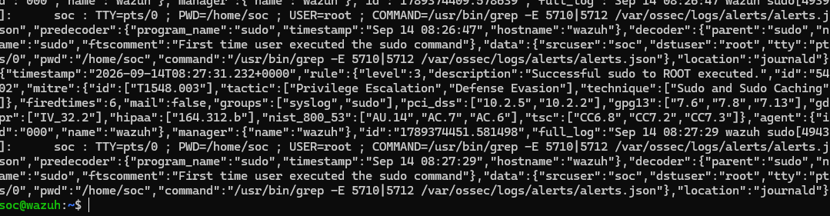
Figure 14. The brute-force alert in Wazuh.
Figure 15. The captured honeypot session.

6.2 Malware delivery — FIM and VirusTotal
The last test moves off the network and onto the endpoint. We dropped the standard EICAR test file into /tmp on a monitored host. EICAR is a harmless string that antivirus engines recognise as a test, so nothing dangerous was ever handled. From there the chain ran on its own the integrity monitor saw the new file and raised rule 554, the manager sent the hash to VirusTotal, and the verdict came back malicious on 64 of 67 engines, which fired rule 87105 with a link to the result. It is worth being precise about which component did what, because it is easy to blur the file integrity monitor is what noticed the file, and VirusTotal is what supplied the opinion on whether it was dangerous. Section 8 follows that split in more detail.
Figure 16. The file-integrity and VirusTotal alerts for the EICAR test.

7. What the Monitoring Actually Recorded
The counts below are the measured figures from our own dashboards over a test window, not illustrative numbers. They are here because they are the proof that the planes were live and collecting, so each should sit next to the dashboard screenshot noted underneath rather than stand on its own.
Plane | Tool | What it recorded
Network | Suricata | 9,600+ alerts test ICMP, LFI attempt (/etc/passwd), SSH scan, ICMP ping each with src, dst, port, protocol, and signature
Network | Zeek | 16,000+ connection records for context and hunting
Endpoint | Wazuh | Authentication events with source, user, and action; the MITRE ranking led by Valid Accounts and Password Guessing
Deception | Cowrie | A full attacker session login plus every command, tied to 10.10.10.40
File | FIM + VirusTotal | A file add in /tmp followed by the malware verdict (rule 87105)
Availability | Zabbix | Host and service health (subject to the clock-skew caveat in 5.8)
Table 4. What each plane recorded during the Phase 1 test window.
For severity we used Wazuh 0 to 15 scale, treating level 8 and above as high and 12 and above as critical. In the seven day window the environment recorded 122 high and 3 critical alerts, 1,541 authentication events, and 309 incidents at level 6 or above. These are the numbers a reviewer tends to ask for first, so they belong on a dashboard the report can point at rather than in prose alone.
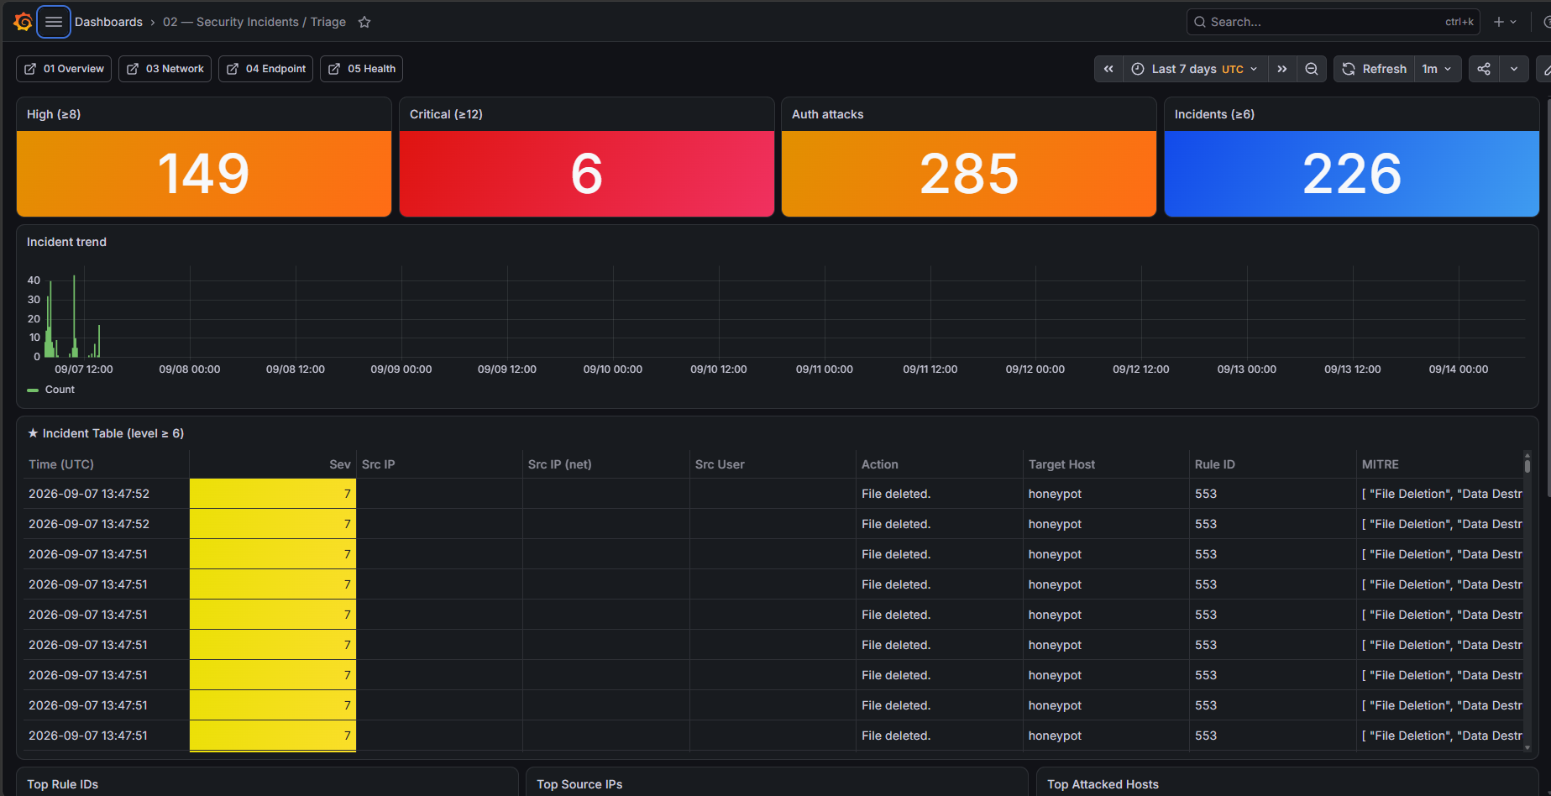
Figure 17. The Grafana overview with the real counts.
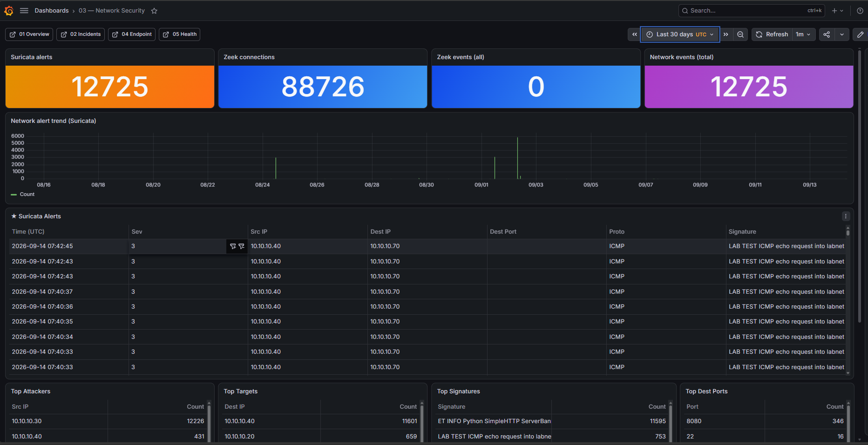
Figure 18. The network-alert breakdown in Grafana.

8. FIM and VirusTotal
Integrity monitoring on its own only tells you a file changed. Pairing it with VirusTotal adds an outside opinion on whether that change is dangerous, and doing it automatically means the analyst opens an already enriched alert instead of a bare one. The flow is short the agent watches /tmp, a new file's hash goes to the manager, the manager asks VirusTotal, and if the answer is malicious, rule 87105 fires. The two roles stay separate the whole way the integrity monitor detects, VirusTotal enriches.
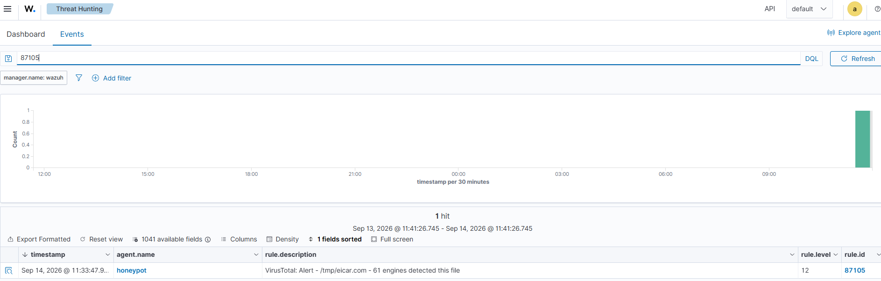
Figure 19. The file-integrity and VirusTotal path.
The EICAR test walked that chain end to end. The file was added, rule 554 recorded the addition, and VirusTotal returned a malicious verdict on 64 of 67 engines, which raised rule 87105 with a permalink. A few practical points are worth carrying forward VirusTotal matches on the file hash, the free tier is rate-limited to a few lookups a minute, and the file has to land in the real /tmp not the honeypot's fake filesystem for the agent to see it at all.
Verification · The full delivery chain fires end to end
Command: agent: place the EICAR test file in /tmp | wazuh: watch for rule 554 then 87105
Expected: rule 554 records the new file, then rule 87105 reports the VirusTotal malicious verdict (64/67) with a link.

9. Kill-Chain Coverage
Mapping the tests to the Cyber Kill Chain gives a quick sense of how much of an intrusion we could see. Six of the seven stages were actively detected. The gap is weaponization, which happens on the attacker's own machine before anything reaches the network no sensor in the lab can observe it, so we mark it as such rather than stretch to claim coverage we do not have.
Stage | Detected by | Status
Reconnaissance | Suricata scan signatures, Zeek | Detected
Weaponization | Off network, on the attacker host | Not observable
Delivery | FIM on /tmp + VirusTotal; Suricata/Zeek transfer | Detected
Exploitation | Cowrie honeypot, Wazuh auth rules | Detected
Installation | FIM + VirusTotal on files, Cowrie downloads | Detected
Command & Control | Suricata C2 signatures, Zeek | Detected
Actions on Objectives | FIM data-staging, Velociraptor, Zabbix | Detected
Table 5. Kill-chain coverage — six of seven stages detected.

10. Readiness Check (Run Before Every Session)
The same short check runs before any test session. If an item fails, we stop and fix it rather than record results we cannot trust the capture test in Section 4 is here for the same reason.
Check | How | Pass condition
Connectivity | ping the manager from each host | reply received
IP assignment | ip -br a on each VM | correct static labnet IP
Sensor tap live | tcpdump + ping at the same time | the sensor sees the packets
Agent health | Wazuh agent list | all agents active
End-to-end data | drop a test event, look for it in Grafana | the event arrives
Table 6. The GO / NO-GO readiness check.

11. What Bit Us
A few things did not work first time, and they are worth recording because they are the kind of detail that only shows up when you actually run the lab.
A silent sensor tap zero packets while pings work is not fixed by a warm reset. The labnet VMs need a cold power cycle. The capture test only works if tcpdump and ping run at the same time, not one after the other. The VirusTotal lookup failed silently until the manager had an outbound NAT interface. Cloud enrichment needs egress. Cowrie sits on port 22 and the real SSH on 2022. Manage the honeypot from 2022, or you lock yourself out of the trap. After a snapshot restore the lab clock is a couple of days behind, which is why some Zabbix tiles read No data. When shipping commands to a host over SSH from PowerShell, single quote them so local variables do not expand first.

12. Conclusion
Phase 1 closed with the monitoring stack doing what we needed and, more usefully, with us able to point at the evidence for each detection instead of assuming it. The flat network handed the attacks an easy path and we watched them take it. The bruteforce showed up on two planes at once and they agreed on the source. The EICAR test carried a dropped file all the way to an automated verdict. The one open item is the lab clock skew affecting how some availability tiles display, which is a cosmetic problem rather than a detection gap.
The distinction that carried into the rest of the lab is the one between an attack working and the SOC seeing it. On a flat segment the two almost always coincide, because the sensor sees everything and no address is disguised. That is exactly what changes once a router sits in the path, and then again when NAT rewrites the source which is what Phase 2 and Phase 3 were built to test.

Appendix A — Snapshots and Insert Fields
Restore points captured during Phase 1:
Snapshot | Contents
phase1-final | The final snap

Every diagram and screenshot to insert, in order (each frame is marked in the report where it belongs):
Field | Type | What to put here
1 | Diagram | Your topology diagram — the flat labnet 10.10.10.0/24 segment with all eight VMs and the passive sensor tap.
2 | Screenshot | A split terminal: tcpdump on the sensor on the left with ICMP packets arriving, and a ping to 10.10.10.20 running on the right at the same moment.
3 | Screenshot | The Suricata local.rules file showing the 9000001 test ICMP rule, the 9000010 LFI rule, and the sqlmap User-Agent rule.
4 | Screenshot | A few lines of /var/log/suricata/eve.json filtered to event_type=alert (for example with jq), showing src_ip, dest_ip, and alert.signature for one of the lab attacks.
5 | Screenshot | The Python script we wrote, next to a sample of the JSON it produces (or the Wazuh localfile entry that reads it), showing the tab-separated Zeek data turned into JSON for the SIEM.
6 | Screenshot | The <syscheck> section of /var/ossec/etc/ossec.conf on a monitored host, showing /tmp set to realtime with report_changes enabled.
7 | Screenshot | The <integration> block in the manager's ossec.conf showing name=virustotal, the syscheck group, and alert_format json (the API key can be blurred).
8 | Screenshot | The relevant rules in local_rules.xml (or the rule detail in the Wazuh interface) for the SSH brute-force, file-added, VirusTotal-malicious, and Cowrie-session rules.
9 | Screenshot | A section of cowrie.json from the brute-force test showing the source 10.10.10.40, the login, and the commands typed inside the fake shell.
10 | Screenshot | The Zabbix latest-data or dashboard view for a monitored host showing CPU / memory / uptime being collected.
11 | Screenshot | The Wazuh alert (rule 5710 or 5712) for the SSH brute-force, showing the source 10.10.10.40 and the repeated authentication failures.
12 | Screenshot | The Cowrie session (from cowrie.json or a Grafana panel) showing the login to the fake SSH and the commands the attacker ran inside it.
13 | Screenshot | The Wazuh alerts showing rule 554 (file added to /tmp) followed by rule 87105 (VirusTotal malicious, 64/67), ideally with the VirusTotal link visible.
14 | Screenshot | The Grafana overview or incidents dashboard showing the high/critical counts, the authentication-event total, and the incident count for the test window.
15 | Screenshot | The Grafana network dashboard showing the Suricata alert count and the top signatures (test ICMP, LFI attempt, SSH scan), with source addresses visible.
16 | Diagram | Your diagram of the FIM + VirusTotal flow: agent /tmp -> hash to the Wazuh manager -> VirusTotal lookup -> rule 87105 if malicious.
Table 7. Every insert field in this report and what each should show.

