SOC Detection Laboratory

Phase 2
Routed and Segmented Network

Splitting the flat network in two with a router, and checking that detection and attribution survive the boundary.

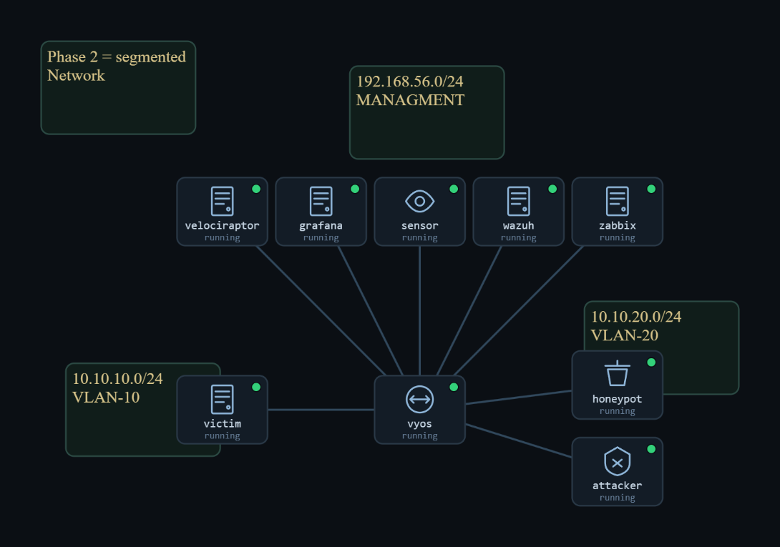
Figure 1. The Phase 2 routed topology.

Project | Home-lab Security Operations Center
Phase | 2 of 4 — Routed / segmented network (no NAT)
Prepared by | Abdulrahman Salem Alshoubaili
Date | 9 / 13 / 2026
Networks | VLAN 10 10.10.10.0/24 <-> VyOS <-> VLAN 20 10.10.20.0/24
Baseline snapshot | phase2-final

Contents
Right-click the field below and choose Update Field in Word to fill in page numbers.
Contents 2
1. What Changed, and the Question It Raised 3
2. The Environment 3
3. The Routing Model 3
3.1 One hop, visible in the TTL 3
3.2 No NAT, so the source stays honest 4
4. Sensor Placement Becomes a Decision 4
5. The Files That Make Phase 2 Work 6
5.1 VyOS router configuration 6
5.2 Per-host netplan — static IP and the cross-segment route 6
5.3 The stale netplan file — the file behind the bug 6
5.4 Suricata — eve.json and local.rules (now on VLAN 20) 7
5.6 Wazuh — alerts.json across the router 7
5.7 Availability agent on the honeypot — zabbix-agent2 7
6. The Attacks, and What Each One Tested 9
6.1 SSH brute-force across the router 9
6.2 ARP man-in-the-middle, contained by the router 9
6.3 Connection-flood denial of service, seen across the router 10
7. Five Planes, Verified Across the Router 11
8. The Bug That Took Longest Stale Config 11
9. What the Monitoring Recorded 11
10. Readiness Check (Run Before Every Session) 11
11. Lessons From Phase 2 12
12. Conclusion 12
Appendix A — Snapshots and Insert Fields 13

1. What Changed, and the Question It Raised
Phase 1 proved the monitoring worked, but it worked on a flat network where a single sensor saw everything for free. That is not how real networks are built. Phase 2 takes the same monitoring stack and does the one thing a flat network does not have: it puts a router in the middle and splits the lab into two segments — a trusted internal network, VLAN 10 (10.10.10.0/24), and an exposed network, VLAN 20 (10.10.20.0/24). Nothing crosses between them except through the VyOS router.
That single change raises two questions a flat network never made us ask. First, where does the sensor have to live now, since a passive tap only sees the segment it is attached to? Second, does the evidence still name the real attacker once the traffic has passed through a router? The second question is the one that matters most, and Phase 2 answers it by keeping the router deliberately simple: it routes, but it does not translate addresses. There is no NAT. That choice is what lets us treat Phase 2 as the clean, attribution-preserved baseline before Phase 3 introduces NAT and takes that away.
- Add a router and split the flat network into two routed segments (VLAN 10 trusted, VLAN 20 exposed).
- Move the sensor onto the exposed segment and treat its placement as a deliberate decision.
- Re-run the monitoring across the routed boundary and confirm every plane still reports to the SOC.
- Keep the router NAT-free so the attacker's real address survives, and test that it does.

2. The Environment
The trusted segment holds the SOC stack and the internal client. The exposed segment holds the attacker, a server, and the honeypot, and it is where the sensor now taps. The router bridges the two with one interface on each side, and the out-of-band management network (192.168.56.x) is unchanged, so SOC administration still runs off the data path.
Machine | Segment | IP
wazuh (SIEM manager) | VLAN 10 trusted | 10.10.10.20 (mgmt 192.168.56.20)
zabbix | VLAN 10 trusted | 10.10.10.22
velociraptor | VLAN 10 trusted | 10.10.10.23
grafana | VLAN 10 trusted | 10.10.10.24
client (throwaway) | VLAN 10 trusted | 10.10.10.50
VyOS router | boundary | eth0 10.10.10.1 / eth1 10.10.20.1
attacker | VLAN 20 exposed | 10.10.20.40
server | VLAN 20 exposed | 10.10.20.60
honeypot | VLAN 20 exposed | 10.10.20.70
sensor | VLAN 20 exposed | passive tap on enp0s8 (mgmt 192.168.56.10)
Table 1. Phase 2 addressing — two routed segments joined by VyOS.

3. The Routing Model

3.1 One hop, visible in the TTL
The simplest proof that the network is now segmented is the TTL field. When the attacker pings a host on its own segment, the reply comes back with the default TTL of 64 — no hops. When it pings a host on the far segment, the reply arrives with a TTL of 63, because the router decremented it by one on the way through. That one missing hop is the boundary, made visible with a single command.
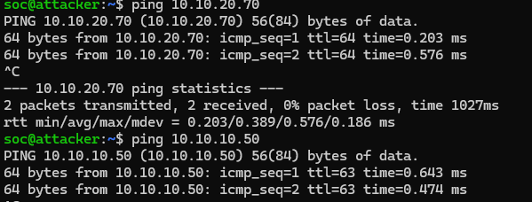
Figure 2. The router hop shown in the TTL.
Verification · The two segments are joined only by the router
Command: attacker: ping -c2 10.10.20.70 (same segment) and ping -c2 10.10.10.50 (across the router)
Expected: the same-segment reply shows ttl 64; the cross-segment reply shows ttl 63 — the single decrement is the router.

3.2 No NAT, so the source stays honest
A router forwards packets; on its own it does not rewrite their addresses. Because the VyOS router performs no NAT, a packet from the attacker keeps its real source address the whole way to the victim. This is easy to state and important to prove, because it is exactly the property Phase 3 removes. When the attacker on VLAN 20 attacks the client on VLAN 10, the alert that lands in Wazuh still reads the true source, 10.10.20.40 the traffic crossed a router and the attribution survived it.

4. Sensor Placement Becomes a Decision
On a flat network the sensor's location did not matter, because it saw everything. On a segmented one it is the single most consequential choice, because a passive tap only sees its own segment. Placed on the trusted VLAN 10, the sensor would watch the SOC and the client exchange quiet, benign traffic, and it would register the attacks over on VLAN 20 as complete silence and silence looks exactly like safety. We put the sensor on VLAN 20, where the attacker and honeypot live, so that every hostile action is captured at its source. The tap interface is enp0s8, the sensor's adapter on the exposed segment.

Verification · The sensor actually sees the exposed segment
Command: sensor: sudo tcpdump -i enp0s8 -n icmp while the attacker pings the honeypot
Expected: the ICMP packets from the attack appear on enp0s8 — the tap is live on VLAN 20.

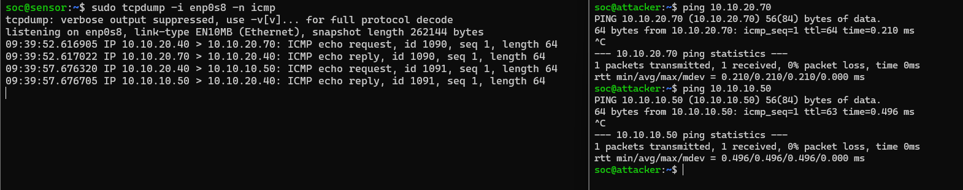
Figure 5. The sensor capturing VLAN 20 traffic.

5. The Files That Make Phase 2 Work
Phase 2 adds a new class of file routing and per host route configuration on top of the detection files carried over from Phase 1. Each important one is explained below, including the file that caused the one real bug of the phase.

5.1 VyOS router configuration
This is the whole behaviour of the boundary. The router assigns eth0 to 10.10.10.1 on the trusted side and eth1 to 10.10.20.1 on the exposed side, and forwards between them. The important thing to read here is what is absent: there is no NAT or masquerade rule. That absence is deliberate, and it is the reason the attacker's address survives the crossing. When Phase 3 replaces this router with a firewall, a NAT rule is exactly what gets added.
Verification · The router routes between the two segments and applies no NAT
Command: vyos: show interfaces and show configuration | grep -i nat
Expected: eth0 = 10.10.10.1 and eth1 = 10.10.20.1 are both present, and the NAT search returns nothing.
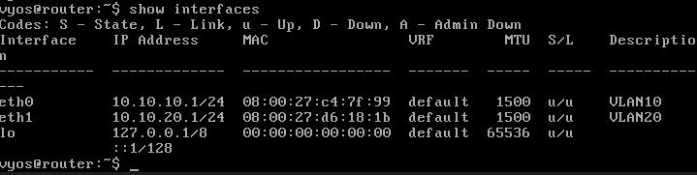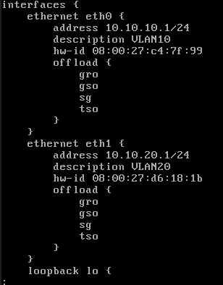

Figure 6. The VyOS routing configuration.

5.2 Per-host netplan — static IP and the cross-segment route
Each Linux host keeps its permanent network settings in a netplan file, 99-labnet.yaml. Beyond the static IP, a host needs a route telling it to reach the other segment through the router, or cross segment traffic simply has nowhere to go. Putting this in netplan rather than typing it at runtime is what makes the topology survive a reboot.
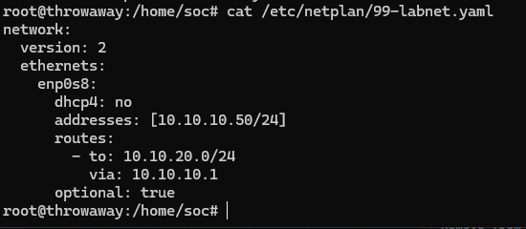
Figure 7. A host's netplan with its address and cross-segment route.

5.3 The stale netplan file — the file behind the bug
One file earned its own section because removing it was the fix for the hardest problem in the phase. A leftover Phase 1 netplan file, 95-flat.yaml, was still present on the honeypot. It gave the host a second, stale IP address, which the system treated as a directly attached network and used to build a route. Replies to the SOC were then sent out the wrong interface and vanished. Section 8 tells the full story; the file is listed here because it is the concrete thing that had to be deleted.
Analyst note — The general rule we took from this: when you re-address hosts for a new phase, remove the previous phase's configuration rather than adding the new one on top of it. Leftover config does not sit quietly; it competes.

5.4 Suricata — eve.json and local.rules (now on VLAN 20)
The network plane is unchanged in function but now taps VLAN 20, where the attacker operates. eve.json holds every alert as JSON, and local.rules holds the lab's custom signatures in the reserved 9000000 range. During the phase, a full port scan of the honeypot is the clearest thing to read here one source touching tens of thousands of ports appears as a wall of alerts and connection attempts, all from 10.10.20.40.
SCREENSHOT TO INSERT — FIELD 8
What to put here: eve.json filtered to event_type=alert (jq) during the nmap scan, showing the attacker 10.10.20.40 as the source.
Figure 8. Suricata alerts from the VLAN 20 scan.

5.6 Wazuh — alerts.json across the router
The manager's alert output is where the Phase 2 headline lands. An agent on VLAN 20 (the honeypot) and the client on VLAN 10 both report to the manager on VLAN 10, which proves the endpoint plane works across the routed boundary. When the attacker bruteforces SSH, Wazuh raises rule 5712, and the source it records is 10.10.20.40 the real attacker, unchanged by the crossing.
Analyst note A small operational point that costs time if you miss it: this Wazuh build writes its alerts to alerts.json, not the plain text alerts.log, so that is the file to grep when the alert does not seem to appear.
SCREENSHOT TO INSERT — FIELD 10
What to put here: The Wazuh alert (rule 5712) in alerts.json showing source 10.10.20.40, reported to the manager on VLAN 10 from across the router.
Figure 10. The brute-force alert reaching the manager across the router.

5.7 Availability agent on the honeypot — zabbix-agent2
The availability plane is extended across the boundary here. The honeypot on VLAN 20 runs a Zabbix agent pointed at the server on VLAN 10 (Server=10.10.10.22), and the Zabbix server polls it through the router. This is what lets the SOC watch the honeypot's health from the trusted side, which matters directly for the denial of service test.
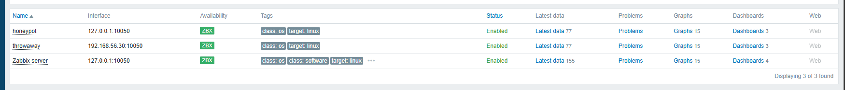
Figure 11. Zabbix polling the honeypot across the router.

6. The Attacks, and What Each One Tested
Three attacks were chosen so that each isolates one consequence of segmentation: attribution across the router, containment of a Layer-2 attack, and availability monitoring across the router. Each was run live from the attacker at 10.10.20.40.
# | Attack | MITRE | What it tests
1 | SSH brute-force (cross-segment) | T1110 | Does attribution survive the router? (endpoint plane)
2 | ARP MITM (same segment) | T1557.002 | Is a Layer-2 attack contained by the router? (network / deception)
3 | Connection-flood DoS | T1499.001 | Can we see host stress across the router? (availability)
Table 2. The Phase 2 attacks and the segmentation lesson each one isolates.

6.1 SSH brute-force across the router
The attacker on VLAN 20 brute-forces SSH on the client on VLAN 10, a dozen rapid login attempts as different bad users, sent straight through the router. There are two things to check, and they are separate questions. The first is whether the endpoint plane still fires when the agent and the manager sit on opposite sides of a router; it does, and Wazuh raises rule 5712. The second, and the point of the test, is whether the alert still names the real attacker. It does the source reads 10.10.20.40 even though the traffic crossed the boundary because the router applies no NAT. This is the attribution baseline that Phase 3 later breaks on purpose.
Verification · The brute-force is detected across the router and names the real source
Command: attacker: for i in $(seq 1 12); do ssh baduser$i@10.10.10.50 true; done | wazuh: grep 5712 alerts.json | grep 10.10.20.40
Expected: rule 5712 fires and the alert's source is 10.10.20.40 — attribution survived the router.

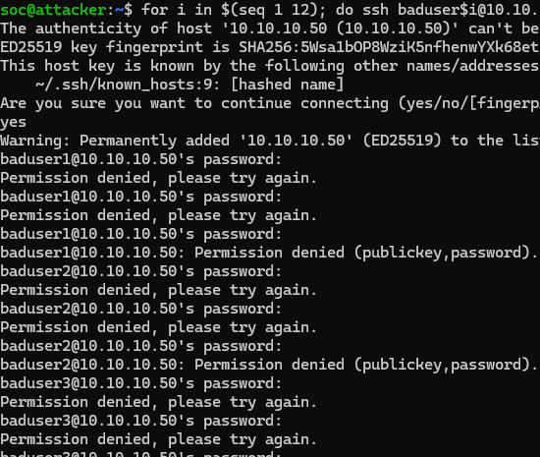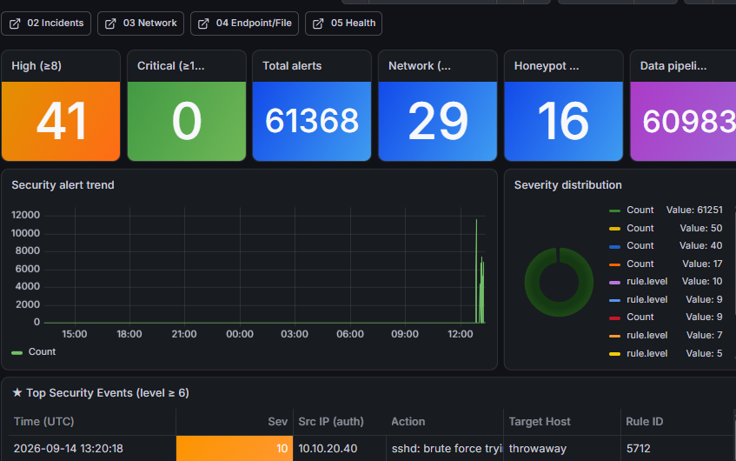
Figure 12. The cross-segment brute-force in Wazuh.

6.2 ARP man-in-the-middle, contained by the router
The attacker poisons the honeypot's ARP cache on VLAN 20, inserting itself between the honeypot and its gateway. The sensor on VLAN 20 sees the give-away: a stream of forged ARP replies claiming the gateway address. The attack works but only on VLAN 20. This is the lesson worth drawing out. ARP is a Layer2 protocol, and Layer2 frames do not cross a router, so the poisoning cannot reach VLAN 10 at all. In Phase 1 this same attack hit every host on the flat segment; segmentation has just contained an entire class of attack to one side of the boundary.
Verification · The ARP attack is seen on VLAN 20 and does not cross to VLAN 10
Command: attacker: sudo arpspoof -i enp0s8 -t 10.10.20.70 10.10.20.1 | sensor: sudo tcpdump -i enp0s8 -n arp
Expected: the sensor shows repeated forged 'arp reply 10.10.20.1 is-at <attacker MAC>'; the client on VLAN 10 is unaffected.

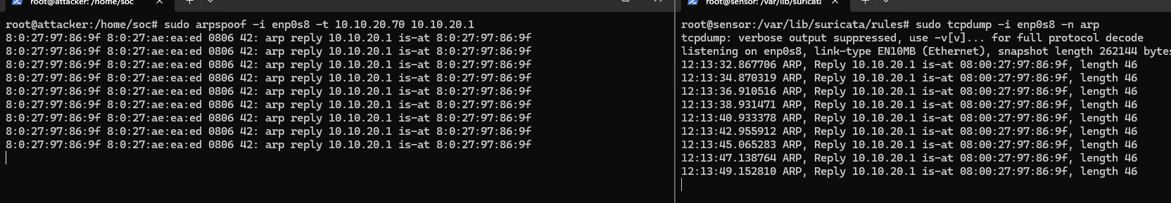
Figure 13. The forged ARP replies on VLAN 20.
Analyst note — Stop the attack cleanly after the screenshot (Ctrl+C, then pkill arpspoof) so the honeypot's ARP cache recovers.

6.3 Connection-flood denial of service, seen across the router
The attacker floods the honeypot's SSH service with thousands of rapid connections, each of which spawns a Cowrie session and drives the host's CPU up. Two planes catch it from the trusted side at the same time. The availability plane Zabbix, polling the honeypot across the router shows the CPU climbing in real time. The network plane Zeek's conn.log counts the flood as thousands of connections from one source in seconds. It is worth being precise about what this proves: not that the honeypot was destroyed, but that a host under stress on the exposed segment was visible to the SOC on the trusted segment, through the router, from two independent angles.
Verification · The flood raises CPU visibly and is counted on the network
Command: honeypot: uptime / top | sensor: grep 10.10.20.40 /opt/zeek/logs/current/conn.log | wc -l
Expected: the honeypot's load rises during the flood (visible in Zabbix / Grafana), and conn.log counts thousands of connections.
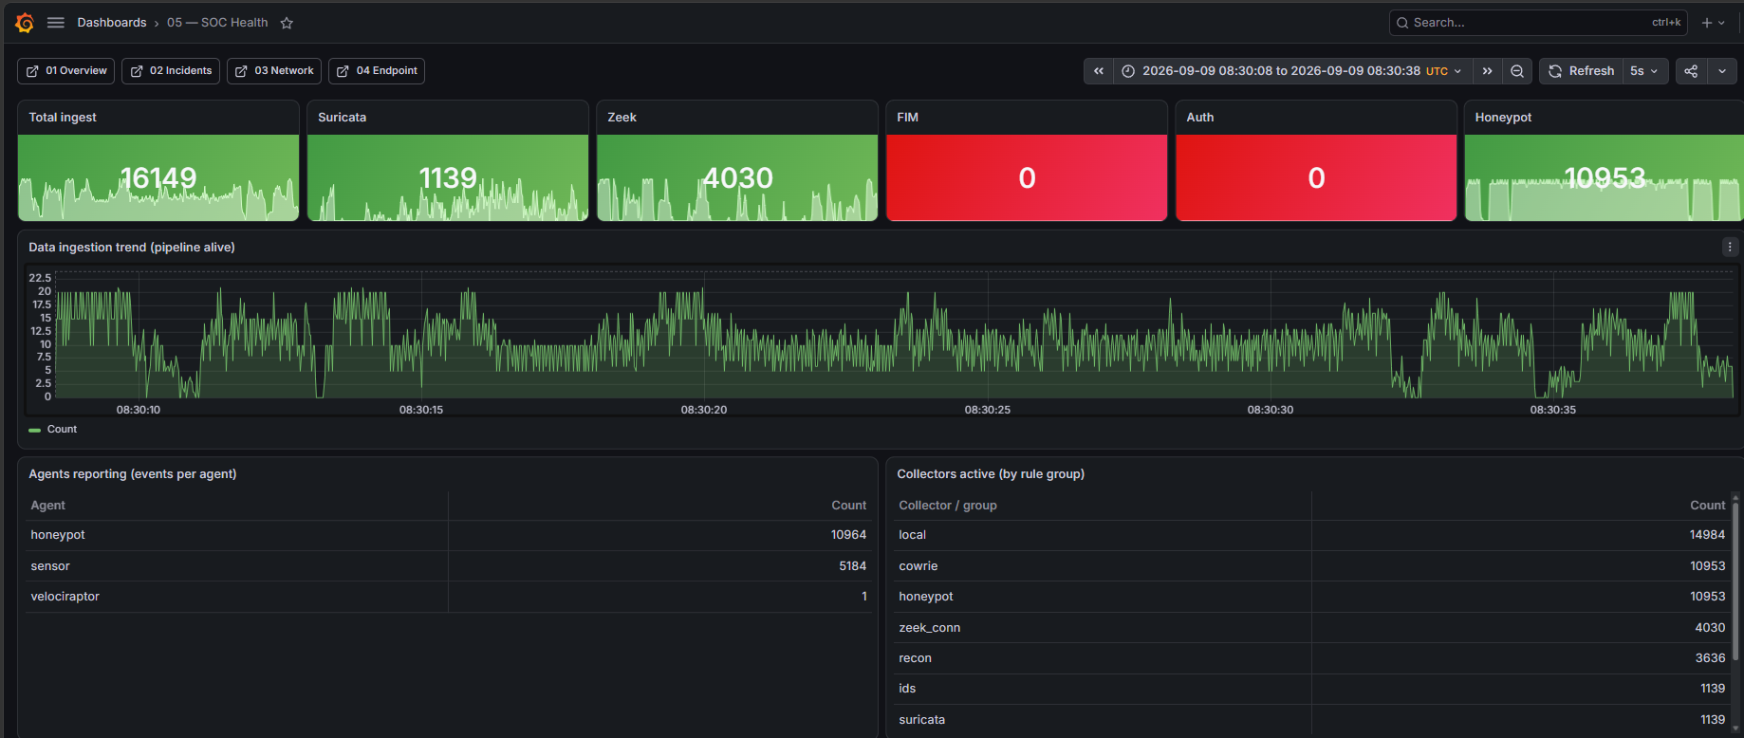

Figure 14. The honeypot CPU spike during the flood.
Analyst note — Run the flood for only twenty to thirty seconds, confirm the spike, then stop so the honeypot recovers.

7. Five Planes, Verified Across the Router
The central Phase 2 question is whether the SOC still works once its sensors and its manager sit on opposite sides of a router. It does. Each plane was rechecked end to end, and all of them converge in Grafana on the trusted side.
Plane | How it crosses the boundary | What confirms it
Network | Sensor taps VLAN 20 directly | the ~65,535-port scan captured on enp0s8
Endpoint | Agent reports to the manager across the router | rule 5712, source 10.10.20.40
Availability | Zabbix server polls the honeypot across the router | honeypot CPU visible in Grafana
Forensic | Velociraptor clients on both segments | honeypot and client show as connected
Deception | Cowrie on VLAN 20 feeds the endpoint logs | the brute-force landing in the honeypot
Table 3. Each plane, and how its data reaches the SOC across the router.

8. The Bug That Took Longest Stale Config
Not everything worked on the first try, and the hardest problem is the most instructive. Connectivity between the honeypot and the SOC worked in one direction only: requests went out fine, but the replies never came back. A one-way connection is a specific kind of clue it points at the return path, not the request path, so rather than rechecking the outbound side we looked at how replies were being routed.
The cause was the leftover Phase 1 netplan file described in Section 5.3. It had given the honeypot a second, stale IP address. The system treated that stale address as a directly attached network and built a route from it, so replies to the SOC were sent out the wrong interface and disappeared. Removing the old netplan file and keeping only the current addressing fixed it immediately.

9. What the Monitoring Recorded
Across the three attacks, every plane reported to the SOC on the trusted side, and the results are what the framing predicted rather than a surprise.
Test | What was expected | How it was confirmed
SSH brute-force | Detected, and the source still named 10.10.20.40 | rule 5712 in alerts.json, source 10.10.20.40
ARP MITM | Seen on VLAN 20, does not reach VLAN 10 | forged ARP on the sensor; client unaffected
Connection-flood DoS | Host stress visible across the router | honeypot CPU spike in Grafana; conn.log count
Five-plane check | Every plane reaches the SOC across the router | all planes visible in Grafana
TTL check | Cross-segment reply arrives as TTL 63 | ping shows 63 vs 64
Table 4. Expected versus confirmed outcome for each Phase 2 test.

10. Readiness Check (Run Before Every Session)
Check | How | Pass condition
Cross-segment reachability | ping across the router | reply received, TTL 63
No stale addresses | ip -br a on each host | exactly one lab IP per interface
Sensor tap live (VLAN 20) | tcpdump on enp0s8 during traffic | the sensor sees the packets
Agents across the router | Wazuh agent list | VLAN 20 agents active on the manager
Availability across the router | Zabbix frontend | honeypot ZBX green
Table 5. The GO / NO-GO readiness check for Phase 2.

11. Lessons From Phase 2
Sensor placement is a decision once the network is segmented a tap sees only its own segment, so put it where the attacker is.
Pure routing with no NAT preserves attribution the logs name the attacker, not the router.
Layer2 attacks stop at a Layer 3 boundary segmentation contains a whole class of attack the flat network could not.
One way connectivity is a return path problem; remove the previous phase's netplan when readdressing hosts.
TTL is a free diagnostic: 64 means same segment, 63 means one router hop.
The SOC watches the exposed segment from the trusted segment, through the router which is how a real SOC is arranged.

12. Conclusion
Adding one router turned an undifferentiated flat network into a segmented one and made the SOC earn its visibility. It did: the sensor was placed deliberately on the exposed segment, every plane was rechecked across the routed boundary, a Layer-2 attack was shown to be contained by the router, and infrastructure monitoring was proven to cross it. Because the router applied no NAT, every alert still named the real attacker, 10.10.20.40. The one hard bug a stale netplan file causing one-way connectivity was traced to the return path and fixed.
Phase 2 establishes segmentation and confirms that a SOC survives it when the monitoring reach is designed rather than assumed. It also sets the baseline that the next phase deliberately disturbs: attribution here is clean because there is no NAT. Phase 3 adds a firewall and NAT, and with them the problem of a source address that changes depending on where it is observed.

Appendix A — Snapshots and Insert Fields
Restore points for Phase 2:
Snapshot | Contents
phase2-start | Before VyOS routing (rollback point)
phase2-final | Phase 2 complete: routed, five planes across the router, attacks run, netplan persisted

Every diagram and screenshot to insert, in order (each frame is marked in the report where it belongs):
Field | Type | What to put here
1 | Diagram | Your topology diagram — VLAN 10 (trusted) and VLAN 20 (exposed) joined by the VyOS router, with the sensor tapping VLAN 20.
2 | Diagram | Your diagram: same-segment traffic keeps TTL 64, cross-segment traffic arrives as TTL 63 (one decrement = the VyOS router).
3 | Diagram | Your diagram: attacker 10.10.20.40 -> VyOS -> client, and the resulting log still names 10.10.20.40 because nothing rewrites the source.
4 | Diagram | Your diagram: sensor on VLAN 20 sees every attack; the same sensor on VLAN 10 would see nothing while VLAN 20 is under attack.
5 | Screenshot | tcpdump on the sensor (enp0s8) showing the attacker's traffic on VLAN 20 while an attack runs.
6 | Screenshot | The output of 'show configuration' (or 'show interfaces') on the VyOS router, showing the two interface addresses and no NAT rule.
7 | Screenshot | The contents of /etc/netplan/99-labnet.yaml on a host, showing the static address (e.g. 10.10.10.50/24) and the routes block pointing the far subnet via the router.
8 | Screenshot | eve.json filtered to event_type=alert (jq) during the nmap scan, showing the attacker 10.10.20.40 as the source.
9 | Screenshot | The script /opt/zeek-wazuh-bridge/translate.py and the output of 'systemctl status zeek-wazuh-bridge', showing the dots-to-underscores field rename that feeds Wazuh.
10 | Screenshot | The Wazuh alert (rule 5712) in alerts.json showing source 10.10.20.40, reported to the manager on VLAN 10 from across the router.
11 | Screenshot | The Zabbix frontend showing the honeypot host as available (ZBX green) with CPU / latest data flowing across the router, or the zabbix-agent2 config with Server=10.10.10.22.
12 | Screenshot | The Wazuh alert (rule 5712) naming 10.10.20.40 as the source of the brute-force against the client, reported across the router.
13 | Screenshot | tcpdump on the sensor (enp0s8) showing the repeated forged ARP replies for 10.10.20.1 from the attacker's MAC.
14 | Screenshot | The Grafana SOC-Health dashboard (Zabbix data) showing the honeypot's CPU spiking during the connection flood, observed across the router.
Table 6. Every insert field in this report and what each should show.

End of Phase 2 report.

