SOC Detection Laboratory

Phase 3
Firewalled Network with a DMZ and NAT

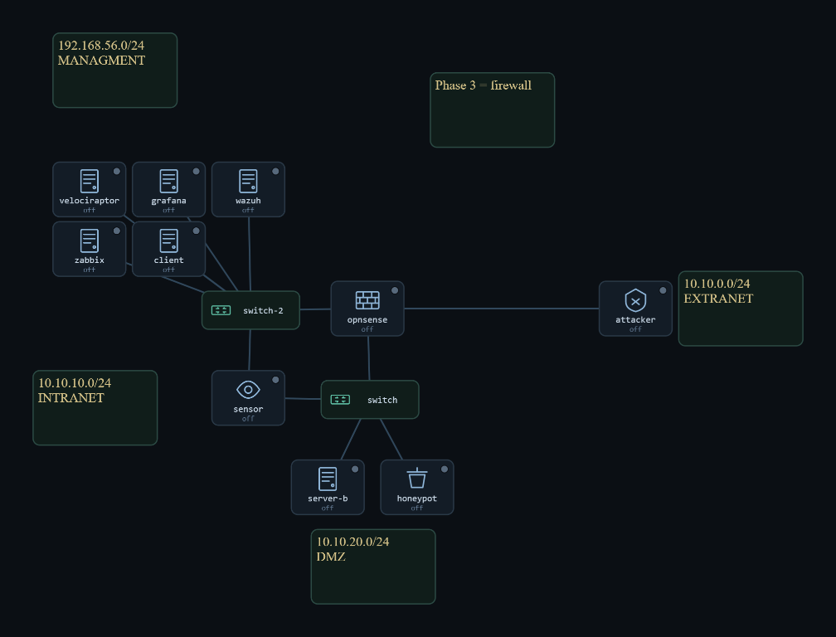
Figure 1. The Phase 3 three-zone topology.

Project | Home-lab Security Operations Center
Phase | 3 of 4 — Firewalled network, DMZ, and NAT
Prepared by | Abdulrahman Salem Ali
Date | 9 / 15 / 2026
Zones | Extranet 10.10.0.0/24 | DMZ 10.10.20.0/24 | Intranet 10.10.10.0/24
Boundary | OPNsense stateful firewall (one box, three legs)
Baseline snapshot | phase3-final

Contents
Right-click the field below and choose Update Field in Word to fill in page numbers.
Contents 2
1. What Changed, and the Question It Raised 3
2. The Environment 3
3. The Firewall Model: Three Zones, Least Privilege 4
3.1 Trust flows downhill only 4
3.2 Each zone has its own rule set, matched on entry 4
3.3 From the outside, the whole lab is one web page 4
4. Two Places to Watch: the Sensor and the Firewall 5
5. NAT, and Why a Single Log Can Lie 5
6. The Files That Make Phase 3 Work 7
6.1 OPNsense config.xml: the whole boundary in one file 7
6.2 The firewall-to-SOC log pipeline: 30-opnsense.conf 7
6.3 The pfSense decoder and rules 8
6.4 local.rules on the sensor: the DMZ's own signatures 8
6.5 The bait web application and per zone routing 9
7. The Attacks, and What Each One Tested 10
7.1 Local file inclusion: the permitted service, abused 10
7.2 Automated recon caught by its fingerprint 10
7.3 The reverse-shell callback that the firewall refuses 11
7.4 The pivot, and the attribution break that matters 12
7.5 The probe storm the sensor cannot see 13
8. The Correlation Exercise: Unmasking the Attacker 13
9. What the Monitoring Recorded 14
10. Readiness Check (Run Before Every Session) 14
11. Lessons From Phase 3 14
12. Conclusion 15
Appendix A: Snapshots and Insert Fields 16

1. What Changed, and the Question It Raised
Phase 2 proved that monitoring survives a router, and it survived cleanly because the router did nothing but forward packets. Every log named the real attacker because there was no address translation to get in the way. Phase 3 removes that comfort on purpose. The plain VyOS router is replaced by an OPNsense stateful firewall, the two segments become three trust zones, and the firewall runs Source NAT on the way out to the Extranet. Two capabilities arrive together: least-privilege control between zones, and a network that can now disguise where a connection came from.
That raises a sharper question than Phase 2 asked. In Phase 2 the question was whether the SOC could still see the attack. In Phase 3 the SOC can see the attack from several angles, but the angles disagree with each other. The sensor inside the DMZ, the endpoint agent on a victim, and the firewall's own log can each name a different source for the same intrusion, and only one of them is the real attacker. The work of Phase 3 is no longer to collect evidence, it is to reconcile it. The phase is built to make that happen and then to show the method that resolves it.
Replace the router with a stateful firewall and split the lab into three trust zones (Extranet, DMZ, Intranet).
Publish exactly one service to the outside and confirm the firewall denies everything else.
Add a second detection surface: the firewall's own block log, feeding the SOC the traffic the sensor can never see.
Introduce NAT and a deliberate pivot path, then show how correlation recovers the real attacker when a single log lies.

2. The Environment
The firewall is the only path between the three zones. The Extranet is the untrusted outside, and it holds the attacker. The DMZ is the exposed middle, and it holds the published web server and the honeypot this is where the sensor taps. The Intranet is the trusted inside, and it holds the full SOC stack and the internal client. Management stays out of band on 192.168.56.x, so administering the SOC never touches the traffic being watched.
Machine | Zone | Security level | Address
attacker | Extranet 10.10.0.0/24 | 0 | 10.10.0.40
OPNsense firewall | boundary (all three) | 3 gates | Extranet .0.1 | Intranet .10.1 | DMZ .20.1
web server A (published) | DMZ 10.10.20.0/24 | 50 | 10.10.20.60 (mgmt 192.168.56.33)
honeypot (Cowrie) | DMZ 10.10.20.0/24 | 50 | 10.10.20.70
sensor | DMZ 10.10.20.0/24 | 50 | passive tap on enp0s8 (mgmt 192.168.56.10)
wazuh (SIEM manager) | Intranet 10.10.10.0/24 | 100 | 10.10.10.20 (mgmt 192.168.56.20)
zabbix | Intranet 10.10.10.0/24 | 100 | 10.10.10.22
velociraptor | Intranet 10.10.10.0/24 | 100 | 10.10.10.23
grafana | Intranet 10.10.10.0/24 | 100 | 10.10.10.24
client | Intranet 10.10.10.0/24 | 100 | 10.10.10.50 (pivot target, :22)
Table 1. Phase 3 addressing — three trust zones joined only by the OPNsense firewall.

3. The Firewall Model: Three Zones, Least Privilege

3.1 Trust flows downhill only
The three zones are ranked by trust the Extranet is the least trusted, the Intranet the most, and the DMZ sits in the middle. The governing rule is the one a real perimeter uses: a lower zone may reach a higher one only through a specific, deliberate hole, and everything else is denied and logged. This is what makes the DMZ useful. It is a place exposed enough to publish a service to the outside, but walled off enough that compromising it does not hand over the trusted inside.

3.2 Each zone has its own rule set, matched on entry
Rules are evaluated where traffic enters the firewall, first match wins, and the default is deny and log. The Extranet is allowed to reach one destination and one port, the published web server on port 80, and nothing else. The DMZ is allowed to reach the three SOC agents it must report to, plus exactly one SSH host inside, and nothing else. The Intranet, being trusted, is allowed out freely. Written down, the policy is short, and its shortness is the point: every allowed path is there for a stated reason.
Entering zone | Allowed | Everything else
Extranet | TCP to web server 10.10.20.60 : 80 only | denied and logged
DMZ | to SOC agents (.20/.22/.23); web .60 to client .50 : 22 | denied and logged
Intranet | allow out (trusted) | —
Table 2. The least-privilege rule set, one row per entering zone.

3.3 From the outside, the whole lab is one web page
The cleanest proof that the policy is real is to stand on the Extranet and try the doors. A port scan of the web server from the attacker returns almost entirely filtered, meaning the firewall dropped the probes silently, with a single port open: 80. Ping to the same host is dropped. The Intranet and the firewall itself are unreachable. This is what least privilege looks like from the attacker's side: a wall with one small window.
Verification · The Extranet can reach exactly one service and nothing else
Command: attacker: sudo nmap -Pn -sS -T4 --top-ports 100 10.10.20.60 and nc -zv -w2 10.10.10.50 22
Expected: the scan reports 99 ports filtered and only 80/tcp open; ICMP is dropped; the Intranet SSH probe is blocked.

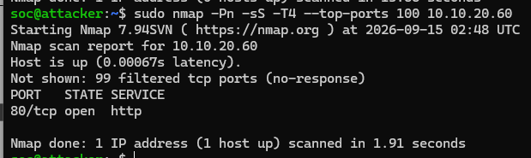
Figure 3. The firewall seen from the attacker's side.

4. Two Places to Watch: the Sensor and the Firewall
A firewall changes not just what an attacker can do, but where the SOC can see them. The sensor is a passive tap, and it only sees the segment it is attached to, the DMZ. That means the sensor is the right eye for anything that happens to the published web server, but it is blind to an attacker rattling doors on the Intranet or on the firewall itself, because that traffic never reaches the DMZ wire. The firewall fills exactly that gap. It sits on all three legs, and it logs every packet it denies, so the traffic the sensor cannot see becomes visible as firewall block events instead.
This division of labour was confirmed directly. When the attacker scanned the published web server, the firewall filtered the scan down to the one open port before it reached the DMZ, so the sensor's own scan signatures did not fire, correctly, there was no scan left on the DMZ wire to detect. The same scan was recorded on the other surface: the firewall logged the dropped probes, forwarded them to the SOC, and Wazuh raised its many blocks from one source rule, naming the real attacker 10.10.0.40. The scan was detected; it was simply detected at the firewall, not at the sensor.
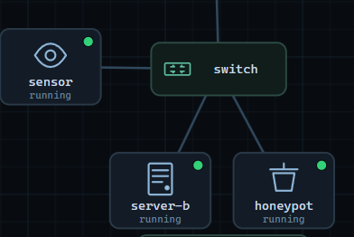

Figure 4. The sensor sees the DMZ; the firewall sees every denial.

Verification · An external scan is caught at the firewall, not the sensor, and still names the real source
Command: attacker: sudo nmap -sS -T4 --top-ports 100 10.10.20.60 | wazuh: tail alerts.json, filter rule 87702 / srcip 10.10.0.40
Expected: the sensor's scan rules stay quiet (the firewall filtered the scan first); Wazuh rule 87702 fires with source 10.10.0.40.

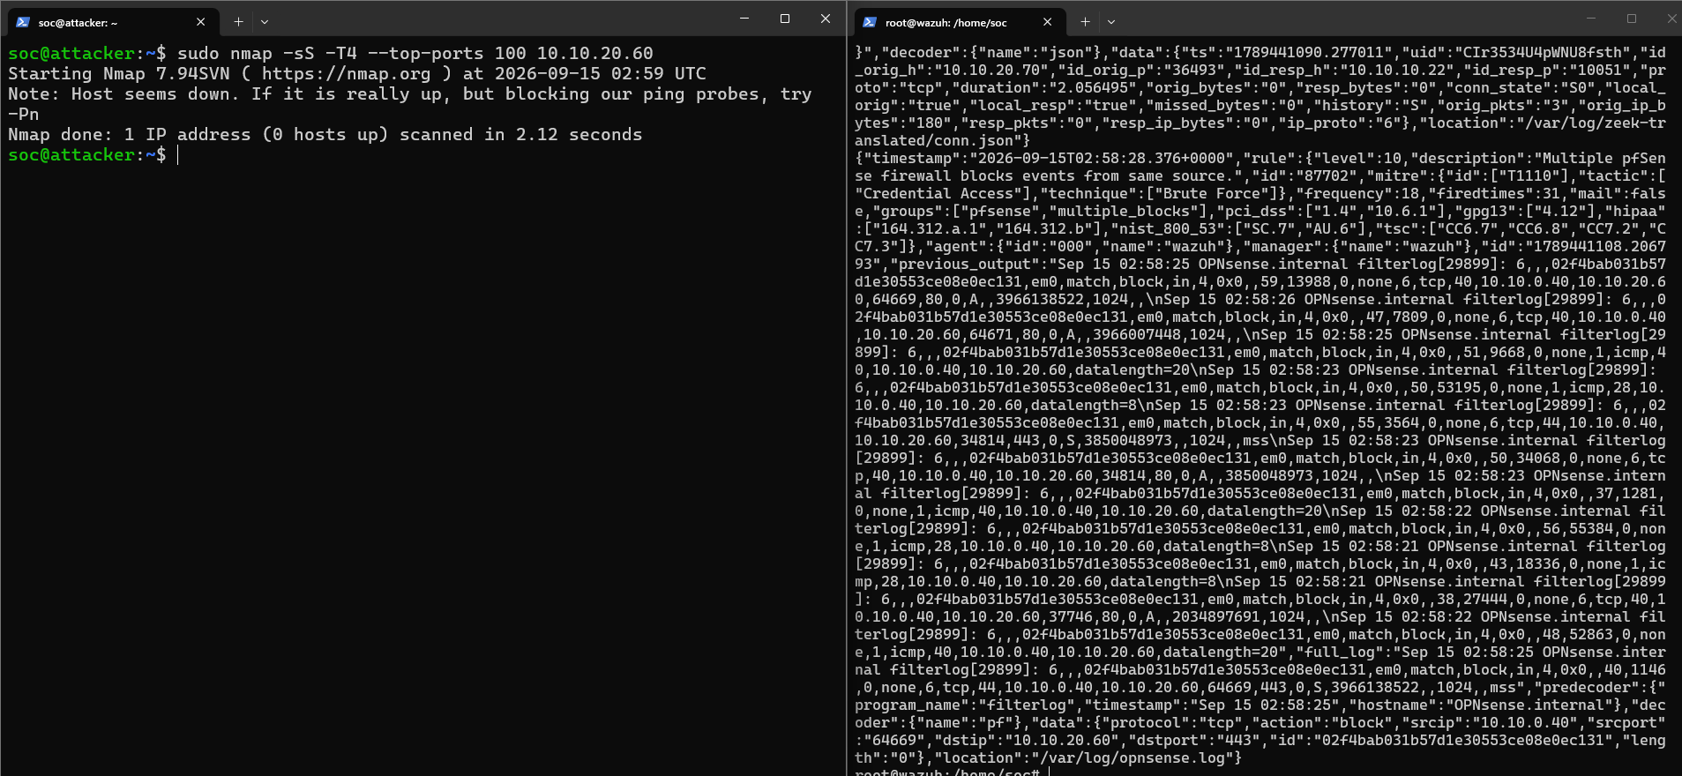
Figure 5. The scan detected on the firewall surface.

5. NAT, and Why a Single Log Can Lie
The firewall runs automatic Source NAT on egress toward the Extranet. Source NAT rewrites the source address of a connection as it leaves, so a flow that began inside the firewall arrives at an outside listener looking like it came from the firewall's own Extranet address, 10.10.0.1, rather than from the machine that really started it. Inbound traffic and traffic between the inside zones are not translated, so real addresses are preserved there. The consequence is specific and important: an address in a log now means different things depending on where the log was written.
It is worth being precise about how this plays out in the lab, because it is easy to overstate. The firewall's egress policy denies the DMZ any path to the Extranet in the first place, so a compromised web server cannot simply dial home the deny happens before NAT would ever apply. NAT's real role in Phase 3 is therefore not a magic trick that hides a working channel, it is the reason a perimeter address can never be trusted on its own, and it is why the firewall's state table, which records both sides of every translation, is the tool that ties a translated address back to the machine behind it. The attribution problem the SOC actually has to solve in this phase comes from the pivot, described in the attacks, and NAT is the reason the perimeter view of it cannot be taken at face value.

6. The Files That Make Phase 3 Work
Phase 3 adds a firewall's worth of configuration and, for the first time, a log pipeline from the firewall into the SOC. Each important file is explained below, with an emphasis on what it is for rather than its full contents.

6.1 OPNsense config.xml: the whole boundary in one file
The firewall's entire behaviour, the three interface assignments, every rule, the NAT configuration, and the aliases, lives in one file, /conf/config.xml. Reading it is how you confirm that the policy on the screen is the policy actually loaded. The three things to look for are the interface to zone mapping (em0 Extranet, em1 Intranet, em2 DMZ), the per interface rules with their default deny, and the automatic outbound NAT toward the Extranet.
Verification · The three zones and the deny-by-default policy are really in place
Command: attacker (Extranet): ping the DMZ web, the Intranet client, and the firewall itself
Expected: only the published web path behaves; the Intranet and the firewall are unreachable — the zone policy is live.

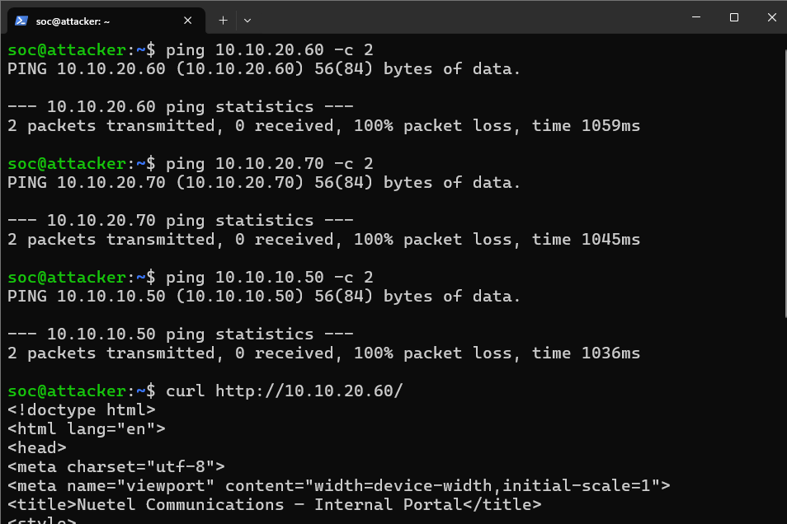
Figure 6. The firewall rule set in the OPNsense GUI.

6.2 The firewall-to-SOC log pipeline: 30-opnsense.conf
This is the new capability of the phase, and it lives in a small rsyslog configuration on the SOC manager, /etc/rsyslog.d/30-opnsense.conf. The firewall is set to send its filter log over the network to the manager on UDP 514; this file is what receives it, checks that the sender really is the firewall (10.10.10.1), and writes it to /var/log/opnsense.log in the traditional syslog format the decoder expects. Without this file the firewall's blocks would exist only on the firewall, and the SOC would be blind to everything the firewall denies.

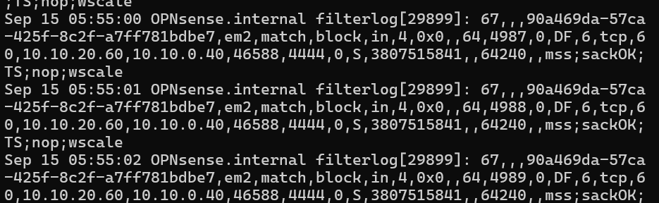
Figure 7. The firewall log arriving on the SOC manager.

6.3 The pfSense decoder and rules
Receiving the log is only half the pipeline the manager still has to understand it. Wazuh ships a decoder that reads the firewall's filterlog format and a matching rule set that turns those decoded lines into alerts. Two rules carry the weight 87701 fires on a single block, and 87702 fires when one source triggers many blocks in a short window, which is the signature of a scan or a brute force sweep and is mapped to the corresponding technique. These firewall alerts are attributed to the manager itself and grouped under the pfSense label, which is how you filter for them.
Verification · Firewall blocks are decoded into SOC alerts
Command: attacker: probe several closed ports on the Intranet | wazuh: filter alerts.json for group pfsense / rule 87701 and 87702
Expected: single blocks raise 87701; a burst from one source escalates to 87702, both naming the real Extranet source.

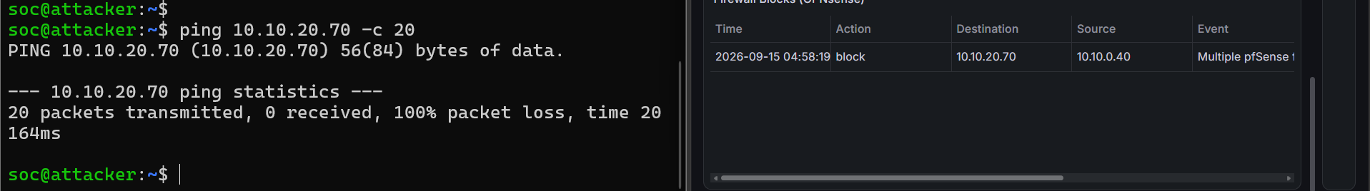
Figure 8. The firewall block escalating to rule 87702.

6.4 local.rules on the sensor: the DMZ's own signatures
The sensor keeps the lab's custom Suricata signatures in /var/lib/suricata/rules/local.rules, in the reserved local range. In Phase 3 these do two jobs. The application layer signatures catch abuse of the one published service: a local file inclusion attempt reading a system file, and the fingerprint of an automated tool by its User Agent. Alongside them sits a small, tuned set of scan detection signatures. Their behaviour behind the firewall is itself a finding: because the firewall filters an external scan down to a single port before it reaches the DMZ, these signatures correctly stay silent on outside scans and fire only on a scan that originates inside the monitored segment, which is exactly where an internal IDS should be looking.

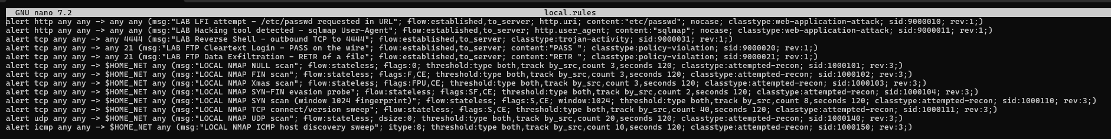
Figure 9. The custom signatures on the sensor.

6.5 The bait web application and per zone routing
Two supporting files complete the picture. On the web server, a deliberately vulnerable page (search, download, and admin endpoints) is the thing being published and attacked; it is the reason the DMZ has anything to expose. On each host, the netplan file carries the static address for its zone and the routes that let it reach the others through the firewall. As in Phase 2, keeping this in netplan rather than typing it at runtime is what makes the topology survive a reboot.

7. The Attacks, and What Each One Tested
The attacks form a single chain rather than a list, and the chain is what teaches the phase: reach the one published service, abuse it, try to escape the DMZ, and hammer the doors that stay shut. Each step isolates one property of the firewalled network. Throughout, it helps to separate three different questions that Phase 1 and 2 could blur together did the attack succeed, did the control stop it, and did the SOC detect it. They do not always have the same answer.
# | Attack / action | MITRE | What it isolates
1 | Web exploitation LFI | T1190 | Detection of abuse of the one permitted service
2 | Automated recon tool fingerprint | T1595 | Catching a loud tool by its own signature
3 | Reverse-shell callback (blocked) | T1071 | Egress control — the DMZ cannot phone home
4 | Pivot: DMZ to Intranet | T1210 | Attribution break — the endpoint blames the puppet
5 | Blocked zone probe storm | T1046 / T1110 | The firewall as a sensor for what the DMZ tap cannot see
Table 3. The Phase 3 attack chain and the property each step isolates.

7.1 Local file inclusion: the permitted service, abused
The attacker uses the download endpoint on the published web server to read a system file through a path traversal string. This is the case where the firewall is not the defender and is not supposed to be its job was to publish port 80, and it did. The defence here is detection, not prevention. The sensor inside the DMZ raises the local file inclusion signature, and because inbound traffic is not translated, the alert names the real source, 10.10.0.40. Attack succeeded; control was not involved; detection succeeded and attribution was clean.
Verification · The web exploit is detected inside the DMZ and names the real source
Command: attacker: curl "http://10.10.20.60/download.php?file=../../../../etc/passwd" | sensor: filter eve.json for the LFI signature
Expected: the LFI signature fires with source 10.10.0.40 — the sensor sees the true attacker because inbound is not NAT'd.

Figure 10. The LFI alert on the sensor.

7.2 Automated recon caught by its fingerprint
Real attackers bring noisy tools, and noisy tools identify themselves. When an automated SQL injection scanner is pointed at the search endpoint, the sensor does not need to wait for a successful injection; it recognises the tool by the User Agent string it announces, and alerts on that alone. The lesson is that a signature does not have to describe a vulnerability to be useful, it can describe the attacker's own equipment.

Verification · The scanning tool is recognised by its own User-Agent
Command: attacker: run the SQLi scanner (or curl -A with its User-Agent) against the search endpoint | sensor: grep the tool name in eve.json
Expected: the tool-fingerprint signature fires, source 10.10.0.40, before any injection would have succeeded.

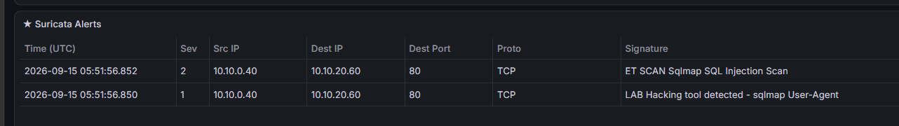
Figure 11. The tool-fingerprint alert.

7.3 The reverse-shell callback that the firewall refuses
A common next step after a web compromise is a reverse shell the victim server dials back out to a listener the attacker controls. In a flat or purely routed network this works, and Phase 3 is where it stops working. The DMZ's egress policy permits it to reach only the SOC agents and the one SSH pivot host; a callback to the attacker's listener on the Extranet matches none of those, so the firewall denies it and logs the denial. This is the clean separation the chain is built to show the web exploit above succeeded, but the attacker still cannot establish a command channel out of the DMZ, because egress is controlled. The block itself becomes evidence on the firewall surface.
Verification · A callback out of the DMZ is denied by egress policy and logged
Command: web server .60: attempt a reverse shell to the attacker on the Extranet (port 4444) | wazuh: look for the matching firewall block from .60
Expected: the connection does not establish; the firewall records a block for the DMZ-to-Extranet attempt, and no C2 channel forms.

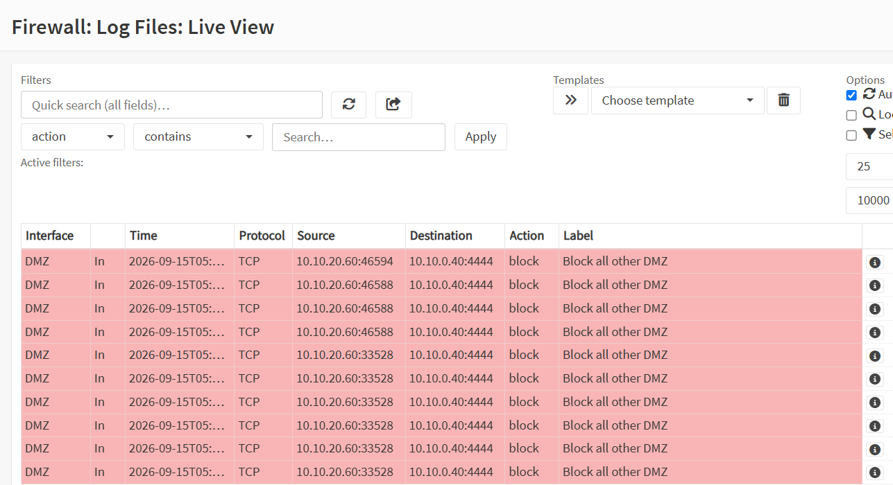
Figure 12. The blocked egress attempt.

7.4 The pivot, and the attribution break that matters
The firewall permits exactly one path deeper into the network: the web server may reach the internal client on SSH. That hole is deliberate, so that the pivot can be watched. Riding the compromised web server, the attacker brute forces SSH on the internal client through it. Now the attribution break appears, and it is not caused by NAT inter zone traffic is not translated, so the client's endpoint agent sees the connection honestly, and honestly it came from the web server, 10.10.20.60. The endpoint therefore blames the web server. That is true and also misleading, because the web server is a puppet the real hand is on the Extranet. A single endpoint log names the machine it can see, which is the intermediary, not the origin.
Verification · The pivot is detected, and the endpoint names the intermediary, not the origin
Command: web server .60: repeated SSH attempts to the client 10.10.10.50 | wazuh: filter alerts.json for the brute-force rule with source 10.10.20.60
Expected: the SSH brute-force rule fires with source 10.10.20.60 (the web server) — the endpoint blames the puppet, not the real attacker.

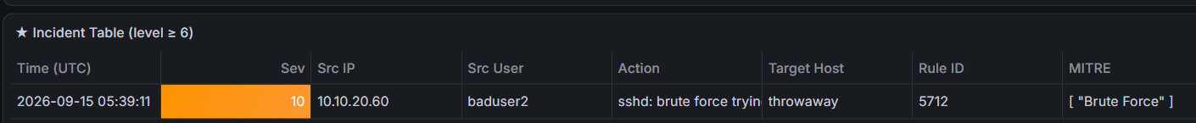
Figure 13. The pivot alert blaming the web server.

7.5 The probe storm the sensor cannot see
Finally the attacker hammers the doors the firewall keeps shut, scanning the Intranet and the firewall itself from the Extranet. None of this traffic reaches the DMZ wire, so the sensor is blind to it by design. This is precisely what the firewall to SOC pipeline was built for. The firewall denies every probe, forwards the denials to the manager, and Wazuh escalates from single block alerts to the many blocks from one source rule, naming the real Extranet attacker. It is the same lesson as Section 4, arrived at from the attacker's side the detection the internal sensor could never make is made on the firewall surface instead.

8. The Correlation Exercise: Unmasking the Attacker
The point of the chain is that no single witness tells the whole truth, and Phase 3 is where the SOC stops trusting one log and starts reconciling several. Three witnesses describe the same intrusion and name different sources. The sensor inside the DMZ, watching the web exploit, has the real attacker. The endpoint on the pivoted client has the web server, because that is the machine it could see. The firewall, wherever NAT applied, has its own address. Laid on one timeline, the disagreement is not a contradiction to be argued about, it is a map of the attacker's path.

Witness | Names the source as | Why it says that
Sensor (DMZ tap) | 10.10.0.40 — the real attacker | inbound is not NAT'd; the tap sees the truth of the web exploit
Endpoint (client) | 10.10.20.60 — the web server | the pivot; the endpoint sees only its immediate peer
Firewall (NAT / state) | 10.10.0.1 — the firewall | Source NAT rewrites egress; the state table records both sides
Table 4. Three witnesses, three sources, one attacker — the Phase 3 correlation.

The method that resolves it is timestamp alignment plus the firewall's own state table. The state table records both halves of every translated connection, so a translated address can be tied back to the machine behind it. Ordered by time, the LFI on the web server, the pivot to the client, and the blocked zone probing line up into a single account: the attacker on 10.10.0.40 reached and exploited the web server 10.10.20.60, rode it toward the client 10.10.10.50, and rattled the doors the firewall kept shut. The real attacker, named nowhere completely by any one log, is named unambiguously by all three together.

9. What the Monitoring Recorded
Across the chain, the separation of attack success, control, and detection is what the results actually show, and it is more informative than a simple pass or fail column.
Step | Attack outcome | Control | Detected by / as
LFI | succeeded (service abused) | not applicable (published) | sensor — LFI signature, source 10.10.0.40
Tool recon | recon performed | not applicable | sensor — tool fingerprint, source 10.10.0.40
Reverse shell | failed to connect | firewall egress deny | firewall block from 10.10.20.60
Pivot | attempted through the hole | hole is deliberate | endpoint — source 10.10.20.60 (the puppet)
Probe storm | all probes blocked | firewall deny | firewall — rule 87702, source 10.10.0.40
Table 5. Attack outcome, control, and detection kept as separate columns.

10. Readiness Check (Run Before Every Session)
Check | How | Pass condition
Perimeter is one door | nmap the web server from the Extranet | only 80/tcp open; the rest filtered
Inside is hidden | nc to an Intranet port from the Extranet | blocked
Sensor tap live (DMZ) | tcpdump on enp0s8 during web traffic | the sensor sees the DMZ packets
Firewall log reaching SOC | tail /var/log/opnsense.log on wazuh | filterlog block entries are arriving
Firewall alerts decoded | filter alerts.json for group pfsense | 87701 / 87702 present after a probe
Table 6. The GO / NO-GO readiness check for Phase 3.

11. Lessons From Phase 3
A DMZ is a trade: expose one service to the world, and wall the compromise of that service off from the trusted inside and least privilege is proven from the attacker's side from the Extranet the whole lab should be one open port and nothing more.
A firewall moves detection as well as control: external reconnaissance is caught on the firewall log, not the internal sensor.
Egress control defeats the reverse shell a web exploit can succeed and still fail to establish a command channel out of the DMZ.
Attribution breaks at the pivot without any NAT at all: an endpoint honestly names its immediate peer, which is the intermediary, not the origin.
No single log is authoritative once the network can translate and relay correlation across the sensor, the endpoint, and the firewall state table is the skill the phase teaches.

12. Conclusion
Replacing the router with a firewall turned a simply segmented network into a governed one. The lab became three trust zones with a single published service, a deliberately narrow pivot, and a firewall that both enforces the policy and reports on it. The monitoring held up under this: the sensor caught abuse of the published service and named the real attacker, the firewall caught the reconnaissance the sensor could never see, egress control refused the compromised server a way out, and the one attribution break the network produced was resolved by correlating three disagreeing witnesses onto a single timeline.
The defining shift from Phase 2 is that evidence is no longer taken at face value. Segmentation made monitoring a matter of placement a firewall with NAT makes it a matter of reconciliation. Phase 4 continues the arc by adding a second firewall and a VPN, extending both the trust model and the correlation problem across an encrypted boundary.

Appendix A: Snapshots and Insert Fields
Restore points for Phase 3:
Snapshot | Contents
phase3-start | Before the OPNsense DMZ build (rollback point)
phase3-firewall | Three-zone firewall validated: segmentation blocked, monitoring open, trusted path OK
phase3-topology-complete | Firewall + published web server + attacker on the Extranet, published :80 works, NAT automatic
phase3-final | Phase 3 complete: firewall, DMZ web server, firewall-to-SOC logging, attacks run and evidence captured
phase3-suricata-nmap-rules | phase3-final plus the tuned scan-detection signatures on the sensor

Every diagram and screenshot to insert, in order (each frame is marked in the report where it belongs):
Field | Type | What to put here
1 | Diagram | Your topology diagram: Extranet (attacker), DMZ (web server + honeypot) and Intranet (SOC + client), joined only by the OPNsense firewall, with the sensor tapping the DMZ.
3 | Screenshot | The attacker's nmap output against 10.10.20.60 showing 99 ports filtered and only 80/tcp open, plus the blocked nc probe to the Intranet — the perimeter reduced to one open door.
4 | Diagram | Your diagram: the sensor tap covering only the DMZ segment, and the firewall (on all three legs) forwarding its block log to Wazuh, so external scans of the Intranet/firewall are caught on the firewall surface, not the sensor.
5 | Screenshot | The Wazuh alert (rule 87702, multiple pfSense blocks from one source) in alerts.json naming 10.10.0.40, captured after the external scan — the detection the DMZ sensor could not have made.
6 | Screenshot | The OPNsense Firewall > Rules screen for the Extranet (WAN) interface, showing the single pass rule to 10.10.20.60:80 and the default block and log rule beneath it.
7 | Screenshot | The tail of /var/log/opnsense.log on the wazuh manager showing filterlog block entries arriving from the firewall (10.10.10.1) over syslog.
8 | Screenshot | The Wazuh alert for rule 87702 (multiple firewall blocks from one source) in alerts.json, showing the pfSense group and the source 10.10.0.40.
9 | Screenshot | The contents of /var/lib/suricata/rules/local.rules on the sensor, showing the application-layer signatures (LFI, tool fingerprint) and the tuned scan-detection signatures.
10 | Screenshot | The sensor's eve.json filtered to the LFI alert during the curl request, showing signature and source 10.10.0.40 -> 10.10.20.60.
11 | Screenshot | The sensor's eve.json entry showing the automated-scanner User-Agent signature with source 10.10.0.40.
12 | Screenshot | The firewall block for the DMZ web server's outbound callback attempt (10.10.20.60 to 10.10.0.40:4444) as seen in the firewall log or in Wazuh the reverse shell that never left the DMZ.
Table 7. Every insert field in this report and what each should show.

End of Phase 3 report.

