SOC Detection Laboratory

Phase 4
Dual-Firewall Network with a Site-to-Site VPN

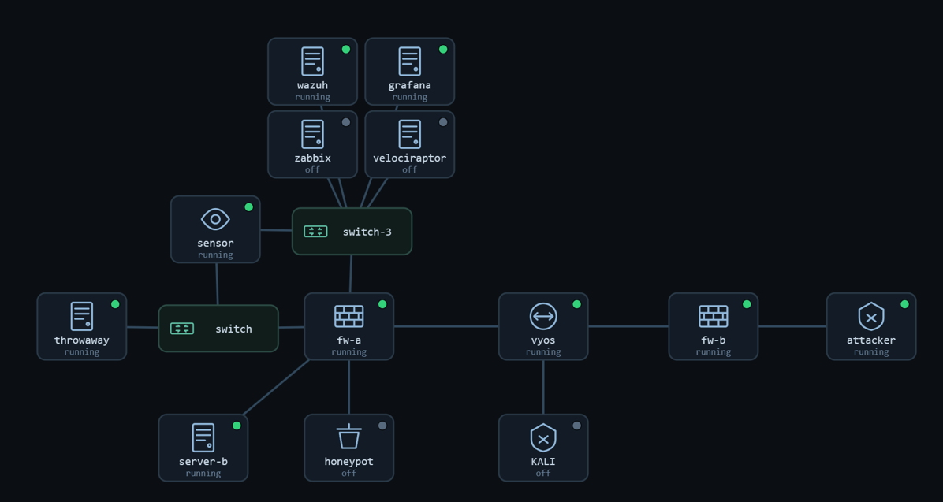
Figure 1. The Phase 4 two-site topology.

Project | Home-lab Security Operations Center
Phase | 4 of 4 Dual firewall and a site-to-site VPN
Prepared by | Abdulrahman Salem Ali
Date | 25 / 9 / 2026
Sites | Site A / SOC 10.10.10.0/24 | Site B / branch 10.10.30.0/24
Transit | 10.10.0.0/24 (untrusted) fw-a WAN .1, fw-b WAN .2
Tunnel | IPsec IKEv2 · AES-GCM · pre-shared key · 10.10.10.0/24 <-> 10.10.30.0/24
Baseline snapshot | phase4-vpn

Contents
Right-click the field below and choose Update Field in Word to fill in page numbers.
Contents 2
1. What Changed, and the Question It Raised 3
2. The Environment 3
3. The VPN Model: Two Firewalls, One Encrypted Tunnel 4
3.1 A routed link versus an encrypted tunnel 4
3.2 How the tunnel is built: IKE agrees the keys, ESP carries the traffic 4
3.3 The tunnel is the only path from the branch to the SOC 5
4. Where Detection Goes When You Cannot Read the Traffic 6
5. Attribution Survives the Tunnel 6
6. The Files and Settings That Make Phase 4 Work 7
6.1 The tunnel definition: swanctl connection and child 7
6.2 Permitting the tunnel: the WAN pass rule 7
6.3 The routes that make the far LAN reachable 7
6.4 Reusing the sensor's signatures at the decryption point 8
7.1 An nmap scan that rides the tunnel 8
7.2 A Nikto web scan over the same tunnel 8
7.3 The on path attacker who sees only ESP 9
8. The Correlation Exercise: Unmasking the Branch Attacker 10
9. What the Monitoring Recorded 10
10. Readiness Check (Run Before Every Session) 11
11. Lessons From Phase 4 11
12. Conclusion 11
Appendix A: Snapshots and Insert Fields 13

1. What Changed, and the Question It Raised
Phase 3 taught the SOC to reconcile logs that disagreed, but every one of those logs could still be read. The sensor could see ports, flags, and payloads; the firewall could log the packets it dropped; the disagreement was about attribution, not visibility. Phase 4 removes the last comfort. A second site is added behind its own firewall, and the two sites are joined by an encrypted IPsec tunnel that runs across an untrusted transit segment. On that transit, the traffic is no longer readable at all. A packet leaving the branch is sealed inside an Encapsulating Security Payload envelope, and anyone sitting on the wire between the two firewalls sees only that envelope: two firewall addresses exchanging opaque blobs, with no ports, no flags, and no payload to match a signature against.
That raises the hardest question the lab has asked. In Phase 2 the question was whether the SOC could still see the attack across a router; in Phase 3 it was which of several logs to believe. In Phase 4 the question is how to detect an attacker whose traffic you cannot read. The answer the phase is built to demonstrate is a shift in where you watch. Content inspection is dead on the encrypted transit, but it is alive and well at the point where the firewall decrypts the tunnel and hands the traffic back to the local network in the clear. Detection does not disappear under encryption; it moves to the decryption point, and correlation stitches the two viewpoints back together.
Add a second site a branch office behind its own OPNsense firewall and an untrusted transit between the two sites.
Join the sites with an encrypted IPsec site to site tunnel (IKEv2, AES-GCM, pre-shared key), so branch traffic reaches the SOC sealed.
Attack the SOC from inside the branch, over the VPN, and confirm the attack is caught at the decryption point with the real source named.
Watch the same attack from the transit and confirm it is unreadable there, then correlate the two views to unmask the branch attacker.

2. The Environment
There are now two firewalls and two sites. Site A is the SOC, unchanged from Phase 3: the Intranet holds the full monitoring stack and an internal host, the DMZ holds the published web server and the honeypot, and the sensor taps the Site A LAN. Site B is a new branch office, a single LAN behind its own firewall. Between them sits the transit, a segment that stands in for the public internet it carries only the two firewall WAN addresses, a passive router, and a seat for an on-path attacker. Management stays out of band on 192.168.56.x for both firewalls, so administering either site never touches the traffic being watched.
Machine | Site / segment | Address
fw-a (OPNsense) | Site A boundary | LAN .10.1 | DMZ .20.1 | WAN 10.10.0.1 (mgmt 192.168.56.9)
wazuh (SIEM manager) | Site A — Intranet | 10.10.10.20 (mgmt 192.168.56.20)
grafana / zabbix / velo | Site A — Intranet | 10.10.10.24 / .22 / .23
client (target) | Site A — Intranet | 10.10.10.50
sensor | Site A — LAN tap | passive tap = decryption point (mgmt 192.168.56.10)
web server A / honeypot | Site A — DMZ | 10.10.20.60 / 10.10.20.70
vyos | transit 10.10.0.0/24 | passive router (does not route between the firewalls)
KALI | transit 10.10.0.0/24 | on-path attacker seat (sees ESP only)
fw-b (OPNsense) | Site B boundary | LAN 10.10.30.1 | WAN 10.10.0.2 (mgmt 192.168.56.13)
attacker | Site B — branch LAN | 10.10.30.40
Table 1. Phase 4 addressing — two sites behind two firewalls, joined across the untrusted transit.

3. The VPN Model: Two Firewalls, One Encrypted Tunnel

3.1 A routed link versus an encrypted tunnel
It is worth stating precisely what a VPN changes, because the whole phase turns on it. A routed link moves packets between networks and leaves them legible: anyone on the path can read every field. A VPN tunnel does one extra thing before forwarding it wraps each original packet inside a new, encrypted one. The inner packet, with its real source, destination, ports, flags, and payload, is sealed; only the outer envelope, addressed firewall to firewall and marked as ESP, is visible on the transit. The tunnel therefore protects the branch's traffic from anyone on the untrusted wire, and, as a side effect, hides that same traffic from a defender who is watching the wire. Confidentiality and blindness are two views of the same property.

3.2 How the tunnel is built: IKE agrees the keys, ESP carries the traffic
The tunnel is established in two stages. First, IKE the Internet Key Exchange is the handshake: the two firewalls authenticate each other with a shared pre-shared key and negotiate the secret keys they will use, a step done once and refreshed on a timer. Second, ESP carries the data: every real packet that should cross the tunnel is encrypted with those keys and wrapped as an ESP packet for the trip across the transit. Two details decide whether the tunnel comes up at all. Both ends must agree on identity, key, and the exact pair of networks the tunnel joins; and ESP is a protocol, number 50, not a port, so the firewall must be told to permit the protocol itself rather than a port number.
Parameter | Value in this lab
Key exchange | IKEv2
Authentication | Pre-shared key (identical string on both firewalls)
Encryption / integrity | AES-GCM · SHA-256 (ESP)
Tunnel endpoints | fw-a 10.10.0.1 ⇄ fw-b 10.10.0.2
Protected networks | 10.10.10.0/24 (Site A) ⇄ 10.10.30.0/24 (Site B)
Established state | IKE_SA ESTABLISHED · CHILD_SA INSTALLED
Table 2. The IPsec parameters that must match on both ends for the tunnel to come up.
Verification · The encrypted tunnel is established between the two firewalls
Command: fw-a: swanctl --list-sas
Expected: the connection to 10.10.0.2 shows IKE_SA ESTABLISHED and the child shows INSTALLED — the tunnel is live and encrypting.

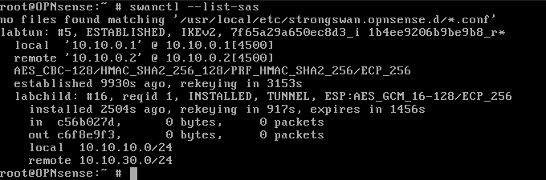.
Figure 3. The tunnel established, seen on fw-a.

3.3 The tunnel is the only path from the branch to the SOC
With the tunnel up, a branch host reaches the SOC by exactly one route: sealed inside the tunnel, across the transit, and out the far firewall. The proof is a round trip. From the branch attacker, a ping to an internal SOC host succeeds, and the reply arrives with a time to live of 62 rather than the usual 64. Two decrements mean the packet crossed two routing hops the two firewalls which is exactly the path the tunnel defines. The traffic that looks, from inside either site, like an ordinary local reach is in fact being encrypted, carried across the untrusted middle, and decrypted at the other end.
Verification · A branch host reaches the SOC only through the tunnel, across both firewalls
Command: branch attacker 10.10.30.40: ping -c4 10.10.10.50
Expected: four replies with TTL 62 — the round trip passed through both firewalls and rode the encrypted tunnel across the transit.

4. Where Detection Goes When You Cannot Read the Traffic
Encryption forces a decision the earlier phases never had to make where do you place the eye. On the transit, between the two firewalls, content inspection is finished. A signature engine matches ports, flags, and payloads, and inside the tunnel there are none of these to match only an opaque ESP blob between two firewall addresses. The most a watcher on the transit can do is traffic analysis: measure the timing, size, and regularity of the encrypted flow and infer that something is happening, without ever learning what. That is a real capability, but it is metadata, not detection.
The decryption point is the opposite. When fw-a receives an ESP packet destined for its own network, it decrypts it and forwards the original packet, in the clear, onto the Site A LAN which is precisely where the sensor taps. There, every field is readable again, signatures fire exactly as they always have, and, crucially, the real source is preserved: inter-site tunnel traffic is not address translated, so a scan launched from 10.10.30.40 in the branch still carries 10.10.30.40 when the Site A sensor reads it. Encryption blinds the middle; the decryption point restores both visibility and attribution. The SOC's job in Phase 4 is to watch the right place and then align it with what the transit could only glimpse.

5. Attribution Survives the Tunnel
A natural worry, coming out of Phase 3, is that the VPN will break attribution the way NAT did. It does not, and the reason is specific. The Source NAT of Phase 3 rewrote the source address of egress traffic, so a perimeter log could not be trusted. The site to site tunnel does the opposite: it carries the inner packet intact and untranslated between the two protected networks. When the branch attacker's scan is decrypted at fw-a, the packet the sensor reads still has its original branch source. So the alert at the decryption point does not merely detect the attack, it names the true origin, 10.10.30.40, even though that attack arrived from across an encrypted tunnel.

6. The Files and Settings That Make Phase 4 Work
Phase 4 adds an IPsec configuration on each firewall and, just as importantly, the small set of rules and routes that let the tunnelled traffic actually flow. Each important piece is explained below, with the emphasis on what it does and how it fails, because IPsec fails quietly and each failure here was a lesson.

6.1 The tunnel definition: swanctl connection and child
On fw-a, the tunnel is defined as a swanctl connection in /usr/local/etc/swanctl/conf.d/. It states the local and remote endpoint addresses (10.10.0.1 and 10.10.0.2), the authentication method, and a child security association whose selectors are the two protected networks. Deliberately, it sets no explicit identity, which lets each end's identity default to its address; this avoids the single most time consuming mistake in the build. The configuration is loaded and the tunnel started with swanctl, and its state is read back with swanctl --list-sas.
Verification · The tunnel definition loads and the child can be initiated
Command: fw-a: swanctl --load-all then swanctl --initiate --child labchild
Expected: the connection loads without error and the child reaches INSTALLED; --list-sas confirms ESTABLISHED.

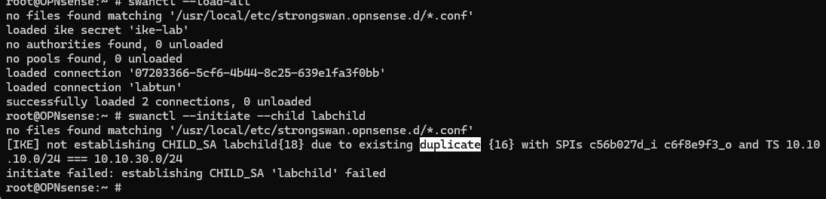
Figure 5. The swanctl tunnel configuration on fw-a.

6.2 Permitting the tunnel: the WAN pass rule
A tunnel that authenticates is not the same as traffic that flows. The firewalls auto generated IPsec rules referenced an older peer address from an earlier build and could not be edited, so fw-a was silently dropping the inbound ESP from the branch. The fix, on both firewalls, is a plain WAN pass rule that permits any protocol from the transit network, which lets IKE (UDP 500/4500) and ESP (protocol 50) through. This is where the earlier point about ESP being a protocol, not a port, becomes concrete: a port-based rule would never have matched it.

6.3 The routes that make the far LAN reachable
The last piece is routing. Each end host must know to send traffic for the far site's LAN to its own firewall, which is the mouth of the tunnel. In the lab this was done with a host route on each side the branch attacker routes 10.10.10.0/24 via fw-b, and the Site A host routes 10.10.30.0/24 via fw-a. Without it, the tunnel is up and permitted but the hosts never hand their cross-site packets to the firewall, so nothing enters the tunnel at all.

6.4 Reusing the sensor's signatures at the decryption point
No new detection content was needed for Phase 4, and that is itself the finding. The sensor's existing custom signatures in /var/lib/suricata/rules/local.rules the tuned nmap scan detection rules and the local file inclusion signature written in Phase 3 fire on the decrypted traffic without modification. A signature does not care that the packet it matches spent part of its journey encrypted; it only sees the clear packet the firewall handed to the LAN. The Phase 4 lesson is not that you need special rules for VPN traffic, it is that you need to place your existing rules where the traffic is readable again.

7. The Attacks, and What Each One Tested
The attacks are chosen to test the two halves of the VPN's single property, confidentiality. One attacker rides the tunnel from inside a trusted branch and is meant to be caught the other sits on the untrusted wire and is meant to see nothing. Between them they answer the phase's question from both directions: what does the VPN let through, and what does it hide.
# | Attack / action | MITRE | What it isolates
1 | nmap scan over the VPN | T1046 | Detection at the decryption point, with the real source named
2 | Nikto web scan over the VPN | T1595 / T1190 | Reused signatures firing on decrypted tunnel traffic
3 | On-path capture on the transit | T1040 | The confidentiality of the tunnel — the wire shows only ESP
Table 3. The Phase 4 attack set and the property each step isolates.

7.1 An nmap scan that rides the tunnel
The branch attacker runs a SYN scan against an internal SOC host. The scan leaves the branch, is encrypted by fw-b, crosses the transit as ESP, and is decrypted by fw-a before it reaches the target and it is on the Site A LAN, after decryption, that the sensor reads it. The tuned nmap signatures fire, reporting the SYN scan and the connect sweep, and every alert names the source as 10.10.30.40. The attack was launched from behind a firewall and arrived fully encrypted, yet it is both detected and correctly attributed, because detection happens where the firewall has already put the traffic back in the clear.
Verification · The branch scan is detected at the decryption point and names the real branch source
Command: branch attacker: nmap -sS 10.10.10.50 | Site A sensor: filter eve.json for the LOCAL NMAP signatures
Expected: the SYN-scan and connect-sweep signatures fire with source 10.10.30.40 — attribution survives the tunnel.

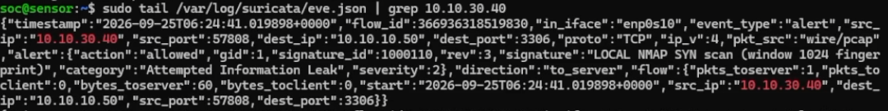
Figure 7. The nmap scan caught after decryption.

7.2 A Nikto web scan over the same tunnel
The second attack repeats the pattern with a web scanner to show that it is general, not a quirk of one signature. From the same branch machine, Nikto is run against a SOC web service. Arriving decrypted at the sensor, it lights up the local file inclusion signature written two phases earlier the scanner repeatedly requests a system file through the URL several times over, alongside a known web application signature, and again every alert carries the true branch source. A rule authored long before this phase existed catches a real scanner that arrived encrypted, which is exactly the point being proven.

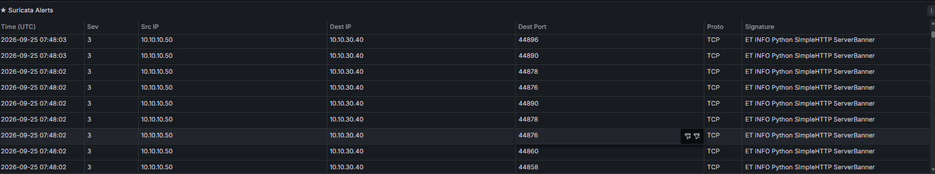
Figure 8. The Nikto scan caught after decryption.

7.3 The on path attacker who sees only ESP
The third view is taken from the transit itself, the seat of a man in the middle. While the exact same branch scan is running, a capture on the transit shows the tunnel from the outside: ESP packets travelling between 10.10.0.2 and 10.10.0.1, each with a security-parameter index and a length, and nothing else. There are no ports, no flags, no 10.10.30.40, and no recognisable scan pattern only two firewalls exchanging encrypted envelopes. This is the confidentiality of the VPN proven from the attacker's own vantage point: on the wire, the scan is invisible, and the best the on path attacker can do is note that the firewalls are talking, and roughly when and how much.
Verification · On the transit, the scan is unreadable only encrypted ESP is visible
Command: transit tap: tcpdump -nei <transit-if> esp (during the branch scan)
Expected: only ESP packets between 10.10.0.2 and 10.10.0.1 are captured; no ports, flags, inner source, or scan pattern are visible.

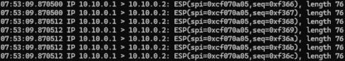
Figure 9. The same attack, blind on the wire.

8. The Correlation Exercise: Unmasking the Branch Attacker
As in Phase 3, the resolution is correlation, but the shape of the problem is new. In Phase 3 several readable logs disagreed about a source; in Phase 4 two witnesses each hold only half of one truth, because encryption split the event in two. The transit knows when a burst of encrypted traffic passed between the firewalls, and how much timing and volume, and nothing about content. The Site A sensor knows who and what the branch host 10.10.30.40 scanning an internal target but not that the traffic crossed an untrusted wire sealed. Neither witness alone can both attribute the attack and place it on the transit.
Witness | What it saw at time T | What it contributes
Transit (on-path) | an encrypted surge, fw-b 10.10.0.2 ⇄ fw-a 10.10.0.1 | when + how much
Site A sensor (decryption point) | 10.10.30.40 scanning 10.10.10.50 | who + what (real source)
Table 4. Two half truths that, aligned by timestamp, name the attacker and place it on the wire.
The method is timestamp alignment. Laid on one timeline, the encrypted surge the transit recorded and the decoded scan the sensor detected are the same event, a moment apart the burst on the wire is the scan, one decryption later. Put together, the branch attacker who was hidden inside the tunnel is fully unmasked the SOC can state not only that 10.10.30.40 scanned an internal host, but that it did so across the encrypted link at a specific time, tying the readable detection inside the site to the unreadable flow on the transit. Once traffic is encrypted, no single log is authoritative, and correlating across the encryption boundary is the skill the phase exists to teach.

9. What the Monitoring Recorded
Keeping attack success, control, and detection as separate ideas — the habit Phase 3 introduced — the results of Phase 4 read cleanly.
Step | Attack outcome | Where visible | Detected by / as
nmap over VPN | scan delivered over the tunnel | Site A LAN (decrypted) | sensor — LOCAL NMAP, source 10.10.30.40
Nikto over VPN | web scan delivered over the tunnel | Site A LAN (decrypted) | sensor — LAB LFI + web-app sig, source 10.10.30.40
On-path capture | tunnel observed from the wire | transit (encrypted) | only ESP 10.10.0.2 ⇄ 10.10.0.1 — no detection possible
Correlation | — | both views, one timeline | branch attacker 10.10.30.40 unmasked
Table 5. Attack outcome, where each attack was visible, and how it was detected.

10. Readiness Check (Run Before Every Session)
Check | How | Pass condition
Tunnel is up | fw-a: swanctl --list-sas | IKE_SA ESTABLISHED, child INSTALLED to 10.10.0.2
Traffic crosses the tunnel | branch: ping -c4 10.10.10.50 | four replies, TTL 62 (two firewalls crossed)
ESP is permitted | fw-a: tcpdump on WAN during the ping | ESP seen both ways; no firewall block for the peer
Sensor sees decrypted traffic | sensor: tcpdump on the Site A LAN tap | the branch host's clear packets are visible
Signatures loaded | sensor: check local.rules is loaded | LOCAL NMAP and LAB LFI signatures present
Table 6. The GO / NO-GO readiness check for Phase 4.

11. Lessons From Phase 4
A VPN is a routed link that seals every packet it protects the traffic from the wire and, as a side effect, hides it from your own sensors.
Encryption does not defeat detection, it relocates it: place the eye at the decryption point, where the firewall hands the traffic back in the clear.
Attribution survives the tunnel inter site traffic is not NAT'd, so a scan decrypted at the SOC still names the real branch source.
Existing signatures need no changes for VPN traffic; they only need to sit where the traffic is readable again, not on the encrypted transit.
IPsec fails quietly: a missing pre shared key, a mirrored remote ID, an unpermitted ESP protocol, or a missing host route each stop the tunnel with no obvious error read the firewall drop log, not just the IPsec log.
On an encrypted boundary no single log is complete; correlating the encrypted flow on the wire with the decrypted detection inside the site is what names the attacker.

12. Conclusion
Adding a second firewall and an encrypted tunnel took the lab from a governed single site to a connected pair of sites, and it introduced the one problem earlier phases had been building toward: traffic you cannot read. The tunnel was established with matching identity, key, and selectors; the firewalls were made to pass ESP and the hosts to route across it; and a branch attacker was then able to reach the SOC by the only path the tunnel allows. The monitoring answered the phase's question exactly as designed. On the transit the attack was invisible, only ESP between two firewalls. At the decryption point the same attack was caught in full and attributed to its true branch source, using signatures written phases earlier and needing no change. And correlating the encrypted flow on the wire with the decrypted detection inside the site unmasked the attacker completely.
Across the four phases the arc is now complete. Phase 1 asked whether the SOC could see; Phase 2 whether it could see across a router; Phase 3 whether it could still be trusted once a firewall could translate and relay; and Phase 4 whether it could detect an attack it could no longer read. The consistent answer is that detection is a question of placement and correlation more than of any single tool: put the eye where the truth is readable, and reconcile the views that each hold only part of it. That is the capability the lab set out to build, demonstrated end to end.

Appendix A: Snapshots and Insert Fields
Restore points for Phase 4:
Snapshot | Contents
phase3-final | Phase 3 baseline (rollback point before the second site was added)
phase4-tunnel | Both firewalls plus the branch, tunnel ESTABLISHED and encrypting
phase4-vpn | Phase 4 complete: tunnel up, branch-to-SOC connectivity, attacks run and evidence captured

Every diagram and screenshot to insert, in order (each frame is marked in the report where it belongs):
Field | Type | What to put here
1 | Diagram | Your topology diagram: Site A (SOC) and Site B (branch), each behind its own OPNsense firewall, joined by an IPsec tunnel across the untrusted transit (vyos + on-path attacker), with the Site A sensor tapping the LAN behind fw-a — the decryption point.
2 | Screenshot | The output of swanctl --list-sas on fw-a showing the security association to 10.10.0.2 as ESTABLISHED / INSTALLED, with the AES-GCM proposal and the 10.10.10.0/24 ⇄ 10.10.30.0/24 selectors.
3 | Screenshot | The contents of the swanctl connection file on fw-a (conf.d/tunnel.conf), showing local_addrs 10.10.0.1, remote_addrs 10.10.0.2, the pre-shared-key auth, and the child selectors 10.10.10.0/24 ⇄ 10.10.30.0/24.
4 | Screenshot | The Site A sensor's eve.json filtered to the LOCAL NMAP alerts during the branch scan, showing the signatures and the real source 10.10.30.40 -> 10.10.10.50.
5 | Screenshot | The Site A sensor's eve.json showing the repeated LAB LFI attempts and the web-application signature during the Nikto run, all attributed to source 10.10.30.40.
6 | Screenshot | The transit tcpdump output during the scan, showing only ESP packets between the two firewall addresses (with SPI and length) and none of the inner packet's fields.
Table 7. Every insert field in this report and what each should show.

