3.1 Stakeholders
The stakeholder refers to “a person, group or company that is directly or indirectly involved in the project and who may affect or get affected by the outcome of the project”.
Table 3 System Stakeholder
ST ID | Stakeholder | Description
ST1
ST2
ST3
ST4
ST5

3.3 Functional Requirements
Functional requirements specify the functions or capabilities that a software system must perform. They describe what the system should do and define its behavior under specific conditions. Functional requirements generally detail the various functionalities, operations, and specific tasks that the software needs to accomplish to meet the user's needs or business objectives. The functional requirements are shown in the Table.

Table 4 Functional Requirements
FR ID Description |  | ST | PRIORITY | INCREMENT
FR1 | User Sign Up:  Allows new users to create an account. | ST3 | High | Increment 1
FR2 | User Log Out:  Users can Log out securely,  terminating their session. | ST3 | High | Increment 1
FR3 | User Login:  Enables users to log into their existing account. | ST3 | High | Increment 1
FR4 | Password Reset:  Allows users to reset their  password if forgotten. | ST3 | High | Increment 1
FR5 | Language Support:  Supports two primary languages (Arabic & English). | ST3, ST5 | Medium | Increment 1

FR6 | Secure Login:  Implements secure authentication  mechanisms for user login. | ST1, ST5 | High | Increment 1
FR7 | Admin Dashboard:  Provides an admin interface to  manage the platform. | ST1 | High | Increment 1
FR8 | Clinic Directory: Lists all available clinics with their details. | ST2, ST3, ST5 | High | Increment 2
FR9 | Clinic Information  Display: Clinics can display their information. | ST2, ST4 | High | Increment 2
FR10 | Service Listings:  Clinics can list their available services with descriptions. | ST2, ST5 | High | Increment 2
FR11 | Promotions Page:  Clinics can list special offers on a promotions page. | ST2 | Medium | Increment 2
FR12 | Appointment  Booking: Users can book  appointments online. | ST3, ST4 | High | Increment 3
FR13 | Basic Search:  Allows pet owners to search for clinics by name or location. | ST3 | High | Increment 3

FR14 | Filtering: Pet owners can filter clinics by one or two basic criteria. | ST3 | Medium | Increment 3
FR15 | Notifications:  Sends notifications for new appointments. | ST3, ST5 | Medium | Increment 3
FR16 | View Clinic Details:  Pet owners can view detailed  information about  clinics. | ST3 | High | Increment 3
FR17 | Appointment  History: Pet owners can view their past  appointment details. | ST3 | Medium | Increment 3
FR18 | Contact Form: Pet owners can send  messages to clinics through a contact form. | ST3 | Medium | Increment 3
FR19 | Feedback Form:  Pet owners can submit feedback through a basic form. | ST3 | Medium | Increment 3
FR20 | Health Records:  Pet owners can upload and view health documents. | ST3 | Medium | Increment 3
FR21 | Emergency  Contact Listing:  Users can add an | ST3 | Medium | Increment 3

 | emergency contact to their profile.
FR22 | Health Tips: Provides pet owners with  health tips and wellness advice. | ST3 | Low | Increment 3
FR23 | SMS Notifications: Sends important updates via SMS. | ST3 | Low | Increment 3
FR24 | Manual Calendar Entry: Pet owners can manually add their  appointments. | ST3 | Low | Increment 3
FR25 | Email Communication:  Sends confirmation emails for appointments. | ST3, ST5 | Medium | Increment 3
FR26 | Review and  Ratings: Pet owners can leave reviews and rate clinics. | ST3 | Medium | Increment 4
FR27 | FAQ Page: A FAQ page with static content. | ST3 | Low | Increment 4
FR28 | Profile Updates:  Clinics can Use their profile information. | ST2 | High | Increment 4
FR29 | Clinic Performance  Reports: Provides performance reports to clinics. | ST2, ST5 | Medium | Increment 4

FR30 | Staff Contact Information:  Clinics can list basic contact  information for staff. | ST2, ST4 | High | Increment 4
FR31 | Interaction History: Clinics can view the history of pet owner interactions. | ST2 | Medium | Increment 4
FR32 | Report  Generation: Clinics can generate simple  appointment reports. | ST2, ST5 | Low | Increment 4
FR33 | Updates Section:  Displays system updates, news, and  announcements. | ST1, ST2 | Low | Increment 4
FR34 | Feedback System:  Users can provide feedback on the platform's usability. | ST3 | Low | Increment 4
FR35 | Audit Trail:  Maintains an audit trail for all critical actions. | ST5 | High | Increment 5
FR36 | Legal Information:  Displays legal information and terms of service. | ST5 | High | Increment 5
FR37 | User Activity Log:  Logs user activities for security and audit purposes. | ST5 | Medium | Increment 5

3.6 Requirements Analysis and the Architecture Design

3.6.1 Requirements analysis
The requirement analysis for the VetVogue project identifies and categorizes functional requirements (FRs) into five core subsystems. These subsystems are designed to meet the project’s objectives and create a smooth, functional platform for users.

User Management Subsystem
Goal (G1): Ensure users can securely create, manage, and access their accounts.
Functional Requirements:
FR1: User Sign Up
FR2: User Sign Out
FR3: User Login
FR4: Password Reset
FR6: Secure Login
FR21: Emergency Contact Listing
FR27: Profile Updates

Appointment Management Subsystem
Goal (G2): Facilitate a seamless and efficient appointment booking process.
Functional Requirements:
FR7: Admin Dashboard
FR12: Appointment Booking
FR15: Notifications
FR17: Appointment History
FR20: Health Records
FR23: SMS Notifications
FR24: Manual Calendar Entry
FR25: Email Communication

Clinic Directory and Information Subsystem
Goal (G3): Provide comprehensive information about clinics and their services.
Functional Requirements:
FR8: Clinic Directory
FR9: Clinic Information Display
FR10: Service Listings
FR13: Basic Search
FR14: Filtering
FR16: View Clinic Details
FR29: Clinic Performance Report
FR30: Staff Contact Information
FR31: Interaction History FR32: Report Generation

Content and Communication Subsystem
Goal (G4): Manage and present content to educate and communicate with pet owners.
Functional Requirements:
FR5: Language Support
FR11: Promotions Page
FR18: Contact Form
FR19: Feedback Form
FR22: Health Tips
FR26: Review And Rating
FR27: FAQ Page
FR33: Updates Section

Security and Audit Subsystem
Goal (G5): Ensure system security and maintain compliance with audit trails.
Functional Requirements:
FR25: Email Communication
FR34: Feedback System
FR35: Audit Trail
FR36: Legal Information
FR37: User Activity Log

3.6.2 The Architecture Design
The architecture design outlines how each subsystem interacts to form a cohesive, efficient platform. It ensures seamless communication between the user management, appointment scheduling, clinic information, content management, and security systems. Each subsystem is interconnected to ensure a smooth user experience.
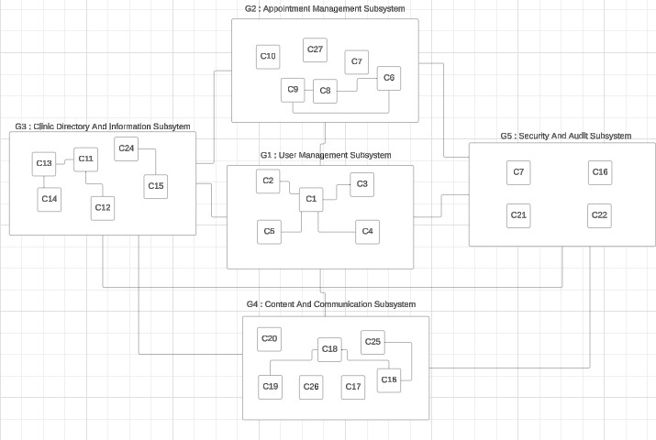
Figure 3 The Architecture Design

NOTE : The Following Table explains what requirement each component holds.
Table 7 Component Analysis
Component Name Requirement ID’s
C1 |  | Authentication and User Management Service |  | FR1, FR3
C2 |  | Session Management Component |  | FR2
C3 |  | Password Recovery Component |  | FR4
C4 |  | Secure Authentication Module |  | FR6
C5 |  | User Profile  Management  Component |  | FR21, FR27
C6 |  | Appointment Scheduling Service |  | FR12
C7 |  | Notification  Management Service |  | FR15, FR25, FR23
C8 |  | Appointment Tracking and History Component |  | FR17
C9 |  | Calendar Integration Module |  | FR24
C10 |  | Administrative Interface Component |  | FR7
C11 |  | Directory and Search Management Service |  | FR8, FR13, FR30
C12 |  | Advanced Search Filtering Component |  | FR14
C13 |  | Clinic Information Viewer |  | FR16
C14 |  | Clinic Data Management Component |  | FR16, FR31
C15 |  | Service Management Component |  | FR10, FR32
C16 |  | Contact and Feedback Collection Module |  | FR18, FR19, FR34
 | C17 |  | Static Content  Management System |  | FR27
 | C18 |  | Content Management System (CMS) |  | FR22, FR33
 | C19 |  | Promotions and  Campaign Management Module |  | FR11
 | C20 |  | News and Updates Component |  | FR33
 | C21 |  | Audit Logging and Monitoring Service |  | FR34, FR37
 | C22 |  | Legal Compliance and Information Module |  | FR36
 | C23 |  | Staff Directory  Component |  | FR30
 | C24 |  | Clinic Performance Reports Component |  | FR29
 | C25 |  | Review and Ratings Component |  | FR26
 | C26 |  | Language Support Module |  | FR5
 | C27 |  | Health Records  Management  Component |  | FR20

3.6.3 Sub-System analysis
User Management Subsystem
This subsystem handles user registration, login, password management, and secure authentication. It ensures that users can manage their accounts securely and access relevant features.
Functional Requirements:
FR1: User Sign Up
FR2: User Sign Out
FR3: User Login
FR4: Password Reset
FR6: Secure Login
FR21: Emergency Contact Listing
Appointment Management Subsystem
This subsystem manages appointment scheduling, history tracking, notifications, and administrative tasks. It ensures that pet owners can book and manage appointments effectively.
Functional Requirements:
FR7: Admin Dashboard
FR12: Appointment Booking
FR15: Notifications
FR17: Appointment History
FR24: Manual Calendar Entry
FR25: Email Communication
Clinic Directory and Information Subsystem
This subsystem provides detailed information about clinics, allowing pet owners to search and filter based on their needs. It ensures users can easily find and connect with the right clinics.
Functional Requirements:
FR8: Clinic Directory
FR9: Clinic Information Display
FR10: Service Listings
FR13: Basic Search
FR14: Filtering
FR16: View Clinic Details
FR30: Staff Contact Information

Content and Communication Subsystem
This subsystem manages static content like FAQs, contact forms, and updates. It ensures that pet owners can access useful resources and communicate with clinics.
Functional Requirements:
FR11: Promotions Page
FR18: Contact Form
FR19: Feedback Form
FR22: Health Tips
FR27: FAQ Page
FR33: Updates Section
Security and Audit Subsystem
This subsystem ensures the security of the platform, tracking user activities, and maintaining audit trails for all critical actions.
Functional Requirements:
FR25: Email Communication
FR34: Feedback System
FR35: Audit Trail
FR36: Legal Information
FR37: User Activity Log

