Paper A

Q.1 Configure ACL and block pc0,pc1 and complete network 192.168.169.0 to access pc6.
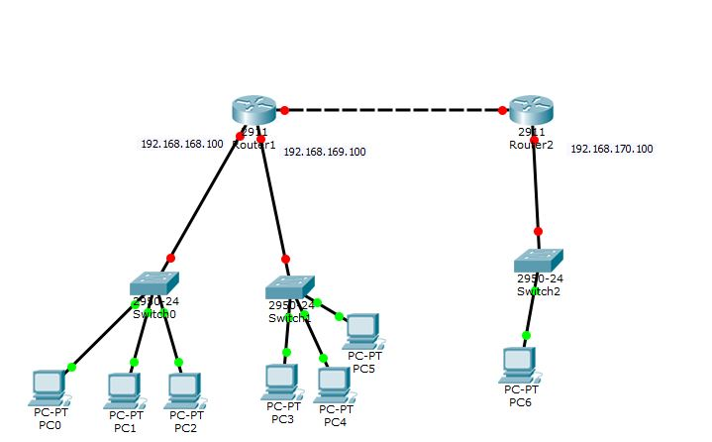

Q.2 Your task is to construct a topology, in which there are 5 departments, of a company such as, sales department, marketing department, development department, procurement department and human resource department, you have to configure VLAN’s for these departments. Moreover, every department has three employees and having their own laptops. After configuring VLAN’s, you have to allow sales department and procurement department to communicate with each other as well.

Q3. Configure the below NAT scenario:
Public ip on server side is 1.1.1.1
Public ip on client side is 5.1.1.1.
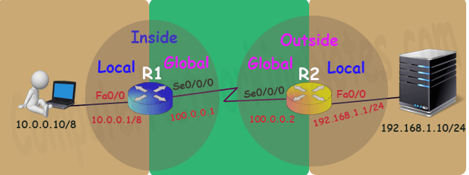

Q.4 Configure OSPF in such a way all pcs should be able to ping each other.
