Campus A
Step 1:
Configuration of Multi-Layer Switch:
CLI command:
enable
configure terminal
hostname Campus-A-MLS
! CREATE VLANs
vlan 10
name Admin
vlan 20
name Faculty
vlan 30
name Students
vlan 40
name WiFi
vlan 50
name Servers
exit

! ENABLE L3 ROUTING
ip routing

! SVIs — Gateway IP for each VLAN
interface Vlan10
ip address 10.0.0.1 255.252.0.0
no shutdown

interface Vlan20
ip address 10.4.0.1 255.252.0.0
no shutdown

interface Vlan30
ip address 10.8.0.1 255.252.0.0
no shutdown

interface Vlan40
ip address 10.12.0.1 255.252.0.0
no shutdown

interface Vlan50
ip address 10.16.0.1 255.252.0.0
no shutdown

! UPLINK PORT → Campus Router (Fa0/1)
interface FastEthernet0/1
no switchport
ip address 192.168.1.2 255.255.255.252
no shutdown

! DOWNLINK PORTS → Department Switches
interface FastEthernet0/2
switchport mode access
switchport access vlan 10
no shutdown

interface FastEthernet0/3
switchport mode access
switchport access vlan 20
no shutdown

interface FastEthernet0/4
switchport mode access
switchport access vlan 30
no shutdown

interface FastEthernet0/5
switchport mode access
switchport access vlan 50
no shutdown

interface FastEthernet0/6
switchport mode access
switchport access vlan 40
no shutdown

! DHCP RELAY — forward DHCP to Server
interface Vlan10
ip helper-address 10.16.0.2

interface Vlan20
ip helper-address 10.16.0.2

interface Vlan30
ip helper-address 10.16.0.2

interface Vlan40
ip helper-address 10.16.0.2

! ACLs — Traffic Restriction Between VLANs

! --- ACL for Admin VLAN (full access) ---
ip access-list extended ADMIN_POLICY
permit ip any any
exit

! --- ACL for Faculty VLAN ---
ip access-list extended FACULTY_POLICY
deny ip 10.4.0.0 0.3.255.255 10.0.0.0 0.3.255.255
permit ip 10.4.0.0 0.3.255.255 10.16.0.0 0.3.255.255
permit ip 10.4.0.0 0.3.255.255 10.12.0.0 0.3.255.255
permit ip any any
exit

! --- ACL for Students VLAN ---
ip access-list extended STUDENT_POLICY
deny ip 10.8.0.0 0.3.255.255 10.0.0.0 0.3.255.255
deny ip 10.8.0.0 0.3.255.255 10.4.0.0 0.3.255.255
permit ip 10.8.0.0 0.3.255.255 10.16.0.0 0.3.255.255
permit ip any any
exit

! --- ACL for WiFi VLAN ---
ip access-list extended WIFI_POLICY
deny ip 10.12.0.0 0.3.255.255 10.0.0.0 0.3.255.255
deny ip 10.12.0.0 0.3.255.255 10.4.0.0 0.3.255.255
permit ip 10.12.0.0 0.3.255.255 10.16.0.0 0.3.255.255
permit ip any any
exit

! APPLY ACLs to SVIs

interface Vlan10
no ip access-group ADMIN_POLICY in

interface Vlan20
ip access-group FACULTY_POLICY in

interface Vlan30
ip access-group STUDENT_POLICY in

interface Vlan40
ip access-group WIFI_POLICY in

end
write memory

Step 2:
Configuration of Access Switches:
CLI Commands:
Admin Switch:
enable
configure terminal
hostname Campus-A-Admin-SW

vlan 10
name Admin
exit

interface FastEthernet0/1
switchport mode access
switchport access vlan 10
no shutdown

interface range FastEthernet0/2 - 24
switchport mode access
switchport access vlan 10
no shutdown

end
write memory
Student Switch:
enable
configure terminal
hostname Campus-A-Student-SW

vlan 30
name Students
exit

interface FastEthernet0/1
switchport mode access
switchport access vlan 30
no shutdown

interface range FastEthernet0/2 - 24
switchport mode access
switchport access vlan 30
no shutdown

end
write memory

Faculty Switch:
enable
configure terminal
hostname Campus-A-Faculty-SW

vlan 20
name Faculty
exit

interface FastEthernet0/1
switchport mode access
switchport access vlan 20
no shutdown

interface range FastEthernet0/2 - 24
switchport mode access
switchport access vlan 20
no shutdown

end
write memory
Servers Switch:
enable
configure terminal
hostname Campus-A-Servers-SW

vlan 50
name Servers
exit

interface FastEthernet0/1
switchport mode access
switchport access vlan 50
no shutdown

interface range FastEthernet0/2 - 24
switchport mode access
switchport access vlan 50
no shutdown

end
write memory

Screen Shots:
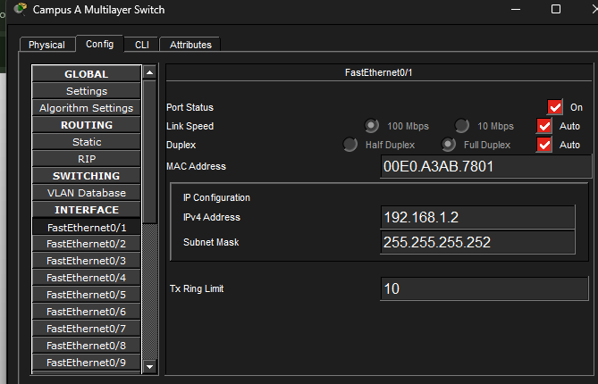
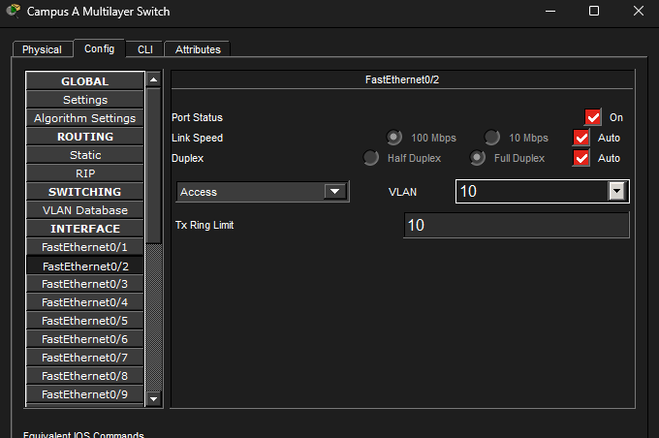
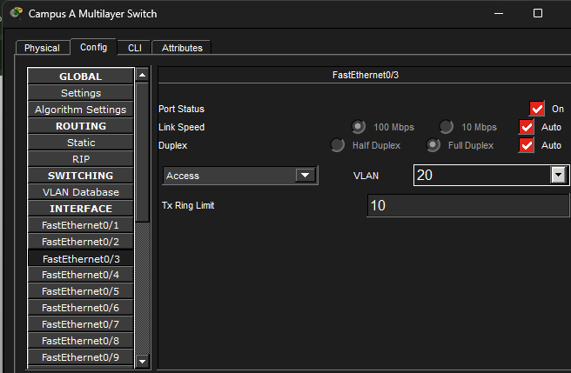
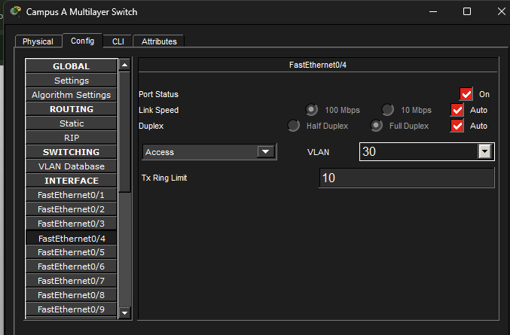
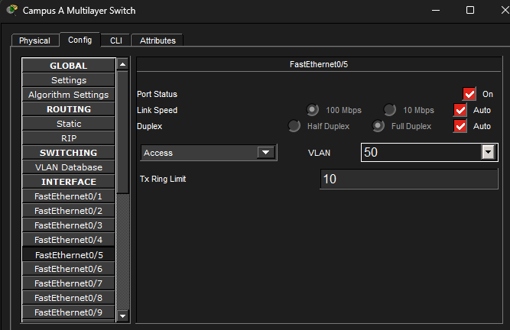
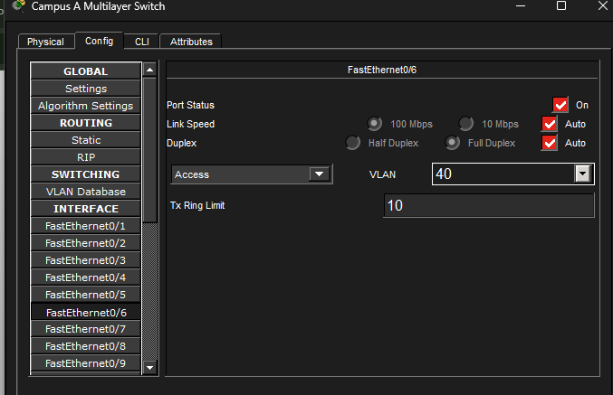

Step3:
Configuration Servers:
DHCP:
Click Server → Desktop → IP Configuration

IP Address : 10.16.0.2
Subnet Mask : 255.252.0.0
Default GW : 10.16.0.1

Click Server → Services → DHCP

Turn Service: ON

Pool 1 — Admin
Pool Name : Admin_Pool
Default GW : 10.0.0.1
DNS Server : 10.16.0.2
Start IP : 10.0.0.2
Subnet Mask : 255.252.0.0
Max Users : 100
→ Click Add

Pool 2 — Faculty
Pool Name : Faculty_Pool
Default GW : 10.4.0.1
DNS Server : 10.16.0.2
Start IP : 10.4.0.2
Subnet Mask : 255.252.0.0
Max Users : 200
→ Click Add

Pool 3 — Students
Pool Name : Student_Pool
Default GW : 10.8.0.1
DNS Server : 10.16.0.2
Start IP : 10.8.0.2
Subnet Mask : 255.252.0.0
Max Users : 1000
→ Click Add

Pool 4 — WiFi
Pool Name : WiFi_Pool
Default GW : 10.12.0.1
DNS Server : 10.16.0.2
Start IP : 10.12.0.2
Subnet Mask : 255.252.0.0
Max Users : 50
→ Click Add
DNS Service:
Click Server → Services → DNS

DNS Service : ON

Add records:
Name : www.campusa.com Type: A Record Address: 10.16.0.2
Name : mail.campusa.com Type: A Record Address: 10.16.0.2

→ Click Add after each

Web Service:
Click Server → Services → HTTP

HTTP Service : ON
HTTPS Service : ON

(Default webpage is already there, you can edit the HTML if you want)
Email Service:
Click Server → Services → EMAIL

SMTP Service : ON
POP3 Service : ON

Domain Name : campusa.com

→ Click Set

Add users:
Username : admin Password : admin123 → Click +
Username : faculty Password : fac123 → Click +
Username : student Password : stu123 → Click +
Test Web
textCopy
Click PC → Desktop → Web Browser
Type: http://www.campusa.com or http://10.16.0.2
→ Should show webpage
Test DNS
textCopy
Click PC → Desktop → Command Prompt
ping www.campusa.com
→ Should resolve to 10.16.0.2
Test Email
textCopy
Click PC → Desktop → Mail
Configure:
Your Name : Admin User
Email : admin@campusa.com
Incoming Mail: 10.16.0.2
Outgoing Mail: 10.16.0.2
Username : admin
Password : admin123
→ Click Save
→ Try Send/Receive

Screenshot:
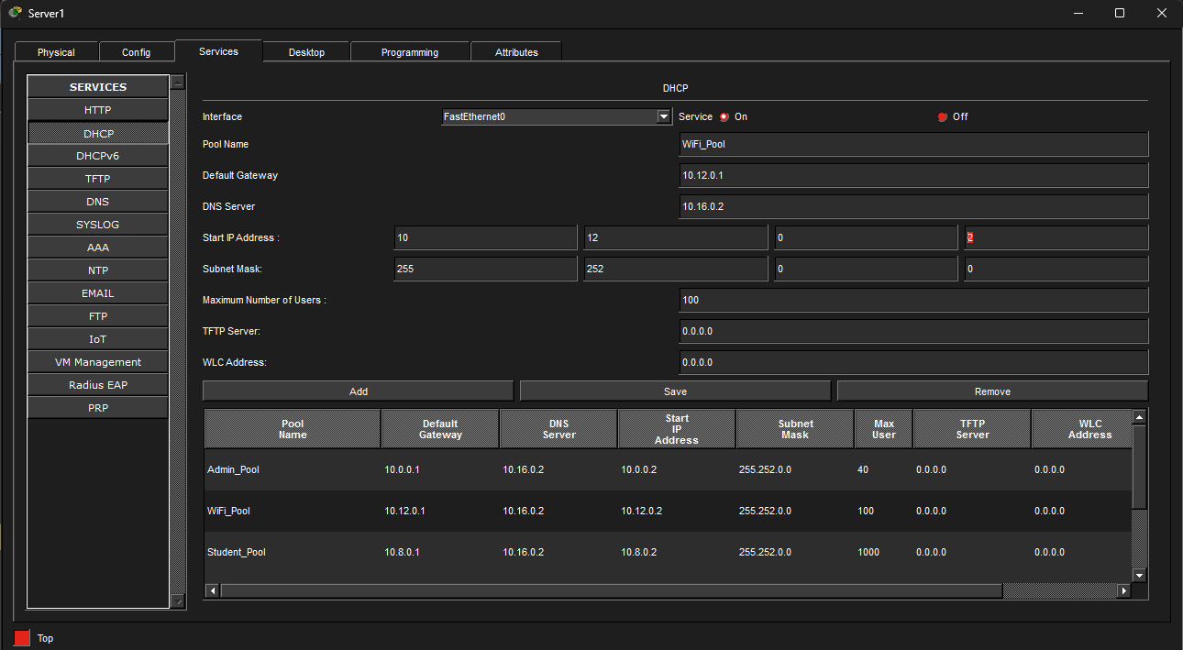
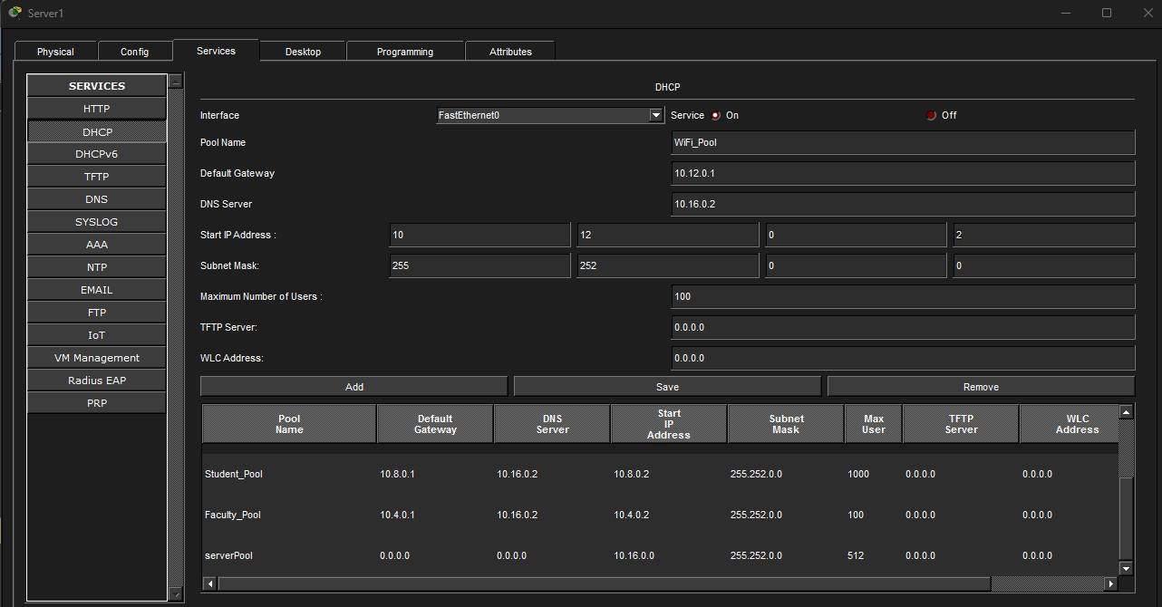
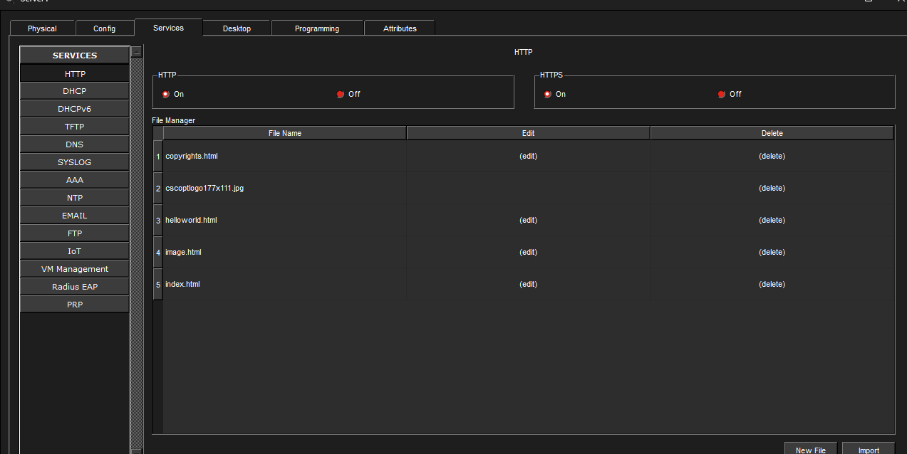
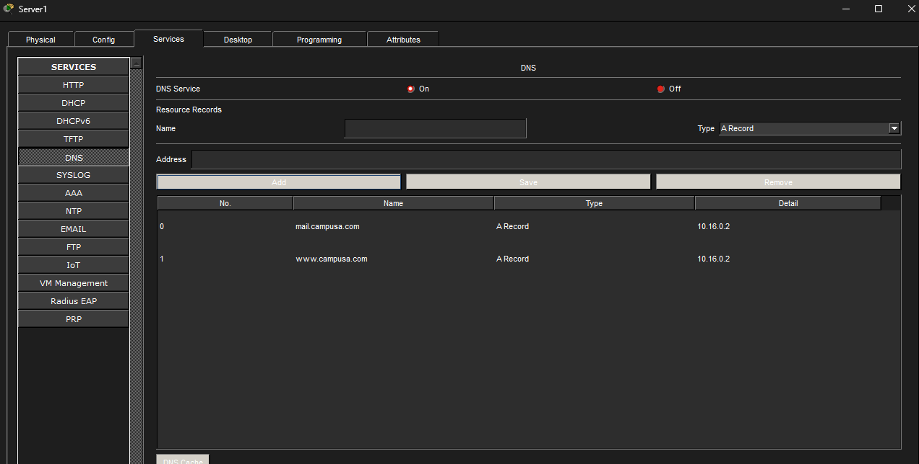
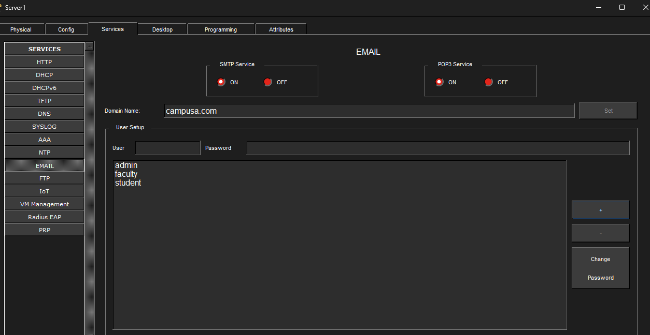

Campus B

Step 1:
Configuration of Multi-Layer Switch:
CLI command:

enable
configure terminal
hostname Campus-B-MLS

! CREATE VLANs
vlan 10
name Admin
vlan 20
name Faculty
vlan 30
name Students
vlan 40
name WiFi
vlan 50
name Servers
exit

! ENABLE L3 ROUTING
ip routing

! SVIs — Gateway IP for each VLAN
interface Vlan10
ip address 10.32.0.1 255.252.0.0
no shutdown

interface Vlan20
ip address 10.36.0.1 255.252.0.0
no shutdown

interface Vlan30
ip address 10.40.0.1 255.252.0.0
no shutdown

interface Vlan40
ip address 10.44.0.1 255.252.0.0
no shutdown

interface Vlan50
ip address 10.48.0.1 255.252.0.0
no shutdown

! UPLINK PORT → Campus B Router (Fa0/1)
interface FastEthernet0/1
no switchport
ip address 192.168.2.2 255.255.255.252
no shutdown

! DOWNLINK PORTS → Department Switches
interface FastEthernet0/2
switchport mode access
switchport access vlan 10
no shutdown

interface FastEthernet0/3
switchport mode access
switchport access vlan 20
no shutdown

interface FastEthernet0/4
switchport mode access
switchport access vlan 30
no shutdown

interface FastEthernet0/5
switchport mode access
switchport access vlan 50
no shutdown

interface FastEthernet0/6
switchport mode access
switchport access vlan 40
no shutdown

! DHCP RELAY
interface Vlan10
ip helper-address 10.48.0.2

interface Vlan20
ip helper-address 10.48.0.2

interface Vlan30
ip helper-address 10.48.0.2

interface Vlan40
ip helper-address 10.48.0.2

! ACLs
ip access-list extended ADMIN_POLICY
permit ip 10.32.0.0 0.3.255.255 any
permit ip any any
exit

ip access-list extended FACULTY_POLICY
deny ip 10.36.0.0 0.3.255.255 10.32.0.0 0.3.255.255
permit ip 10.36.0.0 0.3.255.255 10.48.0.0 0.3.255.255
permit ip 10.36.0.0 0.3.255.255 10.44.0.0 0.3.255.255
permit ip any any
exit

ip access-list extended STUDENT_POLICY
deny ip 10.40.0.0 0.3.255.255 10.32.0.0 0.3.255.255
deny ip 10.40.0.0 0.3.255.255 10.36.0.0 0.3.255.255
permit ip 10.40.0.0 0.3.255.255 10.48.0.0 0.3.255.255
permit ip any any
exit

ip access-list extended WIFI_POLICY
deny ip 10.44.0.0 0.3.255.255 10.32.0.0 0.3.255.255
deny ip 10.44.0.0 0.3.255.255 10.36.0.0 0.3.255.255
permit ip 10.44.0.0 0.3.255.255 10.48.0.0 0.3.255.255
permit ip any any
exit

! APPLY ACLs
interface Vlan10
ip access-group ADMIN_POLICY in

interface Vlan20
ip access-group FACULTY_POLICY in

interface Vlan30
ip access-group STUDENT_POLICY in

interface Vlan40
ip access-group WIFI_POLICY in

end
write memory
Step 2:
Configuration of Access Switches:
CLI Commands:
Admin Switch:
enable
configure terminal
hostname Campus-B-Admin-SW

vlan 10
name Admin
exit

interface FastEthernet0/1
switchport mode access
switchport access vlan 10
no shutdown

interface range FastEthernet0/2 - 24
switchport mode access
switchport access vlan 10
no shutdown

end
write memory
Student Switch:
enable
configure terminal
hostname Campus-B-Student-SW

vlan 30
name Students
exit

interface FastEthernet0/1
switchport mode access
switchport access vlan 30
no shutdown

interface range FastEthernet0/2 - 24
switchport mode access
switchport access vlan 30
no shutdown

end
write memory
Faculty Switch:
enable
configure terminal
hostname Campus-B-Faculty-SW

vlan 20
name Faculty
exit

interface FastEthernet0/1
switchport mode access
switchport access vlan 20
no shutdown

interface range FastEthernet0/2 - 24
switchport mode access
switchport access vlan 20
no shutdown

end
write memory

Servers Switch:
enable
configure terminal
hostname Campus-B-Servers-SW

vlan 50
name Servers
exit

interface FastEthernet0/1
switchport mode access
switchport access vlan 50
no shutdown

interface range FastEthernet0/2 - 24
switchport mode access
switchport access vlan 50
no shutdown

end
write memory

Screenshots:
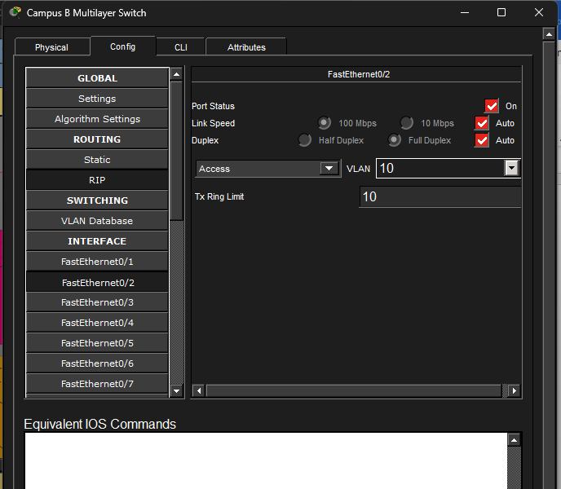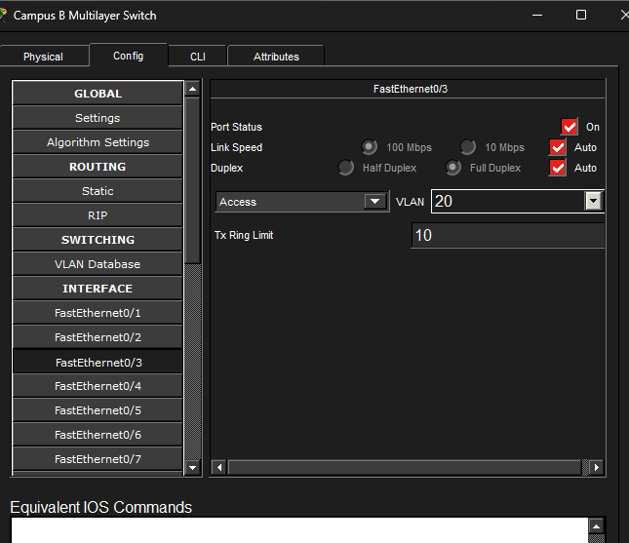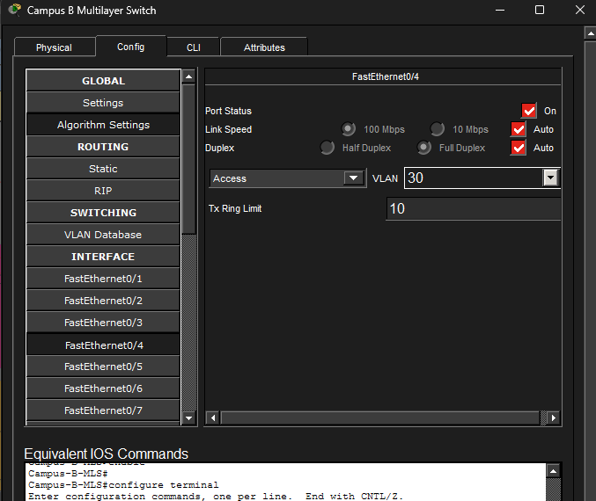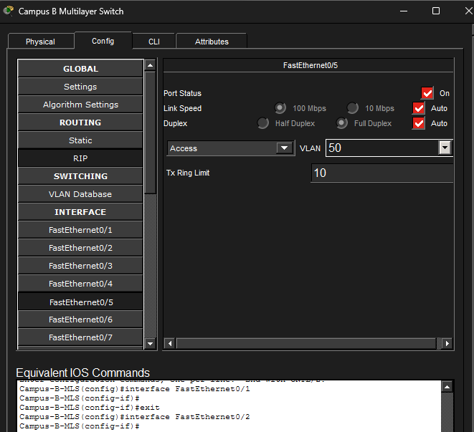
Step3:
Configuration Servers:
DHCP:
IP Address : 10.48.0.2
Subnet Mask : 255.252.0.0
Default GW : 10.48.0.1
Pool Name | Default GW | Start IP | Mask | Max Users
Admin_Pool | 10.32.0.1 | 10.32.0.2 | 255.252.0.0 | 100
Faculty_Pool | 10.36.0.1 | 10.36.0.2 | 255.252.0.0 | 200
Student_Pool | 10.40.0.1 | 10.40.0.2 | 255.252.0.0 | 1000
WiFi_Pool | 10.44.0.1 | 10.44.0.2 | 255.252.0.0 | 50
DNS Service:
www.campusb.com → 10.48.0.2
mail.campusb.com → 10.48.0.2
Email Service:
SMTP Service : ON
POP3 Service : ON

Domain Name : campusb.com

→ Click Set

Add users:
Username : admin Password : admin123 → Click +
Username : faculty Password : faculty → Click +
Username : student Password : stu123 → Click +

Screenshot:
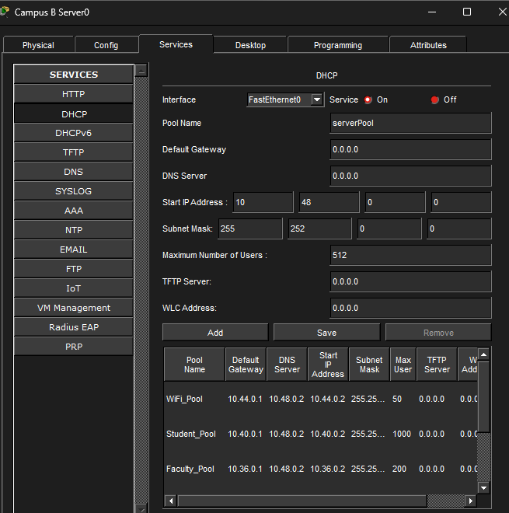

Campus C
Step 1:
Configuration of Multi-Layer Switch:
CLI command:
enable
configure terminal
hostname Campus-C-MLS

vlan 10
name Admin
vlan 20
name Faculty
vlan 30
name Students
vlan 40
name WiFi
vlan 50
name Servers
exit

ip routing

interface Vlan10
ip address 10.64.0.1 255.252.0.0
no shutdown

interface Vlan20
ip address 10.68.0.1 255.252.0.0
no shutdown

interface Vlan30
ip address 10.72.0.1 255.252.0.0
no shutdown

interface Vlan40
ip address 10.76.0.1 255.252.0.0
no shutdown

interface Vlan50
ip address 10.80.0.1 255.252.0.0
no shutdown

interface FastEthernet0/1
no switchport
ip address 192.168.3.2 255.255.255.252
no shutdown

interface FastEthernet0/2
switchport mode access
switchport access vlan 10
no shutdown

interface FastEthernet0/3
switchport mode access
switchport access vlan 20
no shutdown

interface FastEthernet0/4
switchport mode access
switchport access vlan 30
no shutdown

interface FastEthernet0/5
switchport mode access
switchport access vlan 50
no shutdown

interface FastEthernet0/6
switchport mode access
switchport access vlan 40
no shutdown

interface Vlan10
ip helper-address 10.80.0.2

interface Vlan20
ip helper-address 10.80.0.2

interface Vlan30
ip helper-address 10.80.0.2

interface Vlan40
ip helper-address 10.80.0.2

ip access-list extended ADMIN_POLICY
permit ip 10.64.0.0 0.3.255.255 any
permit ip any any
exit

ip access-list extended FACULTY_POLICY
deny ip 10.68.0.0 0.3.255.255 10.64.0.0 0.3.255.255
permit ip 10.68.0.0 0.3.255.255 10.80.0.0 0.3.255.255
permit ip 10.68.0.0 0.3.255.255 10.76.0.0 0.3.255.255
permit ip any any
exit

ip access-list extended STUDENT_POLICY
deny ip 10.72.0.0 0.3.255.255 10.64.0.0 0.3.255.255
deny ip 10.72.0.0 0.3.255.255 10.68.0.0 0.3.255.255
permit ip 10.72.0.0 0.3.255.255 10.80.0.0 0.3.255.255
permit ip any any
exit

ip access-list extended WIFI_POLICY
deny ip 10.76.0.0 0.3.255.255 10.64.0.0 0.3.255.255
deny ip 10.76.0.0 0.3.255.255 10.68.0.0 0.3.255.255
permit ip 10.76.0.0 0.3.255.255 10.80.0.0 0.3.255.255
permit ip any any
exit

interface Vlan10
ip access-group ADMIN_POLICY in

interface Vlan20
ip access-group FACULTY_POLICY in

interface Vlan30
ip access-group STUDENT_POLICY in

interface Vlan40
ip access-group WIFI_POLICY in

end
write memory

Step 2:
Configuration of Access Switches:
CLI Commands:
Admin Switch:
enable
configure terminal
hostname Campus-C-Admin-SW
vlan 10
name Admin
exit
interface FastEthernet0/1
switchport mode access
switchport access vlan 10
no shutdown
interface range FastEthernet0/2 - 24
switchport mode access
switchport access vlan 10
no shutdown
end
write memory
Student Switch:
enable
configure terminal
hostname Campus-C-Student-SW
vlan 30
name Students
exit
interface FastEthernet0/1
switchport mode access
switchport access vlan 30
no shutdown
interface range FastEthernet0/2 - 24
switchport mode access
switchport access vlan 30
no shutdown
end
write memory
Faculty Switch:
enable
configure terminal
hostname Campus-C-Faculty-SW
vlan 20
name Faculty
exit
interface FastEthernet0/1
switchport mode access
switchport access vlan 20
no shutdown
interface range FastEthernet0/2 - 24
switchport mode access
switchport access vlan 20
no shutdown
end
write memory

Servers Switch:
enable
configure terminal
hostname Campus-C-Servers-SW
vlan 50
name Servers
exit
interface FastEthernet0/1
switchport mode access
switchport access vlan 50
no shutdown
interface range FastEthernet0/2 - 24
switchport mode access
switchport access vlan 50
no shutdown
end
write memory

Screenshots:
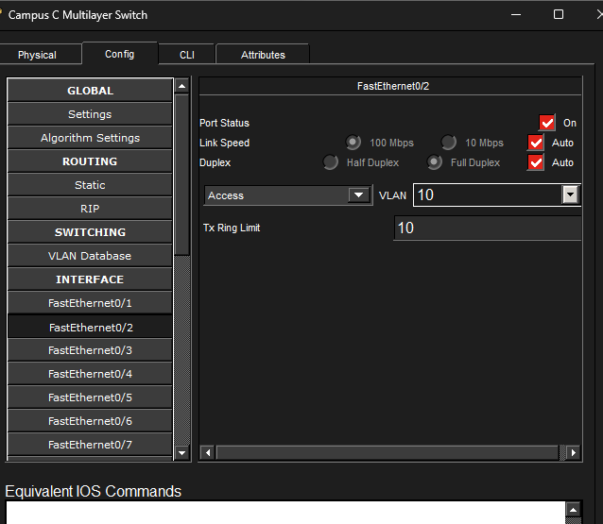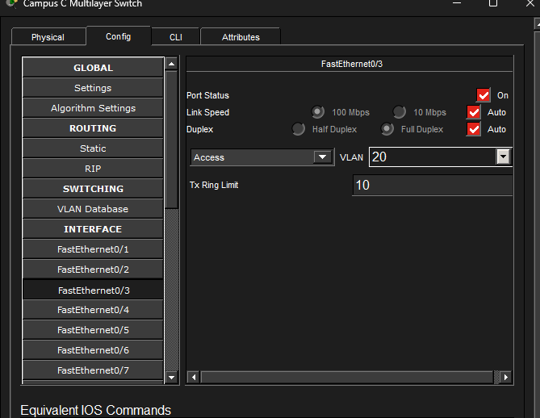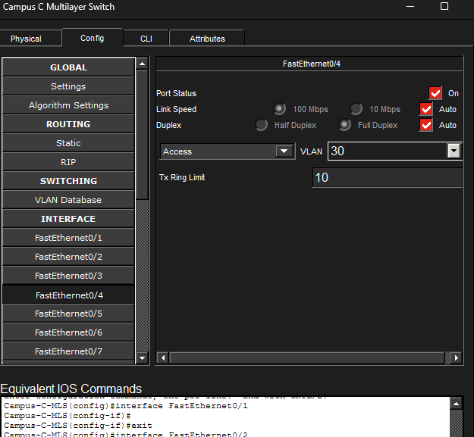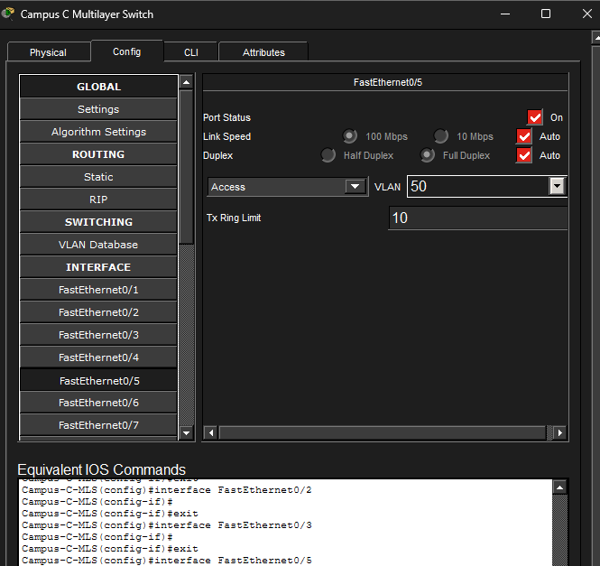
Step3:
Configuration Servers:
DHCP:
IP Address : 10.80.0.2
Subnet Mask : 255.252.0.0
Default GW : 10.80.0.1
Pool Name | Default GW | Start IP | Mask | Max Users
Admin_Pool | 10.64.0.1 | 10.64.0.2 | 255.252.0.0 | 100
Faculty_Pool | 10.68.0.1 | 10.68.0.2 | 255.252.0.0 | 200
Student_Pool | 10.72.0.1 | 10.72.0.2 | 255.252.0.0 | 1000
WiFi_Pool | 10.76.0.1 | 10.76.0.2 | 255.252.0.0 | 50

DNS Service:
DNS: www.campusc.com / mail.campusc.com → 10.80.0.2
Email Service:
SMTP Service : ON
POP3 Service : ON

Domain Name : campusc.com

→ Click Set

Add users:
Username : admin Password : admin123 → Click +
Username : faculty Password : fac123 → Click +
Username : student Password : stu123 → Click +

Screenshot:
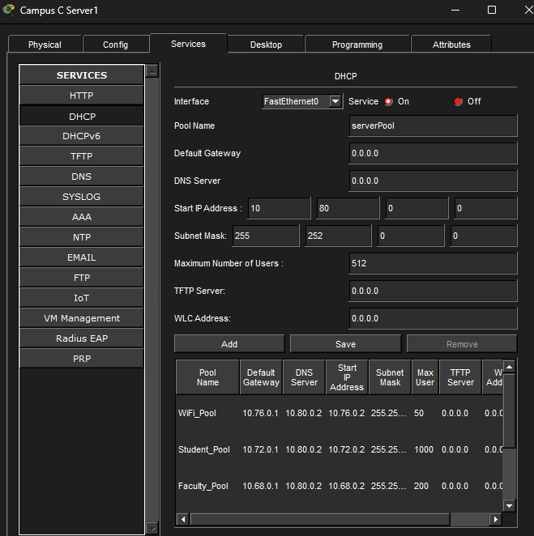

Campus D

Step 1:
Configuration of Multi-Layer Switch:
CLI command:
enable
configure terminal
hostname Campus-D-MLS

vlan 10
name Admin
vlan 20
name Faculty
vlan 30
name Students
vlan 40
name WiFi
vlan 50
name Servers
exit

ip routing

interface Vlan10
ip address 10.96.0.1 255.252.0.0
no shutdown

interface Vlan20
ip address 10.100.0.1 255.252.0.0
no shutdown

interface Vlan30
ip address 10.104.0.1 255.252.0.0
no shutdown

interface Vlan40
ip address 10.108.0.1 255.252.0.0
no shutdown

interface Vlan50
ip address 10.112.0.1 255.252.0.0
no shutdown

interface FastEthernet0/1
no switchport
ip address 192.168.4.2 255.255.255.252
no shutdown

interface FastEthernet0/2
switchport mode access
switchport access vlan 10
no shutdown

interface FastEthernet0/3
switchport mode access
switchport access vlan 20
no shutdown

interface FastEthernet0/4
switchport mode access
switchport access vlan 30
no shutdown

interface FastEthernet0/5
switchport mode access
switchport access vlan 50
no shutdown

interface FastEthernet0/6
switchport mode access
switchport access vlan 40
no shutdown

interface Vlan10
ip helper-address 10.112.0.2

interface Vlan20
ip helper-address 10.112.0.2

interface Vlan30
ip helper-address 10.112.0.2

interface Vlan40
ip helper-address 10.112.0.2

ip access-list extended ADMIN_POLICY
permit ip 10.96.0.0 0.3.255.255 any
permit ip any any
exit

ip access-list extended FACULTY_POLICY
deny ip 10.100.0.0 0.3.255.255 10.96.0.0 0.3.255.255
permit ip 10.100.0.0 0.3.255.255 10.112.0.0 0.3.255.255
permit ip 10.100.0.0 0.3.255.255 10.108.0.0 0.3.255.255
permit ip any any
exit

ip access-list extended STUDENT_POLICY
deny ip 10.104.0.0 0.3.255.255 10.96.0.0 0.3.255.255
deny ip 10.104.0.0 0.3.255.255 10.100.0.0 0.3.255.255
permit ip 10.104.0.0 0.3.255.255 10.112.0.0 0.3.255.255
permit ip any any
exit

ip access-list extended WIFI_POLICY
deny ip 10.108.0.0 0.3.255.255 10.96.0.0 0.3.255.255
deny ip 10.108.0.0 0.3.255.255 10.100.0.0 0.3.255.255
permit ip 10.108.0.0 0.3.255.255 10.112.0.0 0.3.255.255
permit ip any any
exit

interface Vlan10
ip access-group ADMIN_POLICY in

interface Vlan20
ip access-group FACULTY_POLICY in

interface Vlan30
ip access-group STUDENT_POLICY in

interface Vlan40
ip access-group WIFI_POLICY in

end
write memory
Step 2:
Configuration of Access Switches:
CLI Commands:
Admin Switch:
enable
configure terminal
hostname Campus-D-Admin-SW
vlan 10
name Admin
exit
interface FastEthernet0/1
switchport mode access
switchport access vlan 10
no shutdown
interface range FastEthernet0/2 - 24
switchport mode access
switchport access vlan 10
no shutdown
end
write memory
Student Switch:
enable
configure terminal
hostname Campus-D-Student-SW
vlan 30
name Students
exit
interface FastEthernet0/1
switchport mode access
switchport access vlan 30
no shutdown
interface range FastEthernet0/2 - 24
switchport mode access
switchport access vlan 30
no shutdown
end
write memory
Faculty Switch:
enable
configure terminal
hostname Campus-D-Faculty-SW
vlan 20
name Faculty
exit
interface FastEthernet0/1
switchport mode access
switchport access vlan 20
no shutdown
interface range FastEthernet0/2 - 24
switchport mode access
switchport access vlan 20
no shutdown
end
write memory
Servers Switch:
enable
configure terminal
hostname Campus-D-Servers-SW
vlan 50
name Servers
exit
interface FastEthernet0/1
switchport mode access
switchport access vlan 50
no shutdown
interface range FastEthernet0/2 - 24
switchport mode access
switchport access vlan 50
no shutdown
end
write memory

Screenshots:
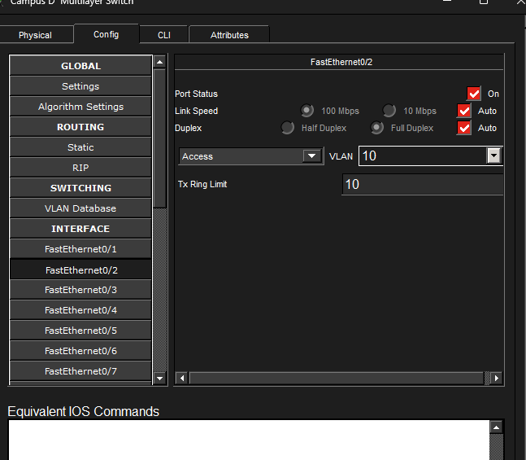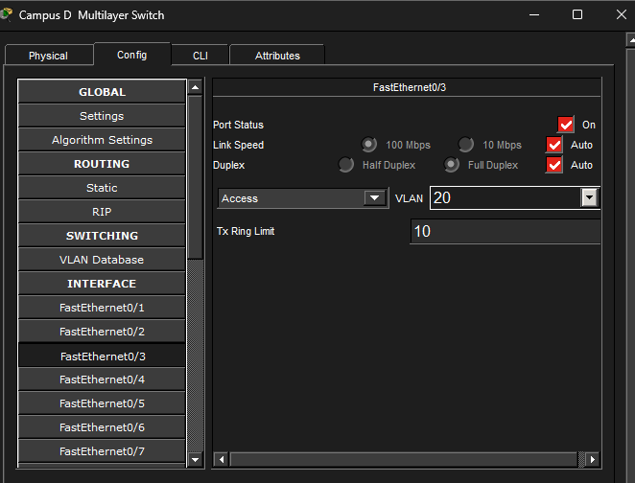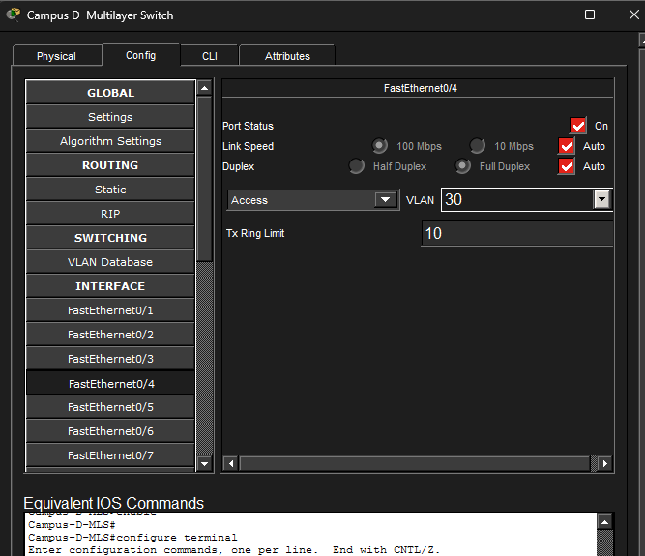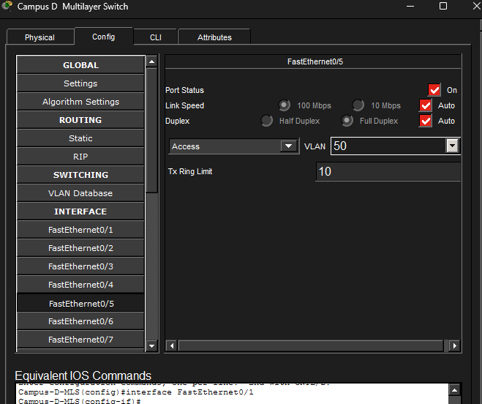
Step3:
Configuration Servers:
DHCP:
IP Address : 10.112.0.2
Subnet Mask : 255.252.0.0
Default GW : 10.112.0.1
Pool Name | Default GW | Start IP | Mask | Max Users
Admin_Pool | 10.96.0.1 | 10.96.0.2 | 255.252.0.0 | 100
Faculty_Pool | 10.100.0.1 | 10.100.0.2 | 255.252.0.0 | 200
Student_Pool | 10.104.0.1 | 10.104.0.2 | 255.252.0.0 | 1000
WiFi_Pool | 10.108.0.1 | 10.108.0.2 | 255.252.0.0 | 50

DNS Service:

DNS: www.campusd.com / mail.campusd.com → 10.112.0.2
Email Service:
SMTP Service : ON
POP3 Service : ON

Domain Name : campusd.com

→ Click Set

Add users:
Username : admin Password : admin123 → Click +
Username : faculty Password : fac123 → Click +
Username : student Password : stu123 → Click +

Screenshot:
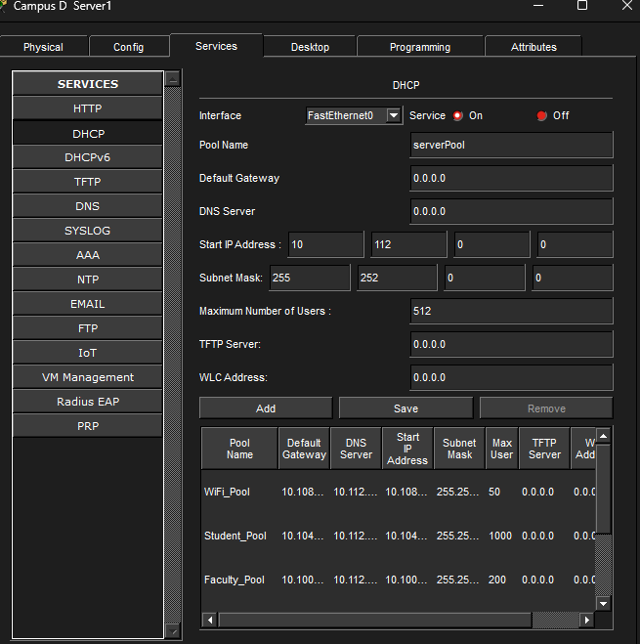
Campus E
Step 1:
Configuration of Multi-Layer Switch:
CLI command:
enable
configure terminal
hostname Campus-E-MLS

vlan 10
name Admin
vlan 20
name Faculty
vlan 30
name Students
vlan 40
name WiFi
vlan 50
name Servers
exit

ip routing

interface Vlan10
ip address 10.128.0.1 255.252.0.0
no shutdown

interface Vlan20
ip address 10.132.0.1 255.252.0.0
no shutdown

interface Vlan30
ip address 10.136.0.1 255.252.0.0
no shutdown

interface Vlan40
ip address 10.140.0.1 255.252.0.0
no shutdown

interface Vlan50
ip address 10.144.0.1 255.252.0.0
no shutdown

interface FastEthernet0/1
no switchport
ip address 192.168.5.2 255.255.255.252
no shutdown

interface FastEthernet0/2
switchport mode access
switchport access vlan 10
no shutdown

interface FastEthernet0/3
switchport mode access
switchport access vlan 20
no shutdown

interface FastEthernet0/4
switchport mode access
switchport access vlan 30
no shutdown

interface FastEthernet0/5
switchport mode access
switchport access vlan 50
no shutdown

interface FastEthernet0/6
switchport mode access
switchport access vlan 40
no shutdown

interface Vlan10
ip helper-address 10.144.0.2

interface Vlan20
ip helper-address 10.144.0.2

interface Vlan30
ip helper-address 10.144.0.2

interface Vlan40
ip helper-address 10.144.0.2

ip access-list extended ADMIN_POLICY
permit ip 10.128.0.0 0.3.255.255 any
permit ip any any
exit

ip access-list extended FACULTY_POLICY
deny ip 10.132.0.0 0.3.255.255 10.128.0.0 0.3.255.255
permit ip 10.132.0.0 0.3.255.255 10.144.0.0 0.3.255.255
permit ip 10.132.0.0 0.3.255.255 10.140.0.0 0.3.255.255
permit ip any any
exit

ip access-list extended STUDENT_POLICY
deny ip 10.136.0.0 0.3.255.255 10.128.0.0 0.3.255.255
deny ip 10.136.0.0 0.3.255.255 10.132.0.0 0.3.255.255
permit ip 10.136.0.0 0.3.255.255 10.144.0.0 0.3.255.255
permit ip any any
exit

ip access-list extended WIFI_POLICY
deny ip 10.140.0.0 0.3.255.255 10.128.0.0 0.3.255.255
deny ip 10.140.0.0 0.3.255.255 10.132.0.0 0.3.255.255
permit ip 10.140.0.0 0.3.255.255 10.144.0.0 0.3.255.255
permit ip any any
exit

interface Vlan10
ip access-group ADMIN_POLICY in

interface Vlan20
ip access-group FACULTY_POLICY in

interface Vlan30
ip access-group STUDENT_POLICY in

interface Vlan40
ip access-group WIFI_POLICY in

end
write memory
Step 2:
Configuration of Access Switches:
CLI Commands:
Admin Switch:
enable
configure terminal
hostname Campus-E-Admin-SW
vlan 10
name Admin
exit
interface FastEthernet0/1
switchport mode access
switchport access vlan 10
no shutdown
interface range FastEthernet0/2 - 24
switchport mode access
switchport access vlan 10
no shutdown
end
write memory

Student Switch:
enable
configure terminal
hostname Campus-E-Student-SW
vlan 30
name Students
exit
interface FastEthernet0/1
switchport mode access
switchport access vlan 30
no shutdown
interface range FastEthernet0/2 - 24
switchport mode access
switchport access vlan 30
no shutdown
end
write memory
Faculty Switch:
enable
configure terminal
hostname Campus-E-Faculty-SW
vlan 20
name Faculty
exit
interface FastEthernet0/1
switchport mode access
switchport access vlan 20
no shutdown
interface range FastEthernet0/2 - 24
switchport mode access
switchport access vlan 20
no shutdown
end
write memory
Servers Switch:
enable
configure terminal
hostname Campus-E-Servers-SW
vlan 50
name Servers
exit
interface FastEthernet0/1
switchport mode access
switchport access vlan 50
no shutdown
interface range FastEthernet0/2 - 24
switchport mode access
switchport access vlan 50
no shutdown
end
write memory

Screenshots:
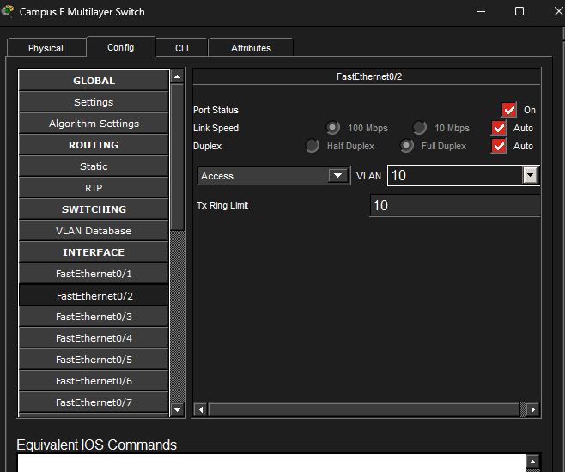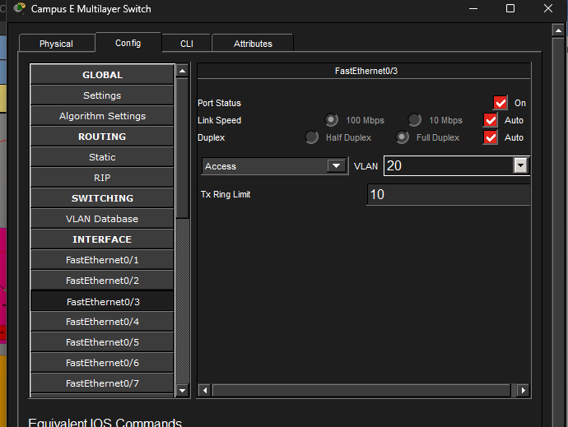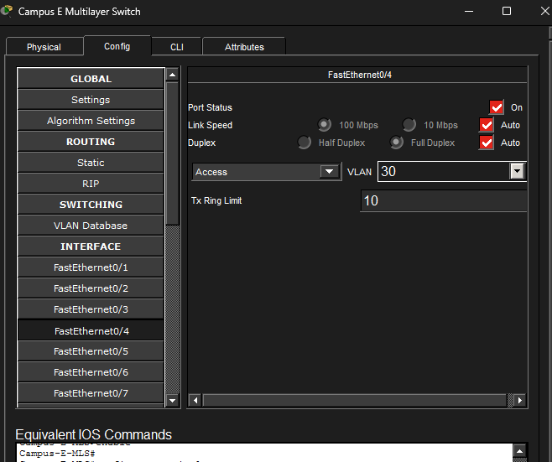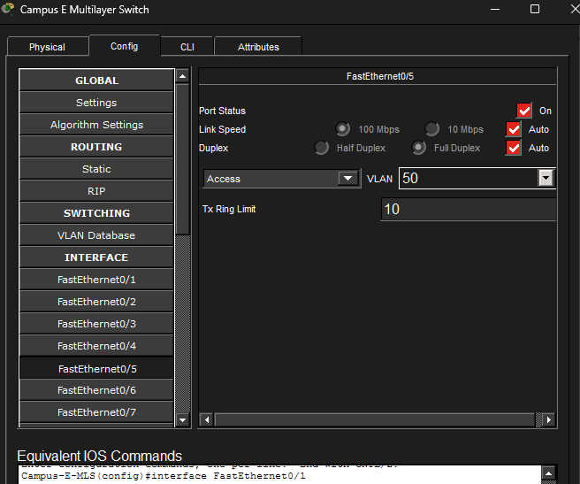
Step3:
Configuration Servers:
DHCP:
IP Address : 10.144.0.2
Subnet Mask : 255.252.0.0
Default GW : 10.144.0.1
Pool Name | Default GW | Start IP | Mask | Max Users
Admin_Pool | 10.128.0.1 | 10.128.0.2 | 255.252.0.0 | 100
Faculty_Pool | 10.132.0.1 | 10.132.0.2 | 255.252.0.0 | 200
Student_Pool | 10.136.0.1 | 10.136.0.2 | 255.252.0.0 | 1000
WiFi_Pool | 10.140.0.1 | 10.140.0.2 | 255.252.0.0 | 50
DNS Service:
DNS: www.campuse.com / mail.campuse.com → 10.144.0.2
Email Service:
SMTP Service : ON
POP3 Service : ON

Domain Name : campuse.com

→ Click Set

Add users:
Username : admin Password : admin123 → Click +
Username : faculty Password : fac123 → Click +
Username : student Password : stu123 → Click +

Screenshot:
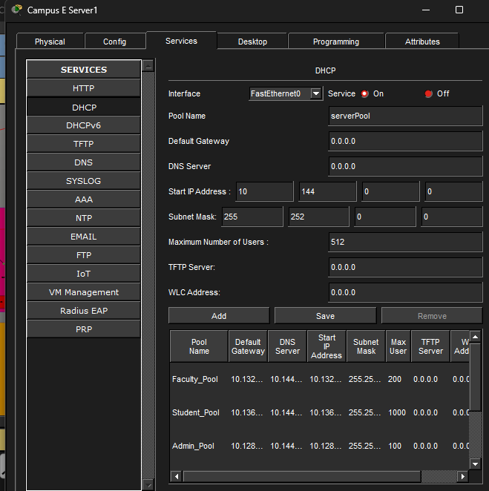

Campus F
Step 1:
Configuration of Multi-Layer Switch:
CLI command:
enable
configure terminal
hostname Campus-F-MLS

vlan 10
name Admin
vlan 20
name Faculty
vlan 30
name Students
vlan 40
name WiFi
vlan 50
name Servers
exit

ip routing

interface Vlan10
ip address 10.160.0.1 255.252.0.0
no shutdown

interface Vlan20
ip address 10.164.0.1 255.252.0.0
no shutdown

interface Vlan30
ip address 10.168.0.1 255.252.0.0
no shutdown

interface Vlan40
ip address 10.172.0.1 255.252.0.0
no shutdown

interface Vlan50
ip address 10.176.0.1 255.252.0.0
no shutdown

interface FastEthernet0/1
no switchport
ip address 192.168.6.2 255.255.255.252
no shutdown

interface FastEthernet0/2
switchport mode access
switchport access vlan 10
no shutdown

interface FastEthernet0/3
switchport mode access
switchport access vlan 20
no shutdown

interface FastEthernet0/4
switchport mode access
switchport access vlan 30
no shutdown

interface FastEthernet0/5
switchport mode access
switchport access vlan 50
no shutdown

interface FastEthernet0/6
switchport mode access
switchport access vlan 40
no shutdown

interface Vlan10
ip helper-address 10.176.0.2

interface Vlan20
ip helper-address 10.176.0.2

interface Vlan30
ip helper-address 10.176.0.2

interface Vlan40
ip helper-address 10.176.0.2

ip access-list extended ADMIN_POLICY
permit ip 10.160.0.0 0.3.255.255 any
permit ip any any
exit

ip access-list extended FACULTY_POLICY
deny ip 10.164.0.0 0.3.255.255 10.160.0.0 0.3.255.255
permit ip 10.164.0.0 0.3.255.255 10.176.0.0 0.3.255.255
permit ip 10.164.0.0 0.3.255.255 10.172.0.0 0.3.255.255
permit ip any any
exit

ip access-list extended STUDENT_POLICY
deny ip 10.168.0.0 0.3.255.255 10.160.0.0 0.3.255.255
deny ip 10.168.0.0 0.3.255.255 10.164.0.0 0.3.255.255
permit ip 10.168.0.0 0.3.255.255 10.176.0.0 0.3.255.255
permit ip any any
exit

ip access-list extended WIFI_POLICY
deny ip 10.172.0.0 0.3.255.255 10.160.0.0 0.3.255.255
deny ip 10.172.0.0 0.3.255.255 10.164.0.0 0.3.255.255
permit ip 10.172.0.0 0.3.255.255 10.176.0.0 0.3.255.255
permit ip any any
exit

interface Vlan10
ip access-group ADMIN_POLICY in

interface Vlan20
ip access-group FACULTY_POLICY in

interface Vlan30
ip access-group STUDENT_POLICY in

interface Vlan40
ip access-group WIFI_POLICY in

end
write memory
Step 2:
Configuration of Access Switches:
CLI Commands:
Admin Switch:
enable
configure terminal
hostname Campus-F-Admin-SW
vlan 10
name Admin
exit
interface FastEthernet0/1
switchport mode access
switchport access vlan 10
no shutdown
interface range FastEthernet0/2 - 24
switchport mode access
switchport access vlan 10
no shutdown
end
write memory
Student Switch:
enable
configure terminal
hostname Campus-F-Student-SW
vlan 30
name Students
exit
interface FastEthernet0/1
switchport mode access
switchport access vlan 30
no shutdown
interface range FastEthernet0/2 - 24
switchport mode access
switchport access vlan 30
no shutdown
end
write memory
Faculty Switch:
enable
configure terminal
hostname Campus-F-Faculty-SW
vlan 20
name Faculty
exit
interface FastEthernet0/1
switchport mode access
switchport access vlan 20
no shutdown
interface range FastEthernet0/2 - 24
switchport mode access
switchport access vlan 20
no shutdown
end
write memory
Servers Switch:
enable
configure terminal
hostname Campus-F-Servers-SW
vlan 50
name Servers
exit
interface FastEthernet0/1
switchport mode access
switchport access vlan 50
no shutdown
interface range FastEthernet0/2 - 24
switchport mode access
switchport access vlan 50
no shutdown
end
write memory

Screenshots:
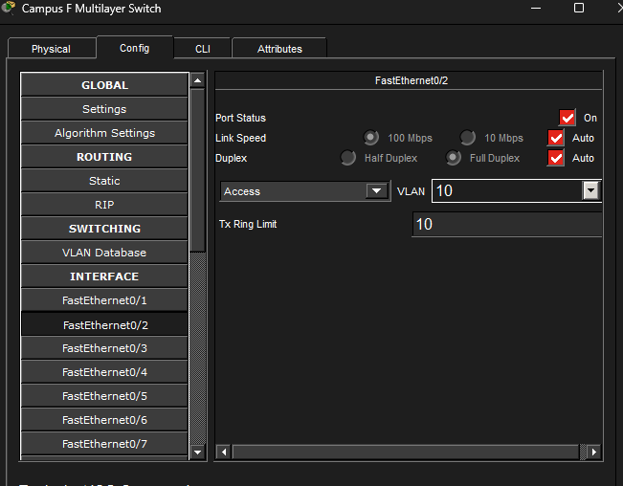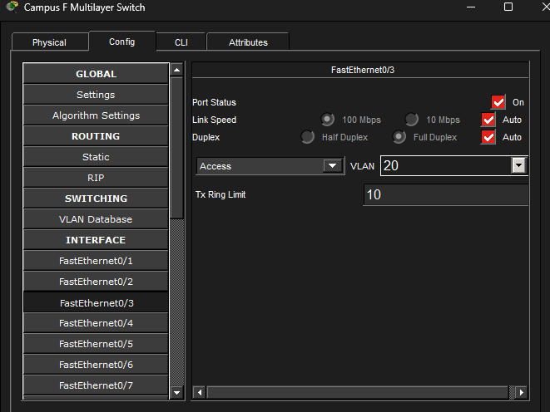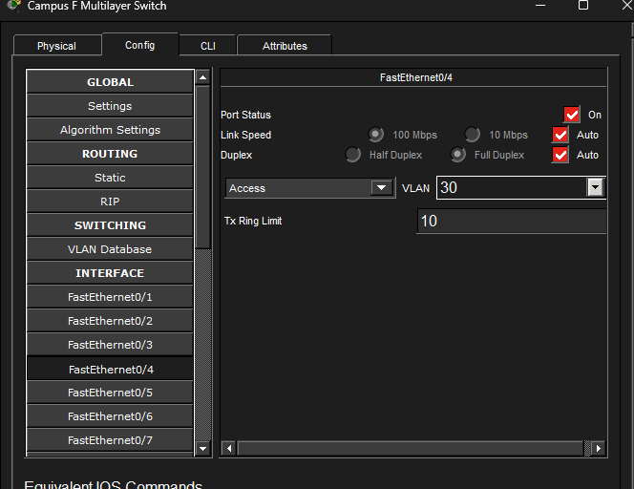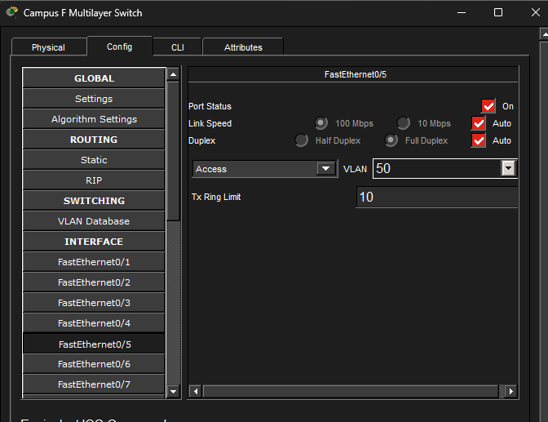
Step3:
Configuration Servers:
DHCP:
IP Address : 10.176.0.2
Subnet Mask : 255.252.0.0
Default GW : 10.176.0.1
Pool Name | Default GW | Start IP | Mask | Max Users
Admin_Pool | 10.160.0.1 | 10.160.0.2 | 255.252.0.0 | 100
Faculty_Pool | 10.164.0.1 | 10.164.0.2 | 255.252.0.0 | 200
Student_Pool | 10.168.0.1 | 10.168.0.2 | 255.252.0.0 | 1000
WiFi_Pool | 10.172.0.1 | 10.172.0.2 | 255.252.0.0 | 50
DNS Service:
DNS: www.campusf.com / mail.campusf.com → 10.176.0.2

Email Service:
SMTP Service : ON
POP3 Service : ON

Domain Name : campusf.com

→ Click Set

Add users:
Username : admin Password : admin123 → Click +
Username : faculty Password : fac123 → Click +
Username : student Password : stu123 → Click +

Screenshot:
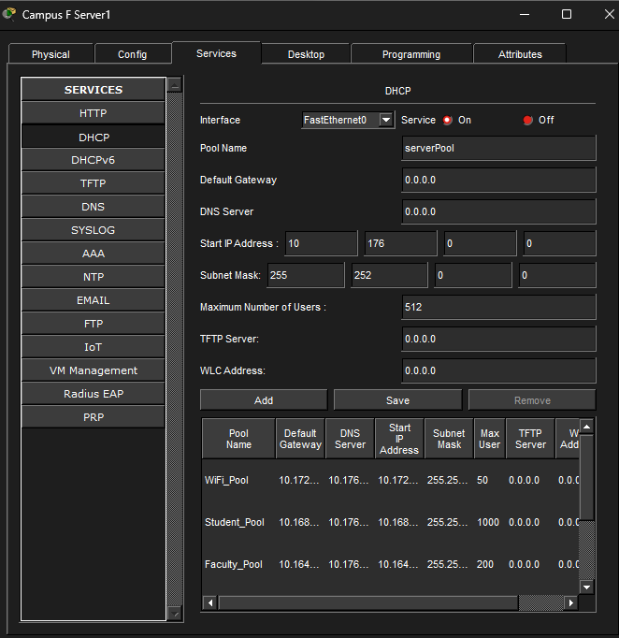

Step 3:
Routing:
Cli Commands:
OSPF(MLS<->Router) and Static Routes on Each Campus Router → Central Router:
Campus A Router:
enable
conf t
ip route 0.0.0.0 0.0.0.0 10.200.0.2
router ospf 1
default-information originate
end
Campus B Router:
enable
conf t
ip route 0.0.0.0 0.0.0.0 10.200.0.5
router ospf 1
default-information originate
end
Campus C Router:
enable
conf t
ip route 0.0.0.0 0.0.0.0 10.200.0.13
router ospf 1
default-information originate
end
Campus D Router:
enable
conf t
ip route 0.0.0.0 0.0.0.0 10.200.0.17
router ospf 1
default-information originate
end
Campus E Router:
enable
conf t
ip route 0.0.0.0 0.0.0.0 10.200.0.9
router ospf 1
default-information originate
end
Campus F Router:
enable
conf t
ip route 0.0.0.0 0.0.0.0 10.200.0.22
router ospf 1
default-information originate
end
Campus A MLS:
enable
conf t

router ospf 1
router-id 1.1.1.1
network 10.0.0.0 0.255.255.255 area 0
network 192.168.1.0 0.0.0.3 area 0
end
Campus B MLS:
enable
conf t

router ospf 1
router-id 2.2.2.2
network 10.32.0.0 0.0.31.255 area 0
network 192.168.2.0 0.0.0.3 area 0
end

Campus C MLS:
enable
conf t

router ospf 1
router-id 3.3.3.3
network 10.64.0.0 0.0.31.255 area 0
network 10.200.0.4 0.0.0.3 area 0
end
Campus D MLS:
enable
conf t

router ospf 1
router-id 4.4.4.4
network 10.96.0.0 0.0.31.255 area 0
network 10.200.0.8 0.0.0.3 area 0
end
Campus E MLS:
enable
conf t

router ospf 1
router-id 5.5.5.5
network 10.128.0.0 0.0.31.255 area 0
network 10.200.0.12 0.0.0.3 area 0
end
Campus F MLS:
enable
conf t

router ospf 1
router-id 6.6.6.6
network 10.160.0.0 0.0.31.255 area 0
network 10.200.0.16 0.0.0.3 area 0
end
Configure Central Router:
enable
conf t
hostname Central-Router

! Campus A link (10.200.0.0/30)
interface Serial0/0/0
ip address 10.200.0.2 255.255.255.252
no shutdown

! Campus B link (10.200.0.4/30)
interface Serial0/0/1
ip address 10.200.0.5 255.255.255.252
no shutdown

! Campus E link (10.200.0.8/30)
interface Serial0/1/0
ip address 10.200.0.9 255.255.255.252
no shutdown

! Campus F link (10.200.0.20/30)
interface Serial0/1/1
ip address 10.200.0.22 255.255.255.252
no shutdown

! Campus C link (10.200.0.12/30)
interface Serial0/2/0
ip address 10.200.0.13 255.255.255.252
no shutdown

! Campus D link (10.200.0.16/30)
interface Serial0/3/0
ip address 10.200.0.17 255.255.255.252
no shutdown

! Static routes to each campus /11 block
ip route 10.0.0.0 255.224.0.0 10.200.0.1
ip route 10.32.0.0 255.224.0.0 10.200.0.6
ip route 10.64.0.0 255.224.0.0 10.200.0.14
ip route 10.96.0.0 255.224.0.0 10.200.0.18
ip route 10.128.0.0 255.224.0.0 10.200.0.10
ip route 10.160.0.0 255.224.0.0 10.200.0.21
end
Screenshots:
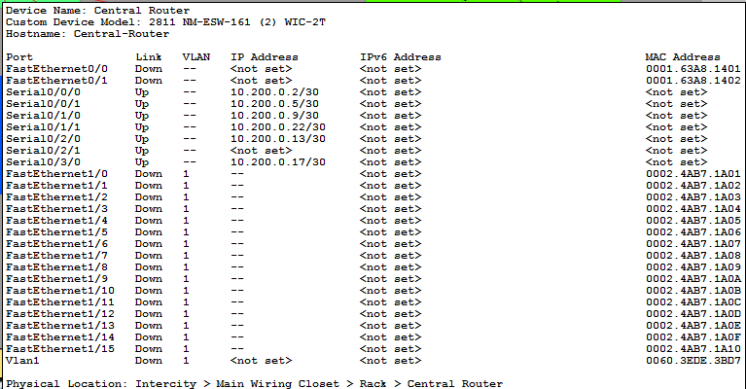
Step 4:
Nat Table on central router:
Cli Commands:
conf t
interface FastEthernet0/0
ip nat inside
interface FastEthernet0/1
ip nat inside
interface Serial0/0/0
ip nat inside
interface Serial0/0/1
ip nat inside
interface Serial0/1/0
ip nat inside
interface Serial0/1/1
ip nat inside
interface Serial0/2/0
ip nat inside
interface Serial0/3/0
ip nat inside
interface Serial0/2/1
ip nat outside
access-list 1 permit 10.0.0.0 0.255.255.255
ip nat inside source list 1 interface Serial0/2/1 overload
end

and

conf t
ip route 0.0.0.0 0.0.0.0 203.0.113.2
interface Serial0/2/1
ip address 203.0.113.1 255.255.255.252
no shutdown
end
ISP Router:
conf t
ip route 0.0.0.0 0.0.0.0 203.0.113.2
interface Serial0/2/1
ip address 203.0.113.1 255.255.255.252
no shutdown
end

Screenshots:
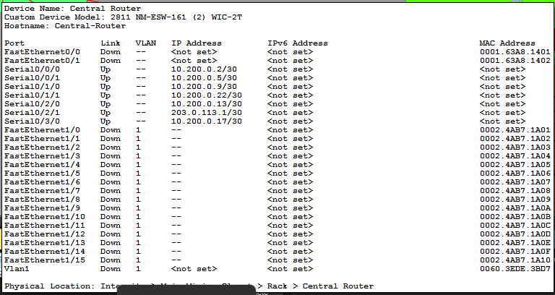
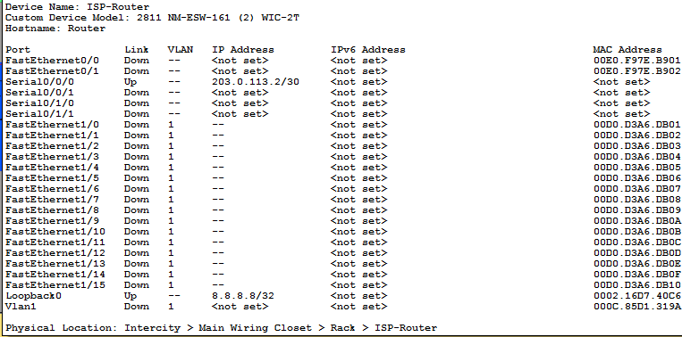

Step 5:
Network Security:
Cli Commands:
Screenshots:

