TABLE OF CONTENTS
1. Introduction………………………………………………………………………………………………………2
2. Project Overview…………………………………………………………………………………………..3
3. Software Development Life Cycle (SDLC)……………………………………………………….6
4. System Architecture………………………………………………………………………………………8
5. Prototype Development………………………………………………………………………………….9
6. GitHub & Version Control……………………………………………………………………………….11
7. Project Management……………………………………………………………………………………….12
8. License, Design Quality & SDG Alignment………………………………………………………….14
9. UML Diagrams…………………………………………………………………………………………………16
10. Conclusion…………………………………………………………………………………………………….22
11. References……………………………………………………………………………………………………23
12. Appendix A – Functional Requirements…………………………………………………………….24
13. Appendix B – Non-Functional Requirements……………………………………………………….26

INTRODUCTION
Sierra Leone is a small West African nation with enormous potential for growth, but like many developing countries, it faces persistent urban and environmental challenges. Among the most visible of these challenges is the management of solid waste. In Freetown, the capital city, and in peri-urban communities across the country, uncollected waste accumulates along streets, in drainage channels, and in informal dumpsites. This waste does not merely create an eyesore — it contributes to flooding during the rainy season, attracts disease vectors such as mosquitoes and rats, contaminates groundwater, and produces toxic runoff that enters rivers and the Atlantic Ocean. The health consequences for communities living near these sites are severe, particularly for children and elderly residents.
The core problem is not simply a lack of will or funding. Much of the inefficiency in waste management in Sierra Leone stems from a lack of data, coordination, and communication between residents, waste collectors, and municipal authorities. Residents do not have a reliable way to report uncollected waste or illegal dumpsites. Waste collectors operate without optimised routes, causing fuel waste, missed collections, and inequitable service distribution. Municipal officers lack real-time dashboards to monitor performance or identify problem areas. The result is a system where well-intentioned effort is undermined by poor information flow.
WasteSmart is a digital solution designed specifically to address these structural gaps. It is a full-stack web application and Progressive Web App (PWA) that connects three types of users: residents who report waste issues, waste collectors who receive optimised routes and manage pickups, and municipal officers who oversee operations and analyse environmental data. WasteSmart brings the power of digital technology — real-time GPS reporting, route optimisation algorithms, push notifications, offline functionality, and data analytics — to bear on one of Sierra Leone’s most pressing public health and environmental challenges.
WasteSmart is designed as a Digital Public Good. This means it is open-source, freely available, and built to serve the public interest without restriction. Its MIT licence allows any NGO, government body, municipality, or international development organisation to adopt, modify, and deploy it at no cost.
PROJECT OVERVIEW
WasteSmart is a web-based and mobile-accessible digital platform designed to modernise solid waste management in Sierra Leone. At its core, it is a reporting, routing, and analytics system that connects three groups of users — residents, waste collectors, and municipal officers — and facilitates the real-time flow of information between them. Instead of residents waiting indefinitely for waste to be collected, or collectors travelling inefficient routes, or officers guessing at the scale of the problem, WasteSmart puts accurate, up-to-date data into the hands of everyone involved.
The platform operates as a Progressive Web App (PWA), which means it can be accessed through any modern web browser on a mobile phone, tablet, or desktop computer without needing to download an app from an app store. For areas with limited internet connectivity, WasteSmart includes offline functionality: residents can submit waste reports even without an active internet connection, and those reports are automatically synchronised with the server as soon as connectivity is restored. This offline-first approach is not an optional extra — it is a fundamental design requirement, given that many communities in Sierra Leone experience intermittent or no internet access.

CORE FEATURES
- Waste Report Submission: Residents can submit a waste report with a single tap, capturing GPS coordinates automatically, selecting the type of waste (Organic, Recyclable, Hazardous, or General), rating the severity, attaching a photograph, and adding a short description. The report is instantly visible to collectors and officers.
- Real-Time Waste Map: An interactive Google Maps-powered map displays all submitted waste reports as colour-coded markers — red for uncollected, amber for assigned to a collector, green for resolved. Users can filter by waste type, date, and community ward.
- Optimised Collection Routes: For each shift, the system calculates an optimised route for waste collectors based on unresolved reports in their assigned area, using a nearest-neighbour algorithm to minimise travel distance and fuel consumption.
- Status Tracking: Residents can monitor the status of every report they have submitted, from initial submission through collector assignment to final resolution. Push notifications are sent at each stage.
- Analytics Dashboard: Municipal officers can view real-time statistics including total reports submitted, resolution rates by community, average time to collection, heatmaps of waste density, and environmental impact metrics such as tonnes of waste diverted from illegal dumpsites.
- Multilingual Interface: The full user interface is available in both English and Krio, Sierra Leone’s national language, ensuring accessibility for the widest possible range of users.
- Admin Panel: Administrators can manage user accounts, assign collectors to wards, configure system settings, and generate regulatory compliance reports for submission to the Freetown City Council or partner NGOs.

Target Users
User Role | Primary Needs | Key Features Used
Resident | Report waste issues, track status, receive updates | Report Submission, Waste Map, Status Tracker, Notifications
Waste Collector | View assigned jobs, navigate routes, update statuses | Optimised Route View, Map Navigation, Status Update
Municipal Officer | Monitor performance, analyse data, generate reports | Analytics Dashboard, Heatmap, Export Reports
Administrator | Manage users, configure system, oversee operations | Admin Panel, User Management, System Configuration

Technology Stack
Layer | Technology | Purpose
Frontend | React.js PWA | User interface, offline support, mobile-first design
Backend | Node.js + Express.js | REST API, business logic, authentication
Database | MongoDB | NoSQL storage for users, reports, routes
Maps | Google Maps Platform | GPS geocoding, interactive maps, route display
Storage | Firebase Storage | Waste report photo uploads
Notifications | Firebase FCM | Push notifications to collectors and residents
Email | SendGrid API | Registration and confirmation emails
Hosting (FE) | Vercel | Global CDN, automatic HTTPS, PWA serving
Hosting (BE) | Render.com | Node.js deployment, auto-scaling

SOFTWARE DEVELOPMENT LIFE CYCLE (SDLC)

SDLC Model: Agile
WasteSmart is developed using the Agile SDLC model. Agile was selected because it accommodates evolving requirements, delivers working software in short iterations, and keeps stakeholders involved throughout development. This is particularly important for a community-facing public good, where feedback from residents, collectors, and municipal officers must be incorporated continuously.

SDLC Phases

Phase 1 – Planning (Week 4)
Defined the project scope, objectives, stakeholders, and constraints. Produced the Project Charter, initial Gantt Chart, and risk register. Identified the core problem and confirmed SDG alignment with Freetown City Council.

Phase 2 – Requirements Analysis (Week 5)
Gathered functional and non-functional requirements through stakeholder interviews and user story mapping. Produced the Requirements Document and Use Case Diagram. Defined 12 functional requirements and 7 non-functional requirements covering performance, security, scalability, and accessibility.

Phase 3 – System Design (Week 5–6)
Designed the three-tier system architecture, all seven UML diagrams, and the ten-screen Figma prototype. Established the design system (colour palette, typography, component library) and confirmed the technology stack.

Phase 4 – Implementation (Weeks 7–8)
Sprint-based development: Sprint 1 (authentication and registration), Sprint 2 (waste report submission and map), Sprint 3 (route optimisation and status updates), Sprint 4 (analytics dashboard and admin panel). All code committed to GitHub with structured branching.

Phase 5 – Testing (Week 9)
Unit testing, integration testing, usability testing on low-cost Android devices, performance testing on 3G connections, and security testing for JWT authentication and data encryption.

Phase 6 – Deployment
PWA deployed on Vercel (frontend) and Render.com (backend). Phased rollout: pilot in three Freetown wards before national expansion.

Phase 7 – Maintenance
Ongoing bug fixes, feature updates based on user analytics, and expansion of route coverage to additional municipalities.

SDLC SUMMARY TABLE
Phase | Key Activities | Deliverable
Planning | Scope, stakeholders, timeline | Project Charter, Gantt Chart
Requirements | User stories, functional/non-functional req | Requirements Doc, Use Case Diagram
System Design | Architecture, UML diagrams, wireframes | Architecture Diagram, Figma Prototype
Implementation | Sprint-based coding, GitHub commits | Working software increments
Testing | Unit, integration, usability, performance | Test Reports, Bug Fixes
Deployment | PWA/APK release, phased rollout | Live Deployed Application
Maintenance | Feedback, updates, coverage expansion | Release Notes, Updated System

SYSTEM ARCHITECTURE
WasteSmart uses a Three-Tier Client-Server Architecture separating presentation, application logic, and external services. This promotes scalability, maintainability, and clean separation of concerns.

Architecture Diagram
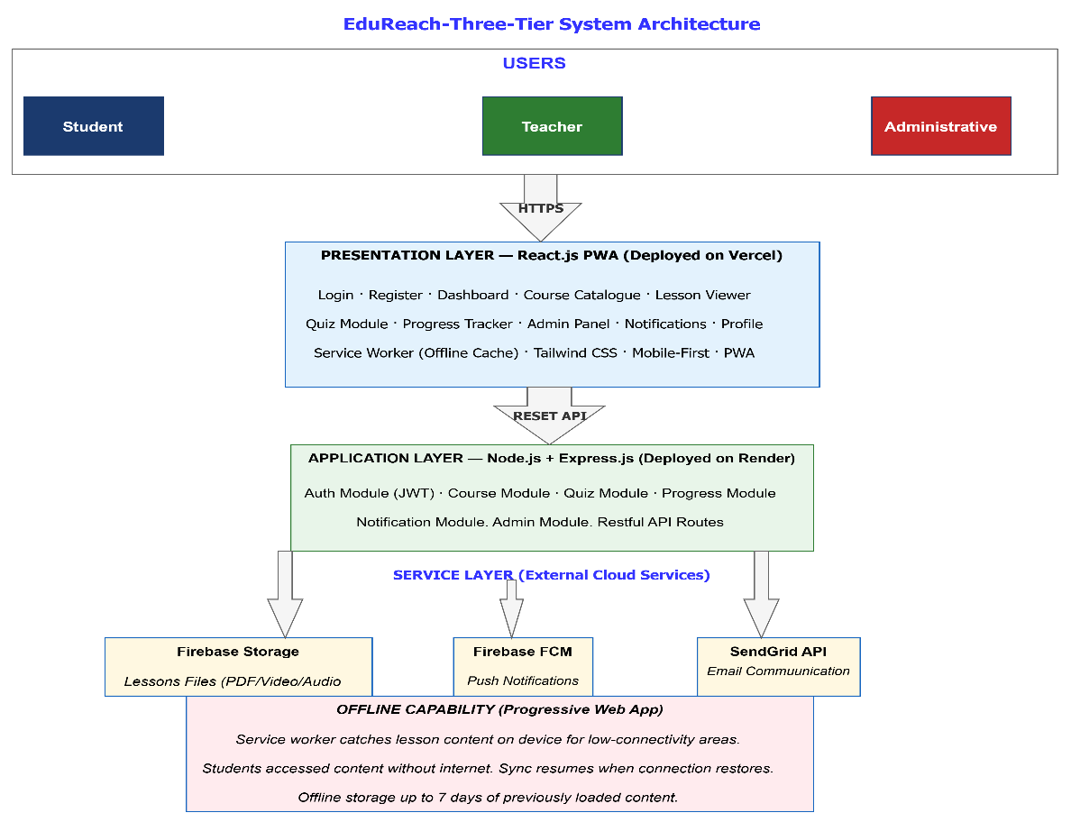

LAYER DESCRIPTIONS

Presentation Layer — React.js PWA (Vercel)
Handles all user interaction. Built with React.js as a PWA with service workers for offline functionality. Communicates with the backend via REST API (JSON over HTTPS). Tailwind CSS provides responsive, mobile-first styling optimised for low-cost Android devices.

Application Layer — Node.js + Express.js (Render.com)

Processes all business logic. Modules: Authentication (JWT), Waste Reports, Route Optimisation, Notifications, Analytics, Admin. Validates all inputs, enforces access control by role, and returns structured JSON responses.

Service Layer — External Cloud Services
- Google Maps Platform — GPS geocoding, interactive map rendering, route visualisation
- Firebase Storage — Photo uploads from waste reports
- Firebase Cloud Messaging — Real-time push notifications
- SendGrid API — Automated registration and confirmation emails
- MongoDB Atlas — Cloud-hosted NoSQL database for all application data
PROTOTYPE DEVELOPMENT
A ten-screen high-fidelity prototype has been created in Figma following a mobile-first, accessible design system. Figma Link: https://figma.com/proto/wastesmart [replace with your actual link].
Design System
Element | Specification | Rationale
Primary Colour | #1B5E20 (Deep Green) | Environmental trust and sustainability
Accent Colour | #FF8F00 (Amber) | CTAs, alerts, and highlights
Background | #F1F8E9 (Light Mint) | Eco theme, reduces eye strain
Success | #2E7D32 (Forest Green) | Completion and positive states
Error | #C62828 (Red) | Error messages, urgent warnings
Heading Font | Poppins Bold | Modern, clear on small screens
Body Font | Inter Regular | High readability for body text

KEY SCREENS

1. Splash / Onboarding
WasteSmart logo on deep green background. Tagline: ‘Clean Communities, Smarter Sierra Leone.’ Role selector (Resident / Collector / Officer) with amber call-to-action button.

2. Registration
Full Name, Phone, Email, Password fields. Two-step progress indicator. Real-time validation with inline error messages.

3. Login
Minimal Phone/Email and Password fields. Biometric login toggle for returning users. Forgot Password link.

4. Resident Dashboard
Personalised greeting, map thumbnail of nearest collection point, Quick Stats (reports submitted/resolved/pending), Report Waste button, bottom navigation bar.

5. Waste Report Form
GPS auto-detects location. Waste type selector. Severity slider. Optional photo. Description field. Submit button with confirmation animation.

6. Report Status Tracker
List of submitted reports with status badges (Pending / Assigned / Collected / Resolved). Timestamps and assigned collector name.

7. Interactive Waste Map
Full-screen Google Maps view. Red markers = uncollected, Amber = assigned, Green = resolved. Filter controls by type, date, ward.

8. Collector Route View
Optimised route with numbered waypoints on map. Each stop shows waste type, severity, address. Google Maps navigation integration.

9. Analytics Dashboard
Bar charts for weekly collection stats. Resolution rate rings by community. Waste density heatmap by ward. PDF export.

10. Admin Panel
User management, collector assignment, system health metrics, environmental impact tracking, regulatory report generation.
RESPOSITORY STRUCTURE
Folder / File | Contents
README.md | Project overview, setup guide, team members
LICENSE | MIT License text
/docs | Final report PDF, requirements, project charter
/diagrams | All 7 UML diagram PNG exports
/prototype | Figma link file and exported screen images
/frontend | React.js source code, Tailwind config, PWA assets
/backend | Node.js/Express source, API routes, middleware

Branching Strategy
- main — Production-ready, tested code only. Changes via pull request.
- develop — Integration branch. Feature branches merge here before release.
- feature/[name] — Individual features (e.g., feature/waste-report-form).
- hotfix/[name] — Emergency fixes branched directly from main.

Commit Message Convention
- feat: New feature — e.g., feat: add GPS auto-detect on report form
- fix: Bug fix — e.g., fix: resolve map marker clustering on mobile
- docs: Documentation — e.g., docs: update README with setup instructions
- style: UI changes — e.g., style: update primary button to deep green
- test: Tests — e.g., test: add unit tests for route optimisation moduleProject Management
PROJECT MANAGEMENT
Work Breakdown Structure
ID | Task Name | Duration | Start | End | Dependency
T1 | Project Planning & Charter | 1 week | Week 4 | Week 4 | —
T2 | Requirements Analysis | 1 week | Week 5 | Week 5 | T1
T3 | System Architecture Design | 1 week | Week 5 | Week 5 | T1
T4 | UML Diagram Development | 1 week | Week 6 | Week 6 | T2, T3
T5 | Figma UI/UX Prototype | 2 weeks | Week 6 | Week 7 | T4
T6 | GitHub Repository Setup | 0.5 week | Week 5 | Week 5 | T1
T7 | Frontend Development | 2 weeks | Week 7 | Week 8 | T5
T8 | Backend Development | 2 weeks | Week 7 | Week 8 | T4
T9 | Integration & Testing | 1 week | Week 9 | Week 9 | T7, T8
T10 | Documentation & Report | 1 week | Week 10 | Week 10 | T9
T11 | Review, Format & Submit | 1 week | Week 11 | Week 11 | T10
GANTT CHART
The Gantt Chart below maps all project tasks against the weekly timeline from Week 4 to Week 11. Tasks are colour-coded by phase: blue (planning), green (design), orange (development), red (testing), purple (documentation). The red dashed border highlights all critical path tasks.
Gantt Diagram
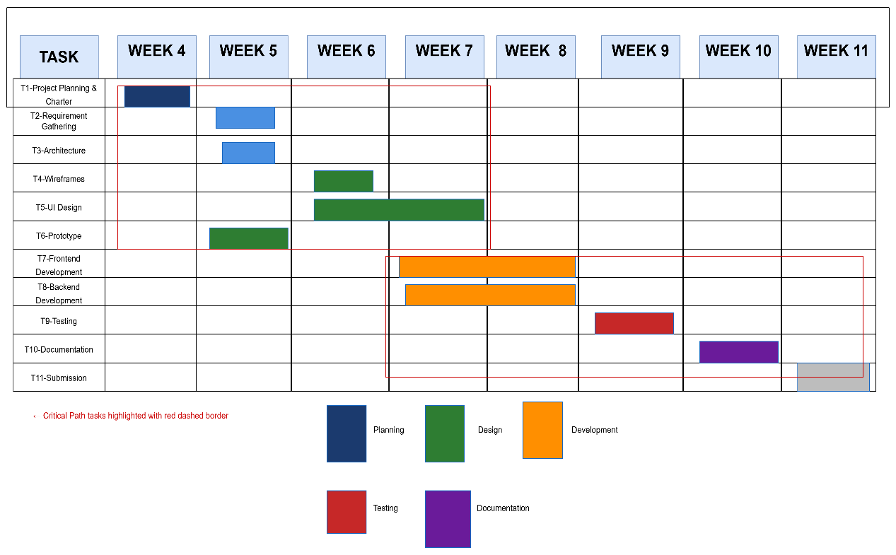

Network Diagram (Critical Path Method)
The Network Diagram models tasks as nodes with directed dependency arrows. Each node shows Early Start (ES), Early Finish (EF), Late Start (LS), and Late Finish (LF). Tasks where ES=LS and EF=LF have zero float and lie on the Critical Path.
Critical Path: T1 → T2 → T4 → T5 → T7 → T9 → T10 → T11 (Total: 8 Weeks)

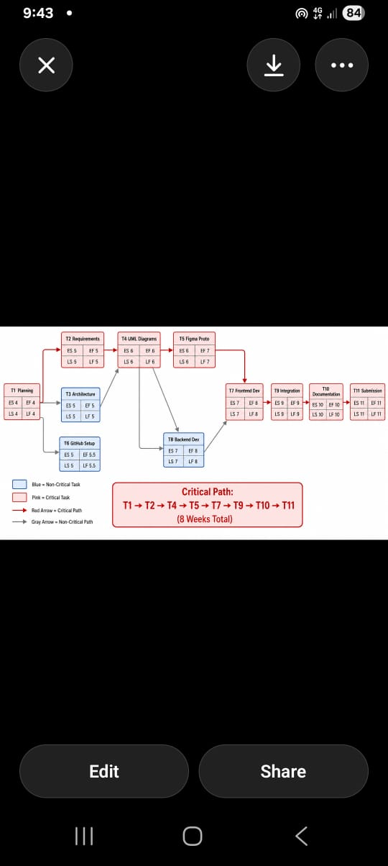 Software License — MIT
WasteSmart is released under the MIT License. It was chosen because WasteSmart is a Digital Public Good and must be freely available for anyone to use, modify, and distribute.
Permission | Condition | Limitation
Commercial use | Include license & copyright notice | No liability
Modification | Include license & copyright notice | No warranty
Distribution | Include license & copyright notice | —
Private use | — | —

Design Quality
- Visual Consistency: Unified design system — colour palette, typography, 8px grid, reusable components across all 10 screens.
- Accessibility: WCAG 2.1 Level AA — minimum 4.5:1 contrast ratio, keyboard navigability, alt text, English and Krio language support.
- Responsive Design: Mobile-first with breakpoints for mobile (480px), tablet (768px), and desktop (1024px). Optimised for 2GB RAM Android devices.
- Feedback: Loading spinners, success toasts, error alerts, and progress bars reduce user uncertainty in low-connectivity environments.
- Gamification: Collector leaderboards and community cleanliness scores increase civic engagement and system adoption.

SDG Alignment
SDG | How WasteSmart Contributes
SDG 11 – Sustainable Cities | Enables coordinated, data-driven urban waste collection in Freetown and beyond.
SDG 12 – Responsible Consumption | Diverts waste from illegal dumpsites to formal collection, supporting circular economy principles.
SDG 13 – Climate Action | Reduces greenhouse gas emissions from open burning and landfill overflow.
SDG 10 – Reduced Inequalities | Free offline access ensures underserved communities receive equal service coverage.
SDG 3 – Good Health | Reduces disease vectors (mosquitoes, rats) associated with uncollected waste.
SDG 17 – Partnerships | MIT open-source licence fosters NGO, government, and private sector collaboration.
UML DIAGRAMS
Use Case Diagram
The Use Case Diagram identifies the four primary actors — Resident, Waste Collector, Municipal Officer, and Administrator — and maps their interactions with the system’s core features. Google Maps Platform is modelled as an external actor providing GPS and mapping services. The diagram shows that Residents primarily interact with reporting and tracking features; Collectors with route and status features; Officers with analytics and reporting; and Administrators with system configuration and user management.
User Case Diagram
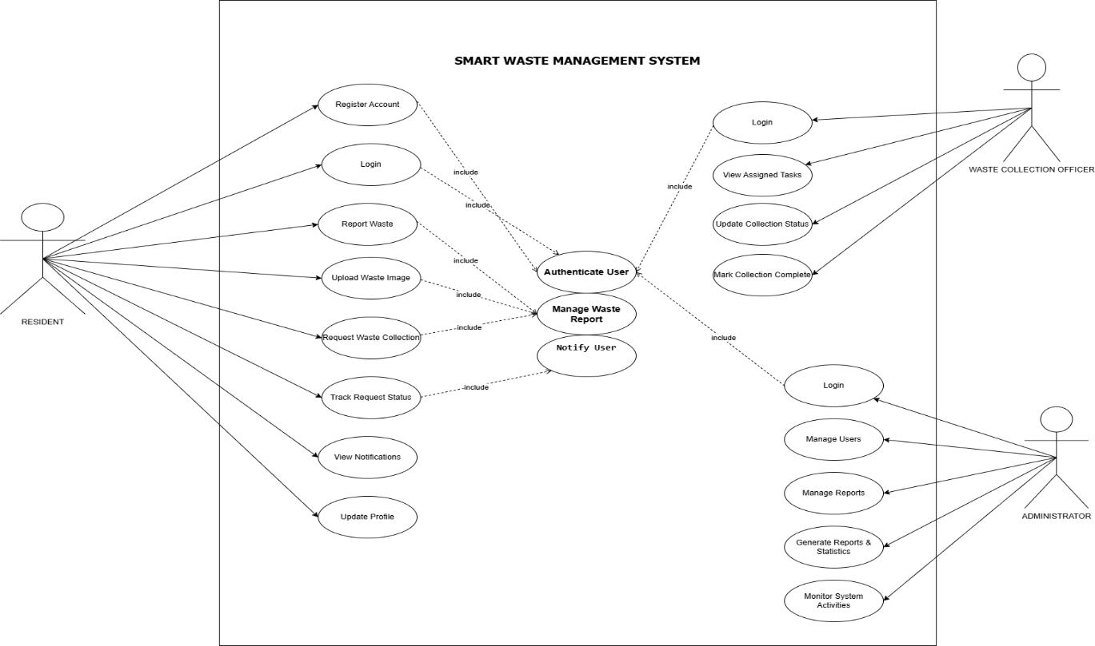

Class Diagram
The Class Diagram models the static structure of WasteSmart, defining the main classes, their attributes, methods, and the relationships between them. The central User class is the parent of four subclasses: Resident, Collector, Officer, and Administrator, each inheriting shared attributes (userID, name, email, password, role, createdAt) and overriding or extending them with role-specific properties and behaviours. The WasteReport class is the primary data entity, linked to the User class through a one-to-many relationship (one Resident submits many WasteReports). The CollectionRoute class aggregates multiple WasteReport objects as waypoints. The Notification class is generated by WasteReport status changes and sent to the relevant User. This structure ensures clear data ownership, enforces role-based access, and provides a solid foundation for MongoDB schema design.
Class Diagram
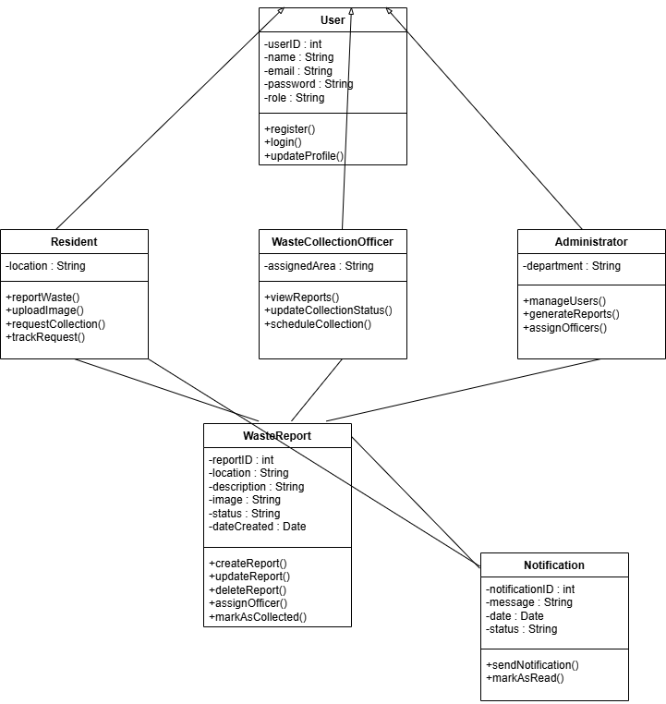

Sequence Diagram
The Sequence Diagram illustrates the dynamic interaction between system components for the most critical user flow: Resident Waste Report Submission and Collector Assignment. The four lifelines represent the Resident (actor), React.js Frontend, Node.js Backend, and Firebase Storage (external service). The sequence begins with the Resident entering waste details and tapping Submit. The frontend validates input locally and sends a POST /reports request (with JWT in the header) to the backend. The backend validates the JWT, geocodes the GPS coordinates via Google Maps API, stores the report in MongoDB, uploads the attached photo to Firebase Storage, calculates the nearest available collector, and sends a Firebase FCM push notification to that collector. The backend returns a 201 Created response with the report ID to the frontend, which displays a success confirmation to the Resident. This complete cycle, from submission to collector notification, occurs in under three seconds on a 4G connection.
Sequence Diagram
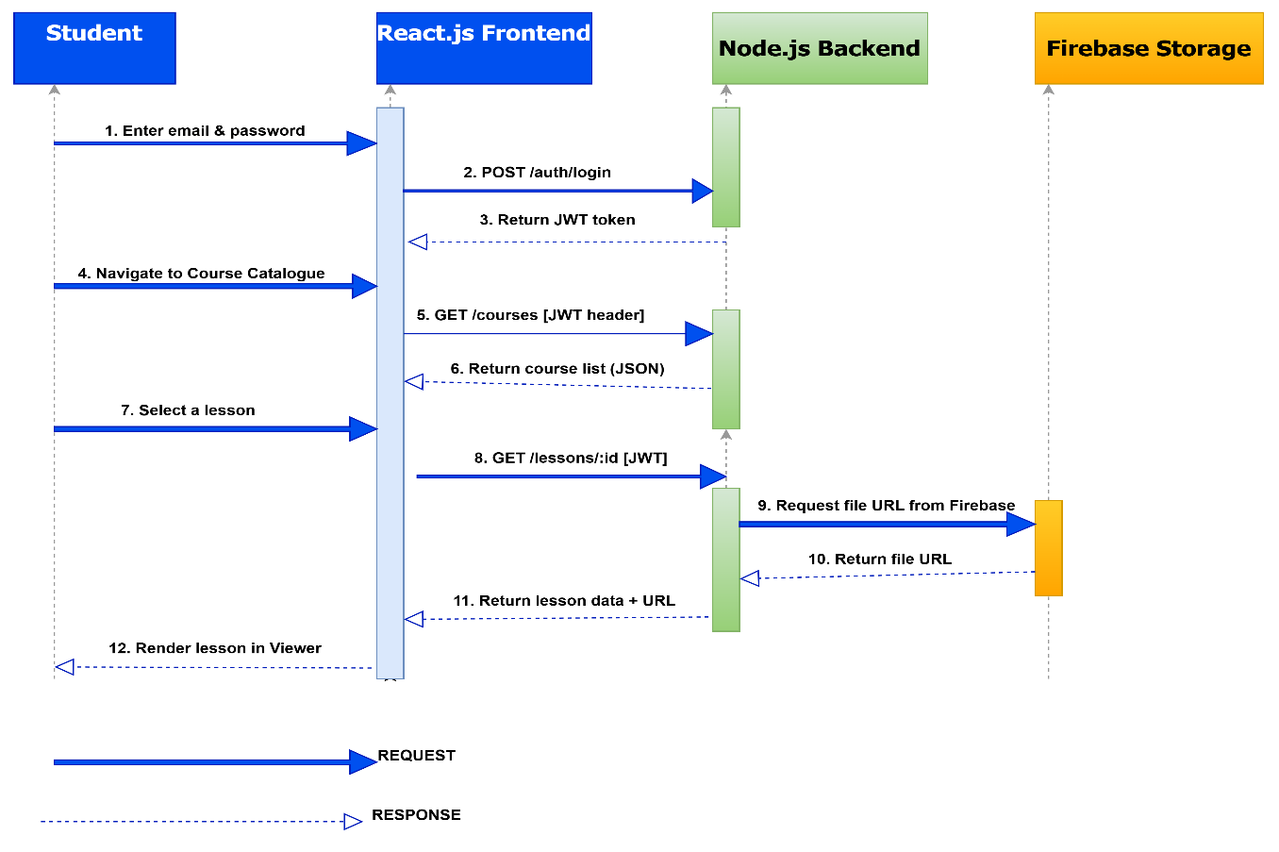

Activity Diagram
The Activity Diagram models the complete Waste Report Resolution Workflow, from the moment a Resident submits a report through to final resolution and community notification. The flow contains three key decision points: first, whether the submitted GPS coordinates are valid (if not, the resident is prompted to correct the location); second, whether a collector is available in the area (if not, the report enters a pending queue and the resident is notified of the delay); third, whether the collector has marked the collection as verified with a photograph (if not, the report is flagged for re-inspection). Upon successful collection verification, the system automatically updates the report status to Resolved, issues a digital acknowledgement to the resident, updates the community cleanliness score, and logs the environmental impact data (estimated tonnes of waste collected) to the analytics dashboard. This diagram captures both the successful path and the exception paths, making it a critical reference for both developers and testers.
Activity Diagram
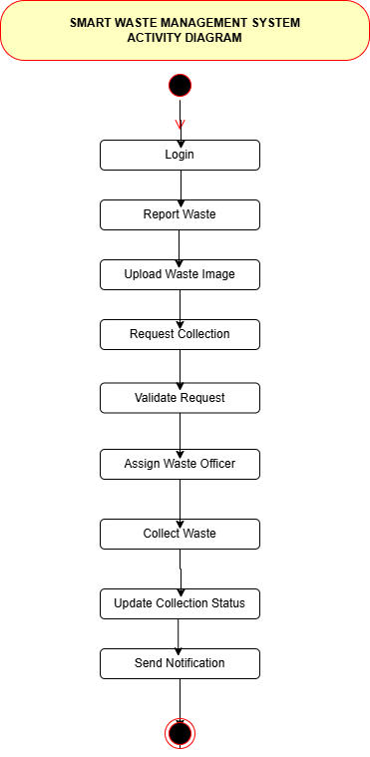

CONCLUSION
WasteSmart represents far more than a software engineering exercise. It is a direct response to one of Sierra Leone’s most persistent and visible public health challenges: the inadequate, inequitable, and inefficient management of solid waste in Freetown and surrounding communities. By placing digital technology in the hands of residents, collectors, and municipal officers, WasteSmart creates a connected, data-driven ecosystem where waste is reported in real time, collected along optimised routes, and tracked from submission to resolution. The system replaces guesswork and disconnection with information, accountability, and civic empowerment.
From a software engineering perspective, this project has demonstrated a comprehensive and professional application of all the core principles covered in PROG 102. The Agile SDLC model provided a structured yet flexible framework for development, enabling continuous feedback, iterative improvement, and a realistic eight-week delivery timeline. The three-tier system architecture — with React.js on the frontend, Node.js on the backend, and a carefully selected suite of cloud services — demonstrates a deep understanding of modern web application design, separation of concerns, and scalability planning. The seven UML diagrams — Use Case, Class, Sequence, Activity, Architecture, Gantt, and Network — provide a complete and internally consistent model of the system’s structure, behaviour, and project timeline, from the highest level of abstraction down to the specific methods and attributes of individual classes.
The Figma prototype demonstrates not only visual design skill but a genuine commitment to the people WasteSmart is built to serve. Every design decision — from the mobile-first layout optimised for low-cost Android devices, to the Krio language option, to the offline-first service worker implementation — reflects an understanding of the real constraints and needs of Sierra Leonean communities. Good software is not software that works in a well-equipped laboratory; it is software that works for real people in the real conditions of their lives.

REFERENCES
- Sommerville, I. (2016). Software Engineering (10th ed.). Pearson Education.
- Pressman, R. S., & Maxim, B. R. (2020). Software Engineering: A Practitioner’s Approach (9th ed.). McGraw-Hill.
- United Nations. (2015). Transforming Our World: The 2030 Agenda for Sustainable Development. UN General Assembly. https://sdgs.un.org/goals
- Freetown City Council. (2023). Freetown Transform Waste Management Strategy 2023–2028. FCC Environmental Services Division.
- Digital Public Goods Alliance. (2024). Digital Public Goods Standard v1.1.5. https://digitalpublicgoods.net/standard/
- React Documentation. (2024). React – The Library for Web and Native User Interfaces. https://react.dev/
- Node.js Foundation. (2024). Node.js Documentation. https://nodejs.org/en/docs/
- Google. (2024). Firebase Documentation. https://firebase.google.com/docs
- Google. (2024). Maps JavaScript API Documentation. https://developers.google.com/maps/documentation/javascript
- World Wide Web Consortium (W3C). (2018). Web Content Accessibility Guidelines (WCAG) 2.1. W3C Recommendation. https://www.w3.org/TR/WCAG21/
- Open Source Initiative. (2024). The MIT License. https://opensource.org/license/mit/
- MongoDB. (2024). MongoDB Documentation. https://www.mongodb.com/docs/

APPENDIX A- FUNCTIONAL REQUIREMENTS
ID | Requirement | Priority
FR-01 | System shall allow users to register with phone number, name, password, and role. | High
FR-02 | System shall authenticate users using JWT tokens with 24-hour expiry. | High
FR-03 | System shall allow residents to submit waste reports with GPS location and optional photo. | High
FR-04 | System shall display an interactive map with colour-coded waste report markers. | High
FR-05 | System shall generate optimised collection routes for collectors per shift. | High
FR-06 | System shall allow collectors to update report status (Assigned / Collected / Verified). | High
FR-07 | System shall track and display real-time status of all submitted reports. | High
FR-08 | System shall support offline report submission with automatic sync on reconnection. | High
FR-09 | System shall send push notifications for report assignment, collection, and resolution. | Medium
FR-10 | System shall allow officers to view analytics dashboards and generate environmental reports. | High
FR-11 | System shall issue a digital acknowledgement to residents upon report resolution. | Medium
FR-12 | System shall support English and Krio language interfaces with a toggle switch. | Medium

APENDIX B-NON-FUNCTIONAL REQUIREMENTS
ID | Requirement | Category
NFR-01 | System shall load key screens within 3 seconds on a 3G connection (10 Mbps). | Performance
NFR-02 | System shall maintain 99.5% uptime, with scheduled maintenance during off-peak hours. | Reliability
NFR-03 | System shall support a minimum of 10,000 concurrent users without performance degradation. | Scalability
NFR-04 | All user data shall be encrypted in transit using HTTPS/TLS 1.2 or higher. | Security
NFR-05 | System shall comply with WCAG 2.1 Level AA accessibility standards. | Accessibility
NFR-06 | UI shall be fully responsive across mobile (480px), tablet (768px), and desktop (1024px). | Usability
NFR-07 | System shall support offline report queuing and synchronisation for up to 7 days. | Availability

