**Currency-Conversion-Service**

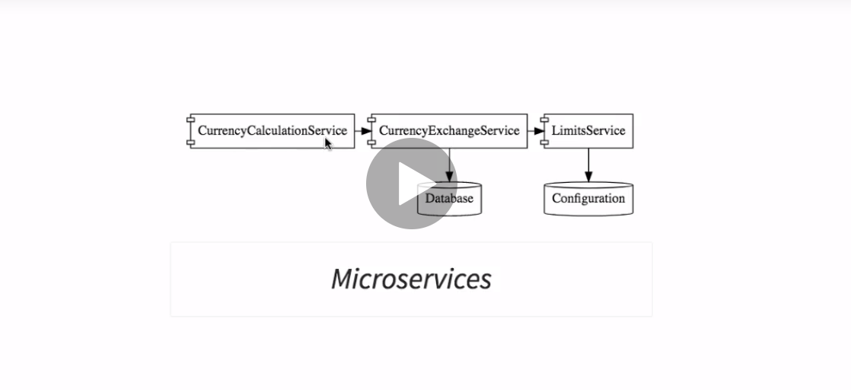

Design

[**http://localhost:8100/currency-converter/from/USD/to/INR/quantity/1000**](http://localhost:8100/currency-converter/from/USD/to/INR/quantity/1000)

**Given the quantity of the currency, the CurrencyCalc Service will call exchange service to get the exchange rate and then multiply with the amount and return the final value.**

Load Distribution

<http://localhost:8100/currency-converter-feign/from/EUR/to/INR/quantity/1000>

