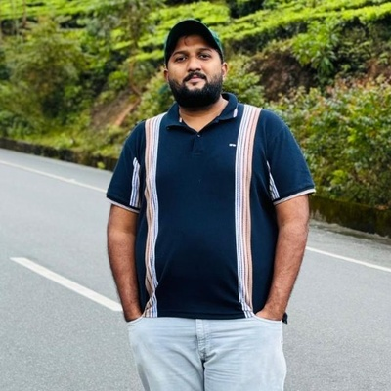 | ABDUL RASAK M R  Senior Software Engineer | Healthcare Integration & Microservices Specialist  📱 Mobile: +91 9447723429 | 📧 Email: rasakmar@gmail.com  📍 Location: India | 🎓 B.Tech CSE (MG University 2012) | 💼 11+ Yrs Exp
――――――――――――――――――――――――――――――――――――――――――――――――――――――――――
PROFESSIONAL SUMMARY
Results-driven Senior Software Engineer with over 11+ years of hands-on experience architecting and engineering enterprise-grade Healthcare Information Systems (HIS/CMS), Pharmacy Systems, and Supply Chain ERPs across UAE and India. Recognized domain specialist in regional healthcare interoperability (HAAD, DHA, Malafi, Nabidh, Riayati) leveraging HL7 v2, FHIR messaging, and Mirth Connect. Proven track record in Laboratory Information System (LIS) device integrations. Currently leading cloud-native microservices modernization using Spring Boot, React.js, OAuth2, and PostgreSQL.
CORE COMPETENCIES & TECHNICAL SKILLS
Category | Technologies & Frameworks
Backend & Microservices | Java (7/8/17+), Spring Boot, Spring MVC, Spring Security, Microservices Architecture, OAuth2, RESTful APIs
Healthcare Interoperability | HL7 v2 Standard, FHIR Messaging, Mirth Connect, HAAD (Abu Dhabi), DHA (Dubai), Malafi, Nabidh, Riayati, LIS Machine Integration
Frontend & Web | React.js, JavaScript (ES6+), jQuery, HTML5, CSS3, Responsive Web Design
Databases & Reporting | MySQL (5.6+), PostgreSQL, Jasper Reports, SQL Optimization
Domain Expertise | Hospital Information Systems (HIS), Clinical Management (CMS), Pharmacy Systems, Revenue Cycle Management (RCM), iERP (Procurement & Warehouse)
WORK EXPERIENCE
Senior Software Engineer | Safecare Technologies Pvt Ltd
March 2015 – Present (11+ Years) [Career Progression: Junior Software Engineer (2.1 yrs) ➔ Software Engineer (1 yr) ➔ Senior Software Engineer (2018 – Present)]
- Architecture Modernization & Microservices: Spearheading the migration of monolithic Java/Spring MVC suites into modern Spring Boot Microservices, React.js frontends, OAuth2 authentication, and PostgreSQL databases.
- Healthcare Interoperability (HIE Integrations): Engineered bi-directional integration engines connecting Cortex HIS/CMS with UAE regional Health Information Exchanges including Malafi (Abu Dhabi), Nabidh (Dubai), and Riayati (MOHAP) using HL7 v2, FHIR standards, and Mirth Connect.
- Laboratory Machine Integration (LIS): Implemented automated laboratory machine connectivity interfacing medical auto-analyzers directly with LIS via HL7 protocols.
- Healthcare Claims & RCM Automation: Designed end-to-end e-Claim processing workflows for HAAD & DHA regulatory compliance (Prior Approvals, Initial Submissions, Remittance Advice parsing, and Resubmissions).
- iERP & Mobile API Development: Built custom procurement and warehouse management suite (iERP), developing REST APIs connecting mobile applications to track real-time field worker activities.
- Reporting & Analytics: Engineered clinical, inventory, and financial reporting modules utilizing Jasper Reports.
Freelance Web Designer & Developer (Jan 2013 – Feb 2015)
- Designed and developed custom, responsive websites and client web applications using HTML5, CSS3, and JavaScript.
Java Software Developer Intern | Brazier IT Solutions, Bangalore (Sep 2012 – Jan 2013)
- Hands-on core Java application development, OOP principles, SQL database queries, and module testing.
MAJOR FEATURED PROJECTS
• Cortex HIS & CMS: Integrated UAE HIEs (Malafi, Nabidh, Riayati) and regional health authorities (HAAD, DHA) via HL7, FHIR, and Mirth Connect. (Java 8, Spring MVC, MySQL, Jasper Reports).
• Microservices Migration & LIS Platform: Architectural refactoring to Spring Boot Microservices, React.js, OAuth2, and PostgreSQL. Automated medical lab machine integration via HL7.
• Pharmacy Management System (UAE & India): Comprehensive drug dispensing and inventory system with HAAD & MOH claim prior approvals, submissions, remittance collection, and resubmissions.
• iERP (Procurement, Supply Chain & Warehouse): Procurement and warehouse management platform with RESTful APIs supporting mobile app task tracking for field workers.
EDUCATION
Bachelor of Technology (B.Tech) in Computer Science & Engineering
MG University, Kerala, India | Passout Year: 2012

