This guide will walk you through the deployment and installation process for the Signature Verification System application. Please follow the steps below:

**Step 1: Install XAMPP**

1. Download XAMPP from the official website (<https://www.apachefriends.org/index.html>).

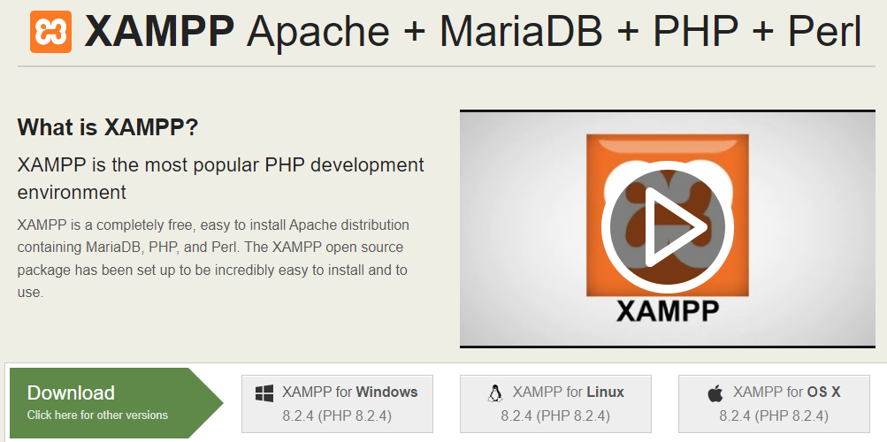

2. Run the downloaded installer and follow the on-screen instructions to begin the installation process.

3. Choose the installation directory where you want to install XAMPP. The default directory is usually "C:\xampp" (for Windows) or "/Applications/XAMPP" (for macOS).

4. Select the components to install. Make sure that both Apache and MySQL servers are selected. You can also include other components like PHP and phpMyAdmin if needed.

5. Click the "Next" or "Continue" button to proceed.

6. Review the installation settings and click the "Next" or "Continue" button to start the installation process.

7. Wait for the installation to complete. This may take a few minutes.

8. Once the installation is finished, click the "Finish" button.

**Step 2: Install MySQL Workbench**

1. Download MySQL Workbench from the official website (<https://www.mysql.com/products/workbench/>).

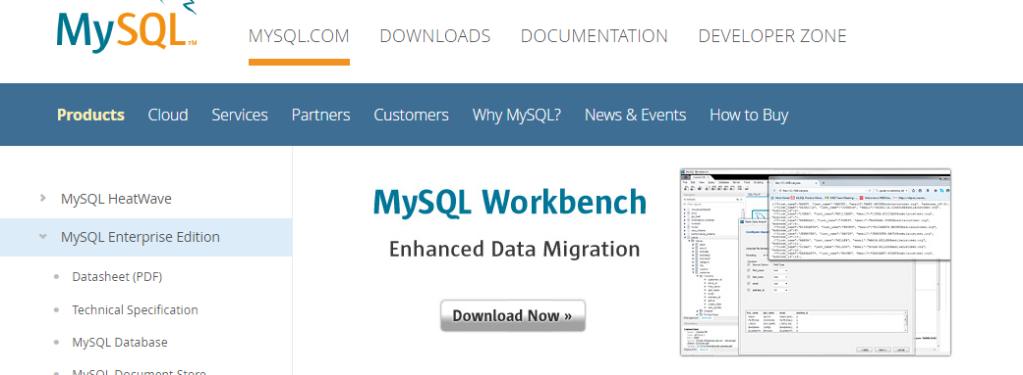

2. Run the downloaded installer and follow the on-screen instructions to begin the installation process.

3. Choose the installation directory where you want to install MySQL Workbench.

4. Select the desired options and features to install. The default options are typically sufficient for most users.

5. Click the "Next" or "Continue" button to proceed.

6. Review the installation settings and click the "Install" button to start the installation process.

7. Wait for the installation to complete. This may take a few minutes.

8. Once the installation is finished, click the "Finish" button.

**Step 3: Set up the Signature Verification System**

1. Launch XAMPP by double-clicking the XAMPP Control Panel icon on your desktop or by navigating to the XAMPP installation directory and running the "xampp-control" application.

2. Start both the Apache and MySQL servers by clicking the "Start" button next to each of them in the XAMPP Control Panel. The server status should change from "Stopped" to "Running."

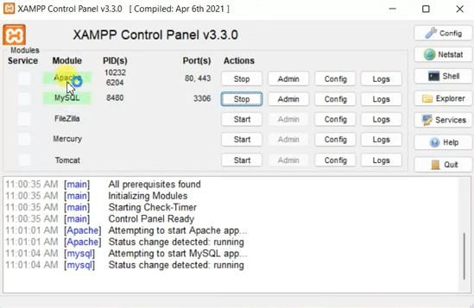

3.Open your web browser and type "http://localhost/phpmyadmin" in the address bar to access the phpMyAdmin interface.

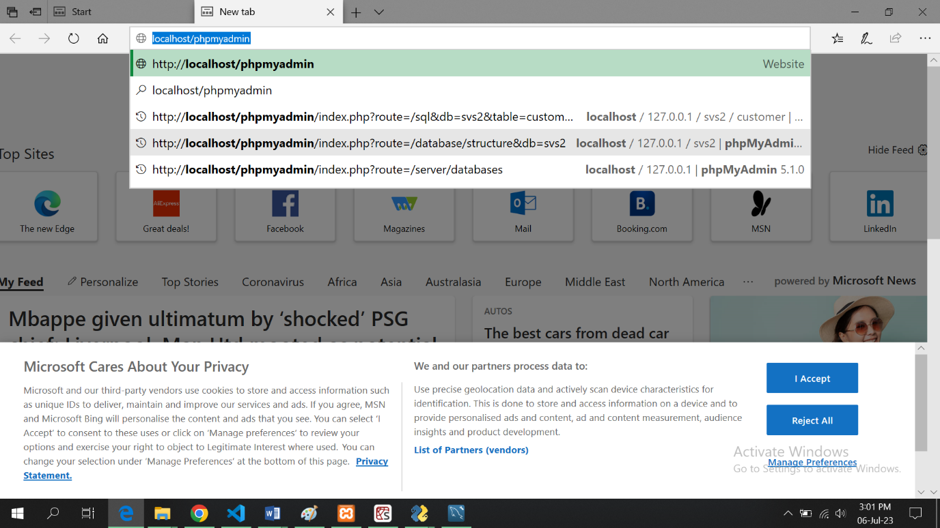

4. If prompted, enter your MySQL username and password to log in to phpMyAdmin.

5. Once logged in, you will see the phpMyAdmin interface with a list of databases on the left-hand side.

6. Click on the "New" button on the left-hand side to create a new database for the Signature

Verification System. Enter a name for the database (e.g., "signature_verification_system") and click the "Create" button.

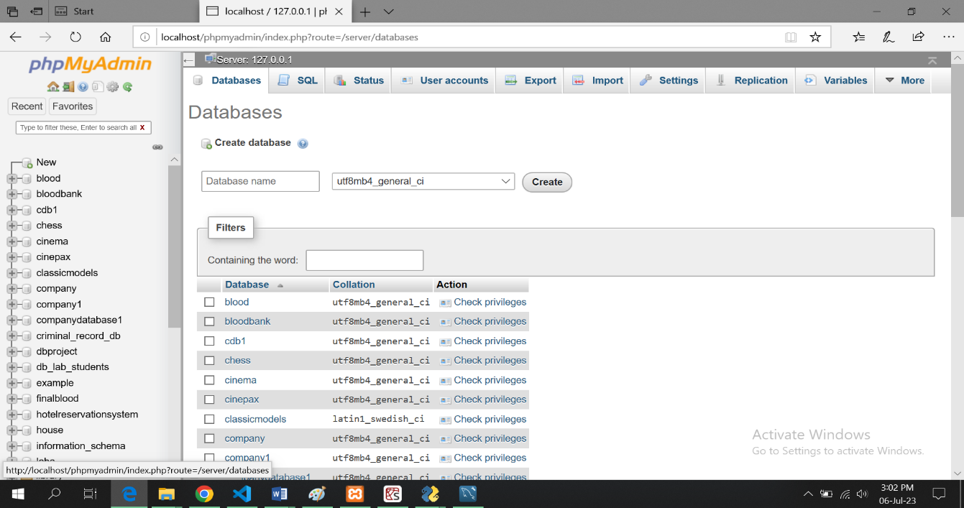

1. After creating the database, click on its name in the left-hand side panel to open it.

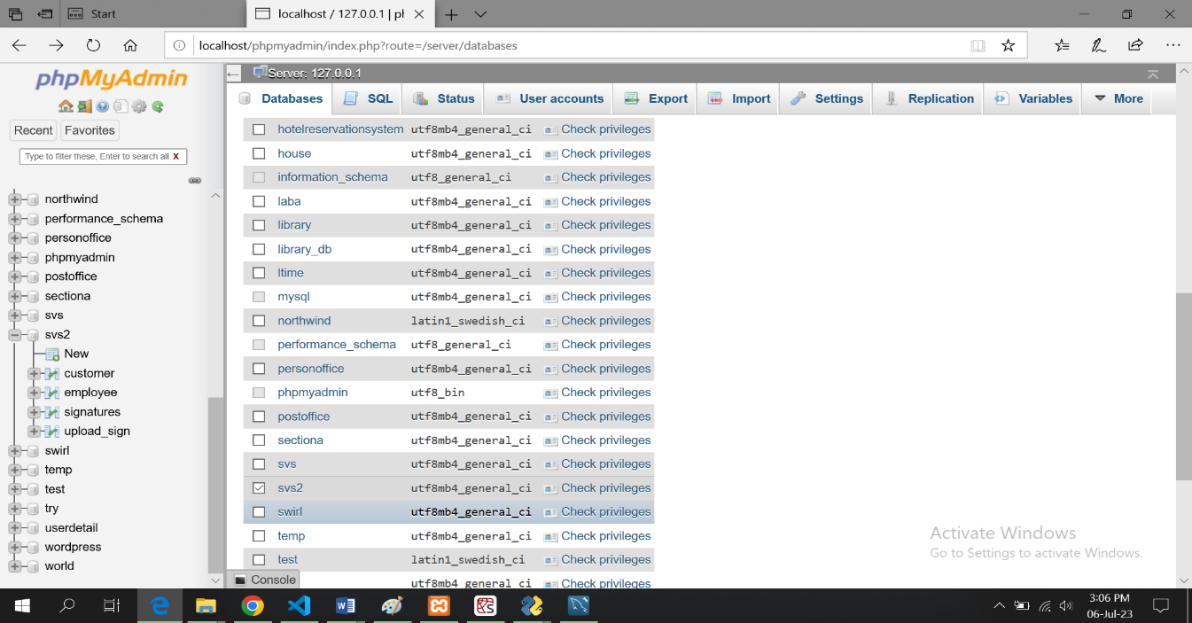

8. Look for the "Import" tab within the phpMyAdmin interface and click on it.

9. Click the "Choose File" button and select the provided database file (usually in .sql format) to import.

10. Click the "Go" button to start importing the database file into your local MySQL server. Wait for the import process to complete. This may take some time, depending on the size of the database.

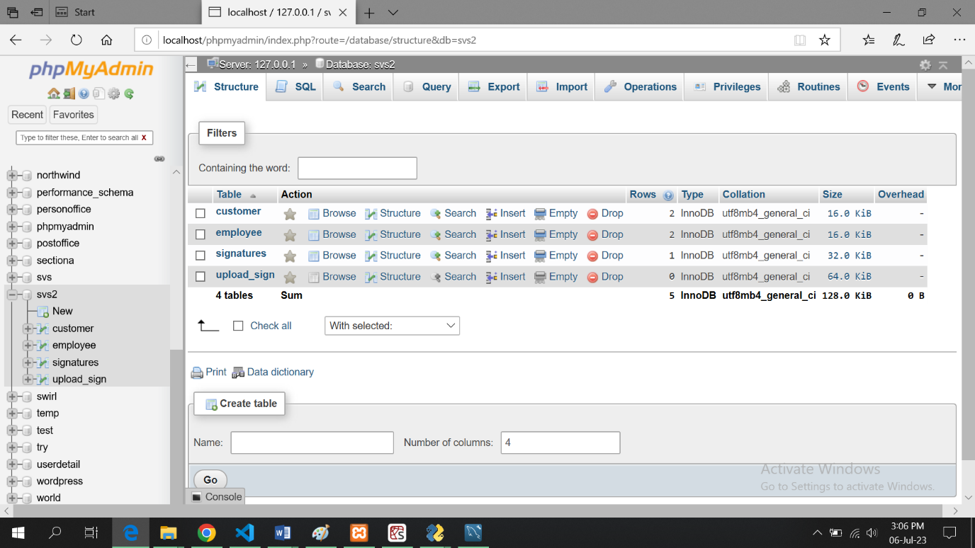

**Choose the table in which you want to add data let us choose customer:**

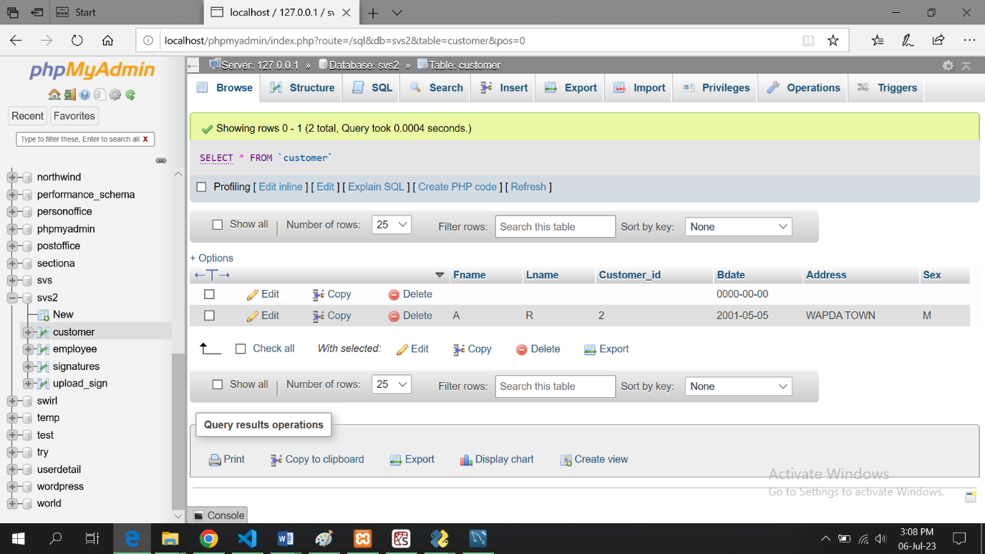

**Click on insert tab to insert data:**

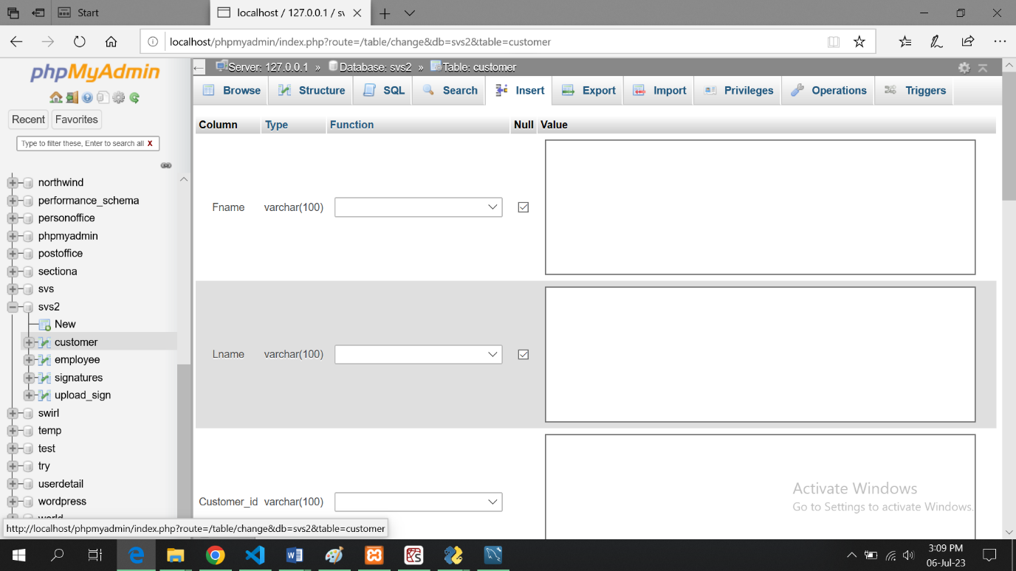

11. Once the import is finished, you should see a message indicating that the import was successful.

**Step 4: Run the Signature Verification System Application**

1. Locate the provided .exe file for the Signature Verification System application.

2. Double-click on

the .exe file to run the application. You may see a security warning or a User Account Control (UAC) prompt. Click "Allow" or "Yes" to proceed with the installation.

3. The installation process will begin, and the necessary files will be extracted and copied to the appropriate location on your system.

4. Follow the on-screen instructions provided by the installer. This may involve selecting an installation directory or accepting the default settings.

5. Once the installation is complete, you can choose to create a desktop shortcut or launch the application directly.

6. Double-click on the .exe file or the desktop shortcut to launch the Signature Verification System application.

7. The application should open and be ready to use.

Note: If you encounter any issues or errors during the installation or setup process, refer to the application's documentation or contact the support team for further assistance.

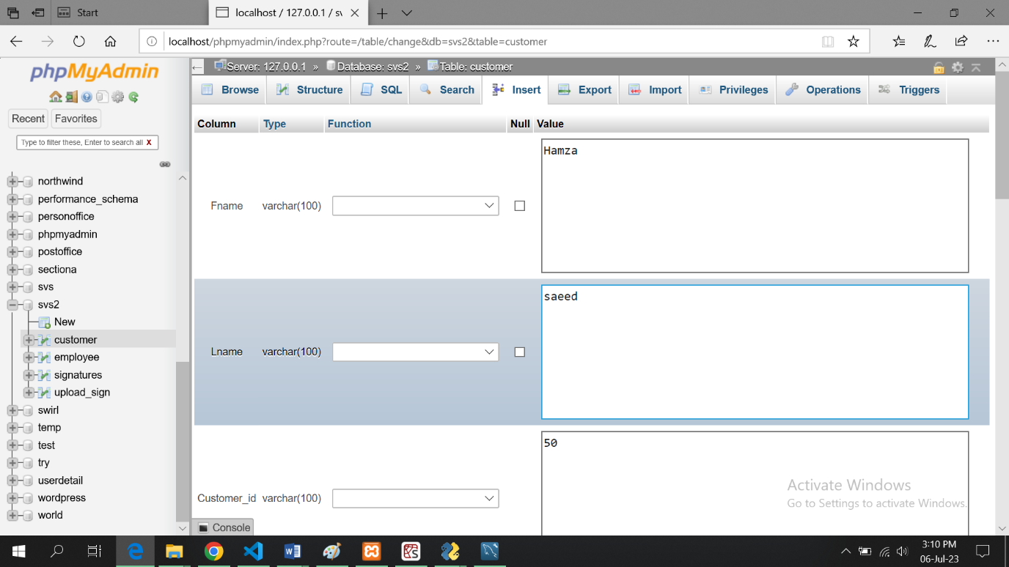

**Click go button:**

