**Introduction:**

* Welcome to the User Guide for the Signature Verification System.
* This guide provides instructions on how to use the system effectively.
* Contact your bank's admin or the designated personnel to gain access to the Signature Verification System.

**Registration:**

* Admin will be the person registered in database
* Admin will be able to register himself in app
* And if admin wants to login he will enter id assigned to him if id exists in database he is a registered employee and will able to login
* Regular User will not be able to register himself he will also be registered by admin
* Customer will also not be able to register themselves they will be registered by admin
* Regular user cannot Add, delete, update any customer’s data
* User can only verify signatures
* Admin can also act as regular user along with administrative rights

**Login:**

* Launch the desktop application by double-clicking the application icon.
* The first screen will prompt you to choose between being a user or an admin.
* Select the desired mode (User or Admin) by clicking on the respective option.
* If you are an admin, enter your admin credentials (username and password) and click the "Sign In" button.
* If you are a user, enter your user id and if you are a registered user, you will able to access your account and start verifying

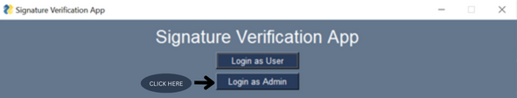

**Admin Panel:**

* After successful admin login, the admin panel will open.
* The admin panel provides various options for managing customer records.

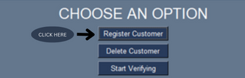**Customer Record Management (Admin):**

* To update a customer's record, select the customer from the list or search for the customer using their details.
* Make the necessary changes to the customer's information, such as name, CNIC, and contact number.
* To delete a customer's record, enter the customer ID you want to delete and the customer and its record will be deleted.



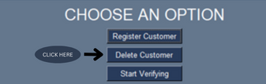

* To add a new customer, click on the "Add Customer" button and provide the required details, including name, ID, contact number.
* Once the customer is registered the app will ask you to enter the 4 genuine signatures of the customer against his id which will be stored in database.

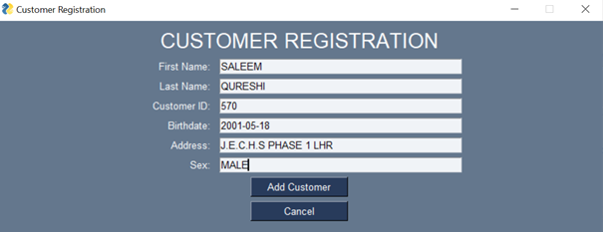

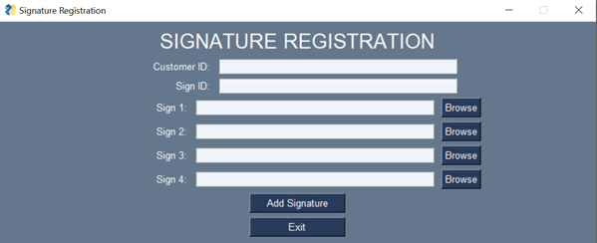

**User Panel:**

* If you are a user, after successful login, the user panel will open.
* Your unique ID will be displayed on the screen.
* You will have two options Start Verifying and exit.
* By pressing exit button, you will leave the app.



* By pressing start verifying a new screen will occur.



* The new screen will require customer id whose signature are to be verified.

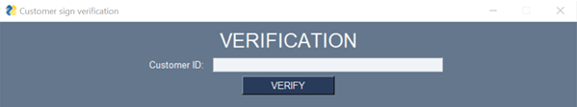

* It will also require 4 genuine signs and 1 test sign
* For every signature there will be a BROWSE button by clicking that button you will be able to choose signature from a folder or wherever you kept the signatures

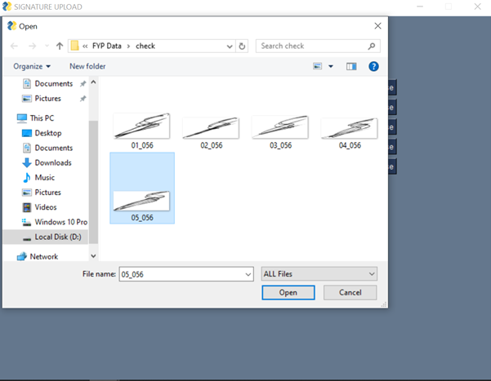

**Signature Verification Process (User):**

To validate your signatures, follow these steps:

* Once 4 genuine signatures and one test signature is uploaded to the app.

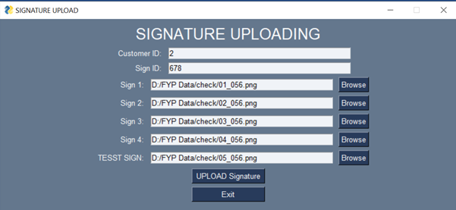

* There will be a test button on screen
* After pressing the test button, the signatures will be given to backend.
* Processing will take some time 10 to 15 seconds.
* After that a result will be shown on screen indicating that if signatures are fake or real.

