BSCS FINAL PROJECT
Phase 1

Offline Signature Verification System



Project Advisor

Awais Muhammad Lodhi

Presented by:
Group ID: F22BS019

Student Reg# Student Name
L1F19BSCS0511 ABDUL RAUF
L1F19BSCS0570 SALEEM QURESHI
L1F19BSCS0544 ZAVIAL SAHAR

Faculty of Information Technology

University of Central Punjab

Software Requirements Specification

Version # 1

Offline Signature Verification System

Advisor: Awais Muhammad Lodhi

Group F22BS019
Member Name | Primary Responsibility
Abdul Rauf | Research and development
Saleem Qureshi | Research and development
Zavial Sahar | Research and development

Table of Contents
Table of Contents i
Revision History ii
Abstract iii
1. Introduction 1
1.1 Review of Related Literature 1
1.2 Problem Statement 1
1.3 Proposed Solution 1
1.4 Problem Scope 1
1.5 Challenges 1
1.6 Knowledge Areas Required 1
1.7 Completeness Criteria 1
1.8 Research Outcomes/Nature of End Product 1
1.9 Learning Outcomes 1
1.10 Document Conventions 1
2. Background Study and Literature Survey 2
3. Overall Description 2
3.1 Proposed Solution 2
3.2 User Classes and Characteristics (if applicable) 2
3.3 Operating Environment 2
3.4 Design and Implementation Constraints 2
3.5 Assumptions and Dependencies 2
4. Functional Requirements 3
4.1 Requirement 1 OR Use-Case 1 (if requirements are modeled as use cases) 3
4.2 Requirement 2 OR Use-Case 2 (and so on) 3
4.3 Proposed Workflow 4
4.4 Analysis and Modeling of Requirements 4
5. Nonfunctional Requirements 4
5.1 Target Performance 4
5.2 Safety Requirements (if applicable) 4
5.3 Security Requirements (if applicable) 4
5.4 Additional Software Quality Attributes 4
6. Other Requirements 4
7. Initial Results 5
8. Revised Project Plan 5
9. References 5
Appendix A: Glossary 6
Appendix B: IV & V Report 7

Revision History
Name | Date | Reason For Changes | Version

Abstract

This project aims to assist organizations in identification of original signatures of a person to avoid forgery using a Desktop based application having a trained model with deep learning (neural networks) and image processing algorithms implemented. Present autonomous signature verification systems are based on live identification of signature based on the pressure at pen tip and its movement between X and Y coordinates which is termed as online SVS and can only be beneficial during live signature verification. However, many organizations need to verify signatures several times, so online signature verification cannot be used everywhere since it requires real time signatures. To overcome this issue Offline signature verification system is needed so that signatures can be verified anytime, when needed, merely with the help of signature image. A modified version of traditional twin Siamese network i.e., 5 ways Siamese network will be used wherein 4 genuine signature images and one test image will be inputted and decision of the authenticity of image will be based upon the similarity between test image and 4 genuine images, once the model is completed the results will be compared with existing models which compares 1 genuine image with test image.

Introduction

Review of Related Literature
Total six research papers were reviewed 2 papers by each group member which include
- Signet convolutional Siamese network for writer independent offline signature verification [3]
- Proceeding of SPIE offline SVS using Convolutional Siamese network [4]
- Signature verification using Siamese network based on one shot learning [5]
- signature verification using a convolutional neural network [6]
- Offline signature verification with CNN [7]
- Machine learning based offline signature verification system A systematic review [8]
4 papers Focus on CEDAR [2] dataset and two papers focus on SIGCOMP 2011 [1] dataset by studying these papers we got knowledge about the architecture, the model and algorithms we are going to use in this project 3 papers focus on convolutional Siamese network 1 paper talked about machine learning techniques for signature verification and 2 papers were on signature verification using CNN, we understood algorithm and architecture of the model we are going to implement to a great extent by studying these papers, we got knowledge about Siamese networks the layers in Siamese network like the layer which calculate distance or also there can be averaging layer, we got knowledge about the CNN architecture and how it extracts features, Loss functions how to calculate loss how to calculate accuracy of a system how to verify error rate true positives true negatives and overall accuracy of the system along with specificity and sensitivity, papers also talked about the results and performance of algorithm on different datasets. Our primary focus was on CEDAR and SIGCOMP datasets, by reading papers we came to know that algorithm achieve maximum efficiency 100% in some cases where CEDAR dataset is used and a less accuracy when SIGCOMP dataset is used, we came to know that images in CEDAR are available in grayscale mode so preprocessing will be easy in cedar dataset on the contrary data in SIGCOMP is not well structured and images are also not available in grayscale mode so preprocessing will be difficult but SIGCOMP being a large dataset is good for training the algorithm as compared to CEDAR as cedar has less images available than SIGCOMP, we came to know that CEDAR give accurate results when the algorithm is being tested whereas sigcomp provide better results when better training of the model is required, we also got knowledge about preprocessing techniques especially image preprocessing techniques superiority of Siamese network was proved over simple CNN architecture by reading these research papers, we got information about neural networks and there layers also we came to know about the effective data split ratio into training and testing parts, we gained knowledge about the implementation of algorithm, we also came to know about APIS and backend like KERAS and TENSORFLOW for model implementation and efficient pairing of data for model training. Multiple image processing techniques were written I paper like Hough transformation and Otsu’s method also different distance calculating algorithms were understood by us like Euclidian distance cosine distance or any combination of two distance calculating algorithms i.e., hybrid distance also there comparison was made in paper, also the reviewed papers talked about what kind of databases, preprocessing techniques and feature extraction methods are required, comparisons between preprocessing techniques and datasets were made some research questions were raised and answered to give a clear understanding about the concepts, paper also talked about deep neural network and shallow neural network, usage of performance evaluation metrics etc., after studying these research papers we have clear understanding of the problem and model we are going to implement.

Problem Statement
Identification of signatures using image processing and deep learning

Proposed Solution
First Data will be acquired and preprocessed. The preprocessing phase will comprise of two phases namely Image Preprocessing and Data Preprocessing. After preprocessing data will be sent to CNN (Convolutional Neural Network) model for feature extraction and after that, model will get trained on the dataset using 5-way Siamese network[9].4 genuine and 1 test signature image will be provided to the model. Once the training phase is over, then comes the evaluation phase. Based on feature comparison between 4 real and 1 test signature image. Consequently, an output resulting in either the signature being real or fake will be provided
A user friendly Desktop app will provide interface to the model where people or the organization using the software will able to register people along with their 4 genuine scanned signatures and will be able to upload a test image to app which will tell either this image is original or fake.
Once the model is completed using 5 way Siamese network results will be compared to traditional model which compare 1 test image with 1 train image based on the extracted features

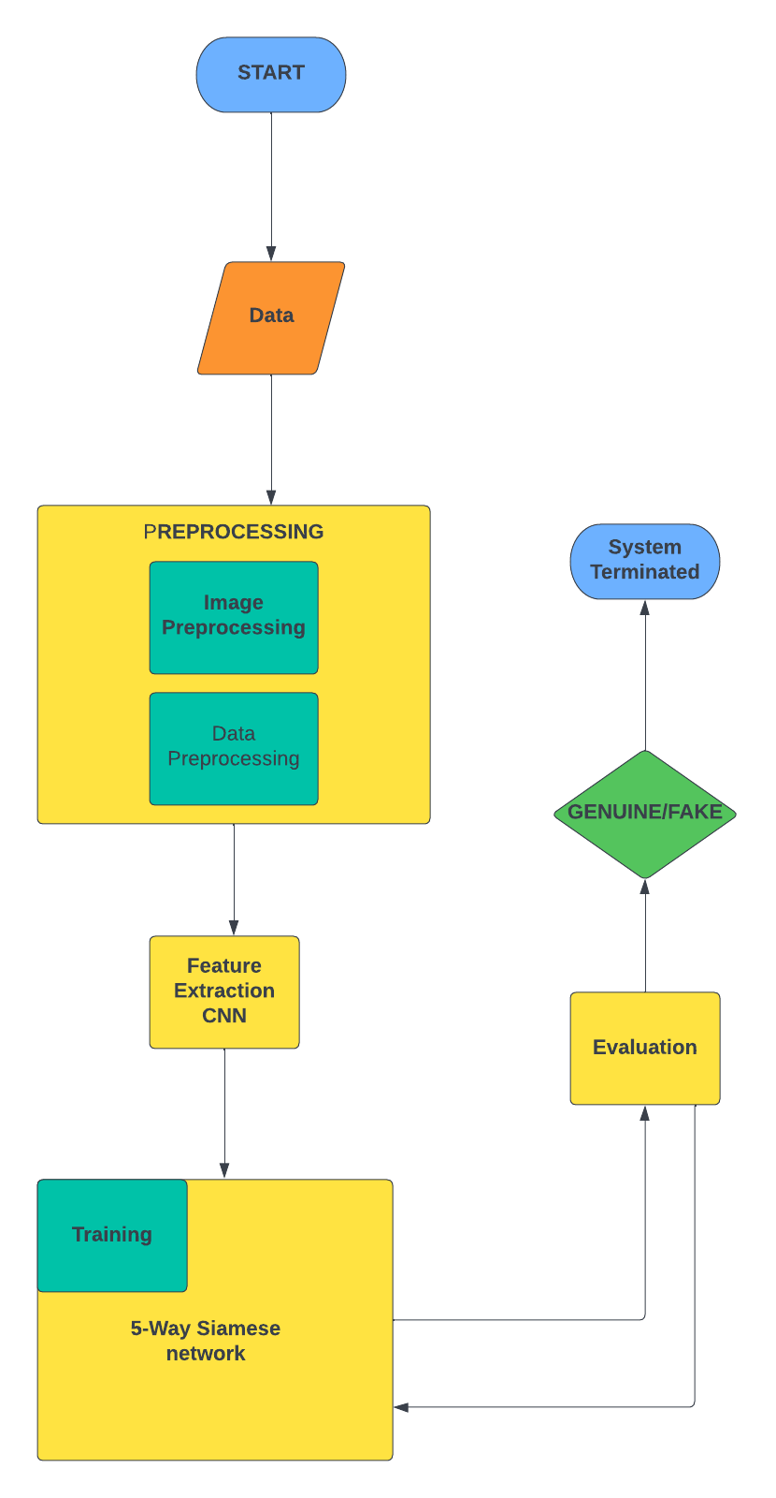

Problem Scope
This model will assist organizations in signature verification using deep learning and image processing techniques. App’s target audience will be banks but other organizations where signature verification is required can also use this app. Signatures can autonomously be identified by the app, this app will able to verify signatures more accurately than human eye because computer can see minute details which human can’t see. SVS will able to verify signatures of any size, color, pen type etc., there are also some limitations and hurdles like thickness of the nib, nib style, security (confidential information can be misused if signatures are wrongly identified), other possible hurdles are also listed below

Challenges
Some of the main Challenges that can be faced while doing this project are
- Algorithm chosen
- As we are using 5 ways Siamese network[9] rather simple CNN or traditional 2way Siamese network so in depth understanding and implementation of the model will be the greatest challenge while doing this project
- Dataset
- Though we are using two standard benchmark datasets i.e., Sigcomp2011[1] and CEDAR[2] to train our model but our project requirement is to identify signature done by any nib type (Thick or Thin), any size, any orientation, angle and color which will also be a big challenge

- Publishing Paper
- Our project requires us to publish a Conference paper along with practical implementation of the project in short period of time where other people are doing only research based projects or developmental projects our project will base on both Research and Development, implementation

- Less Related Work Available
- As already stated, the algorithm we will be using in this project is completely a new and unique algorithm so no related work is available for implementing the model using 5 ways Siamese network[9]. So we will be doing most of the work ourselves which is also a major challenge.

Knowledge Areas Required
Following are the knowledge areas required for this project, some of which we have learned during our degree and some, we will be learning during the course of our project:
- Deep learning (Neural Networks)
Deep learning is the most important knowledge area required to do this project Neural networks like CNN will be used to extract features from the signature image and predict similarity Siamese network is also a type of deep learning algorithm having multiple CNNs so in depth knowledge of deep learning and Neural Networks is required for this project.
- Image Processing
As Signatures will be provided in the form of scanned images to the model so Image Processing plays a vital role in this project for e.g. if there are images of signatures in different colors or resolution first all the signature images will be converted into same format and then further processing will take place. Algorithms like Gray scaling and Morphology will be used so extensive knowledge of Image Processing is also necessary for this project.

- Development Knowledge
Development knowledge is very crucial for this project. Development knowledge can further be divided into two parts i.e.:

- Algorithm Development
We will be using python to implement the logic and for developing the algorithm so a strong hold over python will be required to develop efficient algorithm
- Desktop Application development
The end product of our project will be a Desktop Application so knowledge about app development will also be required for developing the desktop application. We will use python to develop the app

- Probability
Knowledge about probability is important while doing a machine learning or AI based project because most of the algorithms work on the bases of probability

- Linear Algebra
As signatures will be in Image form and Image processing is also required in this project so knowledge about matrices and their operations will also be required

- Software Engineering (Documentation)
  - Knowledge about software engineering will also be required for this project for example which development model to follow, how to make software cost effective and scalable etc. also software engineering information will be required for Documentation

Completeness Criteria
The completeness criteria of our project will be as follow:
- 10% weightage for Desktop Development
- 40% weightage for Algorithm which will further be divided into 3 subcategories
  - 13% weightage for python programming and implementing/understanding libraries
  - 12% weightage for Algorithm development
  - 15% of weightage for understanding the algorithm
- 10% weightage for implementing the whole project and making it a product
- 10% weightage for dataset processing
- 10% of weightage for publishing paper
- 10% of weightage for analyzing related work, research papers and books
- 10% of weightage for staying in contact with advisor and have scheduled meetings

Research Outcomes/Nature of End Product
Following will be the research outcomes of our project:
- N- Way Siamese network implementation and architecture
By the end of this project we will have in depth knowledge of multi way Siamese network and its architecture, also we will get knowledge about the layers in Siamese architecture like distance calculation layer and averaging layer etc.
- Comparison of N- Way Siamese network[9] with tradition models which uses CNN or twin Siamese network
At the end of this project we will compare the results obtained by using 5- way Siamese [9]network and the traditional model which uses simple CNN. Based on the results comparison we will decide the superiority or inferiority of N- way Siamese network over simple CNN model
The end product will be a desktop app having our model implemented in backend which uses N-way Siamese network. For the registration process user will provide 4 genuine signature samples and these samples will be added to database against the user registration id. Now for the verification process user will provide 1 signature image which can either be fake or real and system will give decision based on extracted features

Learning Outcomes
- Familiarization with Python programming
After doing this project we will become familiar to python programming and will have strong hold over python development

- Understanding Deep learning and Machine learning
As this is a deep learning project so after completing this project, we will be able to better understand Deep learning, Neural Networks, how they work and also some other machine learning algorithms and can continue making progress in this field
- Image processing techniques
Along with Deep Learning Image processing is also required to do this project so after doing this project we will have expertise in field of Image processing and its applications
- Understanding N ways Siamese network
We will be using 5 ways Siamese network in this project rather traditional 2-way Siamese network. Our algorithm is a new algorithm which we our self have to implement so after doing this project we will become familiar to this 5 ways network and also will able to develop new algorithms more easily
- Analyzation of past results
Good analytical skills will be developed after doing this project and analyzing related work i.e., work done by others via different techniques will allow us to analyze a paper comprehensively
- Development
Development is also an important aspect of this project as we will be making a user-friendly desktop app in python along with developing our model in python language. Hence after doing this project, we will gain proficiency in App development and Algorithm development
- Rules for writing a research paper
- Familiarization with Python programming
After doing this project we will become familiar to python programming and will have strong hold over python development
- Understanding Deep learning and Machine learning
As this is a deep learning project so after completing this project, we will be able to better understand Deep learning, Neural Networks, how they work and also some other machine learning algorithms and can continue making progress in this field
- Image processing techniques
Along with Deep Learning Image processing is also required to do this project so after doing this project we will have expertise in field of Image processing and its applications
- Understanding 5 ways Siamese network
We will be using 5 ways Siamese network in this project rather traditional 2-way Siamese network. Our algorithm is a new algorithm which we our self have to implement so after doing this project we will become familiar to this 5 ways network and also will able to develop new algorithms more easily
- Analyzation of past results
Good analytical skills will be developed after doing this project and analyzing related work i.e., work done by others via different techniques will allow us to analyze a paper comprehensively
- Development
Development is also an important aspect of this project as we will be making a user-friendly desktop app in python along with developing our model in python language. Hence after doing this project, we will gain proficiency in App development and Algorithm development
- Rules for writing a research paper

Document Conventions
- Referencing style IEEE
- Font Times New Roman
- SVS :: SIGNATURE VERIFICATION SYSTEM
- Headings BOLD
- Size of headings 12
- Size of font 12
- Captions of Images and diagrams= Times new roman italic size 12
- Referencing style IEEE

Background Study and Literature Survey
Six paper were reviewed results and findings are under

- Signet Convolutional Siamese Network for Writer Independent Offline Signature [3]
This Paper is about a writer independent signature verification task with convolutional Siamese network. Siamese network is a twin network with shared weights, training is done by exposing this network to similar and dissimilar observations, minimizing the Euclidian distance between similar pairs and maximizing the Euclidian distance between dissimilar pairs experiments are conducted on signatures in various languages and writing styles. While verifying signatures smallest and critical details need to be seen
Signatures are most commonly used and accepted biometric to identify people, signature verification is of two type online and offline in online SVS special equipment are required but in offline SVS signs are usually captured by scanners or any other imaging device like mobile camera which is a 2Dimensional signature image there can be two scenarios in offline SVS writer dependent and writer independent where writer independent scenario is preferred, for a particular signer signatures are coupled as similar (Genuine, Genuine) and dissimilar (Genuine, Forged) pairs, so signature verification can efficiently be modeled by Siamese network which consist of twin CNN accepting two distinct sign images coming from either similar or dissimilar tuples. Two CNNS are joined by cost function computing distance metric between highest level feature representation on each side of network
Preprocessing
Images of same size are needed for batch training a Neural Network but signature images could have different sizes ranging from 153 X 258 to 819 X 1137, first all images need to be resized to a fixed size which is 155 X 220 in this case after resizing images are inverted using bilinear interpolation so background pixels have 0 values, further images were normalized by dividing the pixel value with standard deviation of the pixel value of image in dataset.
This paper also tells about CNN and its architecture. Deep CNN is a multilayer Neural Network consisting of several Convolutional layers having different kernel sizes interleaved by pooling layers which summarize and down sample the output of its convolutions before feeding to next layer kernel sizes ranging from 11 X 11 to 3 X 3 were used in this project, given a differentiable loss function, weight of different layers are updated using back propagation
Working
The twin CNN have the same configuration with the same parameter and shared weights, parameters updating is mirrored across both subnetworks, these subnetworks are joined by loss function at the top which computes a similarity metric involving Euclidian distance between, feature representation on each side of Siamese network.
Loss
Contrastive loss is a type of loss function used in Siamese network once a high level feature output from both of the constituting CNNs is obtained they are joined with a loss function which is
$$L\left(S1,S2,y\right)=α\left(1-y\right)D^{2} w+βymax{\left(0,m-Dw\right)}^{2}$$
In which L is a function of S1, S2 and y where s1 and s2 are the two samples (signature images) y is a binary indicator denoting whether two samples belong to same class or not α and β are constants and m=1 is margin
$Dw={\left|\left|f\left(s1;w1\right)-f\left(s2;w2\right)\right|\right|}_{2}$ is Euclidian distance computed in the embedded feature space f is an embedding function that maps a signature image to real vector space through CNN and w1, w2 are learned weights for a particular layer, due to the loss function selected this space will have a property that images of same class will be closer to each other than the images of different classes i.e. forgeries or signature of different writers, both branches join together by a layer that computes Euclidian distance between the two points in embedded space in order to decide that two images belong to similar class or dissimilar class then threshold value on distance need to be determined. For convolutional and pooling layers CNN architecture is used the size of the filter is N X H X W where N is number of filter, H is height and W is width
Dataset
4 widely used benchmark datasets were considered including CEDAR, GPDS300, GPDSsynthetic and BHSig290 signature corpus. To evaluate signature verification algorithm. CEDAR contain signatures of 55 signers having 24 signature signed 20 minutes apart so total 1320 genuine signatures and equal number of forged signatures images are available in Gray scale mode in the dataset. Randomly M signatures were selected from K for testing and remaining K-M for testing purpose
Result
A threshold d is used on the distance measured D(Xi, Xj) to decide whether the signature (i, j) belongs to similar or dissimilar class sign pair (i,j) having same identity are denoted by Psimilar and having different identities are denoted by Pdissimilar then set of all the true positives $TP\left(d\right)=\{\left(i,j\right)єPsimilar,with D\left(xi,xj\right)≤d\}$and true negatives
$$TN\left(d\right)=\{\left(i,j\right)єPdissimilar,with D\left(xi,xj\right)>d\}$$
True positive rate $TPR\left(d\right)=\left|TP\left(d\right)\right|/\left|psimilar\right|$ and True negative rate $TNR\left(d\right)=\left|TN\left(d\right)\right|/|Pdissimilar|$
And final accuracy
$$Accuracy=max dєD*\frac{1}{2}(TPR\left(d\right)+TNR(d))$$
100 percent accuracy was achieved when CEDAR dataset was used ,77.76 percent accuracy when GPDS synthetic dataset was used and 63.36 percent accuracy was achieved when GPDS 300 was used

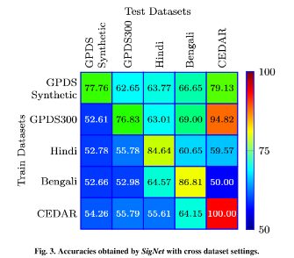

- Offline Signature verification using Convolution Siamese network [4]
This paper presents a method of signature verification using convolutional Siamese network, a deep learning base framework combining feature extraction and metric learning
Introduction:
This system verify person’s identity based on his chosen signature it classifies person’s signature sample genuine or forged. In offline signature verification signature is captured after the completeness of writing process, and represented as digital image, it is similar to other verification problem like face verification or person identification
Working:
Recent work explored different features like contours feature which encode directional property of signatures contours and length of regions enclosed inside letters and curvlet transformation which uses energy of curvlet coefficient computed from whole hand written signature.
In metric learning there are two approaches writer dependent and writer independent. A specialized metric model is learned for each individual, during training phase using person’s genuine or both fake and genuine signatures. Combining feature extraction and metric learning provide better performance. Siamese network is used in this problem, which assess similarity of 2 signature image in pair for offline signature verification and combine the separate modules together i.e. feature extraction and metric learning
System Design/System Working:
In pattern recognition input of Neural Network is sample signature and the output is predicted label, but for signature verification, this style of Neural Network is not suitable so Siamese network is constructed including two sub CNNs which take a pair of sample as input and gives label as output, the input images in the pair are first preprocessed to same size and fed to CNN in Siamese network for feature extraction after that metric method is use to calculate distance of extracted feature.
Dataset:
Two publically available standard benchmark datasets are mentioned in this paper i.e., CEDAR and GPDSsynthetic, CEDAR contain signatures of 55 individual people signed 24 signatures each creating 1320 genuine signatures having equal number of forged signatures. The images in CEDAR are available in grayscale mode, GPDSsynthetic is based on synthetic individual protocol dataset comprises of 4000 signers every individual having 24 genuine and 30 forged signatures making 96000 genuine and 120000 forged signs

Preprocessing:
There are differences between signature images from both datasets, the signature images in both datasets are more skewed so more steps are required to preprocess the signature images in CEDAR compared to GDPSsynthetic for CEDAR images Otsu’s method is used to binarize image which is a threshold selection method from gray level histogram, to clean grain noise connected component analysis is used, Hough transform is used to detect and remove lines which are not part of signature. After preprocessing CEDAR images signature region from images were extracted and it was found that signature images from both datasets have variable size but to train CNN all input needed to be of same size so images were normalized, for CEDAR signatures were centered in canvas of size 1060 X 450 pixels and for GDPSsynthetic signatures were centered in canvas of size 2800 X 1200 pixels then images were resized to fixed size of 224 X 512 pixels
Feature extraction:
Features are extracted by Siamese network containing two identical subnetworks with branches sharing same parameters features were extracted through CNN using automatic feature learning, the first layer in network is convolutional layer with 11 X 11 kernel then there are two parts one part comprises of 5 convolutional layer and 4 maxpooling layer second part make use of low level features, feature map size after first convolutional layer is W X H where w is width and h is height of feature map
Metric learning:
If features extracted from CNN are f1 and f2 now similarity need to be evaluated between these pairs f1 and f2 to measure similarity between feature pair Euclidian and cosine distances are used
$$d^{2}E\left(f1,f2\right)={\left(f1-f2\right)}^{t}(f1-f2)$$
$$dcos\left(f1,f2\right)=(f1*f2)/\left|\left|f1_{2}\right|\right|f2_{2}$$
a hybrid similarity layer combining both Euclidian and cosine distance is formulated
$$f_{hybrid}=[f_{abs},f_{multi}]$$
$$f_{abs}=|f1-f2|$$
$$f_{multi}=f1*f2$$
where abs mean absolute, multi means element wise multiplication a 2d vector [p1, p2] representing predicted probability that 2 signature images belong to same identity or not
Signature verification is considered a binary class classification and use cross entropy loss
$$loss\left(p,\hat{p}\right)=-\left(p\log\left(\hat{p1}\right)+\left(1-p\right)\log\left(\hat{p2}\right)\right)$$
p is target class and p hat is predicted probability if image belong to same signer p1=1, p2=0 else p1=0, p2=1
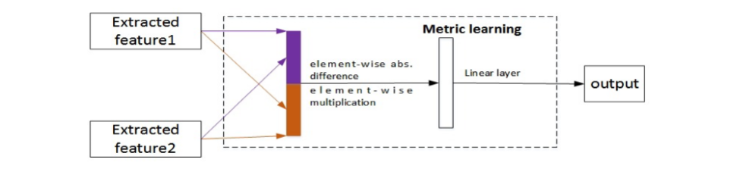

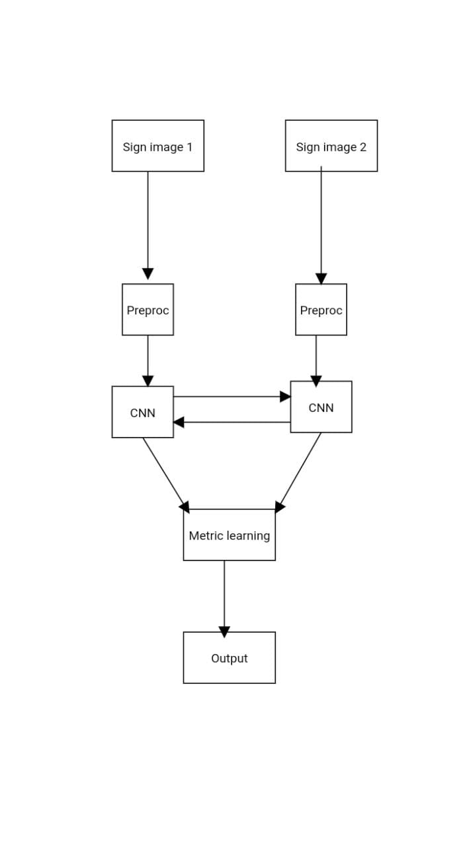
Result:
in GSDPsynthetic there are 24 genuine and 30 forged signers so 276 genuine genuine pairs and 720 genuine forged pairs and totally there are 2000 x 2 x 276 = 1104000 signature pairs for training and testing
in CEDAR there are 1320 genuine and 1320 forged signs of 55 signers 5 signers are randomly selected for testing purpose and rest 50 for training every individual have 24 genuine and 24 forged pairs so total 276 genuine genuine pair and 576 genuine forged pair compared to all algorithms trained on GSDPsynthetic this combined algorithm performed better
EER USING DIFFERENT DISTANCE ALGO

METRIC METHOD | EER
COSINE DISTANCE | 20.46
EUCLIDEAN DISTANCE | 12.30
HYBRID SIMILARITY LEARNING | 10.37
EER RESULT Of sampling GPDSsynthetic

SAMPLING ON TRAIN | SAMPLING ON TEST | EER
NO | NO | 10.65
YES | NO | 10.87
YES | YES | 10.37
Block diagram of Project:

Signature Verification Using a Convolutional Neural Network [6]
- Abstract
This paper discusses techniques for validating written signatures on bank cheque’s. CNN is used in the model for analysis of pixels from the signature image in order to detect abnormalities. CNN will better extract key features and optimize processing time. Multiple layers of receptive fields along with hidden layers will better analyze and extract vital features. The prime use case of this method is to detect and decrease fraud committed, especially in the banking industry. Future uses of signature verification could include legal documents and the justice system.

- How Data is Split & Dataset
SIGCOMP_2011 Dataset is used . 20% Test dataset. 80% as Training dataset with validation of 25%. CNN was designed to split signatures into Dataset. Then Images were categorized into classes based on their origin . The two main categories in dataset are Real Signatures and Forged Signatures.

- Pre-Processing
The check image will be adjusted according to a predefined image size and flattened into a feature vector before using as an input signature. Image Preprocessing is done firstly in order to remove varying backgrounds. Pixel intensity differences are minimized using a kernel. Dataset is labelled as per the signers. Image is preprocessed to fit according to the architecture. This architecture used in this paper accepts 150 x 230 input dimension. Open CV library used for reshaping Image. Image is converted to gray scale. Filter is applied to enhance pixel intensity differences, making edges clearer. Image Centering and Image Boxing are already catered by the dataset.

- Method & Details Regarding Architecture
CNN architecture using the Keras library on Python with a Tensor Flow backend was used. Image comparison system was used based on an image classification system. Each Signature image will be assigned a label with its author name. After providing signature Image to the system, its features will be compared with the features of other signatures that will have similar labels. Computer vision systems will recognize a signature as single entity and then compare the features of the signature, for instance particular edges and spacing, with other signatures having the same label. Then, an image comparison system will provide probability of weather the input signature is valid or not. Multilayered CNN architecture detects precise features with minimal preprocessing. CNNs learn by generating their own filters, and gradually modify those filters to recognize features. This unique characteristic feature allows CNNs to be independent from prior knowledge, work without hand engineered filters. Time and effort for constructing the network is significantly reduced as compared to other neural networks.

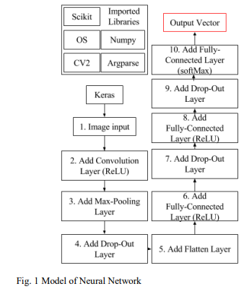

Relevant Libraries are Imported. Image is Input. Image is Flattened to enhance and emphasize prominent image features. Then those features are extracted from Image via multi Layered CNN Model.

NETWORK ARCHITECTURE
Input Layer:
Image will be Input to CNN in the form of Pixel matrix. Each image will have a specific Width and Height in the form of pixels. 3 color channels R (Red) .G (Green) .B(Blue) will be presented in the form of 3-D Python Array. Then the colored Image will be converted to GrayScale. After reading labels Input will be sent to next Layer for further processing.

Convolutional Layer:
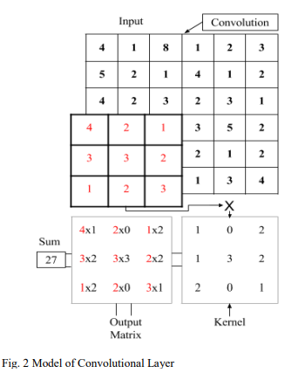
CNN performs a convolution on the input image using several filters to get output images equal to the number of filters applied. Filters are used that are basically grayscale images represented in the form of matrices having pixel values. In this Layer filters / matrix of previous dimensions take each pixel along with surrounding pixel and perform element wise multiplication & sums up the results. The resulting sum is output onto the output image with similar pixel coordinates to the image where kernel was previously present. As surrounding pixels are taken into account the border size of image is decreased which is settled by padding i.e. filling empty border spaces by values that don’t alter the results.

Rectifier Layer:
Rectifier Linear Unit (ReLU) layer performs activation function on the outputs of the CNN Layer.
F(x) = max(0,x) this function is used to convert all negative pixel values to 0 and rest +ve values remain same.

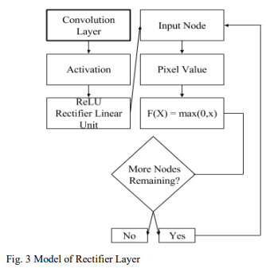

Max pooling layer

An Even Numbered input matrix is equally divided into several non-negative regions of pixels. For instance a 6 x 6 matrix is divided into 4 quadrants of 3 x 3. Now from each of these quadrants a maximum value will be taken and outputted as a smaller new matrix. Now this new matrix will be input of next Layer.
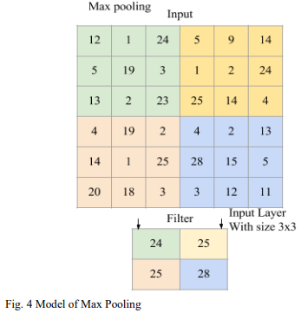

Fully Connected Layer:
The output Image received from Max Pooling Layer get connected to a Fully Connected Layer. Output Nodes are connected to Input layers. Each output Node has a matrix of weights. Node Matrix will be multiplied with weight matrix. Results will be added and placed in the specified output nodes.
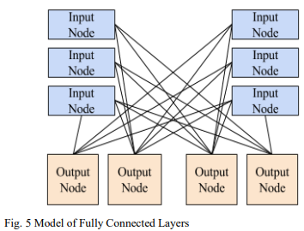

Softmax Function:
Softmax function is used to extract probabilities for each of the classes. Its equation is: $σ(z) j = e^{zj}/ (\sum_{k=1}^{k}{e^{zk}})$
Softmax Function turns a k-dimensional vector of z values to another k-dimensional vector of probability values. This function is used because a it can emphasize higher probabilities and de-emphasize lower probabilities
Categorical Cross-entropy:
Quantifies the quality of the neural network’s predictions, the cross-entropy of the probability distribution of the output vector is compared against the entropy.
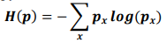

Stochastic Gradient Descent:
This is used to Optimize Neural Network between epochs. A learning rate is specified, and weights are optimized using the following equation

In this equation, 𝝎 is the value of the weight, 𝝁 is the learning rate as a decimal, and 𝑸(𝝎) is an approximation of the gradient.

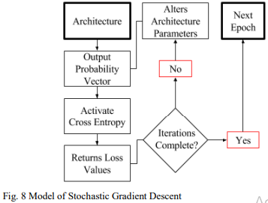

Results
83% Accuracy.

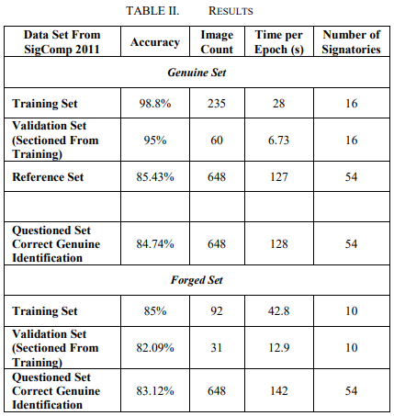

SIGNATURE VERIFICATION USING SIAMESE NETWORK BASED ON ONE-SHOT LEARNING [5]
- Abstract
Signature Verification is a biometric verification type & plays vital role in banking sector, judicial and administrative applications. Signature Verification is of two types, Online & Offline used for identifying signature forgery. Online signature verification is carried out during signing and temporal dynamic data are available regarding the person's signature. Offline verification is applied by scanning the image after signing, and this verification is limited to spatial data. Therefore, the offline signature verification process is considered a more challenging task. This study discusses offline signature verification, independent of the writer, based on One-Shot Learning using Siamese Neural Network. Successful classification by using less numbers of signature images has been achieved using this method. The proposed approach achieved percentage accuracy of 93.23, 90.11, 89.99, 92.35 verification in 4NSigComp2012, SigComp2011, 4NSigComp2010 and BHsig260 respectively

- How Data is Split
4 different Datasets were used in the proposed study.

- Pre-Processing

- Method & Details Regarding Architecture
Signature verification is divided into online and offline signature verification. In offline signature verification, verification is performed by comparing an existing signature with reference signatures previously obtained from the relevant person. At this point, the document, on which the person has put the signature at that moment, is first scanned and converted into image format, then the signature is defined and verified from within this document. Two approaches are used for offline signing. These are writer-dependent and writer-independent approaches. In the writer-dependent approach, a separate model is created for each author, whereas in the writer-independent approach, it is used by creating a single model for all authors. In online signature verification, the signature is put on a tablet or monitor; therefore, features such as pen pressure and pen slope angle can also be analyzed. Therefore, in online signature verification, first of all, individuals' signatures are recorded in the system at the registration stage, with data preprocessing and feature extraction methods. Afterwards, when the user puts the signature again, the same attributes are extracted and compared with the reference signature features. If the difference is below a specified threshold value, it is accepted, otherwise it is rejected.
3 Layered CNN architecture was used. First Layer is convolutional layer, in which a kernel (or filter) of the weights is convoluted so as to extract the features. The second one is the nonlinear layer, which applies an enable function to the feature maps, thereby enabling the network to model nonlinear functions. And the third one is the pooling layer, which reduces spatial resolution by replacing neighborhoods in a feature map with some statistical information about these neighborhoods (average, max, etc.). After this the input data is matched to a 1-dimensional feature vector.
Siamese Network having 2 identical subnets is also used. The twin CNN’s have equal configuration, they share same parameters & weights combined with a distance metric. Parameter updation is reflected in both subnets. In this architecture , one of the twin networks takes a real signature image as input and the other one takes a signature image that is requested to be verified by the model as input. Afterwards, each twin network does a feature extraction based on the given input. Finally, the difference (similarity-difference) of the features extracted by each of the twin networks is found by calculating the distance metric with the loss function applied in the last output layer. Equation for calculating similarity :

S1, S2 = Input Signature Images
y = binary indicator function that indicates whether two examples belong to the same class or not
α = constant
β = constant
m = numerator

= Euclidean Distance
f = embedding function that matches a signature image with a real vector space through CNN
w1 , w2 = learned weights for a particular CNN layer
In Siamese Network feature vectors belonging to same class are closer to each other while feature vectors of images belonging to different class are far. At last a threshold value is determined in the calculated distance metric and comparing to it , decision of image belonging to a class is made.
One Shot Learning:
This method is supported by Siamese Network. In One-Shot learning, learning is done from a single input image and a single target image.One Shot Learning obtains information about classes with one or more images from each object category.
Model Creation:
Firstly, a neural network that can distinguish the class identities of image pairs is trained. This step constitutes the image validation step. The validation model learns the probability that the input pairs belong to the same class or to different classes. Afterwards, it is subjected to one-shot classification by using the network that is successful in the verification process. In the one-shot phase, an image pair is created with the test image and the image belonging to the new class and evaluated by the previously learned model, and it is decided whether the image is a real-fake signature

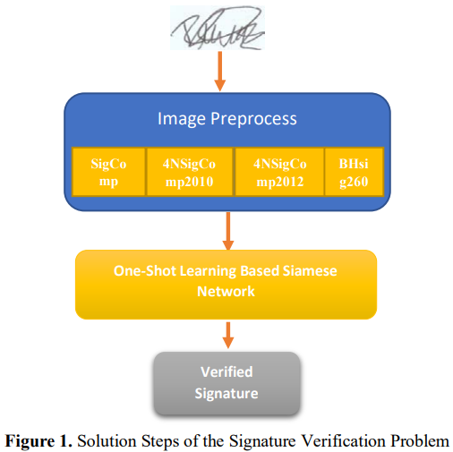

In this Network Architecture image vectors were learned with a supervised metric-based approach, and then the features of this network were re-used with on-shot learning without the need for retraining
Pre-processing :
Bounding-Box method to clip excess background image was applied. To standardize Image size sizing process was performed. Binary thresholding was applied to convert signature Image to binary. Then Images were inverted so that the pixel values of background become 0. Normalization process was performed to achieve standard deviation of pixel values. This pre-processing step was applied for both test and training images

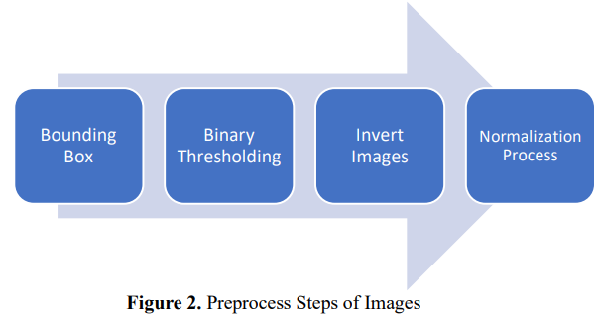

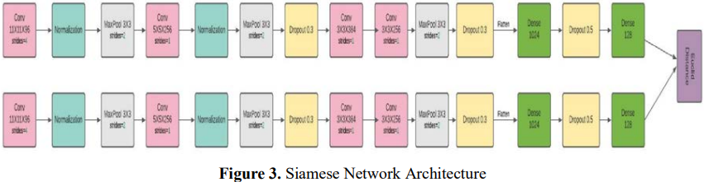

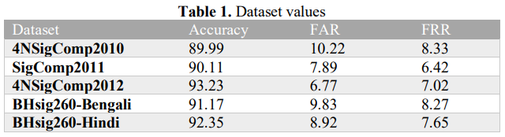
- Machine Learning-based Offline Signature Verification Systems: A Systematic Review [8]
Abstract:
The offline signatures are the most realistic authentication technique in banking systems. The machine learning based model OFSV systems using five aspects like database, preprocessing techniques, feature extraction methods, machine learning based verification model and performance evaluation metrics. These articles were published between January 2014 and October 2019. This review revelated that deep learning neural network achieved the most favorable results for the public datasets and OSFV performances in those selected datasets are (CEDAR, GPDS, MCYT-75,UTSig and BHSig260).

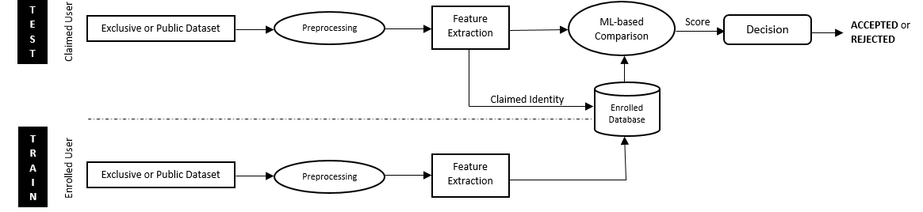

Research Methodology:
In this research methodology, the systematic review is two-phased; the review planning and the review conduction. The review planning phase describes the need for this evaluation, the specification of studies questions, and relevant journal identification and the review conduction phase includes research identification and primary study selection, and data synthesis and extraction.
Phase 1: Review Planning:
This phase covers the identification of the need to review and determine the research questions.
Need for a Review Identification:
To identify the ML-based OfSV systems using five aspects mentioned in Fig.1 to find the answers of the researched questions.

Relevant Journal Databases Identification:
In this research paper, the selected journal databases (ACM, Web of Science, IEEE, ScienceDirect, SpringerLink, and Scopus), which are covering the majority of journals and conference papers published in the world of computer science.
Phase 2: Review Conduction:
The current ML-based OfSV systems published in the English language. Therefore, summarizing the adopted offline datasets like current image preprocessing techniques, feature extraction methods.
Identification and Selection of Primary Studies:
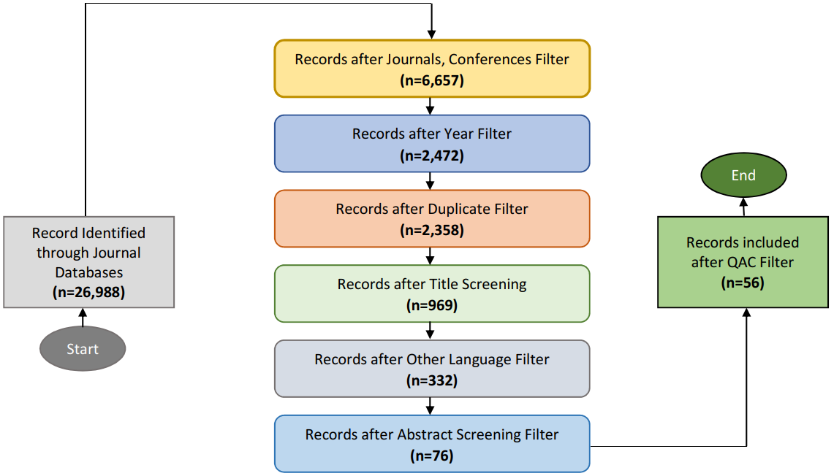

RQ1 Which datasets are adopted for existing ML-based OfSV systems?
Exclusive datasets and public datasets are adopted for existing ML-based OFSV systems. 6.98% of research favored generating the signature dataset themselves via adopting proper strategies. They requested unique signatories to place their signatures on the paper so they manually discarded those signatures, which were overlapping the distance available for any other signature. After that, the papers carrying the set of various genuine and forged signatures were scanned using different predefined dots per inch (dpi) resolution scanners. By scanning these papers, it would permit extracting greater figures and information from the offline signature, which became very beneficial for the photograph processing section of any ml-based totally OFSV machine.

Exclusive datasets used in 56 selected studies.
Table 6:
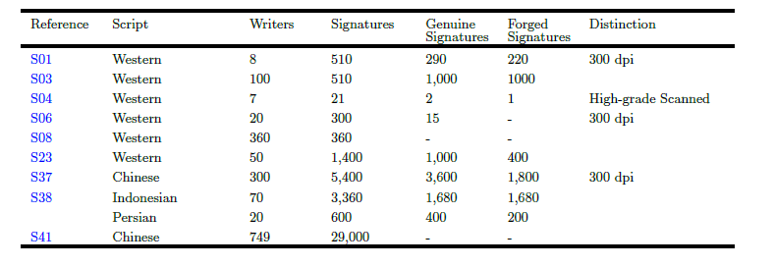

Public datasets, used in 56 selected studies.

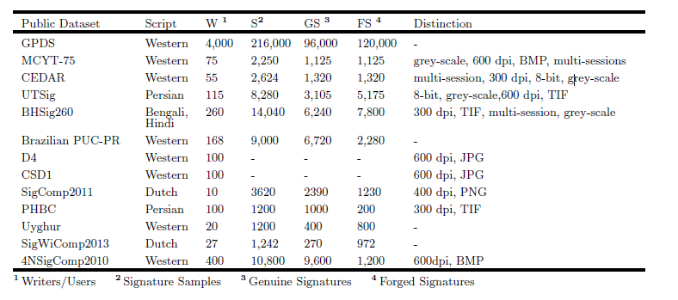

RQ2 Which preprocessing techniques are applied to curtail inconsistencies in offline signature images?
The preprocessing technique is to enhance the signature image quality and to cut out the inconsistencies in the signature image. The tasks involve in OFSV are binarization, thinning, noise removal, bounding box, segmentation, inversion and normalization activities.
Otsu was the most often used algorithm, which separates the offline signature image's pixels into foreground and background classes using a single intensity threshold (Otsu, 1979).

Year-wise distribution of various preprocessing techniques

RQ3 What type of feature extraction methods are used in existing ML-based OfSV systems?
While using the feature extraction method, it’s basically a procedure to convert the raw pixels of an offline signature image into a feature vector by creating new features from the existing ones. So, the feature extraction process can be performed manually or automatically. In manual feature extraction methods, appropriate domain knowledge is required to extract features from the signature image. Whereas, automatic feature extraction methods can extract features while training the model.

Fig. 6: Year-wise distribution of various feature extraction methods

In figure 6 it shows the distribution of various that 5 out of 56 studies adopted geometric methods for feature extraction.

Advantages and limitations of various feature extraction methods used in selected 56 studies.
These are types of feature extraction methods used in existing ML-based OFSV

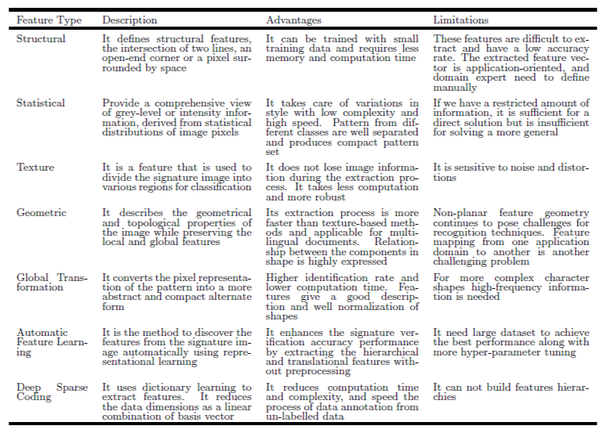

RQ4 What type of ML-based verification models are developed for OfSV systems?
• Template Matching Model:
In this process, it needs to find the signature object in the offline signature image by matching a pre-stored sub-image, containing the signature to be matched. This process works pixel by pixel to identify the matching of a template image with the main offline signature image then the template is placed at every possible pixel of the main image to those pixels, which are giving maximum match. To measure the similarity between the main image and the template image several techniques are being used that are given below:

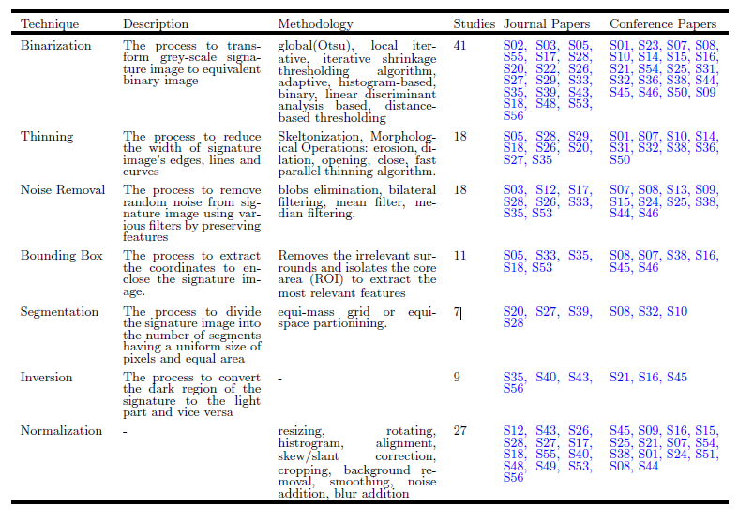

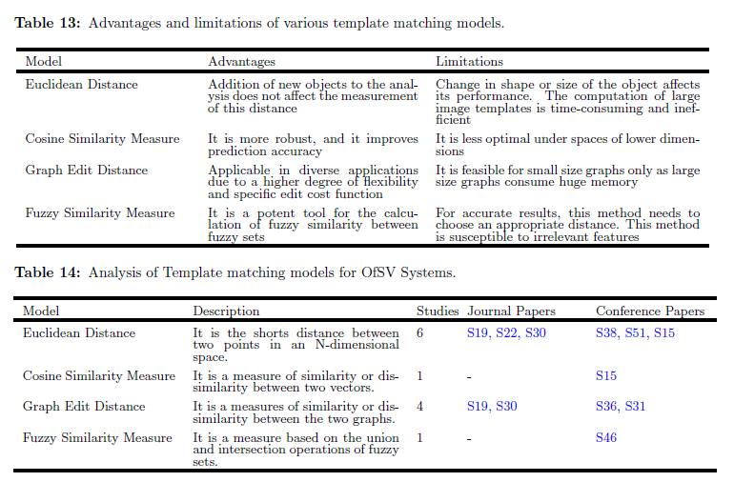

Here we discuss some models called Traditional Based models discussed given below.
• Statistical Model:
This model is being used to analyze and understand the data to make predictions. In OfSV systems, the average signature template is obtained by calculating the already collected template sub-images of the signature. Therefore, when, there is an addition of a new signature for verification purposes to the OfSV system, then these input signature images are compared with the average signature template to find out the minor or major difference using this concept.
• Structural Model:
This model is based on the related system of the low-level features into higher-level structures, and then these structures are compared with pre-stored images in the datasets to differentiate between the original and fake images. These models have shown excellent performance in verifying genuine offline signatures and forged offline signatures. Issues that are currently highlighted are that it uses a large dataset for better accuracy.
• Neural Network-based Models:
They are extensively adopted for their power, learning, ease of use and observing capabilities. The NNs models extract feature automatically and train their models in their own perspective.
• Shallow Neural Networks:
The single hidden layer in NN’s called shallow neural network (SNN). ANN is an advanced learning system that contains many simple components, called neurons or perceptrons or hidden units or nodes. PNN is a four-layered, feedforward neural network consisting of input, hidden, pattern/summation, and output layers. It uses a kernel function to approximate the probability density function.
• Deep Neural Networks:
Deep neural networks (DNN) are multi-layer feedforward neural networks consisting of two or more hidden layers between the layers of input and output. This actually has to be appropriately configured and educate to get the desired performance and the performance of the dnn’s can be authentic due to the growing rate of the hidden layers.

RQ5 Which performance evaluation metrics are employed for the appraisal of existing ML-based OfSV systems?
In the offline signature image, after implementing the process training, the test signatures are then fed to the trained ML-based model to evaluate its performance. This research paper, it will evaluate the process through standard performance evaluation metrics.

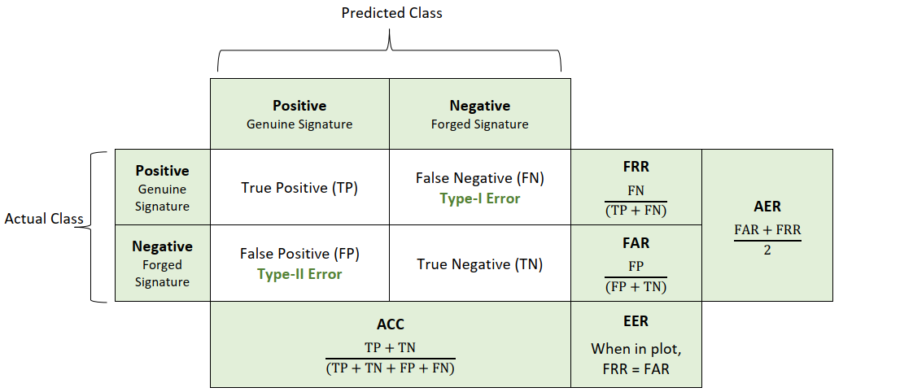

Table 21: Analysis of performance evaluation metrics

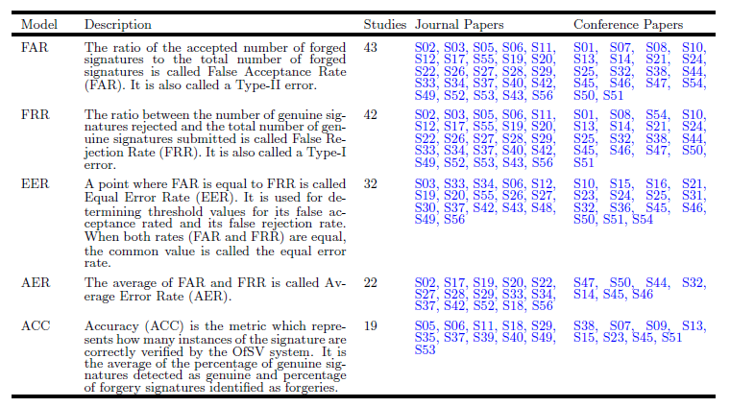

This research paper analyzed the major research in recent offline signature verification systems to help new researchers in this domain. The OFSV articles from 2014 – 2019 were reviewed. It indicates that a systemic approach has been adopted for 56 articles.
The first research question of this SLR is to identify datasets that are being adopted for existing ML-based OFSV system. It identified datasets with their scripts, number of writers, number of signatures, number of genuine signatures, number of forged signatures, image scanning resolution
In 2nd research question, multiple algorithms can be used in binarization preprocessing, but more than half of the researchers have used the Otsu algorithm because of its fast working and enlightening the images with bi-modal histograms, then OFSV systems have achieved better performances by adopting binarization along with other preprocessing techniques

In 3rd research question, DL-based automatic feature extraction methods, take less human efforts. Moreover, these strategies can study the characteristics of raw image with little preprocessing. This shows the great results of DL-based automatic feature learning methods over the manual features for OFSV.
In 4th research question, it was revealed that researchers had shown full-size range in the choice in their ml-primarily based models (template matching models, traditional machine learning-based models, deep learning-based models and structural models) for classification task in their OfSV systems.
In 5th research question, according to the observations of the researchers, the future of ML-based OfSV systems is promising, and the use of DNN may be the key to overcome many of the issues mentioned in this SLR. Between these issues, we highlight motivation in getting researchers to interest in this field.

- Offline Signature Verification with Convolutional Neural Networks [7]
Abstract:
Signature verification is an important technique to find whether the signature is fake or genuine. The project aims to mechanize signature verification using CNN. The version is based on the VGG16 architecture, and it uses the ICDAR 2011 sigComp dataset to instruct the version. When classifying a given signature is forgery or not, it gains accuracies of 97% for Dutch signatures.
Related Work:
Task within the signature verification system:
The University of Hongkong hosted the first international signature verification competition but it was for online signatures. But this event paved the way for both online and offline SVFS. The forgery exposure of the task is determined by what kinds of signatures the model is trained on. Some authors train on forgeries and genuine signatures, but test on different forgeries and genuine signatures during testing; some authors do not use forgeries at all during training. Then, how the training test should be used to accomplish each task? Well, it will develop both writer-dependent and writer-independent models in the report. The writer-dependence distinction is that the model has a different classifier for each identity or a single classifier for all identities. Writer-dependent models use a different classifier for each user.
• Competing Models:
In 2012, Khalajzadeh used CNNs for Persian signature verification, which is the only report of CNNs being used in the offline signature verification literature. Unfortunately, the paper includes truly little information about their methodology. So, they assume that their model is trained on forgeries and genuine signatures for all IDs.

Methods:
• Convolutional Neural Networks(CNN):
CNN have confirmed a success in latest years at a huge variety of picture processing-based machine learning tasks. A cnn consists of a number of layers, starting at the raw image pixels, which each carry out an easy computation and feed the end result to the subsequent layer.
• VGG Architecture:
In this research paper, it used the VGG-16 CNN architecture. This network contains a total of 16 layers with learnable parameters. These layers are of the following types: Fully Connected layers every output depends on every input according to the weight matrixW, a learnable parameter. Outputs also depend on a bias term b which is learnable but doesn’t depend on the inputs.
f(X) = WX + b
W 2 Rnxh; b 2 Rh
ReLU Nonlinearity: ReLU layers do not have any learnable parameters. Their computation is very simple, saving time during training. ReLU neurons also do not become saturated at high input values, meaning their gradient does not vanish to zero when receiving such values.
Softmax Nonlinearity: It appears in the final layer of the neural network and computes final class scores that will be fed into the loss function or outputted during testing. It has no learnable parameters.
Convolutional Layers: Convolutional layers lend themselves naturally to understanding of images, in which the program often wants to extract features by looking at small areas of an image, where it doesn’t care exactly where in the image the feature is.
Max Pooling Layers: Max pooling layers reduce the size of an image by combining 2x2 regions of the input into a single output value. For each 2x2 region of input, the output value is simply the max value of those 4 input pixels.
Dropout layers: A dropout layer takes in a number of inputs and for each input, sets it to 0 with probability p and leaves it unchanged with (1-p) . It behaves deterministically and multiplies all input values by (1-p).

• Transfer learning:
VGG-16 is a large neural network with a huge number of learning parameters. Thus, it requires a large dataset to train a network. Though, it can leverage the similarities between diff image datasets. The low-level features learned by the first few layers of a network will be same. This means that it can initialize the neural network with parameter values learned from a different dataset and expect that the values for the first layers of the network will work well without having to be trained.
• Comparing Networks:
For image patch comparison the model will be used of the siamese and 2-channel network. In the 2-channel network, two images are stacked each image serves as a channel as an input to a convolutional network. The CNN then leads to a fully connected linear decision layer with 1 output that indicates the similarity of the two patches.

Datasets and Features:
• Dataset:
(ICDAR) 2011 Sig-Comp international signature verification competition. The dataset includes both online and offline signatures for both Chinese and Dutch signers. It splits into training sets or testing sets. The Dutch training set includes a total of 366 images for 10 IDS, with about 25 genuine signatures and 11 forged signatures for each ID.
Results:
• Evaluation Metrics:
By evaluating the research dataset, whether a given signature is fake or real. It will evaluate the performance using three metrics: classification accuracy, False Acceptance Rate, and False Rejection Rate.
• Main Task:
In this research paper, the first task was to train a CNN to recognize whether individual signatures are forged or genuine then it will label all data points in SIGCOMP 2011 Dataset as either genuine or forged, then it will train one network on signatures from all identities together. For each language, all the data for that language is split into training, validation, and test data consisting of new copies of signatures of the same people whose signatures are in the training set.
• Parameter Updates:
In this research paper, the most trouble finding the parameters that got Adams. Adam is often recommended as an update rule instead of simpler methods, but it was unable to get Adam to achieve the same accuracies as RMSprop or Nesterovrov. Then the final choice of update algorithm was Nesterov Momentum, which performed similarly to the other best algorithms in terms of accuracy and it was attractive because of its simplicity.
• Hyperparameter choice for Main Task:
This research-based paper uses hyperparameter, a coarse-to-best search technique and selecting values that produced quality accuracy. It used a learning rate of 1e-4 to conduct a few pieces of training but did not see any accomplishments. The value that was coded into VGG-16 architecture of dropout value is 0.5. So finally, it decided to let only the fully connected layers at the end of the network training.
• Unseen Identities Experiment:
In this research paper, the data is split into training test and validation sets containing 80% and 10% of the data. The validation and test data consists of signatures and forgeries by new people. Because of the class skew of the Dutch dataset, a genuine signature would achieve an accuracy of 67% (with an FAR of 100% and FRR of 0%). The actual performance is somewhat better than this, and the mistakes are more evenly spread out between both types of misclassifications.
• Writer-Dependent Comparison Task:
In this research methodology, they adapted the 2- channel network and train network on (genuine, genuine) pairs and (genuine, forged) pairs for all ID’S in the training set. The network should learn to tell when two signatures are diff or the same. There are 10 genuine signatures and 25 genuine and forged signatures. When testing, it sends every questioned signature into the network paired with each genuine signature. Well, this experiment contains some errors but it gives room for hope in future experiments.
Conclusion:
In this research paper, experiment with several variations on signature verification tasks. CNN did an excellent job of verifying the signatures of the same people that are either forged or genuine. A novel architecture model is used. The Writer Dependent Comparison Task also appears to be a promising direction for the future. This task is attractive because it mirrors the situation of a real-world application of signature verification. Although that was unable to achieve high results on this task, the literature on signature verification indicates that this method is promising. Having access to more datasets would likely achieve stronger results. In the end, it will allow training of the model on larger datasets and more layers of training.

Overall Description

Proposed Solution
First Data will be acquired and preprocessed, We will be using 2 standard benchmark datasets namely ICDAR SIGCOMP 2011 and CEDAR, our primary focus will be on sigcomp 2011 dataset as it is a large dataset so training our model on this dataset will provide better results, whereas data in CEDAR dataset is more neatly organized and also images are available in grayscale mode which will make the process easy so cedar can also be used if accuracy of model is to be tested, SIGCOMP dataset contains original signatures of several people and for every original signature of a person there is a forged signature available in dataset some signature images are attached for reference. The preprocessing phase will comprise of two phases namely Image Preprocessing and Data Preprocessing in image preprocessing images will be converted to grayscale mode and will scaled to a fixed size using image processing techniques so that if there is any variation like color and size in test and train signature image can be eliminated using gray scaling and resizing, whereas in data preprocessing our data (Images in this case) will be split into testing and training parts also forged images and real images will be separated and finally data will be arranged according to our requirement i.e 4 genuine signature images against each test image, also we will arrange data in the form where 1 genuine signature will be compared with 1 test signatures, because results will be compared by the end of this project. After preprocessing data will be sent to CNN (Convolutional Neural Network) model for feature extraction and after that, model will get trained on the dataset using 5-way Siamese network.4 genuine and 1 test signature image will be provided to the model. Once the training phase is over, then comes the evaluation phase. Based on feature comparison between 4 real and 1 test signature image. Consequently, an output resulting in either the signature being real or fake will be provided
A user friendly Desktop app will provide interface to the model where people or the organization using the software will able to register people along with their 4 genuine scanned signatures and will be able to upload a test image to app which will tell either this image is original or fake.
Once the model is completed using 5 way Siamese network results will be compared to traditional model which compare 1 test image with 1 train image based on the extracted features
Genuine Signatures
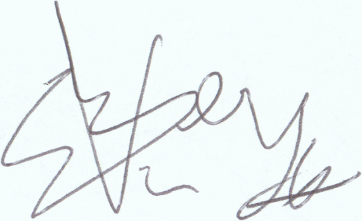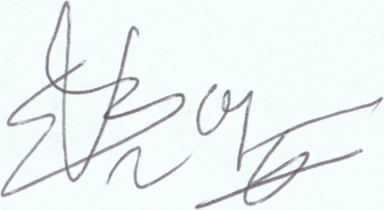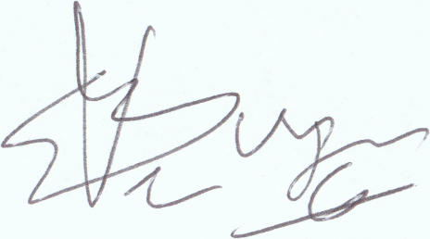
Forged signatures
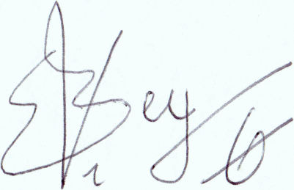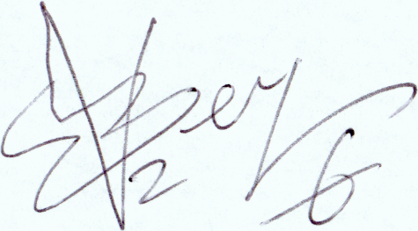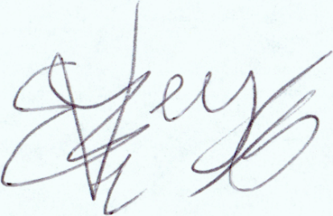
Signature images from SIGCOMP 2011 dataset

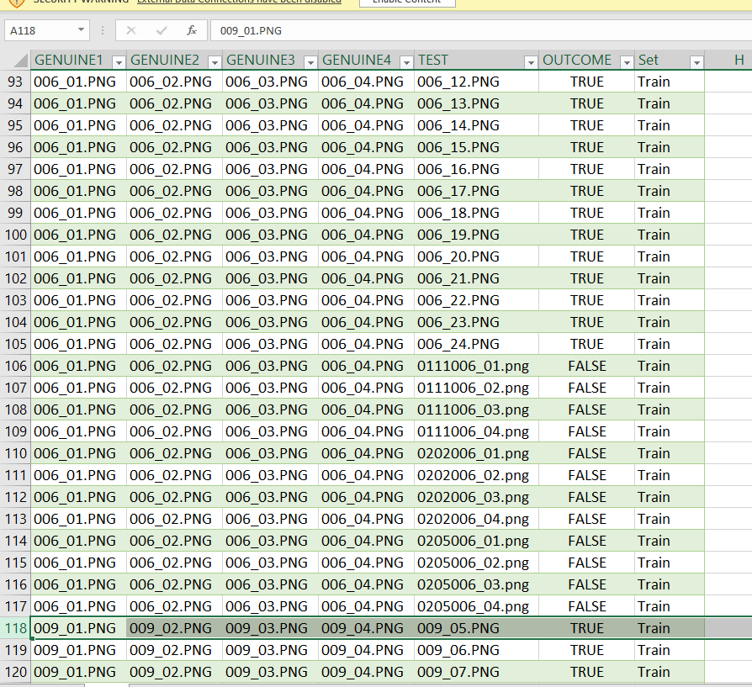
Arrangement of data present in Sigcomp 2011

In this arrangement of dataset we have total 1382 records/rows where in each row there is 4 genuine signature images and 1 test image which can either be original or fake then there is outcome column entry for every row also an entry is present for train and test label of dataset this makes total of 1382 rows and 7 columns of data arranged in excel. There are total 965 train and 415 test records available 631 true and 749 false labeled entries 463 entries are train and true 502 train false entries 168 test true and 147 test false entries available
Block diagram of proposed Solution

User Classes and Characteristics (if applicable)
Users can be classified mainly into two classes which are

ADMIN:
Admin will be the authoritative person
Admin will be able to add a user along with its 4 Signature images
Admin will be able to delete a person’s record
Admin will have rights to add or change policy regarding security issue
CLIENT:
A user or Client will be the customer of Bank
User will have database of their signatures
User will able to see either their Signatures matches or not

Operating Environment
Offline SVS will mostly be used by Banks, other Organizations can also use SVS but the targeted customers will be Banks. The Desktop app will have a good user friendly interface which a layman can also use no special hardware or software will be required to use SVS, just a good PC along with operating system like Windows will be required to use this product

Design and Implementation Constraints
Dataset is most important in this project, Dataset can prove to be a hurdle in this project as the images are available in same format and size in the dataset, though we are using two standard datasets in this project i.e., SIGCOMP 2011 [1] and CEDAR [2] to train our model but our project requirement is to identify signature done by any nib type (Thick or Thin), any size, any orientation, angle and color which can be a hurdle while doing this project. One more constraint is time as Our project requires us to publish a Conference paper along with practical implementation of the project in short period of time where other people are doing only research based projects or developmental projects our project will base on both Research and Development, implementation

Assumptions and Dependencies
In this project we will be developing Algorithm as well as desktop app for algorithm development I.e., N-way Siamese network CNN model will be used to make the architecture of our system and programming language will be python. Also for desktop app python programming Language will be used so we can use any built in library from python while developing Algorithm or App for example we can use numpy and pandas library for calculations and processing on data similarly we can use opencv library for image preprocessing

Functional Requirements
Following are the Use Case diagrams

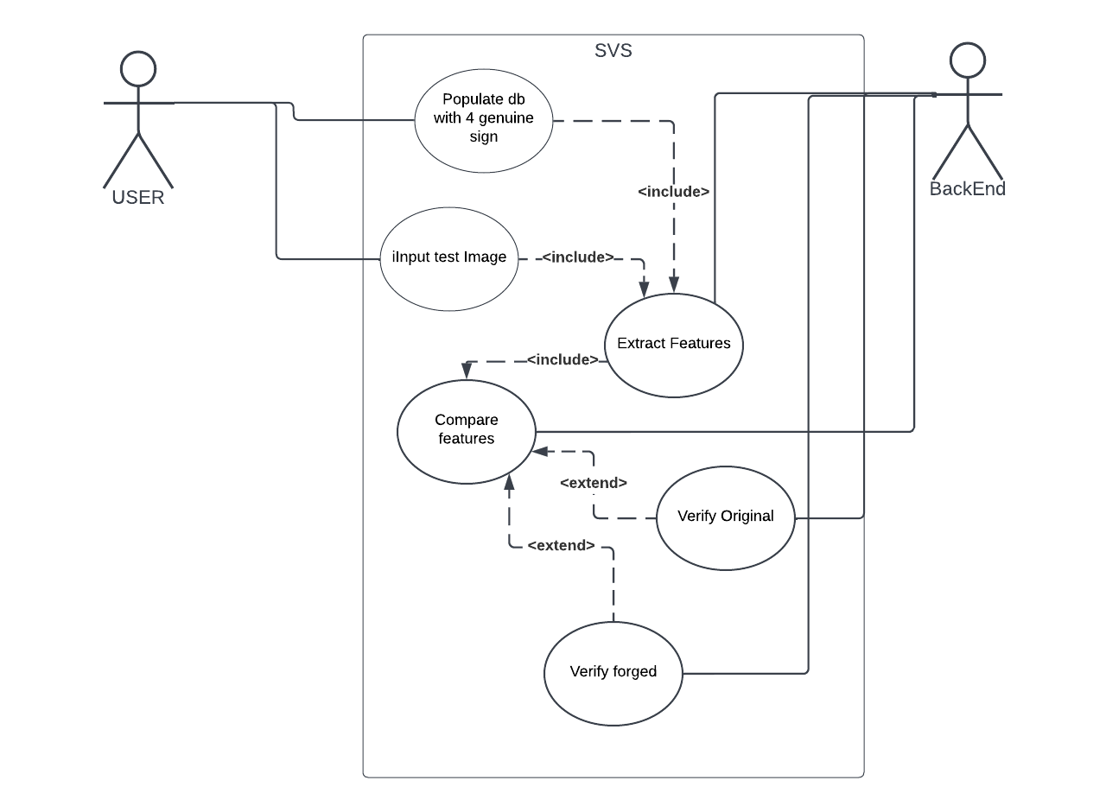

Requirement 1 OR Use-Case 1 (if requirements are modeled as use cases)
Identifier |  | SVS
Purpose |  | Signature Verification
Priority |  | High
Pre-conditions |  | Database should have signatures of people
Post-conditions |  | Signatures will be authenticated based on extracted features
Typical Course of Action
S# | Actor Action |  | System Response
1 | User upload 4 sign Images |  | Extract feature and do training
2 | User upload 1 test image |  | Extract feature
3 | Backend compare feature |  | Signatures verified person is real
…
Alternate Course of Action
S# | Actor Action |  | System Response
1 | User upload 4 sign Images |  | Extract features and do training
2 | User upload 1 test image |  | Extract features
3 | Backend Compare features |  | Signatures are fake person is not real
…
Table 1: SVS Model

Requirement 2 OR Use-Case 2
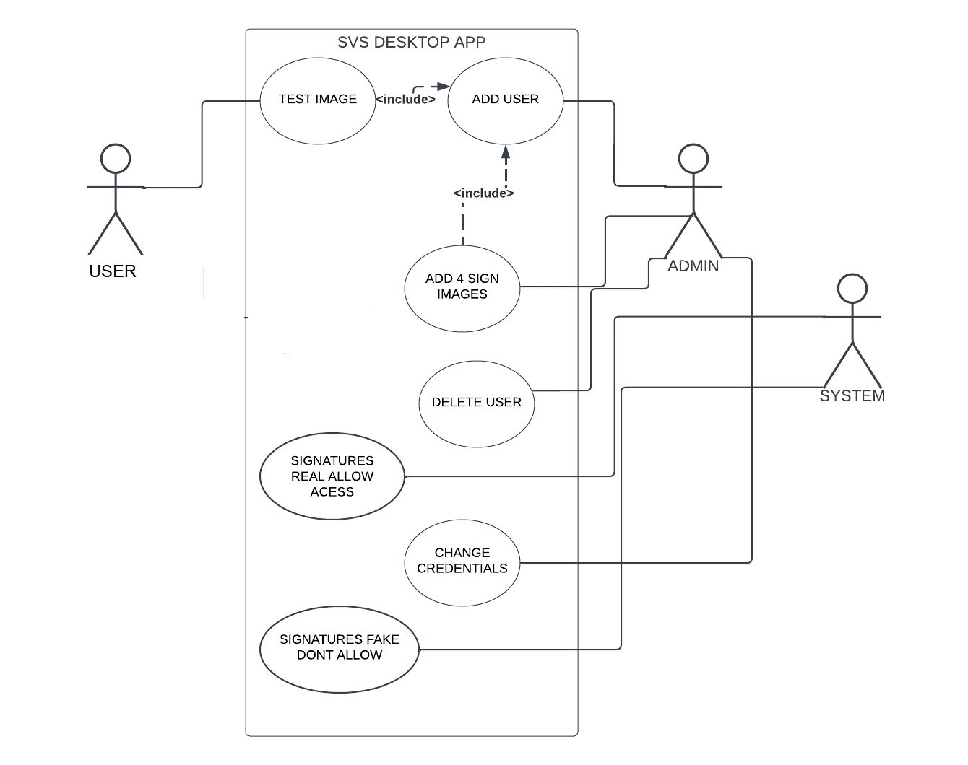

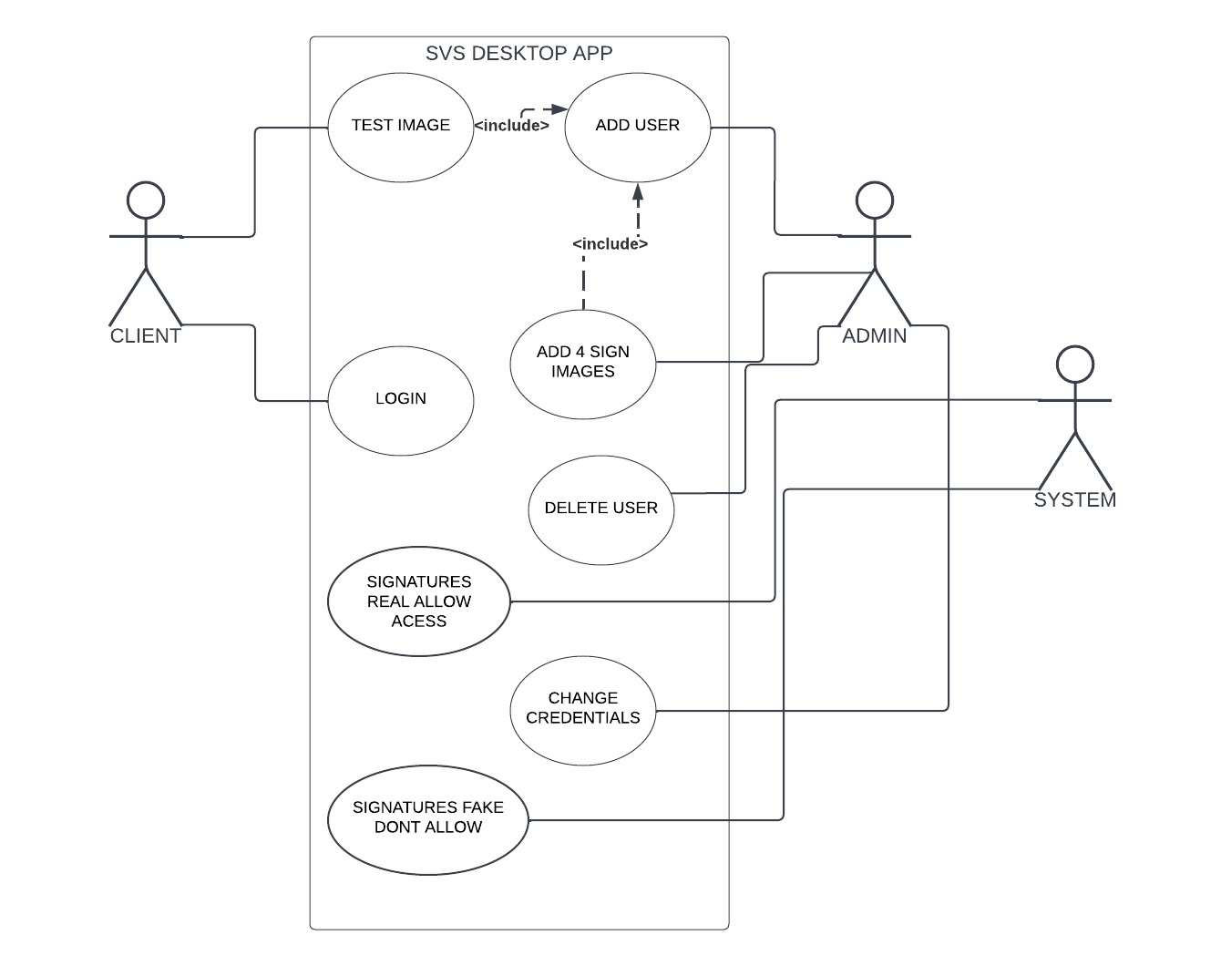

Identifier |  | Desktop App
Purpose |  | User Authentication sign verification
Priority |  | medium
Pre-conditions |  | Model must be implemented in backend
Post-conditions |  | Access to user bank account will be granted based on verified signatures
Typical Course of Action
S# | Actor Action |  | System Response
1 | Admin add user with 4 sign images |  | Populate database with signature against person
2 | User upload test sign image |  | Verify test image accurately
3 | Image matched |  | Grant access to account
Alternate Course of Action
S# | Actor Action |  | System Response
1 | Admin add user with 4 sign images |  | Populate database with signature against person
2 | User upload test sign image |  | Verify test image accurately
3 | Image not matched |  | Deny access to account
SVS DESKTOP APP

Proposed Workflow
The workflow of project is as under
In first phase of our project we reviewed related work, related papers after that we analyzed dataset and have done dataset preprocessing, arranged data according to requirement, then we understand existing algorithms, in 2nd phase of project we will implement and test existing algorithms and will understand 5 way Siamese network in 3rd phase we will implement algorithm and will train and test the model finally in 4th phase of the project we will make a desktop app and our model will be compared with traditional models at last research paper will be published
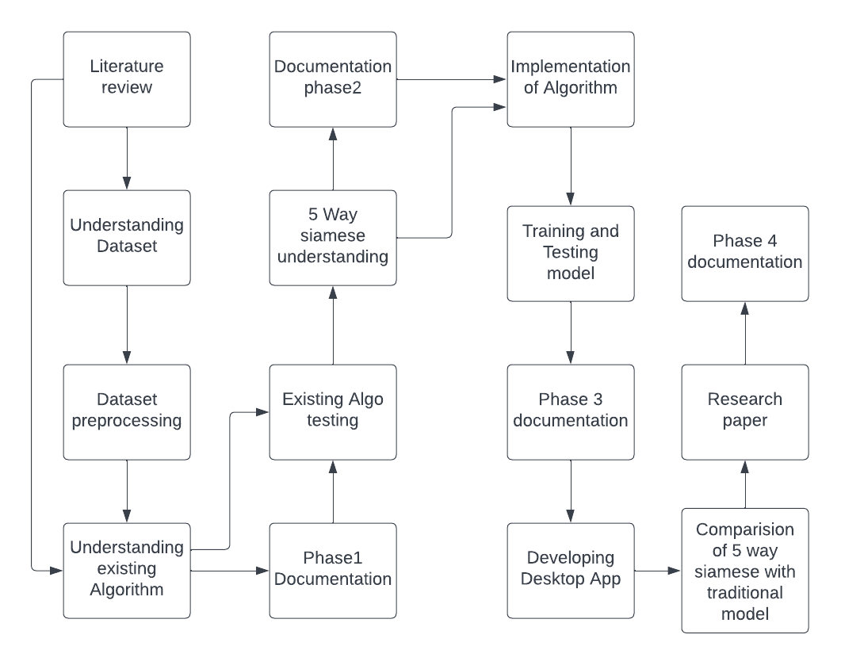
Block diagram of Workflow

Analysis and Modeling of Requirements
All relevant diagrams are:
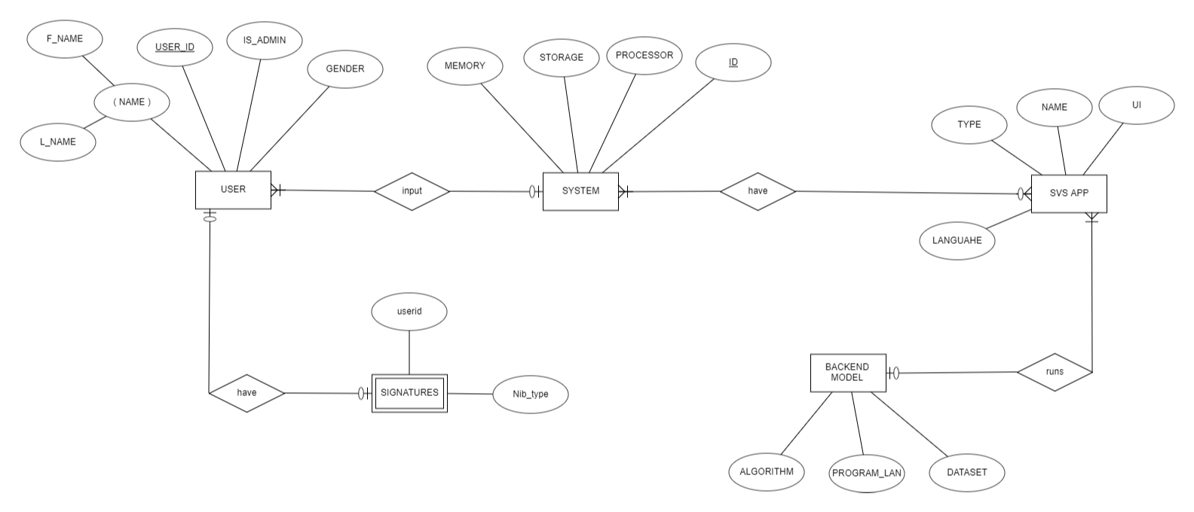

ER Diagram of the system

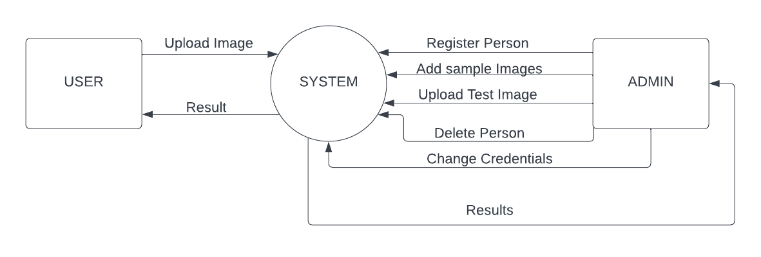
Context/Level0 DFD of the System
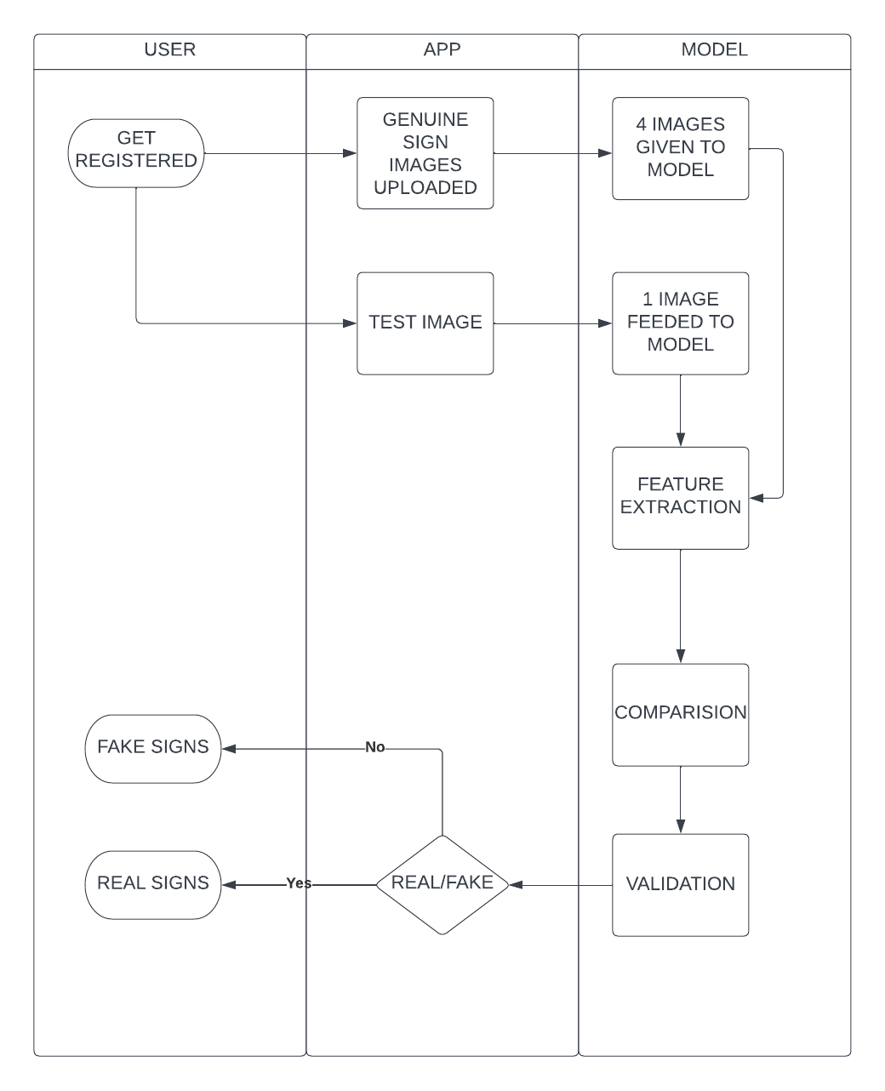

SWIMLANE DIAGRAM OF PROJECT

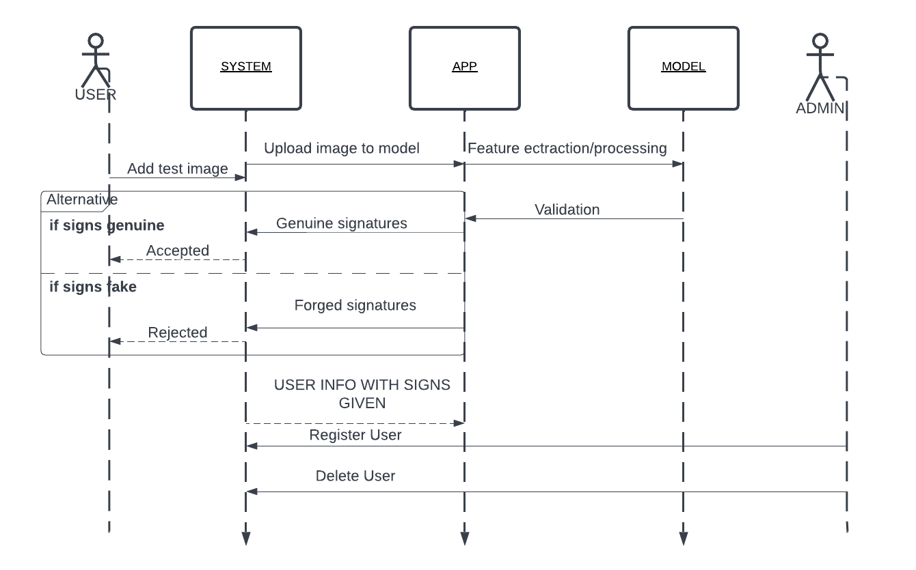
Sequence diagram of the project

Nonfunctional Requirements

Target Performance
In banks, signature verification is being manually done by the relevant officer. As per human tendency, it takes considerable amount of time to verify a signature as real or forged, along with that precision is also compromised. Our model will also take almost the same time to identify the signatures; however, with better accuracy and precision. Because the computer can see and analyze the minutest details which human cannot identify, as we are using 5 ways Siamese network so performance of our system will surely be better as compared to other available systems

Safety Requirements (if applicable)
Banks are meant to have highly secure and protective environment, in order to ascertain customers financial security. A minute level security breach may procure devastating outcomes, like misuse of someone’s signature to access its bank account etc., safety measures to avoid this scenario should be taken

Security Requirements (if applicable)
Every user should have its account protected which no one can change or modify except Admin

Additional Software Quality Attributes
Our app will be user friendly and simple to use for layman so our app will have high adaptability also our app will be scale able in which more information of clients could be added in future, our app will work on common desktop operating systems used by banks or organizations like windows

Other Requirements
All requirements are covered in this SRS

Initial Results
The results obtained till now are:
- Understanding about CNN architecture
- Knowledge about N-way Siamese network
- Dataset preprocessing

Revised Project Plan
In the first phase of project we reviewed, studied and understood related papers, we also analyzed dataset the structure/arrangement of data in dataset and it’s splitting into training and testing parts, we understood Siamese architecture and CNN algorithm with the help of literature review after literature review we worked on dataset and performed dataset preprocessing by arranging it into desired form i.e.
4 original signature images compared with test image that can either be forged signatures or real signatures, after dataset preprocessing we worked on image preprocessing and understood that what we can do and what we can’t do for example we can convert image to grayscale mode we can augment images i.e. we can rotate images but to a certain extent. In the second phase of our project we will implement existing Algorithms that we understood from literature review and will train and test model for our understanding also we will do image preprocessing and will convert images into grayscale mode and to a fixed size. In the third phase of project our Algorithm i.e. modified version of Siamese network (N-Way Siamese network) [9] will be implemented and we will train the algorithm based on preprocessed dataset i.e., 4 original images compared with 1 test image and result of the algorithms will be obtained finally in 4th phase of our project we will make a user friendly desktop app which will provide interface to our model and will publish a research paper in which we will compare the result of our algorithm with traditional model which uses simple CNN and superiority or inferiority of our system will be proved and comparison will be made

References
[1] M. Liwicki et al., "Signature Verification Competition for Online and Offline Skilled Forgeries (SigComp2011)," 2011 International Conference on Document Analysis and Recognition, 2011, pp. 1480-1484, doi: 10.1109/ICDAR.2011.294.
[2]Kaggle cedar_dataset_university_of_buffalo
[3] Dey, S., Dutta, A., Toledo, J. I., Ghosh, S. K., Lladós, J., & Pal, U. (2017). Signet: Convolutional siamese network for writer independent offline signature verification. arXiv preprint arXiv:1707.02131.
[4] Xing, Z. J., Yin, F., Wu, Y. C., & Liu, C. L. (2018, April). Offline signature verification using convolution siamese network. In Ninth International Conference on Graphic and Image Processing (ICGIP 2017) (Vol. 10615, pp. 415-423). SPIE.
[5] ARISOY, M. V. SIGNATURE VERIFICATION USING SIAMESE NEURAL NETWORK ONE-SHOT LEARNING. International Journal of Engineering and Innovative Research, 3(3), 248-260.
[6] Navid, S. M. A., Priya, S. H., Khandakar, N. H., Ferdous, Z., & Haque, A. B. (2019). Signature verification using convolutional neural network. In 2019 IEEE International Conference on Robotics, Automation, Artificial-intelligence and Internet-of-Things (RAAICON) (pp. 35-39). IEEE.
[7] Alvarez, G., Sheffer, B., & Bryant, M. (2016). Offline signature verification with convolutional neural networks. Tech. Report.
[8] Hameed, M. M., Ahmad, R., Kiah, M. L. M., & Murtaza, G. (2021). Machine learning-based offline signature verification systems: a systematic review. Signal Processing: Image Communication, 93, 116139.
[9] Wikipedia. https://en.wikipedia.org/wiki/Siamese_neural_network

Appendix A: Glossary
SVS: Signature Verification System
OFSV: offline signature verification system
CNN: convolutional Neural network, a type of artificial neural network, which is widely used for image/object recognition and classification.
Siamese network: A neural network architecture containing two or more identical subnetworks
Dataset: A structured collection of data
Preprocessing: preliminary processing of data to prepare it for the primary processing or for further analysis
Grayscale: in digital images, grayscale means that the value of each pixel represents only the intensity information of the light

Appendix B: IV & V Report
(Independent verification & validation)
IV & V Resource

Name Signature

S# | Defect Description | Origin Stage | Status | Fix Time
 |  |  |  | Hours | Minutes
1
2
3
…
Table 3: List of non-trivial defects

