

To associate with an innovative organization and

secure a challenging position where my skills and

hard work will be utilized towards the continuous

growth and advancement of the organization.

CAREER OBJECTIVE

2015 - 2017

Aggregate - 96.8%

2015

GPA - 8.5

MATRICULATION

St. ALPHONSA CONVENT HIGH

SCHOOL

INTERMEDIATE

NARAYANA JUNIOR COLLEGE



Volunteered in 5th AICTE

conference 2019 in college

Active member in NSS

Member of TFI(Teach for

Ibhrahim Bagh

EXTRA CURRICULAR ACTIVITIES

LinkedIn:

www.linkedin.com/in/mohammed-

abdul-rawoof

Mancherial,

Telangana, India

abdulrawoof039@gmail.com

(+91)7680997679

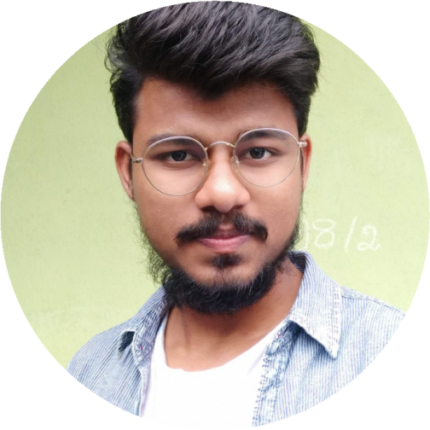

Programming in Java

*NPTEL*

09

/2020

- 12/2020

Introduction to HTML5

*Coursera*

May 2020

CERTIFICATIONS &

CERTIFICATES

MD ABDUL RAWOOF

I

N

F

O

R

M

A

T

I

O

N

T

E

C

H

N

O

L

O

G

Y

S

T

U

D

E

N

T

PROJECTS & INTERNSHIPS

An online application that is used to sell and rent

properties.

HOUSEHUNT

TECHNOLOGIES USED - HTML5/CSS3,

JAVASCRIPT, DJANGO

A Verzeo intership project

Detecting whether a person on webcam is wearing

a mask or not.

FACE MASK DETECTION

AIML, PYTHON

EDUCATION

07

/2018 - Present

CGPA - 6.9

BACHELOR OF ENGINEERING

VASAVI COLLEGE OF

ENGINEERING

Reading

novels

Reading Religious Books

Shuttle, Cricket

INTERESTS

Programming languages: C, Python, Java,

JavaScript.

Markup Language: HTML5/CSS3.

Database: SQL

SKILLS