FYP SRS Document Template

Final Year Project
Software Requirement Specification
For
A Disaster Relief Web Application – “Help Pro”
BSCS
By

S# | Name | Registration #/Roll #/Section | Mobile # | E-Mail
1. | M. Abdul Rehman Faheem | Fa2022-BSCS-225 | 0316 - 0490174 | abdulrehmanfaheem1@gmail.com
2. | M. Zain Awan | Fa2022-BSCS-226 | 0328 - 4363008 | zainawan1523@gmail.com

Supervised by:
Teacher Name ___________________ (Signature)



Department of Computer Science
Lahore Garrison University
Lahore
Table of Contents

1. Introduction........................................................................................................……….
4
4
4
4
4
6
6
7
8
8
8
9
9
9
9
9
9
10
10
10
11
12
14
1.1 Purpose ........................................................................................................................
1.2 Document Conventions ................................................................................................
1.3 Intended Audience and Reading Suggestions ..............................................................
1.4 Product Scope ..............................................................................................................
2. Overall Description ...............................................................................................
2.1 Product Perspective......................................................................................................
2.2 Product Functions ......................................................................................................
2.3 User Classes and Characteristics ...............................................................................
2.4 Operating Environment ..............................................................................................
2.5 Design and Implementation Constraints ....................................................................
2.6 User Documentation ..................................................................................................
2.7 Assumptions and Dependencies ................................................................................
3. External Interface Requirements .................................................................…
3.1 User Interfaces ...........................................................................................................
3.2 Hardware Interfaces ...................................................................................................
3.3 Software Interfaces ....................................................................................................
3.4 Communications Interfaces .......................................................................................
4. System Features ..................................................................................................
4.1 System Feature 1 ........................................................................................................
4.2 System Feature 2 ………….......................................................................................
4.3 System Feature 3 ………….......................................................................................
5. Other Nonfunctional Requirements ...................................................................
5.1 Performance Requirements ........................................................................................ 14
5.2 Safety Requirements .................................................................................................. 15
5.3 Security Requirements ............................................................................................... 15
5.4 Software Quality Attributes ....................................................................................... 15
5.5 Business Rules ........................................................................................................... 15
References .................................................................................................................... 16

1. Introduction

1.1 Purpose
This document is a Software Requirements Specification (SRS) which is defining the purpose and requirements of a web application “HELP PRO”, a disaster relief service provider. This SRS document specifies all the functional requirements and non-functional requirements of the system in detail. This is intended for teachers, supervisors, evaluators and peers to understand the system’s requirements clearly.

1.2 Document Conventions
This document follows a conventional SRS format. The requirements are written in simple english and future tense. The word “shall” specifies all the mandatory requirements, “should” indicates the recommended requirements and “may” indicates the optional requirements. specifies Each requirement is uniquely numbered for easy reference and traceability. The grammar, tense and vocabulary are used in the most articulate manner. Each UML diagram included in this document is clearly labeled and referenced with the intended section.

1.3 Intended Audience and Reading Suggestions
This SRS document is intended for teachers, project supervisors, evaluators, developers and peers involved in development and the assessment of this web application. Teachers, project supervisors and evaluators may analyze this document to understand the scope and requirements of the project. Developers should understand the functional and non-functional requirements of the project. Peers and end-user may review it to a gain general understanding of the app.

1.4 Product Scope
Help Pro is a web-based platform designed to connect disaster victims with donors in real time. During the hard times of natural disasters, the affected people who need help face difficulties while communicating their needs to world. On the other hand, the donors can not find an authentic way to communicate with the victims. This project focuses on providing an efficient, reliable, and transparent system where victims can request aid, admins can approve requests, and donors asses the requests on map and provide help if feasible.

2. Overall Description

2.1 Product Perspective
Help Pro web application is an innovative standalone idea with no prior work done in this context. This product is driven by the idea of solving a real-world problem which is of helping the people suffering in natural disasters. It aims to provide aid to the affected people by connecting them with the people, who want to help them in any way. Help Pro works independently using third-part API servies.

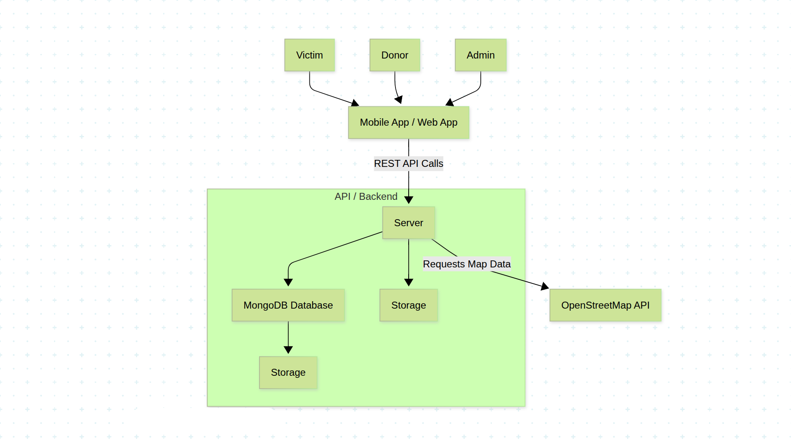
Figure 1. System Architecture Diagram

2.2 Product Functions
- Victim Request: Victims will post an update demanding the aid, this update will carry all the information about the aid requested (location, type, description and other details).
- Admin Verification: Admins will verify the victim’s update to ensure it’s authenticity.
- Donor Access: Once the requests are verified, they are posted on the UI from where donors view the requests.
- Direct Coordination: Donors can directly contact the victim to provide aid.
- Confirmation: After donor has provided the victim with aid, the admin verifies the completeness from both ends.
- Dispute Resolution: In case of any dispute or partial completeness, the request stays in disputed status.
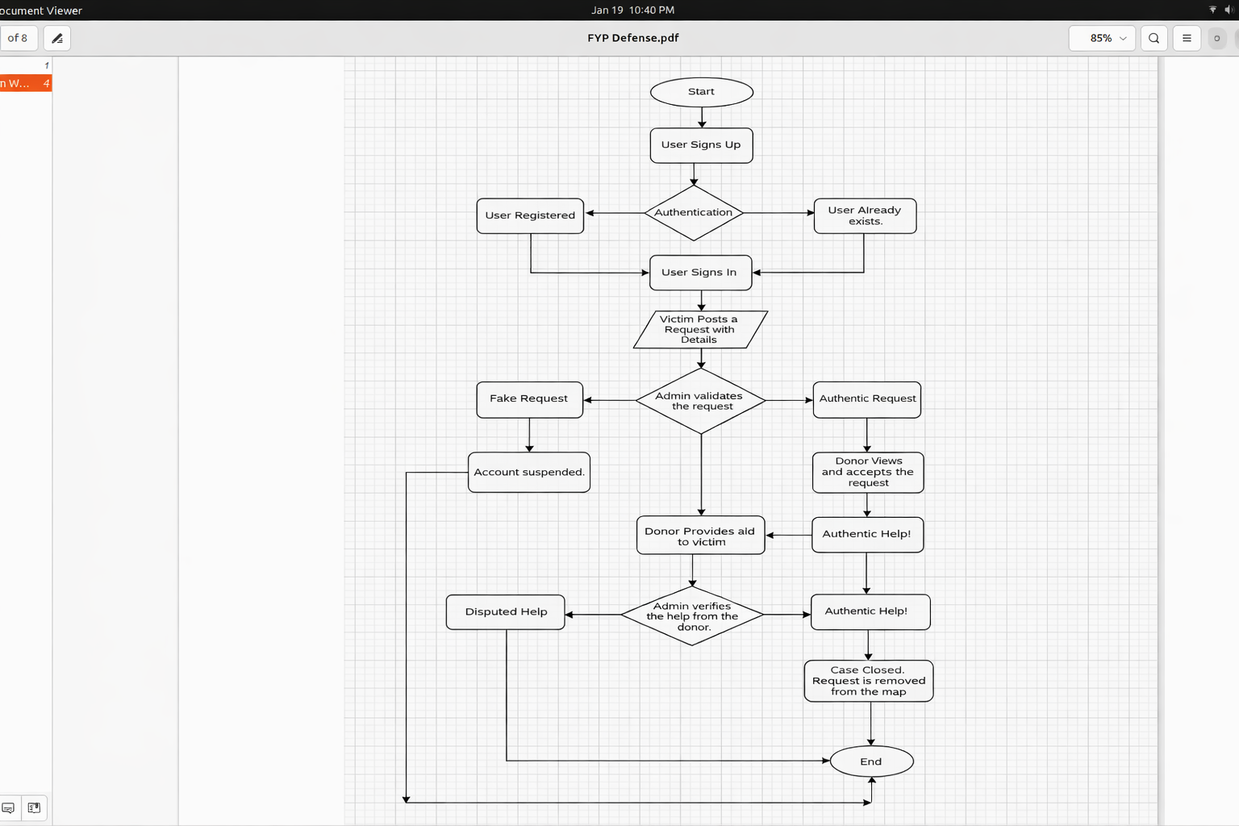

Figure 2. System Flow Diagram of HelpPro

2.3 User Classes and Characteristics
Users:
- Victims
- Donors
- Admin
Victims do not have much technical knowledge, they will just use Help Pro for posting requests. Donors have slight more technical knowledge, they accept requests and provide aid to affected people. Admin have intermediary technical grasp, from managing requests to coordinating victims and slight database operations, this is all by admin.

2.4 Operating Environment
Help Pro is a web-based application.
- The system shall support modern web browsers, including Google Chrome and Mozilla Firefox.
- From an operating system perspective, the application shall run on Linux, Windows, and Android platforms.
- A stable internet connection is required to access and use the application.
- The Help Pro web application shall be accessible on various hardware devices, including:
  - Laptops
  - Personal Computers (PCs)
  - Mobile phones
  - Tablets
  - Desktop computers

2.5 Design and Implementation Constraints
The developers shall be well-equipped with all the technical knowledge in the context of web applications. They shall be familiar with the concepts of scalability, load-balancing, databases and CMD commands. JavaScript serves as the base of developing this application followed by React and Node. Knowledge of HTML and CSS is mandatory for developer. The tools like VS Code (code editor), Postman API and Github are also mandatory. The operational knowledge of Vercel or Netlify may be proved as a plus point. A version control system Git, along with it’s understanding and adaptability shall be an important requirement, as it allows developers to collaborate and track code changes efficiently.

2.6 User Documentation
This documentation will contain a user-manual guiding helping end-users on how to use the Help Pro web application. From registration, request handling, connecting with other users and closing a case, all will be explained.
It will also contain an admin guide, explaining how to manage users, minimal database operations, data handling and system design.

2.7 Assumptions and Dependencies
The foremost assumption in this context is that the user (victim) who is affected by the natural disaster is in a state of using the application by physical means. Secondly, the user is familiar enough with the technology or the use of mobile as the people of rural areas lack in technological advancements. The application assumes that the data provided by the user is reliable and accurate. The user is using the web application on a supported browser or operating system. Lastly, the user does have a GPS-enabled device with a stable internet connection.

3. External Interface Requirements

3.1 User Interfaces
The Help Pro web application provides a simple and user friendly interface starting with sign-in and sign-up pages for victims and donors . Victims can submit aid requests and view their status through an easy-to-use interface. Donors can view verified requests and access location details using an interview map. Admin can verify requests and manage users through a dedicated control panel. The interface supports responsive design for mobile and desktop devices. Clear navigation and system messages help users interact smoothly with the application.

3.2 Hardware Interfaces
The Help Pro web application operates on standard computing devices such as mobile phones, tables, laptops, and desktop computers. Users access the system through devices equipped with a display, keyboard, or touch interface , GPS enabled hardware is used to capture and display real time location information for disaster requests. Internet connectivity hardware such as WIFI or mobile data is required for system access.

3.3 Software Interfaces
The Help Pro web application connects with multiple software components including React for the front-end, Node and Express for back-end services, and MongoDB for database management. The system runs on standard operating systems such as Windows, Linux and Android through web browsers. Third-party map services are integrated to exchange location data for displaying disaster requests. User data, request details, and verification status are exchanged between front-end and back-end using secure sessions and access control. The system relies on RESTful APIs to communication between software components.

3.4 Communications Interfaces
Help Pro communicates using HTTP and HTTPs protocols between clients and servers. Users submit and receive data through web browsers and electronic forms. Data is exchanged in JSON format and HTTPs ensures secure transmission. Real time synchronization updates request and verification status instantly.

4. System Features
This section describes the major system features of the web-application. Each feature represents a core service provided by the web-based application “Help Pro”, with brief description, priority, sequences and in-detail functional requirements.

4.1 User Registration and Authentication

4.1.1 Description and Priority
This feature enable users to create account and securely access the application features and services according to their specific role.
Priority: High

4.1.2 Stimulus/Response Sequences
Stimulus: User opens the website and navigates to sign-up.
Response: The system displays the sign-up form.
Stimulus: User enters valid credentials.
Response: System validates the user input and register them.
Stimulus: After successful registration, user logs in to the system.
Response: The system authenticates the user, grants access and navigates to user dashboard.

4.1.3 Functional Requirements
REQ-1: The system shall registers user, based on valid user credentials.
REQ-2: The system shall authenticates user and grants access to private routes.
REQ-3: The system shall allow user to operate application based on user role.
RE1-4: The system shall restrict unauthenticated user and display the subjected message.

4.2 Alerts and Notifications

4.2.1 Description and Priority
This feature provides user with disaster updates and request status.
Priority: Medium

4.2.2 Stimulus/Response Sequences
Stimulus: The victim posts an aid request.
Response: The system marks an alert pin on map, indicating a request, with a pop-up when clicked.
Stimulus: The donor views the suitable request and accepts it.
Response: The system validates the acceptance and updates the status of request.

4.2.3 Functional Requirements
REQ-1: The system shall indicate donors with a pin mark on map when a request is placed by victim.
REQ-2: The system shall handle the status of request upon acceptance.
REQ-3: The system shall give a real-time update to users regarding a request.
RE1-4: The system shall allow admin to view the requests and deal with related issues.

4.3 Reporting and Monitoring

4.3.1 Description and Priority
This feature enables administrators to monitor system activities and generate statistical reports.
Priority: Low

4.3.2 Stimulus/Response Sequences
Stimulus: Admin sign-in to admin dashboard and navigates to report page
Response: The system generates a statistical report of requests and display to admin.
Stimulus: User enters valid credentials.
Response: System validates the user input and register them.
Stimulus: After successful registration, user logs in to the system.
Response: The system authenticates the user, grants access and navigates to user dashboard.

4.3.3 Functional Requirements
REQ-1: The system shall generate reports on victims requests.
REQ-2: The system shall generate report on donors activities.
REQ-3: The system shall generate a report regarding the most affected areas by natural disaster.

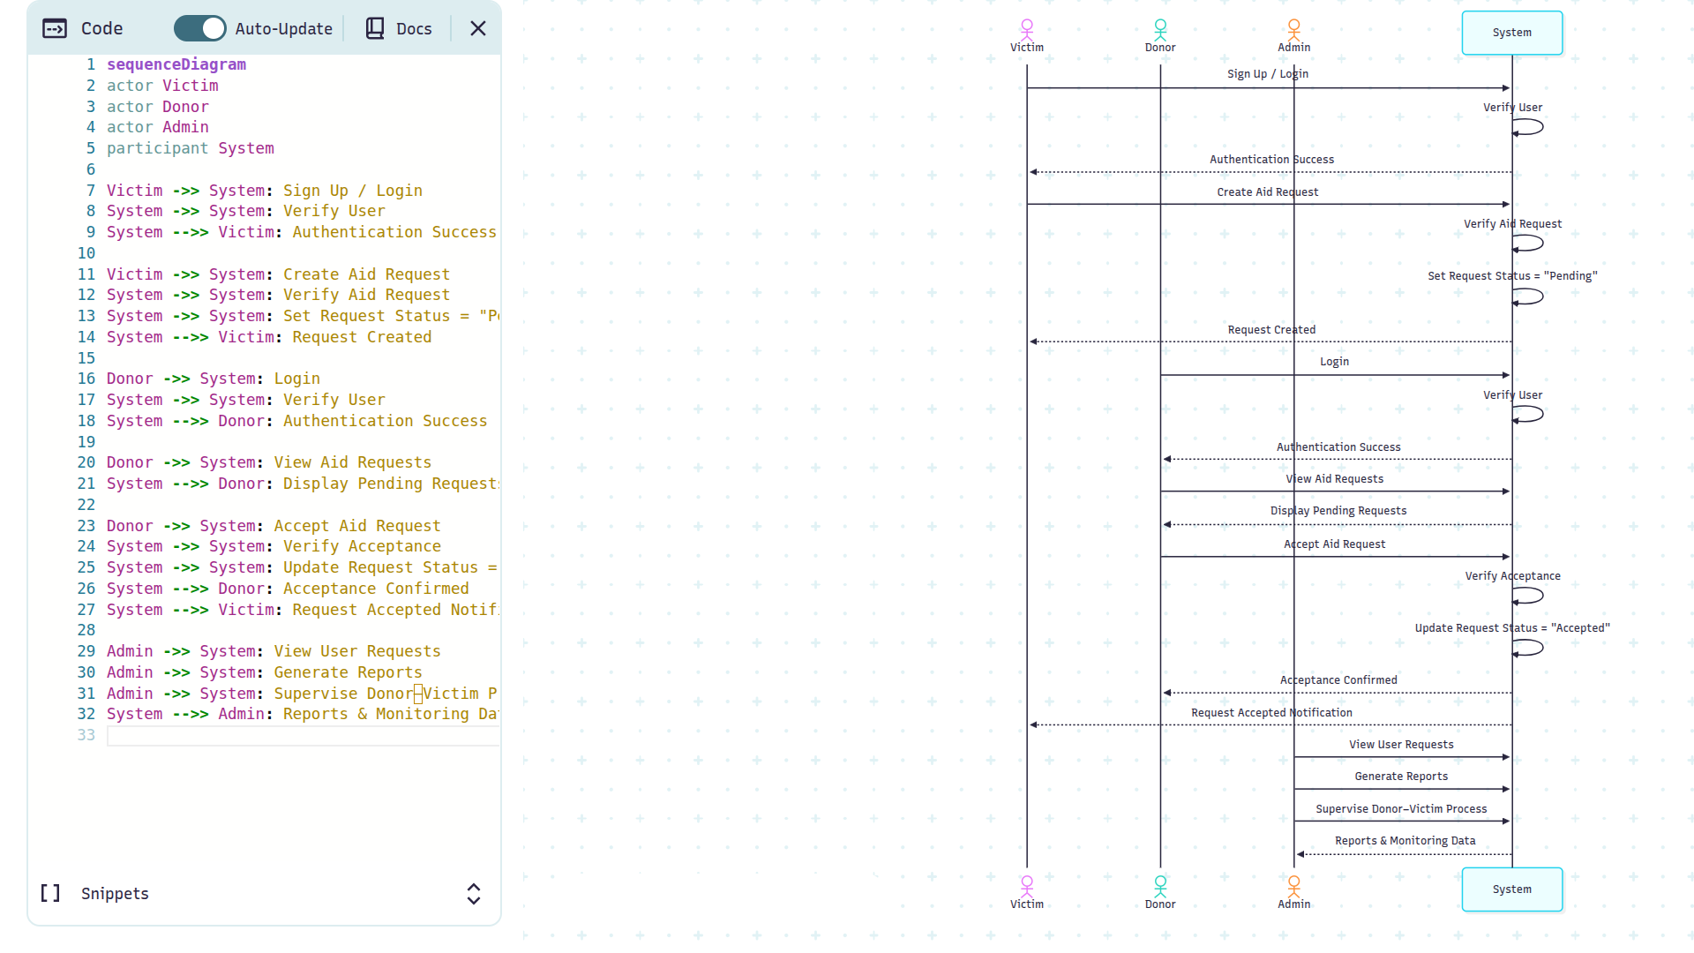
Figure 3. Sequence Diagram of System

5. Other Nonfunctional Requirements

5.1 Performance Requirements
These requirements defines the performance and expected response time of processing core functionalities. This includes description of the following matrices:
- Reliability: The system shall ensure that the request and response of the victims and donors are authentic and the data provided is correct.
- Scalability: The system shall be highly scalable, in terms of high load on the application, the system should be able to handle multiple requests of users at a time.
- Speed: The system shall minimize the time of user navigation between the pages, responses time of every request to server and other user interaction with the application. Maximum average time shall be 5 seconds.
- Real-Time: The system shall handle requests, update their status and user details in real-time.
- User-Experience: The system shall provide user with an articulate and user-friendly user interface to minimize the overhead of technological gaps.
- System-Integration and Future Updates: The system shall be flexible enough to allow integration with other systems in future. It shall allow future updates to meet the requirements of subjected time.
- Maintainability: The system shall have a proper maintenance pattern for bug fixes and user queries.

5.2 Safety Requirements
These requirements addresses the missuses of the web-application:
- The system shall prevent wrong or misleading information regarding natural disasters.
- The system shall identify fake or spam users and block their accounts.
- The system shall prevent user data like contact information and location from misuse.
- The system shall restrict unauthorized users to interact with private routes.

5.3 Security Requirements
These requirements define the security breaches of the system:
- Authentication: The system shall authenticate a user before granting access to application.
- Authorization: The system shall allow user to perform activities based on their role.
- Encryption: The system shall store sensitive user information after encryption.
- Data Privacy: The system shall protect user location data from unauthorized access.

5.4 Software Quality Attributes
The following factors define and determine the overall quality of system:
- Usability: The system should be easy to use for everyone, there should not be any kind of ambiguities or technological gap. The user must feel friendly with the application user interface.
- Reliability: The system shall operate continuously in any kind of disastrous circumstances. It shall recover from gracefully from any kind of unexpected bugs.
- Maintainability: The system shall be flexible to allow developers to maintain it with no complexities and confusions.
- Availability: The system shall be available 24/7, if the device has a stable internet connection.
- Portability:
The system should be able to run on supported desktop platforms without requiring significant changes.
- Scalability: The system shall have a potential of auto-scaling itself to handle large number of requests at a time without any crash failures or latencies.

5.5 Business Rules
Business rules define the operational polices of the web-application Help-Pro:
- Only registered and authenticated users shall have an access to the system.
- Users must provide accurate details while registration and making requests.
- Administrators shall have a right to halt an ambiguous request.
- An account breaching any security policy or misusing the application in any context shall be terminated or removed by the admin.
- Administrators shall not have access to private data of users like passwords, encryption algorithms shall be implemented.
- The system shall improvise a role-based actions. Differentiating admins, donors and victims.
- Donors shall be allowed to accept a request with the status of active and verified.
- The request status shall change once the request is accepted and it shall be removed from the map after the action has been occurred by donor.
- Donors shall only have access to limited data of victim, necessary for the connection. The transparency of the data shall be fulfilled.

References
- Yuan, F., et al. (2021). Smart Flood Resilience: Community-scale Big Data for Flood Impact Assessment. Retrieved from https://arxiv.org/abs/2111.06461
- Abbasi, S., et al. (2022). Trustable Mobile Crowdsourcing for Information from Flooded Areas. Retrieved from https://arxiv.org/abs/2203.07028
- Lorini, V., et al. (2019). Integrating Social Media into a Flood Awareness System. Retrieved from https://arxiv.org/abs/1904.10876
- OpenAI. ChatGPT: AI-based conversational assistant for software documentation support. OpenAI, 2024. Used for guidance in requirement analysis and documentation writing.

