COMPUTER NETWORKS AND DATA COMMUNICATIONS
PROJECT REPORT
ON
SZABIST KARACHI CAMPUS NETWORK INFRASTRUCTURE

CREATED BY:
NAME | REG. NO. | DEGREE
SYED ABDULLAH QADRI | 2312302 | BSCS
ABDUL REHMAN | 2312410 | BSCS
HAMZA KHAN | 2312412 | BSCS
BILAL JUNAID | 2312275 | BSCS
HASEEB KHOKHAR | 2212207 | BSCS

SUBMITTED TO:
Sir Mubeen Ahmed Khan
Sir Asher Tariq

SUBMISSION DATE:
10-June-2026

ACKNOWLEDGEMENT

We would like to express our heartfelt gratitude to our esteemed institution, Shaheed Zulfiqar Ali Bhutto Institute of Science and Technology (SZABIST), Karachi Campus, whose academic environment and resources have made this project possible. Without the foundation it has provided, we would not have been able to undertake and complete a project of this scale.
Our sincere thanks go to our instructors, Sir Mubeen Ahmed Khan and Sir Asher Tariq, for their invaluable guidance, clear instructions, and constructive feedback throughout the duration of this project. Their expertise in computer networks and data communications has been instrumental in helping us design and implement this enterprise-grade campus network infrastructure.
We also extend our appreciation to our parents for their unwavering financial and moral support, and to our peers who stood by us during challenging phases of the project, offering both technical assistance and encouragement. This report is the result of the collective effort and dedication of all five group members, and every contribution is acknowledged with gratitude.

TABLE OF CONTENTS

1. ACKNOWLEDGEMENT 1
2. TABLE OF CONTENTS 2
3. INTRODUCTION 3
4. NETWORK DESIGN AND IMPLEMENTATION 4
4.1 99 Campus Building 4
4.2 100 Campus Building 5
4.3 154 Campus Building 6
4.4 153 Campus Building 7
4.5 79 Campus Building 8
4.6 Media Villa and Research Villa 9
5. IP POOLING AND SUBNETTING (VLSM) 10
6. VLAN IMPLEMENTATION 11
7. NETWORK FUNCTIONALITY AND SECURITY ENHANCEMENTS 12
8. COMPLETE TOPOLOGY DIAGRAM 13
9. CONCLUSION 14

INTRODUCTION

This report presents the design and complete implementation of the enterprise-grade networking infrastructure for the SZABIST Karachi campus. The primary objective is to deliver a robust, scalable, and secure network that interconnects all campus buildings, departments, and data center resources under a unified, centrally managed architecture.
The network is built around a Three-Tier Hierarchical Switched topology — comprising Core, Distribution, and Access layers — spanning seven physical campus zones: 99 Campus (Core Datacenter), 100 Campus, 154 Campus, 153 Campus, 79 Campus, Media Villa, and Research Villa. A total of 27 Cisco Catalyst 2960 switches, 2 Cisco 2911 ISRs, and 4 enterprise data center servers are deployed across the campus.
The project encompasses six phases of implementation: physical hardware engineering, VLAN fabric provisioning, Inter-VLAN routing with centralized DHCP, static node configuration and port security hardening, WAN interconnection with OSPF dynamic routing and PAT/NAT, and advanced ACL-based security with remote management access.
NOTE — Device Credentials:
Enable Secret Password: | szabist123
Console Password: | szabist
VTY (Telnet) Password: | szabist
SVI Management IP (VLAN 80): | 23.122.75.2 (SW_99_CAMPUS)

NETWORK DESIGN AND IMPLEMENTATION

This section describes the hierarchical networking infrastructure deployed across each of the seven physical campus zones of SZABIST Karachi. The network follows an enterprise three-tier model where SW_99_CAMPUS acts as the absolute Core switch, six building-level Distribution switches aggregate local traffic, and twenty dedicated Access switches serve individual departments and labs. All inter-switch links operate under IEEE 802.1Q trunk encapsulation.

4.1 99 Campus Building
The 99 Campus Building serves as the central hub of the entire SZABIST network. SW_99_CAMPUS (Cisco Catalyst 2960) acts as the Core Distribution Switch for all seven zones and simultaneously hosts the six local access-layer switches for the building's own departments. The Data Center server farm — comprising the Web Server, ZABDESK Server, Email Server, and CMS Server — is directly connected to SW_99_CAMPUS on ports Fa0/1 through Fa0/4 within VLAN 70. The building houses the following departments: Classrooms (VLAN 30), Faculty (VLAN 20), Academic Services (VLAN 50), IT Department (VLAN 60), Exams (VLAN 50), and Administration (VLAN 40).

Topology
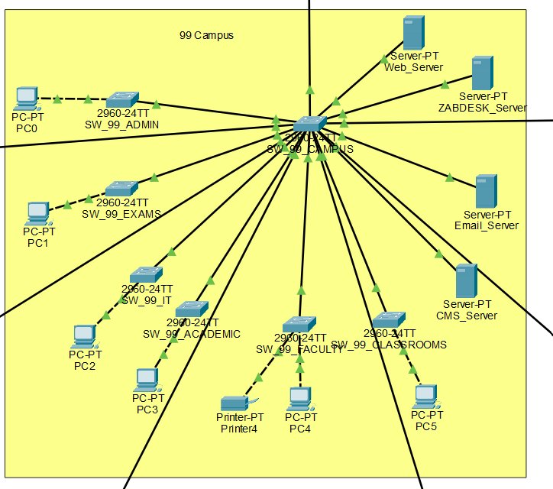

4.2 100 Campus Building
The 100 Campus Building is the largest academic zone and is aggregated through SW_100_DIST (Cisco Catalyst 2960), which connects back to the core via SW_99_CAMPUS Gi0/2. The building contains six functional departments: Labs (VLAN 10) hosting CS_Lab_PC and a local FTP Server, Classrooms (VLAN 30), Faculty (VLAN 20) with a dedicated printer, Academic Services (VLAN 50), Administration (VLAN 40), and the IT Department (VLAN 60). MAC address port security with a maximum of two sticky MAC addresses and a restrict violation policy has been applied to the lab switch to defend against unauthorized bridging.

Topology
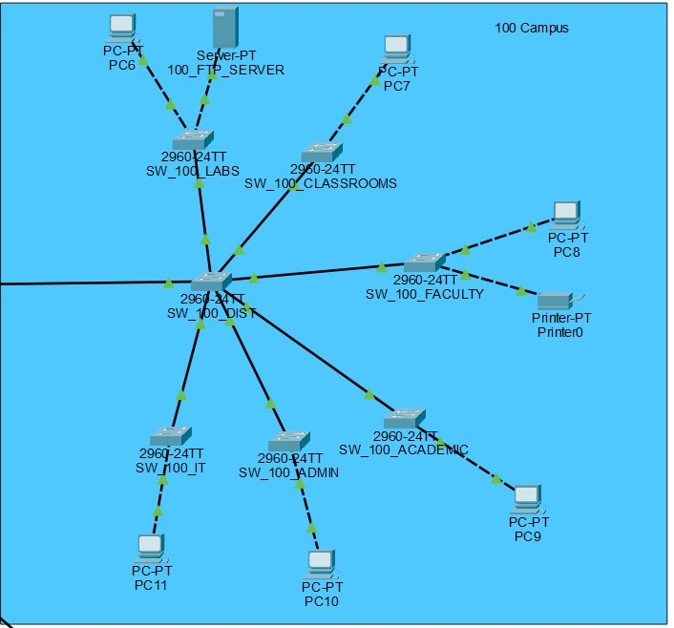

4.3 154 Campus Building
The 154 Campus Building is served by SW_154_DIST connected to the core via SW_99_CAMPUS Fa0/21. It supports five departments: Classrooms (VLAN 30), Faculty (VLAN 20) with a statically assigned printer, Academic Services (VLAN 50), Administration (VLAN 40), and the Mechatronics Labs (VLAN 10). The Mechatronics Lab switch (SW_154_MECH_LABS) is subject to strict MAC-limiting port security with a restrict violation profile, identical to the 100 Campus labs, to prevent unauthorized device connections in the engineering lab environment.

Topology
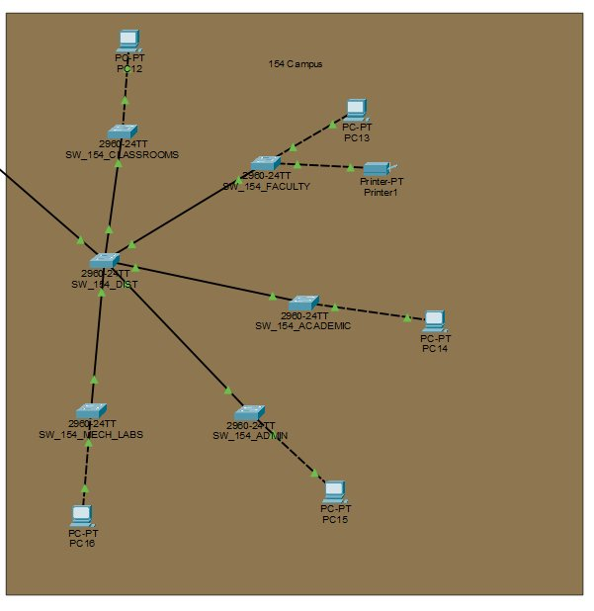

4.4 153 Campus Building
The 153 Campus Building connects to the core through SW_153_DIST via SW_99_CAMPUS Fa0/22. The building houses three departments: Classrooms (VLAN 30), the Admission Department (VLAN 50), and the Academic Department (VLAN 50). Its compact layout makes it one of the lighter buildings in terms of traffic load, though it benefits from the same campus-wide DHCP, VLAN, and ACL policies enforced across all zones.

Topology
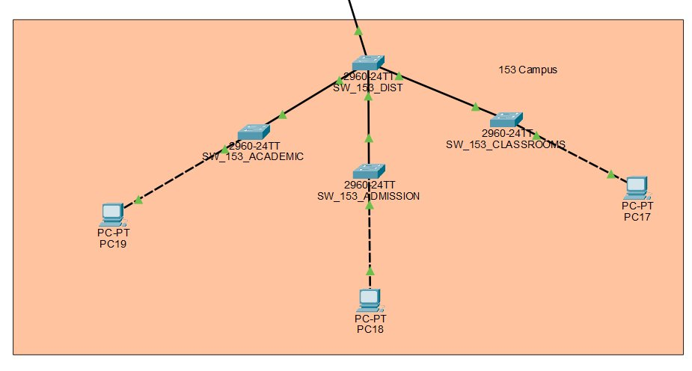

4.5 79 Campus Building
The 79 Campus Building is the primary administrative and support-services hub, aggregated through SW_79_DIST connected to the core via SW_99_CAMPUS Fa0/23. It contains six departments all operating under VLAN 40 (Admin/HR/Finance/Procurement): the Library (VLAN 50), HR Department, Procurement Department, Administration, Finance Department, and the EDC Department. The wide spread of administrative nodes in this building makes the centralized DHCP server and OSPF routing particularly critical for consistent connectivity.

Topology
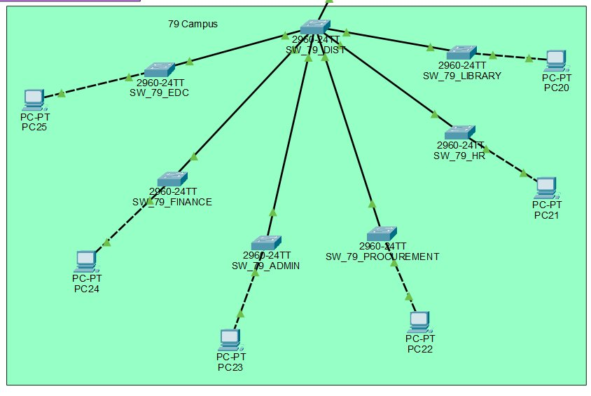

4.6 Media Villa and Research Villa
The Media Villa and Research Villa are two separate buildings that share a combined distribution zone. The Media Villa is served by SW_MEDIA_DIST connected to the core via SW_99_CAMPUS Fa0/24, while the Research Villa is served by SW_RESEARCH_DIST connected via Fa0/20. Both buildings contain Classrooms (VLAN 30), Faculty zones (VLAN 20) with statically assigned printers, and Academic departments (VLAN 50). These buildings benefit from the same enterprise security policies including FACULTY_PRINTER_SECURITY ACL enforcement, ensuring printers remain accessible only to authorized Faculty subnet nodes.

Topology
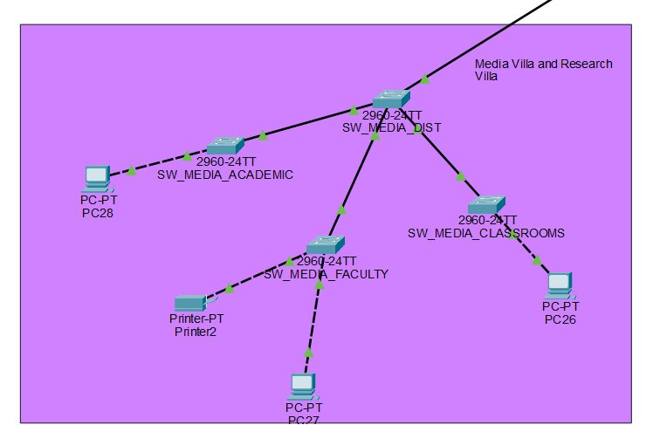

IP POOLING AND SUBNETTING (VLSM)

Variable Length Subnet Masking (VLSM) is applied to optimize IP address allocation and eliminate wastage. Each of the five group members' registration numbers contributes a /24 address pool to the project. The 1:1:1 Engineering Rule is enforced throughout: every functional department maps to exactly one VLAN, one subnet, and one broadcast domain. The first usable IP of each subnet is strictly reserved as the default gateway configured on the EDGE_Router sub-interface.
VLAN | Department / Domain | Network Address | Subnet Mask | Usable Host Range | Broadcast | Gateway IP
10 | Labs (All Buildings) | 23.123.2.0 | 255.255.254.0 (/23) | 23.123.2.1 – 23.123.3.254 | 23.123.3.255 | 23.123.2.1
20 | Faculty Domain | 23.124.10.0 | 255.255.255.128 (/25) | 23.124.10.1 – 23.124.10.126 | 23.124.10.127 | 23.124.10.1
30 | Classrooms (All Buildings) | 23.124.10.128 | 255.255.255.192 (/26) | 23.124.10.129 – 23.124.10.190 | 23.124.10.191 | 23.124.10.129
40 | Admin / HR / Finance / Procurement | 23.124.10.192 | 255.255.255.224 (/27) | 23.124.10.193 – 23.124.10.222 | 23.124.10.223 | 23.124.10.193
50 | Academic / Admission / Exams / Library | 23.124.12.0 | 255.255.255.192 (/26) | 23.124.12.1 – 23.124.12.62 | 23.124.12.63 | 23.124.12.1
60 | IT Department | 23.124.12.64 | 255.255.255.224 (/27) | 23.124.12.65 – 23.124.12.94 | 23.124.12.95 | 23.124.12.65
70 | Data Center Servers | 23.124.12.96 | 255.255.255.248 (/29) | 23.124.12.97 – 23.124.12.102 | 23.124.12.103 | 23.124.12.97
80 | Core Switch Management SVI | 23.122.75.0 | 255.255.255.224 (/27) | 23.122.75.1 – 23.122.75.30 | 23.122.75.31 | 23.122.75.1

Data Center Static IP Allocation (VLAN 70 — 23.124.12.96/29)
Server | IP Address | Subnet Mask | Default Gateway
Web Server | 23.124.12.98 | 255.255.255.248 | 23.124.12.97
ZABDESK Server | 23.124.12.99 | 255.255.255.248 | 23.124.12.97
Email Server | 23.124.12.100 | 255.255.255.248 | 23.124.12.97
CMS Server | 23.124.12.101 | 255.255.255.248 | 23.124.12.97

VLAN IMPLEMENTATION

An identical 8-VLAN mapping matrix is instantiated across all 27 infrastructure switches simultaneously. This guarantees zero broadcast domain leakage and enables global uniform Inter-VLAN packet distribution across all seven campus buildings. VLANs are provisioned in access mode on all endpoint-facing ports and in 802.1Q trunk mode on all inter-switch uplinks. Spanning-Tree PortFast is applied globally to all edge workstation and server-facing ports to maintain zero-latency convergence at startup.
VLAN ID | Department | VLAN Name | Description
10 | Labs | VLAN 10: Labs | All laboratory nodes across campus
20 | Faculty | VLAN 20: Faculty | All faculty staff access layer
30 | Classrooms | VLAN 30: Classrooms | All classroom instructional nodes
40 | Admin / HR / Finance / Proc. | VLAN 40: Admin_HR_Finance | Administrative operational block
50 | Acad / Exams / Lib / Admiss. | VLAN 50: Acad_Exams_Lib_Admiss | Combined academic services domain
60 | IT Department | VLAN 60: IT_Department | Dedicated network admin zone
70 | Data Center Servers | VLAN 70: Data_Center_Servers | Static enterprise resource domain
80 | Switch Management SVI | VLAN 80: Switch_Management_SVI | Isolated in-band device management

Trunk Configuration Summary:
SW_99_CAMPUS Gi0/1 — Master trunk uplink to EDGE_Router (Router-on-a-Stick)
SW_99_CAMPUS Gi0/2, Fa0/20–Fa0/24 — 802.1Q trunks to 6 building distribution switches
SW_99_CAMPUS Fa0/5–Fa0/10 — 802.1Q trunks to local 99 Campus access switches
SW_99_CAMPUS Fa0/1–Fa0/4 — Access mode, VLAN 70 (Data Center server ports, PortFast enabled)

NETWORK FUNCTIONALITY AND SECURITY ENHANCEMENTS

To deliver a fully operational, secure, and manageable campus network, the following advanced techniques were implemented across all six phases of the project:
Inter-VLAN Routing (Router-on-a-Stick):
Eight logical sub-interfaces (Gi0/0.10 through Gi0/0.80) were created on the EDGE_Router, each bound to its corresponding 802.1Q VLAN tag. The first usable IP of each VLSM subnet is assigned as the sub-interface gateway, enabling seamless inter-department communication across all campus buildings.
Centralized DHCP Configuration:
Six dynamic DHCP scopes are hosted on the EDGE_Router, serving VLANs 10, 20, 30, 40, 50, and 60. DHCP exclusion ranges protect gateways, server IPs, printer IPs, and switch SVI addresses from dynamic assignment. The Web Server IP (23.124.12.98) is propagated as the DNS server address to all DHCP clients campus-wide.
Static IP Assignment:
All four Data Center servers (Web, ZABDESK, Email, CMS) are assigned static IPs within VLAN 70 (23.124.12.96/29). Five faculty printers across the campus buildings (99, 100, 154, Media Villa, Research Villa) are statically bound within VLAN 20.
Port Security (MAC Address Hardening):
SW_99_CAMPUS ports Fa0/1–Fa0/4 (Data Center) are configured with sticky MAC addresses and a maximum of 1 allowed MAC address per port, enforcing a protect violation posture. SW_100_LABS and SW_154_MECH_LABS are configured with a maximum of 2 sticky MAC addresses per port and a restrict violation mode to block unauthorized bridging attacks in lab environments.
WAN Interconnection and OSPF Dynamic Routing:
A Serial V.35 DCE WAN link connects the ISP_Router to the EDGE_Router over Serial 0/3/0. A single-area OSPF (Area 0) routing engine is provisioned across the network using precise wildcard mask configurations. The ISP_Router uses default-information originate always to propagate a default internet route to the campus border.
NAT / PAT (Port Address Translation):
Stateful PAT overload is configured on the EDGE_Router, mapping all private campus subnets (access-list 1) to the public Serial 0/3/0 interface. This enables all campus workstations to share a single public IP for internet access. Verified via successful ICMP pings from 79_HR_PC and 99_Class_PC to 8.8.8.8.
Access Control Lists (ACLs):
Two named extended ACLs enforce critical security constraints: ZABDESK_SERVER_SECURITY (applied outbound on Gi0/0.70) restricts ZABDESK Server access to Lab (VLAN 10) and Faculty (VLAN 20) subnets only. FACULTY_PRINTER_SECURITY (applied outbound on Gi0/0.20) blocks all non-Faculty subnets from accessing Faculty printers, fulfilling the project constraint that no other department can access Faculty printers.
Remote Management and AAA Hardening:
Enable secret passwords using MD5 hashing are configured on both the EDGE_Router and SW_99_CAMPUS. Line console 0 and VTY lines are secured with the credential szabist123. VLAN 80 SVI management is activated on SW_99_CAMPUS with IP address 23.122.75.2, verified via successful Telnet sessions from 100_Acad_PC across campus subnets.

COMPLETE TOPOLOGY DIAGRAM

The diagram below illustrates the complete multi-building SZABIST Karachi campus network as implemented in Cisco Packet Tracer. The topology showcases the Three-Tier hierarchical architecture with SW_99_CAMPUS at the core, six building distribution switches at the distribution layer, twenty access switches at the edge, the ISP-EDGE WAN serial link, the enterprise data center server farm, and all inter-building trunk connections.
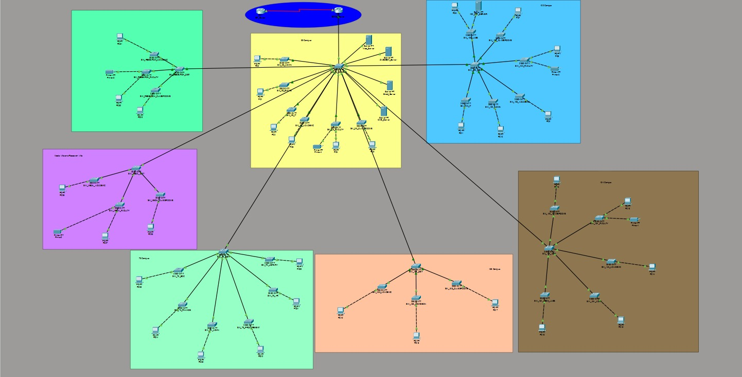

CONCLUSION

The SZABIST Karachi Campus Network Infrastructure Project successfully delivers a resilient, scalable, and secure enterprise-grade network spanning all seven physical campus buildings. Through the disciplined application of the Three-Tier Hierarchical Switched topology, the network achieves clean separation between the Core, Distribution, and Access layers, maximizing both manageability and fault isolation.
The implementation of VLSM-based IP addressing using all five group members' registration number pools ensures efficient utilization of the address space with zero overlap. The eight-VLAN campus-wide fabric, provisioned uniformly across all 27 switches, enforces strict broadcast domain separation and provides the foundation for policy-based traffic control.
Centralized DHCP automation on the EDGE_Router eliminates manual configuration overhead for all dynamic workstations, while static IP assignments for servers and printers ensure predictable and reliable service availability. Port security hardening at the Data Center and lab access layers provides a robust Layer 2 defense against unauthorized device access.
The integration of OSPF dynamic routing, stateful PAT, named extended ACLs, and encrypted remote management access completes a full-spectrum security and connectivity solution. All six phases have been verified through end-to-end ICMP telemetry, DHCP lease confirmation across all departments, Telnet management from remote subnets, and successful internet reachability from campus workstations. The network is fully operational and ready for production deployment across the SZABIST Karachi campus.

