UNINFORMED SEARCH STRATEGIES
Name: Muhammad Abdullah
Roll: 066

Task 1 — Exploring a graph with BFS and DFS
The search starts at A and aims to reach G. The directed links are A→B,C; B→D,E; C→F; and E→G. Nodes D, F and G have no children. The program returns the route to the target along with the order in which nodes were visited.
from collections import deque
graph = {
"A": ["B", "C"], "B": ["D", "E"], "C": ["F"],
"D": [], "E": ["G"], "F": [], "G": []
}
def bfs(start, goal):
queue = deque([(start, [start])])
visited = {start}
order = []
while queue:
node, path = queue.popleft()
order.append(node)
if node == goal:
return path, order
for child in graph[node]:
if child not in visited:
visited.add(child)
queue.append((child, path + [child]))
return None, order
def dfs(start, goal):
stack = [(start, [start])]
visited = set()
order = []
while stack:
node, path = stack.pop()
if node in visited:
continue
visited.add(node)
order.append(node)
if node == goal:
return path, order
for child in reversed(graph[node]):
stack.append((child, path + [child]))
return None, order
print("BFS:", bfs("A", "G"))
print("DFS:", dfs("A", "G"))
BFS uses a first-in, first-out queue and checks nearby levels before going deeper. DFS uses a stack and follows one branch before backtracking. With the child order shown, the target route is A → B → E → G, although the two algorithms can visit the nodes in a different order.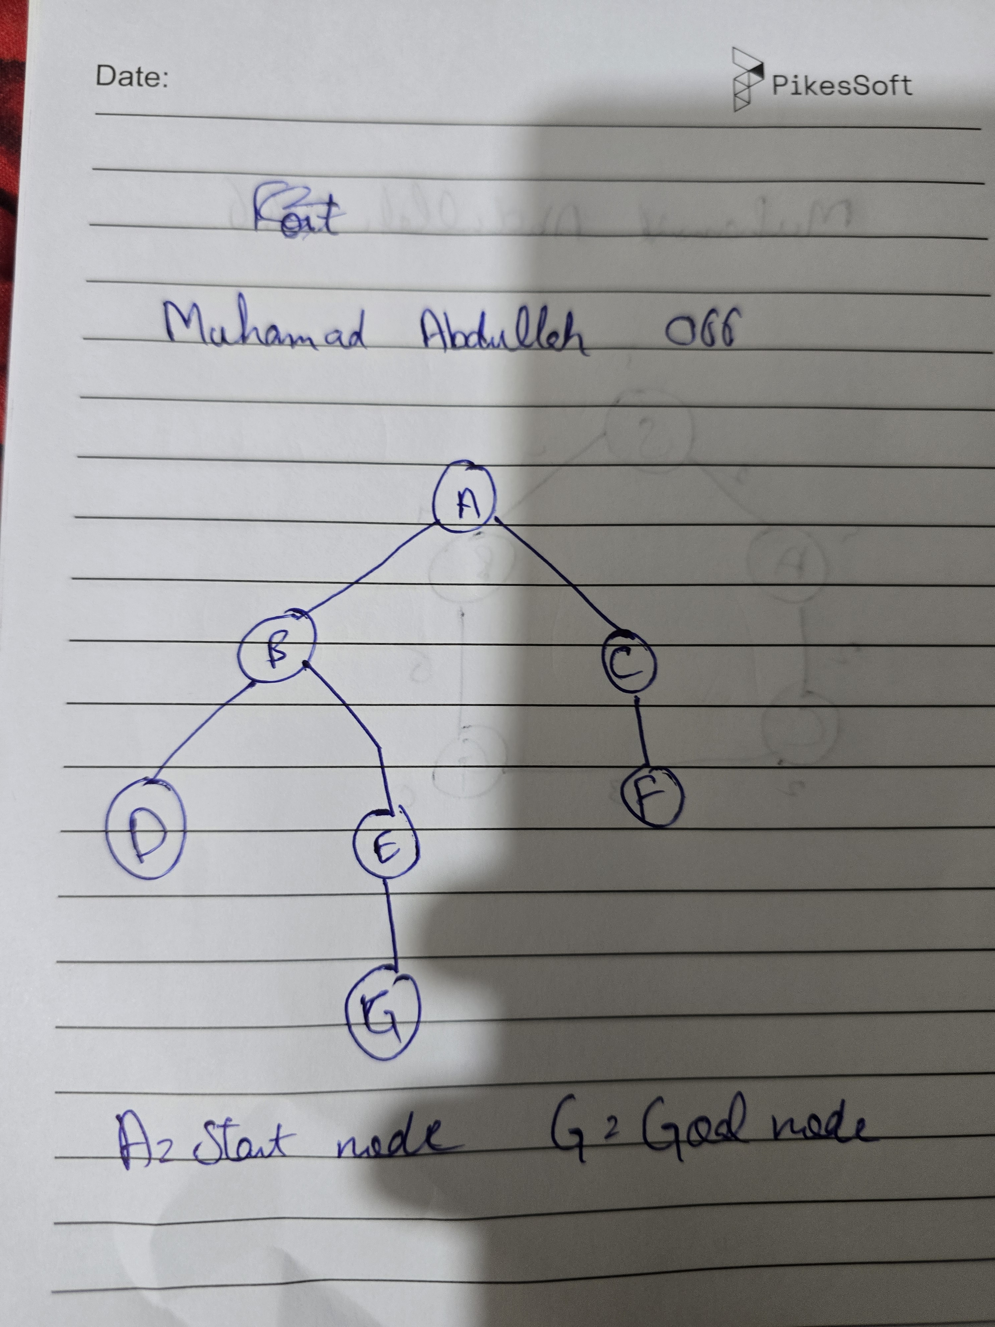

Task 2 — DLS and IDDFS
Depth-Limited Search is similar to depth-first search, but it will not travel beyond a selected depth. Iterative Deepening DFS runs the same search repeatedly, increasing the limit one level at a time until the goal is found or the maximum limit is reached.
graph = {
"A": ["B", "C"], "B": ["D", "E"], "C": ["F"],
"D": [], "E": ["G"], "F": [], "G": []
}
def dls(node, goal, limit, path):
if node == goal:
return "FOUND", path
if limit == 0:
return ("CUTOFF", None) if graph[node] else ("FAILURE", None)
cutoff_found = False
for child in graph[node]:
if child in path:
continue
status, result = dls(child, goal, limit - 1, path + [child])
if status == "FOUND":
return status, result
if status == "CUTOFF":
cutoff_found = True
return ("CUTOFF", None) if cutoff_found else ("FAILURE", None)
def iddfs(start, goal, max_depth):
for depth in range(max_depth + 1):
status, route = dls(start, goal, depth, [start])
print("Limit:", depth, "Status:", status, "Route:", route)
if status == "FOUND":
return route
return None
for depth in range(1, 5):
print("DLS limit", depth, dls("A", "G", depth, ["A"]))
print("IDDFS:")
iddfs("A", "G", 4)
CUTOFF means that the depth boundary stopped the search while more of the graph may remain. FAILURE means there are no further usable branches in the current search. A cutoff at depth two does not prove that G is unreachable; a deeper limit may still find it.

Task 3 — Uniform-Cost Search on a weighted graph
The weighted graph contains A→B (1), A→C (2), B→D (4), B→E (1), C→F (5), C→G (10), and E→G (1). Uniform-Cost Search expands the route with the smallest accumulated cost first.
import heapq
weighted_graph = {
"A": [("B", 1), ("C", 2)],
"B": [("D", 4), ("E", 1)],
"C": [("F", 5), ("G", 10)],
"D": [], "E": [("G", 1)], "F": [], "G": []
}
def ucs(start, goal):
frontier = [(0, start, [start])]
best = {start: 0}
order = []
while frontier:
cost, node, path = heapq.heappop(frontier)
if cost != best.get(node):
continue
order.append(node)
if node == goal:
return path, cost, order
for nxt, weight in weighted_graph[node]:
new_cost = cost + weight
if new_cost < best.get(nxt, float("inf")):
best[nxt] = new_cost
heapq.heappush(frontier, (new_cost, nxt, path + [nxt]))
return None, float("inf"), order
route, cost, order = ucs("A", "G")
print("Route:", route)
print("Total cost:", cost)
print("Visit order:", order)
The least expensive route is A → B → E → G. Its total cost is 3. The priority queue makes sure that a route with a lower accumulated cost is considered before a more expensive alternative.

Extra tests and summary
- If start and goal are both A, the answer should be [A] without exploring other nodes.
- When a target cannot be reached, the search should return no route.
- Adding a cycle such as E→B should not cause DLS or IDDFS to revisit an ancestor indefinitely; the current-path check prevents this.
- A depth limit tells us how far the search was allowed to go, not whether a solution exists at every possible depth.
The experiments show that BFS prioritises shallow paths, DFS explores branches, DLS applies a depth boundary, IDDFS increases that boundary gradually, and UCS selects paths by cost. The best choice depends on whether the graph is weighted and what kind of result is required.

